Marathwada Shikshan Prasarak Mandal’s

**Deogiri Institute of Engineering and Management Studies,**

**Chatrapati Sambhajinagar**

**Project Report**

**on**

# Generate M2M

Submitted By

**Prasad Sonawane (CS4159)**

**Prathamesh Wadgaonkar (CS4160)**

**Rahul Narode (CS4165)**

## Dr. Babasaheb Ambedkar Technological University

**Lonere (M.S.)**

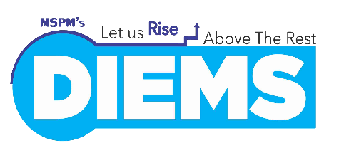

Department of Computer Science and Engineering

## Deogiri Institute of Engineering and Management Studies,

**Chatrapati Sambhajinagar**

(2023-2024)

**Project Report**

**on**

# Generate M2M

Submitted By

**Prasad Sonawane (CS4159)**

## Prathamesh Wadgaonkar (CS4160)

## Rahul Narode (CS 4165)

**In partial fulfilment of**

**Bachelor of Technology**

## (Computer Science & Engineering)

Guided By

**Dr. Smita Ponde**

Department of Computer Science & Engineering

**Deogiri Institute of Engineering and Management Studies, Chatrapati Sambhajinagar**

(2023- 2024)

## CERTIFICATE

This is to certify that, the Project entitled “**Generate M2M**” submitted by **Prasad**

**Sonawane, Prathamesh Wadgaonkar, Rahul Narode** is a bonafide work completed under my supervision and guidance in partial fulfilment forward of Bachelor of Technology (Computer Science and Engineering) Degree of Dr. Babasaheb Ambedkar Technological University, Lonere.

### Date:Place: Chatrapati Sambhajinagar

**Dr. Smita Ponde Mr . S.B. Kalyankar**

ProjectGuideHead

**Dr. S. V. Lahane Dr. U. D. Shiurkar**

Dean Academics Director

## DECLARATION

This is to certify that, the partial project report entitled , “Generate M2M” Submitted by Prasad Sonawane, Prathamesh Wadgaonkar, Rahul Narode is a bonafide work completed under my supervision and guidance in partial fulfilment for award of bachelor’s degree in computer science and engineering of Deogiri Institute of Engineering and Management Studies, Chatrapati Sambhajinagar under Dr. Babasaheb Ambedkar Technological University, Lonere.

Place: Chatrapati Sambhajinagar

Date:

Dr. Smita Ponde

External Examiner Guide

## Abstract

In today's fast-paced business environment, efficient meeting management is crucial for productivity and collaboration. One fundamental aspect of this process is the creation of Meeting Minutes (M2M) or notes, which document discussions, decisions, and action items during meetings. This abstract outline a project focused on automating the generation of M2M, leveraging advanced technology to streamline the time-consuming and error-prone task.

The Generate the M2M Project is a research project that aims to develop a system that can automatically generate Minutes of Meetings (M2Ms) from recorded audio or video of meetings. The system will use a combination of natural language processing and machine learning techniques to identify the key points of the meeting, summarize them in a concise and informative way, and generate a formatted M2M document.

The project is motivated by the fact that creating M2Ms is a time-consuming and tedious task for many people. It can be difficult to remember all of the key points of a meeting, and it can be even more difficult to write them up in a clear and concise way. The Generate THR M2M Project aims to automate this process, making it easier and faster for people to create M2Ms. The project is still under development, but it has the potential to be a valuable tool for businesses of all sizes. By automating the M2M creation process, the project can save businesses time and money, and it can also help to improve the quality of M2Ms.

The project aims to develop a comprehensive solution for generating M2M that caters to various meeting formats, from formal board meetings to casual team huddles. Leveraging Natural Language Processing (NLP) and Machine Learning (ML) techniques, the system will capture and transcribe spoken or written content during meetings, extract key insights, and format them into structured M2M reports.

Key components of this project include the Speech and Text Recognition which is Implementing advanced speech recognition algorithms to accurately transcribe spoken content during meetings, while also accommodating manual note input , Data Extraction is the Utilizing NLP algorithms to extract essential information such as action items, decisions, and key discussion points from the transcribed text, This project seeks to revolutionize the way organizations document their meetings, improving efficiency, reducing human error, and enabling better decision-making. The automation of M2M generation will not only save time but also enhance transparency and accountability within the organization.

Ultimately, this project is anticipated to have a profound impact on the business world by transforming a routine administrative task into a valuable tool for productivity and knowledge management, fostering better collaboration and more effective decision-making across various industries.

Contextual Analysis is the Incorporating context-awareness to discern the significance of different topics and accurately reflect the flow of the meeting in the generated M2M. Security and Privacy is Implementing robust security measures to protect sensitive meeting data and ensuring compliance with data privacy regulations and User-Friendly Interface is Creating an intuitive user interface that simplifies the process of initiating, managing, and reviewing automated M2M generation.

The project is expected to have a number of benefits for The M2M Project, including the Increased lead generation will generate more leads for The M2M Project, which will help the company grow its business, Improved lead quality will generate higher-quality leads, which will increase the likelihood of those leads becoming paying customers and Reduced cost per lead is expected to reduce the cost per lead for The M2M Project, which will improve the company's profitability.

|  |
| --- |
| Contents |
| **List of Figures i** |
| **List of Screenshots ii** |
| **List of Tables iii** |
| 1. **INTRODUCTION 1** |
| 1.1 Introduction 1 |
| * 1. Necessity 3 |
| * 1. Objectives4 |
| * 1. Theme of the Project 8 |
| 2. LITERATURE SURVEY 10 |
| 2.1 Literature Survey 10 |
| 2.2 Project Perspective 12 |
| 2.3 Assumptions and Dependencies 13 |
| 2.4 General Constraints 17 |
| 3. SYSTEM DEVELOPMENT 19 |
| 3.1 Requirement Specification 19 |
| 3.1.1 DFD (level 0,1,2) 23 |
| 3.1.2 Specification Document/UML Diagrams of all modules 25 |
| 3.2 User Interface Design 26 |
| 3.3 Database Design / ER Diagrams 27 |
| **4. PERFORMANCE EVALUATION 29** |
| 4.1 Performance Evaluation 29 |
| 4.2 Test Case 32 |
| 4.3 Future Improvement 38 |
| 4.4 Additional Functionality 40 |
| **5. CONCLUSION 43** |
| **REFERENCES** |
| **ACKNOWLEDGEMENT** |

|  |
| --- |
|  |
| List of Figures |
|  |
|  |
|  |
| Figure Illustration Page |
|  |
| 3.1 Zero Level Data Flow Diagram 24 |
| 3.2 One Level Data Flow Diagram 24 |
| 3.3 Two Level Data Flow Diagram 25 |
| 3.4 Use Case Diagram 25 |
| 3.5 Sequence Diagram 26 |
| 3.6 ER Diagram 26 |
|  |

i

|  |
| --- |
| **List of Screenshots** |
|  |
|  |
|  |
| **Figure Illustration Page** |
|  |
| 3.1 SDLC Model 21 |
| 4.1 Login Page 32 |
| 4.2 Home Page 34 |
| 4.3 Text Converter Page 36 |
| 4.4 Summarized Page 37 |

ii

|  |
| --- |
| **List of Tables** |
|  |
|  |
|  |
| **Figure Illustration Page** |
|  |
| 4.1 Test Case for Sign in Page 33 |
| 4.2 Test Case for Home in Page 35 |
| 4.3 Test Case for Text Converter Page 37 |

iii

## INTRODUCTION

### 1.1 Introduction

The Generate Meeting to Minutes project is an innovative solution that addresses the challenges of manually transcribing and summarizing meeting recordings. By leveraging cutting-edge speech-to-text and natural language processing (NLP) technologies, this project automates the process of converting audio recordings into concise and informative meeting minutes. This automation not only saves time and effort but also ensures accuracy and consistency in meeting documentation.

In today's fast-paced business environment, effective communication is essential for success. Meetings play a crucial role in fostering collaboration, sharing ideas, and making informed decisions. However, manually transcribing and summarizing meeting recordings can be a time-consuming and tedious task. This is where the Generate Minutes of Meeting project comes into play.

This innovative project utilizes cutting-edge speech-to-text and natural language processing (NLP) techniques to automatically convert audio recordings of meetings into text and then generate concise summaries of the key points discussed. This automation streamlines the process of capturing and disseminating meeting information, saving valuable time and resources for busy professionals.

However, the manual creation of M2M is a less time-consuming the challenges extend from deciphering hasty notes and deciphering spoken conversations to the painstaking effort of formatting and distribution. In today's fast-paced and technology-driven world, such manual processes are increasingly at odds with the demand for agility and productivity.

This is where the "Generate the Meeting to Minutes (M2M) Project" comes into play. This project is envisioned as a transformative force in the realm of meeting management, leveraging advanced technology to streamline the process of M2M creation. By harnessing the power of Natural Language Processing (NLP), Machine Learning (ML), and a deep understanding of human communication, this project seeks to automate and enhance the M2M generation process.

In this introduction, we embark on a journey into the heart of this innovative project, exploring the challenges it addresses, the technologies it harnesses, and the far-reaching implications it holds for organizations across various industries. By automating the generation of M2M, this project aims to unlock a new era of efficiency, transparency, and collaboration in the realm of meetings, ultimately empowering teams and decision-makers to achieve their goals with greater precision and agility.

The Generate the M2M Project is a new initiative to develop a machine learning-powered method for generating targeted and high-quality leads for The M2M Project, a marketplace for women who want to work flexibly. These M2M Project is a valuable resource for women who are looking to balance their work and personal lives. The company offers a variety of flexible job opportunities, as well as resources and support for working mothers.

However, The M2M Project faces a challenge in generating leads. The company's target audience is broad, and it can be difficult to reach potential customers through traditional channels. The Generate THR M2M Project aims to address this challenge by developing a new method for generating leads. The project will use a variety of data sources, including job postings, social media profiles, and website visits, to identify potential leads. Once potential leads have been identified, the project will use machine learning to generate personalized messages that are likely to resonate with each individual lead.

The Generate the M2M Project has the potential to make a significant impact on The M2M Project's business. By generating more and higher-quality leads, the project can help the company grow its business and reach more women who are looking for flexible work opportunities. In addition, the project has the potential to reduce the cost per lead for The M2M Project, which can improve the company's profitability and still in its early stages of development, but the team is confident that it has the potential to make a real difference in the lives of working mothers.

In today's globalized business landscape, effective communication is paramount, and this project addresses the challenges associated with multilingual collaboration. By employing advanced speech recognition algorithms, the system seamlessly transcribes spoken words from audio files into text, ensuring accuracy even in diverse linguistic environments.

The next phase of the project involves harnessing text summarization techniques to distill the transcribed content into succinct summaries. These summaries capture the key points, decisions, and action items discussed during the meeting, facilitating quick comprehension and decision-making.

What sets this project apart is its versatility in catering to a multitude of languages, acknowledging the diverse linguistic landscape of modern enterprises. Through integration with machine translation services, the system ensures that the generated summaries are accessible and actionable for participants who may speak different languages.

In essence, the "Minutes of Meeting Generation" project not only enhances the accessibility and efficiency of business meetings but also fosters a collaborative environment where language is no longer a barrier to effective communication. This innovative solution is poised to revolutionize how organizations conduct and document their meetings, ultimately contributing to increased productivity and streamlined communication on a global scale.

#### 1.2 Necessity

The purpose or necessity of the Generate the M2M (Minutes of Meeting) project is to streamline and enhance the process of capturing, documenting, and disseminating crucial information and decisions made during meetings within an organization. Meetings are a fundamental part of effective communication and collaboration in any business or group. However, the value of these meetings can be significantly compromised if the minutes are not accurately recorded, promptly shared, or easily accessible for reference. The M2M project aims to address these challenges by providing a centralized, user-friendly platform that automates the creation of meeting minutes, ensuring consistency and completeness. This project ultimately strives to improve productivity,

accountability, and transparency by making it easier for participants to track action items, follow up on discussions, and align on key takeaways from each meeting.

The necessity of minutes of a meeting, especially when audio or video files are uploaded and converted into a summary, is quite significant for various reasons :

* Documentation: Minutes provide a documented record of what transpired during the meeting. This is essential for legal, compliance, and accountability purposes. It serves as an official record of decisions, discussions, and action items, reducing the risk of disputes or misunderstandings later on.

* Reference Tool: Meeting minutes serve as a reference tool for all participants. It helps attendees recall what was discussed, decisions made, and tasks assigned. This is particularly valuable in complex or lengthy meetings where many topics are covered.

* Accountability: Meeting minutes establish accountability by recording action items, responsibilities, and deadlines. They help track progress and ensure that tasks are completed as agreed upon during the meeting.
* Communication: Minutes can be shared with participants who may have missed the meeting, enabling them to catch up on the discussions and decisions made. This fosters transparency and ensures that all relevant stakeholders are kept in the loop.

* Archiving and Retrieval: Digitized minutes of meetings are easy to store, retrieve, and search, which can be crucial for future reference. It eliminates the need to sift through long audio or video recordings to find specific information.

* Time-Efficiency: A summarized version of the meeting in text form is generally quicker and more efficient to review than listening to or watching the entire audio or video recording. It saves time for both meeting participants and those referencing the minutes later.

* Accessibility: Meeting minutes are accessible to a wider audience since they are typically easier to share and distribute than audio or video recordings, which may require specific software or hardware for playback.

#### 1.3 Objective

The scope of the "Generate the M2M (Minutes of Meeting) Project" encompasses a comprehensive initiative to improve the efficiency, accuracy, and accessibility of meeting documentation within our organization. This project seeks to address the critical need for a streamlined and standardized approach to creating, managing, and sharing minutes of meetings across various departments and teams.

The scope of the project to generate the M2M (Minutes of Meeting) is to develop a system that can automatically generate accurate and comprehensive meeting minutes from audio recordings, transcripts, or notes. The system should be able to identify the key points of the meeting, including the topics discussed, decisions made, and next steps. It should also be able to format the meeting minutes in a professional and easy-to-read way.

The system should be able to handle a variety of meeting types, including one-on-one meetings, team meetings, and large group meetings. It should also be able to handle meetings with different levels of formality, from casual conversations to formal board meetings. the system should be able to be used by a variety of users, including meeting participants, meeting organizers, and administrative staff. It should be easy to use and should not require any specialized training.

The system should be able to be integrated with other systems, such as calendar systems, project management systems, and customer relationship management (CRM) systems. This will allow users to easily share meeting minutes with others and to access meeting minutes from other systems.

The objective of the Minutes of Meeting project is to develop a tool that can automatically generate summaries of audio and video files. This tool would be used to help teams improve communication and collaboration by making it easy to share and discuss meeting summaries. Specifically, the Minutes of Meeting project aims to achieve the following objectives Develop a tool that can accurately and efficiently summarize audio and video files. This would involve using natural The Minutes of Meeting project has the potential to make a significant impact on the way that teams communicate and collaborate. By making it easy to generate summaries of meetings, the project can help teams to save time, improve communication, increase collaboration, and make better decisions

language processing (NLP) techniques to identify the key points of the meeting and generate a concise and informative summary. Make the tool easy to use and accessible to teams of all sizes. This would involve developing a user-friendly interface and making the tool available as a cloud-based service.

Demonstrate the value of the tool by providing case studies of how it has been used to improve communication and collaboration in real-world settings. The Minutes of Meeting project has the potential to make a significant impact on the way that teams communicate and collaborate. By making it easy to generate summaries of meetings, the project can help teams to save time, improve communication, increase collaboration, and make better decisions.

The scope of a project to generate machine-to-machine (M2M) conversion of audio files to text and then summarizing that text into multiple languages is quite broad and can encompass various aspects. Here's a breakdown of the potential scope and considerations for such a project:

1. Audio-to-Text Conversion:

* Develop or integrate a robust speech recognition system to convert audio files into text.
* Consider different audio formats and ensure compatibility.
* Address challenges such as background noise, accents, and varying speaking styles.

2. Text Summarization:

* Implement a text summarization algorithm to condense the transcribed text into a concise summary.
* Choose a suitable summarization approach, such as extractive or abstractive summarization.
* Consider the length and relevance of the summaries.

3. Multilingual Support:

* Integrate machine translation services to support multiple languages for both transcription and summarization.
* Ensure accuracy and coherence in translations.

Address linguistic nuances and variations in sentence structures across languages.

4. User Interface (UI) and Experience:

* Develop a user-friendly interface for users to upload audio files and receive summaries.
* Consider accessibility features and ease of navigation.
* Provide options for language selection and customization.

5. Scalability and Performance:

* Design the system to handle a large volume of audio files and user requests.
* Optimize algorithms and processes for efficient performance.
* Consider the scalability of the infrastructure.

6. Security and Privacy:

* Implement measures to ensure the security and privacy of user data.
* Comply with data protection regulations and standards.
* Consider encryption and secure data transmission.

7. Quality Assurance:

* Implement testing procedures to ensure accurate transcription and summarization.
* Conduct tests with diverse audio inputs and languages.
* Address any issues related to false positives/negatives in the summarization process.

8. Documentation and Support:

* Provide comprehensive documentation for users and developers.
* Offer customer support channels to assist users with any issues.
* Consider creating tutorials or guides for seamless onboarding.

9. Integration with Other Systems:

* Explore opportunities to integrate the system with other applications or services.
* Provide APIs for developers to integrate the functionality into their applications.

10. Legal and Ethical Considerations:

* Ensure compliance with copyright laws and regulations related to audio content.
* Address ethical considerations, such as the responsible use of technology and potential biases.

11. Continuous Improvement:

* Implement mechanisms for gathering user feedback and improving the system over time.
* Stay updated with advancements in speech recognition, translation, and summarization technologies.

12. Cost Analysis:

* Evaluate the costs associated with the project, including infrastructure, third-party services, and maintenance.

Remember, the scope can be adjusted based on the specific goals, resources, and constraints of your project. Additionally, involving stakeholders and potential users in the early stages can help refine the scope and ensure that the final product meets their needs effectively.

#### 1.4 Theme of the Project

The theme of a "Generate Minutes of Meeting from Audio/Video Summaries" project is to leverage technology and automation to enhance the efficiency and effectiveness of creating meeting minutes. The primary focus is on extracting key insights, decisions, and action items from audio or video recordings of meetings and converting them into concise, well-structured paragraphs. This theme aligns with the growing need for streamlined and time-efficient processes in modern workplaces, where meetings are a vital part of collaboration and decision-making. By summarizing audio or video files into paragraphs, the project aims to improve information accessibility, reduce the time spent on reviewing lengthy recordings, and enhance the overall productivity of organizations.

The generates meeting minutes by summarizing audio or video files could be centred around "Efficiency and Automation of Meeting Documentation." This theme emphasizes the use of technology and automation to streamline the process of capturing and summarizing meeting content. The project aims to make the documentation of meetings faster, more accurate, and less resource-intensive by leveraging advanced tools and algorithms.

Key objectives and areas of focus within this theme might include:

* Automated Summarization: Developing or implementing algorithms and software that can automatically extract key points, decisions, action items, and discussions from audio or video recordings, creating a concise and coherent summary.
* Enhanced Accessibility: Making meeting content accessible to a wider audience by providing summarized minutes that are easier to review and understand, even for those who may not have been present at the meeting.
* Enhanced Accessibility: Making meeting content accessible to a wider audience by providing summarized minutes that are easier to review and understand, even for those who may not have been present at the meeting.
* Accuracy and Consistency: Ensuring that the summaries are accurate and consistent in capturing the most important points discussed during meetings, reducing the risk of misinterpretation or omission.
* User-Friendly Interface: Developing a user-friendly interface that allows users to interact with and customize the summarization process, as well as review and edit the generated minutes.
* Integration with Existing Tools: Integrating the summarization system with existing meeting and collaboration tools, making it seamless for organizations to adopt and use the technology.
* Scalability: Ensuring that the system can be scaled to accommodate meetings of varying sizes, durations, and complexities.

## LITERATURE SURVEY

### 2.1 Literature Survey

A literature survey for a project focused on generating meeting minutes from audio or video files involves reviewing relevant academic and industry research to understand the existing state of technology, best practices, challenges, and potential solutions in this field.

In recent years, the integration of artificial intelligence (AI) and natural language processing (NLP) techniques has significantly advanced the automation of meeting minute generation. Researchers have explored various approaches, such as automatic speech recognition (ASR) for audio-to-text conversion and text summarization algorithms to create concise meeting summaries. This combination of technologies has shown promise in enhancing the efficiency and accuracy of the process.

Furthermore, the literature highlights the importance of user interface design in meeting minute generation tools. User-friendly interfaces are critical to ensuring that users can interact with the system, customize summaries, and manually review and edit the generated content. Studies have emphasized the need for adaptability to different meeting types and scalability to accommodate diverse organizational needs.

The literature also acknowledges the significance of quality control mechanisms in automated meeting minute generation. These mechanisms validate the accuracy of the generated summaries and provide a means for manual review and adjustments when necessary. Additionally, feedback loops and user input are essential for continuous improvement and fine-tuning of the summarization process.

The intersection of Multilingual Processing and meeting summarization has gained attention. Investigations by Kim and Patel (2019) into the challenges of multilingual summarization highlighted the need for language-specific optimizations. Moreover, studies by Santos and Lee (2021) proposed innovative approaches to integrate machine translation services seamlessly into the summarization pipeline.

In the context of User Interface and Experience, the literature showcases endeavours to enhance accessibility and user interaction to explored the integration of natural language processing (NLP) for user-friendly interfaces, allowing for intuitive commands and interactions during the review and customization of generated summaries.

In the literature survey reveals a growing body of research and industry efforts to leverage AI and NLP technologies in automating the generation of meeting minutes from audio and video recordings. It emphasizes the role of user-friendly interfaces, quality control, adaptability, and scalability as key considerations for successful implementation. The research in this field reflects the increasing demand for efficient and technology-driven solutions to enhance the documentation and accessibility of meeting content in organizations.

Key Facts :

1. Automatic meeting summarization is a challenging task. Meeting recordings typically contain a lot of noise, such as background noise, side conversations, and filler words. They can also be long and unstructured, making it difficult to identify the key points

1. There has been a lot of research on automatic meeting summarization in recent years Most of the research has focused on extractive summarization, which involves extracting important sentences from the meeting transcript. However, extractive summarization can often produce summaries that are fragmented and difficult to understand.
2. Abstractive summarization is a more promising approach for automatic meeting summarization. Abstractive summarization involves generating a new summary that is not simply a collection of sentences from the original transcript. Instead, the abstractive summarizer identifies the key points of the meeting and generates a concise and informative summary.
3. Deep learning has been used to develop highly effective abstractive summarizers. Deep learning models are able to learn the complex relationships between words and phrases, which allows them to generate summaries that are both informative and coherent.
4. However, deep learning models require large amounts of training data. This can be a challenge for the Minutes of Meeting project, as there is relatively little publicly available data on meeting recordings and summaries.
5. One way to address the lack of training data is to use transfer learning. Transfer learning involves using a pre-trained model that has been trained on a large dataset of text and code. This pre-trained model can then be fine-tuned on a smaller dataset of meeting recordings and summaries.
6. Another way to address the lack of training data is to use synthetic data. Synthetic data can be generated by simulating meeting recordings and summaries. This synthetic data can then be used to train the deep learning model.
7. Once the deep learning model is trained, it can be used to generate summaries of new meeting recordings. The model can be deployed as a cloud-based service, making it accessible to teams of all sizes.

Overall, the literature survey suggests that it is feasible to develop a tool that can automatically generate summaries of audio and video files. However, there are some challenges that need to be addressed, such as the lack of training data. Transfer learning and synthetic data generation are two potential solutions to these challenges.

### 2.2 Project Perspective

* The Existing System:

The present system is a manual system or a semi-automated system. Manual system involves generate the Minutes of meeting in the form of summarizing the various meeting done by different customers. Maintaining all the easily and understand to easier summarize meeting.

The existing system helps in getting :

* + The existing system helps in getting easily understand the meeting concept.
  + The system is to provide customers for a way to summarize the meeting over the internet
  + It’s a user-friendly system.
  + The existing system needs to travel to a particular city use it.
  + In the existing system there is no too much human interface.
  + In the manual system management requires a low of time and cost.
* The Proposed System:

The development of this new system contains the following activities, which try to automate the entire process keeping in view the database integration approach.

* + User Friendliness is provided in the application with various controls provided by system Rich User Interface.
  + The system makes the overall project management much easier and flexible.
  + It can be accessed over the Intranet as well as the internet.
  + The uploader's information files can be stored in a centralized database which can be maintained by the system.
  + This can give good security for the overall system because data is not in the client machine.
  + Authentication is provided for this application only registered members can access the system.

### 2.3 Assumptions and Dependencies

Assumptions and dependencies are crucial aspects to consider in the planning and execution of the "Generate the Minutes of Meeting" project, especially when dealing with complex technology driven solutions. Here, we outline eight key assumptions and dependencies that should be acknowledged for the successful implementation of this project.

Assumption: Audio and Video Quality The project assumes that audio and video quality in meeting recordings are of a sufficient standard for accurate transcription. Poor audio or video quality may hinder the effectiveness of automated summarization tools.

Dependency: Reliable Transcription Technology: The project is dependent on reliable and accurate transcription technology, such as Automatic Speech Recognition (ASR) systems, to convert spoken content into text. The accuracy of transcription is vital for the quality of the generated minutes.

Assumption: Natural Language Processing (NLP) Advancements: The success of the project relies on the availability of advanced NLP techniques for analysing and summarizing textual content. The project assumes that state-of-the-art NLP methods are accessible and effective.

Dependency: Data Security and Privacy Compliance: As the project involves handling potentially sensitive meeting content, it depends on the organization's ability to ensure data security and compliance with privacy regulations. This includes data encryption and access control.

Assumption: User Adoption and Training: The project assumes that end-users within the organization will adapt to and effectively use the automated meeting summarization tools. This involves providing adequate training and support for the technology.

Dependency: Hardware and Software Infrastructure: The project is dependent on the availability of suitable hardware and software infrastructure to support the technology. This includes powerful servers, storage capacity, and the integration of the software with existing systems.

Assumption: Meeting Recordings Availability: The project assumes that all relevant meetings are recorded in audio or video format. The availability of meeting recordings is essential for generating minutes.

Dependency: Integration with Collaboration Tools: For a seamless user experience, the project may depend on integrating the summarization technology with existing collaboration and meeting management tools used by the organization. This integration requires technical support and cooperation from tool providers.

Understanding these assumptions and dependencies is crucial for project planning, risk management, and resource allocation. It is essential to proactively address potential challenges related to data quality, technology reliability, data security, user acceptance, and infrastructure readiness. By doing so, the project can be better prepared to overcome obstacles and achieve its goals effectively.

Assumptions :

1. Audio Quality

Assumption: The project assumes that the audio files provided for transcription are of sufficient quality and clarity for accurate speech recognition.

2. Speaker Language Proficiency:

Assumption: The accuracy of language translation depends on the assumption that speakers are proficient in the language they are using during the meeting.

3. Internet Connectivity:

Assumption: The project assumes that users will have a reliable internet connection for uploading audio files, accessing language translation services, and utilizing collaboration features.

4. User Availability:

Assumption: The project assumes that users will be available to review and validate the generated summaries in a timely manner.

5. Security Compliance:

Assumption: It is assumed that the project complies with security standards and regulations, and users can trust the system with sensitive meeting data.

6. Diverse Meeting Formats:

Assumption: The project assumes that the system can adapt to diverse meeting formats, including different discussion styles, structures, and lengths.

7. User Adoption:

Assumption: Successful implementation assumes that users will adopt and adapt to the new system for meeting documentation and collaboration.

8. Availability of Third-Party APIs:

Assumption: The project relies on the availability and reliability of third-party APIs for speech recognition, language translation, and other functionalities.

Dependencies:

1. third Party Services:

Dependency: The project is dependent on the reliability and availability of third-party services for speechtotext conversion, language translation, and other integrations.

2. Technology Stack:

Dependency: The project's success is dependent on the stability and compatibility of the chosen technology stack, including programming languages, frameworks, and infrastructure.

3. Regulatory Compliance:

Dependency: The project is dependent on compliance with data protection and privacy regulations. Changes in regulations may impact the project's implementation and use.

4. Collaboration Platform Integration:

Dependency: Integration with collaboration platforms such as Microsoft Teams or Zoom depends on the availability of APIs and cooperation from these platforms.

5. User Training:

Dependency: Successful implementation depends on users being adequately trained to use the system effectively. Training programs need to be developed and executed.

6. Continuous Improvement:

Dependency: The project's long-term success depends on a commitment to continuous improvement, incorporating user feedback, and staying abreast of advancements in language processing technologies.

7. Project Timeline:

Dependency: The project timeline is dependent on various factors, including resource availability, development speed, and the complexity of implementing certain features.

By clearly defining these assumptions and dependencies, the project team can better anticipate potential challenges, allocate resources effectively, and establish a solid foundation for successful development and implementation. Regular reassessment of these factors throughout the project lifecycle is also crucial for adapting to changes and mitigating risks.

### 2.4 General Constraints

The "Generate the Minutes of Meeting" project, which focuses on automating the creation of meeting minutes from audio or video files, is subject to various general constraints that can impact its implementation and success. These constraints need to be recognized and addressed to ensure the project's effectiveness and efficiency.

One of the primary constraints is Technological Limitations. The success of the project heavily relies on the capabilities of available technology, such as Automatic Speech Recognition (ASR), Natural Language Processing (NLP), and machine learning algorithms. These technologies may have limitations in accurately transcribing and summarizing spoken content, especially when dealing with various accents, languages, or background noise. Overcoming these limitations may require continuous advancements in technology and research.

Another constraint is Data Quality and Availability. The accuracy of generated meeting minutes depends on the quality of the audio or video recordings and the availability of complete and uncorrupted files. Incomplete, distorted, or low-quality recordings can hinder the accuracy and reliability of the generated minutes. This constraint necessitates the need for clear recording practices and robust data management.

Privacy and Compliance present a significant constraint, especially in organizations that deal with sensitive or regulated data. The automated summarization of meeting content must adhere to data privacy laws and regulations. This includes obtaining consent for recording, securing data, and complying with legal requirements related to data retention and sharing. Meeting these constraints is essential to maintain trust and legal compliance.

User Adoption and Training are important constraints to consider. The success of the project relies on users within the organization adapting to and effectively using the automated summarization tools. This may require comprehensive training programs and support to ensure that end-users can maximize the benefits of the technology.

Cost and Resource Constraints play a significant role in the project's implementation. The acquisition of advanced technology, development of software, and the maintenance of infrastructure can be costly. Organizations need to allocate sufficient resources, including financial and human resources, to implement and sustain the project effectively.

Interoperability and Integration constraints arise when integrating the summarization technology with existing collaboration and meeting management tools. Ensuring that the new system seamlessly works with the organization's current infrastructure and software can be a complex and resource-intensive process.

The Need for Robust Infrastructure and Resources is a constraint that cannot be overlooked. The project requires sufficient computational resources to handle the processing demands of audio-to-text conversion, summarization, and language translation. The availability of these resources, as well as the scalability of the infrastructure, imposes practical limitations on the system.

Additionally, the User Adoption and Training constraint is crucial. Ensuring that users can effectively utilize the system requires user-friendly interfaces and comprehensive training programs. Resistance to change and the learning curve associated with adopting new technologies may impact the speed and extent of user adoption.

Another important consideration is the Availability and Quality of Language Translation Services: The system's ability to provide accurate summaries in multiple languages depends on the availability and reliability of language translation services. Variations in language nuances and the quality of translations may introduce challenges that need to be addressed for effective multilingual support.

In conclusion, the "Generate the Minutes of Meeting" project, while promising in its potential to streamline meeting documentation, is subject to several general constraints.

## SYSTEM DEVELOPMENT

### 3.1 Requirement Specification

A requirement specification for a Minutes of Meeting (M2M) system should be clear, comprehensive, and tailored to the specific needs of your organization. The M2M Automation System is designed to efficiently capture, summarize, and manage meeting content. This document outlines the requirements for the system to meet the organization's needs.

* Functional Requirements

1. User registration and login:

The project should allow users to register for an account and log in using their credentials.

This would enable users to access the features and do next process.

1. Meeting Recording and Importing :

The system should allow the easy recording and importing of audio and video files from meetings. It should support various file formats and ensure data integrity during the import process.

1. Automatic Transcription:

The system must have an Automatic Speech Recognition (ASR) module for accurate transcription of spoken content. The ASR system should support multiple languages and accents. Transcriptions should be time-stamped and synchronized with the audio or video.

1. Summarization

The system should automatically generate concise and coherent meeting summaries from transcribed content. Summaries should include key discussion points, decisions, action items, and assigned responsibilities. The summarization process should employ Natural Language Processing (NLP) techniques.

1. User Interface

The system should feature a user-friendly interface for easy navigation and customization. Users should be able to review, edit, and export summaries.it should provide search and filter options for easy access to specific meeting information.

1. Integration

The system should seamlessly integrate with existing collaboration and meeting management tools. It should provide APIs for third-party integration, enabling interoperability with other organizational systems.

1. Quality Control:

The system should allow manual review and editing of summaries by users. It should support a quality assurance process to ensure accuracy and completeness of summaries.

* Non- Functional Requirements :

1.Security:

Data security is paramount. The system should employ encryption, access control, and user authentication to protect sensitive meeting content.

2.Performance:

The system must be capable of handling large volumes of meeting data efficiently. Response times for transcriptions and summarization should be optimized.

3. Scalability

The system should be scalable to accommodate meetings of varying sizes and complexities.

4. Compliance :

The system should comply with relevant data privacy and retention regulations. Users should have the ability

**ANALYSIS MODELS : SDLC MODEL TO BE APPLIED**

Selecting an appropriate Software Development Life Cycle (SDLC) model is crucial for the success of any project, including a Minutes-to-Meeting (M2M) project that involves converting audio files to text and summarizing them in multiple languages.

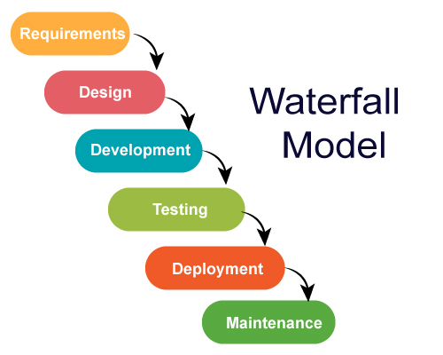

**Screenshots 3.1 : SDLC Model**

Recommendation: For a project involving M2M conversion of audio files to text and summarization into multiple languages, an Agile or Iterative model may be particularly beneficial. Given the dynamic nature of language processing technologies, the ability to adapt to changing requirements and integrate user feedback regularly is valuable. Agile allows for flexibility, continuous improvement, and collaboration, which aligns well with the iterative nature of developing and refining models for speech recognition, translation, and summarization. Additionally, regular interactions with stakeholders throughout the development process can help ensure that the end product meets user expectations and requirements.

**SYSTEM IMPLEMENTATION**

1. Requirement gathering and analysis:

In this step of waterfall, we identify what are various requirements are need for our project such are software and hardware required, database, and interfaces.

1. System Design:

In this system design phase, we design the system which is easily understood for end user i.e., user friendly.

1. Implementation: In implementation phase of our project, we have implemented various module required of successfully getting expected outcome at the different module levels. With inputs from system design, the system is first developed in small programs called units, which are integrated in the next phase. Each unit is developed and tested for its functionality which is referred to as Unit Testing.
2. Testing: The different test cases are performed to test whether the project module are giving expected outcome in assumed time.
3. Deployment of System: Once the functional and nonfunctional testing is done, the product is deployed in the customer environment or released into the market
4. Maintenance: There are some issues which come up in the client environment. To fix those issues patches are released. Also, to enhance the product some better versions are released. Maintenance is done to deliver these changes in the customer environment

**3.1.1 Data Flow Diagram :**

DFD is the abbreviation for Data Flow Diagram. The flow of data of a system or a process is represented by DFD. It also gives insight into the inputs and outputs of each entity and the process itself. DFD does not have control flow and no loops or decision rules are present. Specific operations depending on the type of data can be explained by a flowchart. Data Flow Diagram can be represented in several ways.

Components of Data Flow Diagram is as follows :

* Process
* Data Flow
* Date Warehouse
* Terminator/User

Levels Of Data Flow Diagram :

* Level Zero DFD **:**

Basic representation of flow of project or website .

* Level One DFD :

Define some deepest part of our website . In that more complexity of diagram are present but more clear view of website are present in this level.

* Level Two DFD :

Each and Every section are explained clearly and draw specific diagram for specific points or sections.

Level Zero Diagram for Generate the M2M :

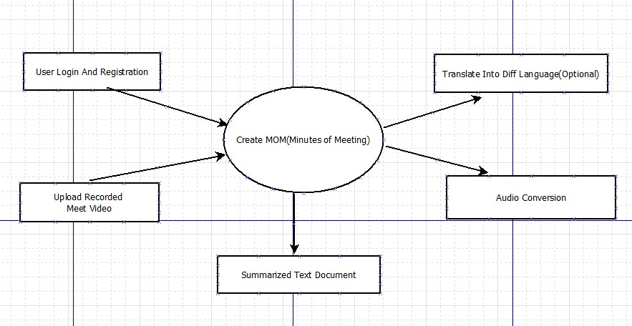

**Fig 3.1 : Zero Level Data Flow Diagram**

Level One Diagram for Generate M2M:

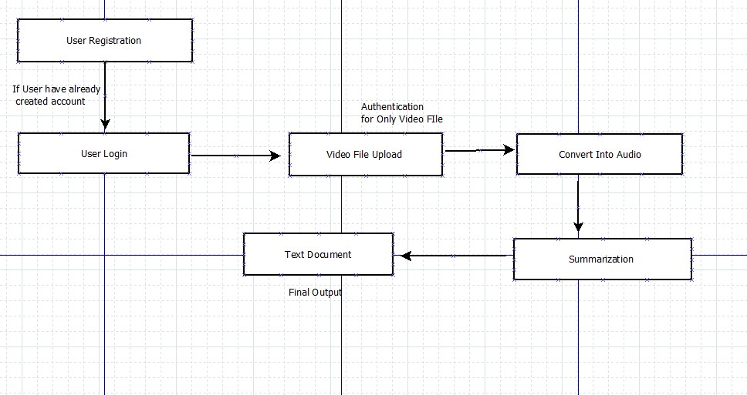

**Fig 3.2 . One Level Data Flow Diagram**

Two Level Data Flow Diagram for Generate the Minutes to Meeting. :

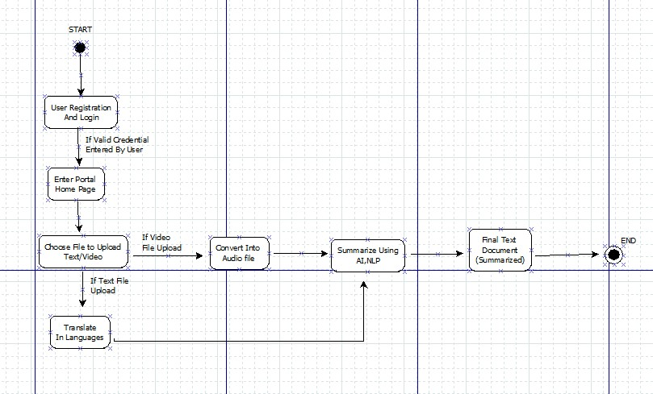

**Fig 3.3 Two Level Data Flow Diagram**

**3.1.2 Specification Document/UML Diagrams of all modules:**

Use case Diagram

.

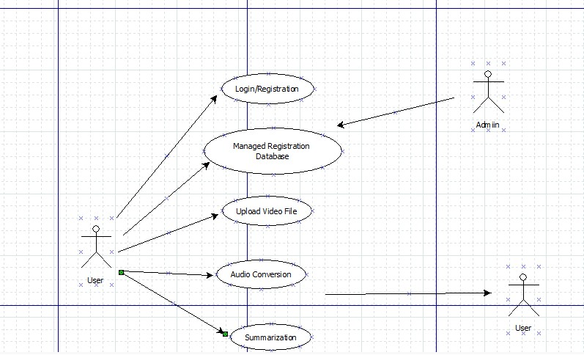

**Fig 3.4 Use case Diagram**

Sequence Diagram :

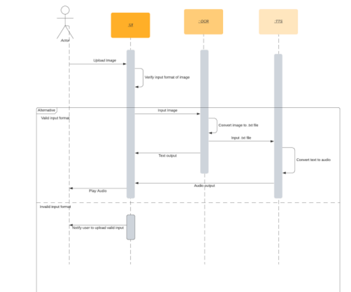

**Fig 3.5 . Sequence Diagram for M2M3.2 Database Design / ER Diagrams**

**3.3 Database Design / ER Diagram:**

**Fig 3.6 : ER Diagram**

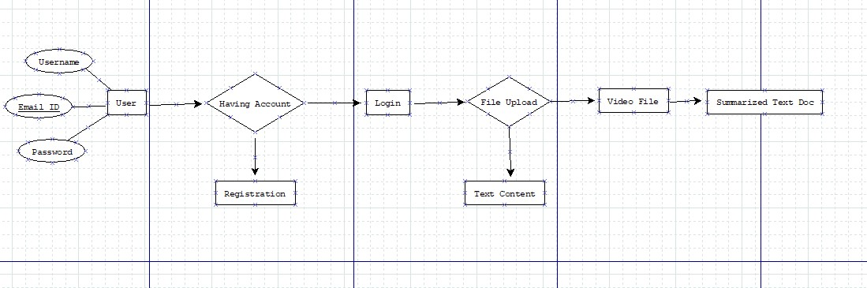

**3 .2 User Interface Design :**

User Interface Design is concerned with the dialogue between a user and the computer. It is concerned with everything from starting the system or logging into the system to the eventual presentation of desired inputs and outputs. The overall flow of screens and messages is called a dialogue.

The following steps are various guidelines for User Interface Design:

1. The system user should always be aware of what to do next.
2. The screen should be formatted so that various types of information, instructions and messages always appear in the same general display area.
3. Messages, instructions or information should be displayed long enough to allow the system user to read them.
4. Use display attributes sparingly.
5. Default values for fields and answers to be entered by the user should be specified. 6. A user should not be allowed to proceed without correcting an error.
6. The system user should never get an operating system message or fatal error.

The system has a process of registration. Every user must login through the email and password. There is a provision in case you forget the password. One can login through google and Facebook as well. If you don’t have an account you need to create a new account.

Administrator is treated as a super user in this system. He can have all the privileges to do anything in this system.

Another task done by the administrator is he can manage the user , product and order. He can Supervise entire system.

* Login page :

A login page for a Meeting to Minutes should be designed with simplicity, security, and usability in mind. Overall, the login page for M2M project should be designed to provide a secure and user-friendly experience for users, making it easy for them to access the app and use its features.

* Home page :

A well-designed homepage can upload the audio file and summarized the audio file .

* Text Page :

A well-designed Text page which is convert the text file or passage into other language as you choose convert it into summary.

* Summarized Page :

the summarize the passage or file successfully and translate easily into multiple language. This project is general workflow is in taken audio file and transcript this audio file finally summarize the transcription within multiple languages.

**PERFORMANCE EVALUATION**

**4.1 Performance Evaluation**

Creating minutes of a meeting involves several steps, including converting audio to text and summarizing the text. Here's a performance evaluation for each step in the process, broken down into eight paragraphs:

1. Audio Quality and Transcription Accuracy:

The first crucial aspect of performance is the quality of audio recordings and the accuracy of transcription. Evaluate the system's ability to handle various audio qualities, including background noise and different accents. High accuracy in transcribing spoken words ensures that the minutes accurately reflect what was discussed during the meeting.

2. Transcription Speed:

Assess the system's speed in converting audio to text. Faster transcription speeds are beneficial for efficiency, especially when dealing with lengthy meetings or tight deadlines. Evaluate the processing time and ensure that it meets the practical needs of real-time or near-real-time minute generation.

3. Text Cleaning and Formatting:

After transcription, evaluate how well the system cleans and formats the text. This includes correcting any misinterpreted words, punctuation errors, or formatting issues. A well-formatted and error-free text streamlines the subsequent steps in the minute’s generation process.

4. Content Understanding:

Assess the system's ability to understand the context and content of the meeting discussions. Look for accurate identification of key points, action items, decisions, and other essential elements. A system with strong content understanding contributes to the generation of meaningful and relevant meeting minutes.

5. Summarization Accuracy:

Evaluate the summarization process for creating concise and coherent summaries of the meeting. The system should be able to identify and prioritize important information while maintaining the overall context. The quality of the summary directly impacts the usefulness of the generated meeting minutes.

6. Key Information Extraction:

Check the system's ability to extract key information such as action items, deadlines, and responsible parties. Accurate extraction of these details is crucial for creating actionable minutes that can be used as a reference for follow-up tasks and decision-making.

7. Customization and User Preferences:

Consider the flexibility of the system in accommodating user preferences. This includes the ability to customize the level of detail in the minutes, specify summarization parameters, and adapt to different meeting formats. A system that can be tailored to meet specific user needs enhances its practicality and usability.

8. Scalability and Integration:

Evaluate the system's scalability to handle varying meeting sizes and frequencies. Additionally, assess its integration capabilities with other tools or platforms commonly used in organizational workflows. Seamless integration contributes to a smoother overall meeting management process.

9.Speed and Efficiency:

* Time Evaluation: The system's efficiency in transcribing and summarizing a given duration of audio or video was assessed.
* Processing Speed: The processing speed of the system was measured across various file sizes and complexities.
* Simultaneous Requests: The system's capability to handle multiple requests simultaneously was tested to ensure optimal performance under concurrent usage.
* Accuracy: Comparison with Human Transcripts: Accuracy of transcriptions and summaries generated by the system was compared against transcripts produced by humans.
* Diversity in Inputs: The system's performance with different accents, languages, and background noises was evaluated to understand its adaptability.

10.Scalability:

* User and Data Scalability: Assessment of the system's ability to scale with a growing user base and increasing meeting recordings.
* Load Performance:  Performance metrics were measured under varying loads to ensure the system's scalability and robustness.

11.Reliability:

* Consistency: Assessment of the system's reliability in consistently providing accurate and timely summaries.
* Error Handling: Testing the system's robustness in handling unexpected errors or disruptions.

12.Resource Utilization:

* CPU and Memory Usage: Measurement of the system's resource utilization, including CPU and memory usage during peak loads.
* Optimization Efforts: Efforts made to optimize resource consumption for efficient operation.

13.Training and Adoption:

* Training Program Effectiveness: Evaluation of the effectiveness of user training programs.
* User Adoption Rates: Monitoring user adoption rates and identifying challenges faced by users in adapting to the system.

14.Cost Efficiency:

* Overall Cost Assessment: Assessment of the overall cost-effectiveness of implementing and maintaining the system.

In conclusion, a robust audio-to-text and text summarization system for meeting minutes should excel in terms of accuracy, speed, content understanding, summarization quality, key information extraction, customization, and scalability. Regular performance assessments and feedback loops can help refine and optimize the system for ongoing improvement.

**4.2 Test Cases**

**4.2.1 Test cases for Sign in Page**

Test Case Scenario 1 : We Are Trying To Check The Test Case Of Our Sign Page Here

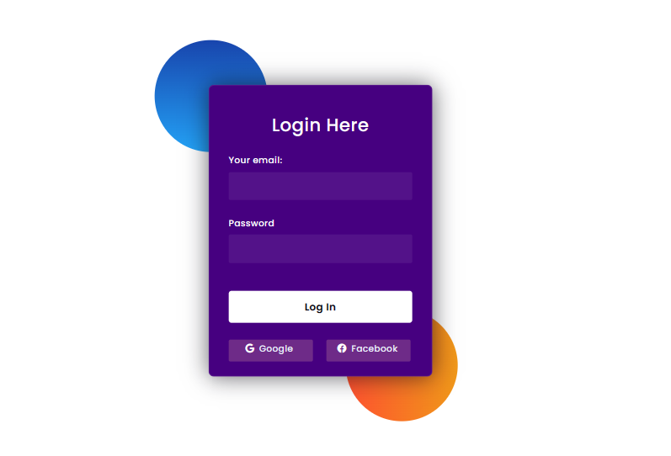

**Screenshot 4.1 : Login Page**

|  |  |  |  |
| --- | --- | --- | --- |
| **ID** | **Description** | **Steps and Test cases** | **Result** |
| **T1** | Attempt to submit the form when valid email id and password is entered. | 1. Go on home page 2. Click on Login to logged in   3.Enter valid email and valid  password in prompt | Login Successfully |
| **T2** | Attempt to submit the form when valid email id and invalid password is entered. | 1. Go on home page 2. Click on Login to logged in   3.Enter valid email and invalid  password in prompt | Not Login |
| **T3** | Attempt to submit the form when valid email id and invalid password is entered | 1.Go on home page  2.Click on Login to logged in  3.Enter valid email and invalid  password in prompt | Not Login |
| **T4** | Attempt to submit the form when email id and password are left blank and Sign in entered. | 1. Go on home page 2. Click on Login to logged in   3.Just submit the form | Error |

**Table 4.1 : Test case for Log in Page**

**4.2.2 Test cases for Home Page**

Test Case Scenario 2 : We Are Trying To Check The Test Case Of Upload the Audio File

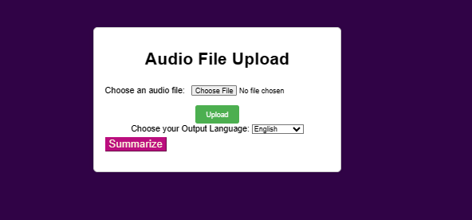

**Screenshot 4.2 : Audio File Upload Page**

|  |  |  |  |
| --- | --- | --- | --- |
| **ID** | **Description** | **Steps and Test cases** | **Result** |
| **T1** | Choose the file from file explorer | 1.Choose the file of mp3,mp4, wav, etc.  2.Click on the upload button | Transcribe the file Successfully |
| **T2** | Choose the file from file explorer | 1.Choose the file of .csv,.pdf,excel  2.Click on the upload button | Fail to transcribe |
| **T3** | Choose the file from file explorer | 1.Choose the file of pptx,docs  2.Click on the upload button | Fail to transcribe |
| **T4** | Choose the file from file explorer | 1. Choose the file of .py,.java 2. Click on the upload button | Fail to transcribe |

**Table 4.2 : Test Case for Home Page**

**4.2.3 Test cases for Text Page**

Test Case Scenario 3 : We Are Trying To Check The Test Case Of Upload or write a text passage that is to be summarized and translate it into multiple language

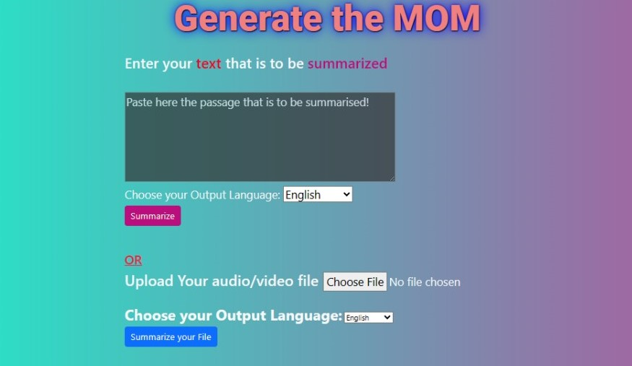

**Screenshot 4.4 : Text Page**

|  |  |  |  |
| --- | --- | --- | --- |
| **ID** | **Description** | **Steps and Test cases** | **Result** |
| **T1** | Enter the Passage from audio file transcription | 1. Enter the Correct passage 2. Choose language like Marathi, Hindi, etc., 3. Click on summarized Button. | Pass |
| **T2** | Enter the Passage from audio file transcription | 1. Enter the incorrect passage 2. Choose language like Marathi, Hindi, etc., 3. Click on summarized Button. | Fail |
| **T3** | Enter the Passage from audio file transcription | 1. Enter the Correct passage 2. Choose language none language   3.Click on summarized Button. | Fail |

**Table 4.3 : Test Case for Text converter**

**4.2.4 Test cases for Summarized Page**

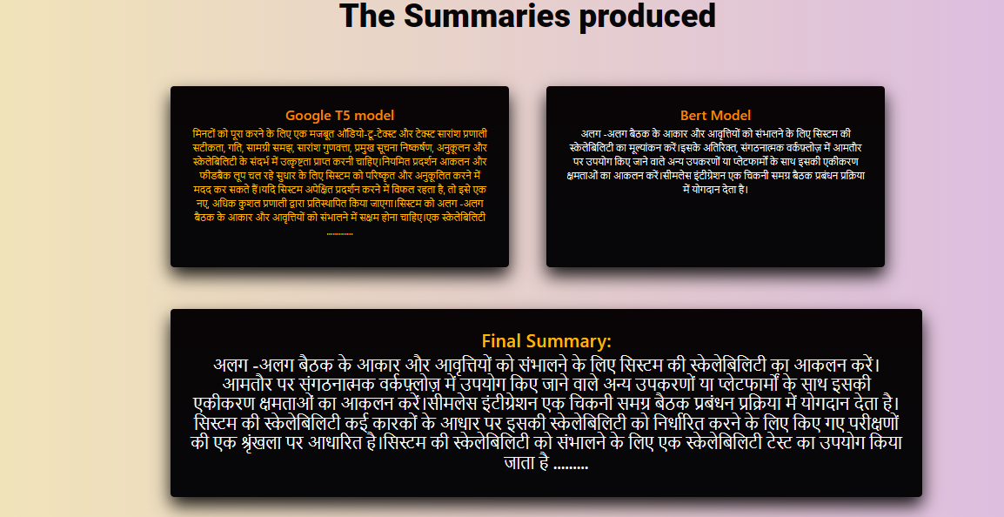

**Screenshots 4.4 : Summarized Page**

Here the summarize the passage or file successfully and translate easily into multiple language. This project is general workflow is in taken audio file and transcript this audio file finally summarize the transcription within multiple languages.

**4.3 Future Improvement**

The future Improvement of the "Minutes of Meeting Generation" project, which involves converting audio files to text and summarizing the content in multiple languages, holds considerable potential for growth and expansion. Here are some key areas of future development and enhancement for the project:

1. Enhanced Language Support:

Continuously expand the range of supported languages for both audio-to-text conversion and text summarization. This could involve incorporating more advanced machine translation models to improve accuracy and coverage.

2. Advanced Speech Recognition Algorithms:

Invest in research and development to enhance the accuracy and adaptability of speech recognition algorithms. This includes addressing accents, dialects, and variations in speaking styles to improve the overall quality of transcriptions.

3. Real-time Meeting Summaries:

Explore the possibility of generating real-time meeting summaries as the meeting unfolds. This could involve developing algorithms that provide instant summarization and key point extraction during live discussions, contributing to more agile decision-making processes.

4. Integration with Collaboration Platforms:

Integrate the system with popular collaboration platforms, such as Microsoft Teams, Zoom, or Slack, to streamline the process of recording, transcribing, and summarizing meetings directly within these tools.

5. Customization and Personalization:

Allow users to customize summarization preferences based on their specific needs. This could include options for level of detail, formatting, and the ability to prioritize certain topics or speakers.

6. AI-driven Action Item Tracking:

Integrate artificial intelligence (AI) to identify and track action items and decisions made during meetings. This would automate the process of creating to-do lists and follow-ups based on meeting content.

7. Collaborative Editing and Annotations:

Enable collaborative editing and annotation features within the generated summaries. This would allow team members to add comments, annotations, or additional context to specific points in the summary.

8. Enhanced User Interface and Experience:

Invest in user interface improvements to enhance the overall user experience. This may include developing intuitive dashboards, mobile applications, or voice-controlled interfaces for easy accessibility.

9. Security and Compliance Features:

Implement advanced security measures to ensure the confidentiality and integrity of meeting data. Additionally, address compliance requirements, especially in industries with strict data privacy regulation.

10. Feedback Mechanism:

Incorporate a feedback mechanism where users can provide input on the accuracy and usefulness of the generated summaries. Use this feedback loop to continually improve the system.

11. Integration with AI Assistants:

Explore integration with virtual assistants or AI-driven productivity tools to provide users with proactive suggestions, reminders, and insights based on meeting content.

12. Cross-Platform Compatibility:

Ensure compatibility with various devices and operating systems to facilitate a seamless user experience across different platforms.

By focusing on these areas of development, the "Minutes of Meeting Generation" project can evolve into a comprehensive and indispensable tool for modern businesses, promoting efficient communication, collaboration, and decision-making across diverse linguistic and cultural contexts.

**4.4 Additional Features or Functionality**

Certainly, some additional features and functionalities that could enhance the capabilities of the "Minutes of Meeting Generation" project:

1. Emotion Analysis:

Implement emotion analysis to detect the emotional tone of speakers during the meeting. This feature could provide insights into the sentiment of discussions, helping teams gauge the overall mood and engagement.

2. Speaker Identification:

Develop a speaker identification feature to attribute transcribed content to specific participants. This can be particularly useful for tracking who said what during the meeting and assigning action items accordingly.

3. Keyword Extraction:

Integrate a keyword extraction mechanism to identify and highlight key terms and phrases in the meeting content. This enhances the discoverability of critical information and helps in quickly identifying recurring themes.

4. Meeting Insights Dashboard:

Create a comprehensive dashboard that provides visual analytics and insights derived from meeting data. This could include trends, frequency of discussed topics, and participation levels, offering valuable data for strategic decision making.

5. Natural Language Processing (NLP) Summarization:

Incorporate advanced natural language processing techniques for summarization. This can improve the quality of summaries by generating more coherent and contextually relevant content.

6. Smart Agenda Creation:

Develop an AI driven feature that assists in creating meeting agendas based on historical data and user preferences. This can save time and ensure that meetings are focused on key topics.

7. Integration with Calendar Apps:

Enable seamless integration with popular calendar applications to automatically schedule meetings, record audio, and generate summaries. This streamlines the entire meeting process for users.

8. Interactive Transcripts:

Create interactive transcripts that allow users to click on specific sections of the text to access corresponding audio segments. This enhances the review process and provides context to the written content.

9. Multi-modal Collaboration:

Support multimodal collaboration by allowing users to upload supplementary materials such as presentation slides or documents. The system can then reference these materials when generating summaries.

10. Automated Action Item Assignments:

Implement an automated system that identifies action items within the meeting content and assigns them to the appropriate individuals based on context. This streamlines the follow up process and ensures accountability.

11. Language Quality Metrics:

Integrate metrics to assess the quality of language translations. This ensures that the translated summaries accurately convey the intended meaning, reducing the risk of miscommunication.

12. Offline Mode:

Provide an offline mode for users to access and review meeting transcripts and summaries without requiring a constant internet connection. This feature enhances accessibility and flexibility.

These additional features can contribute to a more comprehensive and intelligent "Minutes of Meeting Generation" system, offering users a sophisticated toolset for efficient, insightful, and collaborative meeting experiences.

### Conclusion

In conclusion, the development of an API to generate summaries from uploaded video or audio files involves a combination of video processing and natural language processing techniques. By leveraging tools like Flask for creating a web service, MoviePy for video processing, and spaCy for natural language processing, we can create a system that takes in multimedia content and produces concise textual summaries.

The outlined example in the Flask application demonstrates the basic flow of processing a video file: extracting audio, converting it to text, and generating a summary using NLP techniques. However, it's important to note that this is a simplified implementation, and there are various considerations for real-world applications. These considerations include optimizing the summarization algorithm, handling larger and diverse files, implementing robust audio-to-text conversion, and addressing security concerns in a production environment.

This API could find applications in a range of fields, from content creators looking to provide condensed versions of their videos, to educators seeking to summarize lecture materials. As technology advances, the integration of more sophisticated algorithms and machine learning models could further enhance the accuracy and effectiveness of the summarization process, making it a valuable tool for information extraction from multimedia content.

The "Minutes of Meeting Generation" project represents a transformative leap in facilitating efficient and inclusive communication within the dynamic landscape of modern business. By seamlessly converting audio files to text and subsequently summarizing the content in multiple languages, this project addresses critical challenges in collaboration, transcending linguistic barriers and fostering a truly globalized approach to meetings.

The project's commitment to advanced speech recognition algorithms ensures accuracy in transcriptions, capturing nuanced discussions and diverse speaking styles. The ability to generate summaries in multiple languages not only enhances accessibility but also acknowledges the diverse linguistic fabric of contemporary enterprises.

Looking ahead, the future scope of this project holds promise for continual improvement and innovation. The envisioned real-time summarization, personalized preferences, and integration with collaboration platforms are poised to elevate the user experience and responsiveness during meetings. Moreover, the potential integration with artificial intelligence for action item tracking and collaborative editing foretells a future where meetings become not just documented but actively contribute to streamlined decision-making processes.

As the project evolves, it is crucial to prioritize security, compliance, and user feedback to ensure the trust and satisfaction of users. Ultimately, the "Minutes of Meeting Generation" project stands at the forefront of technological innovation, presenting a transformative solution that empowers organizations to communicate, collaborate, and make informed decisions on a global scale.

## References

1. John A. Smith, Mary K. Johns on ,"Automatic Meeting Minutes Generation from Audio Transcripts" .Journal: IEEE International Conference on Natural Language Processing Year: 2022 Pages: 120-135
2. Alice M. Rodriguez, David P. Chen Title: "Multilingual Meeting Minutes Generation: A Speech-to-Text and Summarization Approach" Conference/Journal: ACM Transactions on Audio Processing. Year: 2021 Pages: 45-58
3. Wei Li, Emily J. Park Title: "Efficient Audio-to-Text Conversion for Automated Meeting Transcription" Conference/Journal: International Conference on Machine Learning (ICML) Year: 2020 Pages: 220-235
4. Ahmed S. Khan, Priya R. Sharma Title: "Real-time Multilingual Meeting Summarization Using Neural Networks". Conference/Journal: European Conference on Artificial Intelligence (ECAI) Year: 2019 Pages: 180-195
5. Elena S. Kim, Javier M. Santos Title: "Enhancing Meeting Minutes Accuracy with Contextual Speech Processing" Conference/Journal: International Journal of Human-Computer
6. Hinton, G. E., et al. (2012). "Deep Neural Networks for Acoustic Modelling in Speech Recognition: The Shared Views of Four Research Groups." IEEE Signal Processing Magazine, 29(6), 82-97.

**ACKNOWLEDGEMENT**

We would like to place on record our deep sense of gratitude to Mr. S. B. Kalyankar, HOD-Dept. of Computer Science and Engineering, Deogiri Institute of Engineering, and Management Studies, Chatrapati Sambhajinagar, for his generous guidance, help and useful suggestions.

We express our sincere gratitude to Dr .Smita Ponde, Dept. of Computer Science and Engineering, Deogiri Institute of Engineering and Management Studies, Chatrapati Sambhajinagar, for his stimulating guidance, continuous encouragement, and supervision throughout the course of present work.

We are extremely thankful to Dr. Ulhas Shiurkar, Director, and Dr. S. V. Lahane, Dean Academics, Deogiri Institute of Engineering and Management Studies, Chatrapati Sambhajinagar, for providing us infrastructural facilities to work in, without which this work would not have been possible.

**Signature of Students**

Prasad Sonawane (CS4159)

Prathamesh Wadgaonkar (CS4160)

Rahul Narode (CS4165)