**Directory Al Imam Mohammad Ibn Saud Islamic University**

**College of Computer and Information Sciences**

**Information Technology Department**

|  |  |
| --- | --- |
| **Course Title:** | Web Systems |
| **Course Code:** | IT 390 |
| **Course Instructor:** | Dr. Amir Mohamed Talib, T. Shatha Alkhaldi,  T. Nora Alghamdi |
| **Assessment:** | Project (phase one) |
| **Semester:** | First 2023 |
| **Due date** | Thursday 29 Sep |
| **Marks:** | 4 grades |

|  |  |
| --- | --- |
| **Group Number** |  |
| **Group Members Name** | **Group Members ID** |
| JudyAlzuhair | 440020665 |
| WadhaAlmutairi | 440020981 |
| YaraAlmjudel | 440020360 |
| Jawaher Bin Humaid | 441020896 |
| Fay Altuwaijri | 441019791 |
| **Section Number** | 372 |

|  |
| --- |
| There will be no extension in the submission deadline.  No late submission will be accepted. |

|  |  |  |
| --- | --- | --- |
| **Official Use Only** | | |
| **Question** | **Student Marks** | **Question Marks** |
| 1 |  | 4 |
| **Total** |  | **4** |

* **Introduction**

The project is a site that brings together flower shops, whether electronic or non-electronic, in order to facilitate and save time for the user the process of searching for flower shops in the city

We decided to name our website after one of the flowers, which is the lavender flower(lavender)

Our goal in developing this site is to be a good destination for people who want to set up a project, through which they can study the market and help tourists to learn about flower shops in the area and see the opinions and evaluations of previous users, and our next goal is to make our site serve more than one city.

* Our audience are:

1. City visitors.
2. Everyone interested in flowers.
3. Everyone wants to buy flowers but doesn't know the flower shops in the city.
4. Anyone who wants to start a flower shop business and wants to know his competitors.

* **Competitive Analysis:**

The evaluation is a simple check Y/N; (Y=Yes, N=No) or a number from 1 to 10; (1 is the small value, 10 is the big value)

|  |  |  |  |  |
| --- | --- | --- | --- | --- |
| **Criteria** | | **Name:** lavender  *file:///C:/Users/wathh/Desktop/projweb/homepage.html* | **Name:** thechefz  *(*https://thechefz.co/ar/*)* | **Addition Functions\Features** |
| **Site Design** | Layout (1-10) | 8 | 9 |  |
| Navigation (1-10)  *+ ( list the global navigation)* | 7 | 9 |
| Look and Feel (1-10) | 9 | 10 |
| **Page**  **Info** | Download Time (1-10) | 10 | 10 |  |
| Page Size (1-10) | 10 | 10 |
| **Features** | Search box in all pages (Y/N) | N  (we will add it in the next phase) | Y |  |
| Advanced Search (Y/N)  *+ (list the elements that guide the search)* | N | Y |
| About Us page (Y/N) | Y | Y |
| Contact Us page (Y/N) | Y | Y |
| Advertising Allowed (Y/N) | N | Y |
| Site map page (Y/N) | Y | N |
| Customer review | Y | N |
| Validated by W3C? (Y/N) | N | Y |
| **Ease of use** | Effectiveness  (Ability to successfully use a Web site to find information and accomplish tasks.) | 9 | 9 |  |
| Efficiency  (Ability to quickly accomplish tasks with ease and without frustration) | 9 | 9 |
| Satisfaction  (How much a user enjoys using the Web site) | 9 | 9 |

* **Functionalities:**

**Functionalities for Admin:**

1. Add item.
2. Delete item.
3. Edit item.

**Functionalities for Visitor:**

1. The visitor can add a review.
2. The visitor can add a rating.
3. The visitor can see previous reviews.
4. The visitor can see previous reviews and ratings.
5. The visitor can see a description of the shop and what it offers.
6. The visitor can contact us.
7. The visitor can log in.
8. The visitor can log out.

* **sitemap**

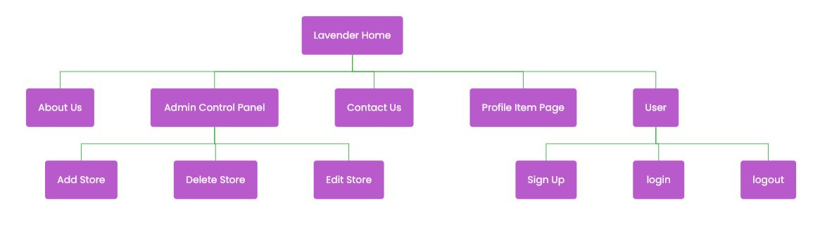

Figure 1:Site map

* **Required pages**:

1. **Home page:**
2. **About us page:**
3. **Item profile page:**
4. **Admin log-in page:**
5. **The Admin Control Panel page:**

It has three links for three different pages:

* 1. **Add Item page:**
  2. **Delete Item page:**
  3. **Edit Item page:**
* **Wireframes**:

Figure 2:Home page Figure 3:About us page

Figure 4:Sign in page Figure 5:Log in pageFigure 6:Forget password page

Figure 7:Item profile page

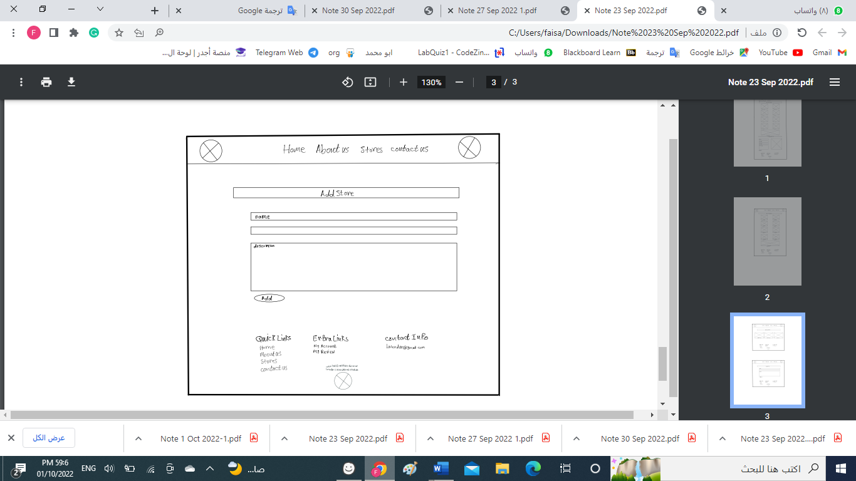

Figure 8:Admin Control Panel page Figure 9: Add Item page

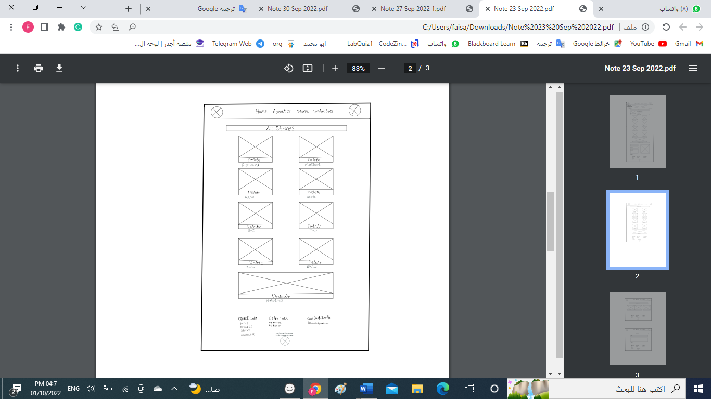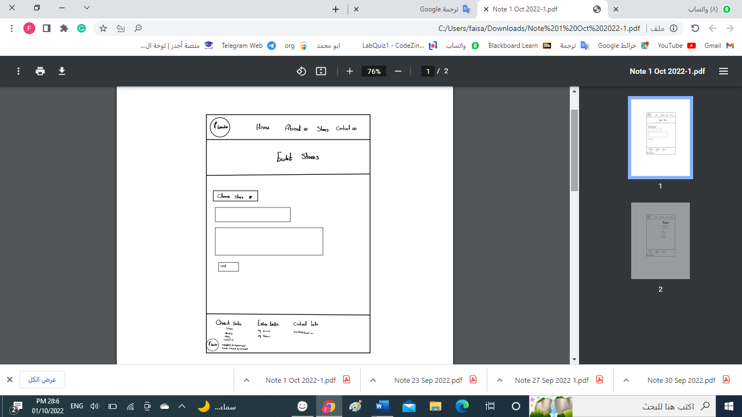

Figure 10:Delete Item page Figure 11: Edit Item page