**NAME:Wadhudh Kavi M J**

**SUPERSET ID:6410381**

**GIT**

**GITHUB: https://github.com/WadhudhKavi520/Cognizant-Digital-Nurture-4.0-Java-Assignments**

**Task 1 : GitLab config using Gitbash**

**Task 2 : Create a “.log” file and a log folder in the working directory of Git**

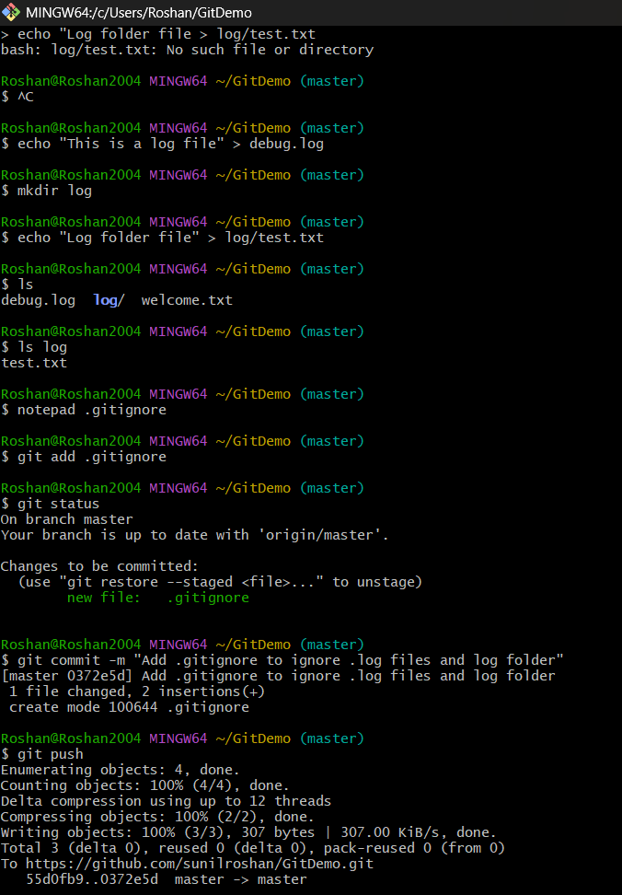

**Task 3 : Git Branching and Merging**

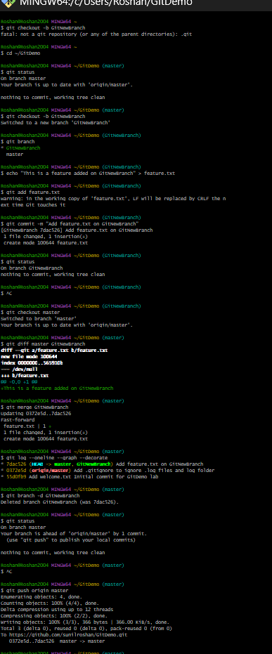

**Task 4 : Implement conflict resolution when multiple users are updating trunk**

**Task 5 : Execute steps involving clean up and push back to remote Git**



