**Experiment 1B: IAM and cloud9**

1.Open the AWS account and search for Cloud9.

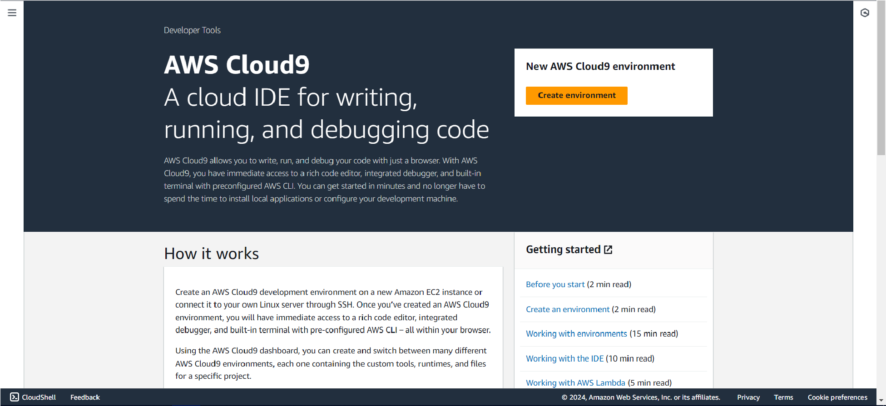

1. Enter the name and other required configuration for creating an environment. In network settings, using the AWS system manager gives an error while creating the environment

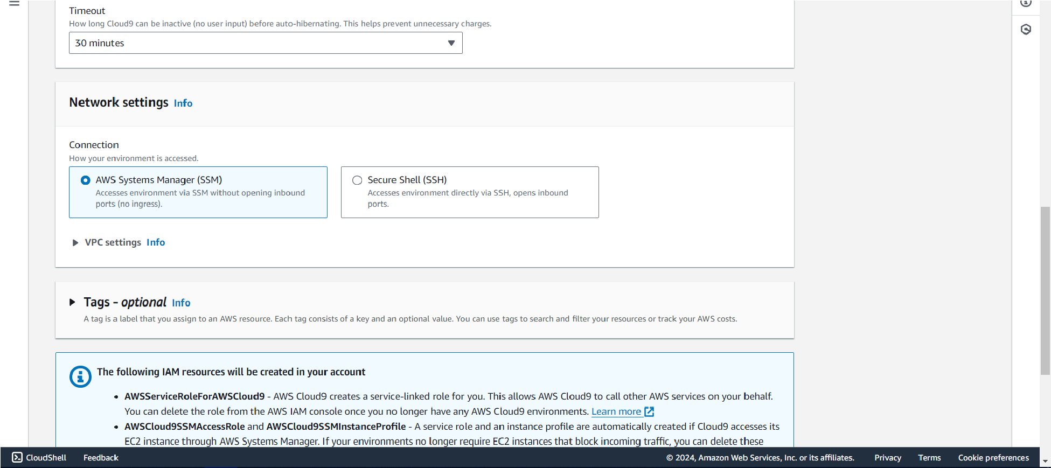

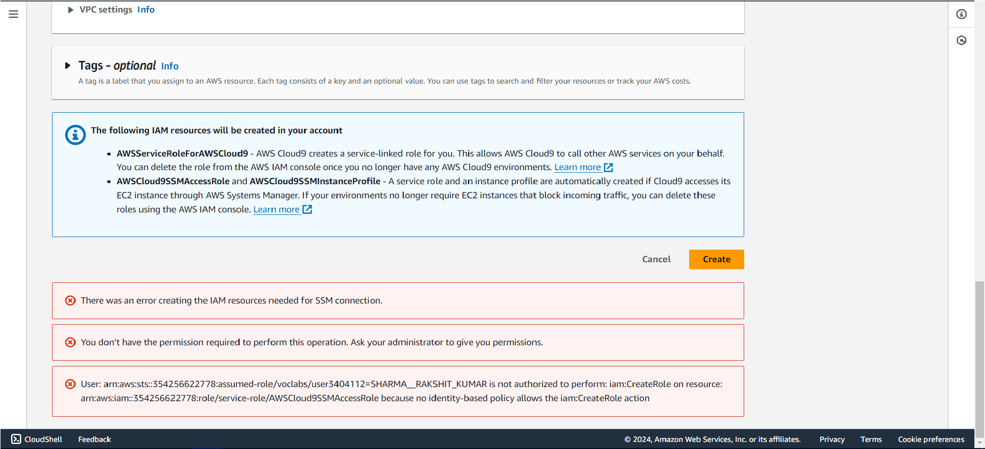

1. Select the Secure Shell (SSH) option in Network settings

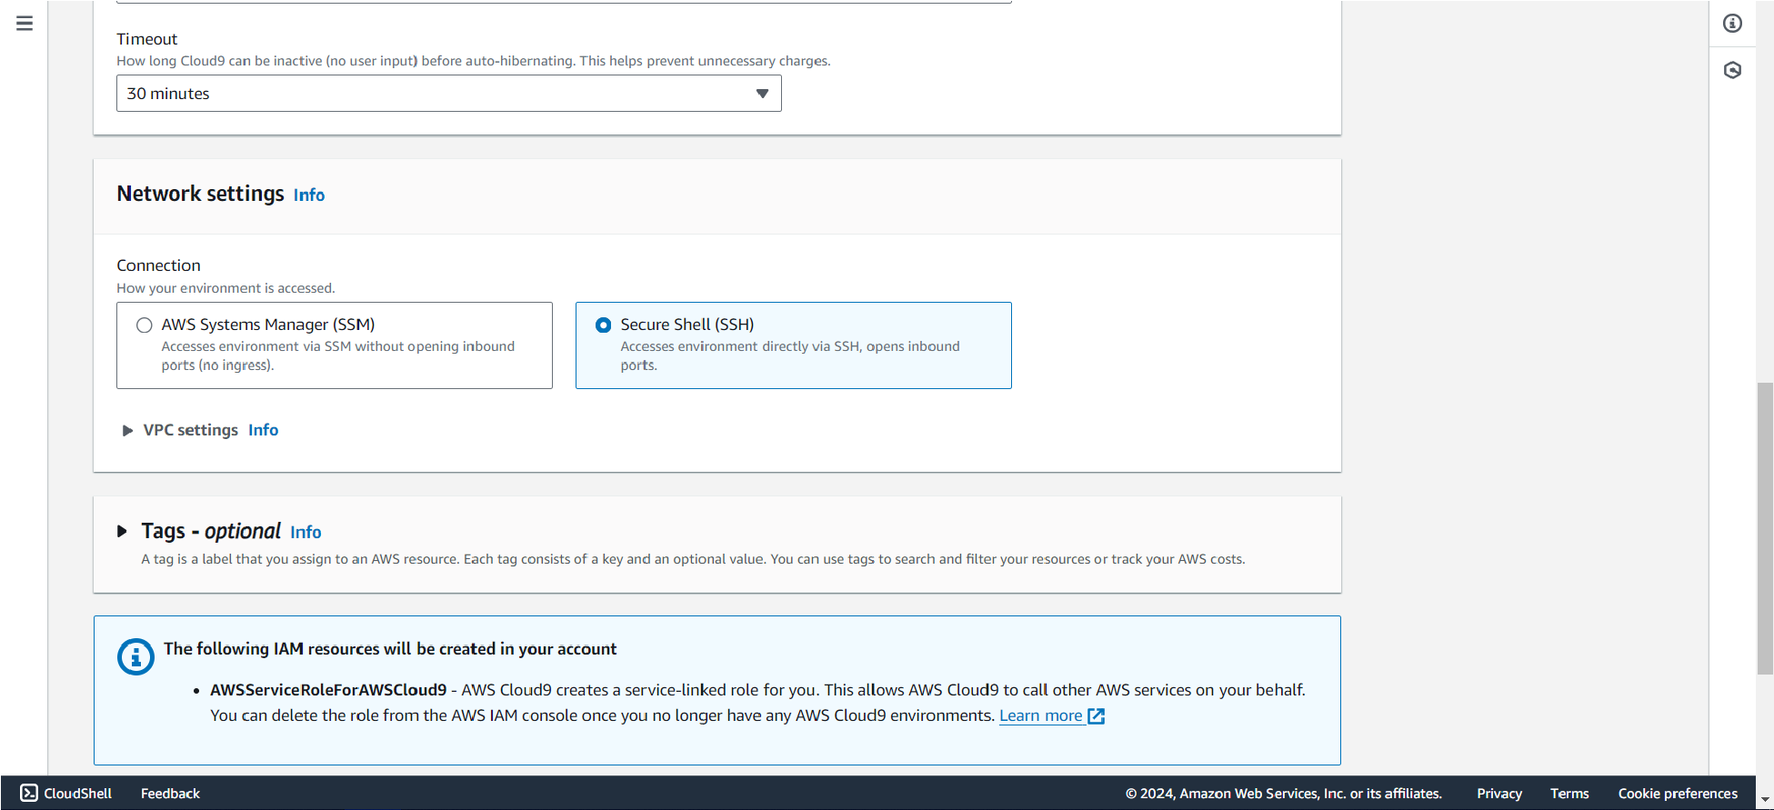

1. Once all configurations are set, click on 'Create Environment' to initiate the Cloud9 environment.

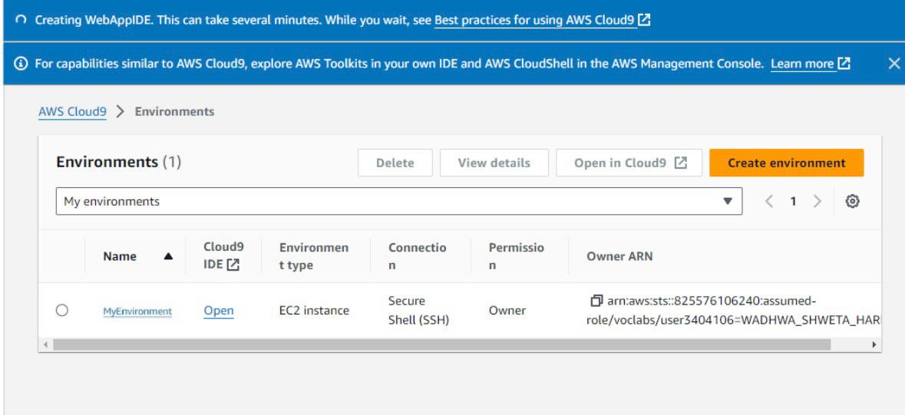

1. To open the Cloud9 environment, click on the environment name.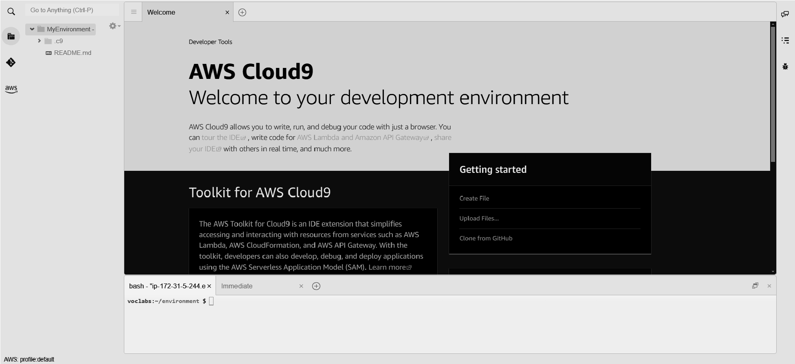

IAM user creation steps

1. Login to your AWS account and search for IAM under services.

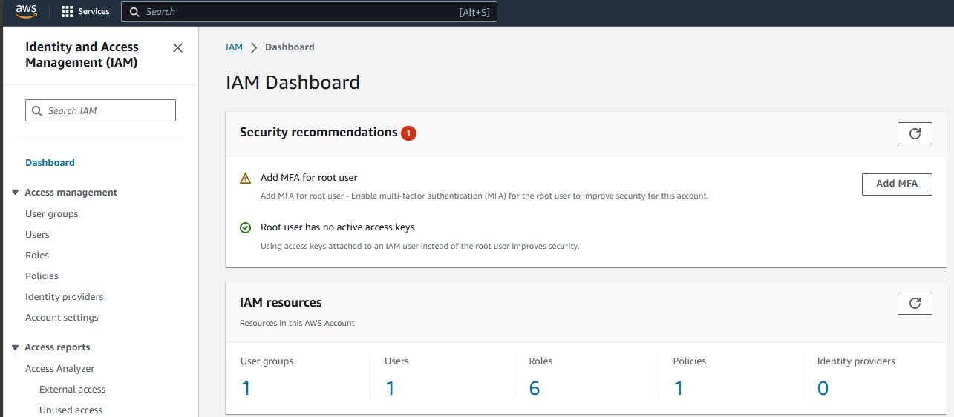

1. From the left-hand panel, select 'Users' and click on the 'Create User' button. Enter the desired username.

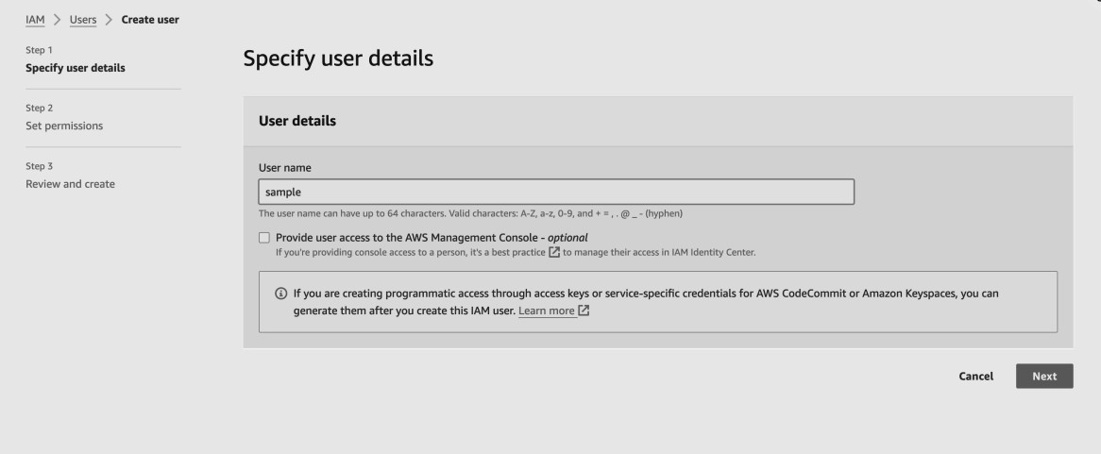

1. If no existing user group is available, click 'Add User to Group

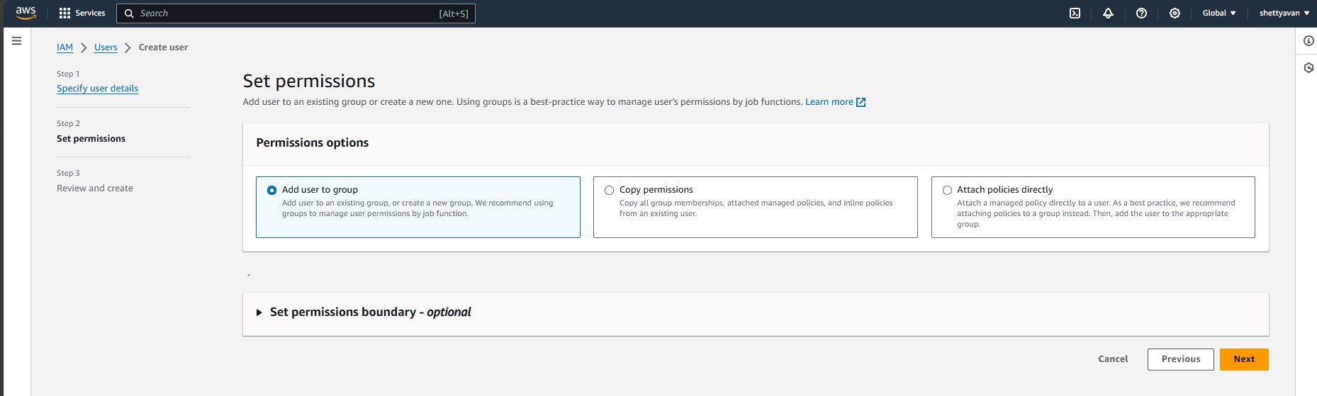

1. Create a new user group by providing a name and selecting the necessary policies.

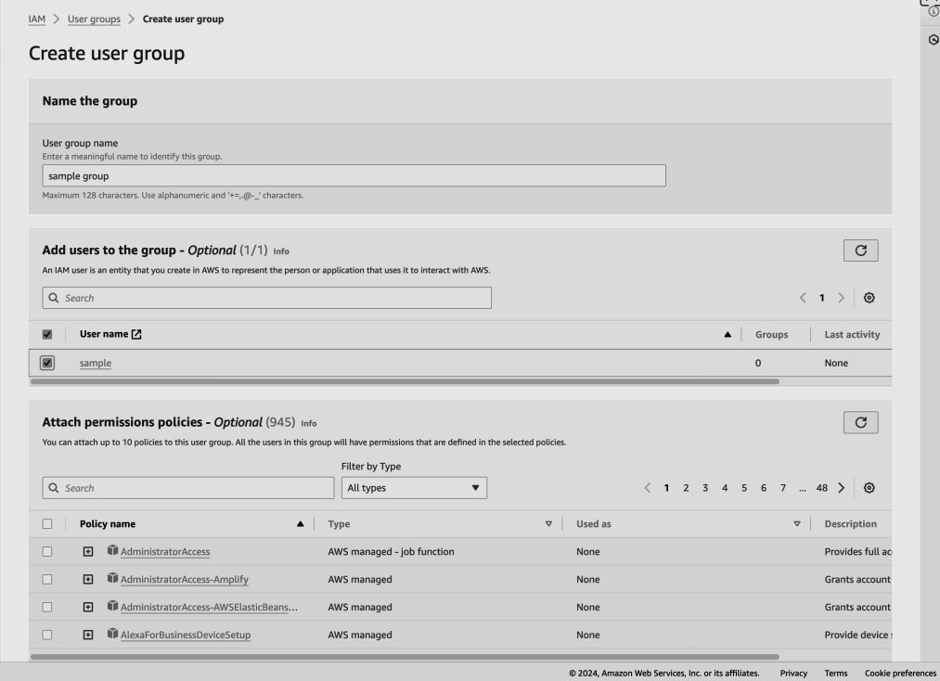

1. After the user group is created, select the group name and proceed by clicking 'Next' to finalize user creation .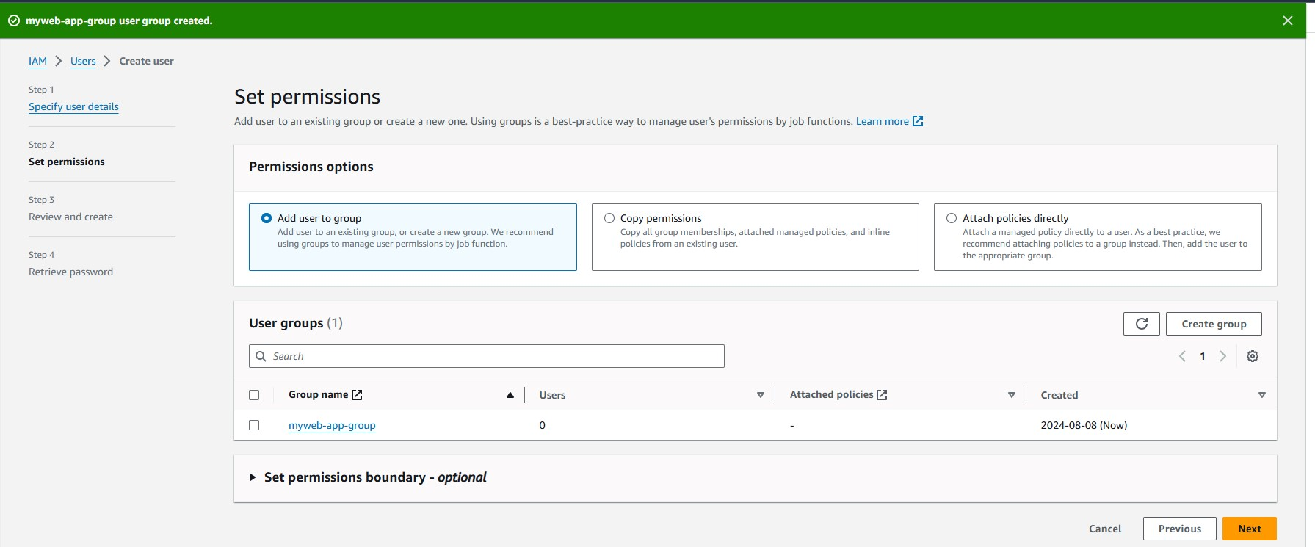
2. Review all configuration details, ensure no steps were missed, and then click the 'Create User' button 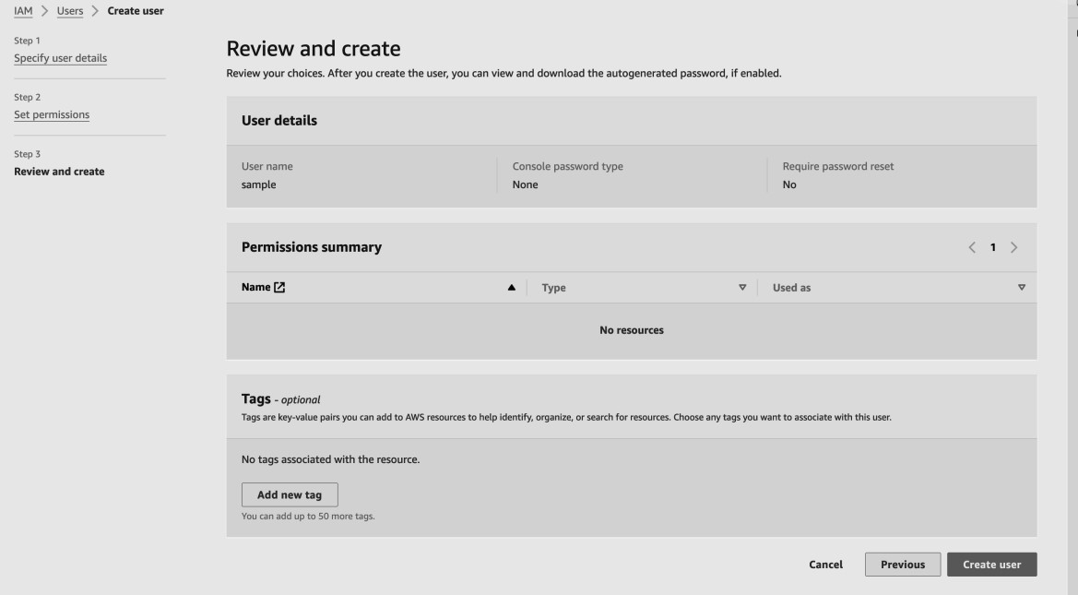
3. Upon successful user creation, a confirmation message will appear. If needed, download the CSV file to store the password securely.

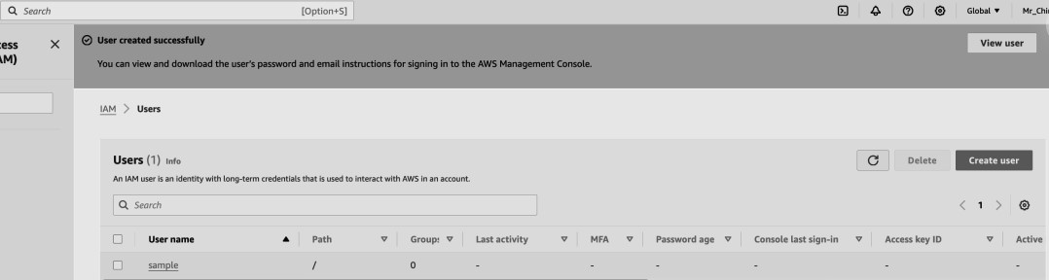

1. After the user is created, go to the 'User Groups' tab, select the appropriate group, and navigate to the 'Permissions' tab. Click on 'Add Permissions' and attach the relevant policy.

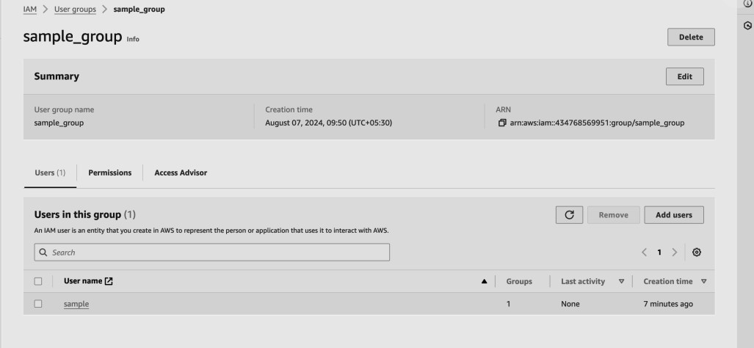

1. Search for the “AWSCloud9EnvironmentMember” policy and attach it.

