

BENAZIR BHUTTO SHAHEED UNIVERSITY OF LYARI

CS/IT DEPARTMENT

Program: BS Artificial Intelligence (1st Batch) – Sec: B
Course: Database
Instructor: Sir Anwar Ali Sathio
Semester: 4th Semester
Members:
Wadood Saleh (B2433125)
Warda M.Nasir (B2433126)
M.Awais (B2433078)

LAB MANUAL
LIBRARY AUTOMATION SYSTEM

1. Installing MySQL
MySQL is a relational database management system (RDBMS). Think of it as the engine that stores and organizes data so your programs can talk to it through queries.
Let’s break installation down for Windows, since that’s what most students use (but I’ll also note the Linux and macOS path briefly).

For Windows

Step 1: Download MySQL Installer
- Go to the official website: https://dev.mysql.com/downloads/installer/
- Choose MySQL Installer for Windows → pick the full version (~400 MB) instead of the “web” version (which requires downloading components later).

Step 2: Run the Installer
- Double-click the .msi file.
- When prompted for setup type, choose:
  - Developer Default — installs MySQL Server, Workbench, Shell, and other useful tools.

Step 3: Installation Process
- Click Next → the installer checks for prerequisites (like Visual C++ Redistributables).
If missing, it’ll prompt you to install them.
- Once all dependencies are ready, proceed.

Step 4: Configuration
Now this is crucial. You’ll be setting up your database server’s behavior:
- Type and Networking:
  - Choose Standalone MySQL Server.
  - Leave TCP/IP enabled (default port: 3306).
  - Keep "Open Windows Firewall port for network access" checked.
- Authentication Method:
  - Select Use Strong Password Encryption (RECOMMENDED).
- Accounts and Roles:
  - Set a root password (this is your admin password).
  - Optional: Add other users with specific roles later.
- Windows Service:
  - Keep “Configure MySQL Server as a Windows Service” checked.
  - Let it start automatically.

Step 5: Finish Installation
- Click Execute and watch it install MySQL Server, Workbench, and Shell.
- When it finishes, open MySQL Workbench — that’s your graphical interface to create and manage databases.
You’re done.
To test it:
- Open MySQL Workbench → connect to localhost → enter root password → you should see “Server connected”.

2. What is a Schema in MySQL?
A schema is basically the blueprint of your database — the entire structure that holds tables, relationships, and data types.
Think of it like a digital library:
- The schema is the library building.
- The tables are bookshelves.
- The columns are book categories.
- The rows are individual books.
In MySQL, “schema” and “database” are technically the same thing — MySQL treats them interchangeably.
Example:
CREATE DATABASE LibraryAutomation;
USE LibraryAutomation;
This creates a new schema (or database) called LibraryAutomation and switches into it for work.
Inside this schema, you’ll then make tables:
CREATE TABLE Books (
BookID INT PRIMARY KEY AUTO_INCREMENT,
Title VARCHAR(100),
Author VARCHAR(100),
Published_Year INT
);

3. What Are Queries?
A query is a command that tells MySQL what to do with data.
There are 4 main types (CRUD):
Type | Purpose | Example
CREATE | Add new data | INSERT INTO Books (Title, Author) VALUES ('1984', 'George Orwell');
READ | View existing data | SELECT * FROM Books;
UPDATE | Change existing data | UPDATE Books SET Author='Orwell' WHERE Title='1984';
DELETE | Remove data | DELETE FROM Books WHERE Title='1984';

Common Query Examples

Create a Database
CREATE DATABASE university;

Select a Database
USE university;

Create a Table
CREATE TABLE students (
id INT AUTO_INCREMENT PRIMARY KEY,
name VARCHAR(100),
department VARCHAR(50),
enrollment_date DATE
);

Insert Data
INSERT INTO students (name, department, enrollment_date)
VALUES ('Wadood Swaleh', 'Computer Science', '2025-11-05');

Read Data
SELECT * FROM students;

Filter Results
SELECT name, department FROM students WHERE department='Computer Science';

Update Data
UPDATE students SET department='AI' WHERE name='Wadood Swaleh';

Delete Data
DELETE FROM students WHERE id=1;

4. How Schemas and Queries Work Together
When you connect to MySQL, you enter a specific schema (like a workspace).
All the queries you run — creating tables, inserting rows, etc. — happen inside that schema.
It’s like saying:
“Open the Library database — now add new books, update borrowers, view the logs.”
Each schema can hold:
- Dozens of tables (Books, Authors, Students…)
- Relationships between them (foreign keys)
- Stored procedures (predefined queries)
- Views (custom filtered data looks)
- Triggers (actions that run automatically)

5. Real-World Connection Example
Let’s say you’re building your Library Automation System.
You create a schema:
CREATE DATABASE LibraryAutomation;
USE LibraryAutomation;
Then create tables:
CREATE TABLE Librarian (
LibrarianID INT PRIMARY KEY AUTO_INCREMENT,
Name VARCHAR(50),
Email VARCHAR(100),
Password VARCHAR(255)
);

CREATE TABLE Books (
BookID INT PRIMARY KEY AUTO_INCREMENT,
Title VARCHAR(100),
Author VARCHAR(100),
Quantity INT
);
Insert entries:
INSERT INTO Librarian (Name, Email, Password)
VALUES ('Anwar', 'anwar@library.com', 'hashed_password_here');

INSERT INTO Books (Title, Author, Quantity)
VALUES ('The Alchemist', 'Paulo Coelho', 5);
And later, when your Python GUI connects, it’ll send queries like:
SELECT * FROM Books WHERE Title LIKE '%Alchemist%';

UNF

UNF (Unnormalized Form)
UNF is the starting point of normalization.
It’s where all the data exists as-is, with no structure, no separation of repeating groups, and no strict relational rules.
Think of it like a rough data sheet where everything—names, usernames, and passwords—might be repeated or bundled together.
At this stage, the data isn’t yet broken down into smaller, logical units. The main goal is to capture all the data elements that exist in the system, even if they’re redundant.

Librarian Table in UNF
Before normalization, the Librarian data might look like this:
Librarian_ID | Librarian_Name | Username |  | Password | Managed_Books
1 | Wadood Swaleh | wadood_admin | admin123 |  | Book1, Book2, Book3
2 | Warda Nasir | warda_admin | admin456 |  | Book4, Book5
3 | Awais Malik | awais_admin | admin789 |  | Book6, Book7, Book8, Book9

-- ==========================================================

-- LIBRARY AUTOMATION SYSTEM - UNNORMALIZED FORM (UNF)

-- ==========================================================

DROP TABLE IF EXISTS Library_UNF;

CREATE TABLE Library_UNF (

record_id INT AUTO_INCREMENT PRIMARY KEY,

-- Book details

book_id INT,

book_title VARCHAR(150),

genre VARCHAR(50),

publication_year INT,

copies_available INT,

-- Author details (repeated for each book)

author_id INT,

author_name VARCHAR(100),

nationality VARCHAR(50),

birth_year INT,

-- Borrower details (Student or Teacher)

borrower_type ENUM('Student','Teacher'),

borrower_id INT,

borrower_name VARCHAR(100),

borrower_department VARCHAR(50),

borrower_email VARCHAR(100),

borrower_phone VARCHAR(15),

-- Librarian details

librarian_id INT,

librarian_name VARCHAR(100),

librarian_username VARCHAR(50),

librarian_password VARCHAR(255),

-- Borrow record details

borrow_date DATE,

return_date DATE

);

-- Example UNF Inserts (redundant data included)

INSERT INTO Library_UNF (

book_id, book_title, genre, publication_year, copies_available,

author_id, author_name, nationality, birth_year,

borrower_type, borrower_id, borrower_name, borrower_department, borrower_email, borrower_phone,

librarian_id, librarian_name, librarian_username, librarian_password,

borrow_date, return_date

) VALUES

(1, 'Harry Potter and the Sorcerer''s Stone', 'Fantasy', 1997, 5,

1, 'J.K. Rowling', 'British', 1965,

'Student', 1, 'Ali Raza', 'Computer Science', 'ali.raza@bbsul.edu.pk', '03120000001',

1, 'Wadood Swaleh', 'wadood_admin', 'hashed_password1',

'2025-10-20', '2025-10-30'),

(2, '1984', 'Dystopian', 1949, 4,

2, 'George Orwell', 'British', 1903,

'Teacher', 1, 'Dr. Anwar', 'Computer Science', 'anwar.cs@bbsul.edu.pk', '03210000001',

2, 'Warda Nasir', 'warda_admin', 'hashed_password2',

'2025-10-22', '2025-11-01'),

(3, 'The Alchemist', 'Adventure', 1988, 6,

3, 'Paulo Coelho', 'Brazilian', 1947,

'Student', 2, 'Fatima Khan', 'English Literature', 'fatima.khan@bbsul.edu.pk', '03120000002',

3, 'Awais Malik', 'awais_admin', 'hashed_password3',

'2025-10-25', '2025-11-05');

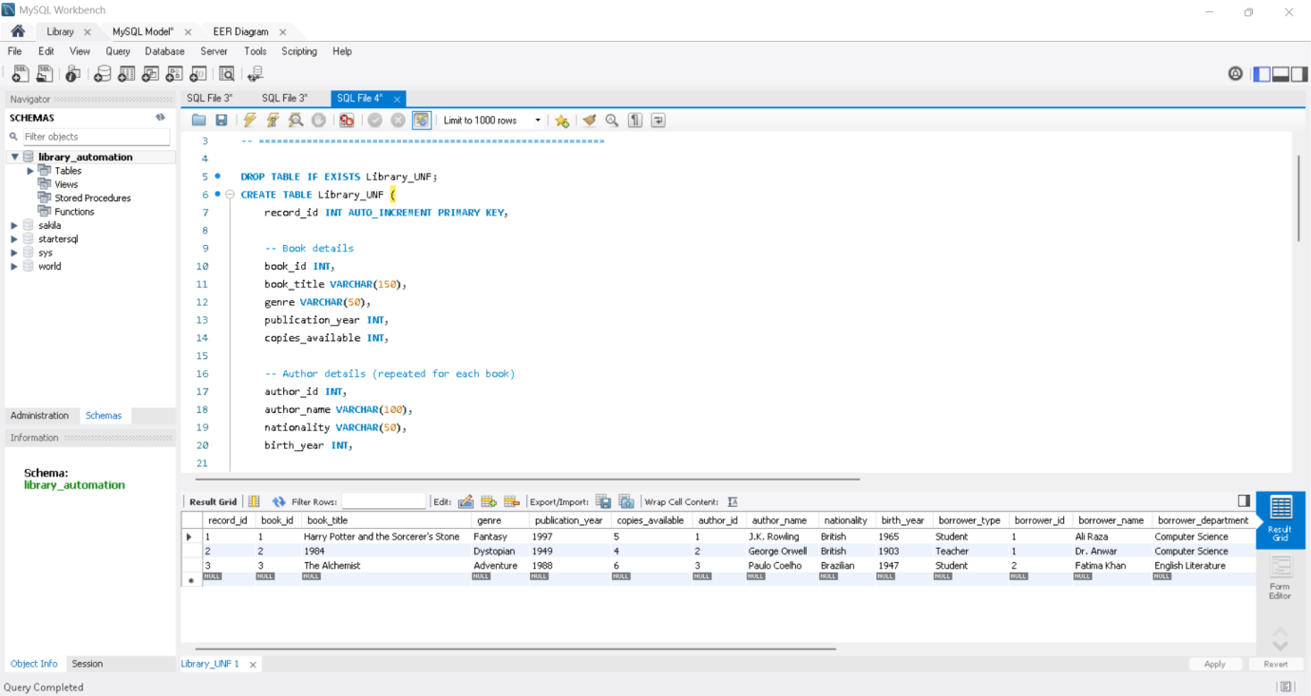

SELECT * FROM Library_UNF;

How It Works at the UNF Stage
- Single Flat File:
All librarian-related information is stored in one large table. There’s no concept of separate entities or foreign keys yet.
- Repeating Groups Exist:
Notice the Managed_Books column — it holds multiple values inside one cell (Book1, Book2, Book3).
This violates the rules of normalization because it’s not atomic (a single cell should hold only one value).
- Data Redundancy:
If a librarian manages many books, their name and login credentials are repeated in multiple records (if we were to list each book on its own row).
That leads to unnecessary duplication.
- Data Integrity Issues:
Since all data is mixed together, updating one librarian’s credentials or assigned books could be messy and error-prone.
For example, if Wadood changes his password, you’d have to update it everywhere his name appears.
- Lack of Relationships:
In UNF, the Librarian table doesn’t have relationships with other entities like Books or BorrowRecords.
Everything exists as one flat, raw dataset.

Purpose of UNF
The UNF version helps analysts or designers:
- Collect all potential data fields from the real-world scenario.
- Understand data dependencies and repetition.
- Identify what needs to be separated later (into 1NF, 2NF, 3NF).

Summary
In UNF, the Librarian table is just a rough starting point — a flat structure that mixes user details and responsibilities.
It captures everything, but it’s inefficient for long-term use.
The real design begins when this table is normalized — turning each repeating or composite field into its own related entity.

1NF

Recap: What 1NF Means
First Normal Form (1NF) is the first step of normalization.
It demands that:
- Each cell contains only a single value — no lists or repeating groups.
- Each record (row) is unique and identifiable by a primary key.
- The table’s columns (attributes) hold values of a single data type.
So, in 1NF, we convert that messy, unstructured data from UNF into a neatly organized table with atomic (indivisible) values.

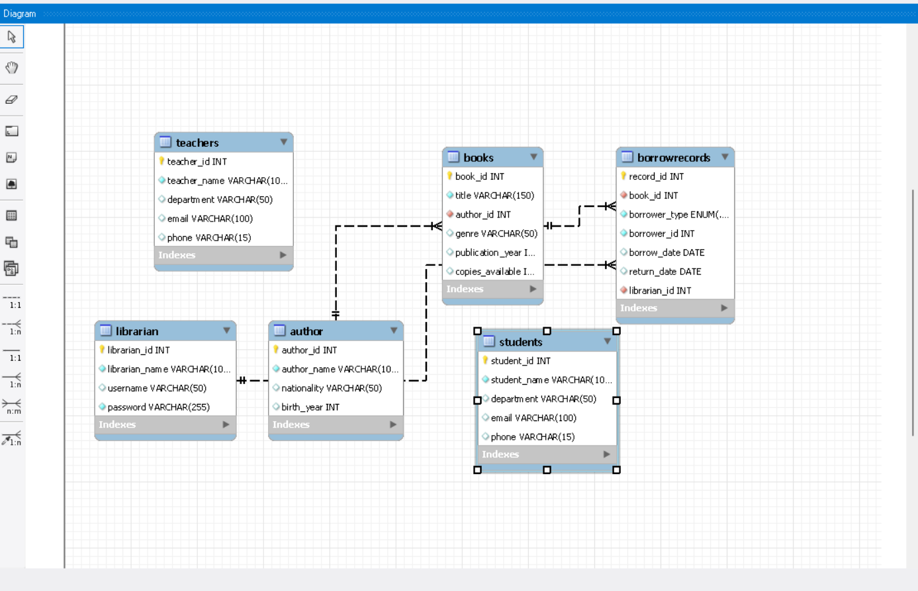

Librarian Table Before 1NF (UNF Example)
Librarian ID | Librarian Name | Username | Password | Managed Books
1 | Wadood Swaleh | wadood_admin | admin123 | Book1, Book2, Book3
2 | Warda Nasir | warda_admin | admin456 | Book4, Book5
3 | Awais Malik | awais_admin | admin789 | Book6, Book7, Book8, Book9
In this raw form:
- The Managed_Books field contains multiple values in one cell, which violates 1NF.
- Each row isn’t truly atomic — it holds a group of books.

How 1NF Fixes It
To bring this into First Normal Form, we remove the repeating groups.
Every field must store only one value, so each book a librarian manages becomes a separate record.

Librarian Table in 1NF
Librarian ID | Librarian Name | Username | Password | Managed Book
1 | Wadood Swaleh | wadood_admin | admin123 | Book1
1 | Wadood Swaleh | wadood_admin | admin123 | Book2
1 | Wadood Swaleh | wadood_admin | admin123 | Book3
2 | Warda Nasir | warda_admin | admin456 | Book4
2 | Warda Nasir | warda_admin | admin456 | Book5
3 | Awais Malik | awais_admin | admin789 | Book6
3 | Awais Malik | awais_admin | admin789 | Book7
3 | Awais Malik | awais_admin | admin789 | Book8
3 | Awais Malik | wais_admin | admin789 | Book9

-- LIBRARY AUTOMATION SYSTEM - 1NF

CREATE DATABASE IF NOT EXISTS library_automation_1NF;
USE library_automation_1NF;

-- TABLE: Author

DROP TABLE IF EXISTS Author;
CREATE TABLE Author (
author_id INT AUTO_INCREMENT PRIMARY KEY,
author_name VARCHAR(100) NOT NULL,
nationality VARCHAR(50),
birth_year INT
);

INSERT INTO Author (author_name, nationality, birth_year) VALUES
('J.K. Rowling', 'British', 1965),
('George Orwell', 'British', 1903),
('Paulo Coelho', 'Brazilian', 1947);

SELECT * FROM Author;

-- TABLE: Books

DROP TABLE IF EXISTS Books;
CREATE TABLE Books (
book_id INT AUTO_INCREMENT PRIMARY KEY,
title VARCHAR(150) NOT NULL,
author_id INT NOT NULL,
genre VARCHAR(50),
publication_year INT,
copies_available INT,
FOREIGN KEY (author_id) REFERENCES Author(author_id)
);

INSERT INTO Books (title, author_id, genre, publication_year, copies_available) VALUES
('Harry Potter and the Sorcerer''s Stone', 1, 'Fantasy', 1997, 5),
('1984', 2, 'Dystopian', 1949, 4),
('The Alchemist', 3, 'Adventure', 1988, 6);

SELECT * FROM Books;

-- TABLE: Students

DROP TABLE IF EXISTS Students;
CREATE TABLE Students (
student_id INT AUTO_INCREMENT PRIMARY KEY,
student_name VARCHAR(100) NOT NULL,
department VARCHAR(50),
email VARCHAR(100) UNIQUE,
phone VARCHAR(15)
);

INSERT INTO Students (student_name, department, email, phone) VALUES
('Ali Raza', 'Computer Science', 'ali.raza@bbsul.edu.pk', '03120000001'),
('Fatima Khan', 'English Literature', 'fatima.khan@bbsul.edu.pk', '03120000002'),
('Ahmed Malik', 'Business Administration', 'ahmed.malik@bbsul.edu.pk', '03120000003');

SELECT * FROM Students;

-- TABLE: Teachers

DROP TABLE IF EXISTS Teachers;
CREATE TABLE Teachers (
teacher_id INT AUTO_INCREMENT PRIMARY KEY,
teacher_name VARCHAR(100) NOT NULL,
department VARCHAR(50),
email VARCHAR(100) UNIQUE,
phone VARCHAR(15)
);

INSERT INTO Teachers (teacher_name, department, email, phone) VALUES
('Dr. Anwar', 'Computer Science', 'anwar.cs@bbsul.edu.pk', '03210000001'),
('Ms. Sana', 'English Literature', 'sana.el@bbsul.edu.pk', '03210000002'),
('Mr. Bilal', 'Business Administration', 'bilal.ba@bbsul.edu.pk', '03210000003');

SELECT * FROM Teachers;

-- TABLE: Librarian

DROP TABLE IF EXISTS Librarian;
CREATE TABLE Librarian (
librarian_id INT AUTO_INCREMENT PRIMARY KEY,
librarian_name VARCHAR(100) NOT NULL,
username VARCHAR(50) UNIQUE,
password VARCHAR(255) NOT NULL
);

INSERT INTO Librarian (librarian_name, username, password) VALUES
('Wadood Swaleh', 'wadood_admin', 'hashed_password1'),
('Warda Nasir', 'warda_admin', 'hashed_password2'),
('Awais Malik', 'awais_admin', 'hashed_password3');

SELECT * FROM Librarian;

-- TABLE: BorrowRecords

DROP TABLE IF EXISTS BorrowRecords;
CREATE TABLE BorrowRecords (
record_id INT AUTO_INCREMENT PRIMARY KEY,
book_id INT NOT NULL,
borrower_type ENUM('Student','Teacher') NOT NULL,
borrower_id INT NOT NULL,
borrow_date DATE,
return_date DATE,
librarian_id INT NOT NULL,
FOREIGN KEY (book_id) REFERENCES Books(book_id),
FOREIGN KEY (librarian_id) REFERENCES Librarian(librarian_id)
);

INSERT INTO BorrowRecords (book_id, borrower_type, borrower_id, borrow_date, return_date, librarian_id) VALUES
(1, 'Student', 1, '2025-10-20', '2025-10-30', 1),
(2, 'Teacher', 1, '2025-10-22', '2025-11-01', 2),
(3, 'Student', 2, '2025-10-25', '2025-11-05', 3);

SELECT * FROM BorrowRecords;

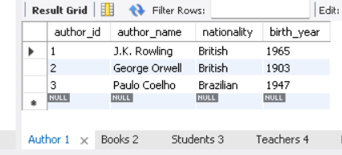

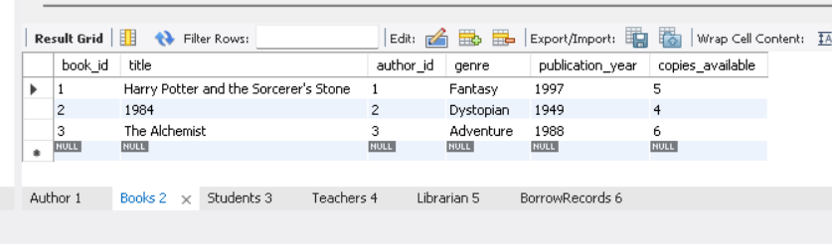

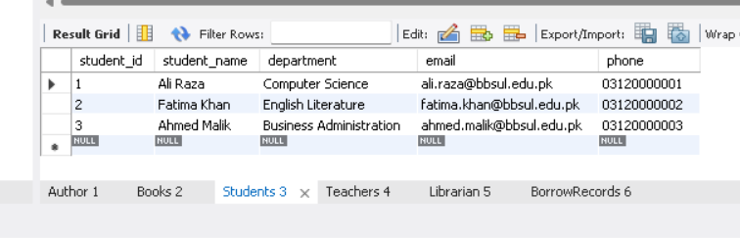

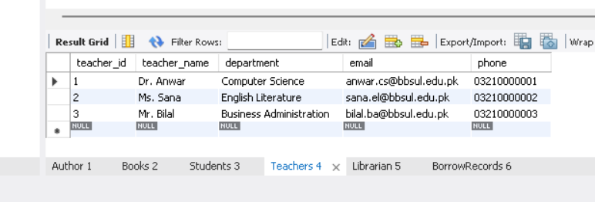

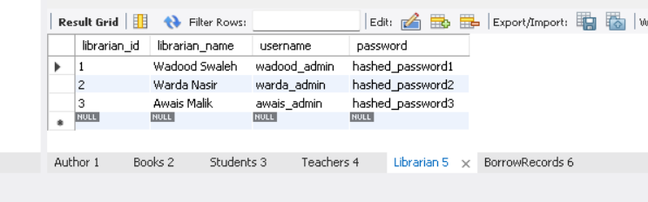

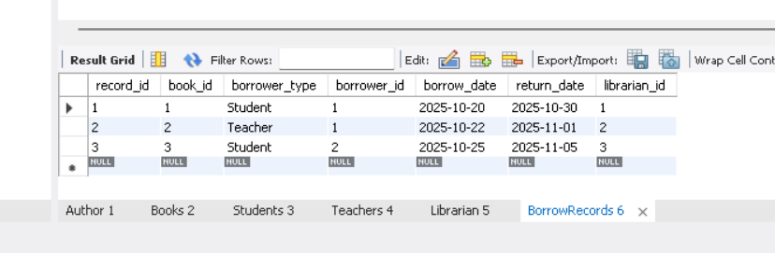

How It Works in 1NF
- Atomic Data Entries
Each record now holds only one book per row, ensuring every cell contains a single, indivisible value.
That satisfies the first rule of 1NF.
- Unique Records
Each librarian’s information is duplicated only to link them with each managed book.
Though it seems repetitive, it preserves the rule that each row represents one fact — one librarian managing one book.
- Defined Primary Key
You can now define a composite primary key — for example,
PRIMARY KEY (Librarian_ID, Managed_Book)
so that each combination of librarian and book remains unique.
- Elimination of Repeating Groups
The “list” of books is gone.
Instead, each book-librarian relationship is now its own record, making the data easier to query, update, and relate to other tables (like a Books table).

Advantages of 1NF
- Removes multi-valued attributes.
- Creates a structured foundation for higher normalization (2NF and 3NF).
- Simplifies searches — you can now easily query which books each librarian manages.

Limitations Still Present
Even though 1NF fixes the repeating groups, redundancy remains:
- The librarian’s name, username, and password are repeated for every managed book.
- If a librarian changes their password, you’d have to update multiple rows.
That’s why 2NF comes next — to separate repeating librarian details into a distinct table.

Summary
In 1NF, the Librarian table becomes:
- Structured and atomic.
- Free from repeating groups.
- Still redundant but now logically organized.
It’s the first real step toward an efficient relational database, where every data point stands alone and every record tells a single, clear story.

2NF

Recap: What 2NF Means
Second Normal Form builds on 1NF.
A table is in 2NF if:
- It’s already in 1NF.
- Every non-key attribute is fully dependent on the entire primary key, not just part of it.
In simpler terms:
If your table has a composite key (like two columns forming the key), no attribute should depend on only one part of that key.

1NF Version Recap
Here’s what the Librarian table looked like in 1NF:
Librarian_ID | Librarian_Name | Username | Password | Managed_Book
1 | Wadood Swaleh | wadood_admin | admin123 | Book1
1 | Wadood Swaleh | wadood_admin | admin123 | Book2
1 | Wadood Swaleh | wadood_admin | admin123 | Book3
2 | Warda Nasir | warda_admin | admin456 | Book4
2 | Warda Nasir | warda_admin | admin456 | Book5
3 | Awais Malik | awais_admin | admin789 | Book6
3 | Awais Malik | awais_admin | admin789 | Book7

Problem in 1NF
The composite primary key here could be (Librarian_ID, Managed_Book).
However, the attributes Librarian_Name, Username, and Password depend only on Librarian_ID, not on Managed_Book.
That’s a partial dependency, which violates 2NF.

How to Fix It for 2NF
We break this large table into two separate tables — one for librarian details, and another for which books each librarian manages.

Table 1: Librarian
Librarian ID | Librarian Name | Username | Password
1 | Wadood Swaleh | wadood_admin | admin123
2 | Warda Nasir | warda_admin | admin456
3 | Awais Malik | awais_admin | admin789
Primary Key: Librarian_ID
- Each row uniquely identifies a librarian.
- Every attribute depends fully on the librarian’s ID — no partial dependency remains.

Table 2: Librarian_Book_Assignment
Librarian ID | Managed Book
1 | Book1
1 | Book2
1 | Book3
2 | Book4
2 | Book5
3 | Book6
3 | Book7
Composite Primary Key: (Librarian_ID, Managed_Book)
Foreign Key: Librarian_ID references Librarian(Librarian_ID)
This table only holds relationships — it tells which librarian manages which books.
Now, all non-key data (Managed_Book) depends fully on the composite key.

LIBRARY AUTOMATION SYSTEM - 2NF

CREATE DATABASE IF NOT EXISTS library_automation_2NF;

USE library_automation_2NF;

-- TABLE: Author

DROP TABLE IF EXISTS Author;

CREATE TABLE Author (

author_id INT AUTO_INCREMENT PRIMARY KEY,

author_name VARCHAR(100) NOT NULL,

nationality VARCHAR(50),

birth_year INT

);

INSERT INTO Author (author_name, nationality, birth_year) VALUES

('J.K. Rowling', 'British', 1965),

('George Orwell', 'British', 1903),

('Paulo Coelho', 'Brazilian', 1947);

-- TABLE: Books

DROP TABLE IF EXISTS Books;

CREATE TABLE Books (

book_id INT AUTO_INCREMENT PRIMARY KEY,

title VARCHAR(150) NOT NULL,

author_id INT NOT NULL,

genre VARCHAR(50),

publication_year INT,

copies_available INT,

FOREIGN KEY (author_id) REFERENCES Author(author_id)

);

INSERT INTO Books (title, author_id, genre, publication_year, copies_available) VALUES

('Harry Potter and the Sorcerer''s Stone', 1, 'Fantasy', 1997, 5),

('1984', 2, 'Dystopian', 1949, 4),

('The Alchemist', 3, 'Adventure', 1988, 6);

-- TABLE: Students

DROP TABLE IF EXISTS Students;

CREATE TABLE Students (

student_id INT AUTO_INCREMENT PRIMARY KEY,

student_name VARCHAR(100) NOT NULL,

department VARCHAR(50),

email VARCHAR(100) UNIQUE,

phone VARCHAR(15)

);

INSERT INTO Students (student_name, department, email, phone) VALUES

('Ali Raza', 'Computer Science', 'ali.raza@bbsul.edu.pk', '03120000001'),

('Fatima Khan', 'English Literature', 'fatima.khan@bbsul.edu.pk', '03120000002'),

('Ahmed Malik', 'Business Administration', 'ahmed.malik@bbsul.edu.pk', '03120000003');

-- TABLE: Teachers

DROP TABLE IF EXISTS Teachers;

CREATE TABLE Teachers (

teacher_id INT AUTO_INCREMENT PRIMARY KEY,

teacher_name VARCHAR(100) NOT NULL,

department VARCHAR(50),

email VARCHAR(100) UNIQUE,

phone VARCHAR(15)

);

INSERT INTO Teachers (teacher_name, department, email, phone) VALUES

('Dr. Anwar', 'Computer Science', 'anwar.cs@bbsul.edu.pk', '03210000001'),

('Ms. Sana', 'English Literature', 'sana.el@bbsul.edu.pk', '03210000002'),

('Mr. Bilal', 'Business Administration', 'bilal.ba@bbsul.edu.pk', '03210000003');

-- TABLE: Librarian

DROP TABLE IF EXISTS Librarian;

CREATE TABLE Librarian (

librarian_id INT AUTO_INCREMENT PRIMARY KEY,

librarian_name VARCHAR(100) NOT NULL,

username VARCHAR(50) UNIQUE,

password VARCHAR(255) NOT NULL

);

INSERT INTO Librarian (librarian_name, username, password) VALUES

('Wadood Swaleh', 'wadood_admin', 'hashed_password1'),

('Warda Nasir', 'warda_admin', 'hashed_password2'),

('Awais Malik', 'awais_admin', 'hashed_password3');

-- TABLE: BorrowRecords (2NF compliant)

DROP TABLE IF EXISTS BorrowRecords;

CREATE TABLE BorrowRecords (

record_id INT AUTO_INCREMENT PRIMARY KEY,

book_id INT NOT NULL,

borrower_id INT NOT NULL,

borrower_role ENUM('Student','Teacher') NOT NULL,

borrow_date DATE,

return_date DATE,

librarian_id INT NOT NULL,

FOREIGN KEY (book_id) REFERENCES Books(book_id),

FOREIGN KEY (librarian_id) REFERENCES Librarian(librarian_id)

);

-- Sample Borrow Records

INSERT INTO BorrowRecords (book_id, borrower_id, borrower_role, borrow_date, return_date, librarian_id) VALUES

(1, 1, 'Student', '2025-10-20', '2025-10-30', 1),

(2, 1, 'Teacher', '2025-10-22', '2025-11-01', 2),

(3, 2, 'Student', '2025-10-25', '2025-11-05', 3);

-- INDEXING

CREATE INDEX idx_book_title ON Books(title);

CREATE INDEX idx_author_name ON Author(author_name);

CREATE INDEX idx_student_email ON Students(email);

CREATE INDEX idx_teacher_email ON Teachers(email);

-- TRIGGER (Automatic Update)

DELIMITER //

CREATE TRIGGER after_borrow_insert

AFTER INSERT ON BorrowRecords

FOR EACH ROW

BEGIN

UPDATE Books

SET copies_available = copies_available - 1

WHERE book_id = NEW.book_id;

END //

DELIMITER ;

-- JOINS (Data Relationship Examples)

-- Join Books and Author

SELECT b.book_id, b.title, a.author_name, b.genre, b.publication_year

FROM Books b

JOIN Author a ON b.author_id = a.author_id;

-- Join BorrowRecords with Students and Books

SELECT br.record_id, s.student_name, b.title, br.borrow_date, br.return_date, l.librarian_name

FROM BorrowRecords br

JOIN Books b ON br.book_id = b.book_id

JOIN Students s ON br.borrower_id = s.student_id

JOIN Librarian l ON br.librarian_id = l.librarian_id

WHERE br.borrower_role = 'Student';

-- VIEW ALL TABLE CONTENTS

SELECT * FROM Author;

SELECT * FROM Books;

SELECT * FROM Students;

SELECT * FROM Teachers;

SELECT * FROM Librarian;

SELECT * FROM BorrowRecords;

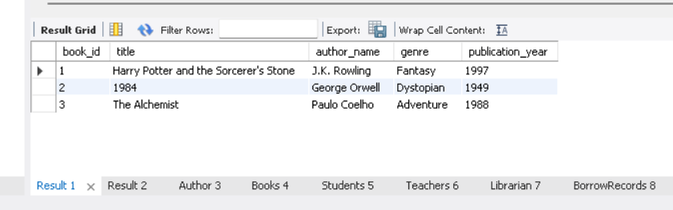

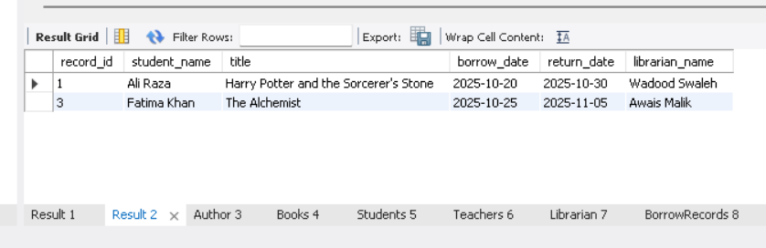

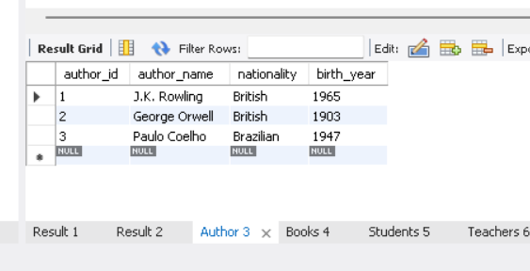

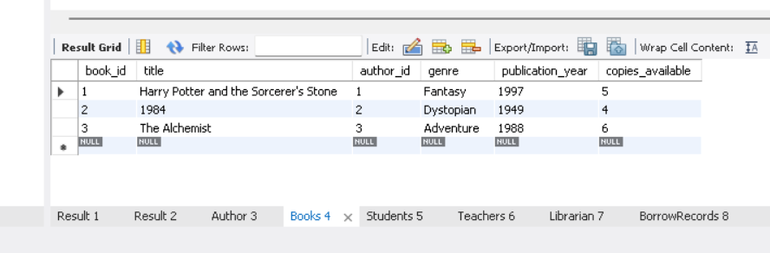

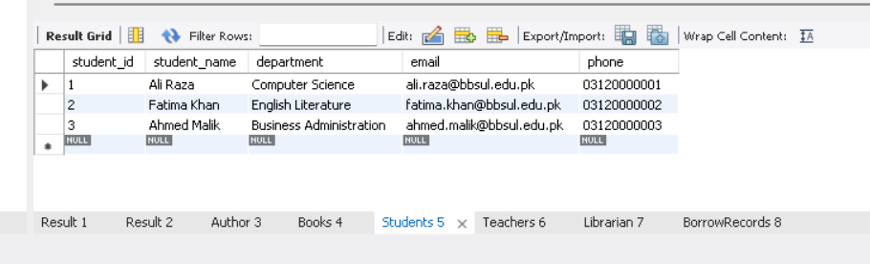

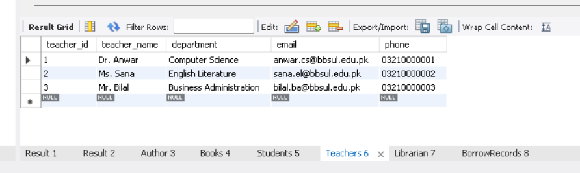

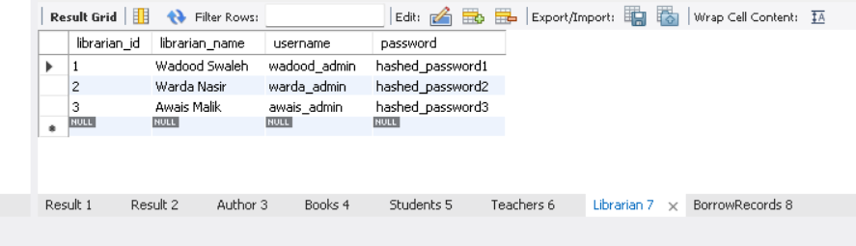

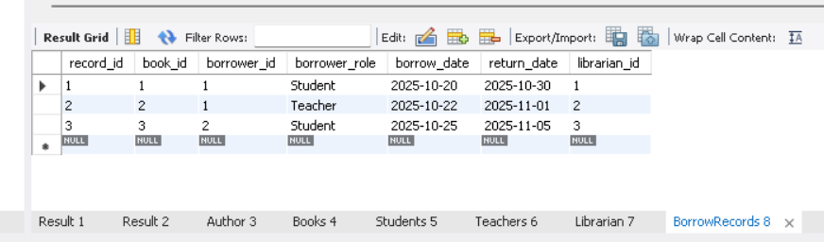

How It Works in 2NF
- Elimination of Partial Dependencies
Each non-key attribute now depends on the whole key.
Librarian info is separate from the list of books, removing redundancy.
- Data Integrity Improved
If a librarian changes their password, you update it once in the Librarian table — no duplicates.
- Relationships Introduced
The Librarian_Book_Assignment table now acts as a link or “bridge” between librarians and books.
- No Data Loss
All information from 1NF is preserved but better organized.
Example Queries After 2NF
To find all books managed by Warda Nasir:
SELECT lb.Managed_Book
FROM Librarian l
JOIN Librarian_Book_Assignment lb ON l.Librarian_ID = lb.Librarian_ID
WHERE l.Librarian_Name = 'Warda Nasir';
To find which librarian manages a specific book:
SELECT l.Librarian_Name
FROM Librarian l
JOIN Librarian_Book_Assignment lb ON l.Librarian_ID = lb.Librarian_ID
WHERE lb.Managed_Book = 'Book3';

Advantages of 2NF
- Removes redundancy and partial dependencies.
- Makes updates faster and consistent.
- Prepares data for more complex relationships (like linking to Books or BorrowRecords tables).

Summary
In 2NF, the Librarian table becomes:
- Divided into two focused tables: Librarian and Librarian_Book_Assignment.
- Free from partial dependencies.
- Fully functional for relational queries.
Each piece of data now has one logical home — personal details in one table, management details in another.

Alright — now we take the Librarian table from Second Normal Form (2NF) to Third Normal Form (3NF) — the stage where the design becomes lean, consistent, and secure.

Recap: What 3NF Means
A table is in Third Normal Form (3NF) if:
- It’s already in 2NF.
- There are no transitive dependencies — meaning,
no non-key attribute depends on another non-key attribute.
Put simply:
Every non-key field must depend only on the primary key — not on something that depends on the primary key.

2NF Structure Recap
We ended 2NF with two tables:
Table 1: Librarian
Librarian_ID | Librarian_Name | Username | Password
1 | Wadood Swaleh | wadood_admin | admin123
2 | Warda Nasir | warda_admin | admin456
3 | Awais Malik | awais_admin | admin789

Librarian_Book_Assignment
Librarian_ID | Managed_Book
1 | Book1
1 | Book2
2 | Book3
3 | Book4

Problem in 2NF
The Librarian table still has a transitive dependency:
- Username determines Password.
(i.e., Password depends on Username, not directly on Librarian_ID.)
This violates 3NF.
We also know that, for security reasons, login credentials are usually managed separately.

3NF

Table 1: Librarian
Librarian ID | Librarian Name
1 | Wadood Swaleh
2 | Warda Nasir
3 | Awais Malik
Primary Key: Librarian_ID
This table now holds only core identity information — no login credentials.

Table 2: Librarian Login
Login ID | Librarian ID | Username | Password
101 | 1 | wadood_admin | admin123
102 | 2 | warda_admin | admin456
103 | 3 | awais_admin | admin789
Primary Key: Login_ID
Foreign Key: Librarian_ID references Librarian(Librarian_ID)
Here, credentials are isolated and directly tied to a librarian through their ID.

Table 3: Librarian Book Assignment
Librarian ID | Managed Book
1 | Book1
1 | Book2
2 | Book3
3 | Book4
Composite Primary Key: (Librarian_ID, Managed_Book)
Foreign Key: Librarian_ID references Librarian(Librarian_ID)

CREATE DATABASE IF NOT EXISTS library_automation_3NF;
USE library_automation_3NF;

-- TABLE: Author

DROP TABLE IF EXISTS Author;
CREATE TABLE Author (
author_id INT AUTO_INCREMENT PRIMARY KEY,
author_name VARCHAR(100) NOT NULL,
nationality VARCHAR(50),
birth_year INT
);

INSERT INTO Author (author_name, nationality, birth_year) VALUES
('J.K. Rowling', 'British', 1965),
('George Orwell', 'British', 1903),
('Paulo Coelho', 'Brazilian', 1947);

-- TABLE: Books

DROP TABLE IF EXISTS Books;
CREATE TABLE Books (
book_id INT AUTO_INCREMENT PRIMARY KEY,
title VARCHAR(150) NOT NULL,
author_id INT NOT NULL,
genre VARCHAR(50),
publication_year INT,
copies_available INT,
FOREIGN KEY (author_id) REFERENCES Author(author_id)
);

INSERT INTO Books (title, author_id, genre, publication_year, copies_available) VALUES
('Harry Potter and the Sorcerer''s Stone', 1, 'Fantasy', 1997, 5),
('1984', 2, 'Dystopian', 1949, 4),
('The Alchemist', 3, 'Adventure', 1988, 6);

-- TABLE: Department (new table to remove transitive dependency)

DROP TABLE IF EXISTS Department;
CREATE TABLE Department (
department_id INT AUTO_INCREMENT PRIMARY KEY,
department_name VARCHAR(50) UNIQUE
);

INSERT INTO Department (department_name) VALUES
('Computer Science'),
('English Literature'),
('Business Administration');

-- TABLE: Students

DROP TABLE IF EXISTS Students;
CREATE TABLE Students (
student_id INT AUTO_INCREMENT PRIMARY KEY,
student_name VARCHAR(100) NOT NULL,
department_id INT,
email VARCHAR(100) UNIQUE,
phone VARCHAR(15),
FOREIGN KEY (department_id) REFERENCES Department(department_id)
);

INSERT INTO Students (student_name, department_id, email, phone) VALUES
('Ali Raza', 1, 'ali.raza@bbsul.edu.pk', '03120000001'),
('Fatima Khan', 2, 'fatima.khan@bbsul.edu.pk', '03120000002'),
('Ahmed Malik', 3, 'ahmed.malik@bbsul.edu.pk', '03120000003');

-- TABLE: Teachers

DROP TABLE IF EXISTS Teachers;
CREATE TABLE Teachers (
teacher_id INT AUTO_INCREMENT PRIMARY KEY,
teacher_name VARCHAR(100) NOT NULL,
department_id INT,
email VARCHAR(100) UNIQUE,
phone VARCHAR(15),
FOREIGN KEY (department_id) REFERENCES Department(department_id)
);

INSERT INTO Teachers (teacher_name, department_id, email, phone) VALUES
('Dr. Anwar', 1, 'anwar.cs@bbsul.edu.pk', '03210000001'),
('Ms. Sana', 2, 'sana.el@bbsul.edu.pk', '03210000002'),
('Mr. Bilal', 3, 'bilal.ba@bbsul.edu.pk', '03210000003');

-- TABLE: Librarian

DROP TABLE IF EXISTS Librarian;
CREATE TABLE Librarian (
librarian_id INT AUTO_INCREMENT PRIMARY KEY,
librarian_name VARCHAR(100) NOT NULL,
username VARCHAR(50) UNIQUE,
password VARCHAR(255) NOT NULL
);

INSERT INTO Librarian (librarian_name, username, password) VALUES
('Wadood Swaleh', 'wadood_admin', 'hashed_password1'),
('Warda Nasir', 'warda_admin', 'hashed_password2'),
('Awais Malik', 'awais_admin', 'hashed_password3');

-- TABLE: BorrowRecords

DROP TABLE IF EXISTS BorrowRecords;
CREATE TABLE BorrowRecords (
record_id INT AUTO_INCREMENT PRIMARY KEY,
book_id INT NOT NULL,
borrower_id INT NOT NULL,
borrower_role ENUM('Student','Teacher') NOT NULL,
borrow_date DATE,
return_date DATE,
librarian_id INT NOT NULL,
FOREIGN KEY (book_id) REFERENCES Books(book_id),
FOREIGN KEY (librarian_id) REFERENCES Librarian(librarian_id)
);

INSERT INTO BorrowRecords (book_id, borrower_id, borrower_role, borrow_date, return_date, librarian_id) VALUES
(1, 1, 'Student', '2025-10-20', '2025-10-30', 1),
(2, 1, 'Teacher', '2025-10-22', '2025-11-01', 2),
(3, 2, 'Student', '2025-10-25', '2025-11-05', 3);

-- VIEW ALL TABLE CONTENTS

SELECT * FROM Author;
SELECT * FROM Books;
SELECT * FROM Department;
SELECT * FROM Students;
SELECT * FROM Teachers;
SELECT * FROM Librarian;
SELECT * FROM BorrowRecords;

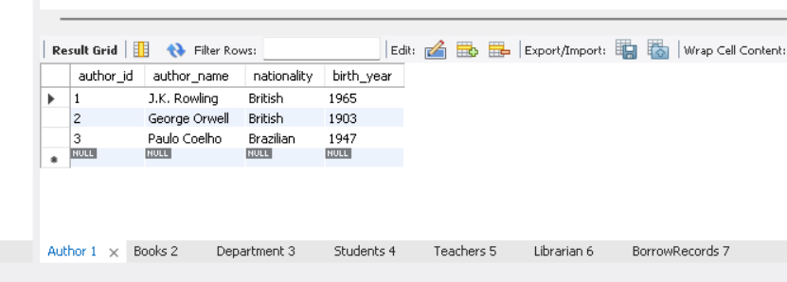

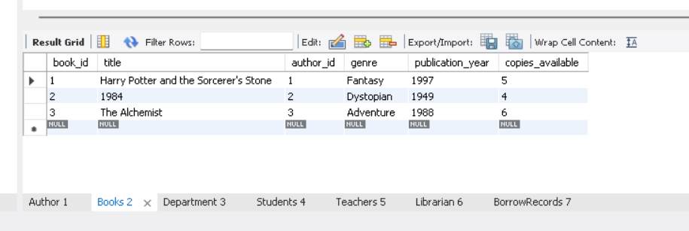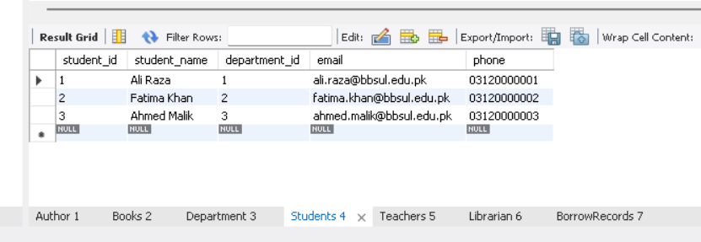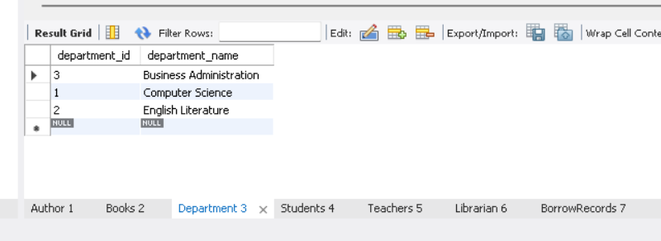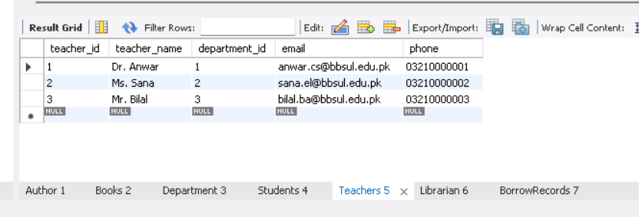
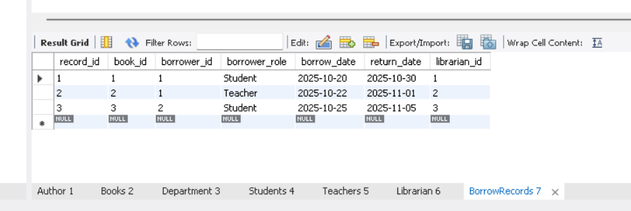

How It Works in 3NF
- Elimination of Transitive Dependencies
  - Password no longer depends on Username.
  - Both now depend only on the primary key (Login_ID).
  - The Librarian’s identity and credentials are completely separated.
- Data Independence
  - If a librarian changes their password, you only update Librarian_Login.
  - If they change their name, it only affects Librarian.
  - Each change stays local to its table.
- Improved Security
Credentials are stored apart from personal info — safer for authentication systems.
- Relational Integrity
The Librarian_ID acts as the linking field across all three tables, ensuring consistency.

Example Queries After 3NF
To get full librarian info with login credentials:
SELECT l.Librarian_Name, ll.Username, ll.Password
FROM Librarian l
JOIN Librarian_Login ll ON l.Librarian_ID = ll.Librarian_ID;
To find all books managed by each librarian:
SELECT l.Librarian_Name, lb.Managed_Book
FROM Librarian l
JOIN Librarian_Book_Assignment lb ON l.Librarian_ID = lb.Librarian_ID;
To verify login credentials (for GUI authentication):
SELECT Librarian_ID
FROM Librarian_Login
WHERE Username = 'wadood_admin' AND Password = 'admin123';

Advantages of 3NF
- Removes transitive dependencies completely.
- Increases data integrity and security.
- Reduces redundancy and storage waste.
- Makes the database structure modular — easy to expand or maintain.

Summary
In 3NF, the Librarian structure becomes:
- Librarian — for identity and base info.
- Librarian_Login — for credentials and authentication.
- Librarian_Book_Assignment — for role and responsibilities.
Every non-key attribute now depends only on its table’s primary key, and nothing else.
The design is efficient, secure, and fully normalized.

BCNF

Recap: What BCNF Means
BCNF (Boyce–Codd Normal Form) is a stronger version of 3NF.
It fixes cases where:
- The table technically meets 3NF,
- But still contains anomalies due to overlapping dependencies.
Formal rule:
A table is in BCNF if,
For every functional dependency (X → Y), X must be a super key.
That means every determinant (the column that decides another) must uniquely identify a record in that table.

3NF Structure Recap
We currently have three well-designed tables:

1. Librarian
Librarian_ID | Librarian_Name
1 | Wadood Swaleh
2 | Warda Nasir
3 | Awais Malik

2. Librarian_Login
Login_ID | Librarian_ID | Username | Password
101 | 1 | wadood_admin | admin123
102 | 2 | warda_admin | admin456
103 | 3 | awais_admin | admin789

3. Librarian_Book_Assignment
Librarian_ID | Managed_Book
1 | Book1
1 | Book2
2 | Book3
3 | Book4

Where 3NF Falls Short
Even though this structure meets 3NF, a potential dependency issue can still exist:
In the Librarian_Login table:
- The attribute Username also determines Password and Librarian_ID.
That means Username → Librarian_ID, Password.
Here, Username isn’t the primary key (Login_ID is).
So, this violates BCNF — because a non–super key (Username) is determining other attributes.

How to Fix It for BCNF
To fix this, we restructure Librarian_Login slightly to ensure every determinant is a candidate key.
-- LIBRARY AUTOMATION SYSTEM – BCNF

CREATE DATABASE IF NOT EXISTS library_automation_BCNF;
USE library_automation_BCNF;

-- TABLE: Author

DROP TABLE IF EXISTS Author;
CREATE TABLE Author (
author_id INT AUTO_INCREMENT PRIMARY KEY,
author_name VARCHAR(100) NOT NULL UNIQUE,
nationality VARCHAR(50),
birth_year INT
);

-- Each author_name uniquely identifies an author → author_id is the key.

INSERT INTO Author (author_name, nationality, birth_year) VALUES
('J.K. Rowling', 'British', 1965),
('George Orwell', 'British', 1903),
('Paulo Coelho', 'Brazilian', 1947);

-- TABLE: Books

DROP TABLE IF EXISTS Books;
CREATE TABLE Books (
book_id INT AUTO_INCREMENT PRIMARY KEY,
title VARCHAR(150) NOT NULL UNIQUE,
author_id INT NOT NULL,
genre VARCHAR(50),
publication_year INT,
copies_available INT,
FOREIGN KEY (author_id) REFERENCES Author(author_id)
);

-- Title uniquely identifies a book → no dependency anomalies.

INSERT INTO Books (title, author_id, genre, publication_year, copies_available) VALUES
('Harry Potter and the Sorcerer''s Stone', 1, 'Fantasy', 1997, 5),
('1984', 2, 'Dystopian', 1949, 4),
('The Alchemist', 3, 'Adventure', 1988, 6);

-- TABLE: Department

DROP TABLE IF EXISTS Department;
CREATE TABLE Department (
department_id INT AUTO_INCREMENT PRIMARY KEY,
department_name VARCHAR(50) UNIQUE
);

INSERT INTO Department (department_name) VALUES
('Computer Science'),
('English Literature'),
('Business Administration');

-- TABLE: Students

DROP TABLE IF EXISTS Students;
CREATE TABLE Students (
student_id INT AUTO_INCREMENT PRIMARY KEY,
student_name VARCHAR(100) NOT NULL,
department_id INT,
email VARCHAR(100) UNIQUE,
phone VARCHAR(15),
FOREIGN KEY (department_id) REFERENCES Department(department_id)
);

INSERT INTO Students (student_name, department_id, email, phone) VALUES
('Ali Raza', 1, 'ali.raza@bbsul.edu.pk', '03120000001'),
('Fatima Khan', 2, 'fatima.khan@bbsul.edu.pk', '03120000002'),
('Ahmed Malik', 3, 'ahmed.malik@bbsul.edu.pk', '03120000003');

-- TABLE: Teachers

DROP TABLE IF EXISTS Teachers;
CREATE TABLE Teachers (
teacher_id INT AUTO_INCREMENT PRIMARY KEY,
teacher_name VARCHAR(100) NOT NULL,
department_id INT,
email VARCHAR(100) UNIQUE,
phone VARCHAR(15),
FOREIGN KEY (department_id) REFERENCES Department(department_id)
);

INSERT INTO Teachers (teacher_name, department_id, email, phone) VALUES
('Dr. Anwar', 1, 'anwar.cs@bbsul.edu.pk', '03210000001'),
('Ms. Sana', 2, 'sana.el@bbsul.edu.pk', '03210000002'),
('Mr. Bilal', 3, 'bilal.ba@bbsul.edu.pk', '03210000003');

-- TABLE: Librarian

DROP TABLE IF EXISTS Librarian;
CREATE TABLE Librarian (
librarian_id INT AUTO_INCREMENT PRIMARY KEY,
librarian_name VARCHAR(100) NOT NULL,
username VARCHAR(50) UNIQUE,
password VARCHAR(255) NOT NULL
);

INSERT INTO Librarian (librarian_name, username, password) VALUES
('Wadood Swaleh', 'wadood_admin', 'hashed_password1'),
('Warda Nasir', 'warda_admin', 'hashed_password2'),
('Awais Malik', 'awais_admin', 'hashed_password3');

-- TABLE: BorrowRecords

DROP TABLE IF EXISTS BorrowRecords;
CREATE TABLE BorrowRecords (
record_id INT AUTO_INCREMENT PRIMARY KEY,
book_id INT NOT NULL,
borrower_id INT NOT NULL,
borrower_role ENUM('Student','Teacher') NOT NULL,
borrow_date DATE,
return_date DATE,
librarian_id INT NOT NULL,
FOREIGN KEY (book_id) REFERENCES Books(book_id),
FOREIGN KEY (librarian_id) REFERENCES Librarian(librarian_id)
);

-- Each record_id uniquely identifies a borrow transaction → no partial/transitive dependency.

INSERT INTO BorrowRecords (book_id, borrower_id, borrower_role, borrow_date, return_date, librarian_id) VALUES
(1, 1, 'Student', '2025-10-20', '2025-10-30', 1),
(2, 1, 'Teacher', '2025-10-22', '2025-11-01', 2),
(3, 2, 'Student', '2025-10-25', '2025-11-05', 3);

-- VIEW ALL TABLE CONTENTS

SELECT * FROM Author;
SELECT * FROM Books;
SELECT * FROM Department;
SELECT * FROM Students;
SELECT * FROM Teachers;
SELECT * FROM Librarian;
SELECT * FROM BorrowRecords;

Table 1: Librarian (No Change)
Librarian_ID | Librarian_Name
1 | Wadood Swaleh
2 | Warda Nasir
3 | Awais Malik
Primary Key: Librarian_ID

Table 2: Librarian_Login (BCNF-Compliant)
Username | Librarian_ID | Password
wadood_admin | 1 | admin123
warda_admin | 2 | admin456
awais_admin | 3 | admin789
Primary Key: Username
Foreign Key: Librarian_ID references Librarian(Librarian_ID)
By making Username the key, the dependency Username → Password, Librarian_ID is now valid, since the determinant is a super key.

Table 3: Librarian_Book_Assignment (No Change)
Librarian_ID | Managed_Book
1 | Book1
1 | Book2
2 | Book3
3 | Book4
Composite Primary Key: (Librarian_ID, Managed_Book)
This table is already in BCNF because:
- Librarian_ID + Managed_Book uniquely identifies each record.
- No non-key attribute determines another.

How It Works in BCNF
- Every determinant is now a key.
  - In Librarian, the only dependency is Librarian_ID → Librarian_Name.
  - In Librarian_Login, Username → Librarian_ID, Password.
  - In Librarian_Book_Assignment, (Librarian_ID, Managed_Book) is the unique composite key.
- No redundancy, no anomaly.
  - No column depends on something that’s not a key.
  - Update, delete, and insert anomalies are fully eliminated.
- Full Referential Integrity.
Each librarian connects cleanly across all tables using their Librarian_ID, but no table overlaps responsibilities.

Example Queries After BCNF
Authenticate a librarian:
SELECT Librarian_ID
FROM Librarian_Login
WHERE Username = 'wadood_admin' AND Password = 'admin123';
Fetch librarian’s name and assigned books:
SELECT l.Librarian_Name, lb.Managed_Book
FROM Librarian l
JOIN Librarian_Book_Assignment lb ON l.Librarian_ID = lb.Librarian_ID;
List librarians with usernames:
SELECT l.Librarian_Name, ll.Username
FROM Librarian l
JOIN Librarian_Login ll ON l.Librarian_ID = ll.Librarian_ID;

Advantages of BCNF
- Eliminates every kind of dependency anomaly.
- Ensures absolute data integrity.
- Perfects the relationship structure between identity, credentials, and responsibilities.
- Makes the schema robust for scaling and auditing.

Summary
In BCNF, the Librarian system achieves full normalization:
Table | Focus | Key
Librarian | Identity info | Librarian_ID
Librarian_Login | Authentication info | Username
Librarian_Book_Assignment | Management info | Librarian_ID + Managed_Book
Every determinant is now a candidate key.
The design is clean, minimal, and ready for real-world database use — reliable, secure, and future-proof.

Question and Queries
1- Why are you using joins and where are you suing joins? Muskan
I'm not using joins in the script you provided that script builds the database.
You use joins later, in SELECT queries, to pull related data together from different tables.
For example, you'd use a join to combine a Student ID from the Book Issue table with the Student Name from the Student table to see who actually has the book.

2- Where have you used triggers? Bonita Naqvi
I have used triggers in three places in your script to automate actions and enforce rules:
Prevent negative stock: This trigger is set on the Books table. It automatically runs before any update to stop the No Of Books from ever going below zero.
After book issue: This trigger is set on the Book Issue table. It automatically runs after a new book loan is inserted and adds a new line to the Issue Log table.
After book return: This trigger is also set on the Book Issue table. It automatically runs after a loan is updated. It checks if the Return Date was just filled in and, if so, adds a "Book Returned" line to the Issue Log.

3-Explain the difference between automation and management? Rahat

Automation is the code that runs by itself to handle background tasks or enforce rules. Management is the code that gives users the power to actively control and run the library system.

4-Why is it safer to GRANT EXECUTE on a procedure to a user, instead of just granting them UPDATE on the table? Mateen
It's all about control.
Granting UPDATE on the Books table is like giving someone a master key to the whole room. They could UPDATE the stock, but they could also change the book's Price, Book Name, or anything else.
Granting EXECUTE on the Issue Book procedure is like giving them a single-purpose "Issue Book" button. They can only perform the exact actions you've built into that procedure (like UPDATE No of Books = No Of Books - 1), and they can only do it if they follow the procedure's rules (like checking if stock is available). It's far more secure.

