Develop Home (Landing Page) | Cost Calculator | User Management(login/Signup/profile) | Dashboard (Place Order | Submit Document |Plans |History)

Subscription For File Checking | Services for Order | Referral System

**User Types: Admin | API User | Employ | User**

**The Application is work like this.**

**Admin Mode:**

* Admin Can Change Users Rols Like User to Employ | User to Api.
* Admin Activate the service or Subscription against specific user.
* Admin can access the user dashboard or Account of specific user.
* Admin Temporary Block to specific user. They can login, but they are unable to perform any action (Show a notification to this user contact Support)
* All New Order Placed by users will show in dashboard.
* After Receiving order admin can be able to handover to a specific employ or if it’s a subscription (Based on Service) then activate this subscription (1 Week, 3 Week, 1 Month) (Limits 100 Documents).
* When order is Completed then admin able to deliver the order to user.
* Admin can see all user history from old month how much quota and file limit he used in specific period.
* Admin adds the Custom Notification to show to each user.
* In Subscriptions Admin can allow Some free tails to new users. Like By default new users able to check 1, 2, …100 documents by default. Admin can set any number of documents.
* Admin can set the referral points on each referral how much they get the points based on the order.
* Admin can see all the processing documents in one page at Processing Stage only. (Those Document that in Queue, Processing)
* Admin can see the history of each user how much file they check in old Months.

**Automation Methods**

**Admin can set these methods.**

**Like:** Use Only 1st Methodor 2nd or 3rd Method | Use Only 1st if not work then move to third method | Use Only 2nd if not work then move to third method |Use Automatic from 1st if not work move to 2nd if not work move to third

**Methods 1** (<https://scopedlens.com/>)

* Admin can add/Update/Remove email and passwords.
* Set allowed limits, Total limits, Reset Days and Expiry Date against each account.
* Accounts can be 1, 2, 3, or Multiple use in Sequence.
* Admin can change the sequences.

**Method 2** (<https://turnitin.report/>)

* Admin can add/Update/Remove email and passwords.
* Set allowed limits, Total limits, Reset Days and Expiry Date against each account.
* Accounts can be 1, 2, 3, or Multiple use in Sequence.
* Admin can change the sequences.

**Method 3** (<https://www.turnitin.com/>)

* Admin can add/Update/Remove email and passwords.
* Set allowed limits, Total limits, Reset Days and Expiry Date against each account.
* Accounts can be 1, 2, 3, or Multiple use in Sequence.
* Admin can change the sequences.

**Orders:**

* All new orders are shown on the dashboard. Then admin can change the status processing, Pending Payment, Delivered, cancelled (When Status Is Change send an email to user )

**Payment Methods:** PayPal, Wise, Offline

**File Storage:**

Admin Can Set Which Storage be used VPS Storage(Optional in case of any emergency we will use and setup this ) or S3 Storage

**Api Mode:**

* User can see own Plans and Allows Limit
* Users get their own Api Details from dashboard.

**Employ Mode**

* Employ able to place order for service or Subscription (Like Simple user)
* Can Access Only **Processing Documents**.
* Employ able to see that order that is handover from admin and work in it and send to admin after working on it. (Extra Feature)

**User Mode:**

* User Login and see active services OR Subscriptions in Dashboard
* When user place an order after placing order show a button to contact to admin (e.g., WhatsApp, Email)
* When there is no active subscription then hide the Submission button only shows when subscription is active in subsection tab.
* New Signup user we see an Expired Subscription notification.
* One More Line Space for Custom Notification (Admin Can add this if Special Message want to show to users. If there is not message added by admin then hide it)

**Service**

* If this is a service user Submit file and show the progress of file or service.

**Subscription**

* If this is a subscription user, then activate the turnitin subscription and user can upload a file according to the allowed no of Limits and Time duration.

**Key Features:**

* Develop and Deploy the All working project on the (cloud cone VPS and after successful Final Testing We Will Copy to Hostinger VPS)
* Develop fully secured App based on tokens for each transaction.
* Make sure files only download by clicking the buttons not directly accessed by Links.
* User MERN Stack with Realtime Each Instance Update (Like Sockets, redux, pipeline, RabbitMq, Minio for File Storage)
* Multiple users can perform Different Task.
* Each Method account When login 1st time then save the Cookies to a file and each task will follow these cookies to login on a website and submit file.
* Users are only able to login to one session if they login to another place logout from 1st place.
* When Order Status Changed Then Send Updated email to user.
* New User will verify their email token based.
* User Account Session is Expired after 30 Mints if there is no activity in their account.
* All code should be commented and easy to find a bug in case of any issue at any place save a log in a file
* Each User has a unique Referral link in each referral refer person get some Points or Documents Limit. Admin can set these Points. Also, there is a choice First time only or each time when they renew.
* Make Sure multiple Files can process at a time like que based in case of Failed retry each time.

Extra Information:

We will Use Blue Theme

For order Placing we will follow something like this (<https://www.assignmentace.co.uk/order/>)

For Plans Pricing you need to follow this type of pricing (<https://www.assignmentace.co.uk/prices/>)

For home Page Something like that (https://www.thesisacewriters.com/)

For Cost Calculator Something like that (<https://www.researchexperts.in/>)

For Admin all users try to use this type of Table

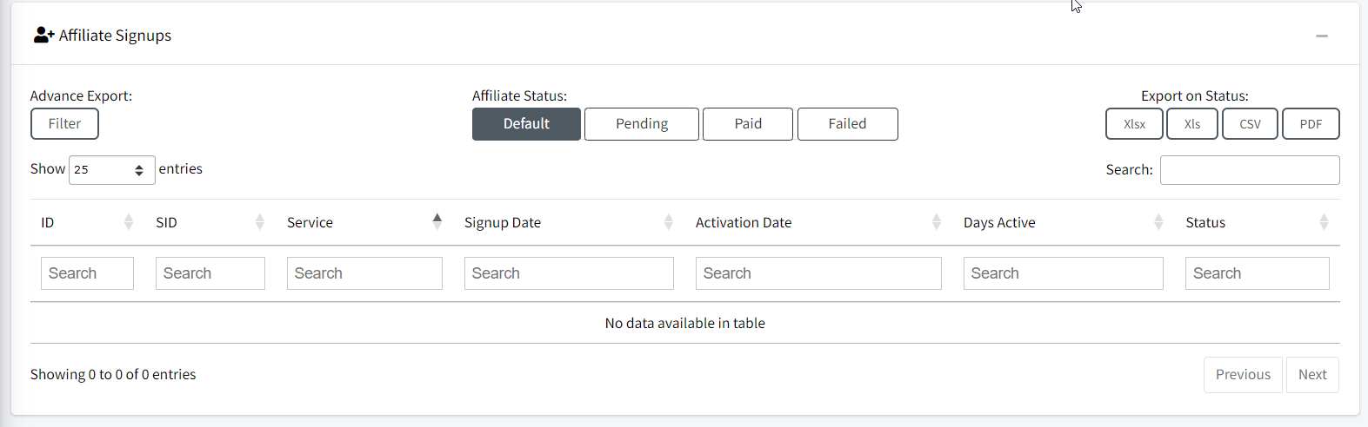

**Methods:**

Use Only 1st Methodor 2nd or 3rd Method

Use Only 1st if not work then move to third method

Use Only 2nd if not work then move to third method

Use Automatic from 1st if not work move to 2nd if not work move to third

**Method 1:**

* **Account 1: M1A1Cookes.json**
* **Account 2: M1A2Cookes.json**
* **Account 3: M1A3Cookes.json**
* **Add Account**

**Method 2:**

* **Account 1:**
* **Account 2:**
* **Account 3:**
* **Add Account**

**Method 3:**

* **Account 1:**
* **Account 2:**
* **Account 3:**
* **Add Account**