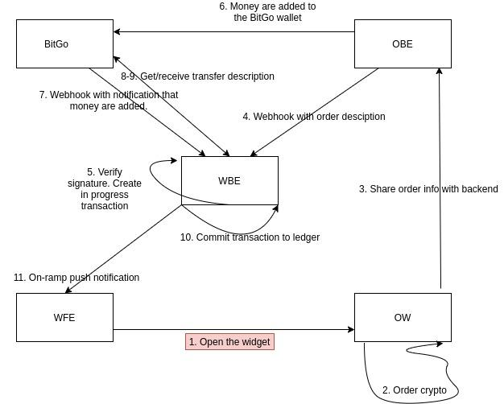

**WFE -** Wadzpay Front-End

**WBE -** Wadzpay Back-End

**OBE -** Onramper Back-End

**OW -** Onramper widget

1. **WFE**. User goes to the Deposit page and opens **OW**.

2. **OW**. User goes through necessary steps with OW and successfully buys crypto there.

3. **OW**. When point 2 is done **OW** propagates info about the order to **OBE** together with ***partnerContext.firebaseUid*** and ***txId***parameters.

4. **OBE**. Blockchain transaction from on-ramp provider wallet to WP BitGo Wallet is successfully created. **OBE** calls **WBE** endpoint via WebHook.

**OBE** puts the ***partnerContext***and ***txId***variables into the request body. Request header contains the signature which should be verified by **WBE**.

5. **WBE**. Receives WebHook from **OBE** and verifies the signature. Also creates an IN_PROGRESS transaction based on *firebaseUid*.

6. **BitGo**. Wallet receives crypto from the on-ramp provider wallet.

7. **BitGo**. Sends notification via WebHook to **WBE** with ***txId*** informing that crypto arrived to the wallet

8. **WBE.** Asks **BitGo** to get a transfer description based on the **txId.**

9. **BitGo.** Sends transfer description back to **WBE**.

10. **WBE**. **WBE** searches the transaction by ***txId,*** verifies itand commits it to the Ledger.

11. **WBE**. **WBE** sends the push notification about on-ramp transaction to **WFE**.

WBE endpoints

**WARNING** for other details about Onramper webhook please refer to [this link](https://docs.onramper.com/API-Reference/#webhooks).

Point 5 (Webhook receiver)

POST ramp/onrampOrder

Request:

Header: X-Onramper-Webhook-Signature //Signature to be verified

Body: important fields - txId, partnerContext.firebaseUid

Response:

200 - OK

401,

404

Point 7 (Webhook receiver)

POST webhook/wallet/

Request:

BitGoEvent(

Id: String

Type: transfer only

Wallet: String //Wallet id

Hash: String //Transaction hash

Coin: BTC/TBTC/ETH/TETH/USDT //Coin types

Transfer: String //Transfer id

State: BitGoState //Ideally processed

Webhook: String //Webhook id (Should match with our private webhook id)

)

Response:

200 - OK

401 - WRONG_WEBHOOK_ID

404 - ON_RAMP_TRANSACTION_NOT_FOUND, BITGO_TRANSFER_NOT_FOUND

422 - INVALID_TRANSACTION_TYPE, TRANSACTION_ALREADY_FINALIZED, WRONG_AMOUNT