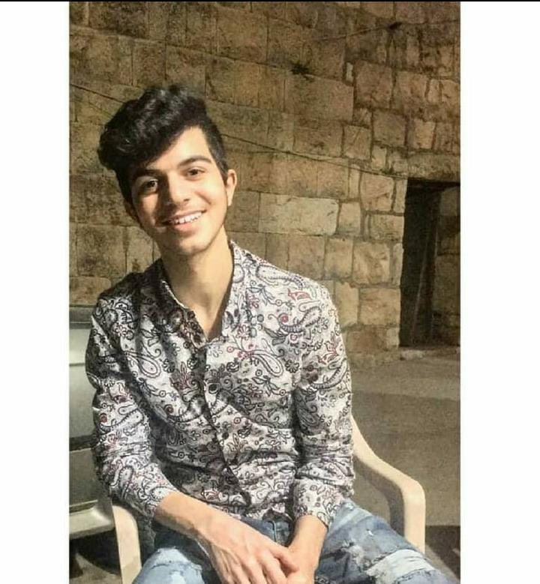

Wael Mattar | 70039327 | wael.mattar@std.balamand.edu.lb

# About me

A motivated and personable student pursuing Computer science at University Of Balamand. Eager to learn new things in the industry of computer science.

# Education

**University Of Balamand** *2021-present*amazing

# Skills

* Java
* C++
* html
* Css
* Js
* SQL
* NodeJs
* python