KinJo
  - Kindergarten & Childcare Management Platform (Jordan)
IEEE SRS + Agile Backlog (Epics, User Stories, Acceptance Criteria, Test Scenarios)
Version: 1.0
Date: 12 January 2026

Note: This document is structured for immediate requirements execution. To insert an auto Table of Contents in Word, use References -> Table of Contents; headings are already styled.

1. IEEE Software Requirements Specification (SRS)

1.1 Purpose
This Software Requirements Specification defines the functional and non-functional requirements for KinJo, an enterprise-grade kindergarten/childcare management platform tailored for Jordan. The SRS is intended to be used by product, engineering, QA, security, and stakeholders to implement, verify, and govern the solution.

1.2 Scope
KinJo supports multi-kindergarten operations for early childhood services. Core capabilities include parent onboarding, child enrollment with capacity and waitlist automation, class and staff management (including replacement assignment), attendance and check-in/out, daily child reports with managerial approval, communication and engagement features, safety and safeguarding workflows, curriculum/observations/portfolios, and governance-grade KPI dashboards with benchmarking.

Key Constraints (Non-Negotiable Business Rules)
- Child age eligibility: minimum 70 days; maximum 4 years and 8 months.
- A child cannot hold two active enrollments across different kindergartens at the same time.
- Each kindergarten must have exactly one active Kindergarten Manager.
- Each class has one active Supervisor assignment at a time; a Supervisor cannot be assigned to multiple classes concurrently.
- Managers and Supervisors belong to one kindergarten only (no multi-kindergarten assignments).
- If nationality is Jordanian: National ID is required; otherwise Passport number is required (for Parent and Mother identity fields).

1.3 Definitions, Acronyms, and Abbreviations
See Section 2 (Glossary & Abbreviations).

1.4 References
This SRS is aligned to common childcare management best practices, privacy-by-design principles, and governance reporting patterns. Legal interpretation is out of scope; KinJo must be configurable to support Jordan PDPL controls and childcare/education sector expectations.

1.5 Document Overview
Section 2 defines terminology. Section 3 provides overall product description and users. Section 4 defines system features by module with workflows, forms, fields, and validations. Section 5 defines reporting/KPIs. Section 6 defines non-functional requirements. Section 7 provides the Agile backlog (epics, user stories, acceptance criteria, test scenarios).

2. Glossary and Abbreviations

2.1 Glossary
Multi-tenant architecture | One platform serving multiple logically isolated kindergartens (tenants) securely.
Network | An operator/organization managing multiple kindergartens in KinJo.
Kindergarten (Site) | A single childcare facility operating as one tenant within KinJo.
RBAC | Role-based access control: permissions determined by role and scope.
Parent/Guardian | A legal guardian responsible for one or more children.
Enrollment application | A request to enroll a child into a kindergarten, governed by a status workflow.
Active enrollment | An accepted enrollment that is currently valid and occupies capacity.
Waitlist | A prioritized queue of eligible children awaiting capacity.
Seat offer | A time-limited offer sent to a waitlisted applicant when capacity becomes available.
Class | A group of children within a kindergarten defined by age band and capacity.
Supervisor | Staff responsible for a class; produces daily reports and executes checklists.
Replacement assignment | A temporary supervisor assignment for a class during approved leave/absence.
Daily report | Child’s daily record (arrival/leave, meals, naps, activities, notes) submitted by supervisor and approved by manager.
Attendance log | Check-in/out records used for child-days, attendance rate, and ratio monitoring.
Staff presence log | Records of staff presence used for staff-child ratio compliance.
Checklist | Scheduled tasks for safety/hygiene/environment with due time and pass/fail result.
Incident | A logged safety/health/behavior event, potentially requiring follow-up within an SLA.
Safeguarding case | A restricted protection concern case with escalation/closure SLAs and strict access controls.
Consent record | Versioned record of parent/guardian consent for a specific purpose (e.g., media sharing).
KPI | Key Performance Indicator used for governance and benchmarking.
Governance Score | Composite score (0-100) per kindergarten derived from governance indices and KPI components.

2.2 Abbreviations
PDPL | Jordan Personal Data Protection Law
KPI | Key Performance Indicator
RBAC | Role-Based Access Control
SLA | Service Level Agreement (time-bound requirement)
NPS | Net Promoter Score

3. Overall Description

3.1 Product Perspective
KinJo is a centralized platform supporting one or multiple kindergartens in Jordan. It uses a multi-tenant architecture with strict tenant data isolation and role-scoped access. Network-level reporting aggregates KPIs without granting cross-site operational access.

3.2 Product Functions (High Level)
- User and role management (Admin, Manager, Supervisor, Parent/Guardian).
- Kindergarten directory, profiles, and service catalog (e.g., extended time, waiting hour).
- Parent profile management with Jordan identity validation.
- Child enrollment applications, review/approval, capacity enforcement, and automated waitlist seat offers.
- Class setup (age bands and capacities), supervisor assignment, and controlled replacement assignments.
- Digital attendance (check-in/out), authorized pickup tracking (optional), and live ratio monitoring.
- Daily reports (supervisor submission, manager approval, parent viewing) and rich daily feed (consent-gated).
- Communication: messaging, announcements, events with RSVP and consent, and surveys/polls with satisfaction and NPS.
- Curriculum planning, observations and assessments, and child digital portfolios (consent-gated).
- Safety incidents, health alerts, safeguarding cases with SLAs and restricted access.
- Governance analytics: KPIs, dashboards, benchmarking, exports with masking and audit trails.

3.3 User Classes and Characteristics
Platform Administrator (System/Network Admin) | Manages kindergartens, global policies, reporting, integrations, and security oversight.
Kindergarten Manager | Runs a single kindergarten: approves enrollments, manages classes and supervisors, approves daily reports, runs communications, and owns site governance actions.
Supervisor | Operates a single class: submits daily reports, completes checklists, records observations, and supports communications.
Parent/Guardian | Registers, submits enrollments, receives reports/notifications, and engages via messaging/events/surveys.

3.4 Operating Environment
- Web application for Admin/Manager/Supervisor (desktop-first).
- Mobile-first web or mobile app for Parent/Guardian.
- Arabic-first UI with RTL support; English supported.
- Integration-ready for SMS/email gateways used in Jordan.

3.5 Design and Implementation Constraints
- Jordan identity rules: Jordanian requires National ID; non-Jordanian requires Passport number.
- Age eligibility hard limits (70 days to 4 years 8 months).
- No double enrollment or double staff assignments across kindergartens.
- Consent gating for media and optional sharing features.
- Strict audit logging for sensitive actions and exports.

3.6 Assumptions and Dependencies
- Each kindergarten maintains an operating calendar (open/closed days) used for expected attendance computations.
- Staff presence logs exist (manual or system-driven) to compute ratio compliance accurately.
- KPI thresholds, SLAs, and weights are configurable at Network level.

4. Specific Requirements (System Features by Module)
For each module, KinJo specifies: functions, forms (fields), workflows (states), and validation levels.
Validation levels: L1 Field, L2 Cross-field, L3 Business rule, L4 Permission, L5 Compliance/Audit.

4.1 Identity and Access Management

Functions
- Parent self-registration and login.
- Admin/Manager creation of staff accounts (Manager, Supervisor).
- Role-based access control (RBAC) with kindergarten scope enforcement.
- Optional two-factor authentication for Admin/Manager.
- Session management and login monitoring.
- Audit logging for security-relevant actions (role changes, resets, export actions).

Workflows

Account Lifecycle
- Parent: Unregistered -> Registered -> Active -> Suspended (optional).
- Staff: Created -> Activated -> Suspended -> Reactivated (optional).

Forms and Fields

Parent Registration Form
Field | Required | Validation | Notes
first_name / second_name / last_name | Yes | L1 required; length limits | Arabic and English supported.
phone_number | Yes | L1 Jordan phone format | Normalize stored format.
gender | Yes | L1 enum
nationality | Yes | L1 enum/list
national_id | No | L2 required if nationality=Jordanian | Masked by default in exports.
passport_number | No | L2 required if nationality!=Jordanian | Masked by default in exports.
home_address | Yes | L1 required | Prefer structured fields (governorate/city/area/address line).
work_address | No | L1 optional
correspondence_preference | Yes | L1 boolean | Controls announcements/notifications.

Staff Account Form (Admin/Manager)
Field | Required | Validation | Notes
full_name | Yes | L1 required
username/email | Yes | L1 format; unique
role | Yes | L1 enum | Manager or Supervisor.
kindergarten_scope | Yes | L4 scope binding | Staff belong to exactly one kindergarten.
status | Yes | L1 enum | Active/Suspended.

Validation Rules (by Level)
- L4: Staff accounts must be scoped to a single kindergarten; prevent multi-kindergarten assignment.
- L3: One active Manager per kindergarten; enforce uniqueness at all times.
- L5: Log role changes, login events, account suspensions, password resets, and export/download actions.

Key Data Attributes (Minimum)
- User.id, User.role, User.kindergarten_id (for Manager/Supervisor), User.status
- ParentProfile fields (identity, phone, addresses, preferences)
- AuditLog for security events

4.2 Kindergarten Directory, Profile, and Services

Functions
- Admin creates/updates kindergarten profiles.
- Parent searches and views kindergartens by name, location, and services.
- Manager configures service catalog (e.g., waiting hour, extended time).
- Operating hours and closures maintained for attendance expectations and reporting.

Workflows

Kindergarten Status
- Draft -> Active -> Inactive (deactivated)

Service Lifecycle
- Enabled/Disabled (immediate effect)

Forms and Fields

Kindergarten Profile Form
Field | Required | Validation | Notes
name_ar, name_en | Yes | L1 required | Arabic-first display.
location (governorate/city/area) | Yes | L1 required | Jordan administrative regions.
contact_phone, email | Yes | L1 format
operating_hours/calendar | Yes | L1 required | Used for expected attendance and closures.
status | Yes | L1 enum | Active/Inactive.

Service Form
Field | Required | Validation | Notes
service_name | Yes | L1 required | e.g., Extended Time, Waiting Hour.
description | Yes | L1 required
enabled_flag | Yes | L1 boolean
eligibility_constraints | No | L2 cross-field | Optional age band or schedule window constraints.

Validation Rules (by Level)
- L4: Only Admin or the scoped Manager can modify kindergarten services.
- L3: Enforce exactly one Manager per kindergarten (assignment rule enforced in Identity module).

Key Data Attributes (Minimum)
- Kindergarten.id, name_ar/en, location fields, contacts, operating calendar
- KindergartenService.service_name, enabled_flag, constraints

4.3 Child Profiles and Enrollment Applications

Functions
- Parent or Manager creates child profile and enrollment application.
- Manager reviews applications and accepts/rejects with reasons.
- System enforces age eligibility and prevents duplicate active enrollments across kindergartens.
- If accepted but no capacity: system places child on waitlist.

Workflows

Enrollment Application Workflow
- Draft -> Submitted -> Pending Review -> Accepted OR Rejected OR Withdrawn.
- Accepted (no capacity) -> Waitlisted.
- Accepted (capacity available) -> Active Enrollment.

Forms and Fields

Child Enrollment Form (repeatable per child)
Field | Required | Validation | Notes
child_first_name, child_last_name | Yes | L1 required
gender | Yes | L1 enum
date_of_birth | Yes | L1 date | Age calculated automatically.
father_name | Yes | L1 required | May be auto-filled from parent profile (policy).
mother_first/second/last_name | Yes | L1 required
mother_nationality | Yes | L1
mother_national_id | No | L2 required if mother_nationality=Jordanian | Masked by default in exports.
mother_passport_number | No | L2 required if mother_nationality!=Jordanian | Masked by default in exports.
correspondence_flag | Yes | L1 boolean | Eligible to receive announcements/notifications.
selected_kindergarten | Yes | L4 scope check | Managers can submit only for their kindergarten.
enrollment_source | Yes | L1 enum | online/walk-in/manager

Validation Rules (by Level)
- L3: Age eligibility hard rule: 70 days <= age <= 4 years 8 months.
- L3: Prevent a child from holding two active enrollments across kindergartens.
- L1/L2: Identity rules for Parent and Mother: Jordanian requires National ID; non-Jordanian requires Passport number.
- L4: Parents may create applications only for their own children; Managers only within their kindergarten scope.
- L5: Audit acceptance/rejection decisions and reason codes.

Key Data Attributes (Minimum)
- Child (identity, DOB, derived age, father/mother details)
- EnrollmentApplication.status, status_reason, source, submitted_at, decision_by, decision_at

4.4 Capacity, Eligibility Engine, and Waitlist

Functions
- Define class capacities and age-band eligibility.
- Place eligible applicants on waitlist when capacity is full.
- Apply configurable priority rules (siblings, staff child, application date).
- Auto-offer seats when capacity opens, with offer expiry timers.
- Allow parent to accept/decline offers; auto-advance if expired.

Workflows

Waitlist Workflow
- Waitlisted -> Offered (offer_expiry_at set) -> Accepted OR Declined OR Expired.
- Expired/Declined -> Next candidate Offered automatically (when enabled).

Forms and Fields

Class Capacity and Age Band Form
Field | Required | Validation | Notes
capacity_total | Yes | L1 integer >= 1 | Hard capacity limit.
min_age_months | Yes | L1 integer | Eligibility lower bound.
max_age_months | Yes | L2 must be >= min_age_months | Eligibility upper bound.

Waitlist Configuration (Network/Kindergarten Policy)
Field | Required | Validation | Notes
priority_rules | Yes | L1 list | Order/weights configurable.
offer_expiry_hours | Yes | L1 integer | Seat offer expiry timer.

Validation Rules (by Level)
- L3: Do not allow accepting beyond class capacity_total.
- L3: Enforce age-band eligibility before offering a seat.
- L3: Enforce offer expiry; expired offers cannot be accepted.
- L4: Only Manager/Admin can reorder/override waitlist; override must be audited.
- L5: Audit seat offers, expirations, acceptances, and overrides.

Key Data Attributes (Minimum)
- Class.capacity_total, min_age_months, max_age_months
- WaitlistEntry.status, priority_score, offer_expiry_at
- Enrollment.status_reason (e.g., no_capacity, ineligible)

4.5 Attendance (Check-in/out) and Live Ratio Monitoring

Functions
- Digital check-in/out using PIN, QR, or kiosk (configurable by kindergarten).
- Record who dropped off and picked up the child (optional authorized pickup policy).
- Generate child-days attended and expected attendance for KPIs.
- Capture staff presence logs for ratio calculations.
- Compute and alert on staff-child ratio compliance in near real time.

Workflows

Attendance Lifecycle (per day)
- Checked-in -> Checked-out (optional: missing checkout flagged).

Forms and Fields

Attendance Log (system-generated)
Field | Required | Validation | Notes
check_in_at | Yes | L1 datetime
check_out_at | No | L2 must be after check_in_at | May be required by policy by end of day.
method | Yes | L1 enum | PIN/QR/Kiosk
dropped_by_name | No | L1 | Optional but recommended.
picked_by_name | No | L1 | Optional but recommended.

Staff Presence Log
Field | Required | Validation | Notes
start_at, end_at | Yes | L2 end_at after start_at | Used for ratio compliance.

Validation Rules (by Level)
- L2: Time ordering: checkout must be after checkin; staff presence end after start.
- L3: Attendance allowed only for children with active enrollment at that kindergarten.
- L3: Ratio compliance computed only within operating minutes (calendar-aware).
- L4: Parents can view only their child attendance; staff view is scope-limited.
- L5: Exports masked by default; all exports logged.

Key Data Attributes (Minimum)
- AttendanceLog (child_id, date, check_in/out, method)
- StaffPresenceLog (staff_id, time window)
- RatioCompliance rollups (minutes_compliant, minutes_operating)

4.6 Daily Reports and Parent Daily Feed

Functions
- Supervisor creates and submits one daily report per child per date.
- Manager reviews and approves (or returns for edit).
- Parents view approved reports only.
- Nap duration calculated automatically from nap start/end.
- Rich daily feed aggregates meals, naps, activities, notes, and optional photos (consent-gated).

Workflows

Daily Report Workflow
- Draft -> Submitted -> Approved OR Returned for edits.
- Approved -> Visible to Parent.

Forms and Fields

Daily Report Form
Field | Required | Validation | Notes
arrival_time, leave_time | Yes | L2 arrival <= leave
meals (breakfast/snack/milk/lunch) | No | L1 structured fields | Extendable list.
nap_start, nap_end | No | L2 nap_end >= nap_start | nap_duration auto-calculated.
activities | No | L1 | Prefer structured tags + optional notes.
notes | No | L1 length limit | Use categories; minimize free text.
media_attachments | No | L5 consent-gated | Blocked if no media consent.

Validation Rules (by Level)
- L3: Enforce one report per child per date (uniqueness).
- L2: Time ordering for arrival/leave and nap.
- L4: Supervisors can submit only for children in their assigned class.
- L5: Media attachment requires active media consent; approvals and edits must be audited.

Key Data Attributes (Minimum)
- DailyReport.status, approved_by, approved_at
- Derived nap_duration_minutes
- Consent flags (media consent)

4.7 Communication, Events, and Surveys

Functions
- Two-way messaging: direct parent-staff, class groups, broadcast announcements.
- Attachments supported (policy-controlled).
- Events calendar with RSVP and reminders; events may require consent (e.g., trips).
- Surveys and polls for satisfaction; include NPS-style question.
- Optional Arabic-English message translation support (store translated text for convenience).

Workflows

Event Workflow
- Draft -> Published -> RSVP Open -> Completed/Closed.

Survey Workflow
- Draft -> Active -> Closed -> Results Published (optional).

Forms and Fields

Message
Field | Required | Validation | Notes
thread_type | Yes | L1 enum | direct/class/broadcast
message_body | Yes | L1 required | Arabic-first supported.
media_attachments | No | L5 consent-gated | Blocked if no media consent.

Event
Field | Required | Validation | Notes
type | Yes | L1 enum | trip/meeting/holiday
start_at, end_at | Yes | L2 end>=start
requires_consent_flag | Yes | L1 boolean | If true, RSVP yes requires consent.

Survey
Field | Required | Validation | Notes
dimensions | Yes | L1 list | safety/communication/learning/cleanliness
nps_question_enabled | Yes | L1 boolean

Validation Rules (by Level)
- L4: Parent messaging scope limited to their child’s kindergarten context.
- L5: Consent enforcement for trip events and media attachments.
- L5: Announcements and messaging exports must be audited.

Key Data Attributes (Minimum)
- Message.thread_type, translated_text (optional), media_ids
- Event.requires_consent_flag, RSVP status
- SurveyResult.dimension, score, NPS fields

4.8 Curriculum, Observations, and Digital Portfolios

Functions
- Define curriculum plans (term/weekly/daily) linked to learning domains.
- Record observations and assessments mapped to outcomes and age bands.
- Build and publish digital portfolios from observations and media evidence.
- Track parent views and export portfolio summaries (policy-controlled).

Workflows

Portfolio Workflow
- Draft -> Published -> Archived (optional)

Forms and Fields

Observation
Field | Required | Validation | Notes
domain | Yes | L1 enum | social-emotional/physical/cognitive/language
linked_outcomes | No | L1 list | Outcome codes.
outcome_mastery_level | No | L1 enum | on-track/needs-support/etc.
evidence_media | No | L5 consent-gated | Media requires consent.

Validation Rules (by Level)
- L4: Supervisors can record observations only for children in their class.
- L5: Portfolio publishing respects consent; exports logged.

Key Data Attributes (Minimum)
- CurriculumOutcome.domain, age_band, indicator_code
- Observation.linked_outcomes, mastery_level
- Portfolio.status, parent_viewed_at

4.9 Safety, Health Alerts, Incidents, and Safeguarding

Functions
- Record incidents with type and severity; track parent notification time.
- Generate required follow-up steps with SLAs; monitor closure within SLA.
- Record health alerts (allergies, chronic conditions) with stricter access.
- Manage safeguarding cases with restricted access and escalation/closure SLAs.
- Provide governance-safe rollups while restricting case details.

Workflows

Incident Workflow
- Opened -> Follow-up required (optional) -> Closed

Safeguarding Case Workflow (Restricted)
- Opened -> Escalated -> Closed

Forms and Fields

Incident
Field | Required | Validation | Notes
type | Yes | L1 enum | injury/behavior/illness/other
severity_level | Yes | L1 enum | low/medium/high/critical
occurred_at | Yes | L1 datetime
notify_parent_at | No | L1 datetime | Used for time-to-notify KPI.
followup_required_flag | Yes | L1 boolean | Creates SLA if true.

Validation Rules (by Level)
- L4: Safeguarding case details accessible only to authorized roles; strict logging required.
- L3: If follow-up is required, SLA deadline must be defined and tracked.
- L5: All views/exports of safeguarding data must be audited with higher sensitivity.

Key Data Attributes (Minimum)
- Incident.severity_level, notify_parent_at, followup SLA fields
- SafeguardingCase.opened/escalated/closed timestamps, SLA flags

5. Governance KPIs and Reporting Requirements
KinJo reporting must support multi-level dashboards (Network -> Region -> Kindergarten -> Class -> Child (restricted)) with benchmarking (median/quartiles) and Red-Amber-Green banding. KPIs must be defined in a single catalog with formula, inputs, exclusions, and refresh cadence.

5.1 Standard Units
- Child-day attended: a child attended any part of a day (derived from attendance logs).
- Expected child-day: a child is expected to attend based on active enrollment and operating calendar.
- Operating minutes: minutes a site/class is scheduled open.
- Compliant minutes: operating minutes where staff-child ratio meets policy.

5.2 Global Exclusions (Apply to All KPIs)
- Test/demo records; voided/deleted/superseded records.
- Days when kindergarten is officially closed.
- Records outside the reporting period.
- Cross-tenant data (must never appear).

5.3 KPI Catalog (Governance Set)
KPI | Definition / Formula (Plain Language) | Required Inputs | Key Exclusions | Refresh | Notes
Incident rate per 100 child-days | (All incidents in period / total child-days attended) x 100 | Incidents; Attendance child-days | Test/voided; out-of-period; closures | Daily + monthly snapshot | Use child-days (not headcount) to compare across sizes.
Serious incident rate per 100 child-days | (High/critical incidents / total child-days attended) x 100 | Incidents with severity; Attendance child-days | Exclude minor incidents unless reclassified | Daily (alert-capable) | High severity: hospital, serious injury, protection concern.
Checklist compliance % | (Required checks completed on time and passed / required checks) x 100 | Checklists required/completed/pass | Exclude optional; late; failed | Near real-time + daily rollup | Supports safety/hygiene/environment categories.
Regulatory compliance status | License validity + open findings + avg closure time (graded) | License status; inspection findings | Informational-only findings | Daily | Regulatory breaches override green bands.
Staff-child ratio compliance % | (Compliant operating minutes / total operating minutes) x 100 | Attendance counts; staff presence; operating calendar; ratio policy | Closed time; authorized override window | Near real-time + daily rollup | Compute for site and class.
Training/qualification coverage % | (Staff compliant with required trainings / active staff) x 100 | Training records; staff active list | Optional trainings; policy-based leave exclusions | Daily | Includes safeguarding/first aid/H&S.
Staff turnover rate % | (Staff exits in period / avg headcount) x 100 | Staff start/end; exit events | Policy: exclude planned temporary ends | Monthly | Track avg tenure in parallel.
Attendance rate % | (Child-days attended / expected child-days) x 100 | Enrollment dates; operating calendar; attendance logs | Closures; out-of-enrollment days | Daily | Also compute per child and per class.
Chronic absence % | (Children with absence >= threshold / active children) x 100 | Child attendance rates; active children | Policy: minimum expected days required | Monthly | Default threshold 10-15% missed (configurable).
Incident follow-up within SLA % | (Incidents closed within SLA / incidents requiring follow-up) x 100 | Incident SLA fields; closure timestamps | Incidents with no follow-up requirement | Daily | Supports governance discipline.
Safeguarding handling time (restricted) | Avg days to escalate/close; % within SLA | Safeguarding timestamps; SLA policy | Restricted access; aggregate only by default | Daily (restricted) | Details visible only to authorized roles.
Parent engagement index (0-100) | Composite of logins, report views, message interactions, event participation | Engagement events; activity timestamps | System-generated; duplicates/debounced | Daily + monthly snapshot | Weights configurable.
Parent satisfaction & NPS | Dimension averages; NPS = %promoters - %detractors | Survey results | Incomplete/test surveys | On survey close + periodic rollup | At least annual; recommended quarterly.
Complaint resolution time | Median days to resolve; % resolved within SLA | Complaint opened/closed; SLA | Withdrawn/merged duplicates (policy) | Daily + monthly summary | Supports accountability.

5.4 Composite Indices and Governance Score
- Governance Quality Index (GQI): weighted mix of ratio compliance, checklist compliance, regulatory status, training coverage, and incident follow-up SLA.
- Child Experience Index (CEI): weighted mix of attendance, chronic absence, serious incidents, and parent satisfaction.
- Final Governance Score (0-100): derived from GQI plus selected CEI components; weights configurable; component breakdown must always be visible.

6. Non-Functional Requirements

6.1 Security and Privacy
- Tenant data isolation between kindergartens; cross-tenant access is forbidden.
- Encryption in transit and at rest.
- Least privilege RBAC; restricted roles for safeguarding and sensitive health data.
- Audit logs for: role changes, enrollment decisions, supervisor assignment changes, daily report approvals, exports/downloads, safeguarding access.
- Consent gating for media sharing and optional processing; exports masked by default for National IDs and passports.

6.2 Performance and Scalability
- Responsive performance during peak check-in/out windows.
- Support large networks (many kindergartens) with benchmarking dashboards.
- Reporting aggregates refreshed per defined cadence without blocking operational workflows.

6.3 Reliability and Data Integrity
- Strong integrity for capacity, enrollments, and assignments (no double enrollment, no double assignment).
- Idempotent handling of attendance events to avoid duplicates.
- Monthly KPI snapshots must be immutable for audit comparisons.

6.4 Usability and Localization
- Arabic-first UI with RTL support; English supported.
- Mobile-first parent experience; clear validation messages and guided forms.
- Accessibility considerations (readability, touch targets) for parent workflows.

7. Agile Backlog (Epics -> User Stories -> Acceptance Criteria -> Test Scenarios)
Backlog is organized by module-aligned epics. Each user story includes acceptance criteria and test scenarios.

Epic E1: Identity and Access - US-1

User Story
As a Parent/Guardian, I want to register with Jordan-valid identity information and login securely, so that I can enroll my children and receive communications.

Acceptance Criteria
- Registration requires names, phone, nationality, gender, home address, and correspondence preference.
- If nationality is Jordanian, National ID is required; otherwise Passport number is required.
- Invalid Jordan phone formats are rejected with clear error messages.
- Successful registration creates an active parent account and profile.

Test Scenarios
- Register with Jordanian nationality and missing National ID -> validation error.
- Register with non-Jordanian nationality and missing passport -> validation error.
- Register with invalid phone format -> validation error.
- Register with valid inputs -> account created; login succeeds.

Epic E1: Identity and Access - US-2

User Story
As a Platform Administrator, I want to create staff accounts and assign roles with correct scope, so that each staff member can access only their kindergarten.

Acceptance Criteria
- Admin can create Manager and Supervisor accounts.
- Staff accounts must be bound to exactly one kindergarten scope.
- System prevents assigning the same Manager to two kindergartens at the same time.
- All role changes and scope changes are logged.

Test Scenarios
- Assign one manager to two kindergartens -> system blocks.
- Create supervisor without kindergarten scope -> system blocks.
- Change role/scope -> audit entry created.

Epic E2: Kindergarten Directory and Services - US-3

User Story
As a Parent/Guardian, I want to search kindergartens by name, location, and services, so that I can choose the best option for my family.

Acceptance Criteria
- Search filters include name, governorate/city/area, and enabled services.
- Only active kindergartens appear in results.
- Service list is visible on kindergarten profile.

Test Scenarios
- Search by location returns only matching kindergartens.
- Inactive kindergarten does not appear.
- Service enabled/disabled updates are reflected in parent view.

Epic E2: Kindergarten Directory and Services - US-4

User Story
As a Kindergarten Manager, I want to configure kindergarten services (extended time, waiting hour), so that parents see accurate offerings during enrollment.

Acceptance Criteria
- Manager can enable/disable services for their kindergarten only.
- Changes are reflected immediately in parent-facing views.
- Service changes are audited.

Test Scenarios
- Manager tries to edit services for another kindergarten -> denied.
- Enable service -> appears in search filter and profile display.
- Audit log created on service update.

Epic E3: Enrollment and Eligibility - US-5

User Story
As a Parent/Guardian, I want to submit enrollment applications for one or more children, so that my children can be considered for admission.

Acceptance Criteria
- Parent can create multiple child applications in one session.
- Each child must pass age eligibility: 70 days to 4 years 8 months.
- Mother nationality requires National ID if Jordanian, else passport.
- Application status becomes Submitted/Pending and parent receives confirmation.

Test Scenarios
- Submit child DOB outside age range -> blocked with reason.
- Submit multiple children; one valid and one invalid -> valid saved; invalid rejected.
- Mother Jordanian without National ID -> blocked.

Epic E3: Enrollment and Eligibility - US-6

User Story
As a Kindergarten Manager, I want to accept or reject enrollment applications with standardized reasons, so that decisions are traceable and parents are informed.

Acceptance Criteria
- Manager can accept or reject Pending applications for their kindergarten.
- Rejected applications require a reason code.
- Parents are notified of decision and reason.
- Decision actions are audited.

Test Scenarios
- Reject without reason -> system blocks.
- Accept application -> creates active enrollment if capacity available.
- Decision -> notification sent; audit entry created.

Epic E4: Capacity and Waitlist - US-7

User Story
As a Kindergarten Manager, I want to manage waitlist priority and let the system auto-offer seats, so that capacity openings are filled quickly and fairly.

Acceptance Criteria
- If capacity is full, accepted applicants become Waitlisted.
- Waitlist ordering follows configured priority rules.
- When a seat becomes available, system generates a seat offer with expiry time.
- If an offer expires or is declined, system offers the next candidate.

Test Scenarios
- Capacity full -> accepted applicant becomes waitlisted.
- Seat opens -> offer created with correct expiry.
- Offer expires -> next candidate offered automatically.

Epic E4: Capacity and Waitlist - US-8

User Story
As a Parent/Guardian, I want to accept a seat offer before it expires, so that my child can secure enrollment.

Acceptance Criteria
- Parent can view offers and expiry time.
- Accepting before expiry activates enrollment (or moves to ready-for-class-assignment per policy).
- Accepting after expiry is blocked with clear messaging.

Test Scenarios
- Accept offer within expiry -> enrollment active.
- Attempt accept after expiry -> blocked.

Epic E5: Classes and Staff Assignments - US-9

User Story
As a Kindergarten Manager, I want to create classes with age bands and capacity and assign supervisors, so that operations are organized and compliance is enforceable.

Acceptance Criteria
- Class requires capacity_total and min/max age months.
- System enforces one active supervisor per class at a time.
- System prevents a supervisor from being assigned to two classes concurrently.
- All assignments are audited.

Test Scenarios
- Create class with max_age < min_age -> blocked.
- Assign supervisor to two classes with overlapping dates -> blocked.
- Assignment change -> audit created.

Epic E5: Classes and Staff Assignments - US-10

User Story
As a Kindergarten Manager, I want to assign a replacement supervisor during approved leave, so that the class continues safely with accountable supervision.

Acceptance Criteria
- Replacement supervisor must be registered in the same kindergarten.
- Replacement assignment requires start and end dates and auto-expires.
- Replacement cannot overlap with another class assignment.
- All replacement actions are audited.

Test Scenarios
- Assign replacement without end date -> blocked.
- Replacement overlaps another assignment -> blocked.
- Replacement expires -> class returns to primary supervisor; logged.

Epic E6: Attendance and Ratio Monitoring - US-11

User Story
As a Parent/Guardian, I want to check my child in and out using configured methods (PIN/QR/kiosk), so that attendance is recorded accurately.

Acceptance Criteria
- Check-in records timestamp and method.
- Check-out time must be after check-in time.
- Attendance is available for active enrollments only.

Test Scenarios
- Check-out earlier than check-in -> blocked.
- Attendance attempt for inactive enrollment -> blocked.
- Valid check-in/out -> attendance record saved.

Epic E6: Attendance and Ratio Monitoring - US-12

User Story
As a Kindergarten Manager, I want to monitor staff-child ratio compliance and receive alerts when at risk, so that I can prevent governance failures.

Acceptance Criteria
- Ratio compliance computed from attendance counts and staff presence during operating minutes.
- System highlights non-compliant windows for investigation.
- Alerts triggered according to configurable thresholds.

Test Scenarios
- During operating hours, reduce staff presence -> ratio non-compliance detected.
- Non-operating hours -> ratio not computed.
- Alert triggered when threshold crossed.

Epic E7: Daily Reports and Feed - US-13

User Story
As a Supervisor, I want to create and submit one daily report per child per day, so that parents receive consistent daily updates.

Acceptance Criteria
- System enforces one report per child per date.
- Nap duration is calculated automatically when nap start/end provided.
- Arrival time must be <= leave time; nap end >= nap start.
- Submitted reports are pending manager approval.

Test Scenarios
- Create second report for same child/date -> blocked.
- Invalid time ordering -> blocked.
- Valid report -> submitted and visible to manager for review.

Epic E7: Daily Reports and Feed - US-14

User Story
As a Kindergarten Manager, I want to approve daily reports before parents can view them, so that parents see verified information.

Acceptance Criteria
- Only approved reports are visible to parents.
- Returned reports require supervisor edits before approval.
- Approvals and returns are audited.

Test Scenarios
- Parent attempts to view submitted-but-not-approved report -> not visible.
- Manager approves -> parent can view.
- Manager returns -> supervisor sees required edits.

Epic E8: Communication, Events, and Surveys - US-15

User Story
As a Parent/Guardian, I want to message staff and receive announcements, so that I can stay informed and engaged.

Acceptance Criteria
- Parent can message only within their child’s kindergarten context.
- Broadcast announcements appear in parent feed/notifications.
- Attachments are allowed only per policy and consent.

Test Scenarios
- Parent tries to message staff outside their kindergarten -> blocked.
- Announcement published -> appears for all parents in scope.
- Attachment added without consent -> blocked.

Epic E8: Communication, Events, and Surveys - US-16

User Story
As a Kindergarten Manager, I want to create a trip event that requires consent and track RSVPs, so that participation is safe and documented.

Acceptance Criteria
- Event requires start/end and type.
- If requires_consent_flag is true, RSVP Yes requires consent.
- RSVP report shows counts and non-responders.

Test Scenarios
- RSVP yes without consent -> blocked.
- RSVP yes with consent -> recorded.
- Event summary shows RSVP counts.

Epic E9: Curriculum and Portfolios - US-17

User Story
As a Supervisor, I want to record observations linked to curriculum outcomes, so that child development progress is tracked systematically.

Acceptance Criteria
- Observation requires domain and child reference.
- Optional linkage to outcome indicators and mastery level.
- Evidence media requires consent if enabled.

Test Scenarios
- Create observation without domain -> blocked.
- Attach media without consent -> blocked.
- Valid observation -> appears in portfolio draft.

Epic E9: Curriculum and Portfolios - US-18

User Story
As a Parent/Guardian, I want to view a published portfolio for my child, so that I can understand my child’s progress over time.

Acceptance Criteria
- Only published portfolio items are visible to parents.
- Parents can view only their own child portfolios.
- Parent views are tracked for engagement reporting.

Test Scenarios
- Parent tries to view another child portfolio -> blocked.
- Publish portfolio -> visible to parent.
- Viewing updates parent_viewed_at.

Epic E10: Safety and Safeguarding - US-19

User Story
As a Kindergarten Manager, I want to record incidents with severity, notify parents, and track follow-up SLAs, so that safety issues are handled consistently and on time.

Acceptance Criteria
- Incident requires type, severity, and occurred time.
- Parent notification timestamp can be recorded.
- If follow-up is required, SLA deadline is created and tracked.
- Incidents contribute to KPI rollups.

Test Scenarios
- Create incident without severity -> blocked.
- Follow-up required but no SLA -> blocked.
- Close incident within SLA -> reflected in KPI follow-up completion.

Epic E10: Safety and Safeguarding - US-20

User Story
As a Authorized Safeguarding Role, I want to manage safeguarding cases with restricted access and SLA tracking, so that protection concerns are handled securely and quickly.

Acceptance Criteria
- Safeguarding case details visible only to authorized roles.
- Escalation and closure timestamps are tracked.
- All access and edits are logged with elevated audit level.
- Dashboards show aggregated counts by default.

Test Scenarios
- Unauthorized user attempts access -> denied and logged.
- Authorized user updates escalation -> timestamps updated.
- Aggregated KPI view visible without exposing details.

Epic E11: Governance KPIs and Dashboards - US-21

User Story
As a Platform Administrator, I want to benchmark kindergartens using standardized governance KPIs and quartile bands, so that I can prioritize interventions and track improvement.

Acceptance Criteria
- Dashboard supports network median and quartile benchmarks.
- Red/Amber/Green bands computed consistently per period.
- Regulatory non-compliance overrides green banding.
- Monthly snapshots are immutable.

Test Scenarios
- Compare kindergartens -> ranks and quartiles shown.
- License invalid -> kindergarten cannot appear as green.
- Monthly snapshot locked -> values do not change after close.

Epic E11: Governance KPIs and Dashboards - US-22

User Story
As a Kindergarten Manager, I want to drill down from KPI tiles to evidence (incidents, checklists, ratio windows, complaints), so that I can investigate root causes and take corrective action.

Acceptance Criteria
- Each KPI tile links to filtered evidence lists for the same period and scope.
- Evidence views respect permissions and masking policies.
- Exports are masked by default and logged.

Test Scenarios
- Drill down from ratio compliance -> show non-compliant windows.
- Export evidence -> masked IDs and audit log created.
- Restricted data remains hidden for unauthorized roles.

Appendix A. Visual Models
The diagrams below are reference models to support requirements validation and stakeholder alignment. They are intentionally technology-agnostic and should be refined during solution design.

A1. Enrollment, Capacity & Waitlist Flow
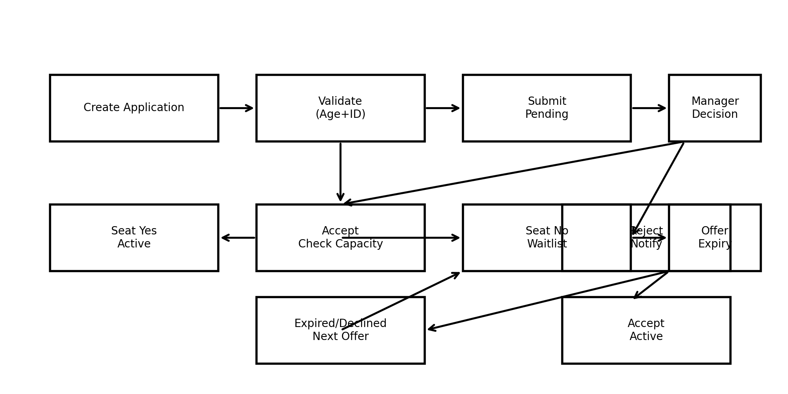
Figure: A1. Enrollment, Capacity & Waitlist Flow

A2. High-Level Use Case Diagram
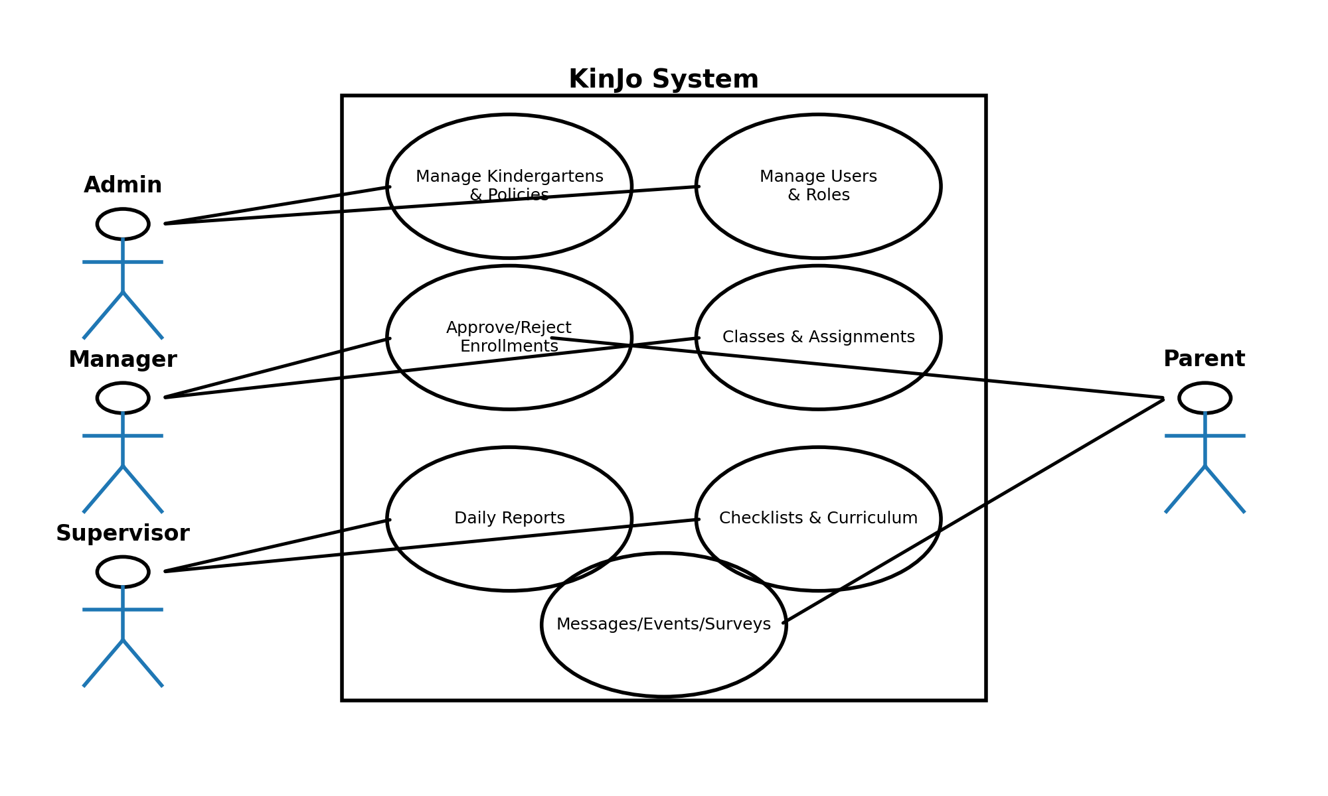
Figure: A2. High-Level Use Case Diagram

A3. Reference Architecture (Logical)
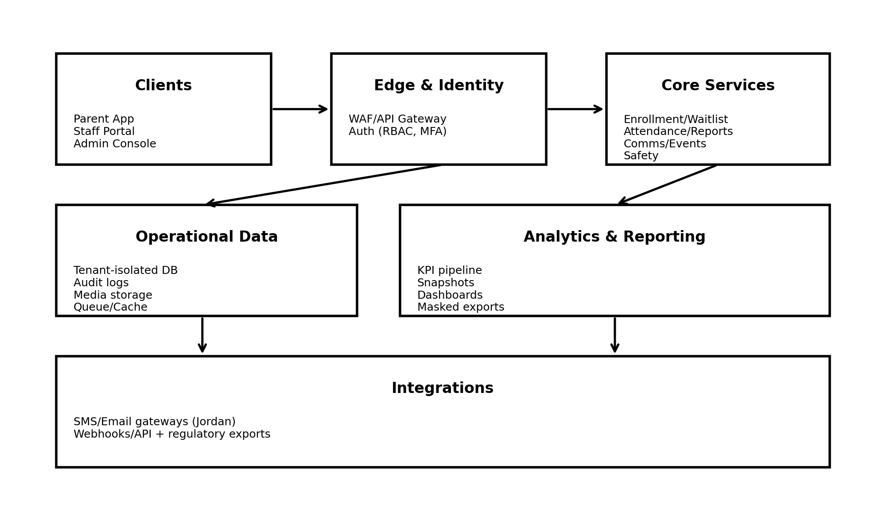
Figure: A3. Reference Architecture (Logical)

A4. Website / Portal Sitemap
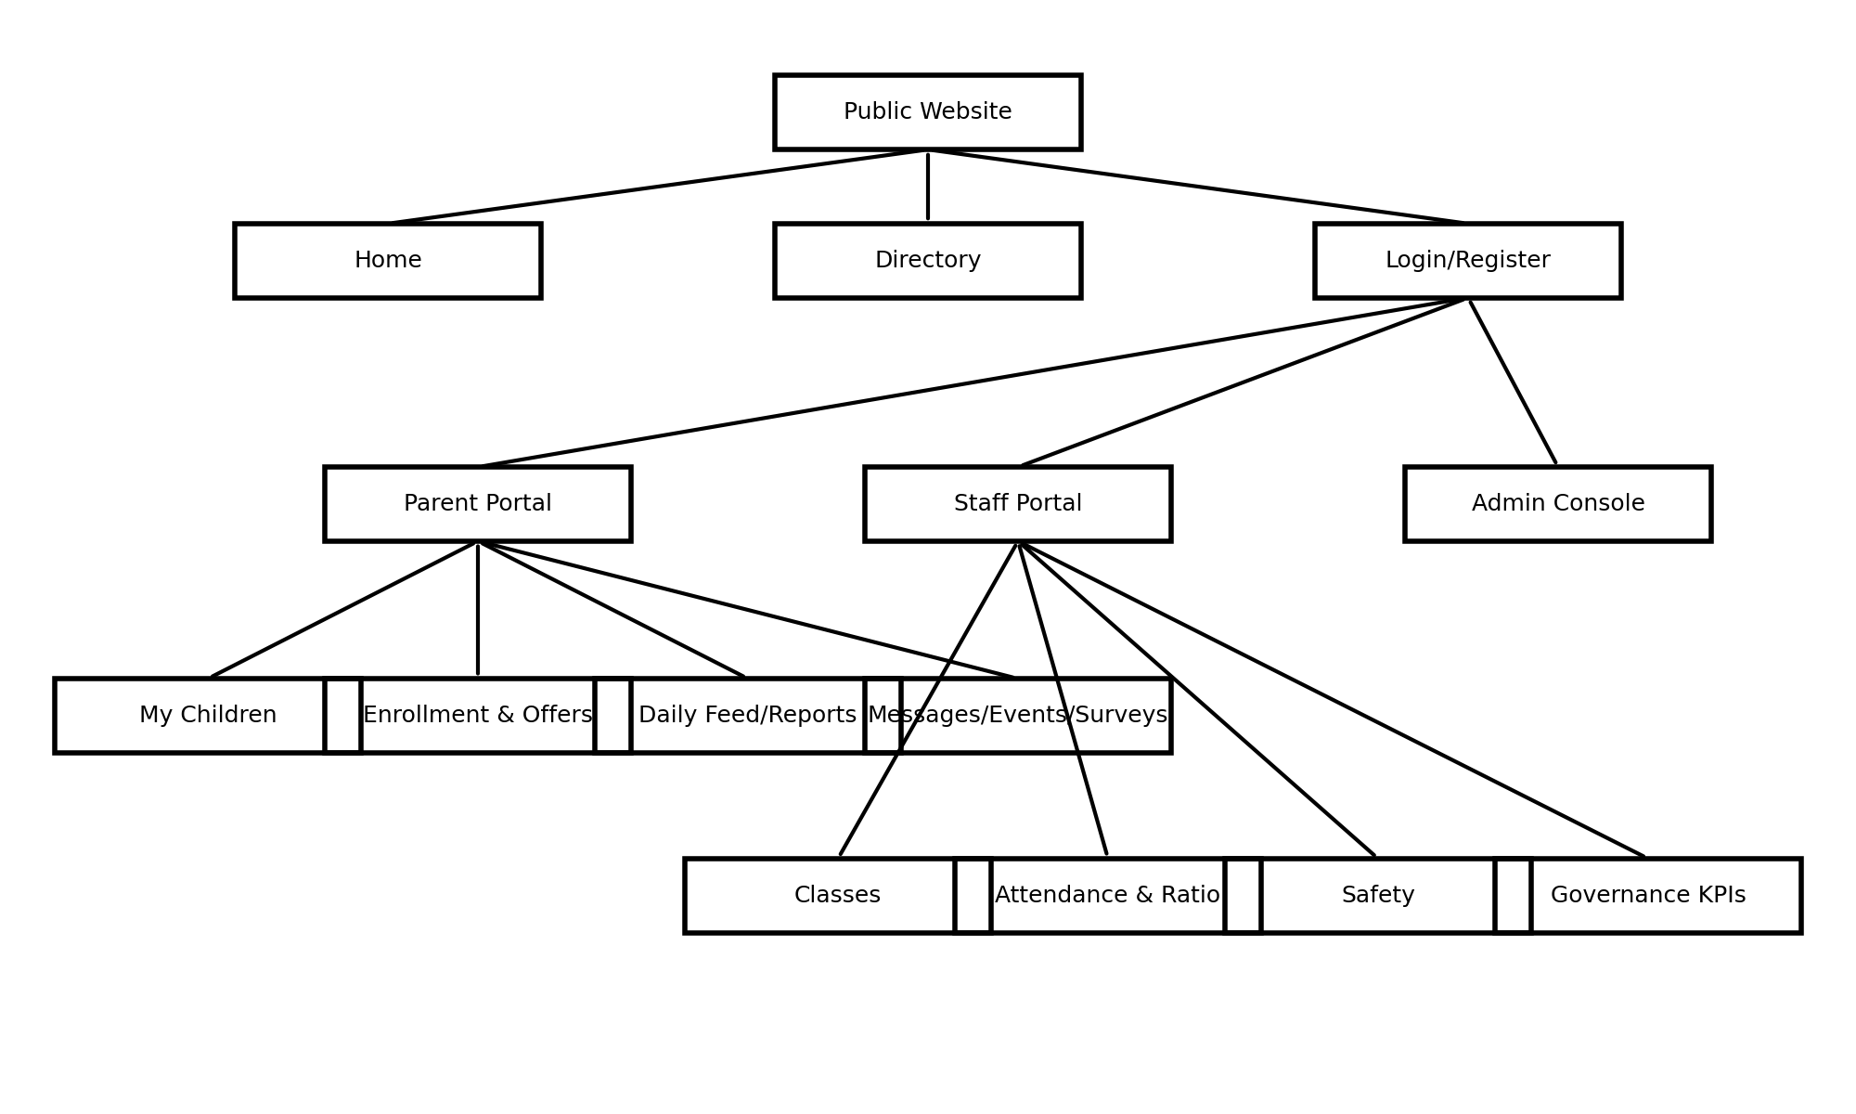
Figure: A4. Website / Portal Sitemap

Appendix B. Deep Audit Notes & Enhancements (Ready for Requirements Workshops)

B1. Terminology & Consistency Fixes
- Use “Tenant” (Kindergarten/Site) consistently; avoid mixing with “Tenancy”.
- Use “Parent/Guardian” consistently (legal guardian), and avoid “forum” — use “form”.
- Use “Child” consistently; avoid “childeren”.
- Use “Supervisor” as the class lead; if teacher roles are later added, define them explicitly.

B2. Gaps to Confirm in Workshops
- Authorized pickup: whether to store approved pickup persons and require selection at checkout.
- Operating calendar: weekends, holidays, emergency closures, makeup days; expected attendance rules.
- Ratio policy: legal/internal ratio by age band; whether ratio is computed at site-level, class-level, or both.
- Media consent types: internal-only vs parent-visible, and whether consent can be child-specific vs global per parent.
- Incident severity taxonomy: define a Jordan-aligned severity catalog and mandatory fields per severity.
- Safeguarding workflow: escalation contacts and evidence handling; strict least-privilege roles.

B3. Low-Manual-Effort Platform Enhancements (Automation)
- Auto-validation and guided forms (Jordan ID rules, age eligibility) to reduce manual back-and-forth.
- Automated seat-offer engine with expiry timers and notifications to minimize manager workload.
- Auto-generated checklists (daily/weekly) with reminders and overdue escalation.
- Auto KPI snapshots (monthly) with immutable history for governance audits.
- Policy-driven masking and export approvals for sensitive data.

8. Deep Audit Enhancements Addendum (Jordan + Best Practices)
This addendum incorporates identified gaps and strengthens KinJo to be enterprise-grade, Jordan-aligned, and requirements-workshop ready. Items below are written as normative requirements.

8.1 Document Governance (Revision History, Sign-off, Traceability)

8.1.1 Revision History
Version | Date | Author/Owner | Change Summary
1.0 | 2026-01-12 | Wael Alzyadat / Product | Initial SRS + backlog baseline.
1.1 | 2026-01-13 | Wael Alzyadat / Product | Added diagrams + audit appendix.
1.2 | 2026-01-13 | Wael Alzyadat / Product | Deep audit enhancements: compliance, IAM hardening, health, pickup, RTM, MoSCoW, KPI thresholds, NFR SLAs.

8.1.2 Acceptance & Sign-off
Sign-off confirms readiness to proceed to the formal requirements phase.
Role | Name | Signature | Date
Product Owner
Technical Lead / Architect
QA Lead
Security/Privacy Lead (PDPL)
Kindergarten Operations Representative

8.1.3 Requirements Traceability Matrix (RTM)
RTM maps Requirement IDs (SRS) → User Stories (Backlog) → Test Scenarios (QA).
Req ID | Requirement Title | Module | Priority | User Stories | Test Scenarios | Status
REQ-IAM-01 | Jordan ID rule validation (National ID vs Passport) | Identity | Must | US-1 | TS-IAM-01
REQ-ENR-01 | Age eligibility 70 days–4y8m enforced | Enrollment | Must | US-5 | TS-ENR-01
REQ-ENR-02 | No double active enrollment across kindergartens | Enrollment | Must | US-5, US-6 | TS-ENR-02
REQ-WL-01 | Auto seat offers with expiry timers | Waitlist | Must | US-7, US-8 | TS-WL-01
REQ-ATT-01 | Check-in/out time validation | Attendance | Must | US-11 | TS-ATT-01
REQ-KPI-01 | Governance KPI catalog + immutable monthly snapshots | Analytics | Must | US-21 | TS-KPI-01

8.2 Identity & Access Management Hardening
- Password policy: minimum length, complexity rules, prohibited common passwords, password history, and optional expiry configurable by Network Admin.
- Account lockout: lock after N failed attempts within a time window; lock duration configurable; audited unlock workflow.
- Session management: idle timeout, absolute session lifetime, concurrent session limits, forced logout on role/scope change.
- Self-service recovery: password reset via verified phone/email; verification required before changing sensitive identity attributes.
- Login anomaly detection: flag suspicious logins (new device, unusual geo/IP); notify and log.
- Guardian relationship types: relationship_type (father/mother/legal_guardian/other) + verification_flag.
- Emergency contacts: EmergencyContact entity with priority order; at least one required per child.

Minimum additional attributes
- User.failed_login_count, User.locked_until, User.last_login_at, User.last_login_ip
- Session.created_at, Session.last_activity_at, Session.revoked_at
- Guardian.relationship_type, Guardian.verification_flag
- EmergencyContact.name, phone, relationship, priority_order, verification_status

8.3 Kindergarten Directory, Licensing & Facility Profile
- Licensing/accreditation: license_number, license_expiry_date, accreditation_status, last_inspection_date, open_findings_count.
- Facility details: total_area_sqm, outdoor_space_flag, accessibility_features, transport_available_flag.
- Supported age bands at site level: supported_age_bands[] (for search filtering).
- Parent-facing gallery (optional): kindergarten_gallery[] with policy-controlled visibility.
- Holiday/closure calendar entity: holiday_type (national/school/emergency_closure) affects expected attendance and KPI exclusions.
- Parent directory results should show derived totals: total_capacity, current_enrollment, available_seats (policy-controlled).

8.4 Child Profiles & Enrollment Enhancements
- Sibling linkage: sibling_group_id for priority and reporting.
- Support needs: support_needs_flag, support_category, support_notes (restricted), and consent gating where applicable.
- Preferred language: preferred_language (Arabic/English) for communications.
- Document uploads: document_uploads[] with document_type, upload_date, verification_status (birth certificate, custody docs).
- Enrollment withdrawal: status=Withdrawn with withdrawal_reason_code, withdrawal_date, exit_interview_completed_flag (optional).
- Re-enrollment rules: define re-verification and waitlist handling when capacity is full.
- Transfer workflow (network): request → approvals → capacity check → enrollment migration; preserve audit history and prevent overlap.

8.5 Capacity, Waitlist & Promotions
- Waitlist position visibility: configurable (hide / show rank / estimated range).
- Seat offer history: offer_history[] with offer_date, expiry_date, response, response_date, responded_by.
- Priority override controls: override_reason and override_by mandatory; always audited.
- Capacity buffer policy (optional): buffer_seats; must never violate regulatory ratios.
- Age-up / class promotion workflow when child ages into next band; approval required; preserve class history.

8.6 Attendance, Authorized Pickup & Absence Automation
- AuthorizedPickup: name, relationship, ID_number (National ID/Passport), photo (optional), verification_status, active_flag.
- Pickup authorization workflow: parent manages list; staff verifies at checkout; verification event logged.
- Late/early flags: late_arrival_flag and early_departure_flag based on configurable thresholds.
- Absence modeling: absence_type (notified/unexplained), absence_reason_code; minimization rules.
- Absence automation: if not checked-in by cutoff (e.g., 09:30), send reminders and optional escalation; log delivery.
- Ratio policy by age band: ratio_policy per age_band with enforcement in alerts and compliance KPI; configurable and auditable.

8.7 Daily Reports & Parent Feed Enhancements
- Structured meals: meal_items[] with meal_type and quantity_consumed (all/most/some/none).
- Mood indicator: mood_indicator enum to reduce free text and improve analytics.
- Diaper/toilet tracking: diaper_changes[] for infants (time, type, notes).
- Medication administration link: medication_log[] with medication_name, dose, time, administered_by.
- Templates by age band: infant vs toddler to reduce manual effort.
- Parent acknowledgment: parent_acknowledged_at and optional acknowledgment flag.
- Supervisor reminder automation if report not submitted by cutoff; escalation configurable.

8.8 Communication, Events & Surveys Enhancements
- Read receipts: per-recipient read_at timestamp.
- Message templates: template_library for common messages.
- Emergency broadcast: urgent_flag with delivery confirmation tracking.
- Event attendance: actual_attendance_count post-event.
- Survey anonymity: anonymous_flag; if enabled, do not link responses to parent identity.
- Survey reminders: auto-remind non-responders before closing.
- Suggestion box: qualitative feedback entity with status tracking.

8.9 Curriculum, Observations & Portfolios Enhancements
- Outcome library: selectable outcome framework (Jordan-aligned or international reference), configurable per network.
- LessonPlan entity: date, objectives, activities, materials, reflection_notes; link to outcomes.
- Observation frequency metric support: observations_per_child_per_month.
- Milestone checklist: expected_by_age and achieved_date per milestone.
- Portfolio PDF export requirement with branding and summaries (consent-gated).
- Parent reactions/comments to published portfolio items (policy-controlled).

8.10 Health, Safety & Safeguarding Enhancements
- HealthProfile: allergies[], chronic_conditions[], medications[], doctor_contact, blood_type (optional).
- Allergy alerts: display allergy flags during meal and report entry.
- MedicationAuthorization: dosage, frequency, parent_consent_date, expiry_date required before admin logs.
- Immunization history (optional, restricted): vaccine_name, date_administered, next_due_date.
- Incident witnesses: witness_names and witness_statements.
- Incident evidence media (restricted): incident_photos[] with strict access and purpose tags.
- Near-miss/hazard reporting: incident_type includes near_miss and hazard.
- Safeguarding access gating by training completion (policy configurable).

8.11 Governance KPIs & Reporting Enhancements
- RAG thresholds per KPI: configurable at network level with effective dates.
- Trend indicators: improving/stable/declining based on period-over-period change.
- Targets per KPI per kindergarten/period.
- KPI alert subscriptions for managers.
- Scheduled reports: daily/weekly/monthly delivery to authorized recipients; delivery logged.
- Ad-hoc report builder with masking and permission enforcement.
- Exports: CSV/XLSX/PDF with consistent masking and watermarking; report access and export always logged.

Suggested additional attributes
- KPIThreshold.kpi_id, green_min, amber_min, effective_from, effective_to
- KPITarget.kpi_id, target_value, period, scope
- ReportSchedule.cadence, recipients, last_run_at, next_run_at, delivery_status
- ReportAccessLog.user_id, report_id, accessed_at, export_flag

8.12 Non-Functional Requirements Hardening
- Performance SLAs: check-in/out <500ms; common screens <2s; dashboards <3s for standard filters.
- Availability: define uptime target (e.g., 99.5% monthly) and maintenance policy.
- Scalability: define peak concurrent users and peak check-in volume assumptions.
- Disaster recovery: define RPO and RTO; run periodic restore drills.
- Backups: frequency, retention, encryption, and restore test cadence.
- Accessibility: WCAG 2.1 AA target for parent-facing experience.
- Localization: Arabic RTL default; consistent date/time formats; optional Hijri display policy.

8.13 Jordan Compliance Layer (PDPL + Child Rights)
- PDPL rights workflows: access, rectification, deletion where lawful, objection, portability; ticketed with SLA and audit.
- Consent versioning: consent_version, consent_text_snapshot, captured_at, captured_by; re-consent on policy change.
- Retention defaults: define default retention per record type; legal-hold flag required.
- Cross-border transfers: sub-processor registry, data location controls, and transfer safeguards register.
- Breach handling: incident response workflow and notification templates; evidence preservation.
- Child Rights mapping: safeguarding process explicitly mapped to child protection obligations and confidentiality.

8.14 Additional Modules (Optional, Policy-Controlled)
- Transport: vehicles, routes, bus attendance, driver assignment, optional GPS with consent/purpose limitation.
- Menu planning: Menu with allergen flags linked to HealthProfile.
- Staff training & certification: training records with expiry and compliance dashboards.
- Document management: policies/contracts/templates repository with versioning and staff acknowledgment tracking.
- Parent onboarding checklist: consents, health info, emergency contacts completion tracking.
- Offline mode (future): offline check-in/out with sync and audit controls.

8.15 Agile Backlog Enhancements
Add MoSCoW priority, story points, dependencies, acceptance owner, and additional edge/performance tests per story.
Story | MoSCoW | Points | Dependencies | Acceptance Owner | Extra Test Scenarios (examples)
US-1 | Must | 5 | None | QA + Product | Account lockout after N failures; reset via verified phone; session timeout.
US-5 | Must | 8 | US-1 | QA + Product | Boundary DOB: exactly 70 days and exactly 4y8m; future DOB rejected.
US-7 | Must | 8 | US-5, US-6 | QA + Ops | Offer expiry; override requires reason; audit entry created.
US-11 | Must | 5 | US-5 | QA + Ops | Load: peak check-in rate; duplicate scan idempotency.
US-21 | Must | 13 | US-11, US-19 | QA + Admin | Load: network dashboard; snapshot immutability after close.

