تقدمة الطلاب:
وائل الشيخ فئة أولى
عمار السليمان فئة أولى
جورج ديوب فئة أولى
عيسى البحري فئة خامسة

بإشراف المهندسة: نهلة سعد الدين

1.0. Introduction
1.1. Purpose :
The purpose of this document is to present a detailed description of a 3D market shopping. It will explain the purpose and features of the system, the interfaces of the system, what the system will do, the constraints under which it must operate and how the system will react to external stimuli. This document is intended for both the stakeholders and the developers of the system and will be proposed to the Regional Historical Society for its approval.
1.2. Scope of Project :
This software system will be a 3D market shopping for local customers . This system will be designed to enable customers from shopping online.
More specifically, this software is created to save time for customers and to reduce the trouble of ordinary shopping and carrying bags and stuff through the ease of shopping by our website as well as home delivery for stuff.
The system also contains a relational database containing a list of customer's accounts , admin's accounts and products quantities
1.3. Glossary :
Term | Definition
Admin | The person who can get into the database
Customer | The person who can get serviced from the software system

1.4. References :
IEEE. IEEE Std 830-1998 IEEE Recommended Practice for Software Requirements Specifications.IEEE Computer Society, 1998.
1.5. Overview of Document :
The next chapter, the Overall Description section, of this document gives an overview of the functionality of the product. It describes the informal requirements and is used to establish a context for the technical requirements specification in the next chapter.
The third chapter, Requirements Specification section, of this document is written primarily for the developers and describes in technical terms the details of the functionality of the product.
Both sections of the document describe the same software product in its entirety, but are intended for different audiences and thus use different language.
2.0.Overall Description
2.1 System Environment :
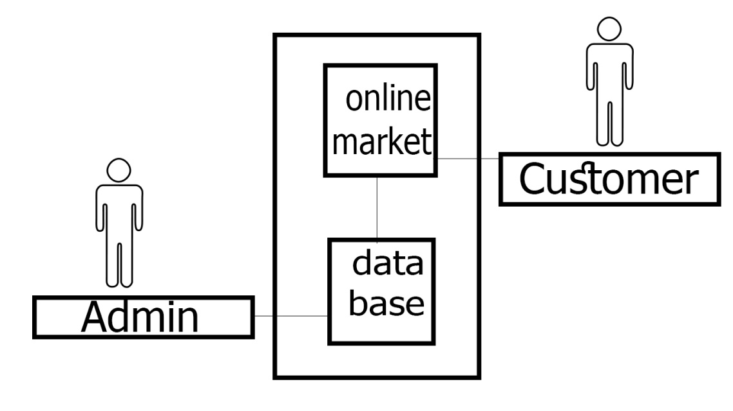
The 3D market shopping has two active actors and one cooperating system. The Customer and the Admin accesses the 3D market shopping through the Internet. Any customer communication with the system is through email while the admin can get into the system without connection.

2.2 Functional Requirements Specification :
this section outlines the use cases for each of the active customers separately. The customer and the admin have only one use case.
2.2.1 Customer usecase
Use case : chose products
Diagram :
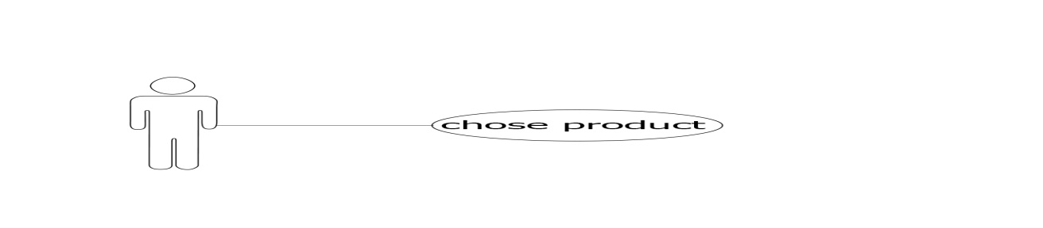
Brief Description :
The Customer accesses the 3D market , shops for products add them to the basket for buy it.

Initial Step-By-Step Description :
Before this use case can be initiated, the Customer has already accessed the online 3D market

1.The Customer shop the offered products and chose what he wants.
2.The desired product have to be added to the basket.

2.2.2 Admin usecase
Use case : edit products quantities
Diagram :
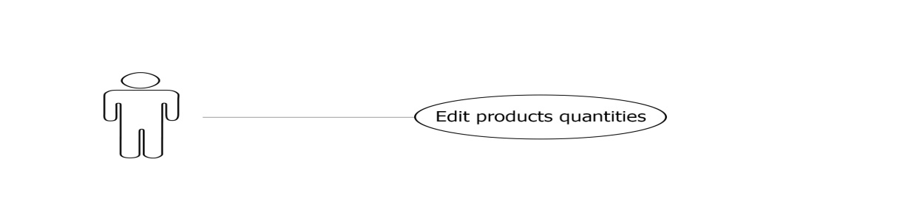
Brief Description :
The Admin accesses the market's database , adjust the products quantities, increase or decrease.

Initial Step-By-Step Description :
Before this use case can be initiated, the Admin has already accessed the market's database through the internet.

1.The Admin chooses to search by product name, category, or brand.
2.The System displays the choices to the Admin
3.The Customer selects the desired product from the recommended ones .
5.The desired product's quantity have to be increased or decreased.

2.3 User Characteristics :
The customer is expected to be Internet literate and be able to use a search engine.
The Admin is expected to be able to deal with database interfaces so he can increase and decrease the quantities of the products.

2.4 Non-Functional Requirements :
The Online market will be on a server with high speed Internet capability, it will be suitable to be executed on all the devices with android system. The speed of the Customer's connection will depend on the hardware used more than characteristics of this system.
The fast delivery of products as well as chose the nearest road so the Customer pay minimum delivery cost .
The products should be well classified and organized on the shelves so the customer could easily find his request .

Reqirements specification:
- External interface Reqirements: the only link is to connect to the database to verify the account of the person who wants to buy from the store,it is necessary to log in and verify the password and it returns a logical value whether it meets the conditions or not.

Fanctional Reqirements: -
customer | Use case name
Log in to the store from the customer. | trigger
There is an account for the customer. | Precondition
Logging in to the store for the cutomer-  - Confirm the customer account and password  -Connecting to the database to see if the customer has a previous login. | Basic path
If he does not have an account must be created. | Alternative path

admin | Use case name
Checking the customer's condition from the admin . does he have all the condition? | Trigger
Available all the time. | Precondition
-verify the customer account and password.  -Receive research from the customer.  - ensure that the product is available in the store.  -display the price and available products. | Basic path
The customer can request to save in order to log in . | Alternative path

3.3 Detailed Non-Functional Requirements
3.3.1 Logical Structure of Data
The logical structure of the data to be stored in the goods manager
The database is presented below.

Admin
buy
customer
products
modifying

Figure 4 - Product manager data logical structure

The data descriptions of each of these data entities is as follows:

Admin Data Entity
Data Item | Type | Description | Comment
Name | Text | Name of admin
Password | Text

Products Data Entity
Data Item | Type | Description | Comment
Name | Text | Name of Product
ID | Integer | Product Code | Used as key
Specialty | Category | Product Type

Customer Data Entity
Data Item | Type | Description | Comment
Name | Text | Name of customer
password | Text
Address | Text

3.3.2 Security
Each user will have a name and a special password through which he can access his account and a method will be provided to verify the identity of the user in the event of a problem or conflict, in addition to sending a confirmation message when making a purchase

Commit:
* I am Wael Alsheikh

