Team ID: 26

To Dr.Rania Elgohary

Dr. Alshaimaa Abo-alian

Dr.Amira Aly

Our TA:Mohamed Ashraf

Contact us: Wael.mohamed91.22@gmali.com

**Team Members :**

Ahmed Mohsen Ahmed Section 2

Beshoy Shaher Hazkial Section 6

Wael Mohamed Section 20

Gehad Khaled Sayed Section 6

Asmaa Sobhy Mostafa Section 5

***Problem Tracking System***

**Table of Contents**

Interview Report 2

SOW 4

SRS 6

User requirements7

System requirements7

Functional requirements8

Nonfunctional requirements9

Gantt Chart10

Activity Network 11

Businessuse case 12

Use case 12

Activity Diagram 13

Class Diagram 15

Sequence Diagram 16

State Chart 18

Context Diagram19

DFD Level-0 Diagram 19

WBS 20

Component and Deployment Diagram 21

**First: interview Report**

**Interview Outline**

**Interviewee:** **Dr.Mohamed Ashraf**

**Interviewers:** **Wael Mohamed**

**Gehad Khaled**

**Asmaa Sobhy**

**Ahmed Mohsen**

**Beshoy Shaher**

Location: TA's Room

Appointment Date: 27-2-2019

* Start Time : 02:30 Pm
* End Time : 03:00 Pm

Objectives:

* Know who will use the system?
* What should system do?
* Related Work
* What is kind of our system (Web-Android Application-Desktop Application)

Agenda:

1. Introduction
2. System Description
3. Background of our Project
4. Interviewee imagine about project
5. Who will use our system
6. What are levels of user's who will use system
7. What data should we collect from user (name-id –SSN-Grade-etc.)
8. Summary of our point
9. Question of interviewee
10. Closing

System Description:

Our system is responsible about solve the problem face who deal with this faculty as (Students, Staff member, client).The problem is face them like (schedule change, other infrastructure problems, parking problem (if applicable), dispute between students & faculty members etc.).

The user will send his/her problem by official email, his id and valid password.

After this, the admin will send to him /her email content what is the time take to solve this problem.

It will enable regulating the process of resolving the problems/issues.

Students / faculty can know the status of their problem resolution. An automated email will be generated to notify respective action.

Questions:

* What system should do?

Our system should manage problem-tracking system let student report about problem, and know what happened if any faculty member see it and when modify on it user will receive nonfiction on his email

* Who will use the system?

Students-faculty members-admins

* What data should we collect from user will enroll new issue?

Name-E mail -Password

**Second: SOW**

**Statement of Work**

**Project Name: Problem Tracking System**

**PVF project manager: Mohamed Ashraf**

**Project Start/End: 25/2 To 28/4**

**PVF Development Staff Estimates (person-months):**

**Programmers: 0.8**

**Jr. Analysts: 0.6**

**Sr.Analysts: 0.5**

**Supervison: 0.3**

**Total: 2.2**

**Project Description:**

* Our system is responsible about solve the problem face who deal with this faculty as (Students, Staff member, Doctors).
* The problem is face them like (schedule change, other infrastructure problems, parking problem (if applicable), dispute between students & faculty members etc.).
* The user will send his/her problem by official email and valid password.
* After this, the (doctor or dean) and student Affairs will be able to Solve The problem.
* It will enable regulating the process of resolving the problems/issues Students / faculty can know the status of their problem resolution. An automated email will be generated to notify respective action.

**Objectives**

* Solve the problem with more efficient ways and faster than direct dealing
* Make the faculty more advanced
* Make the dealing between students and faculty members easier
* Reduce the number of student Affairs work in faculty
* Inform the complainant with the solution of his problem with formal way
* This system will extract report about any problem /issue easier than blunted.

**Phase Of work:**

1. **Milestone 1: 3-3**
2. **Milestone 2 Design I :18-3**
3. **Milestone 3 Design II :1-4**
4. **Milestone 4 implementation:28-4**

**SRS Document:**

1. **Purpose of this document**

* This document intended to represent the software requirements specification of the Problem Tracking Management System. The scope of document is to identify the requirements of the Student Tracking Management System using UML diagrams and some interface designs. The document is the first version and additions are expected in further versions.
* The system should store, process, retrieve and analyse information concerned with the administrative and inventory management within a Problem Tracking System,
* This project aims at maintaining all the information about the problems that faces the student and show it to the administrations of the system, and help them manage and solve these issues with student in a better way.

**Scope of this document**

* The proposed system will enable students / faculty to report any problems / issues they face (Schedule change, between students and faculty members etc.
* It will enable regulating the process of resolving the problems / issues students / faculty can know the status of their problem resolution.
* An automated email generated to notify respective action.

**2. General Description**

**System Goal**

* The goal of this system is to manage the issues that dealing with the student's it will enable regulating the process of resolving the problems / issues students / faculty can know the status of their problem resolution .
* An automated email generated to notify respective action.

**System Objectives:**

* The Problem Tracking management system designed to store, process, retrieve and analyze information about the issues that faces with the students and faculty members.
* It aims to enable regulating the process of resolving the problems.
* It aims at maintaining all different problems and divide it as groups in each problem type.
* It aims to the administrations can know the status of their problem resolution
* It aims to help them manage in a better way.

**User Requirement:**

* All students Can Write their problems
* All student Affairs Officers and doctors can replay to the specific problem.
* Student Affairs Undersecretary Can Write his Problem.
* All Doctors Can Write their Problems
* When Take Action in any problem the owner of problem will Receive Response.

**System Requirement:**

**Actors Who Can Interact With System:**

* Students
* student Affairs Officers
* Doctors
* Student Affairs Undersecretary
* Dean of the College

1. The Problem Tracking management system should allow students / faculty to report any problems / issues they face.
2. The Problem tracking management system should allow to the all Doctors to Write their problems and report about it.
3. Problem tracking management system should allow to Student Can Write his Problem.
4. The Tracking problem management system should allow to All Doctors Response on Student Problem
5. When Take Action in any problem the owner of problem will Receive Response.

**Functional Requirement:**

1. All Can Write a problem and system is responsible about the problem will Send to whom?
   1. Problem from Student Will send student Affairs Officers.
   2. Problem from student will sent too to Doctors
   3. Problem from Doctors Officers will send to Student Affairs Undersecretary or Dean.
   4. Problem from Doctors will send to Dean of the College.
2. What System Should Do When one of Officials Replay on any Problem?
   1. When student Affairs Officers Replay on problem belong to Officer system will notify in Officer Account about this Response.
   2. When Dean Replay on problem belong to Doctor system will notify in Doctor Account about this Response.
   3. When Doctor of the College Replay on problem belong to student system will notify in student Account about this Response.
   4. When Officer of the College Replay on problem belong to student , system will notify in student Account about this Response.

**Non-Functional Requirement:**

* + Security
  + Binary Compatibility
  + Reliability
  + Maintainability
  + Portability
  + Extensibility
  + Reusability
  + Application Affinity/Compatibility
  + Resource Utilization
  + Serviceability

... Others as appropriate.

**Scheduling Diagrams (Gant Chart and Activity Network)**

* **Gant Chart**

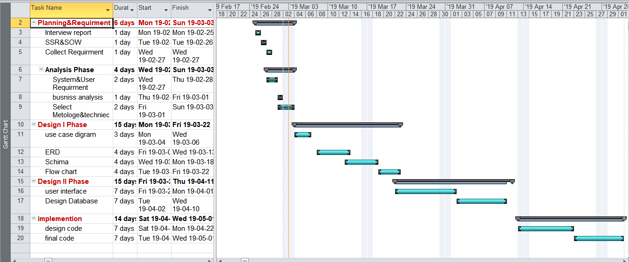

* **Activity Network**

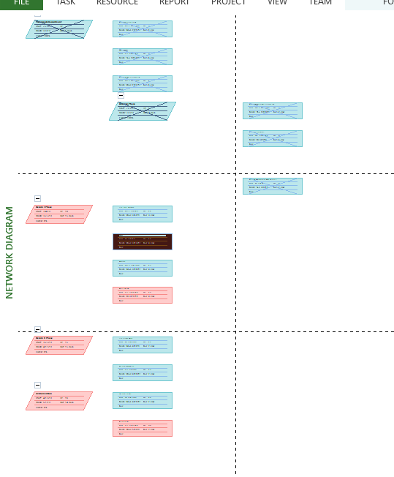

* **Business Use Case Diagram**

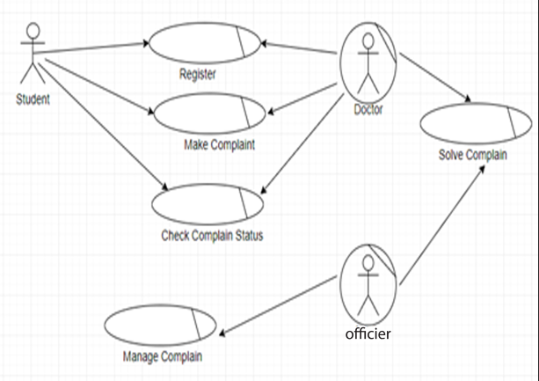

* **Use Case Diagram**

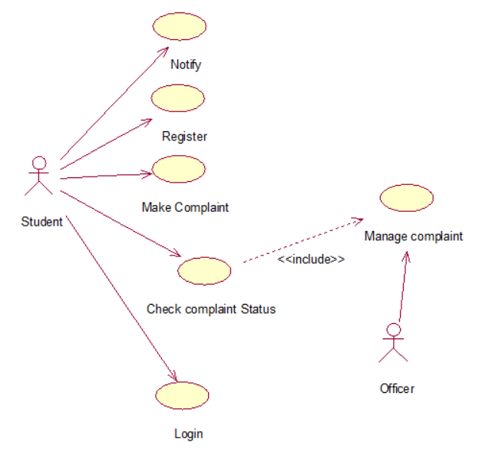

* **Activity Diagram**

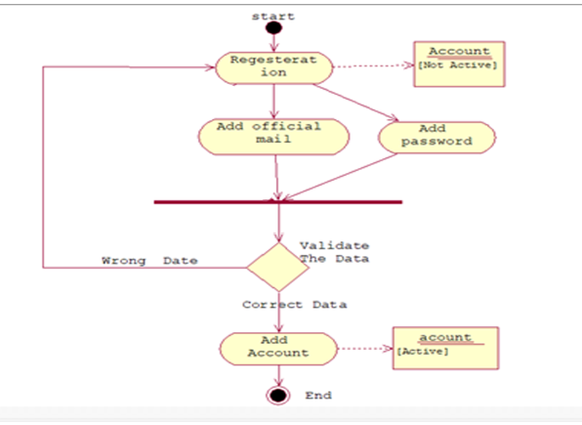

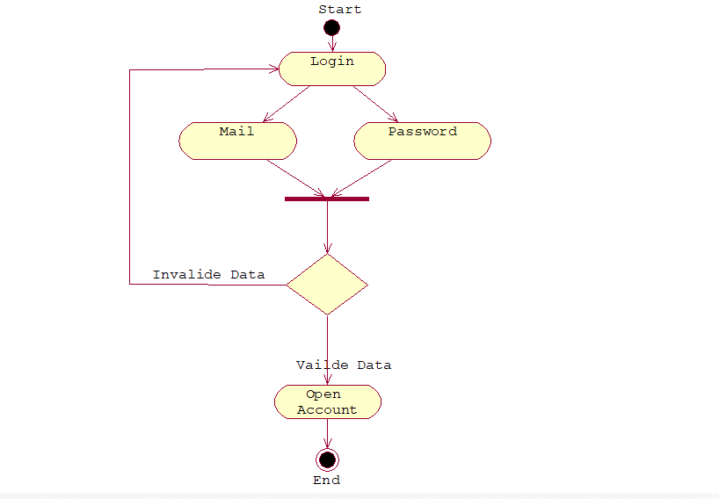

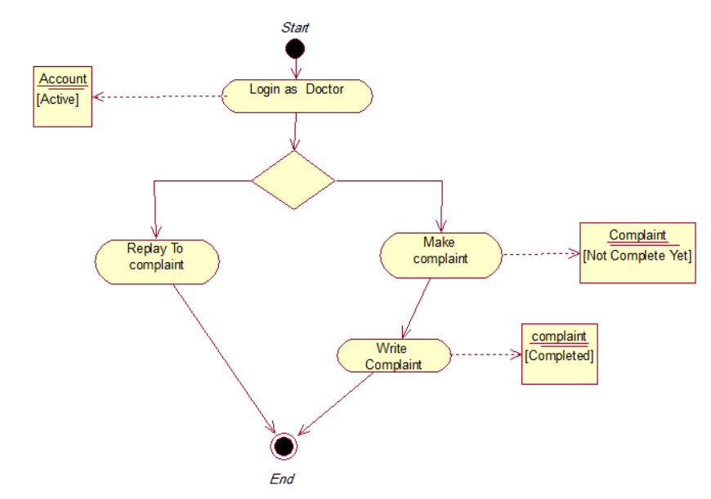

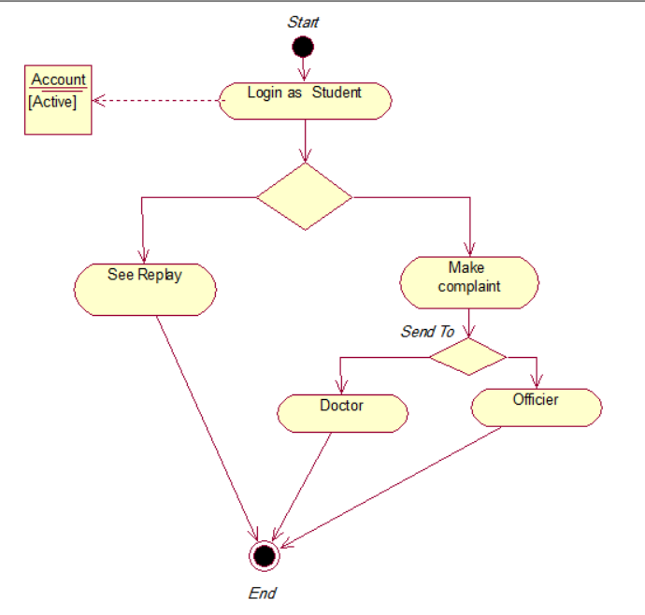

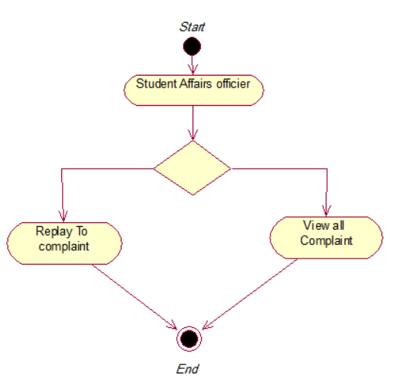

* **Class Diagram**

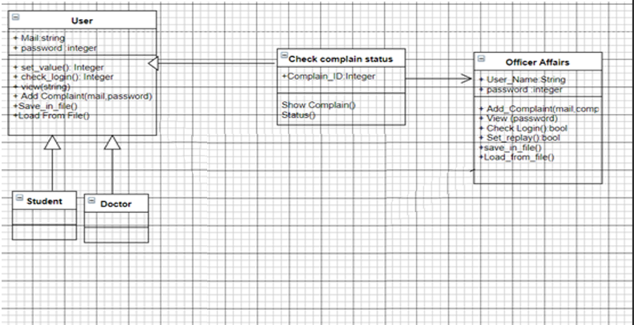

* **Sequence Diagrams**

1. **Login student**

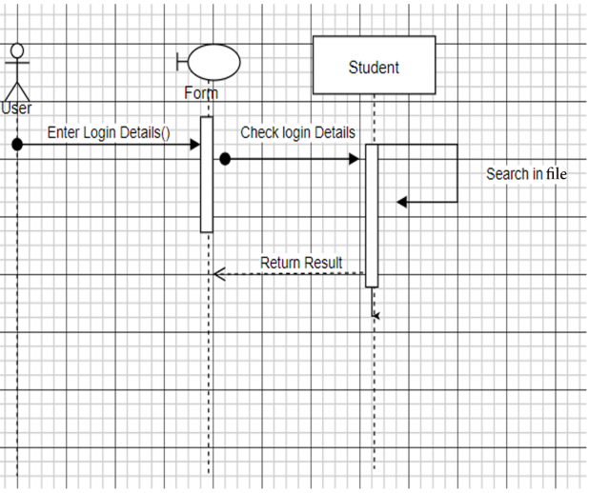

1. **Register**

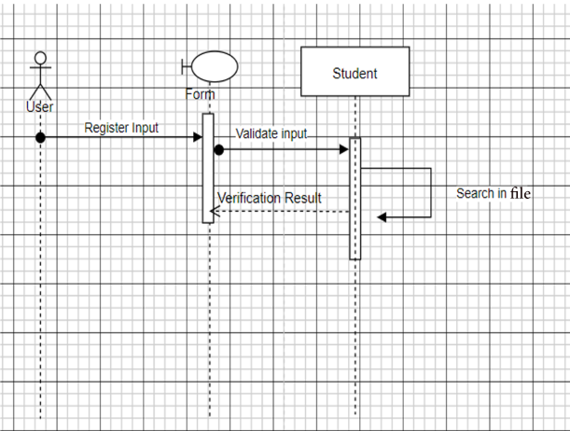

1. **Send Complain**

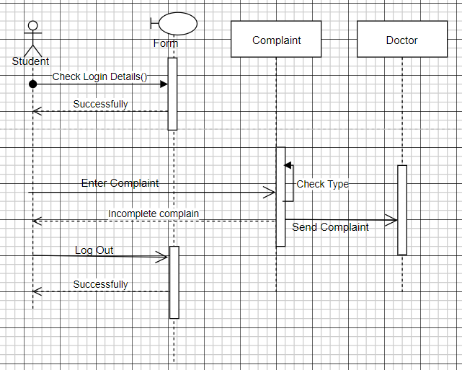

1. **Complain Status**

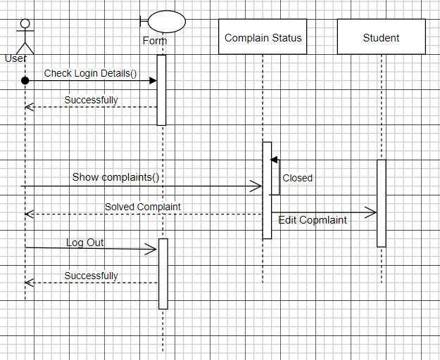

1. **Doctor Solve Complain**

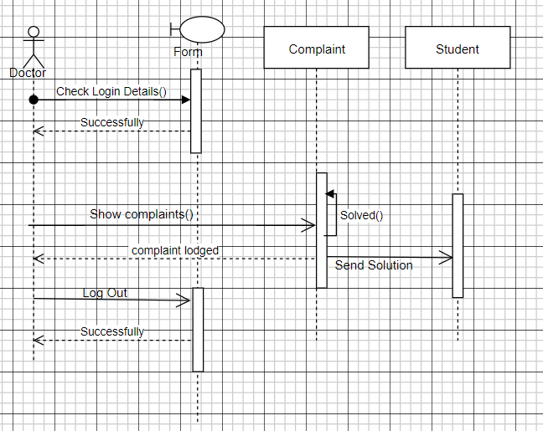

* **State-Chart Diagram**

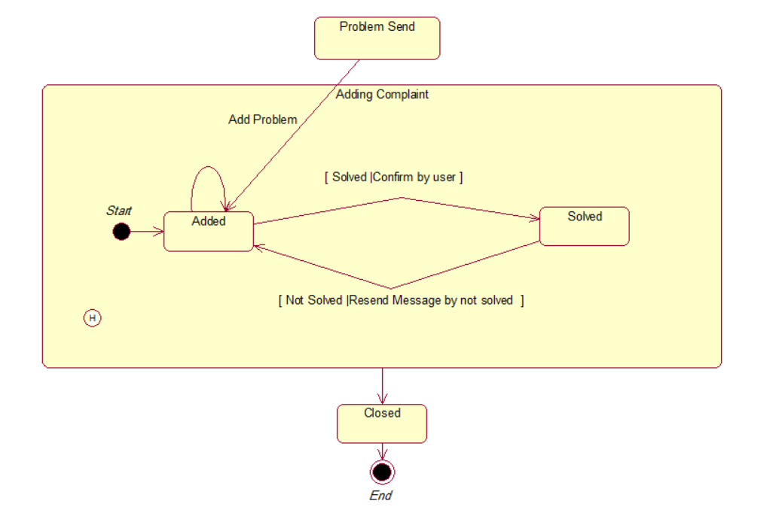

* **Context Diagram**

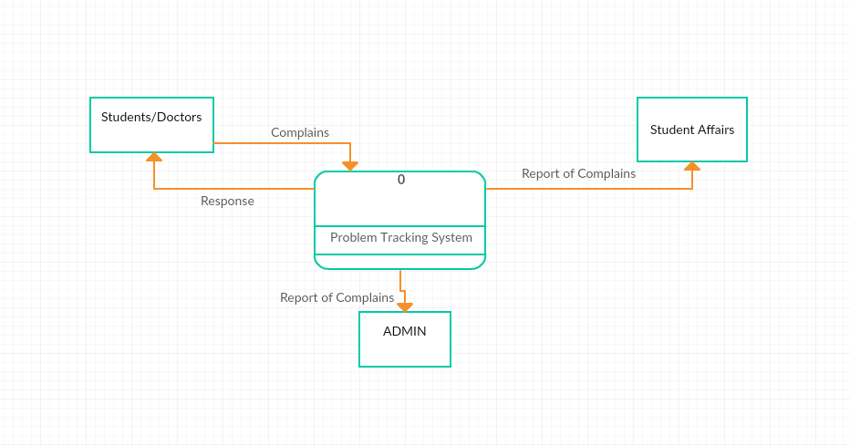

* **DFD Level-0 Diagram**

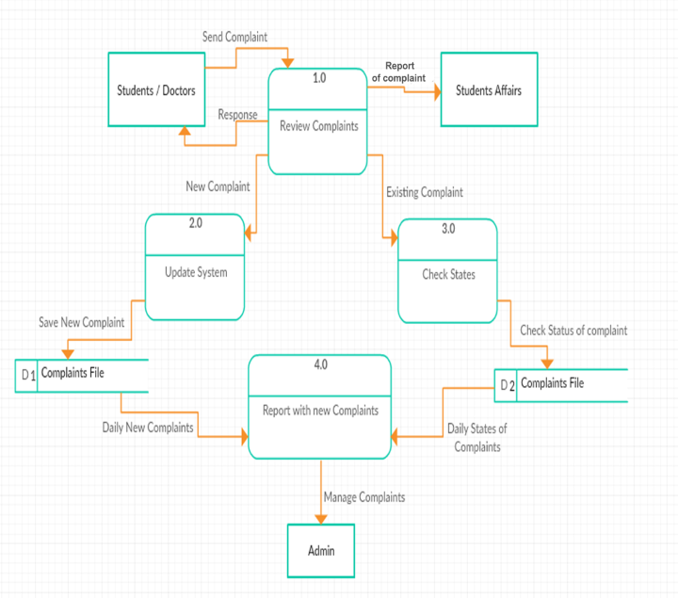

* **WBS**

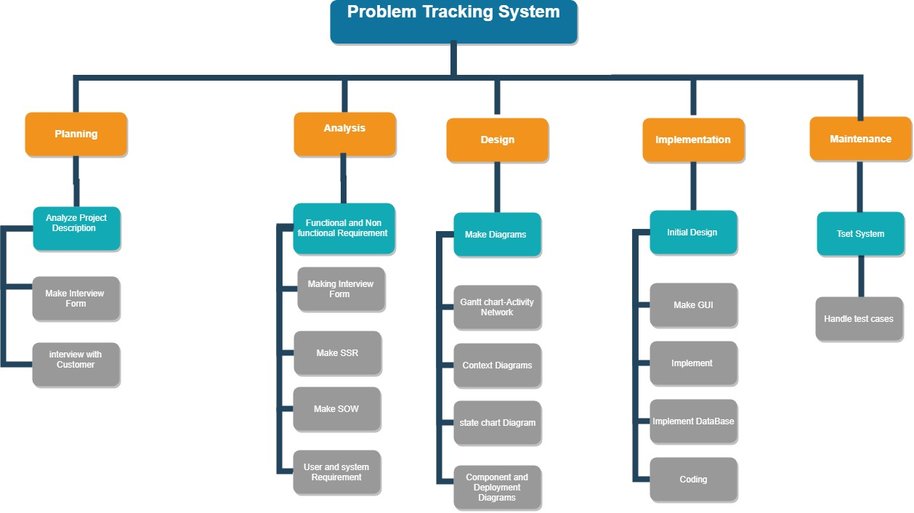

* **Component and Deployment Diagram**

