Score Level Decision Maps
English guide to the function and its helper calls
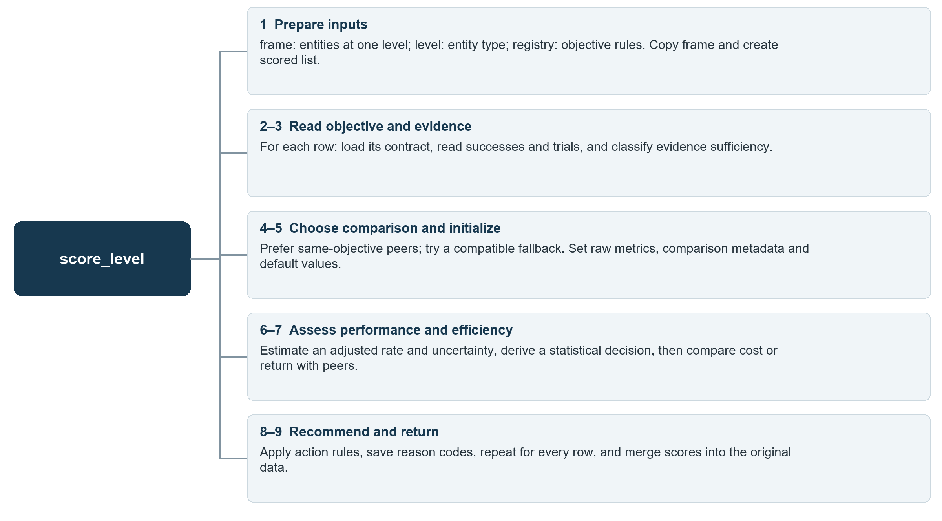
Scope: score_level produces primary scores and recommendations. Semantic scoring and budget allocation run later.

Steps 1 to 3 Inputs and evidence
Map 2 of 9 | score_level
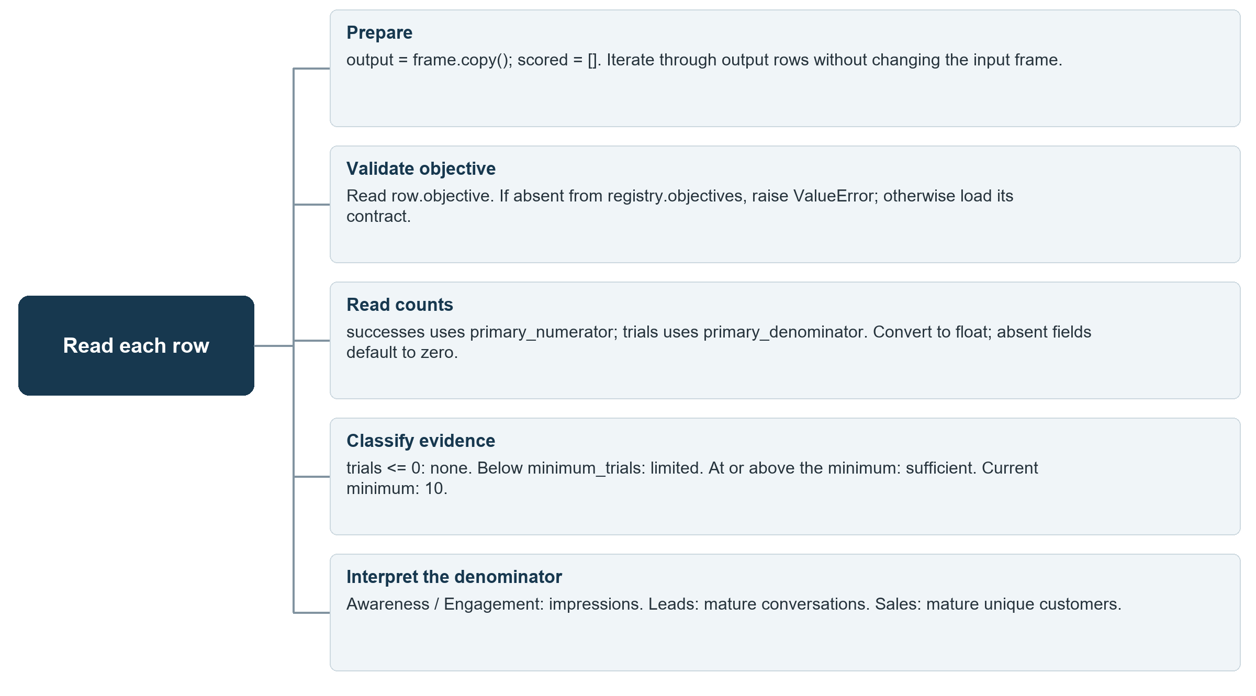
Evidence classification does not stop calculations. The final action checks sufficiency again.

Step 4 Select the benchmark
Map 3 of 9 | score_level
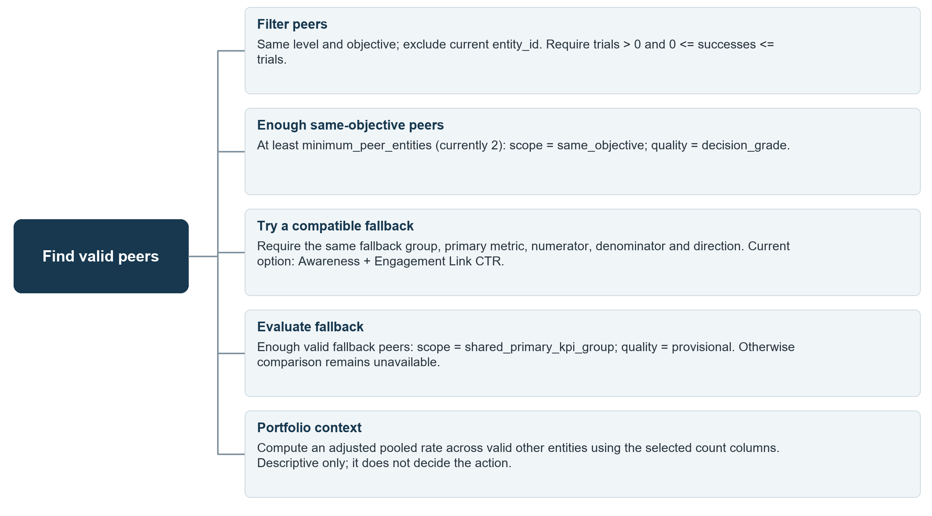
Provisional comparisons can only support KEEP_AS_TEST when evidence is sufficient. The current entity never benchmarks itself.

Step 5 Initialize the score record
Map 4 of 9 | score_level
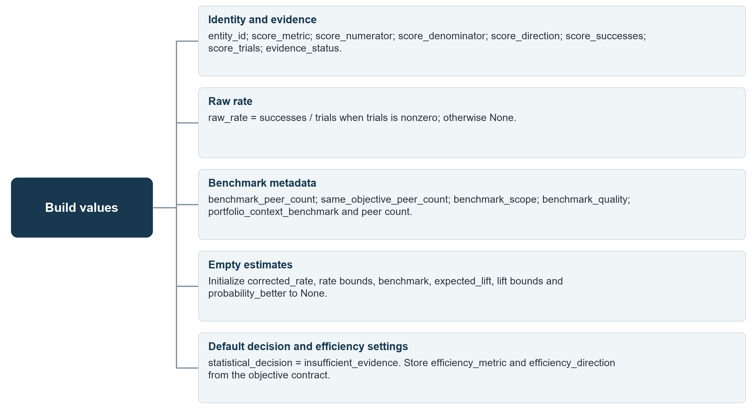
These defaults remain when statistical estimation cannot run, avoiding unsupported numerical estimates.

Step 6 Build the statistical estimate
Map 5 of 9 | score_level
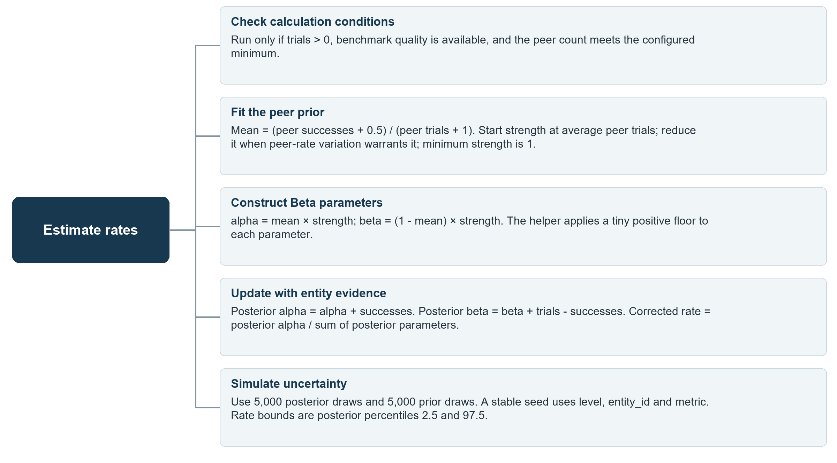
The calculation can run below 10 trials, but limited evidence still blocks a final funding recommendation.

Step 6 Derive the statistical decision
Map 6 of 9 | score_level
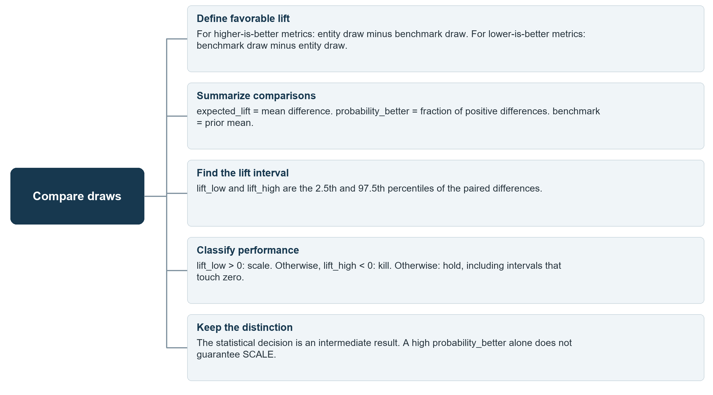
Example: a lift interval from -4 to +12 percentage points produces hold, even when the average lift is positive.

Step 7 Compare efficiency
Map 7 of 9 | score_level
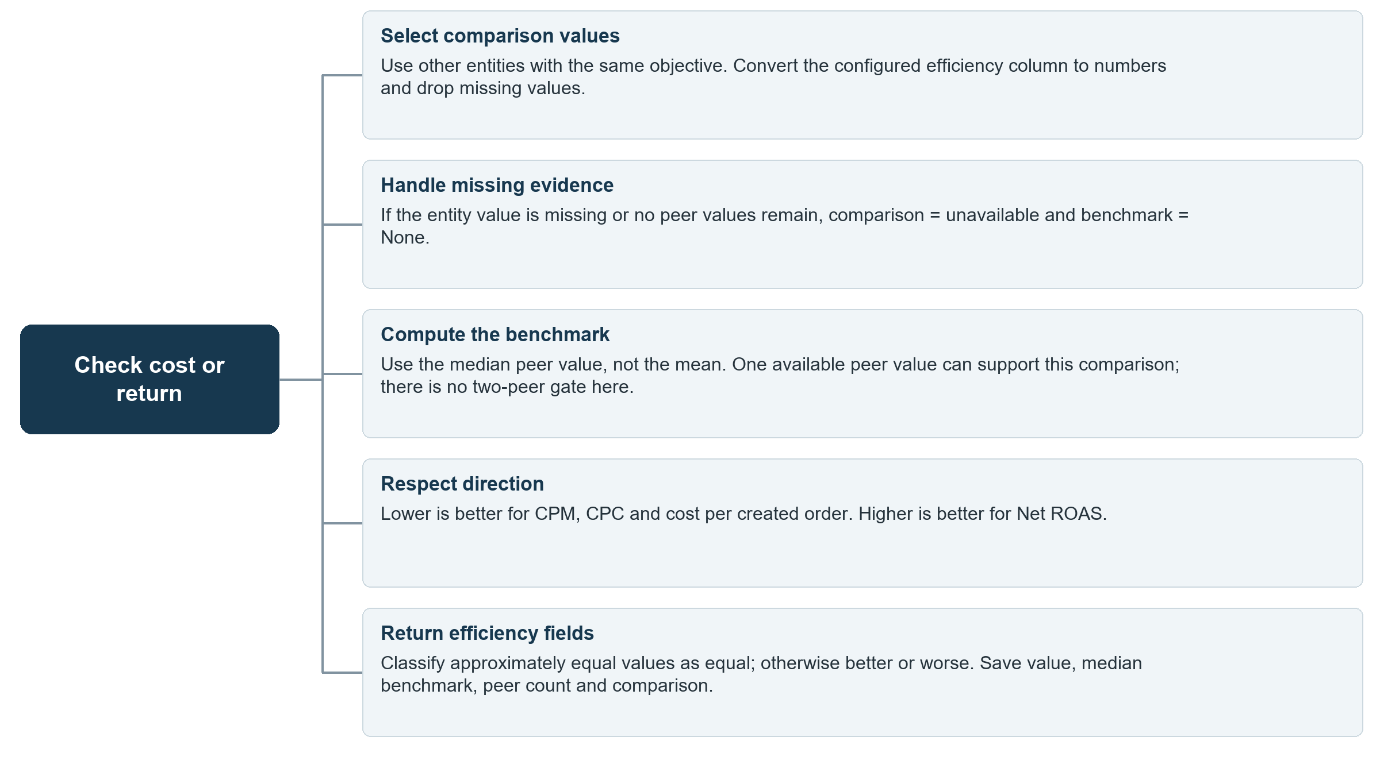
Efficiency always uses same-objective peers. It gates final SCALE recommendations rather than changing the primary statistical score.

Step 8 Apply the final action rules
Map 8 of 9 | score_level
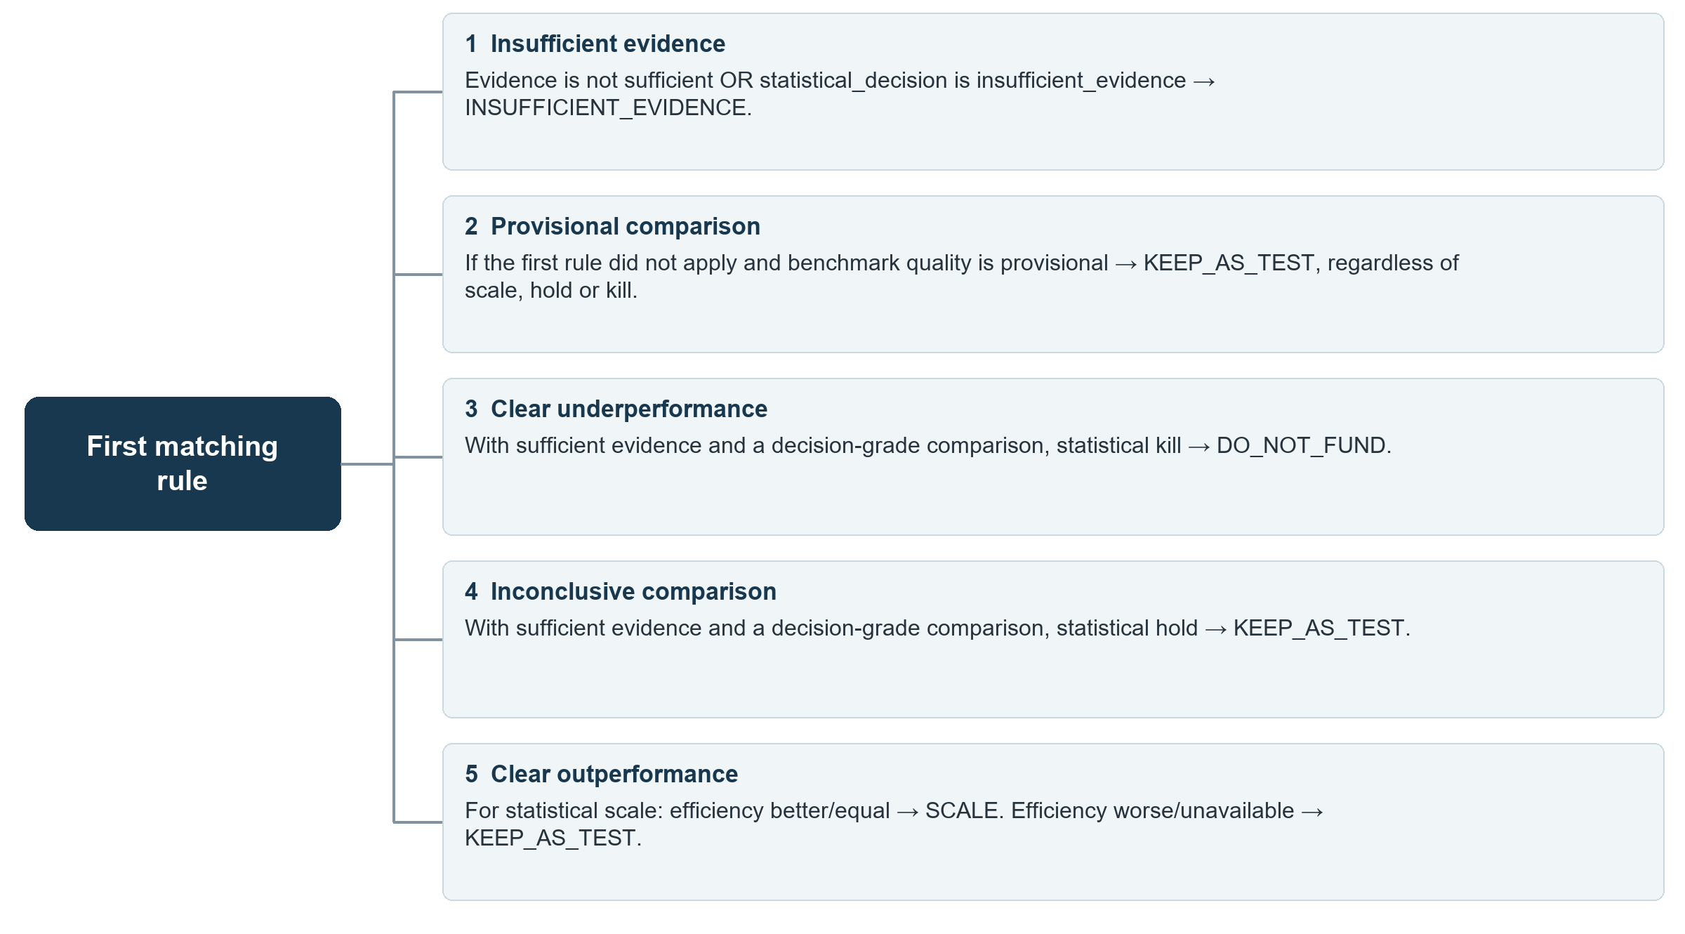
Rule order matters. Each outcome includes reason codes explaining evidence, lift, fallback comparison or efficiency.

Step 9 Save and return results
Map 9 of 9 | score_level
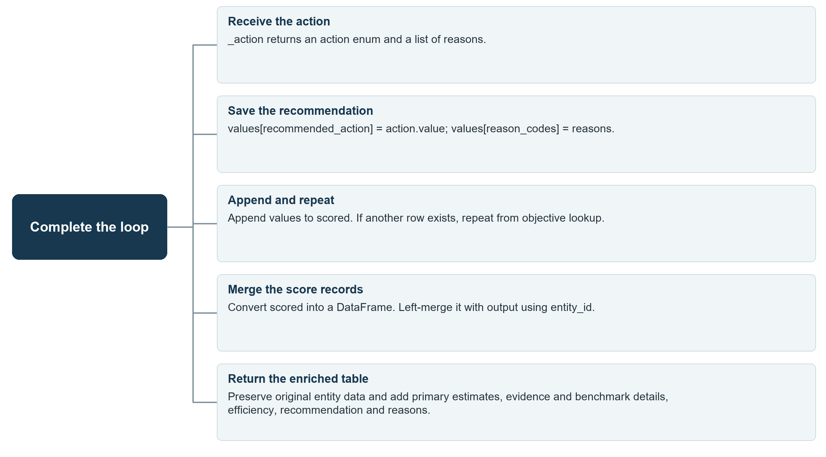
Source: src_mvp/statistics.py, score_level and its helpers; objective defaults: src_mvp/config/objectives.yaml.

