

NWEN 302

Lab 3

Wael Aldroubi  
300456658

PART A

Task 1:

|  |  |  |  |  |  |
| --- | --- | --- | --- | --- | --- |
| [**Router**](https://ecs.victoria.ac.nz/Courses/NWEN302_2018T2/Lab3?sortcol=0;table=2;up=0#sorted_table) | [**Port**](https://ecs.victoria.ac.nz/Courses/NWEN302_2018T2/Lab3?sortcol=1;table=2;up=0#sorted_table) | [**Cable**](https://ecs.victoria.ac.nz/Courses/NWEN302_2018T2/Lab3?sortcol=2;table=2;up=0#sorted_table) | [**IPv4 Address**](https://ecs.victoria.ac.nz/Courses/NWEN302_2018T2/Lab3?sortcol=3;table=2;up=0#sorted_table) | [**IPv4 Netmask**](https://ecs.victoria.ac.nz/Courses/NWEN302_2018T2/Lab3?sortcol=4;table=2;up=0#sorted_table) | [**IPv6 Address**](https://ecs.victoria.ac.nz/Courses/NWEN302_2018T2/Lab3?sortcol=5;table=2;up=0#sorted_table) |
| R1 | 2 | c1 | 10.10.1.1 | 255.255.255.0 | 2404:2000:2002:101::1/64 |
| R1 | 3 | c2 | 10.10.2.1 | 255.255.255.0 | 2404:2000:2002:102::1/64 |
| R1 | 0 | c10 | 10.10.10.1 | 255.255.255.0 | 2404:2000:2002:110::1/64 |
| R1 | 1 | c11 | 10.10.11.1 | 255.255.255.0 | 2404:2000:2002:111::1/64 |
| R2 | 0 | c1 | 10.10.1.2 | 255.255.255.0 | 2404:2000:2002:101::2/64 |
| R2 | 2 | c8 | 10.10.8.1 | 255.255.255.0 | 2404:2000:2002:108::1/64 |
| R2 | 1 | c9 | 10.10.9.1 | 255.255.255.0 | 2404:2000:2002:109::1/64 |
| R3 | 3 | c7 | 10.10.7.1 | 255.255.255.0 | 2404:2000:2002:107::1/64 |
| R3 | 1 | c2 | 10.10.2.2 | 255.255.255.0 | 2404:2000:2002:102::2/64 |
| R3 | 2 | c3 | 10.10.3.1 | 255.255.255.0 | 2404:2000:2002:103::1/64 |
| R3 | 0 | c9 | 10.10.9.2 | 255.255.255.0 | 2404:2000:2002:109::2/64 |
| R4 | 2 | c13 | 10.10.13.1 | 255.255.255.0 | 2404:2000:2002:113::1/64 |
| R4 | 3 | c3 | 10.10.3.2 | 255.255.255.0 | 2404:2000:2002:103::2/64 |
| R4 | 1 | c4 | 10.10.4.1 | 255.255.255.0 | 2404:2000:2002:104::1/64 |
| R4 | 0 | c12 | 10.10.12.1 | 255.255.255.0 | 2404:2000:2002:112::1/64 |
| R5 | 1 | c6 | 10.10.6.2 | 255.255.255.0 | 2404:2000:2002:106::2/64 |
| R5 | 3 | c4 | 10.10.4.2 | 255.255.255.0 | 2404:2000:2002:104::2/64 |
| R5 | 0 | c5 | 10.10.5.1 | 255.255.255.0 | 2404:2000:2002:105::1/64 |
| R5 | 2 | c8 | 10.10.8.2 | 255.255.255.0 | 2404:2000:2002:108::2/64 |
| R6 | 3 | c5 | 10.10.5.2 | 255.255.255.0 | 2404:2000:2002:105::2/64 |
| R6 | 2 | c7 | 10.10.7.2 | 255.255.255.0 | 2404:2000:2002:107::2/64 |
| R7 | 3 | c6 | 10.10.6.1 | 255.255.255.0 | 2404:2000:2002:106::1/64 |
| m1 | eth0 | c10 | 10.10.10.2 | 255.255.255.0 | 2404:2000:2002:110::2/64 |
| m2 | eth0 | c11 | 10.10.11.2 | 255.255.255.0 | 2404:2000:2002:111::2/64 |
| m3 | eth0 | c12 | 10.10.12.2 | 255.255.255.0 | 2404:2000:2002:112::2/64 |
| m4 | eth0 | c13 | 10.10.13.2 | 255.255.255.0 | 2404:2000:2002:113::2/64 |

Questions:

1. All IP addresses are divided into portions. One part identifies the network (the network number) and the other part identifies the specific machine or host within the network (the host number).
2. In IPv4, the subnet mask 255.255.0.0 is 32 bits and consists of four 8-bit octets. The address: 10.10.0.0 subnet mask 255.255.0.0 means that the subnet is a range of IP addresses from 10.10.0.0 - 10.10.225.255.

The prefix-length in IPv6 is the equivalent of the subnet mask in IPv4. However, rather than being expressed in four octets like it is in IPv4, it is expressed as an integer between 1 through 128. For example: 2001:db8:abcd:0012::0/64 specifies a subnet with a range of IP addresses from: **2001:db8:abcd:0012:**0000:0000:0000:0000 - **2001:db8:abcd:0012:ffff:ffff:ffff:ffff**. The portion in bold is called the network portion of the IP address, or the prefix. The non-bold portion is called the host portion of the IP address, since it identifies an individual host on the network.  
In our example we noticed that 2404:2000:2002 was the network portion while the rest was the host portion.  
For example IPv4 10.10.1.1 will have IPv6 2404:2000:2002:111::1/64.

1. Subnet masks (IPv4) and prefixes (IPv6) identify the range of IP addresses that make up a subnet, or group of IP addresses on the same network. For example, a subnet can be used to identify all the machines in a building, department, geographic location, or on the same local area network (LAN).

Dividing an organization's network into subnets allows it to be connected to the Internet with a single shared network address. Subnet masks and prefixes are used when a host is attempting to communicate with another system. If the system is on the same network or subnet, it attempts to find that address on the local link. If the system is on a different network, the packet is sent to a gateway that then routes the packet to the correct IP address.

…………………………………………………………………………………………………..

Task 2:

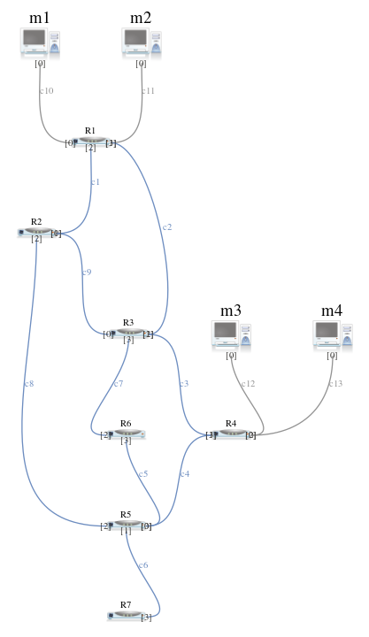

Task 3:

I did the tests for router 1 and router 6, as R1 connected to hosts and a R2, while R6 at the other part of the network and connected to many routers

For Router 1:

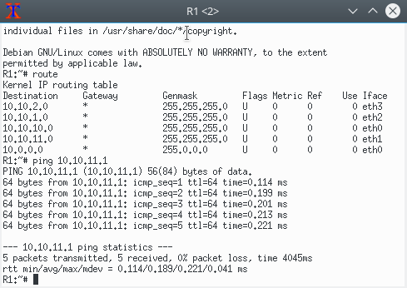

For router 6:

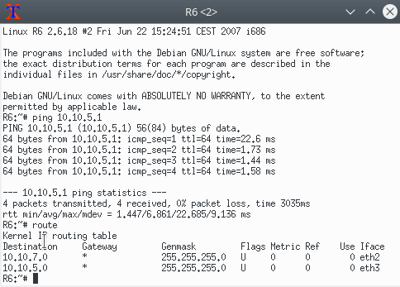

Question 4

A default gateway is used to allow devices in one network to communicate with devices in another network. If your computer, for example, is requesting an internet webpage, the request first runs through your default gateway before exiting the local network to reach the internet.  
  
An easier way to understand a default gateway might be to think of it as an intermediate device between the local network and the internet. It's necessary for transferring internal data out to the internet, and then back again.  
  
So, the default gateway device passes traffic from the local subnet to devices on other subnets. The default gateway often connects the local network to the internet, although internal gateways for communication within a local network also exist.

Task 4

Added text to the hosts:

For m2:

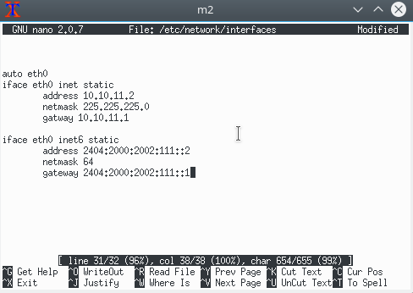

For m3:

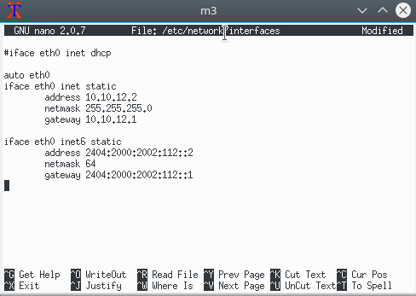

For m4:

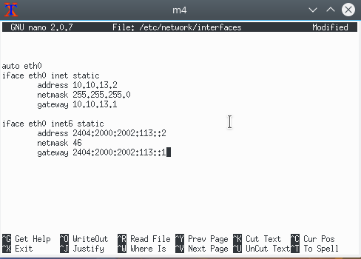

I had applied ping for M1 and M3 to test it and it was successful as M1 is connected to R1 and M3 connected to R4:

For m1:

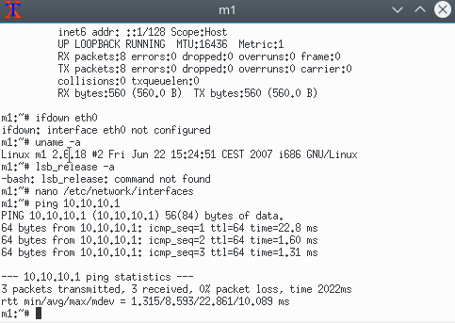

For m3:

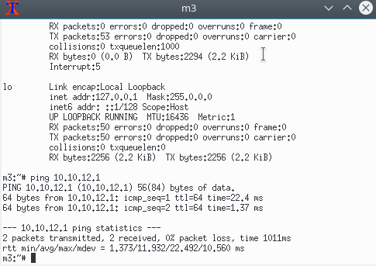

Question 5:

The functionality of the IPv6 Neighbour Discovery protocol corresponds to a combination of the IPv4 protocols: Address Resolution Protocol (ARP), Internet Control Message Protocol (ICMP) Router Discovery, and ICMP Redirect. IPv4 does not have a generally agreed on protocol or mechanism for neighbour unreachability detection. However, host requirements do specify some possible algorithms for dead gateway detection. Dead gateway detection is a subset of the problems that neighbour unreachability detection solves.

The following list compares the Neighbour Discovery protocol to the related set of IPv4 protocols.

1. Router discovery is part of the base IPv6 protocol set. IPv6 hosts do not need to snoop the routing protocols to find a router. IPv4 uses ARP, ICMP router discovery, and ICMP redirect for router discovery.
2. IPv6 router advertisements carry link-local addresses. No additional packet exchange is needed to resolve the router's link-local address.
3. Router advertisements carry site prefixes for a link. A separate mechanism is not needed to configure the netmask, as is the case with IPv4.
4. Router advertisements enable address auto configuration. Auto configuration is not implemented in IPv4.
5. Neighbour Discovery enables IPv6 routers to advertise an MTU for hosts to use on the link. Consequently, all nodes use the same MTU value on links that lack a well-defined MTU. IPv4 hosts on the same network might have different MTUs.
6. Unlike IPv4 broadcast addresses, IPv6 address resolution multicasts are spread over 4 billion (2^32) multicast addresses, greatly reducing address resolution-related interrupts on nodes other than the target. Moreover, non-IPv6 machines should not be interrupted at all.
7. IPv6 redirects contain the link-local address of the new first hop. Separate address resolution is not needed on receiving a redirect.
8. Multiple site prefixes can be associated with the same IPv6 network. By default, hosts learn all local site prefixes from router advertisements. However, routers can be configured to omit some or all prefixes from router advertisements. In such instances, hosts assume that destinations are on remote networks. Consequently, hosts send the traffic to routers. A router can then issue redirects, as appropriate.
9. Unlike IPv4, the recipient of an IPv6 redirect message assumes that the new next-hop is on the local network. In IPv4, a host ignores redirect messages that specify a next-hop that is not on the local network, according to the network mask. The IPv6 redirect mechanism is analogous to the XRedirect facility in IPv4. The redirect mechanism is useful on non-broadcast and shared media links. On these networks, nodes should not check for all prefixes for local link destinations.
10. IPv6 neighbour unreachability detection improves packet delivery in the presence of failing routers. This capability improves packet delivery over partially failing or partitioned links. This capability also improves packet delivery over nodes that change their link-local addresses. For example, mobile nodes can move off the local network without losing any connectivity because of stale ARP caches. IPv4 has no corresponding method for neighbour unreachability detection.
11. Unlike ARP, Neighbour Discovery detects half-link failures by using neighbour unreachability detection. Neighbour Discovery avoids sending traffic to neighbours when two-way connectivity is absent.
12. By using link-local addresses to uniquely identify routers, IPv6 hosts can maintain the router associations. The ability to identify routers is required for router advertisements and for redirect messages. Hosts need to maintain router associations if the site uses new global prefixes. IPv4 does not have a comparable method for identifying routers.
13. Because Neighbour Discovery messages have a hop limit of 255 upon receipt, the protocol is immune to spoofing attacks originating from off-link nodes. In contrast, IPv4 off-link nodes can send ICMP redirect messages. IPv4 off-link nodes can also send router advertisement messages.
14. By placing address resolution at the ICMP layer, Neighbour Discovery becomes more media independent than ARP. Consequently, standard IP authentication and security mechanisms can be used.

Question 6:

I will need 2 static routes:   
first one between R1 and R3, and second one between R3 and R4, then M1, M2, M3 and M4 can talk to each other as R1 and R4 has all connected devices.

Question 7:

Choosing the path can depend on many factors, and choosing that factor will affect the path I am taking:

I can take the path which is the:

1. Shortest.
2. Cheapest (less cost).

And many other factors might affect the decision.

Question 8:

As I defined the routes as static, then the connection between those two devices might not work, and I don’t know if the routers have the ability to contact the other router using alternative way or using another routers to do that.

But for the hosts M1, M2, M3, M4 and R7, when the link fail, definitely the connection is lost and they are outside of the network.

Question 9:

Adding additional router can increase the number of static routes, and can be added to routers that have any interface free, can’t be connected to hosts as they are already connected to other routers.

PART B

Task 1:

I will include the table for 1st router and last one and the one between.

I will take R1, R4 and R7:

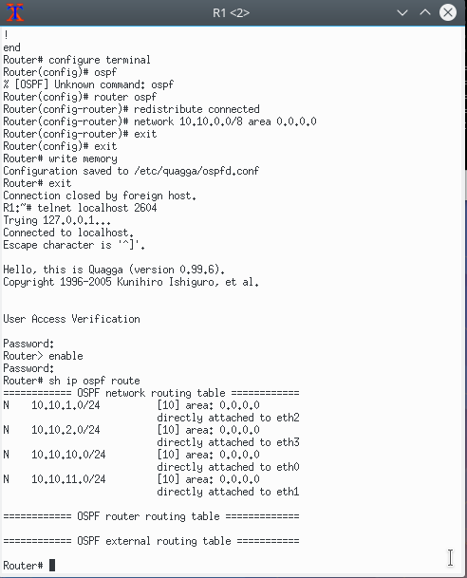

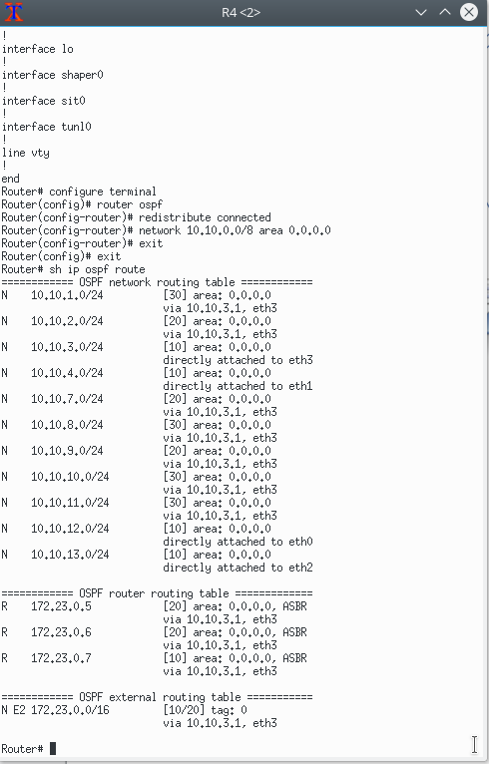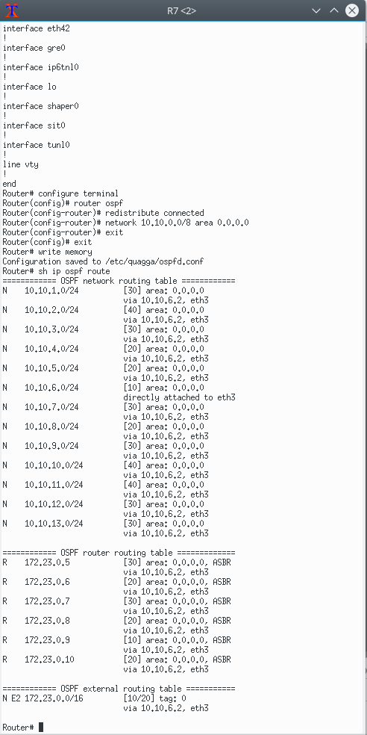

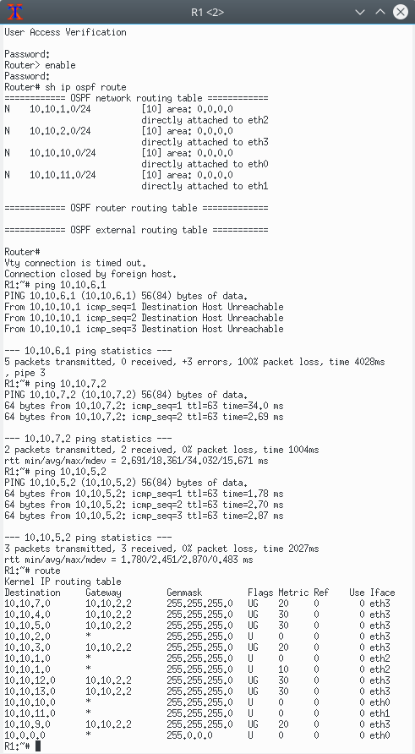

Question1:

Of course it is the last table to add ospf to it, in my case R7, as all routes defined, then all routers will have full table.

Question2:

Of course No as the every router will have different connected ports, different routes, but will be connected to the other devices, each ospf route table will have 13 entries in the network routing table, and 6 entries in the router routing table.

Question 3:

I had checked the R1 route table after implementing ospf, the table increased and have new entries as it has new routes to other devices.

Task 2:

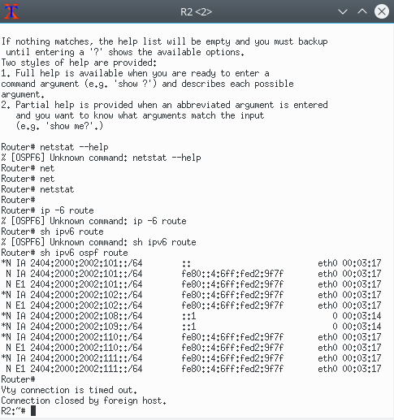I will record R2, R4 and R7 to show my IPV6 ospf process:

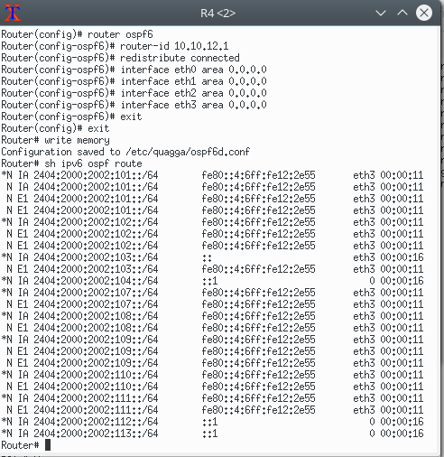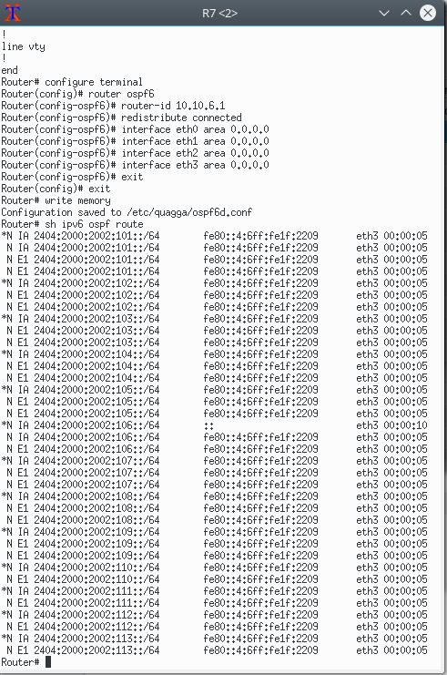

Question 4:

We can check if IPV6 is working by pinging ipv6 over the network, and this is what I did R2 pings R5:

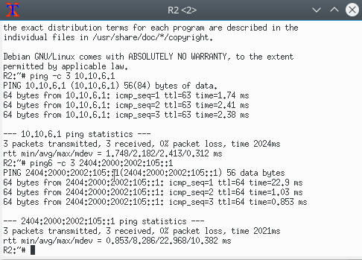

And it was successful.

Question5:

It will ping the first working wires and will show starts for the disconnected wire, and then will find alternative route, in my case it did not work, it was showing the 1st working wire only, but for one friend it was changing the route to find alternative one.

But the devices still can ping each other after disconnecting the wire, as the router is using other devices ports, unfortunately my edge devices could not ping each other, don’t know why even though it can ping every connected device and the one after it.

R1 could not ping R2 port 2 only, also don’t know why even though the route table and ospf table has all entries and working probably, it might be related to marionnet?!!

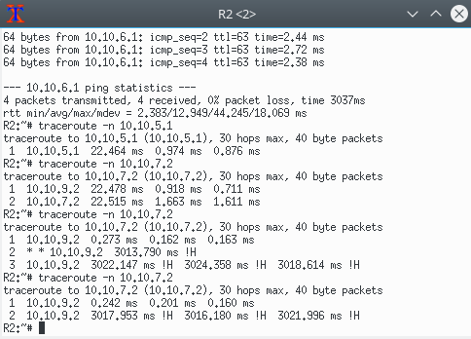

The answer is not correct as it is supposed to find alternative route.

Question 6:

Waiting sometime the router will find alternative route, but in my case it is stick in the previous working wire.

Question 7:

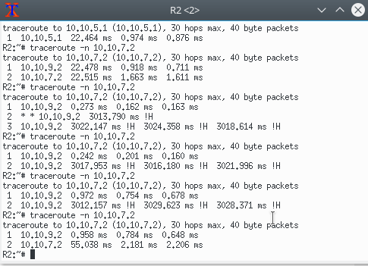After connecting the wire it will take the same 1st route defined as it the best route defined by the router.

Question 8:

Traceroute command is showing the response time for all devices when the route is connected or not, if there is a cable broken, changing routes takes time in ms, so it is fast, but to get the total time I don’t know if marionnet can do that and marionnet resources online are limited, I think using wireshark or other network applications can show helpful results about the time required.

Task 3:

It is the same as IPV4, but when disconnecting the cable we ping IPV6, and the router will find the other alternative way by its self.

Question 9:

When disconnecting the cable, the route table will be changed as the cable port will be removed as if it is not there, and the router will define the new routes, and update the table, and will return to the old table once the cable is connected again.

Task 4:

Unfortunately as the port 2 at R2 is not working probably, I could not continue the lab to the end, I tried everything I could do but I do understand what is going on in the network, even with the help the lab instructor we could not solve it together, most of the devices could ping each other but only R2 port 2 was not working well, and it does missed up my network.