

Data Technician

Name:
Course Date:
Table of contents
Day 1: Task 1 3
Day 1: Task 2 3
Day 1: Task 3 4
Day 2: Task 1 5
Day 3: Task 1 9
Day 3: Task 2 10
Day 3: Task 3 11
Day 4: Task 1 12
Day 4: Task 2 13
1. Scenario Background 13
2. Data Laws and Regulations 14
3. Azure Service Recommendations 14
4. Data Types and Data Modelling 14
5. Data Storage Formats and Structures in Azure 14
6. Additional Considerations 15
Submission Guidelines: 15
Course Notes 17
Additional Information 17

Day 1: Task 1

Please research and complete the below questions relating to key concepts of cloud.

Be prepared to discuss the below in the group following this task.

What can cloud computing do for us in the real-world? | Daily Life and Consumer Applications  • File Storage and Sharing : Services like Google Drive, Dropbox, and iCloud let you store photos, documents, and videos online, freeing up space on your devices and making your files accessible from any internet-connected location.  • Streaming Media: Platforms like Netflix, Spotify, and YouTube rely on the cloud to store massive libraries of content and deliver it instantly to millions of users worldwide, ensuring smooth, on-demand playback without downloads.  • Email and Communication: Web-based services like Gmail and Outlook store your emails, contacts, and attachments on cloud servers, allowing you to access them  Benefits for Businesses and Organizations  Cost Savings
How can it benefit a business? | Instead of buying and maintaining expensive hardware, companies pay for resources as they use them (pay-as-you-go model), converting large upfront capital expenses into predictable operating expenses.  Businesses can rapidly increase or decrease their computing resources (like storage or processing power) based on demand. This is crucial for handling sudden traffic spikes (e.g., during a flash sale) without system crashes.
What’s the alternative to cloud computing? | - On-Premises Computing (On-Prem)  This is the traditional model where a company owns, hosts, and manages its entire IT infrastructure (servers, storage, network, software) within its own physical facilities (like a private data center or server room  2. Edge Computing  Edge computing is a newer, distributed architecture that is less a replacement for the cloud and more a complement or a targeted alternative for latency-sensitive applications  3. Hybrid Cloud (The Common Middle Ground)  Most large organizations today do not choose one or the other; they use a Hybrid Cloud model, which combines an on-premises infrastructure (a private cloud) with public cloud services.
What cloud providers can we use, what are their features and functions?
  Features | AWS | Azure | GCP
  Market Position | Leader. Largest market share ($\approx 30\%-32\%$) and most mature platform. | Strong Challenger. Second largest market share ($\approx 20\%-25\%$), rapidly growing. | Data & Innovation Focus. Third largest ($\approx 10\%-13\%$),
  Core Strength | Breadth and Depth of Services. Has the largest and deepest ecosystem of services (250+). | Enterprise and Hybrid Cloud. Seamless integration with existing Microsoft enterprise products | Big Data, AI/ML, and Kubernetes. Leverages Google’s internal tech for advanced analytics.
  Pricing Model | Pay-As-You-Go model. Offers Reserved Instances and Savings Plans for committed use. | ay-As-You-Go. Offers Reserved Instances and major savings through Azure Hybrid Benefit (using existing Microsoft licenses). | Per-Second Billing and Automatic Sustained Use Discounts (discounts automatically apply the longer you use a service).

Day 1: Task 2

Please research the below cloud offerings, explain what they are and examples of use cases.

Cloud Offerings | Explain what it is | When / how might you use this service in the real-world?
IaaS (Infrastructure as a service) | IaaS (Infrastructure as a Service) is the most fundamental category of cloud computing services. It provides the basic building blocks for cloud IT, giving you on-demand access to and control over the most essential computing resources over the internet, typically on a pay-as-you-go basis | Development and Testing Environments  Disaster Recovery and Business Continuity  Hosting Custom, High-Traffic Web Applications  Big Data and High-Performance Computing (HPC)
PaaS (Platform as a service) | Platform as a Service (PaaS) is a cloud computing model that provides developers with a ready-made platform—including infrastructure, operating systems, databases, and development tools—to build, deploy, and manage applications without worrying about the underlying hardware or software setup | A company needs to quickly launch a new web app, mobile backend, or API, often under tight deadlines.  Developers upload their application code (e.g., Python, Node.js, Java) directly to a PaaS offering like Azure App Service, AWS Elastic Beanstalk, or Google App Engine.
SaaS (Software as a service) | SaaS (Software as a Service) represents the highest level of abstraction and the simplest model of cloud computing for the end-user. | Multiple SaaS applications are likely used every day. SaaS is utilised whenever a standardised, ready-to-use software solution is required for a specific business function.  Examples:  - Microsoft 365 (Word, Excel, Outlook): Users access full office productivity tools via the web without local installation hassles.  - Google Workspace (Gmail, Docs, Sheets): Provides real-time, cloud-based collaboration.

Day 1: Task 3

Please research the below terms and explain what they are, when they would be appropriate and a real-world example of where it could be implemented (i.e. what type of organisation).

Public Cloud | Resources owned and operated by a third-party vendor (e.g., AWS) and shared publicly over the internet.  Maximum scalability and cost efficiency (Pay-as-you-go).  Retail E-commerce, Startups, Web Hosting.
Private Cloud | Resources dedicated exclusively to a single organisation.  Maximum control, security, and compliance  Investment Banks, Government Agencies, and Organisations with strict regulatory needs.
Hybrid Cloud | A mix of public and private clouds, connected to allow data sharing.  Flexibility to optimise costs and security; supports Cloud Bursting.  Large Insurance Companies, Financial Services, and Enterprises with varying data sensitivity.
Community Cloud | Resources shared by several organisations with common concerns (e.g., compliance, mission).  Uniform security and standards for collaboration.  Consortium of Research Hospitals, Regional Government Agencies, and Shared Industry Projects.

Day 2: Task 1

Describe, with examples, the three major areas that the Computer Misuse Act deals with.

Area | Description | Example
Unauthorised Access to Computer Material | This is the basic offence of hacking. It covers intentionally causing a computer to perform any function to secure unauthorised access to any program or data, knowing the access is unauthorised. | A person uses a stolen or guessed password to log into a server they have no authority to use, simply to browse the file structure.
Unauthorised Access with Intent to Commit or Facilitate Further Offences | This is an aggravated hacking offence. It requires committing the Section 1 offence plus the specific intent to use the access to commit or enable another serious crime (like fraud, blackmail, or theft). | A hacker breaks into a bank's system with the intent to transfer money to an offshore account.
Unauthorised Acts with Intent to Impair Operation of Computer | This covers computer vandalism or damage. It involves performing an unauthorised act that you intend, or are reckless as to whether it will, impair the operation of a computer, prevent access to data, or impair data reliability. | An individual intentionally releases a computer virus or ransomware onto a company's network, causing files to be encrypted and systems to crash.

The computer misuse act 1990 is an act where an individual can be criminalised because of computer related offense. Describe three extra powers that the Police and Justice Act 2006 (Computer Misuse) has added.

Description

Look at the below website to answer the questions:
https://www.gov.uk/personal-data-my-employer-can-keep-about-me

Write down three items of data which a company can store about an employee.
- name
- address
- date of birth

Give three more examples of data that an employer can only store if they first get the employee’s permission.
- race and ethnicity
- religion
- political membership or opinions

Conduct further research to answer the below questions.

Question | Answer
Provide one example of: Copyright infringement | Unauthorised Downloading and Sharing of Music or Films
Provide one example of: Plagiarism | someone inserts the minimally altered paragraph into their essay without using quotation marks.
What are two consequences of copyright infringement and software piracy? | Infringement can lead to severe financial and legal repercussions from the copyright holders  Exposure to Malware, Viruses, and Security Risks
Give three possible consequences for individuals when using pirated software | Loss of Technical Support and Upgrades  Risk of Job Loss or Academic Sanction  Computer Instability and Data Corruption

Listed below are some laws which we have covered today:

1. Computer Misuse Act 1990
2. Police and Justice Act 2006 (Computer Misuse)
3. Copyright, Designs and Patents Act 1988
4. Copyright (Computer Programs) Regulations 1992
5. The Health and Safety (Display Screen Equipment) Regulations 1992
6. Data Protection Act 2018
7. Consumer Rights Act 2015

- Insert a number in the first column of each row to match each of the statements with one of the above Acts.

- One of statements is incorrect and not illegal. For this statement, write ‘Not illegal’.

Act number | Clause
3 | With some exceptions, it is illegal to use unlicensed software
7 | Any product, digital or otherwise, must be fit for the purpose it is supplied for
1 | Unauthorised modification of computer material is illegal
1 | It is illegal to create or use a hacking tool for penetration testing
6 | Personal data may only be used for specified, explicit purposes
5 | Employers must provide their computer users with adequate health and safety training for any workstation they work at
1 | It is illegal to distribute hacking tools for criminal purposes
3 | It is illegal to distribute an illicit recording
6 | Personal data may not be kept longer than necessary
1 | Gaining unauthorised access to a computer system is illegal
4 | Employers must ensure that employees take regular and adequate breaks from looking at their screens
1 | It is illegal to prevent or hinder access (e.g. by a denial-of-service attack) to any program or data held in any computer
6 | Personal data must be accurate and, where necessary, kept up to date

Day 3: Task 1

Please complete the below lab (3) ‘Explore relational data in Azure’ and paste evidence of the completed lab in the box provided.



Completed lab | 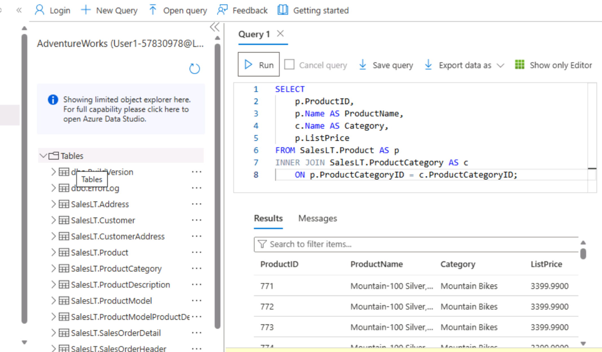

Day 3: Task 2

Please complete the below lab (4) ‘Explore non-relational data in Azure’ and paste evidence of the completed lab in the box provided.



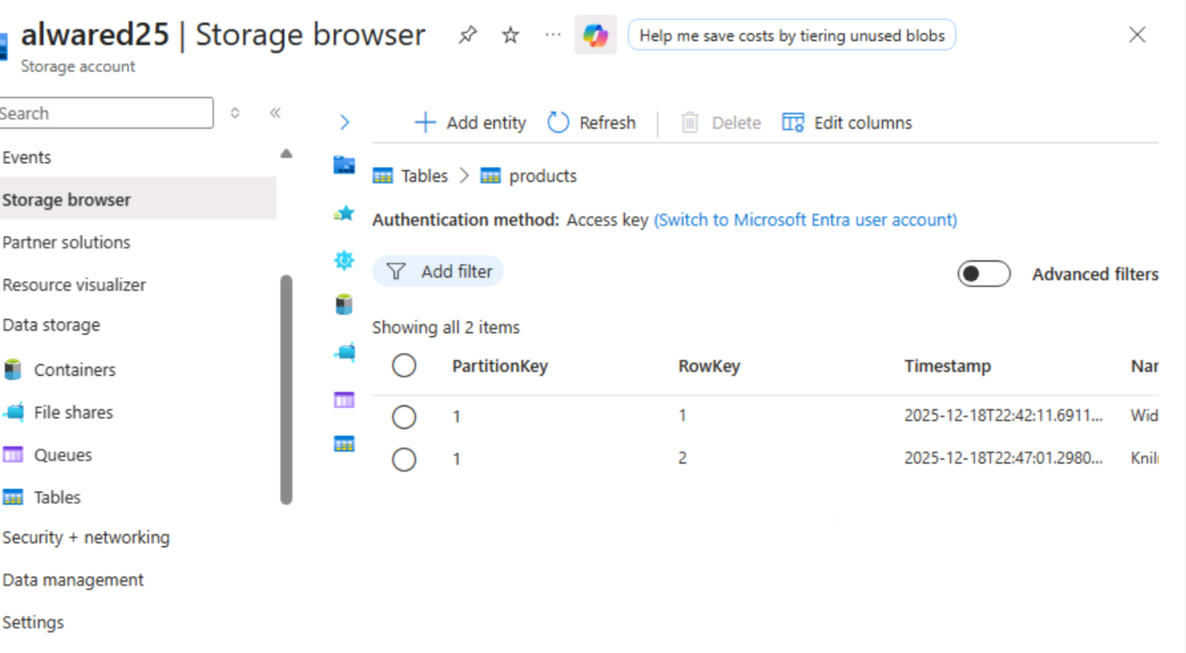
Completed lab | 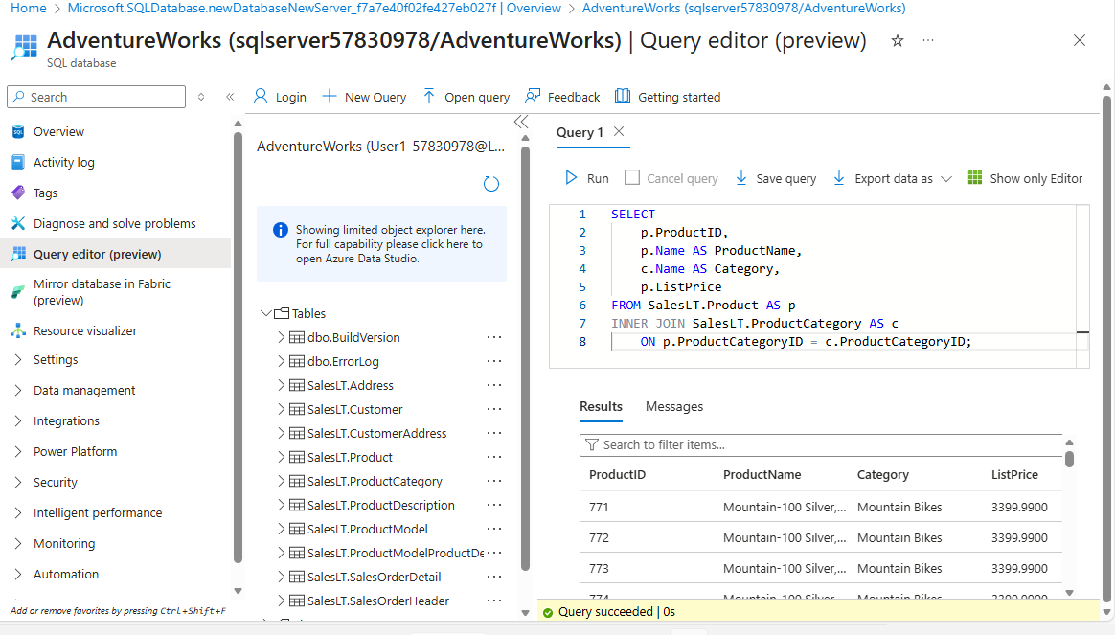

Day 3: Task 3

Please complete the below lab (5) ‘Explore data analytics in Azure’ and paste evidence of the completed lab in the box provided.

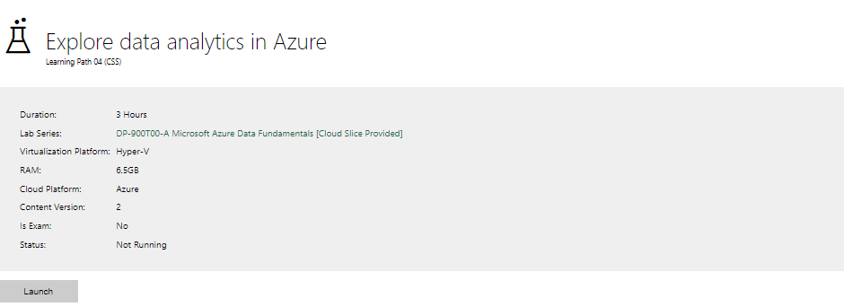

Completed lab | I have been attempting this lab multiple times, but I am consistently encountering an issue after successfully creating the Lakehouse. The process takes me to a step involving Parquet files, but I am unable to name the resulting table 'taxi_rides'. I am stuck at this point and unable to proceed."  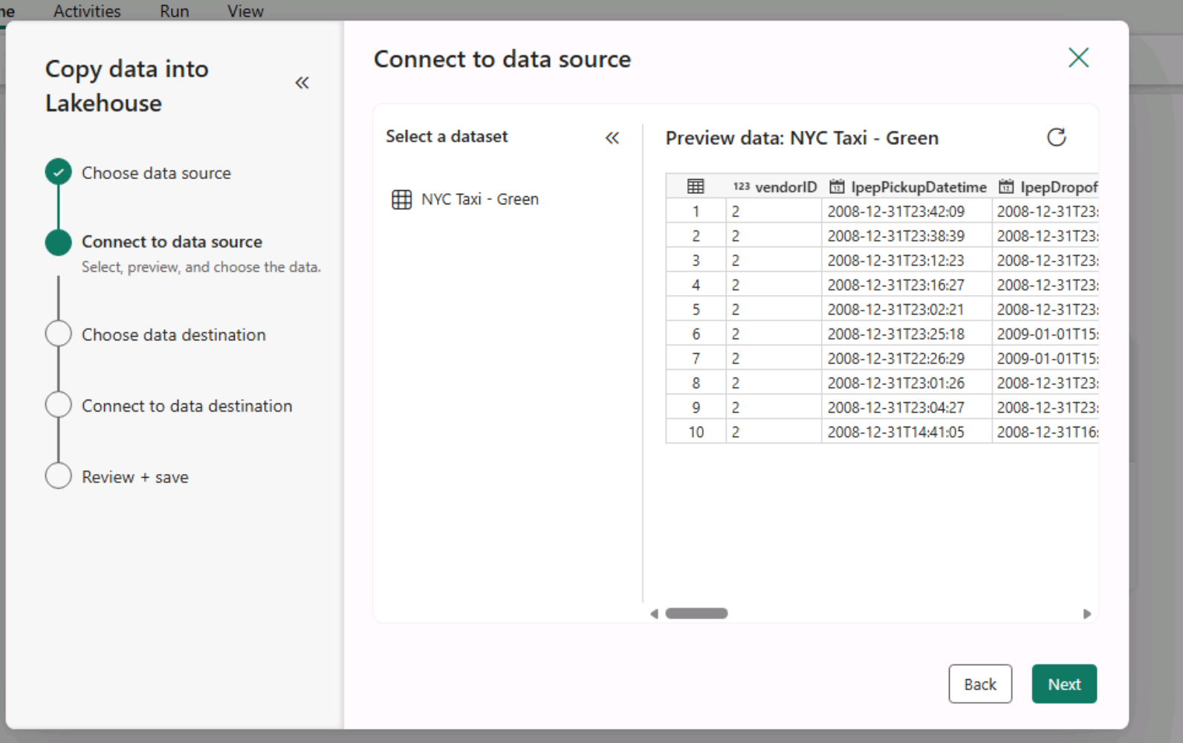  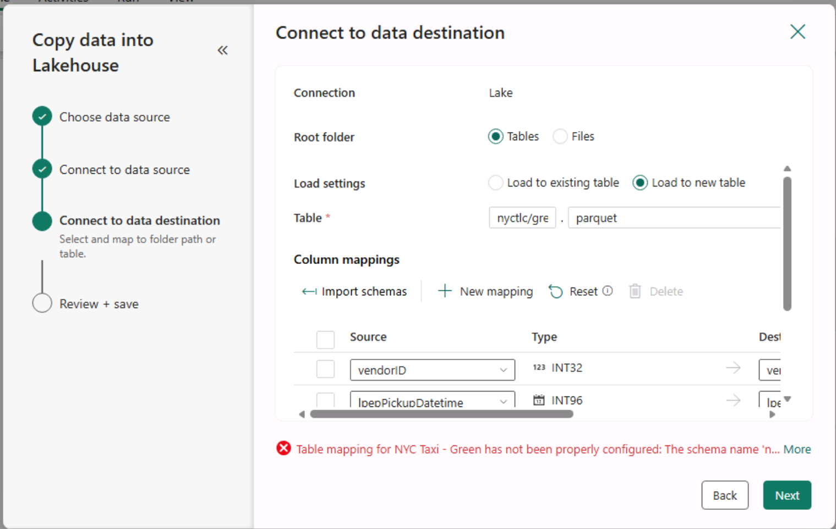

Day 4: Task 1

In your teams, complete the Azure DP-900 practice exam and paste your result below – this is open book and please research and discuss your answers as a team.


Result | 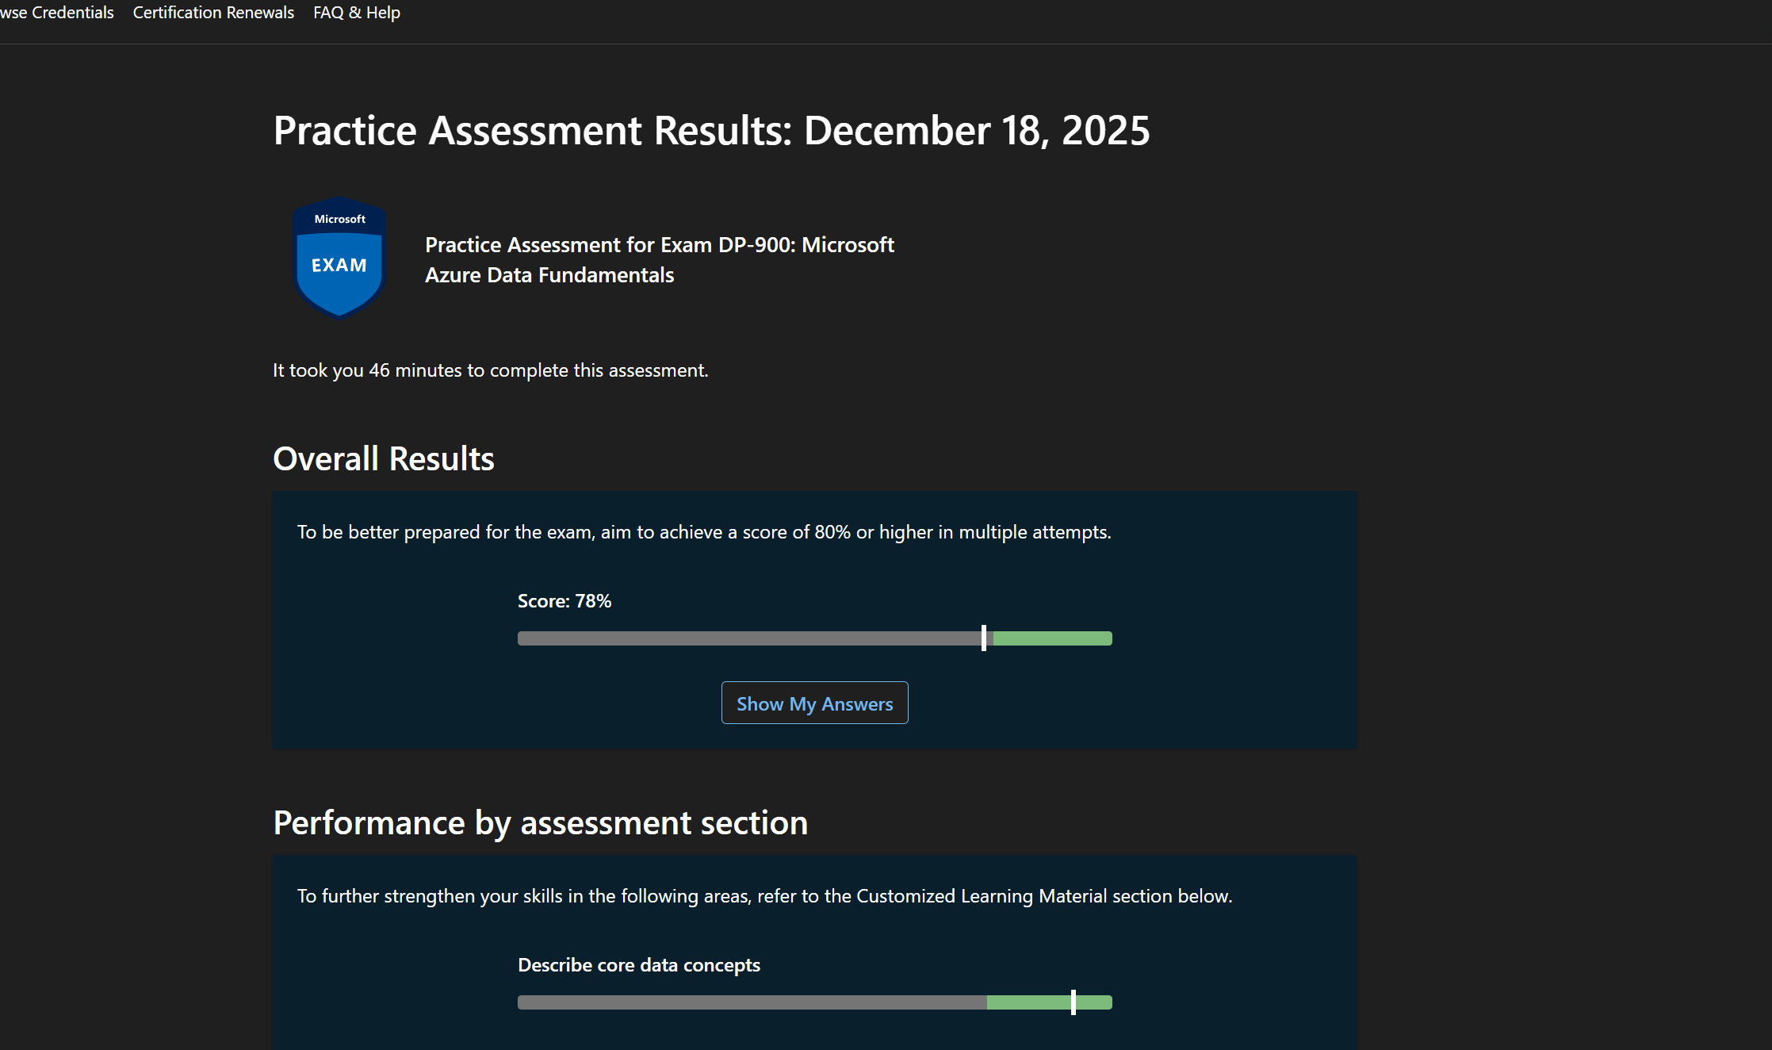

Day 4: Task 2

1. Scenario Background
"Paws & Whiskers" is a growing pet shop that aims to improve its business by analysing sales, customer information, and inventory data. Currently, the data is collected manually or stored in spreadsheets. Management is interested in transitioning to Microsoft Azure to streamline data storage, analysis, and reporting, enabling them to make data-driven decisions.

2. Data Laws and Regulations
Identify and explain the data laws and regulations relevant to handling customer data within the proposal. Ensure you cover the following points:
- GDPR Compliance: Highlight the importance of adhering to the General Data Protection Regulation (GDPR), particularly as it relates to storing and processing customer information.
- Data Protection Act (DPA) 2018: Outline how the DPA 2018 may affect the way "Paws & Whiskers" collects and stores data, ensuring compliance with UK laws on data privacy.
- Other Industry Standards: Research any additional data protection standards or regulations that may apply to pet shop data, particularly if they involve sensitive or payment information.

3. Azure Service Recommendations
Recommend Microsoft Azure services that would suit the company’s data analysis needs and explain why these services are suitable. Your recommendations should include:
- Data Storage: Identify suitable storage options, such as Azure Blob Storage or Azure SQL Database, and discuss the benefits of each for storing large datasets, including inventory, sales transactions, and customer details.
- Data Analysis Tools: Recommend tools such as Azure Machine Learning for customer behaviour analysis or Azure Synapse Analytics for analysing sales trends.
- Data Integration and Automation: Explain how services like Azure Data Factory could automate data collection and integration processes, improving efficiency.

4. Data Types and Data Modelling
Define the types of data "Paws & Whiskers" will need to work with and describe your approach to data modelling:
- Data Categories: Identify key data types, such as customer demographics, transaction history, pet inventory, and product categories.
- Data Modelling Approach: Outline how you would structure this data using a relational model or a data warehouse approach, considering factors like tables, entities, relationships, and primary keys.

5. Data Storage Formats and Structures in Azure
Discuss how you would store data within Azure and the formats you would recommend:
- Data Formats: Specify recommended formats (e.g., CSV for raw data imports, JSON for structured data, Parquet for analytics) and explain why these formats are suitable for specific data types.
- Data Security and Encryption: Include recommendations for securing data using Azure’s built-in encryption features and access controls to ensure compliance with data privacy regulations.

6. Additional Considerations
Provide any other considerations that might enhance data handling and efficiency in Azure, such as:
- Backup and Disaster Recovery: Outline a backup plan using Azure Backup or Azure Site Recovery to safeguard against data loss.
- Data Visualisation: Discuss potential use of Power BI within Azure for creating dashboards that provide management with real-time insights into sales and customer trends.
- Future Scalability: Comment on how Azure services can scale as the business grows, accommodating larger datasets and more complex analyses.

Submission Guidelines:
- Structure: Ensure your report is well-organised, with sections for each task (e.g., Data Laws, Azure Services, Data Types, etc.).
- Formatting: Include headings, bullet points where appropriate, and any visuals or diagrams that support your explanations.
- References: Cite any resources or regulations referenced in the report.
- Length: Aim for 1500-2000 words.

Please see the other file attached to this email.

Course Notes

It is recommended to take notes from the course, use the space below to do so, or use the revision guide shared with the class:

Additional Information

We have included a range of additional links to further resources and information that you may find useful, these can be found within your revision guide.

END OF WORKBOOK

Please check through your work thoroughly before submitting and update the table of contents if required.

Please send your completed work booklet to your trainer.

