

Data Technician

Name: Alaa Mostafa
Course Date: 16/12/24
Table of contents
Day 1: Task 1 2
Day 2: Task 1 2
Day 2: Task 2 3
Day 2: Task 3 4
Day 3: Task 1 4
Day 3: Task 2 5
Dataset: 5
Step 1: Create a Pivot Table 5
Step 2: Use the SWITCH Function 5
Submission: 6
Day 3: Task 3 6
Day 4: Task 1 7
Course Notes 9
Additional Information 10

Day 1: Task 1

Please complete the below boxes on commons laws and regulations that must be followed when working with customers data, use the below bulleted list to support your answers.

- What is it
- Why is it important
- Provide a real-world example of how you can follow it
- How does it impact working with data
- What could happen if you breached it

Data Protection Act | The Data Protection Act (DPA) is a law that controls how personal information is used by organizations, businesses, and the government.  Protects individuals’ privacy  Prevents identity theft and fraud  Gives people control over their data  Legal Consequences
GDPR | GDPR is a law that makes sure companies keep your personal data safe, use it fairly, and tell you what they are doing with it.  GDPR makes sure personal information (like your name, email, location, health info) is kept safe and not misused.  Makes companies responsible  You protect your online accounts so your personal data stays secure.
Freedom of Information Act | It means taking steps to keep your online accounts safe so no one can access your personal information.  these actions stop other people from breaking into your accounts and stealing your personal data (like messages, photos, bank info, or emails).
Computer Misuse Act | The Computer Misuse Act is a law that makes hacking, spreading viruses, and accessing computer systems without permission illegal.  Protects personal data, Protects organizations, Prevents crime, Ensures online safety  You never try to log into someone else’s email, social media, or online account without their permission. You also avoid downloading or sharing viruses, malware, or hacking tools.

Day 2: Task 1

Please research and complete the following tasks within the retail-sales_dataset.xlsx document, paste a print screen into the provided boxes below:

- In the sheet ‘retail_sales_dataset’ add all available data between columns A –J into a ‘table’
- Using the ‘sort’ function, sort ‘Age’ to ‘largest to smallest’
- Using the ‘SUM’ function, show me the commission total in cell ‘L10’
- Using the ‘AVERAGE’ function, show me the average commission in cell ‘L11’

Print screen 1 | 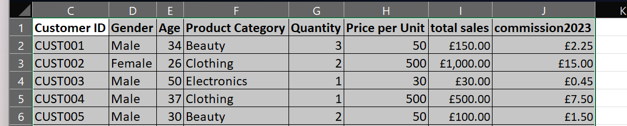
Print screen 2 | 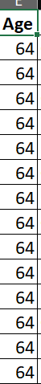
Print screen 3 | 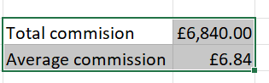
Print screen 4 | 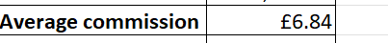

Day 2: Task 2

Please research and complete the following tasks within the retail-sales_dataset.xlsx document, paste print screens into the provided box below:



Print screen 1

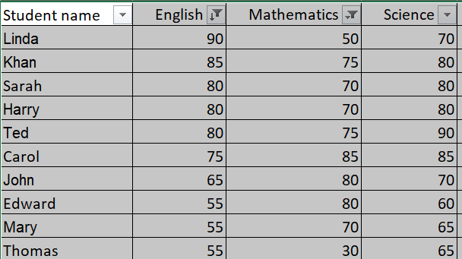
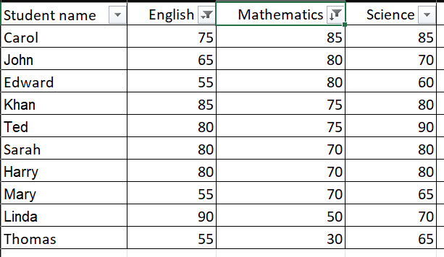

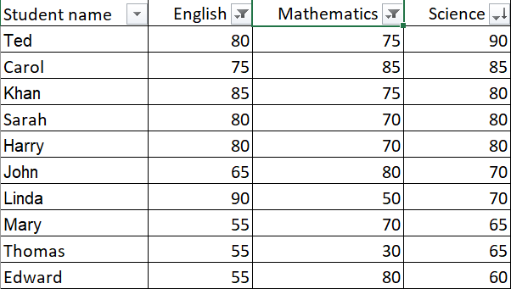
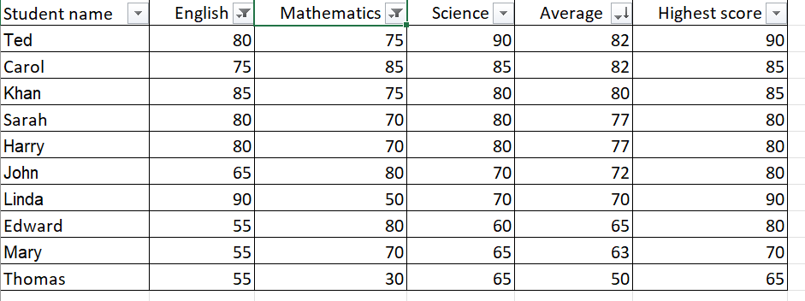
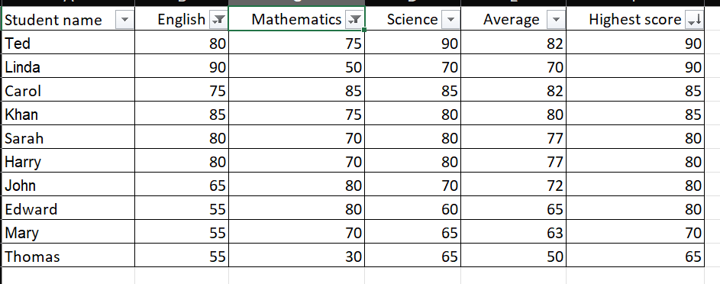
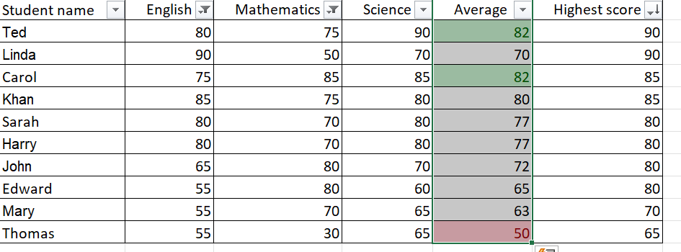

Day 2: Task 3

Using the skills developed today, have some fun with the data set you have imported. Paste your work below and enjoy!

Print screen 1

Day 3: Task 1

Please download the dataset ‘Day_3_Task_1_Bike_Sales_Pivot_Lab.xlsx’ and the lab instructions.

Do not worry if you do not complete the lab, just working with data and playing with the pivot table will be good experience.

Please paste your final pivot table below and complete the reflection questions:

Print screen 1 | 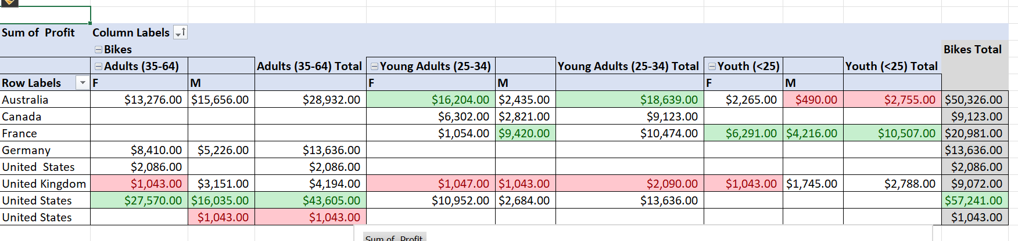
In which markets does Germany have customers? | Only adults 35-64
What country has sales in all markets? | The United States.
What are the most profitable markets by country, age group, and gender? | By country: USA,  By Audults male and Female: USA .  By Young Adults: Australia  By Young Adults Female: Australia  By Youth Male: France  By Young Female: France
Any other findings? | United Kingdom appears to have some of the lowest or most problematic profit figures, with several cells shaded red.

Day 3: Task 2

The dataset below tracks the sales performance of different products in various counties in England. Please paste the dataset into a blank Excel workbook. Your task is to:
- Create a Pivot Table to summarise the data by county and product.
- Use the SWITCH function to categorise products based on their sales volume.

Dataset:
County | Product | Sales Volume
Yorkshire | Laptops | 500
Yorkshire | Smartphones | 200
Cornwall | Laptops | 700
Cornwall | Printers | 400
Lancashire | Smartphones | 150
Lancashire | Laptops | 600
Essex | Printers | 800
Essex | Smartphones | 300
Durham | Laptops | 250
Durham | Printers | 300
Greater Manchester | Smartphones | 600
Greater Manchester | Laptops | 400

Step 1: Create a Pivot Table
- Select the dataset (columns A to C).
- Insert a Pivot Table to summarise the data by County in the rows and Products in the columns. Use Sales Volume as the value to be summarised.

Step 2: Use the SWITCH Function
In a new column next to your data, use the SWITCH function to categorise products based on Sales Volume as follows:
  - For sales greater than 600: "High"
  - For sales between 300 and 600: "Medium"
  - For sales less than 300: "Low"
SWITCH Function Example:
=SWITCH(TRUE, C2 > 600, "High", C2 >= 300, "Medium", "Low")
- Apply this formula to each row, and check if the products are categorised correctly.

Submission:
- A completed Pivot Table summarising sales by county and product.
- A new column in the dataset categorising products by sales volume using the SWITCH function.
  - Please paste your completed work below

Print screen 1 | 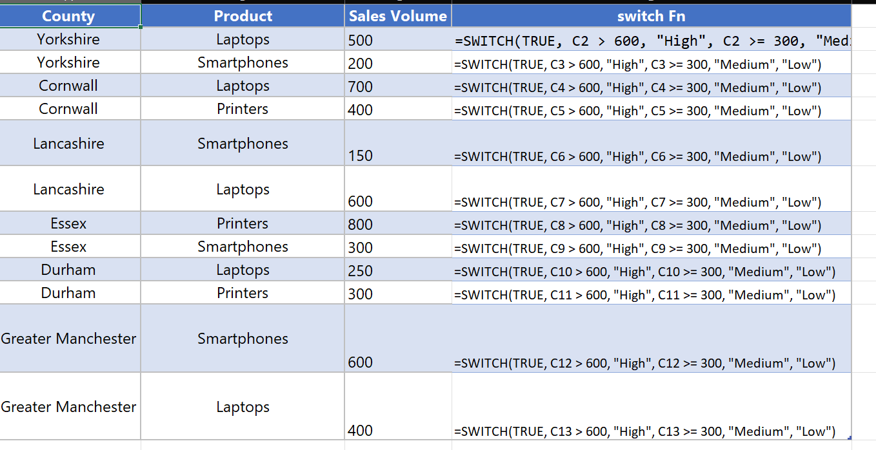  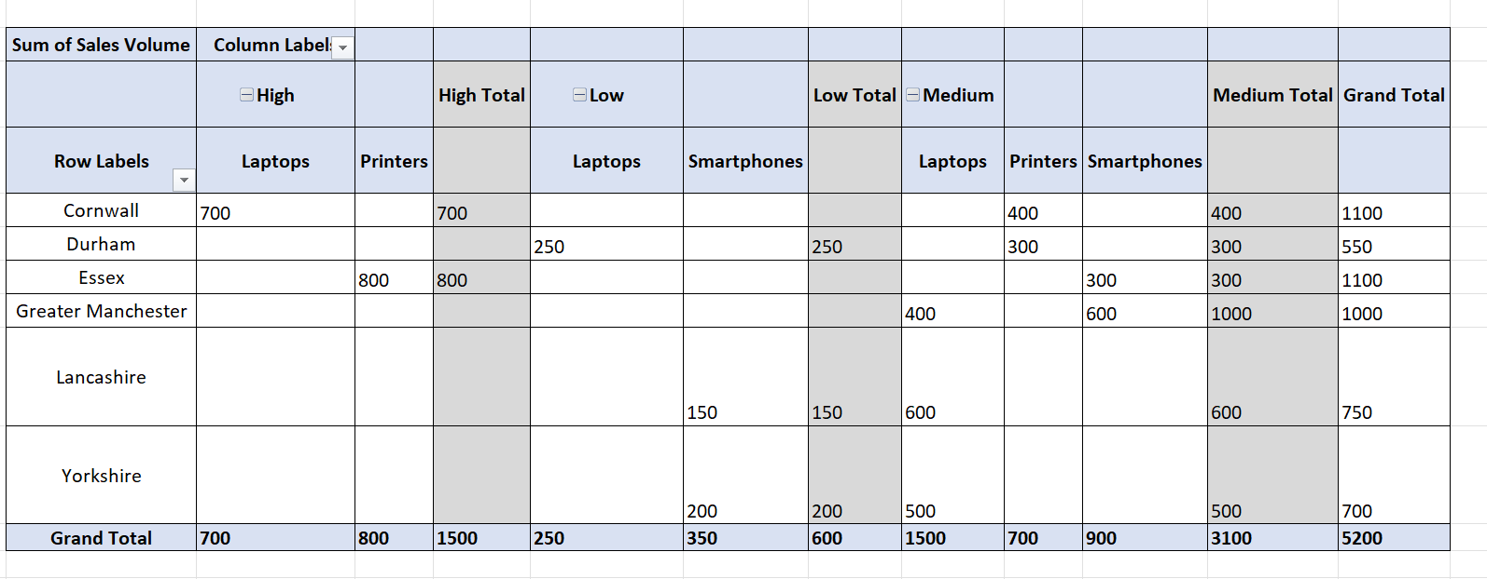

Day 3: Task 3

Please download the dataset ‘Day_3_Task_3_Bike_Sales_Visualisations_Lab.xlsx’ and the the lab instructions. Do not worry if you do not complete the lab, just working with data and playing with the charts will be good experience.

Please paste your results below:

Print screen 1 | 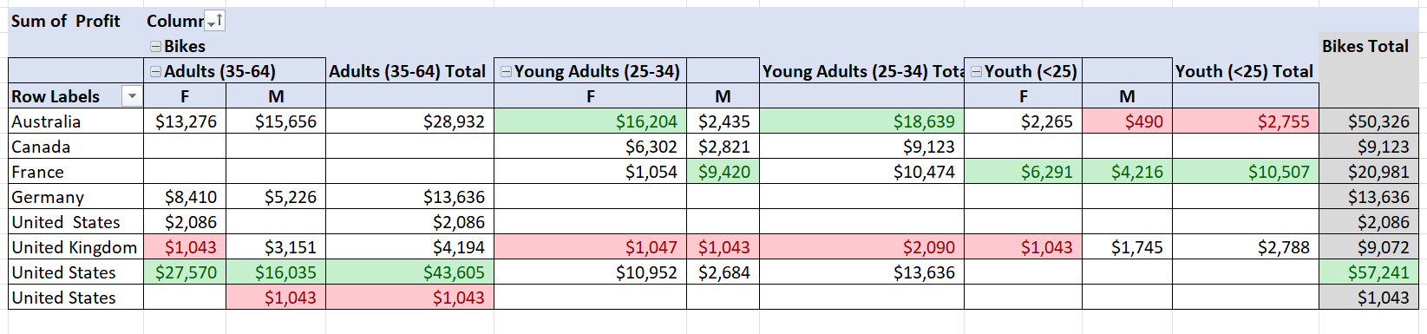

Day 4: Task 1

You have been asked to deliver your analysis findings to the board of directors, with your analysis you have identified that customers are leaving your company at the 12-month point, this is typically when they receive their renewal price.

Conduct research and complete the below questions:
How would you prepare for the delivery? | The preparation can be broken down into three core phases: Content Development, Visual Presentation, and Rehearsal.  The "What": Clearly state the finding: "Customers are leaving at the 12-month mark."  The "When": Immediately link this to the trigger: "Receipt of the renewal price."  The "Impact": Quantify the loss. What is the Churn Rate at 12 months? What is the corresponding Lost Revenue (in absolute terms and as a percentage of total revenue)? Include the Lost Customer Lifetime Value (CLV).
What tools would you use for the delivery? | Microsoft Excel/Google Sheets (for raw data/pivot tables) and Tableau, Power BI
What is prospecting and why would you complete this before your delivery? | In sales, prospecting is the first step in the sales cycle. It is the systematic process of identifying and engaging potential customers (prospects) who fit your ideal customer profile and are likely to buy your product or service.  The goal is to move a contact from a 'lead' (a potential fit) to a 'qualified prospect' (a confirmed fit with budget, authority, need, and timeframe).
Tell me best practices for public speaking and providing updates to senior leaders | These practices ensure you deliver your message with confidence, clarity, and impact.  Start with the Conclusion, Impact, and Recommendation  Focus on Impact and Action and Be Prepared for the Q&A
What will you show the board in your delivery? | The Problem, The Cause, and The Recommendation
How will you articulate the changes that are needed? | I will present a clear, concise operational plan, articulating that the required change is a shift in your Retention and Pricing Model.
Provide a list of online resources and videos that will support your preparation for public speaking  Evaluate tools that provide visualisation. | - YouTube Channels & Videos (Quick, Tactical Tips)  - Online Courses (Structured Learning) like Coursera, Udemy,and edX.  The evaluation of data visualization tools for an executive presentation, such as your board delivery, centers on Executive-Level Functionality, Integration, and Ease of Use.
Tell me what they are.  Tell me what you would choose when delivering your presentation and why | These tools are crucial because the final delivery to the board will likely happen within one of these presentation environments.  To deliver your presentation to the board effectively, I would choose a combination of specific tools and techniques, prioritizing impact, data credibility, and executive-level clarity.

Course Notes

It is recommended to take notes from the course, use the space below to do so, or use the revision guide shared with the class:

Additional Information

We have included a range of additional links to further resources and information that you may find useful, these can be found within your revision guide.

END OF WORKBOOK

Please check through your work thoroughly before submitting and update the table of contents if required.

Please send your completed work booklet to your trainer.

