

Data Technician

Name:
Course Date:
Table of contents
Day 1: Task 1 2
Day 1: Task 2 2
Day 2: Task 1 3
Day 2: Task 2 3
Day 3: Task 1 4
Day 3: Task 2 5
Day 4: Task 1 6
Day 4: Task 2 7
Course Notes 7
Additional Information 8

Day 1: Task 1

Please research the different versions of Tableau, compare and contrast them below and explain the limited functionality on ‘Tableau Public’.

Different Tableau versions
  Version | Primary Purpose | Environment | Cost
  Tableau Desktop | Authoring (Creating visualizations, dashboards, stories) | Desktop Application (Windows/Mac) | Paid Subscription (Professional or Creator)
  Tableau Server | Sharing & Collaboration (Publishing, securing, and managing content) | Self-hosted (On-premise or Private Cloud) | Paid Subscription
  Tableau Cloud (formerly Tableau Online) | Sharing & Collaboration (Publishing, securing, and managing content) | Tableau-hosted Cloud (SaaS) | Paid Subscription
  Tableau Public | Free Authoring & Public Sharing (Learning and sharing public data visualizations) | Desktop App and Cloud Platform | Free
  Tableau Reader | Viewing (Interacting with local Tableau files) | Desktop Application | Free
  Tableau Prep Builder | Data Preparation (Cleaning, shaping, and combining data) | Desktop Application | Paid Subscription

Day 1: Task 2

Using the EMSI_JobChange_UK dataset, create your own dashboard, I want to see a bar chart showing percentage change and a UK based map showing the key city locations impacted.

Paste your print screen here | 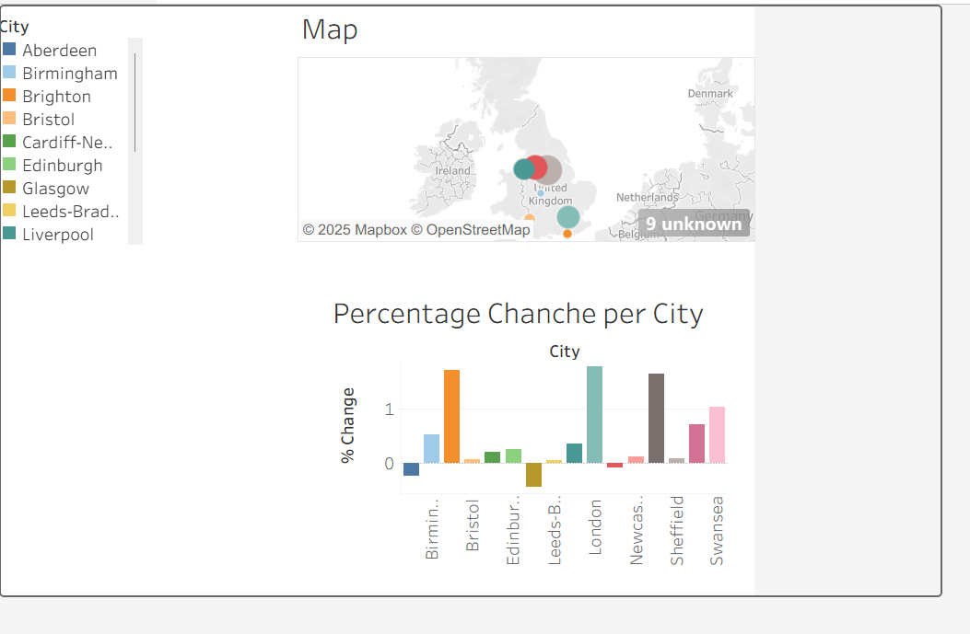

Day 2: Task 1

Using the Spotify data set, conduct an analysis to find trends and key information that could be used by an organisation for future projects.

There is no set scope for the analysis, simply to find trends and document them below:

Paste your print screens here | 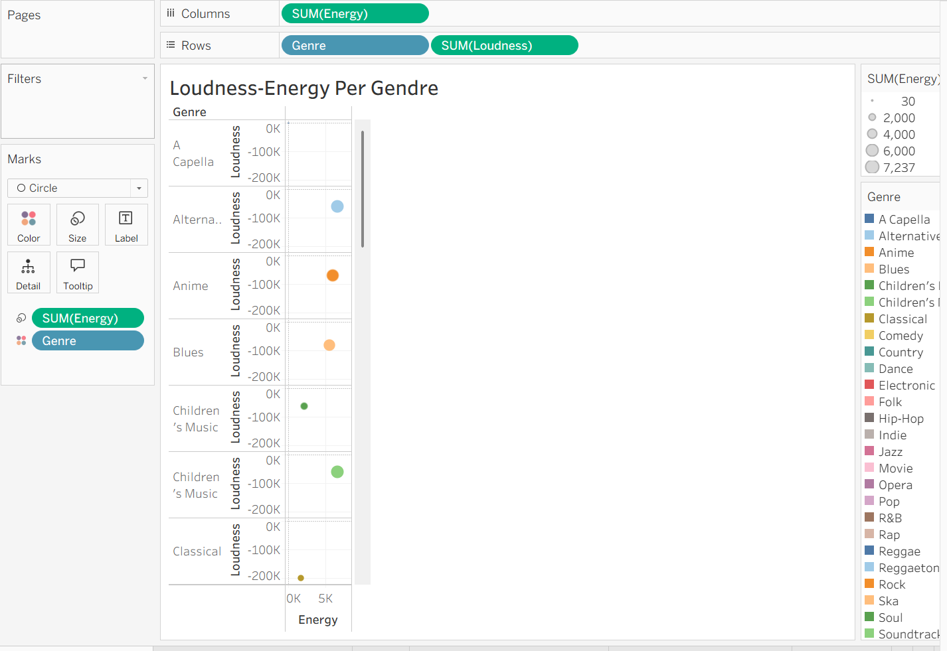  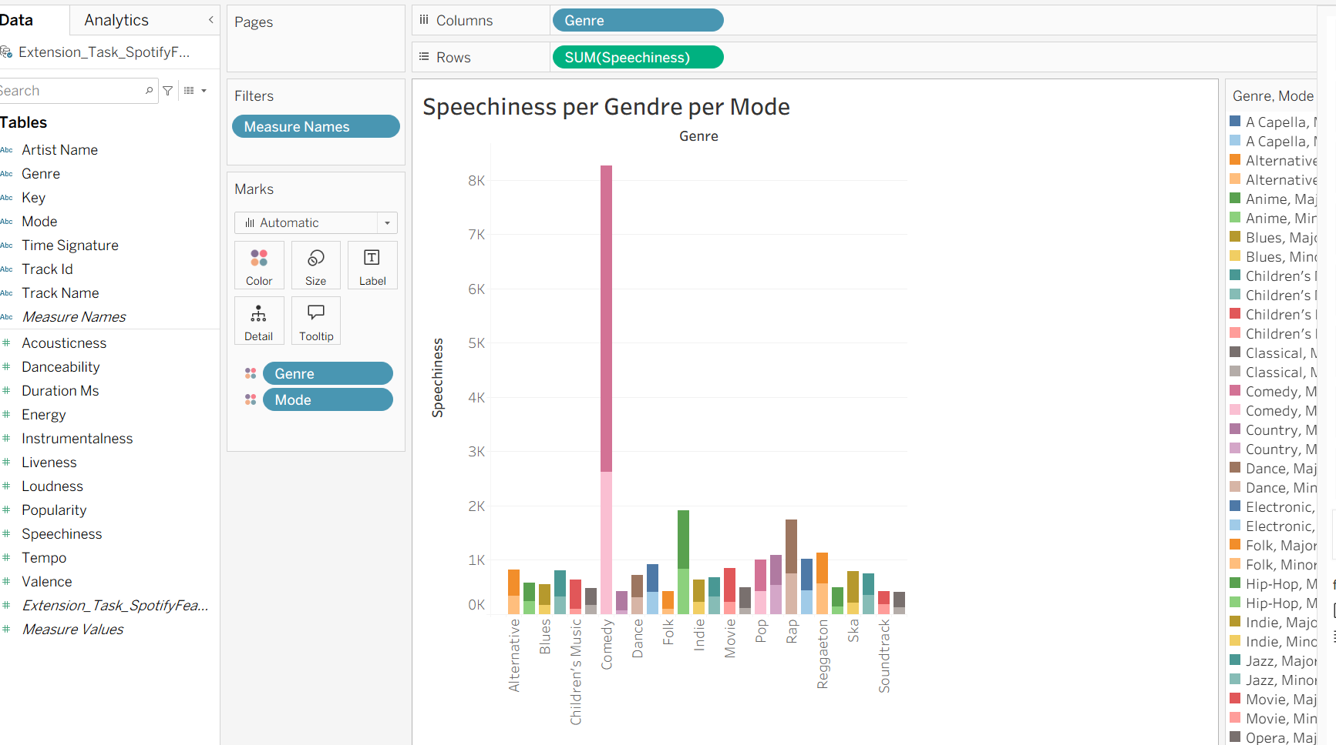  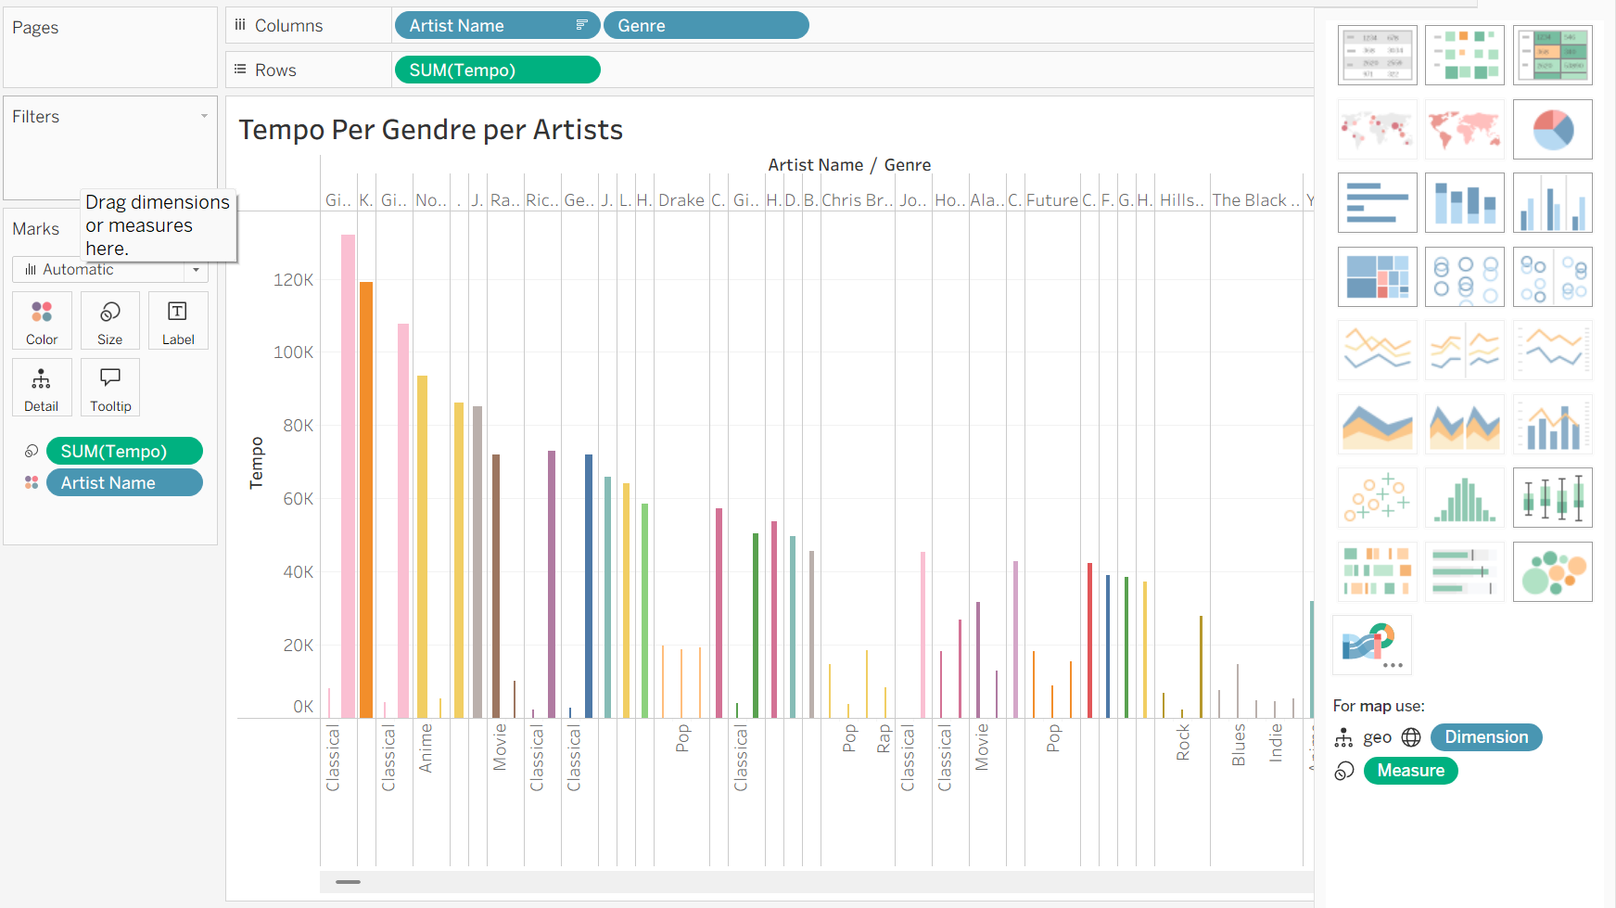  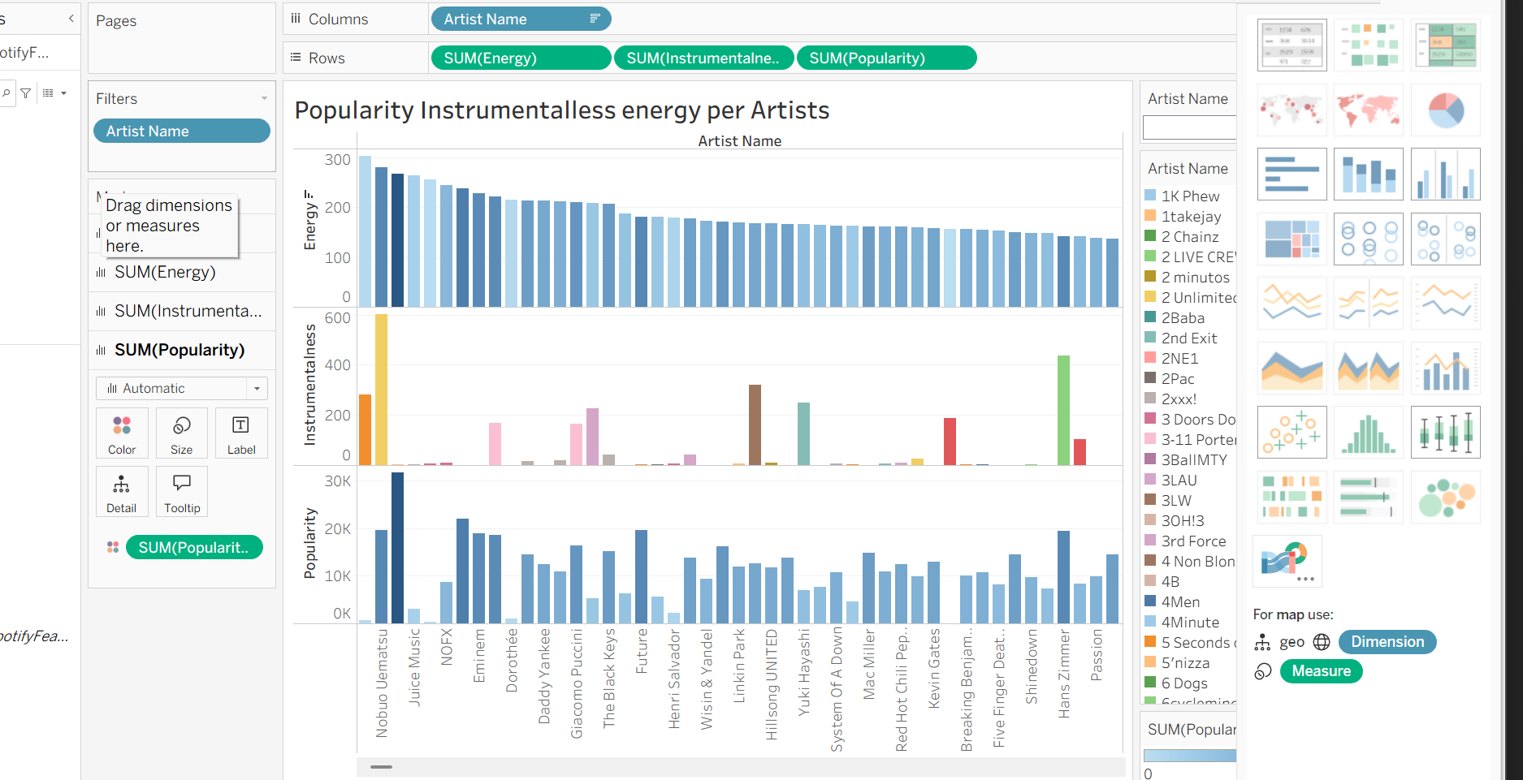  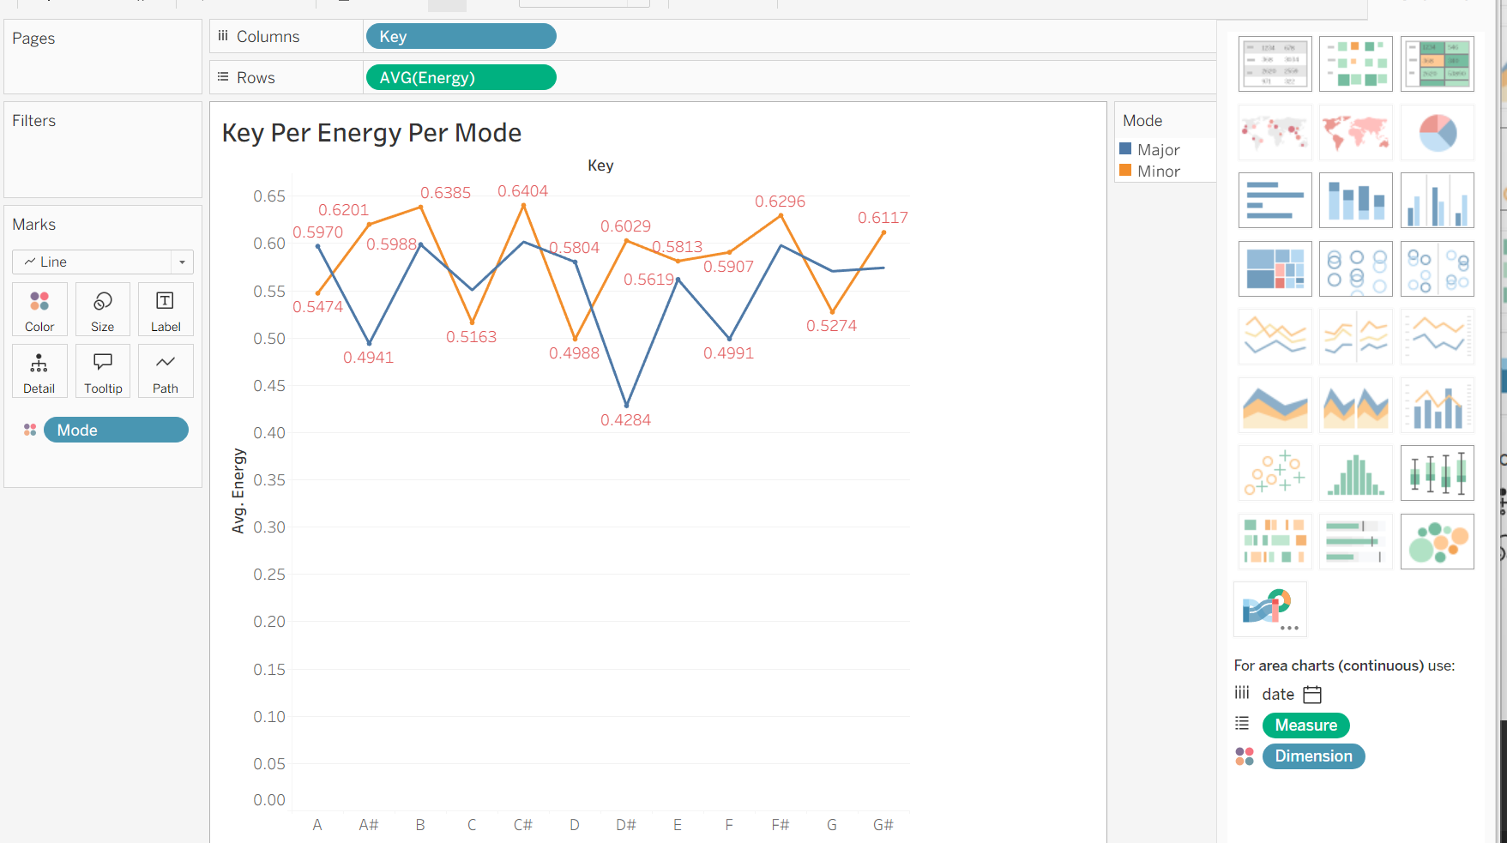

What did you find? | The visual can see which artist has  Very High Popularity  High Valence (Happy, Positive)  High Tempo (Fast-Paced)  High Loudness (Loud, Compressed)  Low Speechiness (Mostly Singing)

Day 2: Task 2

Using the Health, conduct an analysis to find trends and key information that could be used by an organisation for future support.

There is no set scope for the analysis, simply to find trends and document them below.

- Data can be lifesaving and is being used more within the NHS, reflect on how this data could support decision making for the NHS.

Paste your print screens here | 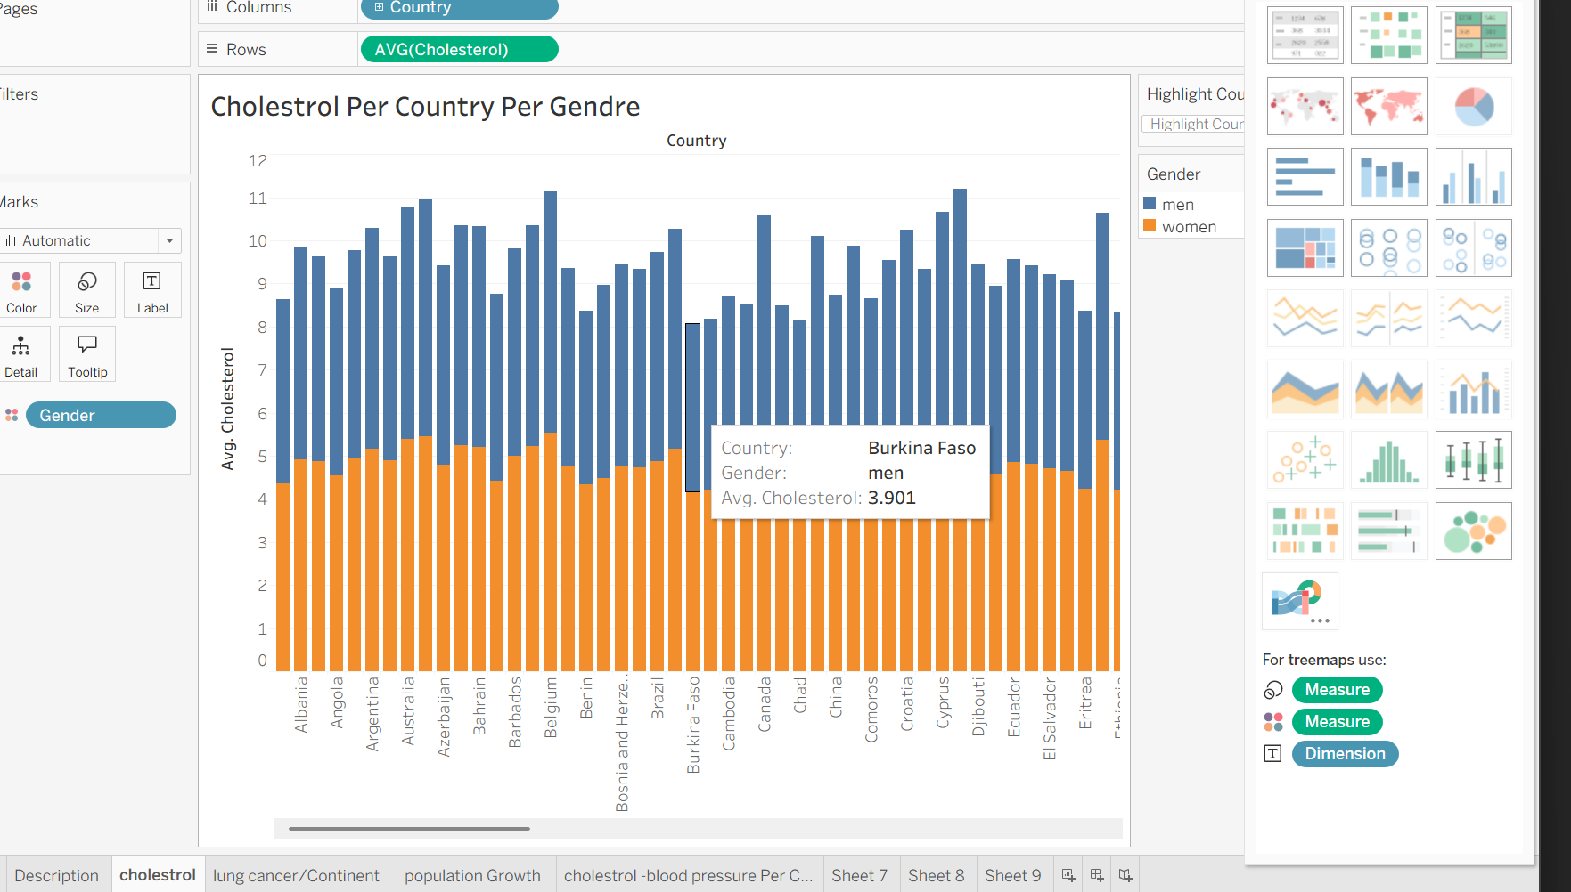  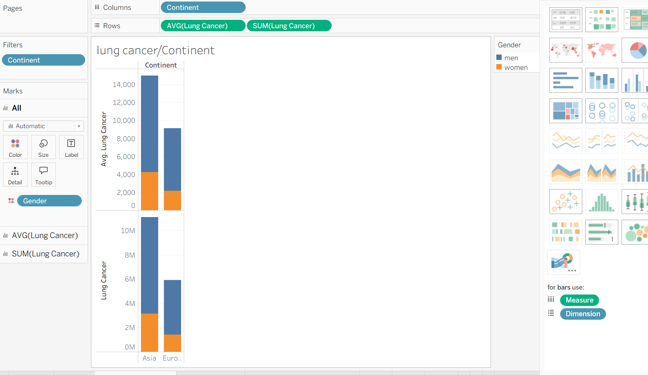  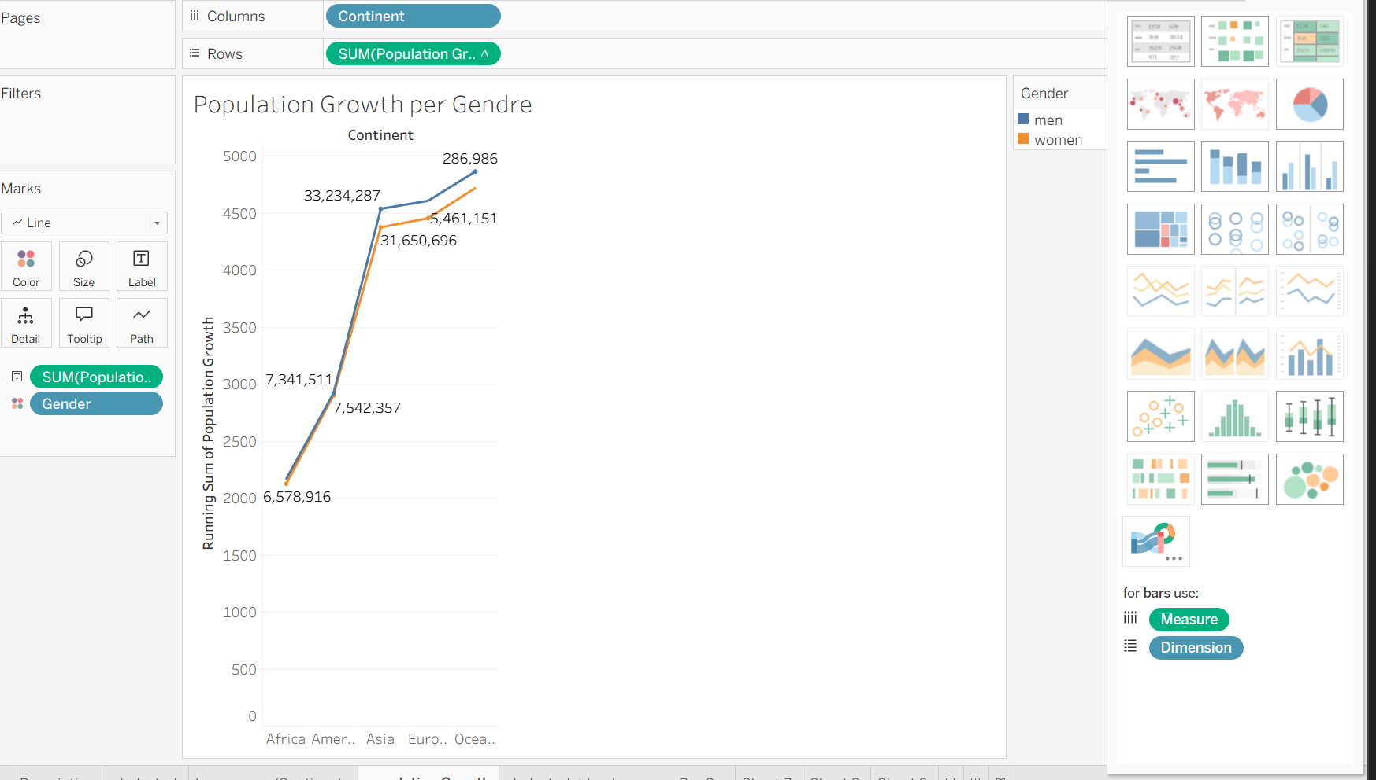  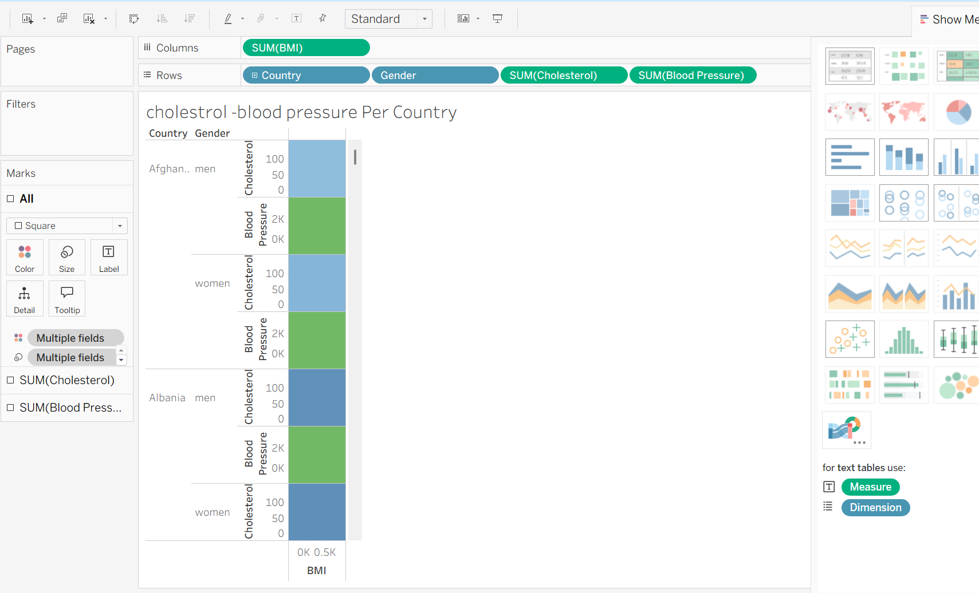
What did you find and any reflections on how the NHS could use this? | Global health data, such as worldwide rates of lung cancer, liver cancer, cholesterol, and blood pressure, is vital to the NHS. It primarily helps the NHS through strategic benchmarking and future-proofing its healthcare system, moving beyond national statistics to understand its performance in a global context.

Day 3: Task 1

Please complete Lab 1 ‘Get Data in Power Bi Desktop’. Once complete, paste a print screen below and in the collaboration board.

“Teaching is the best way to learn, so please listen out for support requests from the class and we’ll work through the challenges together”

Paste your completed lab here | 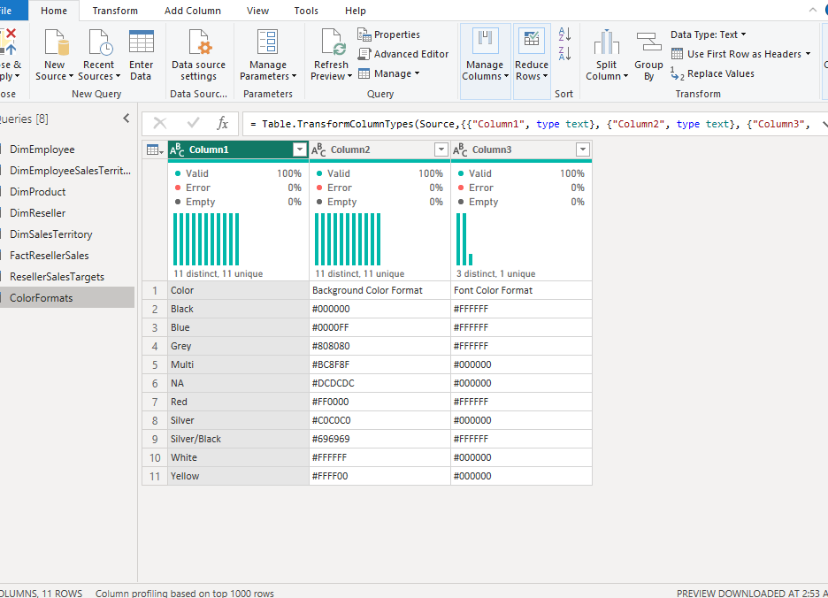

Day 3: Task 2

Please complete Lab 2 ‘Load Transformed Data in Power BI Desktop’. Once complete, paste a print screen below and in the collaboration board.

“Teaching is the best way to learn, so please listen out for support requests from the class and we’ll work through the challenges together”

Paste your completed lab here | 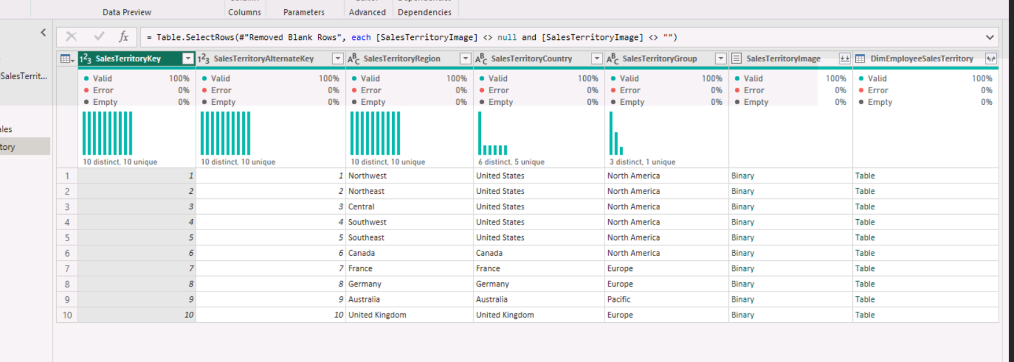

Day 4: Task 1

Please complete Lab 8 ‘Design a Report in Power BI Desktop’. Once complete, paste a print screen below and in the collaboration board.

“Teaching is the best way to learn, so please listen out for support requests from the class and we’ll work through the challenges together”

Paste your completed lab here | 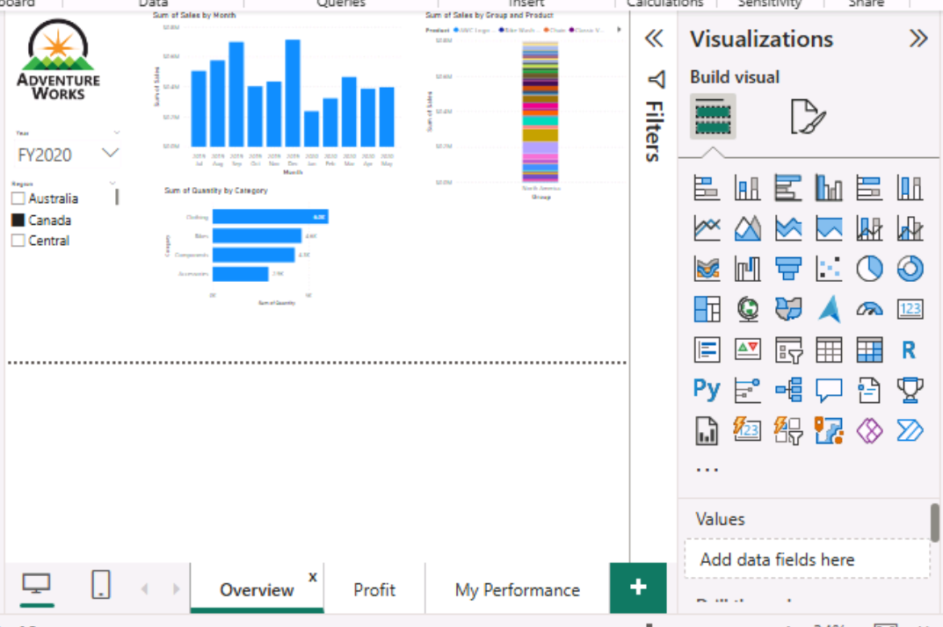  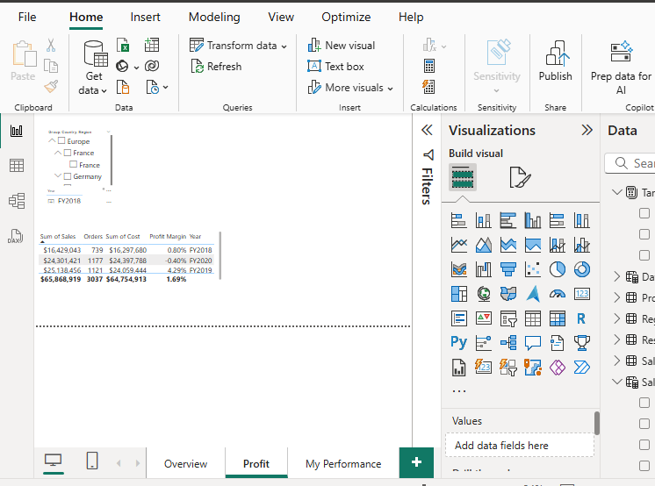  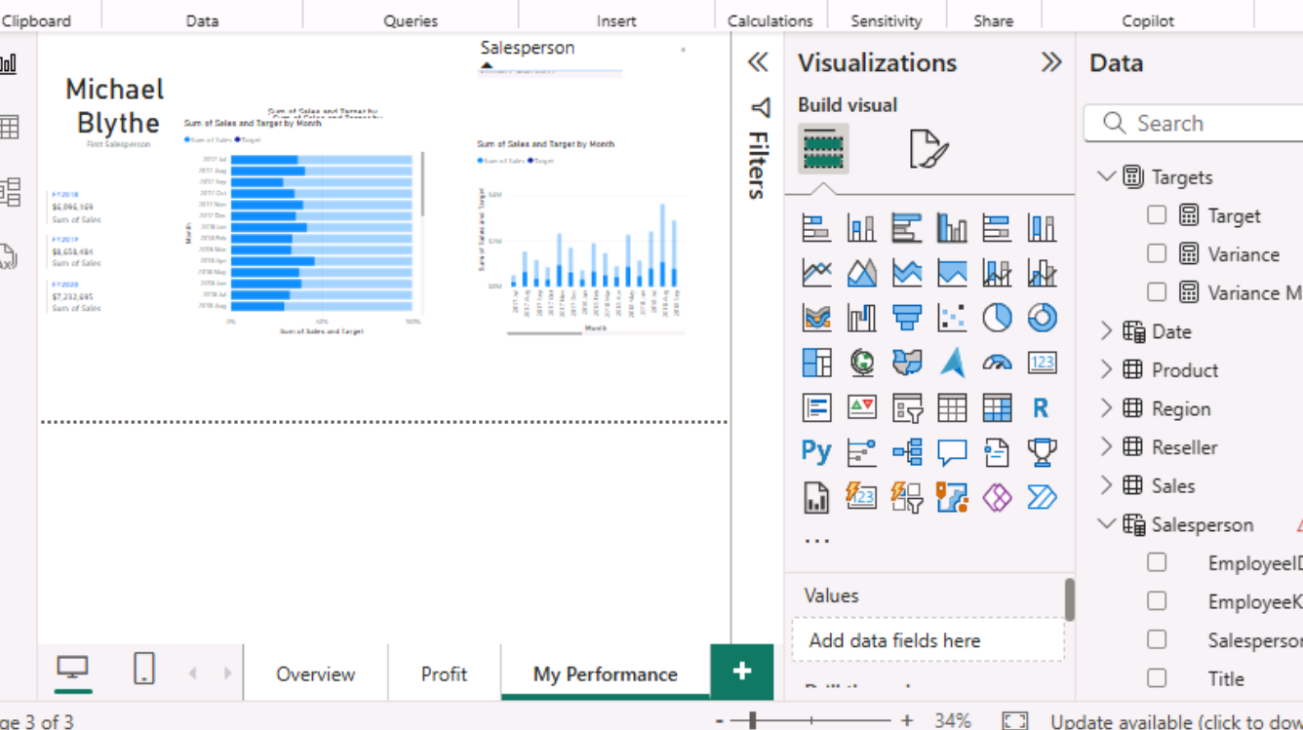

Day 4: Task 2

Please complete Lab 12 ‘Create a Power BI Dashboard’. Once complete, paste a print screen below and in the collaboration board.

“Teaching is the best way to learn, so please listen out for support requests from the class and we’ll work through the challenges together”

Paste your completed lab here | 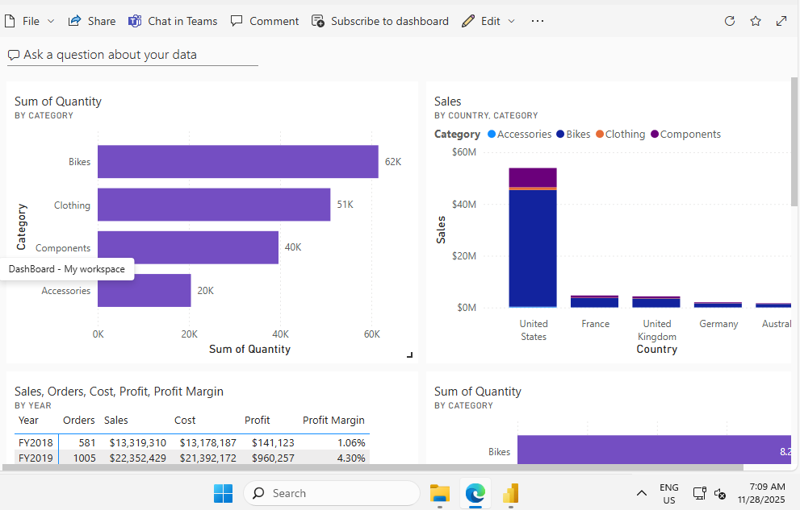  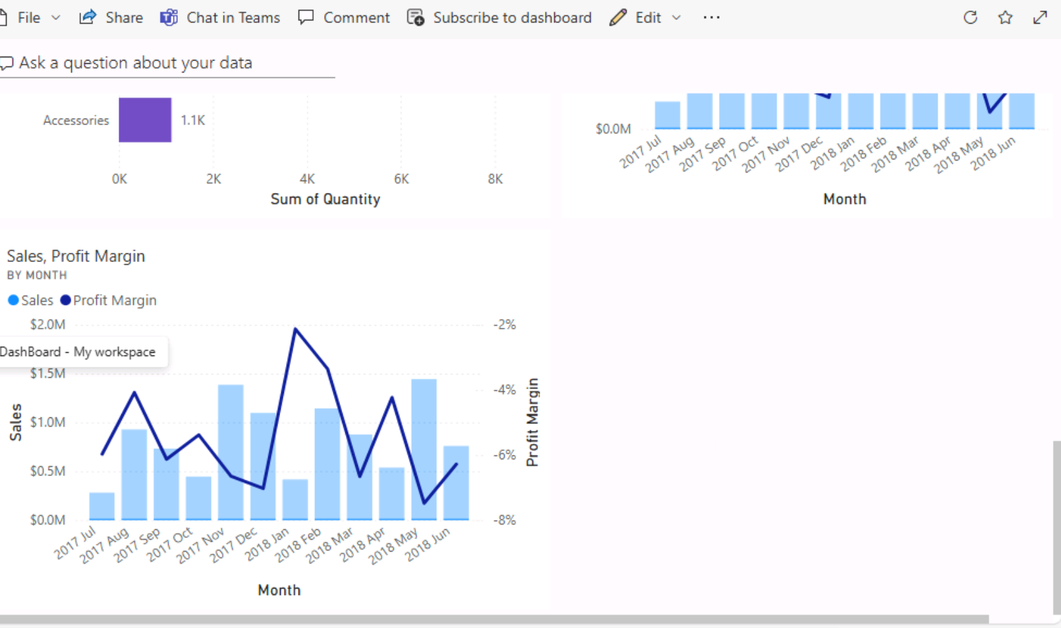

Course Notes

It is recommended to take notes from the course, use the space below to do so, or use the revision guide shared with the class.

We have included a range of additional links to further resources and information that you may find useful, these can be found within your revision guide.

END OF WORKBOOK

Please check through your work thoroughly before submitting and update the table of contents if required.

Please send your completed work booklet to your trainer.

Information

