

Data Technician

Name:
Course Date:
Table of contents
Day 1: Task 1 3
Day 1: Task 2 3
Day 3: Task 1 4
Day 4: Task 1: Written 6
Day 4: Task 2: SQL Practical 9
Course Notes 19
Additional Information 19

Day 1: Task 1

Please research and complete the below questions relating to key concepts of databases.

What is a primary key? | It is a specific column or a set of columns in a database table that is used to uniquely identify every single record (row) within that table.
How does this differ from a secondary key? | The key difference between a Primary Key (PK) and a Secondary Key lies in their purpose, uniqueness requirement, and role in defining the structure and integrity of the database table.
How are primary and foreign keys related? | The Primary Key (PK) and the Foreign Key (FK) are fundamentally related because the Foreign Key in one table references or points to the Primary Key in another table.  Their relationship is the mechanism used to link tables together in a relational database, establishing the relationship itself and enforcing data consistency.
Provide a real-world example of a one-to-one relationship | A classic and clear real-world example of a one-to-one (1:1) relationship in a database context is between a User and their specific User Profile or Login Credential.  For every single record in the USERS table, there is exactly one and only one corresponding record in the LOGIN_CREDENTIALS table.
Provide a real-world example of a one-to-many relationship | A very common and essential real-world example of a one-to-many (1:M) relationship in a database is between Departments and Employees in an organization.  A single Department can have many Employees, but each Employee works for only one Department.
Provide a real-world example of a many-to-many relationship | A very common and essential real-world example of a many-to-many (M:M or N:M) relationship in a database is between Students and Courses in an academic system.  A single Student can enroll in multiple Courses, and a single Course is attended by multiple Students.

Day 1: Task 2

Please research and complete the below questions relating to key concepts of databases.

What is the difference between a relational and non-relational database? | The difference between Relational Databases (SQL) and Non-Relational Databases (NoSQL) centres on their data structure, schema flexibility, and data integrity guarantees. They are fundamentally built to solve different types of data storage and access problems.  Relational Databases (SQL Databases)  Examples: MySQL, PostgreSQL, SQL Server, Oracle.  Key Characteristics  - Structured: Data is organized in tables with rows and columns.  - Schema-based: You must define the structure (schema) before inserting data.  - Uses SQL: Interacted with through Structured Query Language (SQL).  - Relationships: Supports relationships between tables using foreign keys.  - ACID-compliant: Strong guarantees for data integrity and transactions.  Non-Relational Databases (NoSQL Databases)  Examples: MongoDB, Cassandra, Redis, DynamoDB.  Key Characteristics  - Flexible schema or schema-less: Data can be stored without a predefined structure.  - Multiple data models:  - Document (e.g., MongoDB)  - Key–value (e.g., Redis)  - Column-family (e.g., Cassandra)  - Graph (e.g., Neo4j)  - Horizontal scaling: Designed to scale across many servers easily.  - Eventual consistency (in many systems) instead of strict ACID.
What type of data would benefit off the non-relational model?  Why? | Non-Relational databases are best suited for unstructured, semi-structured, and highly variable data where speed, massive scale, and flexible schema are prioritized over strict transactional consistency.  • Schema Flexibility: You don't need to define every possible product attribute beforehand. You can add new fields to documents on the fly without affecting the rest of the database.  • Speed: Related data (like product details and reviews) can be stored together in a single document, reducing the need for costly database joins and making retrieval very fast Here are the types of data that benefit most—and why:  - Unstructured or Semi-structured Data  - Rapidly Changing Data  - Massive, High-Volume Data (Big Data)  - Data With Highly Variable Structure  - Data With Highly Variable Structure

Day 3: Task 1

Please research the below ‘JOIN’ types, explain what they are and provide an example of the types of data it would be used on.

Self-join | A table is joined with itself.  Used for hierarchical or relationship data inside the same table.  Employee table:  - employee_id  - manager_id  A self-join can show:  - Each employee paired with their manager
Right join | Returns all rows from the right table, and matching rows from the left table.  ll records from the second table are kept, even if the first table has no matching rows.  - Show all orders, even orders whose customer information is missing or deleted.
Full join | Returns all rows when there is a match in either table.  Unmatched rows from both sides will appear with NULLs. Use when you want a complete view of both tables, including:  - Records that match  - Records that exist only in the left table  Records that exist only in the right table Comparing two datasets:  - Customer list from last year  - Customer list from this year  You can see:  - Customers who appear in both years  - Customers who appear only last year  - Customers who appear only this year
Inner join | Returns only the rows that have matching values in both tables.  Data existing in both tables is used when unmatched records are not cared about.  Example  Customers table  Orders table  Customers with orders only (no customers without orders, and no orders without customers)
Cross join | Returns the Cartesian product: every row of table A combined with every row of table B.  Used rarely, mostly for:  - Generating combinations  - Creating test data  - Expanding data sets (e.g., calendar dates × employees)
Left join | Returns all rows from the left table, and the matching rows from the right table.  If there is no match, NULLs appear for right-side columns.  All records from the first table are kept, even if they don't have related data in the second table.  Show all customers, including those who never placed an order.  Each customer appears at least once; orders may appear as NULL.

Day 4: Task 1: Written

In your groups, discuss and complete the below activity. You can either nominate one writer or split the elements between you. Everyone however must have the completed work below:

Imagine you have been hired by a small retail business that wants to streamline its operations by creating a new database system. This database will be used to manage inventory, sales, and customer information. The business is a small corner shop that sells a range of groceries and domestic products. It might help to picture your local convenience store and think of what they sell. They also have a loyalty program, which you will need to consider when deciding what tables to create.

Write a 500-word essay explaining the steps you would take to set up and create this database. Your essay should cover the following points:
- Understanding the Business Requirements:
  - What kind of data will the database need to store?
  - Who will be the users of the database, and what will they need to accomplish?
- Designing the Database Schema:
  - How would you structure the database tables to efficiently store inventory, sales, and customer information?
  - What relationships between tables are necessary (e.g., how sales relate to inventory and customers)?
- Implementing the Database:
  - What SQL commands would you use to create the database and its tables?
  - Provide examples of SQL statements for creating tables and defining relationships between them.
- Populating the Database:
  - How would you input initial data into the database? Give examples of SQL INSERT statements.
- Maintaining the Database:
  - What measures would you take to ensure the database remains accurate and up to date?
  - How would you handle backups and data security?

Your essay should include specific examples of SQL commands and explain why each step is necessary for creating a functional and efficient database for the retail business.

Please write your 500-word essay here | Corner Café  - Understanding the Business Requirements:  A cafe's operational requirements necessitate a comprehensive database system. The core business involves the sale of a variety of products, including hot and cold beverages, pastries, and snacks, alongside the operation of a customer loyalty scheme to foster repeat business.  The database must be architected to centrally manage critical operational data. This includes detailed records of all menu items and their associated ingredients, comprehensive customer details, all sales transactions, records of supplier orders, and the management of loyalty points.  The primary system users are tiered: baristas, supervisors, IT Staff, and the shop manager. The system's design must prioritize the baristas' need for immediate access to menu items and stock levels. Conversely, managerial access must be optimized for long-term analysis,  - Designing the Database Schema  Once the business requirements are clear, the next step is designing the database schema. The schema should be structured in a way that separates data into logical tables.  ProductItems - ProductID, ProductName, Category, Price, stockquantity.  Customers table - CustomerID, Name, Email, Loyalty points.  Staff table – Staff_ID, first_name, last_name, Role Position  Sales table - SaleID, CustomerID, ProductID and TotalAmount, quantity, Payment method, suppliers, sale_date.  SupplierOrders – Supplier_ID, SupplierName, orders_dates, stockquantity, order_amount  Relationships:  Sales table will pull info from ProductItems table and Customers table to track sales info, much like a receipt.  The ProductItems is linked to SupplierOrders as the end-user monitors the stock via stockquantity.  Loyalty Points (from Customers table) will be informed by Loyalty PointsSales Table.  Staff Table will grant permissions based on Role Position.  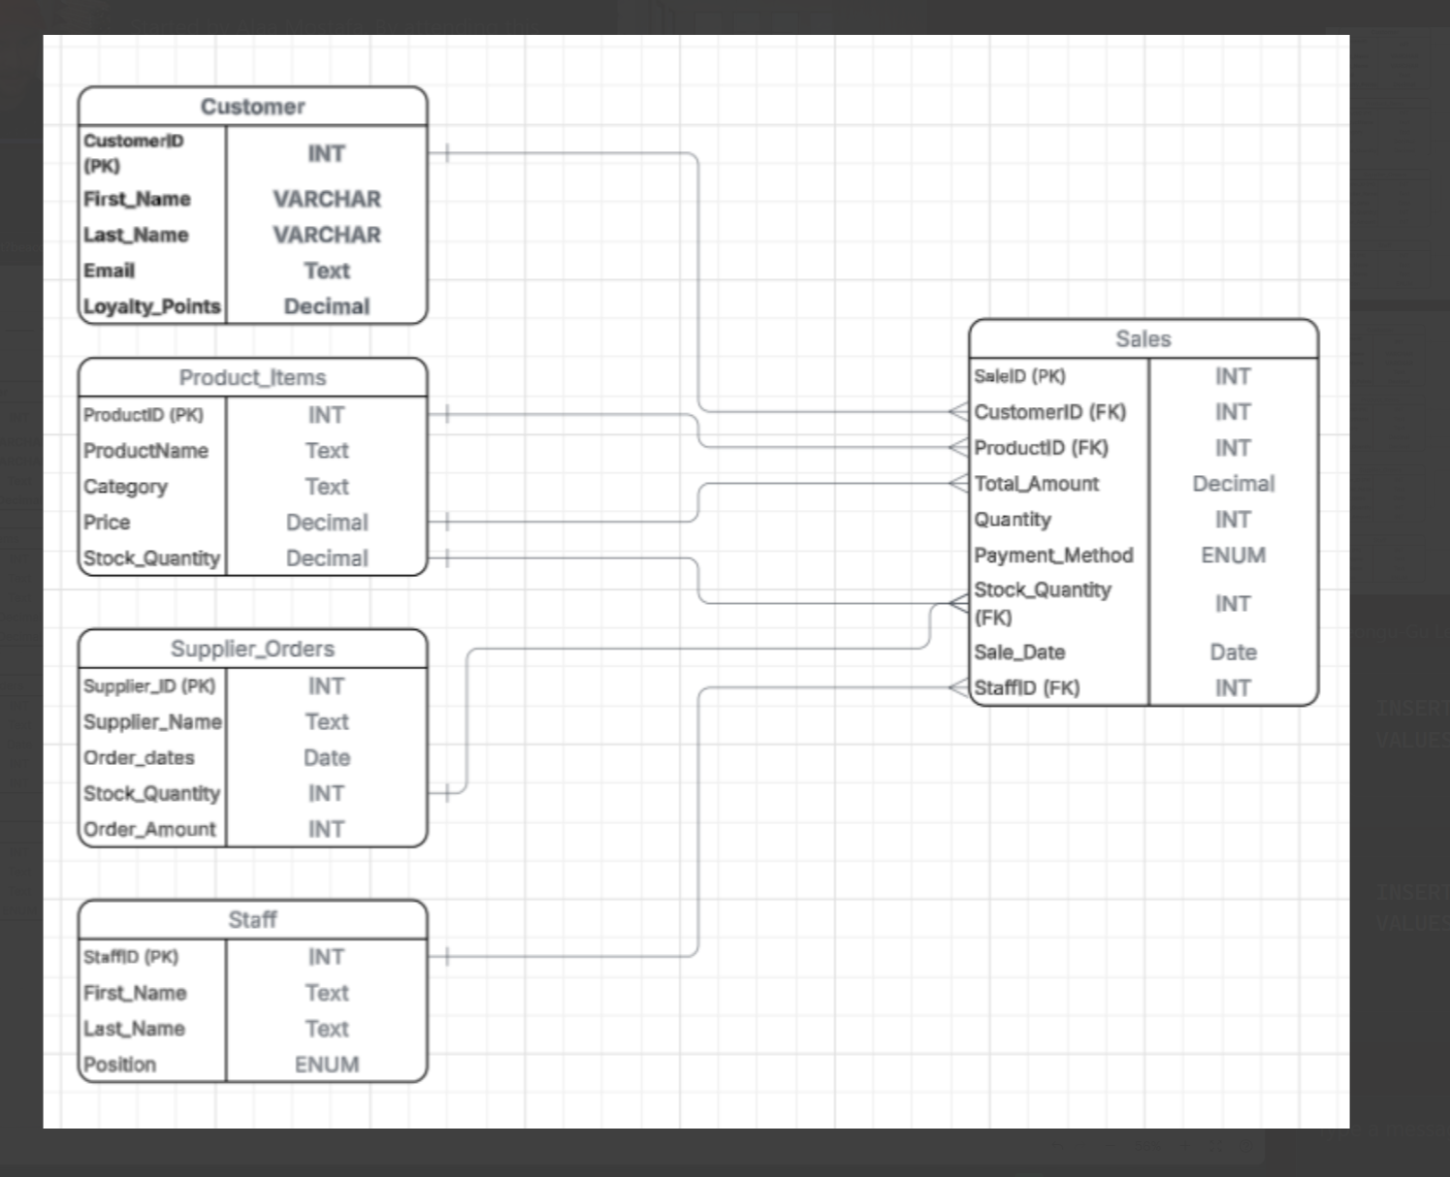  - Implementing the Database  Once the schema is finalized, the structure is built using SQL Data Definition Language (DDL) commands. First, the database is created, followed by the tables. Constraints like PRIMARY KEY and FOREIGN KEY are explicitly defined during creation to enforce data integrity and the relationships established in the design phase.  CREATE DATEBASE Corner Cafe;  SHOW DATEBASE;  USE Corner Cafe;  CREATE TABLE Customer  (  CustomerID INT AUTO_INCREMENT PRIMERY KEY  First_Name VARCHAR,  Last_Name VARCHAR,  Email TEXT,  Loyalty_Points DECIMAL,  );  CREATE Product_Items  (  ProductID INT AUTO_INCREMENT PRIMERY KEY  ProductName VARCHAR,  Category VARCHAR,  Price DECIMAL,  Stock Quantity DECIMAL,  );  CREATE Supplier_Orders  (  Suplier_ID INT AUTO_INCREMENT PRIMERY KEY  Supplier VARCHAR,  Category ENUM,  Price DECIMAL,  Stock Quantity INT,  );  CREATE Staff  (  StaffID INT AUTO_INCREMENT PRIMERY KEY  First_Name VARCHAR,  Last_Name VARCHAR,  Position ENUM,  );  CREATE Sales  (  SaleID INT AUTO_INCREMENT PRIMERY KEY,  CustomerID INT FOREIGN KEY,  ProductID INT FOREIGN KEY,  Total_Amount DECIMAL,  Quantity INT,  Payment_Method ENUM,  Stock_Quantity INT FOREIGN KEY,  Sale_Date DATE,  StaffID ENUM FOREIGN KEY,  );  - Populating the Database  The system needs initial data to be functional. This is achieved using the SQL Data Manipulation Language (DML) command INSERT INTO.  NSERT INTO Products (ProductID, ProductName, Category,Price,StockQuantity)  VALUES (101, “Milk (1L)”, Drink, 50, 1.25);  Maintaining the Database  To ensure the database remains a reliable business asset, maintenance is ongoing. Accuracy is maintained through application-side input validation and database-level constraints (like NOT NULL and CHECK constraints). To protect the data, a rigorous backup schedule must be established, involving automated daily snapshots to a secure, off-site location. Furthermore, access to the database must be secured by granting users the minimum necessary permissions—store staff, for example, only need permission to insert sales data, not to delete entire product tables.

Day 4: Task 2: SQL Practical

In your groups, work together to answer the below questions. It may be of benefit if one of you shares your screen with the group and as a team answer / take screen shots from there.

Setting up the database:

- Download world_db(1)
- Follow each step to create your database

For each question I would like to see both the syntax used and the output.

- Count Cities in USA: Scenario: You've been tasked with conducting a demographic analysis of cities in the United States. Your first step is to determine the total number of cities within the country to provide a baseline for further analysis.

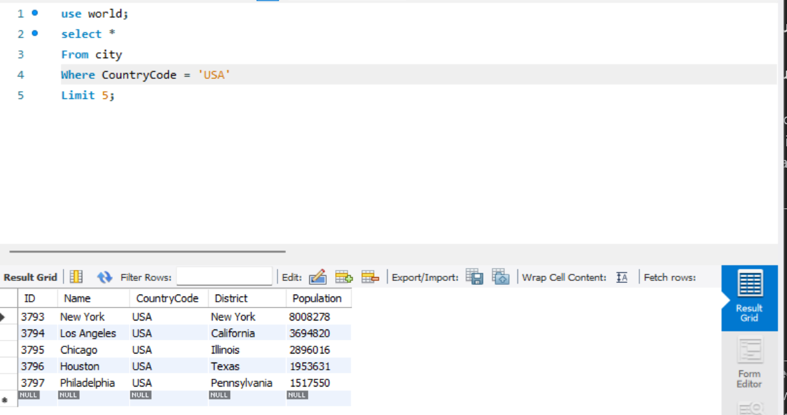

- 2. Country with Highest Life Expectancy: Scenario: As part of a global health initiative, you've been assigned to identify the country with the highest life expectancy. This information will be crucial for prioritising healthcare resources and interventions.

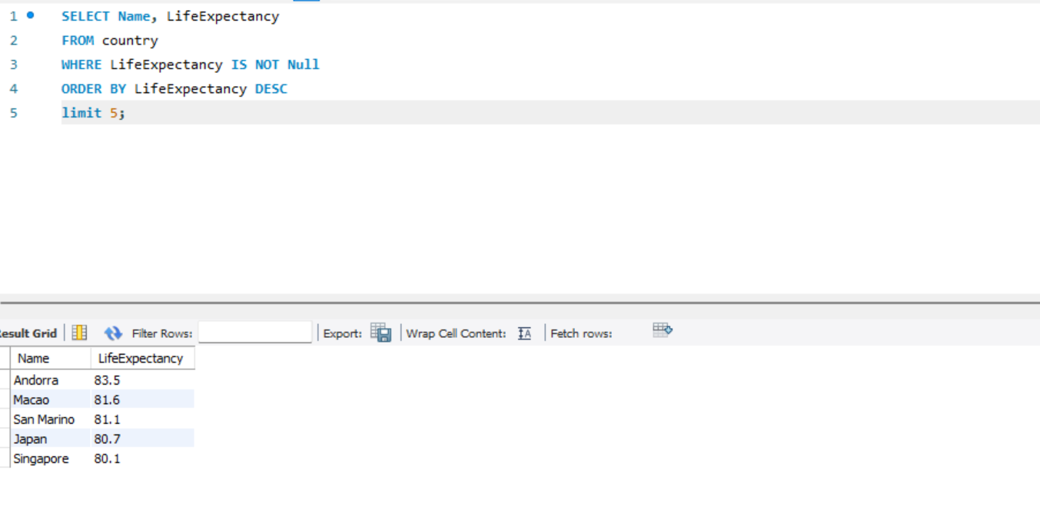

- "New Year Promotion: Featuring Cities with 'New : Scenario: In anticipation of the upcoming New Year, your travel agency is gearing up for a special promotion featuring cities with names including the word 'New'. You're tasked with swiftly compiling a list of all cities from around the world. This curated selection will be essential in creating promotional materials and enticing travellers with exciting destinations to kick off the New Year in style.

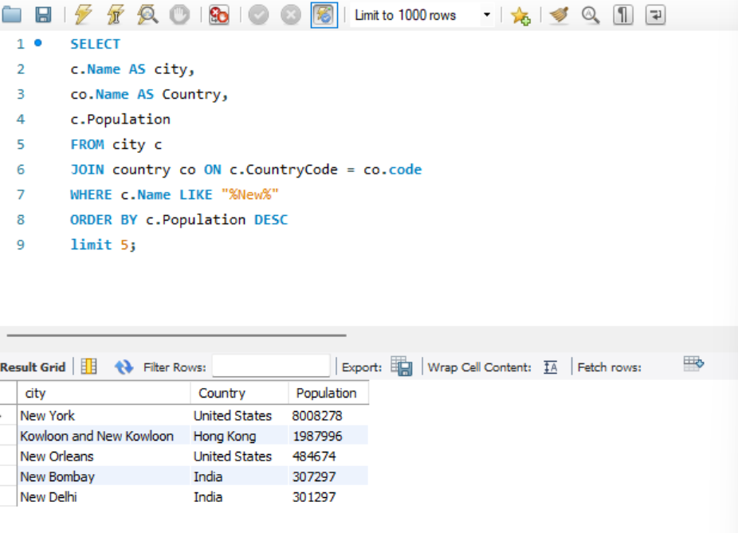

- Display Columns with Limit (First 10 Rows): Scenario: You're tasked with providing a brief overview of the most populous cities in the world. To keep the report concise, you're instructed to list only the first 10 cities by population from the database.

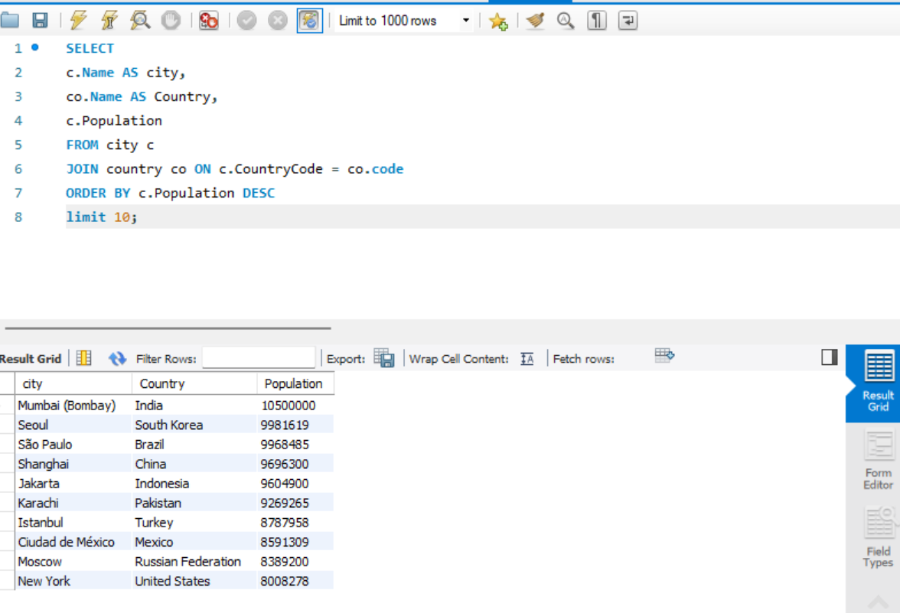

- Cities with Population Larger than 2,000,000: Scenario: A real estate developer is interested in cities with substantial population sizes for potential investment opportunities. You're tasked with identifying cities from the database with populations exceeding 2 million to focus their research efforts.

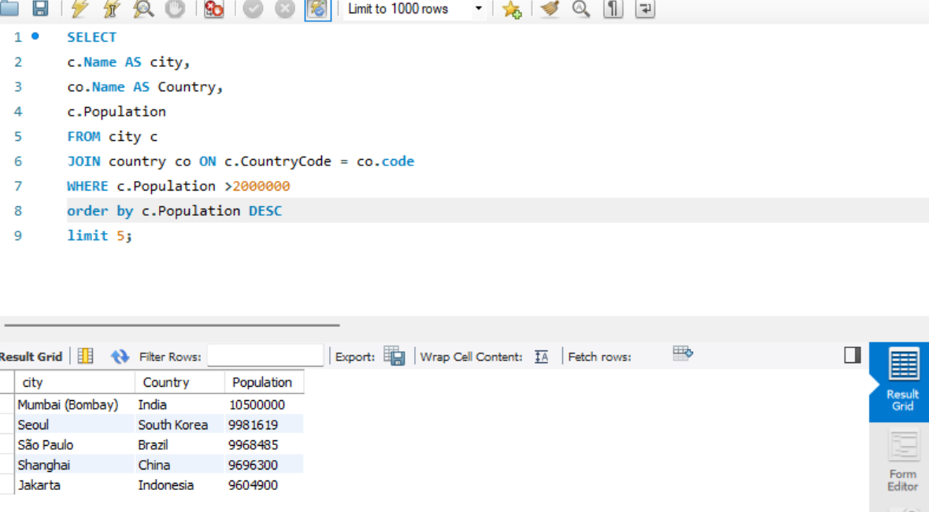

- Cities Beginning with 'Be' Prefix: Scenario: A travel blogger is planning a series of articles featuring cities with unique names. You're tasked with compiling a list of cities from the database that start with the prefix 'Be' to assist in the blogger's content creation process.

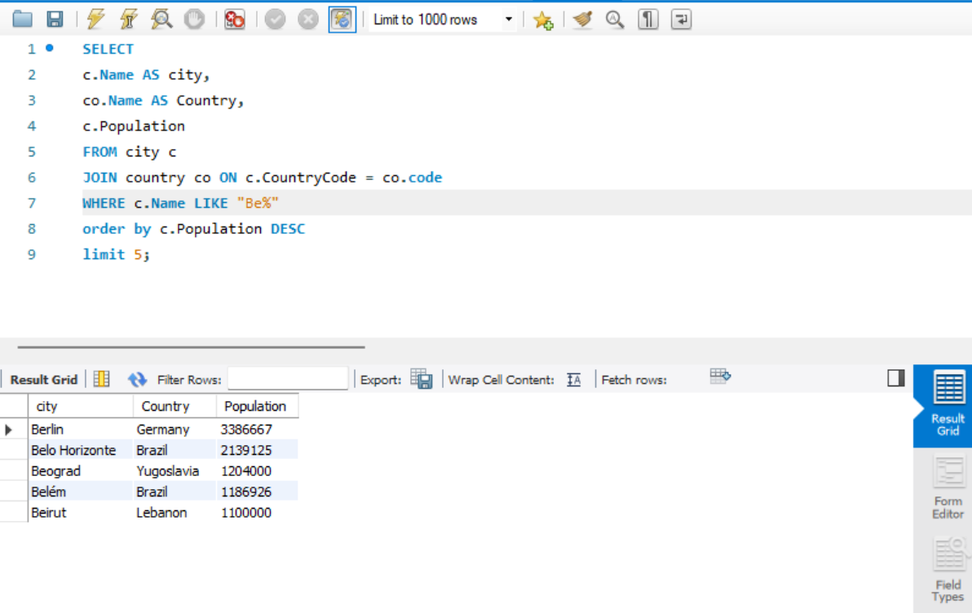

- Cities with Population Between 500,000-1,000,000: Scenario: An urban planning committee needs to identify mid-sized cities suitable for infrastructure development projects. You're tasked with identifying cities with populations ranging between 500,000 and 1 million to inform their decision-making process.

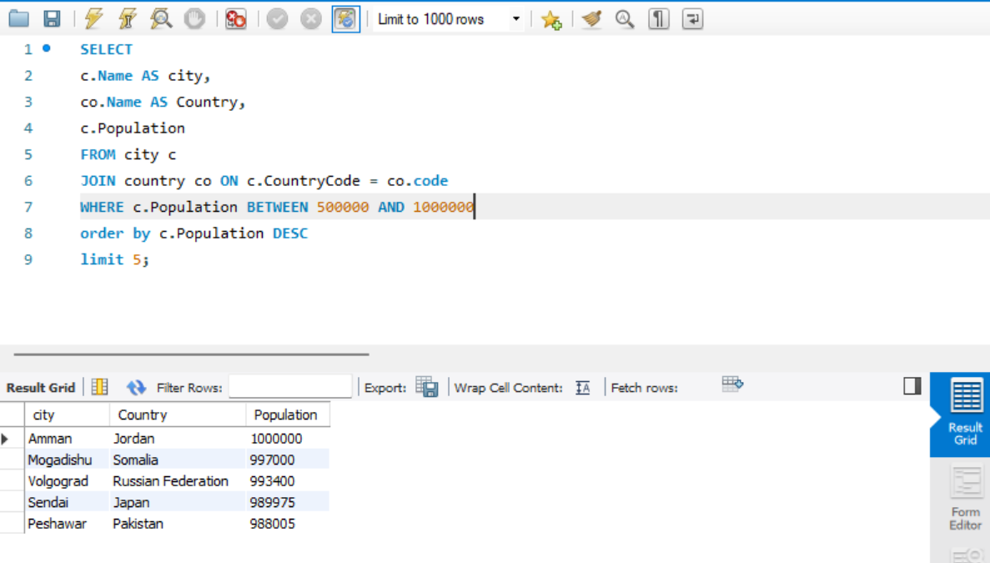

- Display Cities Sorted by Name in Ascending Order: Scenario: A geography teacher is preparing a lesson on alphabetical order using city names. You're tasked with providing a sorted list of cities from the database in ascending order by name to support the lesson plan.

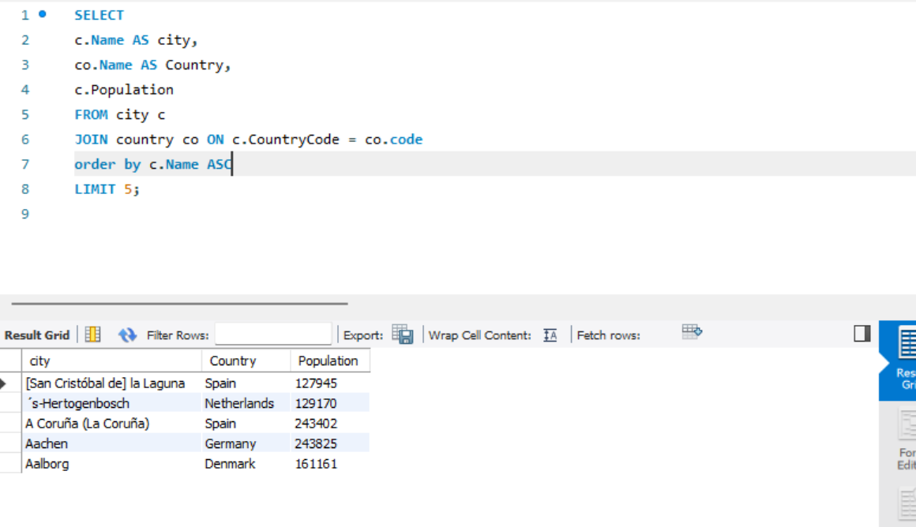

- Most Populated City: Scenario: A real estate investment firm is interested in cities with significant population densities for potential development projects. You're tasked with identifying the most populated city from the database to guide their investment decisions and strategic planning.

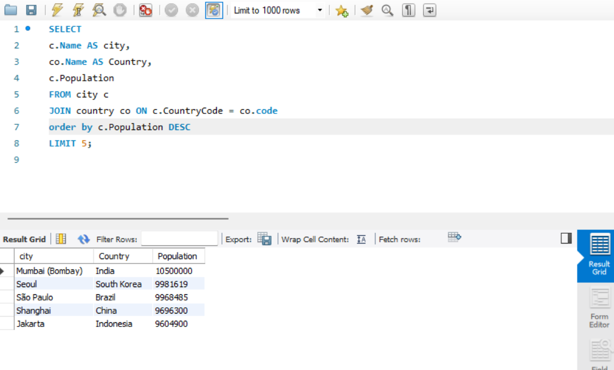

- City Name Frequency Analysis: Supporting Geography Education Scenario: In a geography class, students are learning about the distribution of city names around the world. The teacher, in preparation for a lesson on city name frequencies, wants to provide students with a list of unique city names sorted alphabetically, along with their respective counts of occurrences in the database. You're tasked with this sorted list to support the geography teacher.

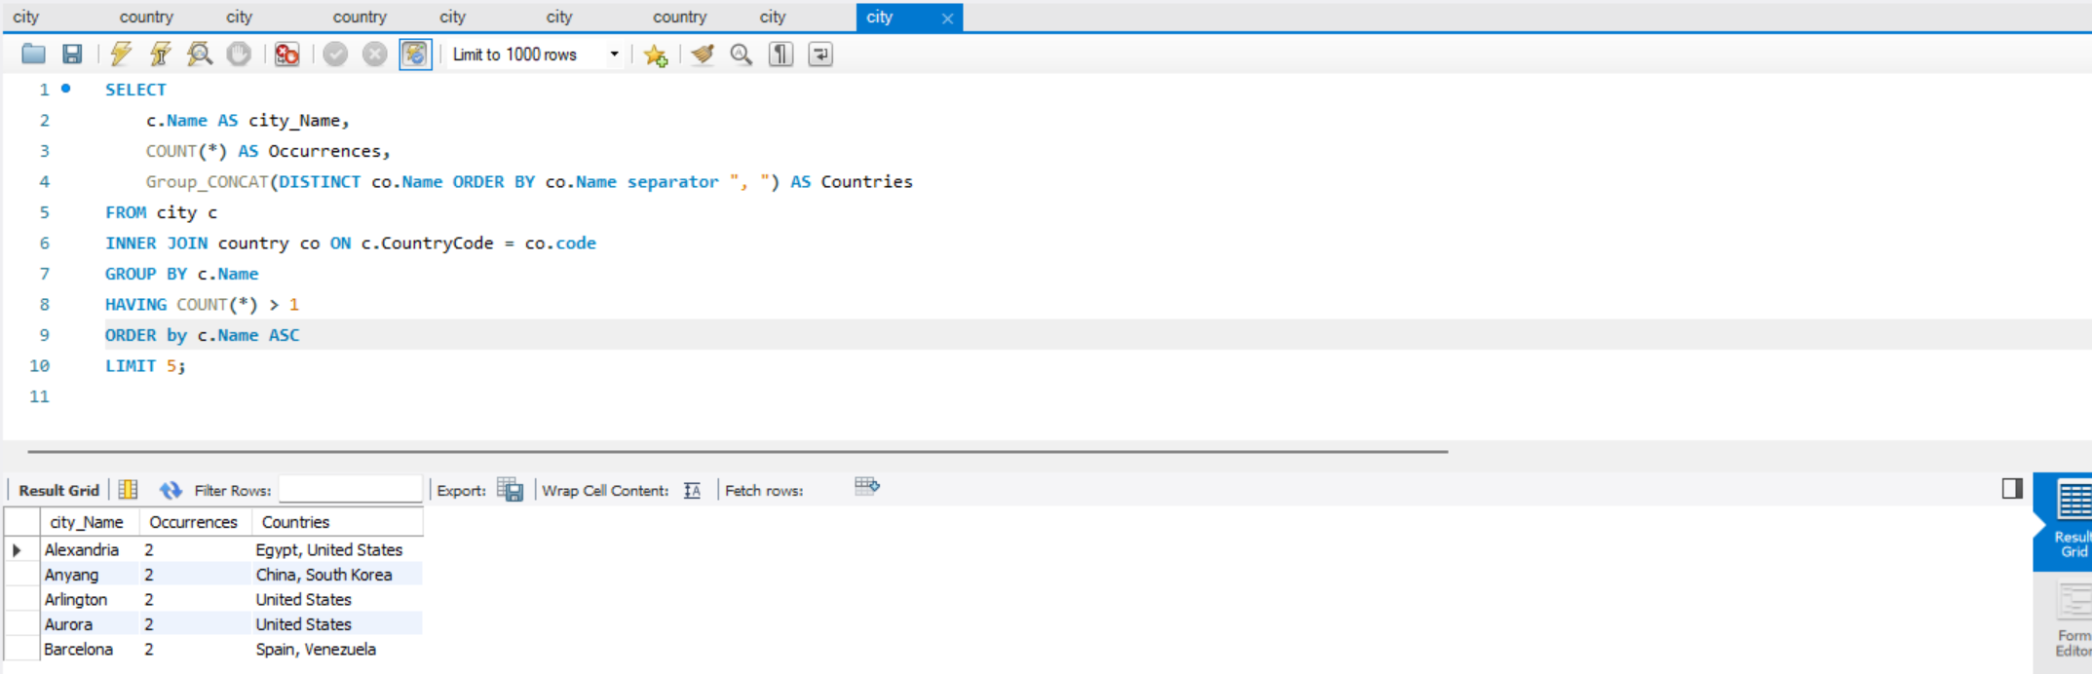

- City with the Lowest Population: Scenario: A census bureau is conducting an analysis of urban population distribution. You're tasked with identifying the city with the lowest population from the database to provide a comprehensive overview of demographic trends.

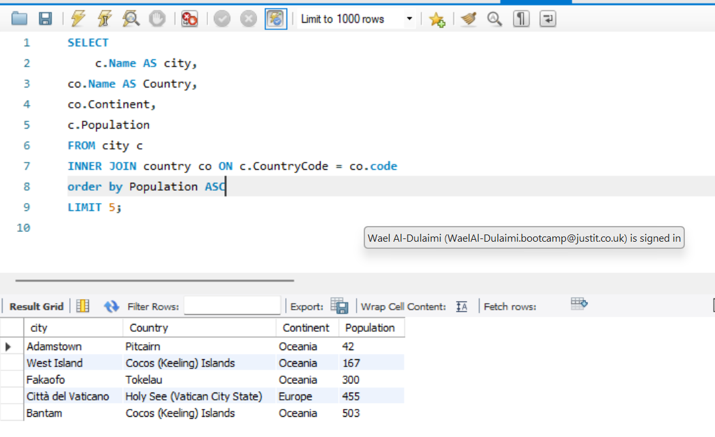

- Country with Largest Population: Scenario: A global economic research institute requires data on countries with the largest populations for a comprehensive analysis. You're tasked with identifying the country with the highest population from the database to provide valuable insights into demographic trends.

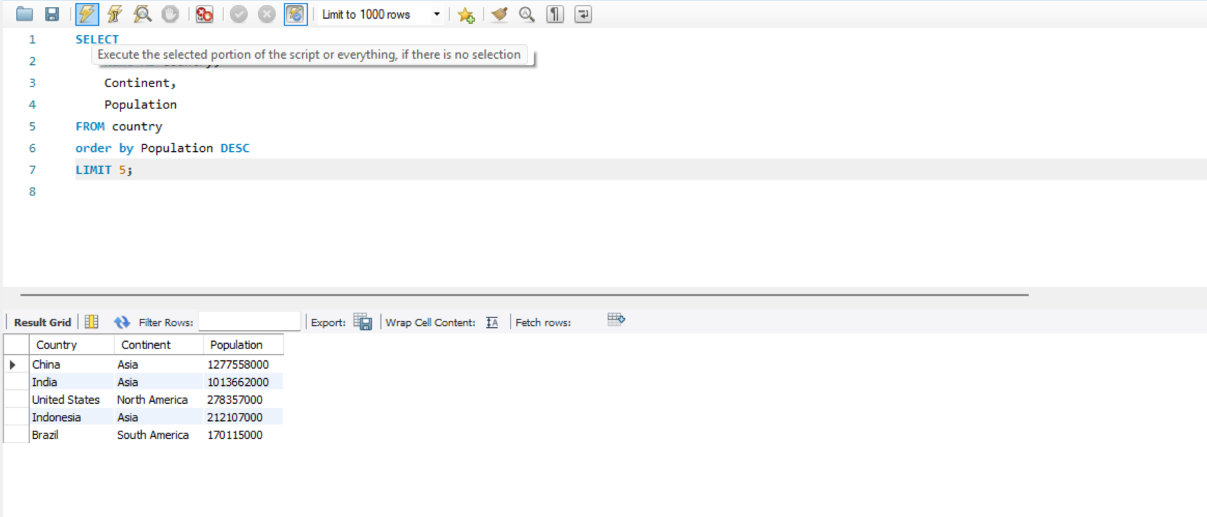

- Capital of Spain: Scenario: A travel agency is organising tours across Europe and needs accurate information on capital cities. You're tasked with identifying the capital of Spain from the database to ensure itinerary accuracy and provide travellers with essential destination information.

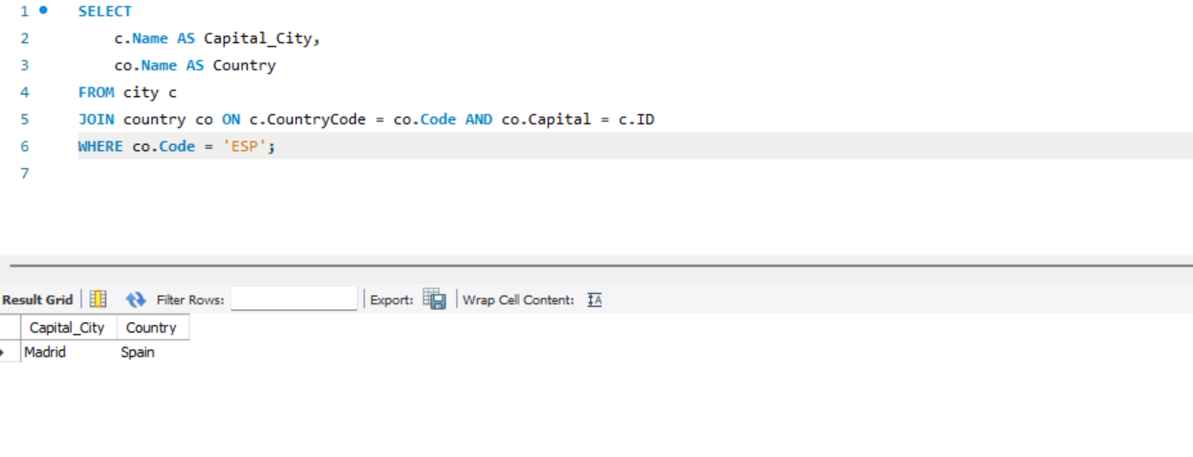

- Country with Shortest Life Expectancy: Scenario: A healthcare foundation is conducting research on global health indicators. You're tasked with identifying the country with the highest life expectancy from the database to inform their efforts in improving healthcare systems and policies.

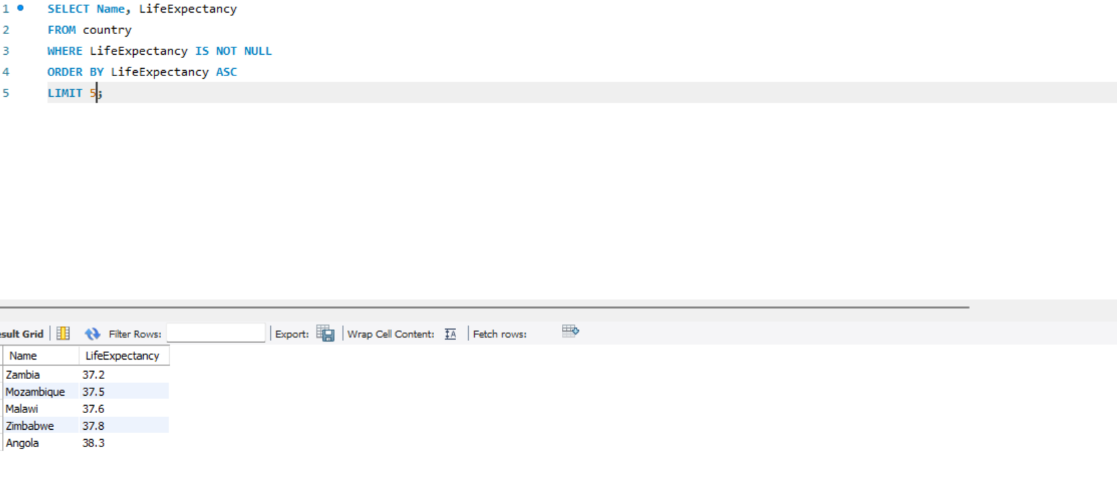

- Cities in Europe: Scenario: A European cultural exchange program is seeking to connect students with cities across the continent. You're tasked with compiling a list of cities located in Europe from the database to facilitate program planning and student engagement.
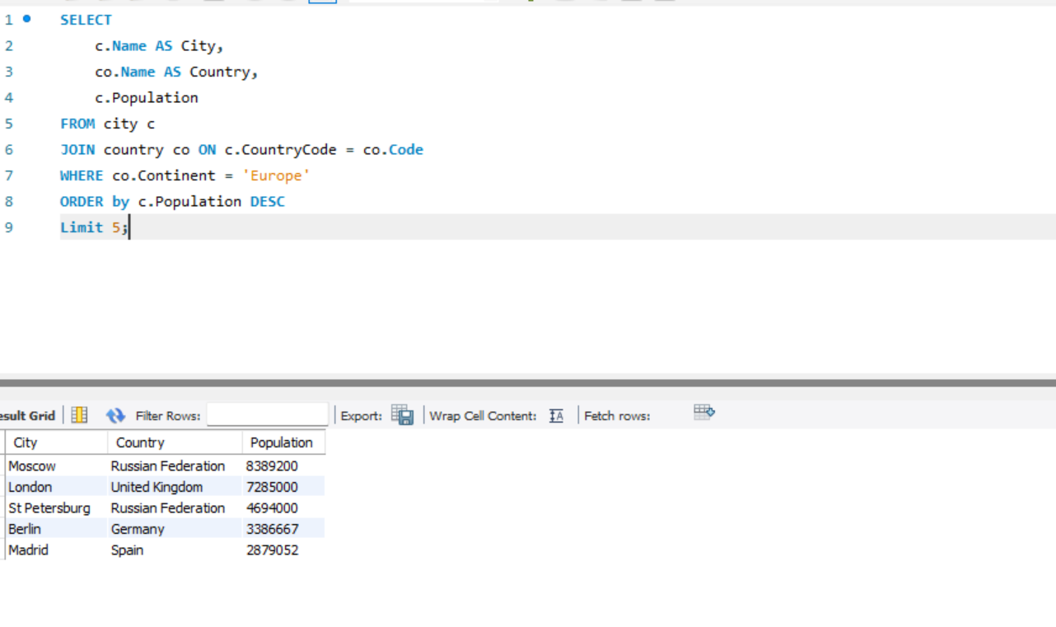

- Average Population by Country: Scenario: A demographic research team is conducting a comparative analysis of population distributions across countries. You're tasked with calculating the average population for each country from the database to provide valuable insights into global population trends.

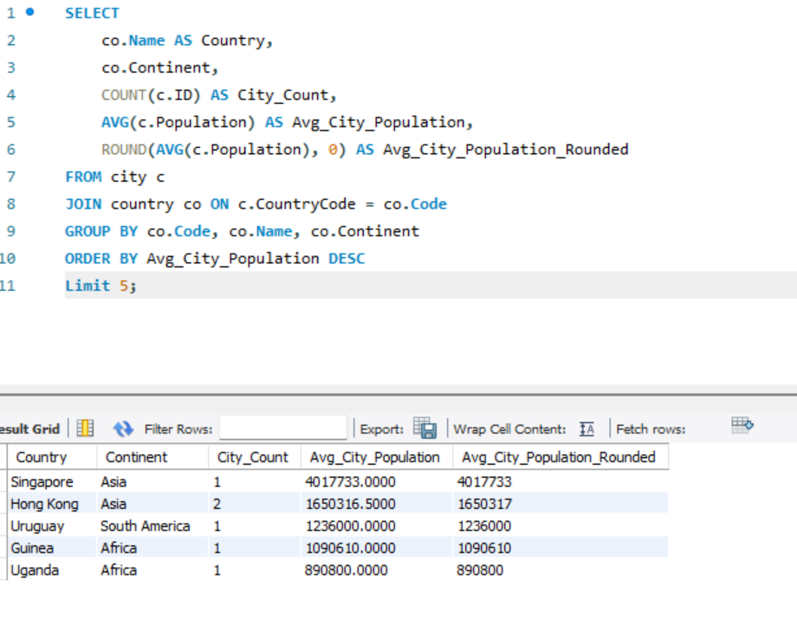

- Capital Cities Population Comparison: Scenario: A statistical analysis firm is examining population distributions between capital cities worldwide. You're tasked with comparing the populations of capital cities from different countries to identify trends and patterns in urban demographics.

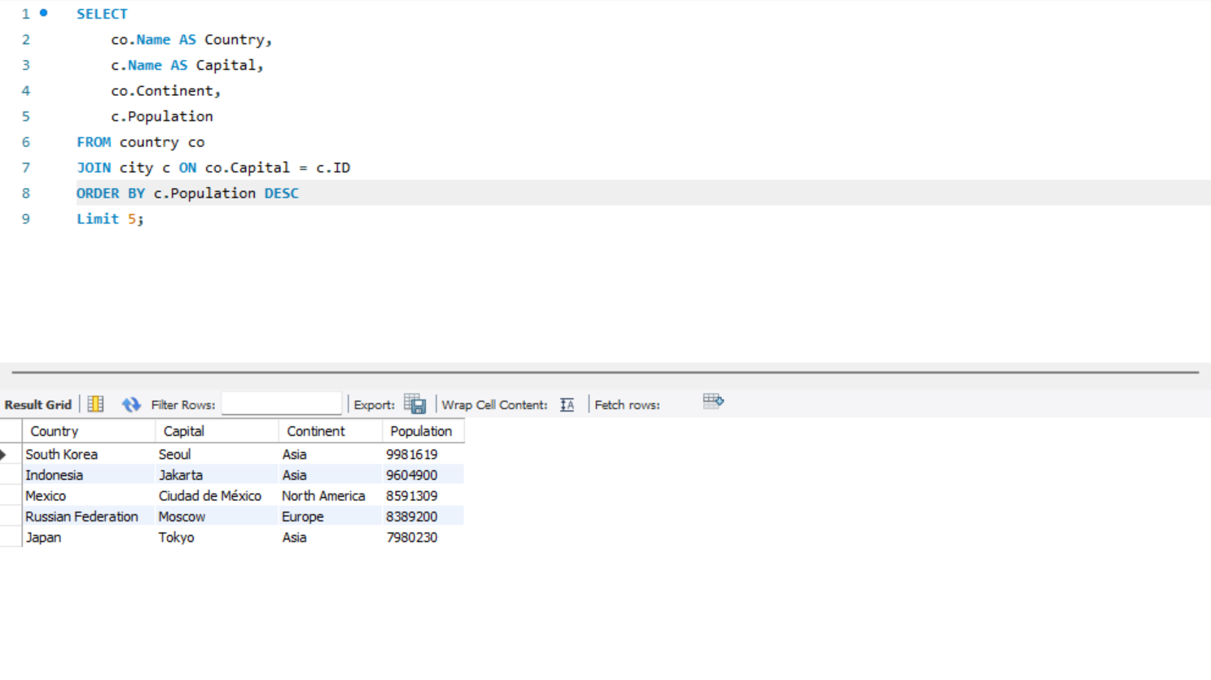

- Countries with Low Population Density: Scenario: An agricultural research institute is studying countries with low population densities for potential agricultural development projects. You're tasked with identifying countries with sparse populations from the database to support the institute's research efforts.

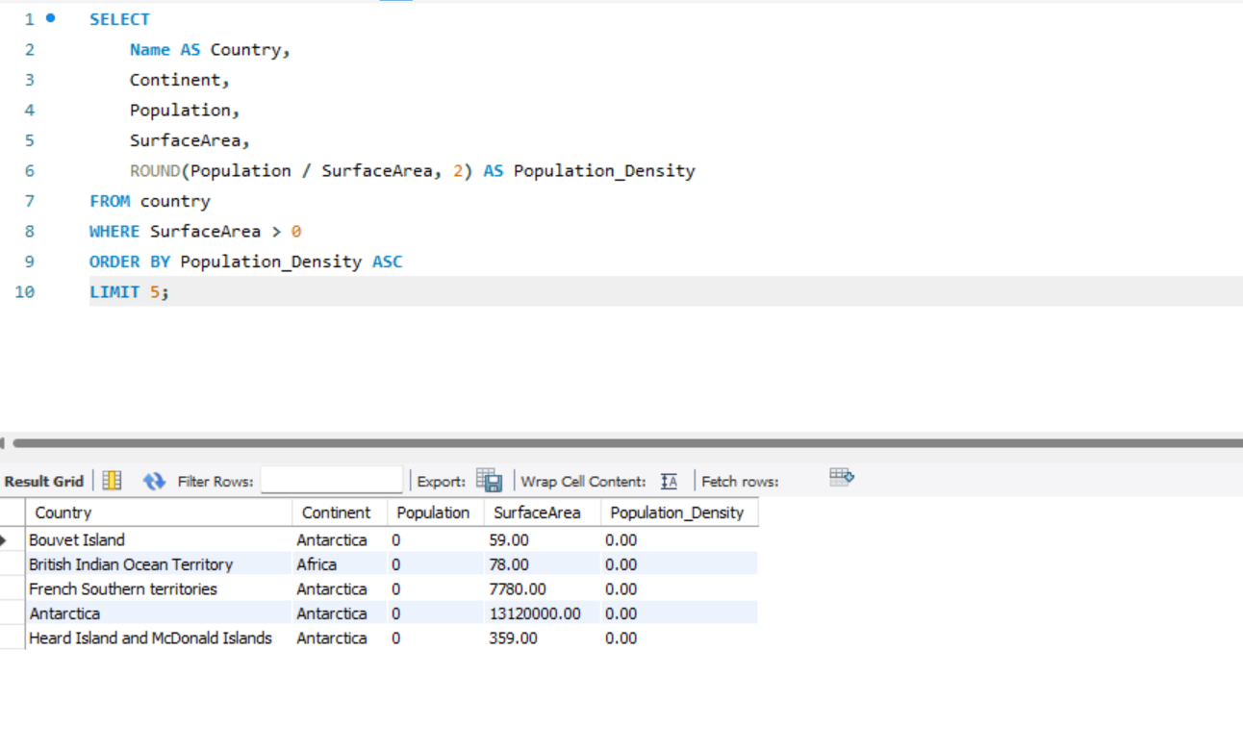

- Cities with High GDP per Capita: Scenario: An economic consulting firm is analysing cities with high GDP per capita for investment opportunities. You're tasked with identifying cities with above-average GDP per capita from the database to assist the firm in identifying potential investment destinations.

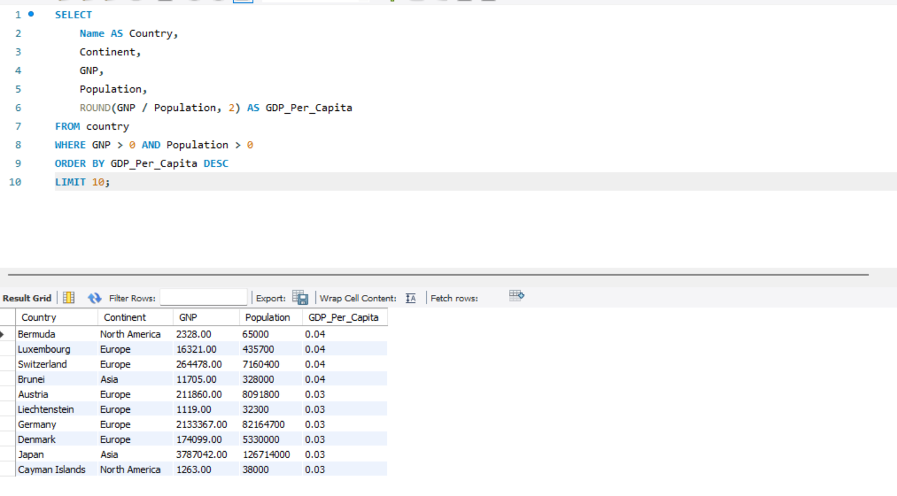

- Display Columns with Limit (Rows 31-40): Scenario: A market research firm requires detailed information on cities beyond the top rankings for a comprehensive analysis. You're tasked with providing data on cities ranked between 31st and 40th by population to ensure a thorough understanding of urban demographics.

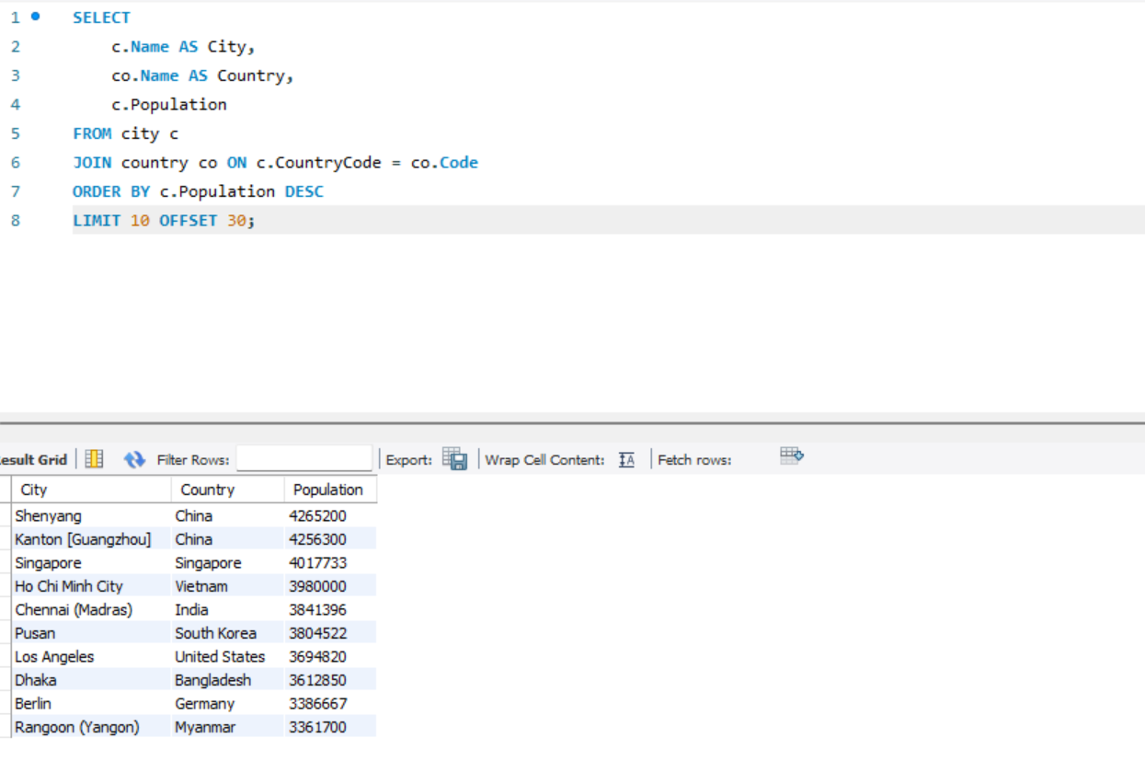

Course Notes

It is recommended to take notes from the course, use the space below to do so, or use the revision guide shared with the class:

Additional Information

We have included a range of additional links to further resources and information that you may find useful, these can be found within your revision guide.

END OF WORKBOOK

Please check through your work thoroughly before submitting and update the table of contents if required.

Please send your completed work booklet to your trainer.

