????????
??????
? ? ?? ?????
? ? ?? ?????
? ? ?? ?????
? ? ?? ???????????????
? ?? ?????
????? ??? ?? ????
????? ??? ?? ????
? ? ?? ??? ?? ????
????? ??
?????
?????
???????2026 ? 6 ? 23 ?
????????????

??????
???? | ???? | ???? | ???
??????? | ????? | ??????????????????????????? | 35%
??A????? | ????? | ?????????????????????????? | 25%
??B????? | ????? | ?????????????????????????? | 25%
??C????? | ????? | SQL???????????????????? | 15%

????????????????????????????

??
???????????????????????????????????????????????????????????????????????????????????????????????????? Agent ???????????????????????????????L1-L5 ???????????????????L4/L5 ????????????????????????????????????????????????????????????????????????????? BCNF ???????? SQL Server ???????????????????????????????????????? Spring Boot 3?Spring JDBC?Spring Security?Vue 3?Element Plus ? SQL Server/H2??????????????????????????? Agent????????????????????????Markdown ???????????????-??-??-??-??-??????????????????????????????????????????????????????
????????????????????????????????????? Agent

Abstract
This project designs and implements a data security governance system based on data classification and grading. It builds a unified database model around data assets, field-level classification, masking policies, access requests, approval records, audit logs, and governance agents. The system supports asset registration, sensitive-field identification, L1-L5 grading, rule-based automatic classification, dynamic masking, approval control for L4/L5 raw-value access, audit tracing, risk alerts, and security report generation. The database design follows integrity, least privilege, auditability, and traceability principles, and implements tables, constraints, indexes, views, stored procedures, and triggers in SQL Server. The implementation adopts Spring Boot 3, Spring JDBC, Spring Security, Vue 3, Element Plus, and SQL Server/H2. A local rule-based governance agent is added to provide classification suggestions, access review suggestions, audit-risk analysis, security reports, and question-answer assistance.
Keywords: Data Security; Database Design; Classification and Grading; Dynamic Masking; Access Approval; Audit Log; Governance Agent

??
1 ??
1.1 ???????
1.2 ???????
1.3 ????????
2 ????
2.1 ??????
2.2 ?????
3 ????
4 ????
5 ?????
????

1 ??

1.1 ???????
???????????????????????????????????????????????????????????????????????????????????????????????????????????????????????????????????????????????????????????????????????????????????????????????????
???????????????????????????????????E-R ??????????????SQL ?????????????????????????????????????????????????????????????????????

1.2 ???????
??????????????????????????????????????????????????????????????????????????????????????????????????????????????????????????????????????????????????????????????????????? Agent???????????

1.3 ????????
- ??????????????????????????? Agent ???????
- ???? 20 ??????????????????????????????
- ???????????????????? BCNF ????
- ?? SQL Server ????????????????????????
- ?? Spring Boot ? Vue ?????????????????????????????????? Agent ???
- ???????????????????????????????

2 ????

2.1 ??????

2.1.1 ??????
???????????????? Vue 3?Vite?Element Plus ? Axios????????????????????????? Agent ????????????? Spring Boot 3?Spring Web?Spring JDBC ? Spring Security????? REST API??????? SQL Server ???????????? H2 ???????????????
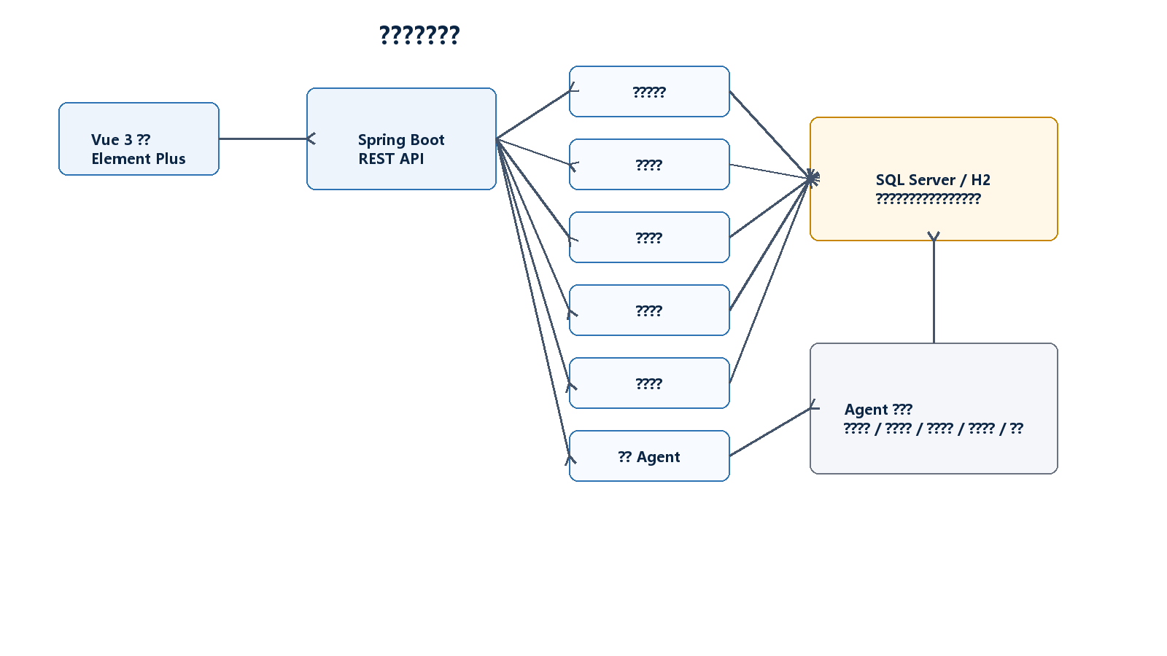
?2-1 ???????

2.1.2 ????????
?????????????????????????????????????????? Agent ???????????????????? L4/L5 ???????????????????????????????? Agent ??????????????????????? Agent ???????????????????????????????????
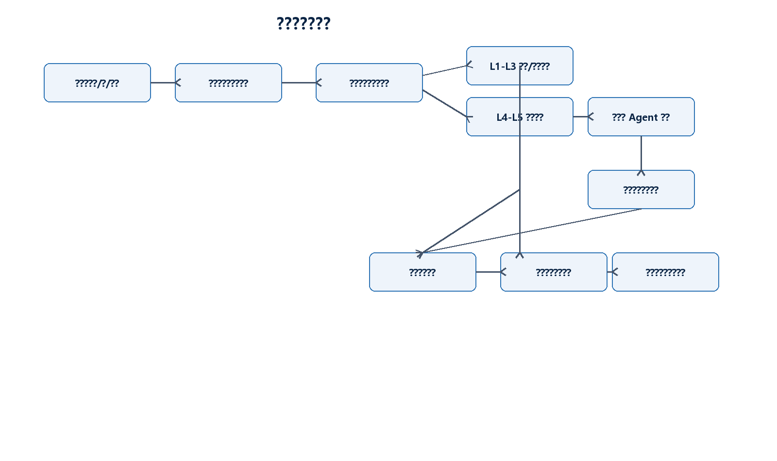
?2-2 ???????

2.1.3 ?????????
- ????????? data_field_asset ??????????????????????????????
- ??????????L3 ?????????L4/L5 ?????????????????????
- ??????????????????????????????Agent ????? audit_log?
- ????????????????????????????????????????????
- ???? Agent???????????????????????????????????

2.2 ?????

2.2.1 ??????
?????????-??-????????-??-??????????-??-????Agent ??-??-??-?????????????????????????????????????????????????????????????????????????????????????????????????????????????????????Agent ????????????????????????????
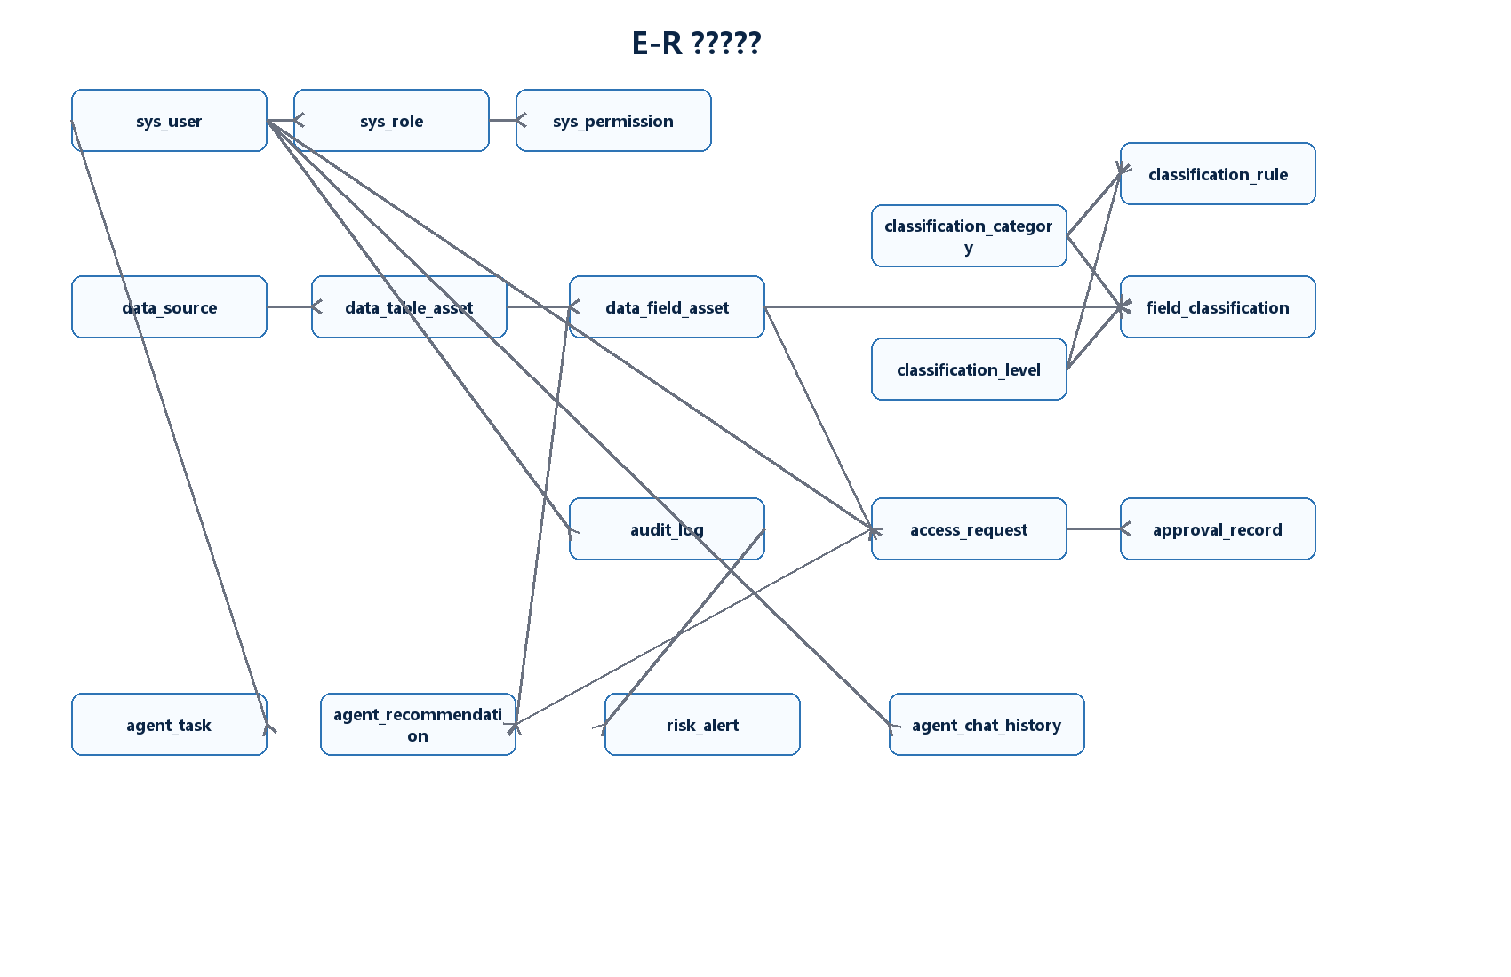
?2-3 E-R ?????

2.2.1.1 ?????????
?? | ???? | ????
sys_user | id, username, password, real_name, email, phone, enabled | ???????????????????
sys_role / sys_permission | role_code, permission_code, description | ??????????????? RBAC?
data_source / data_table_asset | source_name, table_name, business_name, owner_department | ????????????
data_field_asset | table_id, field_name, field_type, sample_value, is_sensitive | ??????????????????????
classification_category / classification_level | category_name, level_code, level_order | ??????? L1-L5 ?????
classification_rule | match_type, match_pattern, category_id, level_id | ????????? keyword ? regex?
field_classification | field_id, category_id, level_id, classify_method | ???????????
masking_policy | policy_type, example_before, example_after | ?????????
access_request / approval_record | user_id, field_id, status, approval_result | ??????????????
audit_log | operation_type, target_type, operation_time, result | ??????????
Agent ? | task_type, confidence, risk_level, question, answer | ?? Agent ???????????????

2.2.1.2 ???????
- data_source ? data_table_asset ? 1:N?data_table_asset ? data_field_asset ? 1:N?
- data_field_asset ? field_classification ? 1:0..1??????????????????
- classification_category?classification_level ??? field_classification?classification_rule ? 1:N?
- sys_user?sys_role?sys_permission ?? sys_user_role?sys_role_permission ??????
- access_request ????????????approval_record ???????????
- audit_log ???????????????????????

2.2.2 ??????

2.2.2.1 ??????
?? E-R ???????????????? M:N ???????????? 1:N ?????????????????? field_id ?????????????????????????????????????????????? access_request ? approval_record ?????????????????????
???? | ?? | ??/??
sys_user(id, username, password, real_name, email, phone, enabled) | id | username unique
sys_user_role(user_id, role_id) | (user_id, role_id) | user_id -> sys_user, role_id -> sys_role
data_table_asset(id, source_id, table_name, business_name) | id | source_id -> data_source
data_field_asset(id, table_id, field_name, field_type, sample_value) | id | table_id -> data_table_asset
field_classification(id, field_id, category_id, level_id, classify_method) | id | field_id unique; category_id -> category; level_id -> level
access_request(id, user_id, field_id, reason, status, valid_until) | id | status in PENDING/APPROVED/REJECTED
approval_record(id, request_id, approver_id, approval_result) | id | request_id -> access_request; approver_id -> sys_user
audit_log(id, user_id, operation_type, target_type, target_id, operation_time) | id | operation_type not null

2.2.2.2 ???
??????????????????????????????????????????????????????????????????????????????????????????????? BCNF?
- sys_user ? username ?????real_name?email?phone?enabled ?????? id ? username?
- data_field_asset ?????????? id?????? table_id ???????????????????
- field_classification ? field_id ??????category_id?level_id?classify_method?classified_time ???? field_id ? id?
- classification_rule ????????????????????????? id?????????????????
- access_request ? approval_record ????????????? id???????????? id?

2.2.2.3 ??????
?? | ?? | ??
???? | sys_user, sys_role, sys_permission, sys_user_role, sys_role_permission | ????????????????
???? | data_source, data_table_asset, data_field_asset | ?????????????????
???? | classification_category, classification_level, classification_rule, field_classification | ????????????????
???? | masking_policy, access_request, approval_record, audit_log | ??????????????
Agent?? | agent_task, agent_recommendation, risk_alert, agent_chat_history | ????????????????????

2.2.3 ??????
????? SQL Server ????? bigint identity ?????nvarchar ?????????datetime2 ?????decimal(5,2) ?????????????????????????????????????????????Agent ?????????????????????
???? | ?? | ??
?? | idx_data_field_name | ?????????????????
?? | idx_field_classification_level | ??? L1-L5 ??????????
?? | idx_audit_user / idx_audit_time | ?????????????????
?? | idx_access_status | ????????????
?? | sensitive_field_view | ???? L3 ????????
?? | user_accessible_field_view | ?????????????????
???? | sp_count_sensitive_fields_by_source | ????????????????
???? | sp_auto_classify_fields | ?????????????????
??? | trg_audit_field_classification_update | ????????????????
??? | trg_audit_access_request_update | ??????????????????

2.2.4 ????????
- ?????????????????????? Bearer token??????????
- ??????? admin?security_admin?user?approver ????????????????????????
- ?????L1-L3 ??????????L4/L5 ????????? APPROVED ???
- ?????????????????????????????????????????????
- ??????????????????????????????????Agent ????? audit_log?
- ??????????????????????????????????????????????
- ?????Agent ?????????????????????? IP ??????????????????????

2.2.5 ?? SQL ??
???? | ????
field_classification.field_id unique | ??????????????????????????
classification_rule.match_type check in ('keyword','regex') | ?????????
access_request.status check in ('PENDING','APPROVED','REJECTED') | ???????????
sensitive_field_view where level_order >= 3 | ???? L3 ????????
user_accessible_field_view | ????????????????????????
sp_auto_classify_fields | ?????????????????? is_sensitive?
trg_audit_access_request_update | ??????????????????

3 ????

3.1 ???????
?? | ??/?? | ??
?? | Java 17, Spring Boot 3.3.5, Spring Web, Spring JDBC, Spring Security, Lombok | ?? REST API???????????????????
??? | SQL Server, H2 | SQL Server ????????H2 ???????
?? | Vue 3, Vite, Element Plus, Axios, Vue Router | ???????????? Agent ???
?? | Maven, npm | ?????? JAR ????????

3.2 ????

3.2.1 ?????????
?????? /api/auth/login ? /api/auth/me ?????????? token????? localStorage ????????? Authorization ????

3.2.2 ????????
???????????????????????????????????????????????????????????? L4/L5 ?????????????????

3.2.3 ?????????
???????????????????????????????????????????????????? match_pattern ?????????? field_classification?

3.2.4 ???????????
MaskingService ????????????????????????????token?secret ??????????????????????????????????????

3.2.5 ???????????
??????????????????????? id????IP???????????????????????????/????????????

3.2.6 ?????? Agent ??
Agent ???????????????????????????????????????????????????????????????????????
???? | ?? | ??
AgentWorkbench.vue | GET /api/agent/workbench | ?????????????????????
AgentFieldClassify.vue | POST /api/agent/classify-field/{id} | ????????????
AgentApprovalAdvice.vue | POST /api/agent/review-access-request/{id} | ?????????
AgentRiskAlerts.vue | POST /api/agent/analyze-audit-logs | ??????????????
AgentSecurityReport.vue | GET /api/agent/security-report | ?? Markdown ???????
FloatingAgent.vue / AgentChat.vue | POST /api/agent/chat | ??????????????

4 ????

4.1 ????
?????? Windows ??????????? Maven ?? Spring Boot ??????? H2 ???????? schema.sql ? data.sql????? npm run dev ?? Vite ???????? http://localhost:5173?????? SQL Server ????????? sql/sqlserver_schema_init.sql ??? sqlserver profile?

4.2 ?????????
?? | ??? | ???? | ???? | ??
T1 | ???? | ?? admin/123456 ?? | ?? token ????? | ??
T2 | ???? CRUD | ????????????????? | ???????????????? | ??
T3 | ???? | ?? phone/id_card/password ?????????? | ????????? L3/L4/L5 ?? | ??
T4 | ???? | ?? phone?email?id_card?bank_card?password_hash ??? | ????????? | ??
T5 | ?????? | ?????? L4/L5 ??????? | ?? requiresApproval=true??????????? | ??
T6 | ?????? | ??????????????????? | ??????????????????? | ??
T7 | ???? | ????????????????? | audit_log ???????????????? | ??
T8 | Agent ???? | ? id_card_no ? password_hash ?? Agent ?? | ???????????????????? | ??
T9 | Agent ???? | ???????? | ?? risk_alert ?????? | ??
T10 | ???? | ???????? | ???????????????????? | ??

4.3 ??????
- ???????????????????????????/?????
- ???????????????????????????
- ???????????????????????????????????
- ????????????????????????????????
- ???????????????????????
- Agent ????????????????????????????????
?????????????????????????????????????????????????????????????????

5 ?????

5.1 ??????

5.1.1 ???????
- ????????????????????????????????????
- ?? 20 ???????????????????????????????? Agent ???
- ?? SQL Server ??????????????????????????????
- ?? Spring Boot ?? REST API ? Vue 3 ????????????????
- ??????? Agent?????????????????????????????

5.1.2 ??????????
?? | ???? | ?????? | ????
???? | ??????????????????? | ????????? Agent ???? | ??????????
????? | ?? E-R?????? SQL ?? | ???????????????? | ?????????
???? | ???? CRUD ????? | ?? CRUD??????????Agent ?? | ?????????
???? | ??????????? | ?????????????????Agent ?? | ????????
???? | ??????????? | ??????????????? | ?????????????

5.1.3 ???????????
?? | ?????? | ????
??????? | ???????????????????? | ???????????????????????????????
??A????? | ????????????????Agent ?? | ???????????????????
??B????? | ??????????????Agent ?? | ??????????????????????
??C????? | SQL ???????????????? | ???????????????????????????

5.2 ????????
- ?????????????????????? BCrypt ? Argon2 ???????
- ???? Agent ????????????????????????????
- ????????????????????????????????????????
- ???????????????????????????

5.3 ??????
- ????????????????????????????????
- ??????????????????????????????????????
- ???????????????????????????
- ??????????????? Agent ??????????????????
- ??????????????????????????????????????????????

????
[1] ???????????????????????????Z?????????????2024?
[2] ???????????????????????????Z?????????????2024?
[3] ?????????????????????????????Z?????????????2024?
[4] GB/T 22239-2019??????? ?????????????S?????????????2019?
[5] GB/T 35273-2020??????? ?????????S?????????????2020?
[6] GB/T 41479-2022??????? ???????????S?????????????2022?
[7] ???????????????GB/T 44226-2024 ?????? ???????????S?????????????2024?
[8] ????????AIGC????????????????????J??????????????????2023?25(6)?121-130?
[9] ???????????????????????????????J???????2023?34(3)?1213-1235?
[10] ???????????D:/database/backend?D:/database/frontend?D:/database/sql/sqlserver_schema_init.sql?

