**IMAGE RECOGNITION USING IBM CLOUD VISUAL RECOGNITION**

**INTRODUCTION:**

Creating a face recognition website is an exciting endeavor that combines cutting-edge technology with practical applications. Face recognition technology has rapidly evolved, enabling a wide range of use cases from user authentication to personalized user experiences. In this guide, we'll explore the key steps and considerations for developing your own face recognition website.

**PROBLEM DEFINITION:**

* Goal: Find faces in an image

1. All images are in color
2. Images all contain a similar background
3. Images have a similar number of faces
4. Faces are all approximately the same scale

* Design an algorithm which takes advantage of these facts

**DESIGN THINKING:**

1.Set UP IBM Cloud:

Start by creating an IBM Cloud account if you don’t have one already. Then in IBM Cloud, create an instance of the Visual Recognition service and gather dataset.

2.Build the User Interface:

Develop a user-friendly web interface or mobile app where users can upload images.

3.Image classification:

It is a fundamental task in vision recognition that aim to understand and categorize an image as a whole under a specific label.

4.Generate AI-generated Captions:

Use the descriptions provided by the Visual Recognition service or implement a separate AI model to generate compelling captions based on the image content.

5.Engagement Strategies:

Develop strategies to encourage user engagement and adaption of your platform such as marketing and user education.

**INNOVATIVE STEPS:**

1. Setup:

- Install necessary libraries such as OpenCV for image processing and a sentiment analysis library (e.g., NLTK, TextBlob, or VADER).

2. Load Image:

- Use OpenCV to load the image you want to generate a caption for.

3. Preprocess the Image (Optional):

- You can resize, crop, or apply any necessary preprocessing to the image to improve sentiment analysis.

4. Perform Sentiment Analysis:

- Use a sentiment analysis library to analyze the sentiment of the image. This involves extracting text from the image (if any) or using the image content itself.

5. Generate Caption:

- Based on the sentiment analysis results, create a caption that reflects the emotions and mood of the image. You can use conditional statements to map sentiment scores to corresponding captions.

6. Display or Save Caption:

- You can choose to display the generated caption alongside the image or save it to a file.

**IMPLEMENTATION STEPS:**

Step 1: Data Collection: Gather a dataset of images with associated sentiment labels. You can use existing datasets like the AffectNet or create your own by crowdsourcing sentiment annotations.

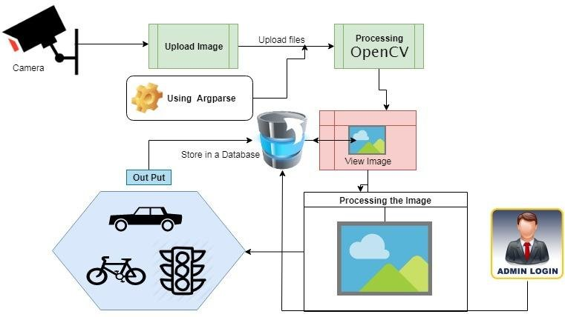

**Fig:** Data Collection

Step 2: Preprocessing: Preprocess the images and convert them into a format suitable for analysis. Extract features using techniques like CNNs (Convolutional Neural Networks) or pre-trained models like VGG, ResNet, or Inception.

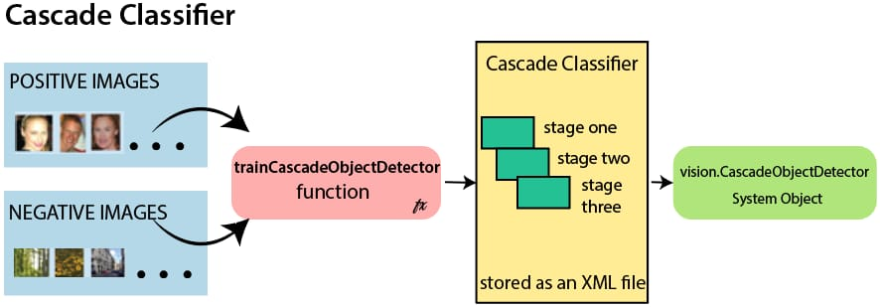

**Fig**: Preprocessing

Step 3: Sentiment Analysis: Implement a sentiment analysis model, which could be a deep learning model like an LSTM (Long Short-Term Memory) or a Transformer-based model like BERT. Train this model on the sentiment-labeled dataset to predict emotions or sentiment scores for each image.

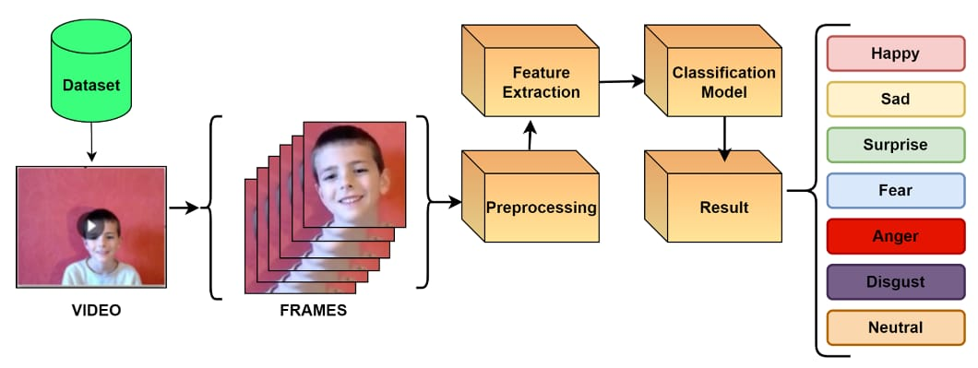

**Fig:** Sentiment Analysis

Step 4: Image Captioning Model: Build or use a pre-trained image captioning model. Popular choices include models based on recurrent neural networks (RNNs) or transformer architectures. You can fine-tune a pre-trained model on your specific task.

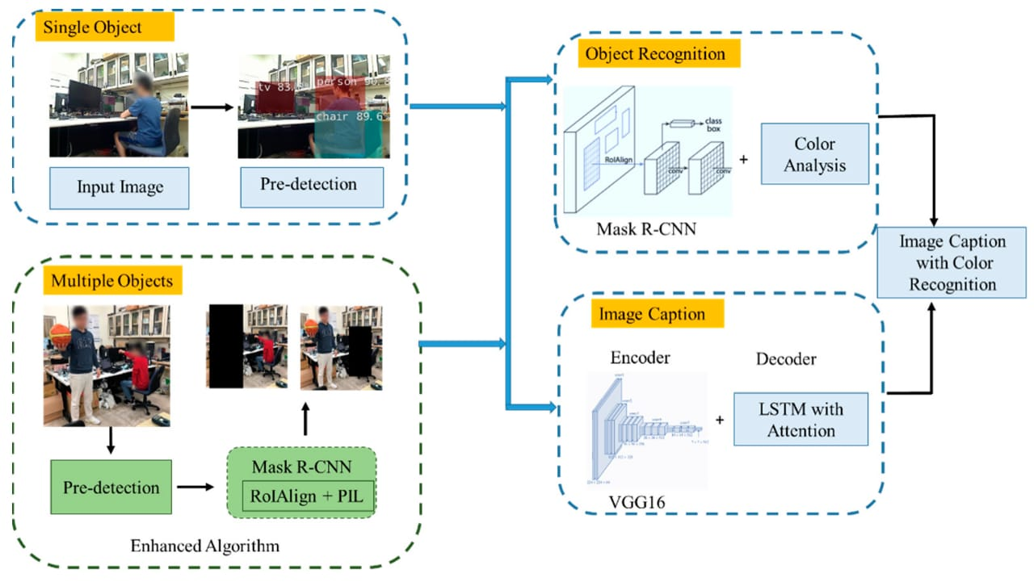

**Fig:** Image Captioning Model

Step 5: Combine Sentiment and Captioning: Modify the image captioning model to incorporate sentiment information. You can concatenate the sentiment scores or embeddings with the image features as an additional input. This guides the model to generate captions that reflect the mood or emotions in the image.

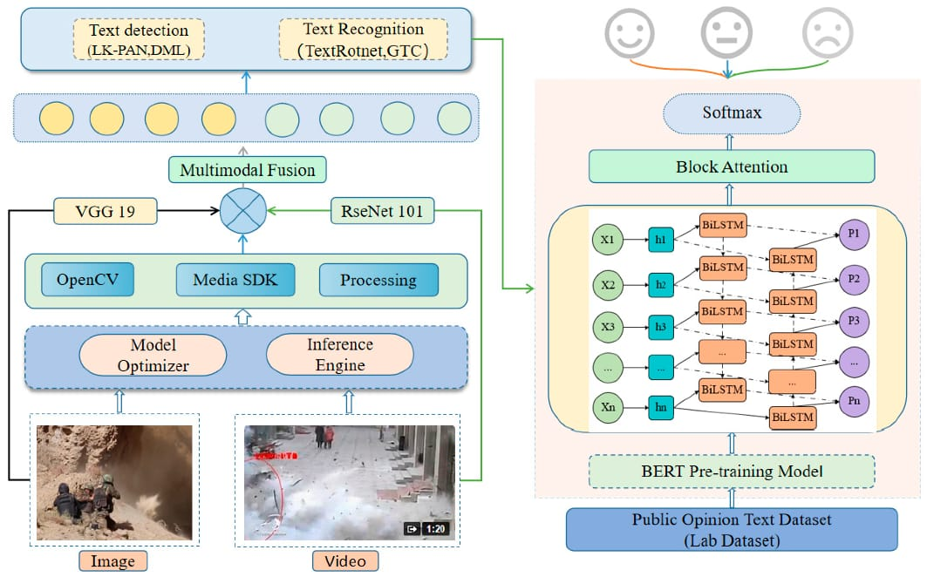

**Fig:** Combine Sentiment and Captioning

Step 6: Evaluation: Establish evaluation metrics to measure the performance of your model. Metrics like BLEU, METEOR, or ROUGE can be used to evaluate the quality of generated captions. Additionally, you can assess how well the generated captions match the predicted sentiments.

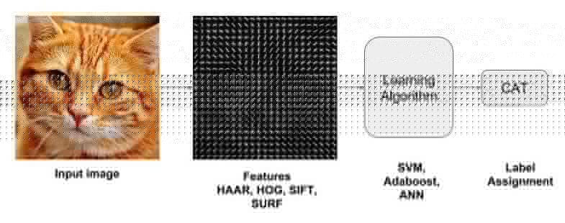

**Fig:** Evaluation

Step 7: Fine-Tuning: Fine-tune your combined model on a validation set to optimize its performance. Experiment with hyperparameters to achieve the desired route.

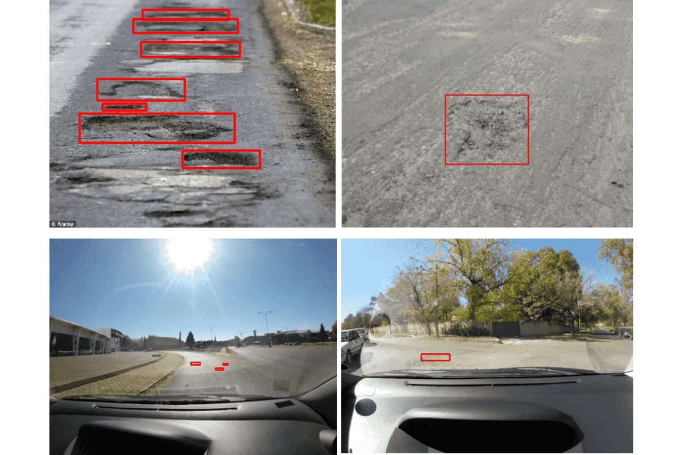

**Fig:** Fine-tuning

Step 8: Testing and Deployment: Test your model on a separate test dataset to ensure it generalizes well. Once satisfied with the performance, deploy the model in your application or system.



**Fig:** Testing and Deployment

Step 9: Continuous Improvement: Continuously monitor and improve the model's performance by collecting user feedback and retraining it with new data.

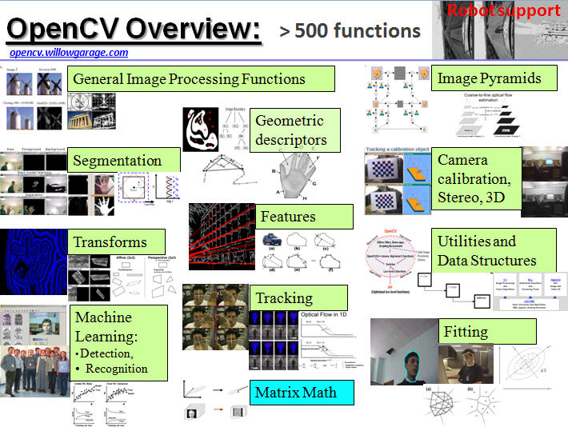

**Fig:** Continuous Improvement

Step 10: User Interface: Design a user-friendly interface that displays the image along with the sentiment-aware caption to enhance the user experience.

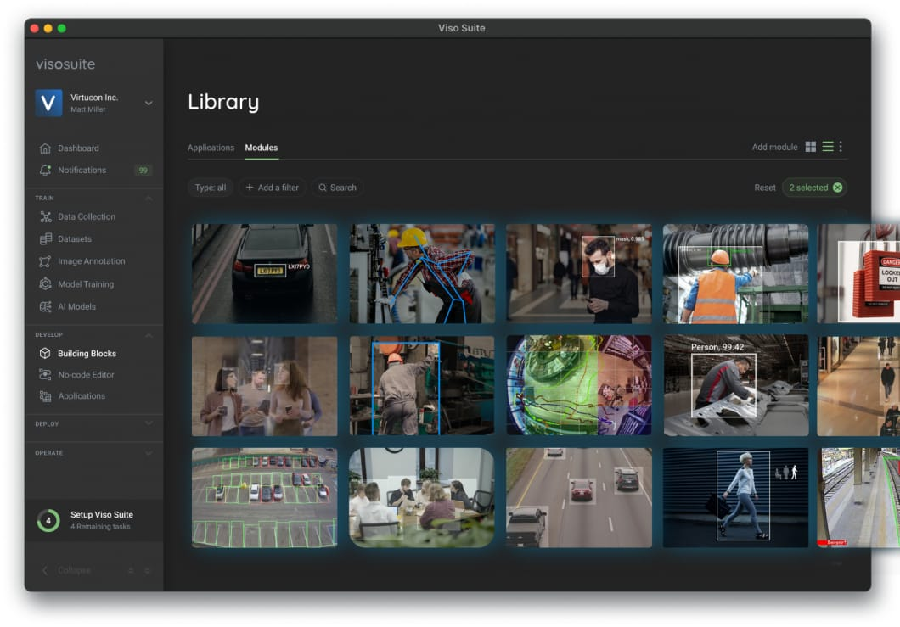

**Fig:** User Interface

**FLOWCHART:**

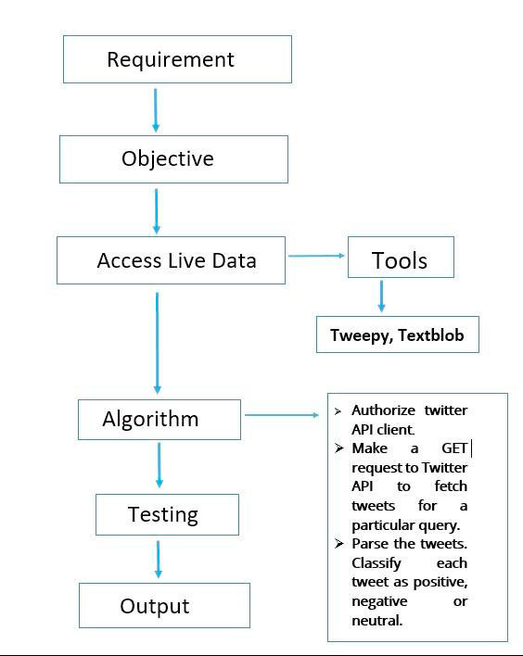

**DEVELOPING STEPS:**

IBM Cloud Account:

First, sign up for an IBM Cloud account if you don't already have one.

Create a Visual Recognition Service:

Create a new instance of the Visual Recognition service in the IBM Cloud catalog. This service allows you to analyze and classify images.

API Key:

After creating the service, you'll receive an API key. This key is essential for accessing the service programmatically.

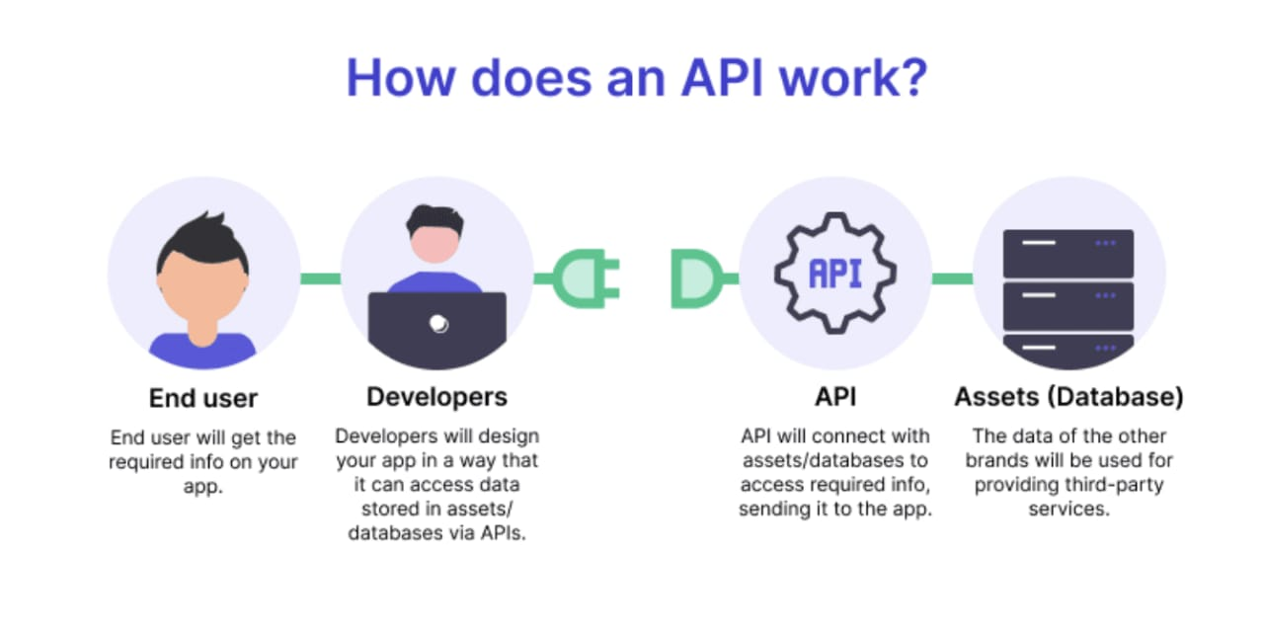

**Fig:** API key

Collect and Label Data:

You'll need a dataset of labeled images to train your image recognition model. Collect a diverse set of images and label them according to the objects or categories you want your system to recognize.

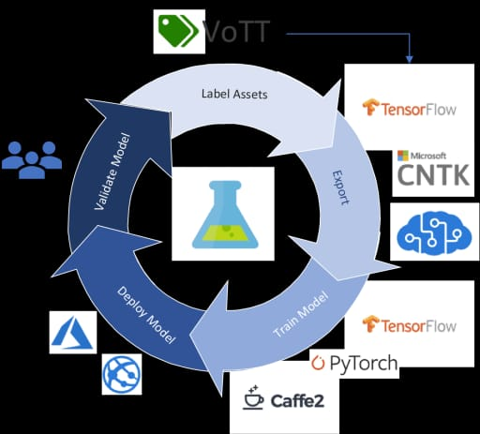

**Fig:** Collect and Label Data

Train Your Model:

Use the IBM Visual Recognition tool to upload and train your model. IBM Visual Recognition supports both custom models and pre-trained models, which can be fine-tuned.

Test and Evaluate:

Test your model with various images to ensure it's performing well. You can use the API key to integrate the model into your applications or services.

Integrate with Your Application:

Integrate the image recognition model into your application by using the IBM Cloud SDK or RESTful API. You can use various programming languages like Python, Node.js, or Java.

Continuous Improvement:

Monitor the performance of your model and retrain it as needed with new data to improve accuracy.

Scaling:

Depending on your application's demands, you may need to scale your IBM Cloud resources to handle increased usage.

Security and Compliance:

Ensure that your image recognition system complies with data protection and privacy regulations, especially if it processes sensitive information.

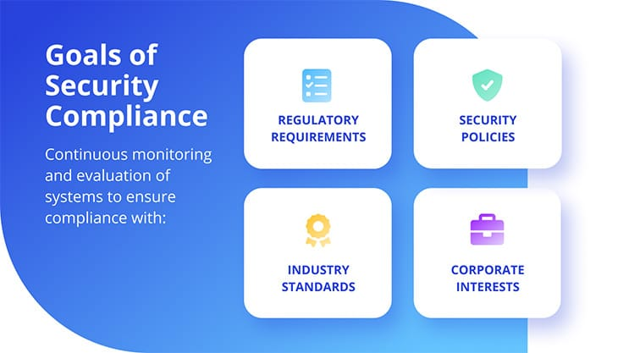

**Fig:** Security and compliance

Management:

Keep an eye on the costs associated with using IBM Cloud services. IBM provides pricing information to help you understand the expenses.

Documentation and Support:

IBM offers extensive documentation and support resources to assist you in building and maintaining your image recognition system.

**LOGIN PAGE:**

<!DOCTYPE html>

<html lang="en">

<head>

    <title>Login Page</title>

</head>

<body>

    <div id="login-container">

        <h1>Login</h1>

        <form

        action="your_authentication_script.p

        hp" method="post">

    <label

for="username"<Username:</label>

<input type="text"

id="username" name="username"

required><br>

<label

for="password">Password:</label>

<input type="password"

id="password" name="password"

required><br>

<input type="submit"

value="Login">

</form>

 </div>

</body>

</html>

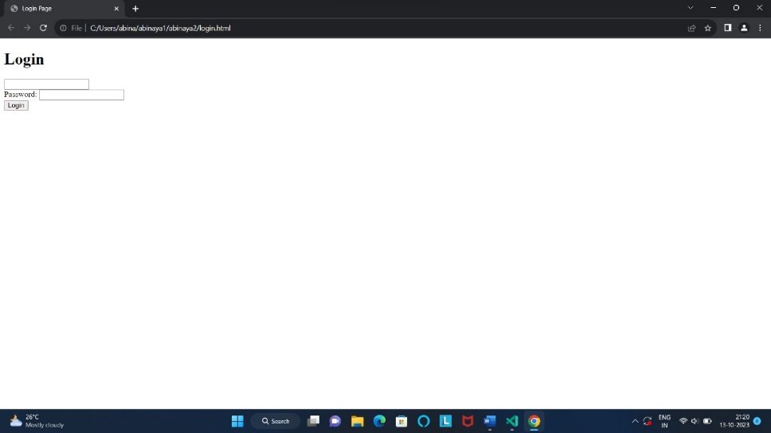

**LOGIN STEPS:**

A face recognition website typically contains the following components and features:

1. User Interface: The website will have a user-friendly interface for users to interact with. This might include a landing page, login/registration forms, and options to upload or capture images for recognition.

2. Face Detection and Recognition Algorithms: The core of the website is the face recognition technology, which includes algorithms for detecting and recognizing faces in images or videos.

3. User Authentication: Many face recognition websites offer user authentication features, allowing users to log in or register using their face as a biometric identifier.

4. Image Uploading/Capturing: Users can upload images or capture images using their device's camera for face recognition.

5. Face Database: A database to store and manage registered user faces and their associated data.

6. Face Matching: The system should be able to match the input face with faces in the database and provide results on whether a match is found.

7. Security and Privacy: Strong security measures to protect user data and privacy, especially when handling biometric information.

8. User Management: Features to manage user profiles, permissions, and access control.

9. Error Handling: Proper error messages and handling to guide users in case of issues during recognition.

10. Analytics and Reporting: Track usage, monitor system performance, and generate reports on recognition results.

11. Integration: APIs and tools for integrating the face recognition service into other applications or systems.

12. Documentation and Help: Instructions and support for users and developers to understand how to use the service.

13. Legal and Compliance: Compliance with data protection laws and regulations, such as GDPR, as well as terms of service and privacy policies.

14. Mobile Responsiveness: Support for mobile devices and responsive design for various screen sizes.

15. User Feedback: Mechanisms for users to provide feedback or report issues.

16. Support and Maintenance: Ongoing maintenance, updates, and customer support.

The specific contents and features can vary depending on the purpose of the face recognition website, whether it's for authentication, identification, verification and its application.

**PROFILE PAGE:**

html

<!DOCTYPE html>

<html>

<head>

    <title>My Profile</title>

</head>

<body>

    <header>

        <h1>My Profile</h1>

        </header>

        <section>

            <h2>About Me</h2>

<p>Name:Your name</p>

<P>Age:Your age</p>

<p>Gender: Your gender</p>

<p>Phone number:xxxxxxxxxx</p>

            <p>Location:City,Country</p>

            <p>Bio:This is a brief description about me.</p>

            </section>

            <h2>Interest</h2>

            <u1>

                <li>Hiking</li>

                <li>Programming</li>

                <u1>

                </section>

                <section>

                    <h2>Contact Information</h2>

                    <p>Email:@example.com</p>

                    <p>Twitter:<a href="https.//twitter.com/abi"target="_blank">@abi</a></p>

                    </section>

                    <footer>

                        <p>&copy;2023 My Profile.com"</p>

                        </footer>

                    </body>

                    </html>

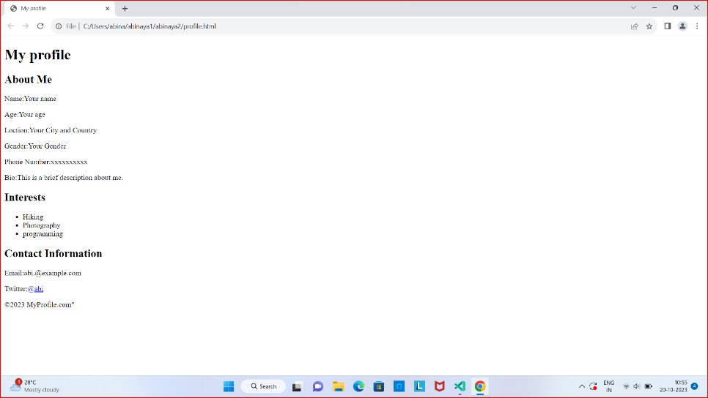

**PROFILE PAGE STEPS:**

1. Set Up IBM Cloud Account:

- If you don't have an IBM Cloud account, sign up for one.

2. Create an IBM Cloud Visual Recognition Service:

- Log in to your IBM Cloud account.

- From the IBM Cloud dashboard, go to the catalog and search for "Visual Recognition."

- Create an instance of the Visual Recognition service.

3. Collect and Prepare Training Data:

- Gather a dataset of images for training. These images should be related to the profiles you want to recognize.

4. Train a Custom Classifier:

- In the IBM Cloud Visual Recognition service, create a custom classifier.

- Upload the training images and label them with appropriate classes or labels (e.g., profile pictures of different individuals).

5. Train the Model:

- Initiate the training process for your custom classifier.

- This may take some time, depending on the size of your dataset

6. Test and Evaluate:

- Once the training is complete, test your custom classifier with new images to ensure it's accurately recognizing profiles.

7. Integrate with Your Profile Page:

- Obtain the API credentials (API key) for your Visual Recognition service.

- Implement code in your profile page to make API calls to the Visual Recognition service for image recognition.

- You can use various programming languages and SDKs provided by IBM to interact with the service.

8. Display Recognition Results:

- Display the recognition results on your profile page, showing which profile is recognized in the uploaded image.

9. Handle Errors and Edge Cases:

- Implement error handling and consider how to deal with cases where the recognition might not be accurate.

10. Monitor and Fine-Tune:

- Continuously monitor the performance of your image recognition system.

- If necessary, fine-tune the model or add more training data to improve accuracy.

11. Secure Your API Keys:

- Ensure that your API keys are kept secure and not exposed to the public.

**LOGOUT PAGE:**

<!DOCTYPE html>

<html>

<head>

    <title>Logout Page</title>

</head>

<body>

<h1>Logout</h1>

<from action="logout.php" method="post">

    <p>Are you sure you whant to log out?</p>

    <input type="submit" value="Logout">

</from>

</body>

</html>

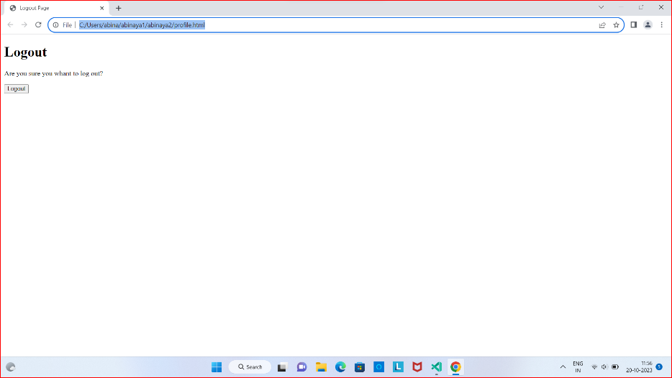

**LOGOUT PAGE STEPS:**

1. Access IBM Cloud Dashboard: Log in to your IBM Cloud account and access the IBM Cloud Dashboard.

2. Select the Visual Recognition Service: Locate the IBM Cloud Visual Recognition service in your dashboard. It should be listed under your resources.

3. Access the Service: Click on the Visual Recognition service to access its details.

4. Navigate to Service Credentials: In the Visual Recognition service dashboard, navigate to "Service Credentials." This is where you can find the credentials associated with your service.

5. Delete or Deactivate Credentials: You can either delete the credentials you've created for the service or deactivate them. This will effectively log you out of the service.

**CONCLUSION:**

In conclusion, embarking on the journey to create a face recognition website is a dynamic and promising endeavor. Face recognition technology has evolved to become a powerful tool for a multitude of applications, from user authentication to enhancing user experiences. By understanding the underlying technology and following a structured development process, you can build a website that is both innovative and