# IMAGE RECOGNITION WITH IBM COUD VISUAL RECOGNITION

Image recognition, in the context of IBM Cloud, refers to the process of using artificial intelligence (AI) and machine learning(ML) technologies to analyze and interpret visual information from images or videos. IBM Cloud offers a range of services and tools that enable image recognition and computer vision capabilities for various applications.

# INNOVATIVE STEPS

**Setup**

Setting up an image recognition system involves several stages, from data collection and preparation to model training and deployment. It includes Advanced deep learning models, Transfer learning, Custom training data, Data augmentation, Custom classifiers.

**Load Image:**

The load image stage in image recognition refers to initial step in processing an image for analysis by an image recognition system. In this stage, an image is loaded into memory or a processing pipeline to prepare it for further processing.

**Preprocess the Image (Optional):**

The specific preprocessing steps and their order depend on the characteristics of the image dataset and the requirement of the image recognition task. Preprocessing is a critical step because it can significantly impact the performance of the recognition model by ensuring that the input data is clean, standardized, and suitable for analysis.

**Perform Sentiment Analysis:**

Sentiment analysis is typically performed on text data to determine the sentiment or emotion tone expressed in a piece of text, such as a review or comment. It involves classifying the text as positive, negative, or neutral, or assigning a sentiment score.

**Generate Caption:**

Image captioning involves automatically generating descriptive textual captions or sentences that describes the content of an image. Libraries and frameworks like PyTorch and TensorFlow offer pre-trained models and resources to help you get started with image captioning tasks

**Display or Save Caption:**

To display or save captions generated in an image recognition or image captioning system, you can use various methods and technologies depending on your application and platform.

# IMPLEMENTATION STEPS

**Data collection**

Gather a diverse dataset of images that contain the objects or features you want to recognition. This dataset will be used for training and testing your image recognition model.

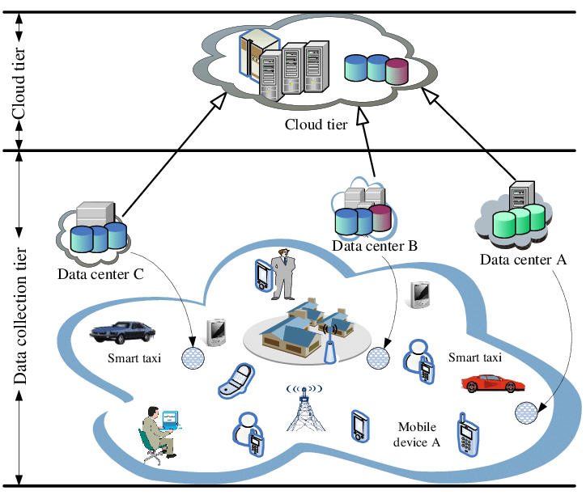

**Data preprocessing**

Preprocess the images to ensure they are in a suitable format for analysis.

**Feature Extraction**

Extract relevant features from images. For traditional computer vision, the might involve hand-crafted feature extraction techniques like HOG, SIFT.

**Data Labelling**

Annotate the images in your dataset by labelling the objects or features you want to recognize.

**Training Data Split**

Divide the dataset into three subsets: a training set, a validation set, and a test set. The training set is used to train the model, the validation set helps tune hyperparameters, and the test set is used to evaluate the model’s performance.

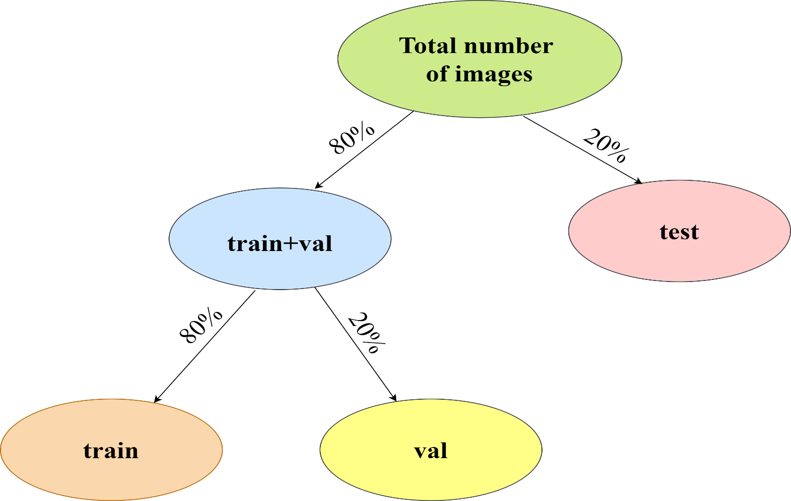

**Model Selection**

Choose an appropriate model architecture for your image recognition task. This could be a traditional machine learning model or deep learning model.

**Model Training**

Train your selected model using the labeled training data. During training, the model learns to recognize patterns and features in the images and make predictions based on them.

**Hyperparameter Tuning**

Fine-tune hyperparameters, such as learning rate and batch size, using the validation set to optimize the model’s performance.

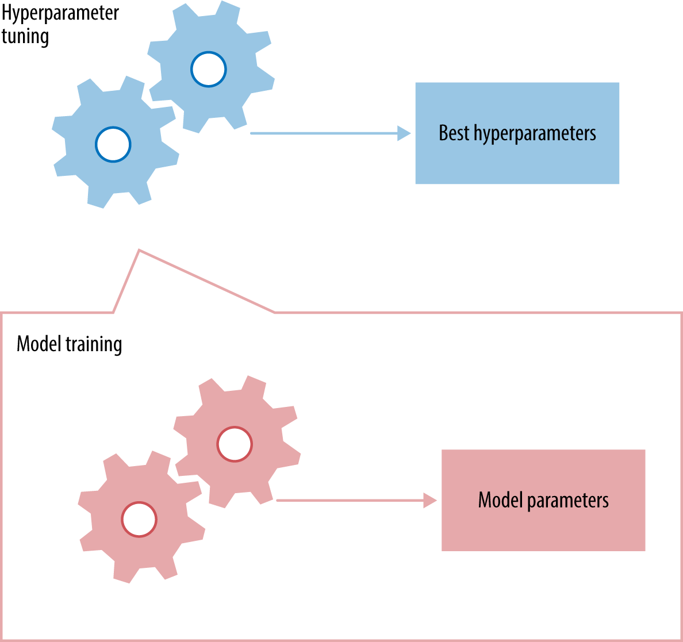

**Model Evaluation**

Assess the model’s performance on test set using evaluation metrics such as accuracy, precision, recall, F1 score, or mean average precision (mAP)

**Post-Processing**

Apply post-processing techniques to refine the recognition results if necessary.

**Deployment**

Deploy the trained image recognition model in your application or system, making it capable of recognition objects or features in new, unseen images.

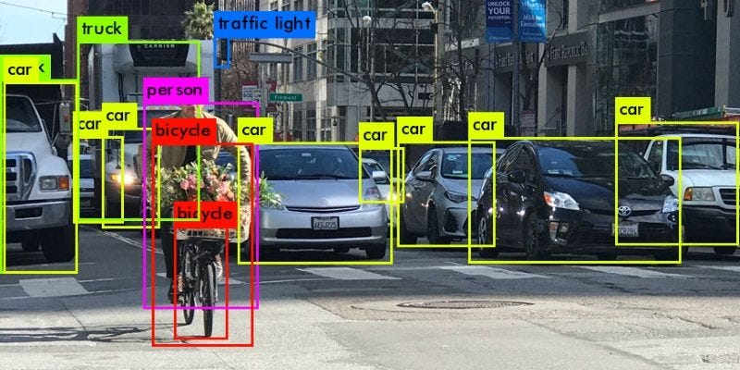

**Inference**

Use deployed model for inference by feeding it new images and obtaining recognition results.

**Monitoring and Maintenance**

Continuously monitor the model’s performance in a production environment and retrain it periodically with a new data to maintain accuracy.

**Documentation and Training**

Provide documentation and training materials for users or operators who interact with image recognition system.

# FLOWCHART FOR IMAGE RECOGNITION WITH IBM CLOUD VISUAL RECOGNITION

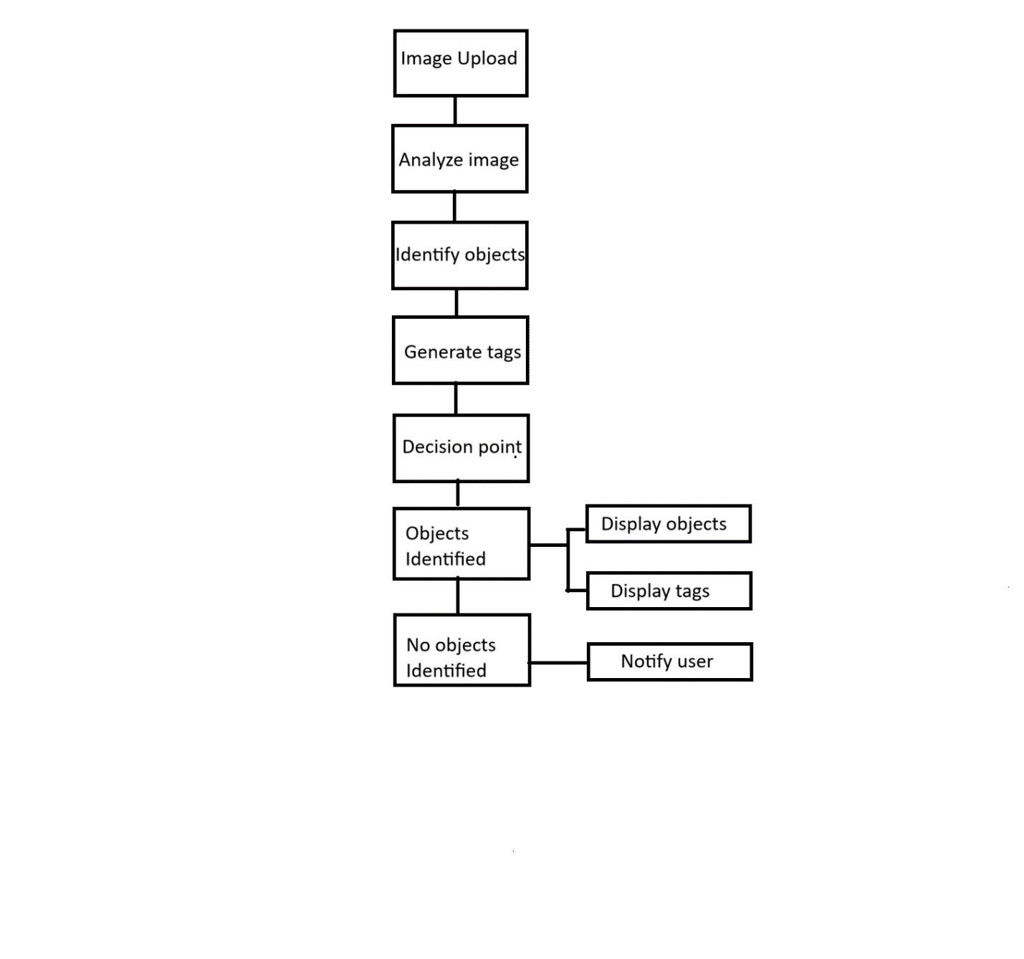

# CONCLUSION

In conclusion, the process of implementing image recognition using IBM Cloud Visual Recognition involves several key steps. These steps are crucial for achieving accurate and meaningful results in image analysis and classification: Data collection, Data preprocessing, Training the model, Model evaluation, Customization, Integration, Testing and validation, Deployment, Data Privacy and security. By the following steps we can carefully and continually monitor and improve the system, businesses, and developers can harness the power of image recognition for a wide range of applications and use cases.