Research Trends in Social Robots for Learning

Wafa Johal  
University of New South Wales  
Faculty of Engineering  
Sydney, Australia  
[wafa.johal@unsw.edu.au](mailto:wafa.johal@unsw.edu.au)

**Abstract**

**Purpose of Review**With the growth in the number of market-available social robots, there is an increasing interest in research on the usage of social robots in education. This paper proposes a summary of trends highlighting current research directions and potential research gaps for social robots in education. We are interested in design aspects and instructional setups used to evaluate social robotics system in an educational setting.

**Recent Findings**   
The literature demonstrates that as the field grows, setup, methodology and demographics targeted by social robotics applications seem to settle and standardize - a tutoring Nao robot with a tablet in front of a child seems the stereotypical social educational robotics setup.

**Summary** An updated review on social robots in education is presented here. We propose, first, an analysis of the pioneering works in the field. Secondly, we explore the potential for education to be the ideal context to investigate central human-robot interaction research questions. A trend analysis is then proposed demonstrating.

**Keywords**Social robots, Education, Robots for learning, Robot tutor, Human-Robot Interaction

**Introduction**Over the years, the field of social robotics has considerably grown, represents a big share of all human-robot interaction research. Social educational robots are pedagogical or intelligent agents that aim to support learning and teaching. As illustrated in Figure 1(extrapolated from (1)), social educational robotics is a multi-disciplinary field embedding notions, methods and theories from learning sciences, robotics and human-computer interaction.

Several recent review papers have analyzed new findings in social educational robots, some of which target specific areas of the curriculum. Some focused on works dealing with language or literacy (2–6). Other reviews focused on the methods, for instance Yang and Zhang (7) present Artificial Intelligence (AI) methods for Intelligent Tutoring Robots; and, Jamet *et al.* (8) review research works using the Learning by Teaching approach. Other reviews looked at the application of social robotics to specific target groups of learners; for instance, social robots for primary (9), and special education (10).

Belpaeme *et al.* (11) proposed a systematic review of papers published between 1992 and May 2017, and presenting studies featuring social robots in education. In this survey, authors specifically targeted three questions around the notions of *Efficacy*, *Embodiment,* and *Interaction Role*. In terms of embodiment, their findings showed a predominance of studies using the Nao robot. The role of the robot seems to be predominantly that of a tutor or a teacher. Rosanda and Istenic (12) found a similar trend when analysis studies were conducted in classroom settings. Finally, in terms of efficacy, authors found that studies were targeting two main outcomes: affective (i.e. empathy or immediacy) and/or cognitive (i.e. learning gain). Their analyses showed that the effect of social robots in education seems to be as for now, limited to “short, well-defined lessons”.

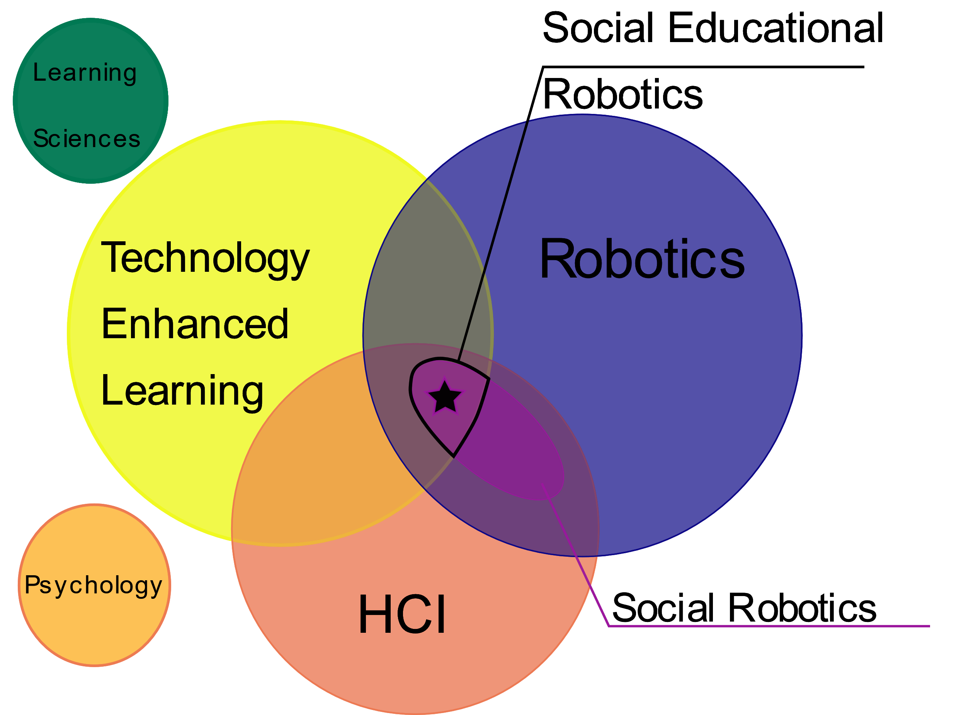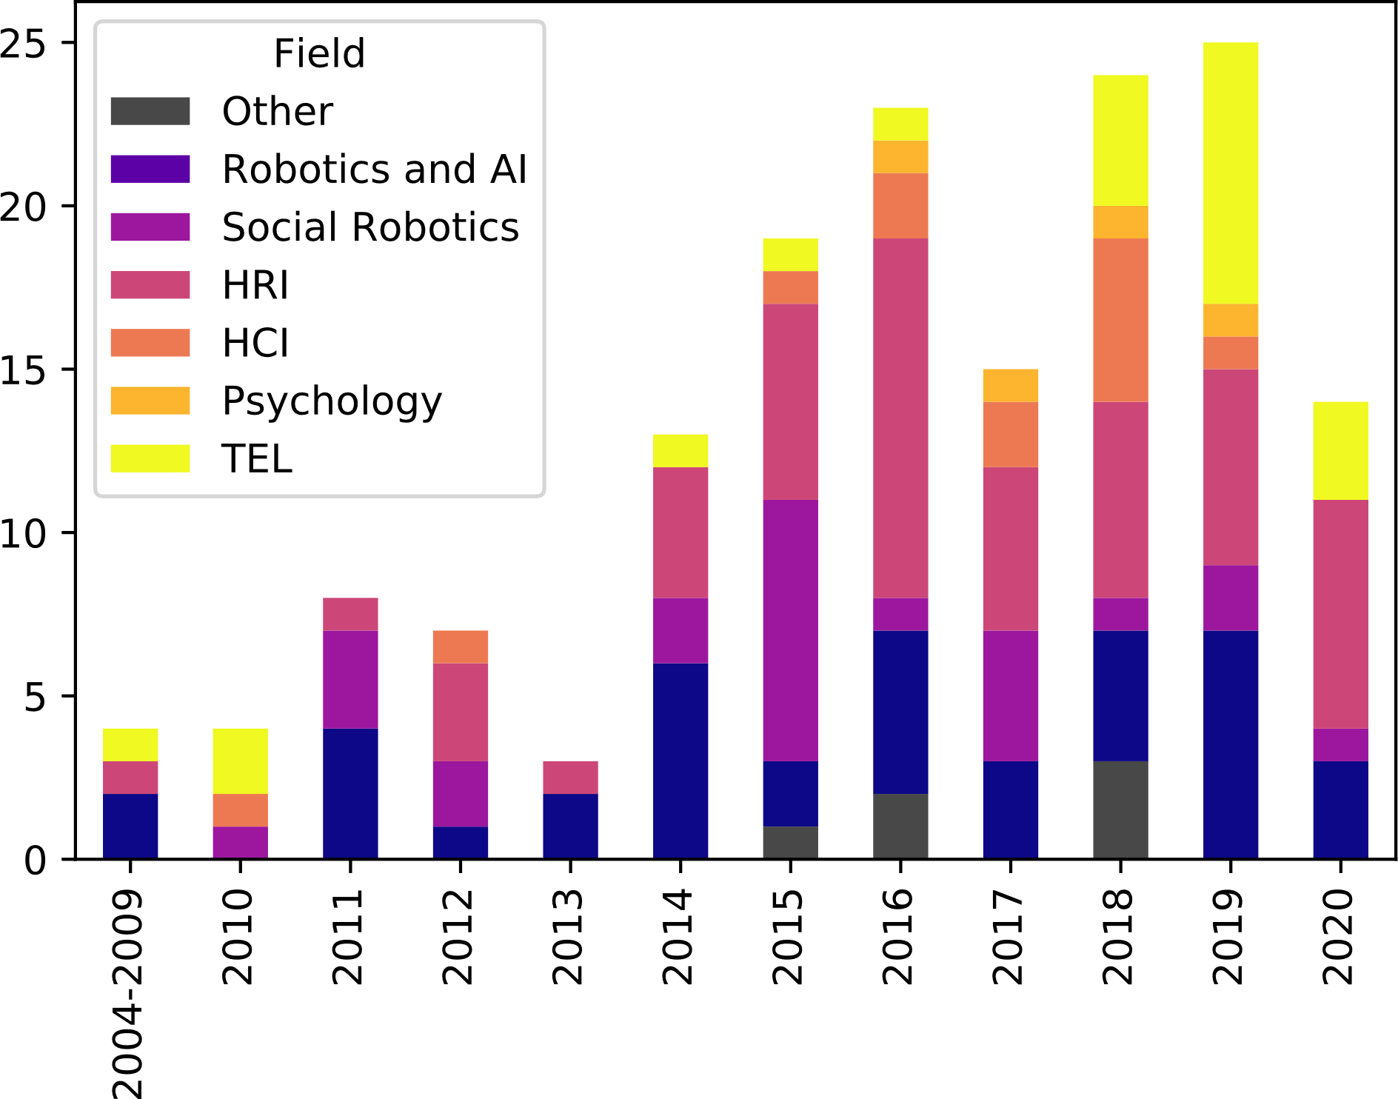

**Figure 1**| View of fields of study that conformed social educational robotics. HCI: Human-Computer Interaction and * denotes Social Educational Robotics (extrapolated from (1)).

**Figure 2** | Publication field for papers in the dataset throughout the years. (HRI): Human robot Interaction, (HCI): Human-computer Interaction, and (TEL): Technology Enhanced Learning.

As we will show in this review, education provides interesting technical, theoretical and methodological challenges for robotics. Education is one of the most growing area for commercialization of social robots, foreseen to provide an engaging and personalized learning experience. This instant in social educational robotics provides a unique opportunity to reflect on where the research originated and where it is heading. In this article we extend on a recent review by Belpaeme et al. (11) incrementing the number of papers considered in the analysis by more than a third issued from publication since May 2017 until March 2020. We review technical and research trends in the field and consider what the future may hold for the field.

**Methodology**

Our aim with this paper is to highlight trends of research. We will be looking at evolution thought this past 15 years of several aspects of social educational robotics. Using Belpaeme et al. ’s collection as an initial base, we first extended the list of papers to cover research from 2004 until Mars 2020. This was done by reproducing the methodology described in the original paper and searching the same keywords. Furthermore, we annotated this new enriched collection aiming to answer novel questions and focusing on temporal trends of the field. Finally, in order to obtain bibliometric information about the published papers, we used the CrossRef python API (13)and scrapped information based on papers’ Digital Object Identifier (DOI). Papers without a DOI were excluded from our dataset. The output dataset contains 160 papers and is available online as well as the source code used for our analysis(14).

With a first look at the paper datasets, we propose to cluster the publication venue (i.e. journal title, conference proceedings title) in relation with the fields that encompass social educational robotics. Table 1 presents the list of venues and how they were clustered. Figure 2 shows the evolution of the publication fields over the years. Looking at this data, we observe a recent trend of publications in Technology Enhanced Learning venues and less in more core HCI and robotics venues. This could be explained by more reliable robotics system allowing to focus on educational impact of social robots in real world settings.

.

**The origins of Social Robots for Education**

|  |  |  |  |
| --- | --- | --- | --- |
| Article | Citation count | | |
| **Crossref** | **Google Scholar** |
| Tanaka and Matsuzoe, “Children teach a care-receiving robot to promote their learning.” (15) | 126 | 245 |
| Fasola and Matarić. “A socially assistive robot exercise coach for the elderly.” (16) | 122 | 232 |
| Saerbeck, Schut, Bartneck, and Janse. “Expressive robots in education: varying the degree of social supportive behavior of a robotic tutor.” (17) | 108 | 260 |
| Szafir and Mutlu. “Pay attention! Designing adaptive agents that monitor and improve user engagement.” (18) | 85 | 224 |
| Fridin. “Storytelling by a kindergarten social assistive robot: a tool for constructive learning in preschool education.”(19) | 77 | 163 |
| Han, Jo, Jones, and Jo. “Comparative study on the educational use of home robots for children.” (20) | 68 | 178 |
| Kennedy, Baxter, and Belpaeme. “The robot who tried too hard: social behaviour of a robot tutor can negatively affect child learning.”(21) | 64 | 148 |
| Leyzberg, Spaulding, and Scassellati. “Personalizing robot tutors to individuals’ learning differences.”(22) | 58 | 148 |

In order to capture the most prominent and influential papers from early years, we use our enriched survey based on (11), now containing 160 papers published from 2004 to March 2020. To determine which articles are the most influential, we used the number of citations for each work as the discriminant metric. The number of citations is a bibliometric measure, commonly used to determine the influence of papers, researchers and institutions. In order to obtain the number of citations for the list of papers in our concerned dataset, we crossed the papers using their DOI with data obtained from Crossref[1]. Crossref’s citation count however, is limited to citation that include a DOI and thus susceptible to being incomplete. For completion, we used the count of citations from Google Scholar on 20th of March 2020. The top 8 most cited papers from the survey are listed in Table 2. All these works have either introduced new methods, new areas of application or novel perspectives and hence been highly influential in the field.

Table 2| The top 8 most cited papers from 2014 to 2020. citations retrieved on 6 March 2020

The most cited article is by Tanaka and Matsuzoe (15) and presents one of the first long-term experiments in a school. The paper reports on experiments featuring a robot care-receiver used for L2 English vocabulary learning for children in Japan. The study is one of the initial works using the Learning by Teaching (LbT) paradigm. This approach places the robot as a learner and the student as the robot’s teacher. LbT is a very interesting paradigm for social robots in education as it can play both on the student’s extrinsic motivation and be used to adapt the training. Several projects have been using this paradigm for handwriting or reading for instance (23,24). A recent review by Jamet et al. presents an overview of the HRI studies using LbT (8).

The second most cited paper by Fasola and Matarić (16) presents an autonomous robotic coach system for elderly to learn physical exercise. This paper points out the applicability of autonomous tutoring for elderly and the importance of embodiment in engaging adult participants. Although assistive robotics studies often frame their contributions apart from learning, they measure off-line benefits of training and include motor learning evaluation with sometimes pre-post test (25).

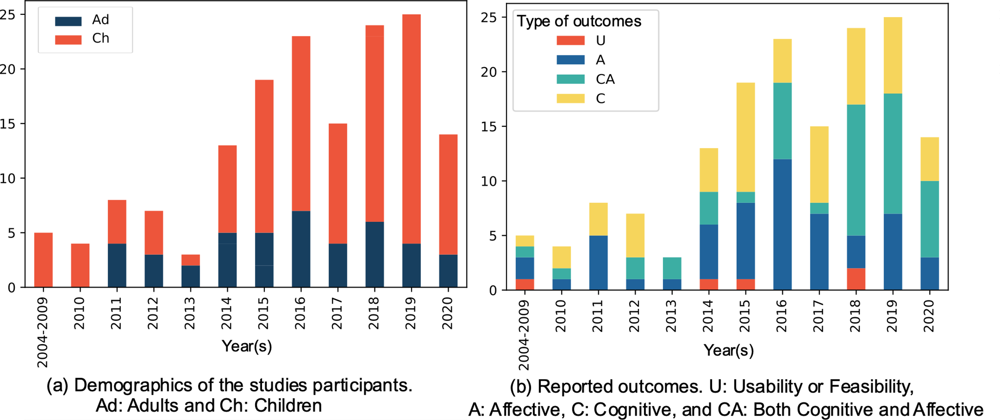

Figure 3 | Demographics and Reported Outcomes of Studies.

Saerbeck *et al.* (17) present a study showing social robotic tutor with supportive behaviors and demonstrate its positive learning effects. Similarly, Han *et al.* (20) introduced a home robot-assisted learning system targeting L2 (in this case English for Korean children) and demonstrated post-experimental positive effects of the social robots in comparison with a computer-based learning system. This study constituted one of the first large studies (90+ students) demonstrating significant results.

Fridin (19) explored a different role for the social robot and proposes one of the pioneering research studies featuring a robot teaching assistant, helping the teacher to teach kindergarteners new concepts and motor skills. This work demonstrated the use of social robots in preschool to assist teachers in an interactive storytelling scenario.

Personalization and social adaptation are key areas of research in social educational robotics. Szafir and Mutlu (18) show how one can measure the learner’s attention using EEG during the learning task and present an adaptive robotics agent that can regain attention, demonstrating improvements in recall. Leyzberg *et al.* (22) report one of the pioneer works evaluating the influence of personalized tutoring by a robot tutor compared to not personalized with a large cohort. They showed a “one-sigma” improvement in post-test showing positive benefits of personalization. A year after, Kennedy *et al.* (21) show that robots can effectively employ teaching strategies when used to teach prime numbers to children. However, their study also showed that “*a robot which is not appropriately social led to greater learning gains of children in a maths task than a robot with appropriate social behaviours*.” This novel study has nourished even more research to assess the potential of social personalisation in learning with a robot tutor.

From these pioneering and highly cited works, we derive two research-question areas that are often addressed in social robots for education:

* *Effectiveness*: Does social behavior enhance learning? What can be taught with a social robot? What is the role of social robots in education?
* *Social adaptation and personalized learning*: Can educational paradigm be applied to robots for learning? What are the added values of personalization and adaptation? Is there an effect of the social agent embodiment?

These questions go beyond the special context of using robots in education. This makes the educational context a challenging and interesting area for social assistive robotics to tackle important challenges.

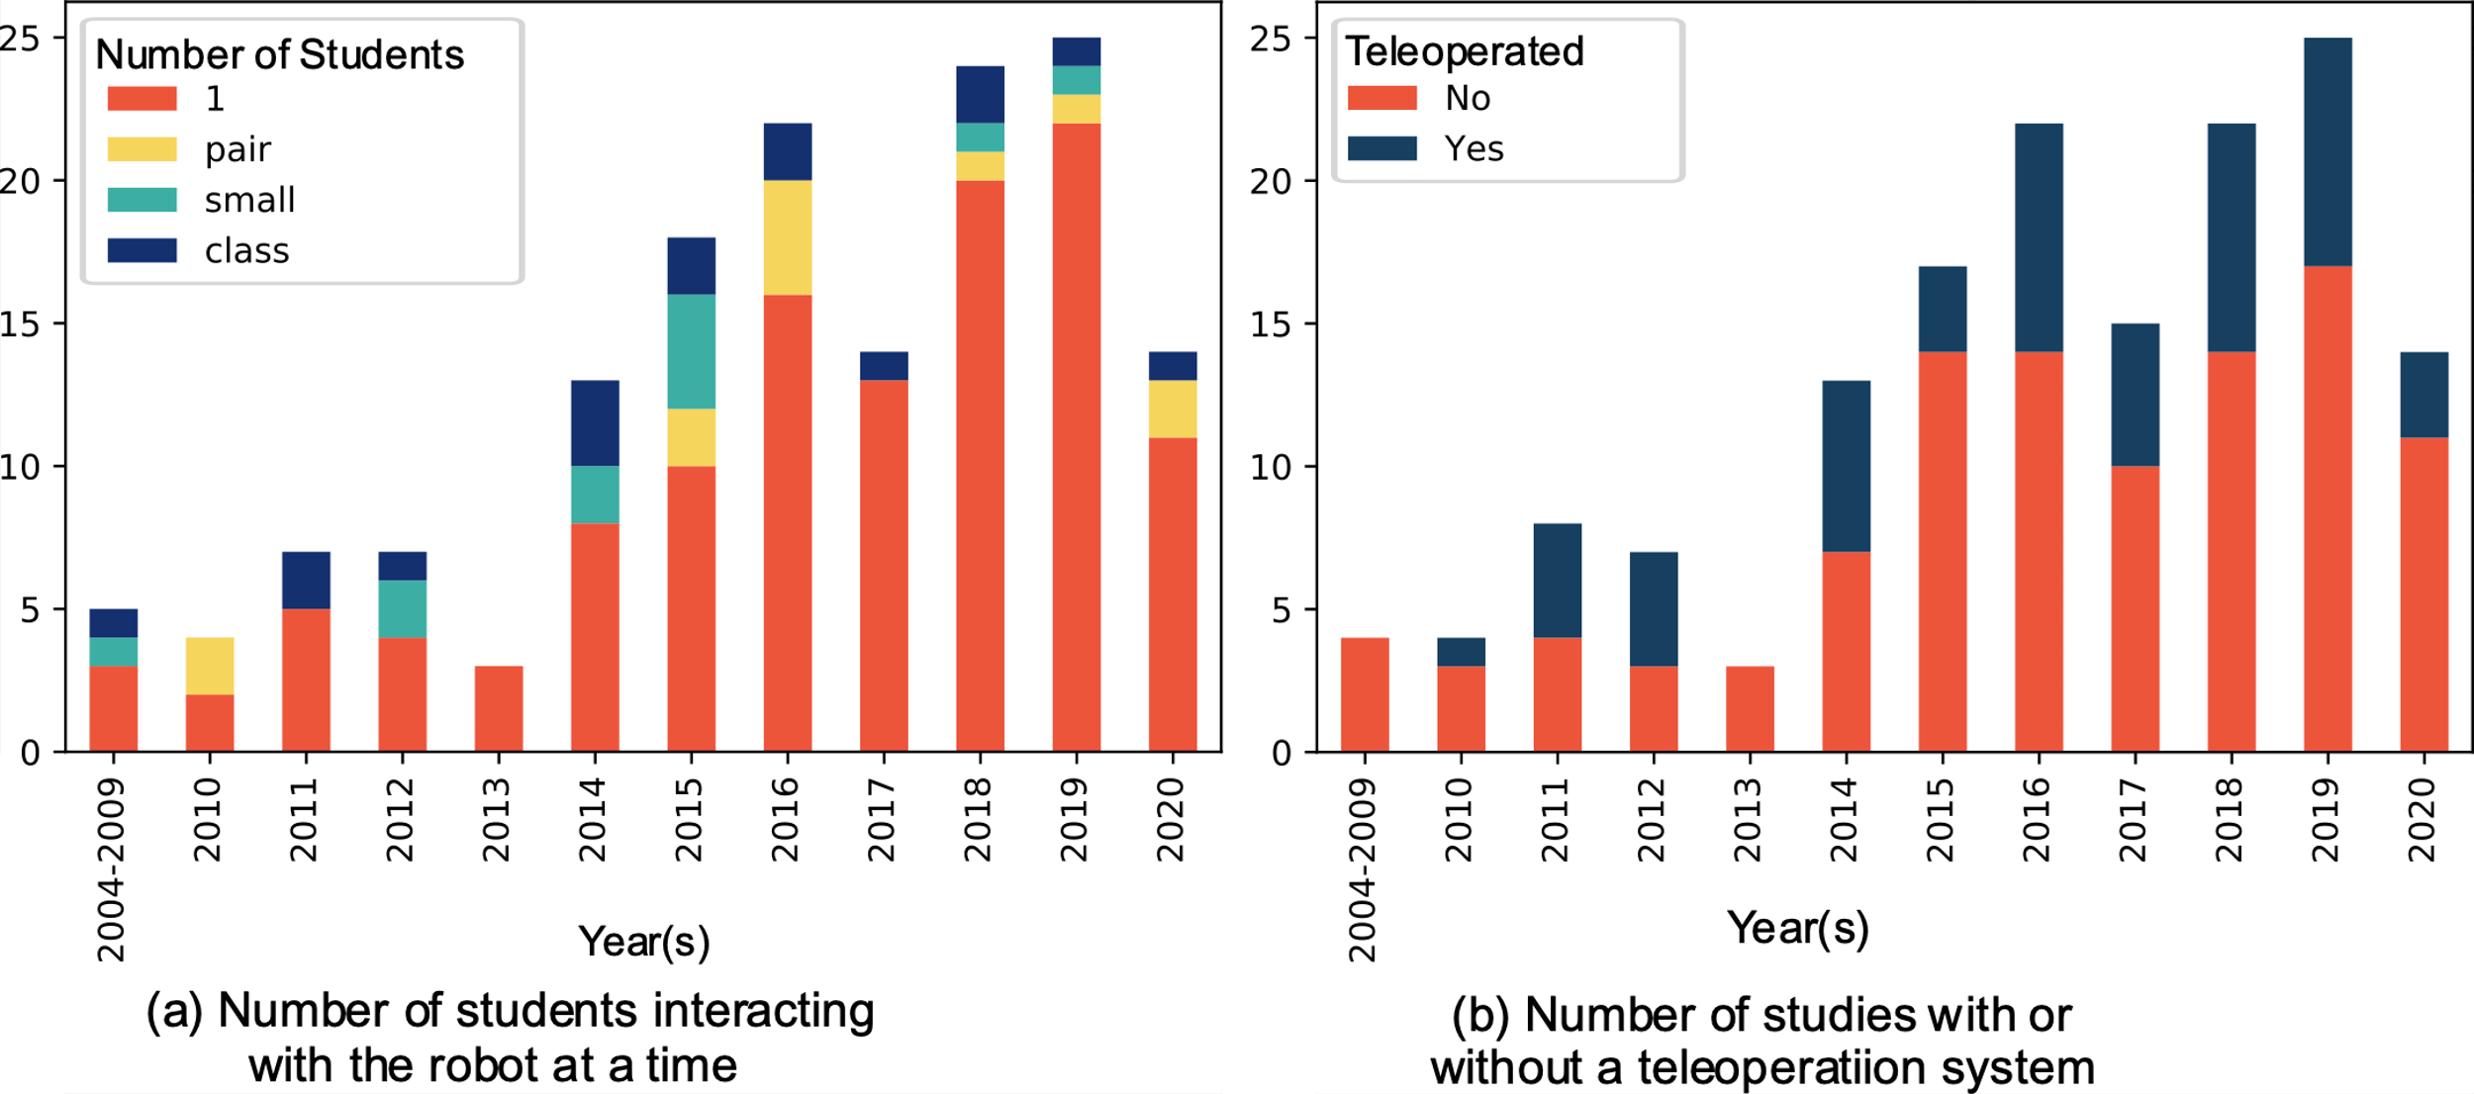

Figure 4 | Experimental setup. Small: 3-5 students, Class: 6 and above

**Evolution of Social Educational Robotics Over the Years**

As discussed earlier, and simply looking at the publication venues, there seems to be a shift of the field towards demonstrating effective robot’s intervention in learning contexts. This section aims to look at the evolution of key aspects of studies in social educational robotics over the last 16 years to observe potential research trends.

Figure 3 (a) shows a clear trend of research studies involving **children participants**. Like the observations of Belpaeme et al. (11), we noticed a large body of research pertaining to elementary and primary school learners. While this trend can be justified by the current educational needs of the younger population, one can wonder if it could be a consequence of the robot’s design, its’ abilities and its’ credibility in the social role attributed to it in the learning context. Concerning the reported outcomes, affective and cognitive outcomes were distinguished and annotated for the new papers added to the dataset similarly to (11). While before 2016, studies were tackling either affective or cognitive outcomes exclusively. Using data up to 2016, Belpaeme et al. found that a large number of works were presenting affective outcomes. However, the past three years have revealed an emerging inclusive trend of reporting on **both affective and cognitive outcomes** rather than focusing on a single one (see Figure 3 (b) ). This trend is at the benefit of evaluating cognitive impact of the robot and to investigate its worth. We also noticed that a very small number of studies target the teachers’ or the educators’ ease at physically using social robots in educational contexts.

Looking at the offline impact of learning sessions with a robot, we investigated how many papers were reporting **retention outcomes**. Indeed, when dealing with learning, especially with a robot, one would expect that the effect of learning is not limited to the session itself but that students not only retain but even find themselves to be able to transfer what they’ve learned with the robot afterwards in time. While most of the works reporting cognitive outcomes present results on immediate post-tests, only 15% of works published report on retention outcomes.

A major research-question addressed in social educational robotics research deals with **social adaptation and personalization**. This research is motivated by the will to promote individualized and tailored learning experience. As a consequence, a large majority of research studies reporting on advances in personalization of learning are conducted with one student at a time (see Figure 4 (a) ). This trend is particularly true for papers published over the last 5 years, during which the proposition of **one-to-one** setups has increased up to more than 80%. These studies have proposed exiting novel methods to enable robots to adapt the learning content as well as its social behavior. We refer to works that mentioned using a Wizard of Oz or other kinds of human interventions to control the robot while it was interacting with the learners as ‘**Teleoperated’**. Figure 4 (b) presents the number of studies over the years according to the autonomous vs teleoperated modality. Over the last five years, the number of studies in which the robot is not teleoperated became relatively high (above 60%) compared to studies with a wizard or a teleoperating system. On this matter, Clabaugh and Matarić (26) propose an interesting analysis of current methods and constraints to reach fully autonomous social assistive robotics.

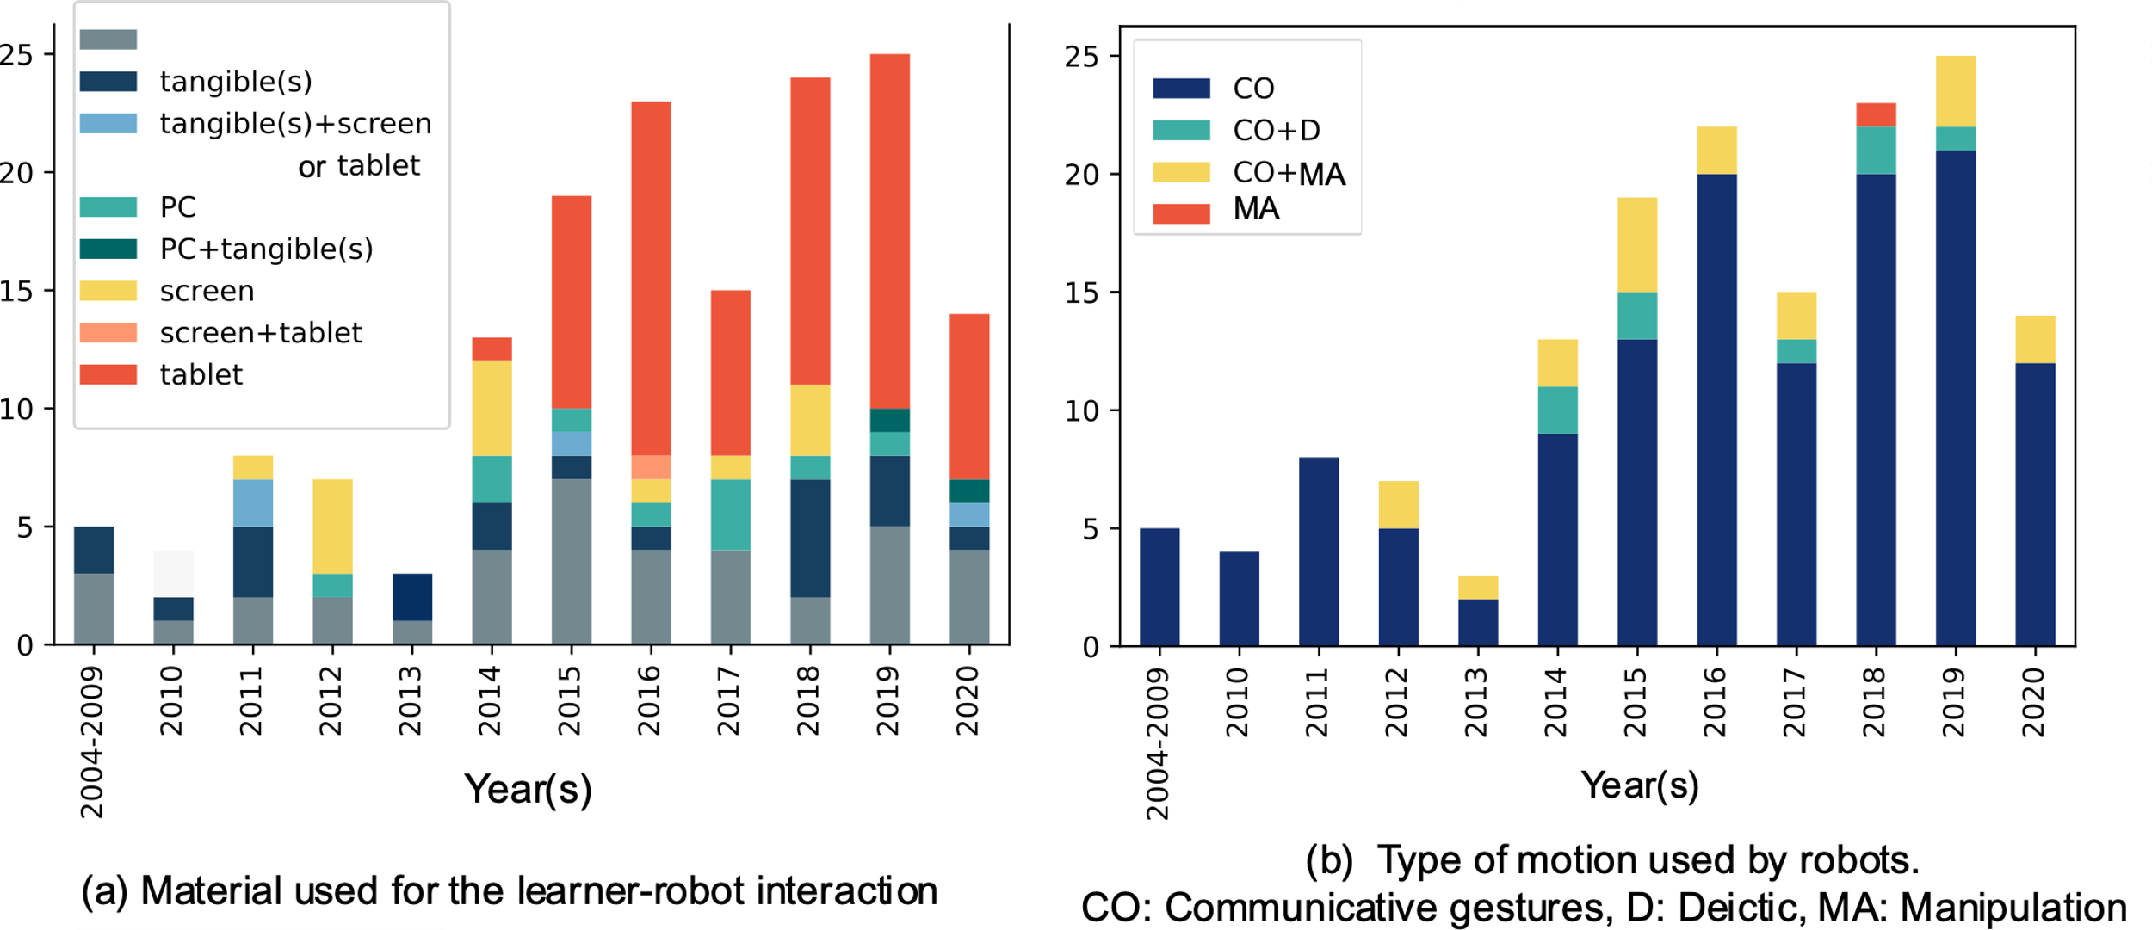

Figure 5 | Type of material and motion

Another important aspect in instructional design is the material used. Preparing the learning material is a major task for all educators. While social robots often need a computer (to handle the computations) or external sensors to operate, we were particularly interested in the **material used as a medium** for the interaction between the learner and the robot. To address this question, we annotated the dataset and defined four categories of tools. Some setups made use of tangible interfaces including custom made buttons (24), physical objects (27), (28), cards; usually manipulated by the learner (29), and books (30). Some papers reported the use of computers and laptops, used both to display material and for the learner to answer questions (31). Touch screens such as interactive tablets (allowing several learners at a time) and tablets were also quite abundant. Several studies also reported the use of screens that were, used to augment the discourse of a lecturing robot. Despite the majority of works using external tools, some studies did not use any external material at all – solely the robot was interacting directly with the learner. This was particularly the case in studies targeting motor imitation such as sign language (32). Figure 5 (a) shows the proportion of each of the material category. While some studies were using a combination of different tools, we see that most studies were using none or **touch screens**. The use of touch screen is not specifically particular to the educational context of social robot as noted by Park *et al.* (33). Tablets and touch screens can ease the interaction especially in the absence of automatic speech recognition, which we know is not yet robust in spontaneous context for children (34).

Another aspect that we considered was the way the robot was moving in the interaction. Robots are embodied agents, and while their motion can be used to enhance their social presence through communicative gestures, robots can also be capable of manipulating objects while collaborating with humans (35). We were interested in the types of motion that robots were exhibiting during robot-learner interactions. We annotated the dataset for robot motions being either communicative (non-verbal gestures that correspond to speech-acts or affective gestures), deictic (pointing) or manipulative (directly interacting with objects of the environment) gestures. We found that almost all the studies presented social robots that used communicative gestures while a very few used manipulative gestures (see Figure 5 (b) ). Several factors can explain this: robots used in educational contexts do not have bodily manipulation capabilities (i.e. Jibo, Tega). There is also a trade-off between the reliability and the speed of object manipulations (from perception to plan execution) and interaction flow. Most of the contributions of these studies being non-technical but theoretical, the object manipulation came second. We noticed that nearly none of the mobile robots were moving in the environment, and that the interaction with student was confined to being at a tablet or in a dedicated area in the classroom.

**Reflections on Social Robots in Education**

At this point, several potentials and threats are to be considered for the growth of the social educational robotics. This section makes some concrete recommendations for future research in social robots in education.

**Analyze the Learning Process:** One big area of research in technology enhanced learning is learning analytics. Learning analytics aims to use data mining techniques to understand learning & interaction processes and to inform the design of learner models (36–38). Several reasons make social educational robots interesting for learning analytics. On one hand, robots feature lots of sensors that can be used as inputs to investigate the temporality and multimodality of learning mechanisms. These sensors can be used to build affective and knowledge learner models. On the other hand, learning analytics provide tools to analyze and model data streams, and to provide insights on the learning outcomes beyond the simple pre-post-test analysis. Some recent works in robots in education have started to use learning and interaction logs to extract learners’ strategies in a problem-solving task (39) and or to model learner’s behavior in a literacy scenario (40).

**Benchmark, reuse and reproduce**: As noted previously by Belpaeme *et al.* (11), there have been several research studies covering similar curriculum areas (i.e. handwriting, L2 and literacy) which sometimes use the same platform (48% of studies used the Nao robot). Besides, we noticed that the robots were often used for communicative motions. These motions are not platform dependent and could have been acted with a different social robot. For these reasons, a major recommendation is to propose a wider use of open source systems and benchmarked material as well as design and empirical challenges. To evaluate the interaction effect, one needs to have a solid learning activity, with a real benefit, with the adequate learning material as well as evaluation (i.e. pre-test, post-test and retention test). With shared instructional designs, researchers in social educational robotics could tackle core and general robotics or human-robot interaction research challenges. A good example of this is the Cowriter project (23), a project that aims to help children with handwriting difficulty using the Learning by Teaching paradigm, which published its code openly on Github[2]. Several researchers have been extending the initial work looking at long-term interaction (41), status of the robot (42), the influence of learner-robot spatial arrangement (43), the impact of engagement styles (44) and the applicability to help with the Kazakh script transition (45). A shared repository of learning materials will guarantee reproducibility and a robust design of the learning material. These learning materials would need to specify the eventual prerequisites, the targeted skills and concepts covered by the learning scenario, the types of feedback, the structure of the interaction (i.e. problem solving, guided lessons) as well as the educational material (i.e. books, webapplication) that are presented to the learner during the activity. Finally, instructional design challenges involving educators could help to develop scenarios that can be tested outside of research. As several platforms that are used in social HRI are commercial products, many of these robots might not be affordable for public schools. Making their scenario usable by teachers in their classroom, researchers would be able to evaluate long-term and unplugged effects of social robots in learning.

**Scale up**: While individualizing learning is a first foreseen application of social robots in education, it is less realistic to allocate one physical robot per student in a class and that the robot would be facing only one user at a time, given that most social educational robots are relatively expensive for public educational institutions. Besides, one of the recent challenges of Human-Robot Interaction research has been focusing on developing solutions to permit robots to handle social interaction with multiple users… Research challenges that are brought from handling multiple users are different from one on one interaction and should be prioritized to demonstrate applicability and worth of social robots in education.

**Conclusion**

Robots have started to show a real potential as learning or teaching companions for children in classrooms or at home, for elderly to maintain cognitive and physical abilities and for learners with deficiencies to adapt content to their capabilities. Robots show the potential to improve individual adaptation by learning from and with the user. Several research projects have aimed to apply HRI to education and learning in order to teach broader disciplines than just STEM, such as languages or handwriting. Robots also have the potential to enhance learning via kinesthetic interaction. They have shown to enable users to improve their self-esteem and to provide adaptive empathic feedback. Robots can thus be a means to engage the learner and to motivate him in the learning task. While robots for learning is quite an applied topic of HRI, we found that the context of learner-robot interaction is one of the most challenging and interesting for research while having the potential of a great impact.

In this paper, we proposed to update the review proposed by Belpaeme et al. in 2018 and to analyze the list of works with novel questions aiming to discover research trends. This study is subject to several limitations. Firstly, some studies meeting our inclusion criteria could have been missed in the data acquisition process. This would have had a limited effect on our analysis due to the already substantial number of works included. Secondly, we only report empirical studies in which the robot was used during the learning activity. We have also excluded research papers that did not report on participants. We excluded short research papers and other reviews. Finally, our manual annotation of the dataset can be prone to errors. An automatic extraction of information could be envisioned to update the database in the future.

Social educational robotics has the potential to enhance research in human-robot interaction. Stronger collaboration with educators and learning science researchers can also be made in order to use robots to design and evaluate novel learning paradigms. This could be achieved by inter disciplinary contributions published in Technology Enhanced Learning venues.

**References**

1. Angel-Fernandez JM, Vincze M. Towards a Formal Definition of Educational Robotics. In: Austrian Robotics Workshop 2018 [Internet]. 2018 [cited 2020 Mar 30]. Available from: http://dx.doi.org/10.15203/3187-22-1-08

2. Kanero J, Geçkin V, Oranç C, Mamus E, Küntay AC, Göksun T. Social Robots for Early Language Learning: Current Evidence and Future Directions. Child Dev Perspect. 2018;12(3):146–51.

3. van den Berghe R, Verhagen J, Oudgenoeg-Paz O, van der Ven S, Leseman P. Social Robots for Language Learning: A Review. Rev Educ Res. 2019 Apr 1;89(2):259–95.

4. Randall N. A Survey of Robot-Assisted Language Learning (RALL). ACM Trans Hum-Robot Interact. 2019 Dec 11;9(1):7:1–7:36.

5. Wit J de, Krahmer E, Vogt P. Social Robots as Language Tutors: Challenges and Opportunities. In: Proceedings of the Workshop on the Challenges of Working on Social Robots that Collaborate with People, ACMCHI Conference on Human Factors in Computing Systems (CHI2019 SIRCHI Workshop) [Internet]. 2019 [cited 2020 Apr 18]. Available from: https://research.tilburguniversity.edu/en/publications/social-robots-as-language-tutors-challenges-and-opportunities

6. Neumann MM. Social Robots and Young Children’s Early Language and Literacy Learning. Early Child Educ J. 2020 Mar 1;48(2):157–70.

7. Yang J, Zhang B. Artificial Intelligence in Intelligent Tutoring Robots: A Systematic Review and Design Guidelines. Appl Sci. 2019 Jan;9(10):2078.

8. Jamet F, Masson O, Jacquet B, Stilgenbauer J-L, Baratgin J. Learning by Teaching with Humanoid Robot: A New Powerful Experimental Tool to Improve Children’s Learning Ability [Internet]. Journal of Robotics. 2018 [cited 2020 Mar 19]. Available from: https://www.hindawi.com/journals/jr/2018/4578762/

9. Tuna G, Tuna A, Ahmetoglu E, Kuscu H. A survey on the use of humanoid robots in primary education: Prospects, research challenges and future research directions. Cypriot J Educ Sci. 2019 Sep 30;14(3):361–73.

10. Kaburlasos VG, Vrochidou E. Social Robots for Pedagogical Rehabilitation: Trends and Novel Modeling Principles [Internet]. Cyber-Physical Systems for Social Applications. IGI Global; 2019 [cited 2020 Mar 18]. p. 1–21. Available from: www.igi-global.com/chapter/social-robots-for-pedagogical-rehabilitation/224413

11. Belpaeme T, Kennedy J, Ramachandran A, Scassellati B, Tanaka F. Social robots for education: A review. Sci Robot [Internet]. 2018 Aug 15 [cited 2020 Apr 1];3(21). Available from: https://robotics.sciencemag.org/content/3/21/eaat5954

12. Rosanda V, Istenic Starcic A. The Robot in the Classroom: A Review of a Robot Role. In: Popescu E, Hao T, Hsu T-C, Xie H, Temperini M, Chen W, editors. Emerging Technologies for Education. Cham: Springer International Publishing; 2020. p. 347–57. (Lecture Notes in Computer Science).

13. Chamberlain S. sckott/habanero [Internet]. 2020 [cited 2020 Apr 23]. Available from: https://github.com/sckott/habanero

14. Johal W. WafaJohal/SocialRobotUpdate [Internet]. 2020 [cited 2020 Apr 23]. Available from: https://github.com/WafaJohal/SocialRobotUpdate

15. Tanaka F, Matsuzoe S. Children teach a care-receiving robot to promote their learning: field experiments in a classroom for vocabulary learning. J Hum-Robot Interact. 2012 Jul 28;1(1):78–95.

16. Fasola J, Matarić MJ. A socially assistive robot exercise coach for the elderly. J Hum-Robot Interact. 2013 Jun 18;2(2):3–32.

17. Saerbeck M, Schut T, Bartneck C, Janse MD. Expressive robots in education: varying the degree of social supportive behavior of a robotic tutor. In: Proceedings of the SIGCHI Conference on Human Factors in Computing Systems [Internet]. Atlanta, Georgia, USA: Association for Computing Machinery; 2010 [cited 2020 Feb 26]. p. 1613–1622. (CHI ’10). Available from: https://doi.org/10.1145/1753326.1753567

18. Szafir D, Mutlu B. Pay attention! designing adaptive agents that monitor and improve user engagement. In: Proceedings of the SIGCHI Conference on Human Factors in Computing Systems [Internet]. Austin, Texas, USA: Association for Computing Machinery; 2012 [cited 2020 Feb 26]. p. 11–20. (CHI ’12). Available from: https://doi.org/10.1145/2207676.2207679

19. Fridin M. Storytelling by a kindergarten social assistive robot: A tool for constructive learning in preschool education. Comput Educ. 2014 Jan 1;70:53–64.

20. Han J-H, Jo M-H, Jones V, Jo J-H. Comparative Study on the Educational Use of Home Robots for Children. J Inf Process Syst. 2008;4(4):159–68.

21. Kennedy J, Baxter P, Belpaeme T. The Robot Who Tried Too Hard: Social Behaviour of a Robot Tutor Can Negatively Affect Child Learning. In: 2015 10th ACM/IEEE International Conference on Human-Robot Interaction (HRI). 2015. p. 67–74.

22. Leyzberg D, Spaulding S, Scassellati B. Personalizing robot tutors to individuals’ learning differences. In: Proceedings of the 2014 ACM/IEEE international conference on Human-robot interaction [Internet]. Bielefeld, Germany: Association for Computing Machinery; 2014 [cited 2020 Mar 18]. p. 423–430. (HRI ’14). Available from: https://doi.org/10.1145/2559636.2559671

23. Lemaignan S, Jacq A, Hood D, Garcia F, Paiva A, Dillenbourg P. Learning by Teaching a Robot: The Case of Handwriting. IEEE Robot Autom Mag. 2016 Jun;23(2):56–66.

24. Yadollahi E, Johal W, Paiva A, Dillenbourg P. When deictic gestures in a robot can harm child-robot collaboration. In: Proceedings of the 17th ACM Conference on Interaction Design and Children [Internet]. Trondheim, Norway: Association for Computing Machinery; 2018 [cited 2020 Feb 26]. p. 195–206. (IDC ’18). Available from: https://doi.org/10.1145/3202185.3202743

25. Wade E, Parnandi A, Mead R, Matarić M. Socially assistive robotics for guiding motor task practice. Paladyn. 2011 Dec 1;2(4):218–27.

26. Clabaugh C, Matarić M. Escaping Oz: Autonomy in Socially Assistive Robotics. Annu Rev Control Robot Auton Syst. 2019;2(1):33–61.

27. Davison DP, Wijnen FM, Charisi V, van der Meij J, Evers V, Reidsma D. Working with a Social Robot in School: A Long-Term Real-World Unsupervised Deployment. In: Proceedings of the 2020 ACM/IEEE International Conference on Human-Robot Interaction [Internet]. Cambridge, United Kingdom: Association for Computing Machinery; 2020 [cited 2020 Mar 16]. p. 63–72. (HRI ’20). Available from: https://doi.org/10.1145/3319502.3374803

28. Charisi V, Gomez E, Mier G, Merino L, Gomez R. Child-Robot Collaborative Problem-Solving and the Importance of Child’s Voluntary Interaction: A Developmental Perspective. Front Robot AI [Internet]. 2020 [cited 2020 Mar 26];7. Available from: https://www.frontiersin.org/articles/10.3389/frobt.2020.00015/full

29. Chandra S, Alves-Oliveira P, Lemaignan S, Sequeira P, Paiva A, Dillenbourg P. Children’s peer assessment and self-disclosure in the presence of an educational robot. In: 2016 25th IEEE International Symposium on Robot and Human Interactive Communication (RO-MAN). 2016. p. 539–44.

30. Michaelis JE, Mutlu B. Reading socially: Transforming the in-home reading experience with a learning-companion robot. Sci Robot [Internet]. 2018 Aug 22 [cited 2020 Mar 19];3(21). Available from: https://robotics.sciencemag.org/content/3/21/eaat5999

31. Reich-Stiebert N, Eyssel F. (Ir)relevance of Gender? On the Influence of Gender Stereotypes on Learning with a Robot. In: Proceedings of the 2017 ACM/IEEE International Conference on Human-Robot Interaction [Internet]. Vienna, Austria: Association for Computing Machinery; 2017 [cited 2020 Mar 18]. p. 166–176. (HRI ’17). Available from: https://doi.org/10.1145/2909824.3020242

32. Kose H, Akalin N, Uluer P. Socially Interactive Robotic Platforms as Sign Language Tutors. Int J Humanoid Robot. 2014 Mar 1;11(01):1450003.

33. Park HW, Coogle RA, Howard A. Using a shared tablet workspace for interactive demonstrations during human-robot learning scenarios. In: 2014 IEEE International Conference on Robotics and Automation (ICRA). 2014. p. 2713–9.

34. Kennedy J, Lemaignan S, Montassier C, Lavalade P, Irfan B, Papadopoulos F, et al. Child Speech Recognition in Human-Robot Interaction: Evaluations and Recommendations. In: Proceedings of the 2017 ACM/IEEE International Conference on Human-Robot Interaction [Internet]. Vienna, Austria: Association for Computing Machinery; 2017 [cited 2020 Apr 16]. p. 82–90. (HRI ’17). Available from: https://doi.org/10.1145/2909824.3020229

35. Thomaz A, Hoffman G, Cakmak M. Computational Human-Robot Interaction. Found Trends Robot. 2016;4(2–3):104–223.

36. Clow D. The learning analytics cycle: closing the loop effectively. In: Proceedings of the 2nd International Conference on Learning Analytics and Knowledge [Internet]. Vancouver, British Columbia, Canada: Association for Computing Machinery; 2012 [cited 2020 Apr 17]. p. 134–138. (LAK ’12). Available from: https://doi.org/10.1145/2330601.2330636

37. Siemens G. Learning Analytics: The Emergence of a Discipline. Am Behav Sci. 2013 Oct 1;57(10):1380–400.

38. Papamitsiou Z, Economides AA. Learning Analytics and Educational Data Mining in Practice: A Systematic Literature Review of Empirical Evidence. J Educ Technol Soc. 2014;17(4):49–64.

39. Nasir J, Norman U, Johal W, Olsen JK, Shahmoradi S, Dillenbourg P. Robot Analytics: What Do Human-Robot Interaction Traces Tell Us About Learning? In: 2019 28th IEEE International Conference on Robot and Human Interactive Communication (RO-MAN). IEEE; 2019. p. 1–7.

40. Westlund JMK, Dickens L, Jeong S, Harris PL, DeSteno D, Breazeal CL. Children use non-verbal cues to learn new words from robots as well as people. Int J Child-Comput Interact. 2017 Jul 1;13:1–9.

41. Jacq A, Lemaignan S, Garcia F, Dillenbourg P, Paiva A. Building successful long child-robot interactions in a learning context. In: 2016 11th ACM/IEEE International Conference on Human-Robot Interaction (HRI). 2016. p. 239–46.

42. Chandra S, Paradeda R, Yin H, Dillenbourg P, Prada R, Paiva A. Do Children Perceive Whether a Robotic Peer is Learning or Not? In: Proceedings of the 2018 ACM/IEEE International Conference on Human-Robot Interaction [Internet]. Chicago, IL, USA: Association for Computing Machinery; 2018 [cited 2020 Mar 18]. p. 41–49. (HRI ’18). Available from: https://doi.org/10.1145/3171221.3171274

43. Johal W, Jacq A, Paiva A, Dillenbourg P. Child-robot spatial arrangement in a learning by teaching activity. In: 2016 25th IEEE International Symposium on Robot and Human Interactive Communication (RO-MAN). 2016. p. 533–8.

44. El Hamamsy L, Johal W, Asselborn T, Nasir J, Dillenbourg P. Learning By Collaborative Teaching: An Engaging Multi-Party CoWriter Activity. In: 2019 28th IEEE International Conference on Robot and Human Interactive Communication (RO-MAN). IEEE; 2019. p. 1–8.

45. Sandygulova A, Johal W, Zhexenova Z, Tleubayev B, Zhanatkyzy A, Turarova A, et al. CoWriting Kazakh: Learning a New Script with a Robot. In: Proceedings of the 2020 ACM/IEEE International Conference on Human-Robot Interaction [Internet]. Cambridge, United Kingdom: Association for Computing Machinery; 2020 [cited 2020 Mar 17]. p. 113–120. (HRI ’20). Available from: https://doi.org/10.1145/3319502.3374813

**Appendix**

|  |  |  |  |  |  |
| --- | --- | --- | --- | --- | --- |
| Field | Journals | | | | Conferences |
| Technology Enhanced Learning (TEL) | British Journal of Educational Technology  Computers & Education  International Journal of Emerging Technologies in Learning (iJET)  Journal of Computer Assisted Learning  LNCS Artificial Intelligence in Education  LNCS Adaptive Instructional Systems  Journal of Special Education Technology | INTED Conference  European Conference on Game Based Learning  Proceedings of the 2019 on Creativity and Cognition  Annual SIGdial Meeting on Discourse and Dialogue  European Association for Computer Assisted Language Learning  European Association for Computer Assisted Language Learning  IEEE International Conference on Advanced Learning Technologies (ICALT) | | | |
| Psychology | Cognitive Systems Research  Educational Psychology  Computers in Human Behavior  Interaction Studies | | | |  |
| Human-Computer Interaction (HCI) | International Journal of Child-Computer Interaction  Frontiers in ICT  ACM Transactions on Interactive Intelligent Systems | | ACM Conference on Human Factors in Computing Systems (CHI)  IEEE Colombian Conference on Communications and Computing (COLCOM)  International Conference on Human-Agent Interaction (HAI)  ACM Conference on Interaction Design and Children (IDC)  ACM on International Conference on Multimodal Interaction (ICMI) | | |
| Robotics and AI | Frontiers in Robotics and AI  Journal of Advanced Computational Intelligence and Intelligent Informatics  Advances in Intelligent Systems and Computing  Autonomous Robots  Mechanical Engineering Letters  Robotics and Autonomous Systems  International Journal of Humanoid Robotics  IEEE Robotics & Automation Magazine  LNCS Towards Autonomous Robotic Systems  Science Robotics  Science Robotics  Paladyn Journal of Behavioral Robotics | | | IEEE/RSJ International Conference on Intelligent Robots and Systems  IEEE-RAS International Conference on Humanoid Robots (Humanoids)  International Conference on Robotics and Mechatronics (ICRoM)']  IEEE International Conference on Systems, Man, and Cybernetics  IEEE/RSJ International Conference on Intelligent Robots and Systems (IROS)  Proceedings of the AAAI Conference on Artificial Intelligence  Proceedings of the AAAI Conference on Artificial Intelligence | |
| Human-Robot Interaction (HRI) | Journal of Human-Robot Interaction  ACM Transactions on Human-Robot Interaction | | | ACM/IEEE International Conference on Human-Robot Interaction (HRI)  IEEE International Symposium on Robot and Human Interactive Communication (RO-MAN) | |
| Social Robotics | International Journal of Social Robotics  LNCS Social Robotics | | | | International Conference on Companion Technology (ICCT) |
| Others | -Technologies  -Frontiers in Computational Neuroscience  -Topics in Stroke Rehabilitation | | | | -IEEE International Conference on Development and Learning and Epigenetic Robotics (ICDL-EpiRob)  -International Conference on Software, Telecommunications and Computer Networks (SoftCOM)  -IEEE Congress on Evolutionary Computation (CEC)  -Annual SIGdial Meeting on Discourse and Dialogue |

Table 1| Publication Venues for Papers in the Dataset

1. <https://www.crossref.org/>
2. <https://github.com/chili-epfl/cowriter>