**Sales Performance Analysis Dashboard**

1. **Introduction**

* **Purpose:**

This document provides a thorough analysis of the 100,000 Sales Records Dataset. The objective is to identify trends, sales patterns, and actionable insights for optimizing business strategy.   
The dataset includes transactions from various regions, countries, product types, and sales channels.

## Objectives:

- Investigate sales performance across regions, products, and sales channels.  
 - Identify the most profitable regions and product types.

* **Scope:**  
  This interactive dashboard contains three main pages that focus on visualizing sales trends and providing comparative insights, especially from the year 2017.

**2. Data Overview**

* Dataset Name: 100,000 Sales Records
* Source: Kaggle
* Total Records: 100,000 sales transactions.
* **Fields:**  
  Key fields include:
  + Order Date
  + Region & Country
  + Item Type
  + Sales Channel
  + Units Sold, Revenue, Profit, and Cost
  + Order Priority (Low, Medium, High, Critical)

**3. Metrics and KPIs**

The dashboard highlights the following KPIs to evaluate sales performance:

1. **Total Units Sold**
2. **Total Revenue (Sales Value)**
3. **Total Profit**
4. **Total Cost**
5. **Average Order Value**
6. **Average Profit Margin**
7. **Average Units Sold**
8. **Units Sold by Region**
9. **Total Profit by Region**
10. **Sales Revenue by Item Type, Sales Channel, Country and Region**

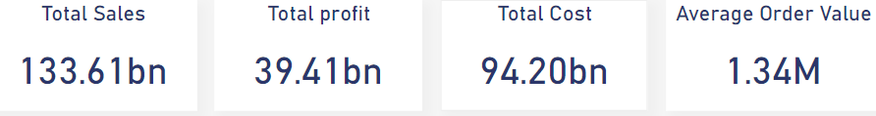

**4. Dashboard Layout**

**Page 1: Sales Overview**

**Focus:**  
General analysis of sales and revenue across all years.

**Visualizations:**

* Bar charts, area charts, treemaps, and pie charts showing sales by region, year, item type, and sales channel.

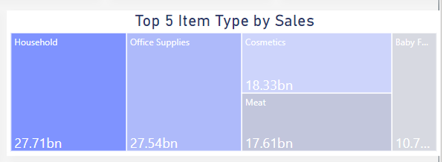

* Filters enable drilling down into specific years, regions, item types, and sales channels.



**Page 2: Profit Overview**

**Focus:**  
Analysis of profit and profit margin by region, item type, and sales channel.

**Visualizations:**

* Comparative bar charts, donut charts, and area charts for profit by region, item type, and sales channels and area chat for average profit margin by region.

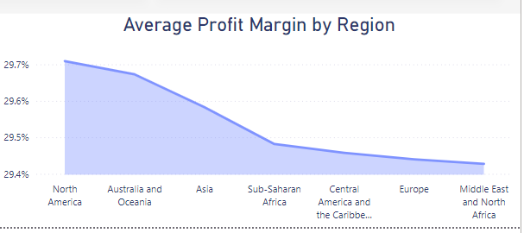

* Filters enable drilling down into specific regions, item types, and sales channels.

**Page 3: Region Analysis**

**Focus:**  
Analysis of sales, profit, and units sold across regions.

**Visualizations:**

* Bar charts, area charts, clustered column charts and maps for total units sold, total cost, revenue and profit, and total profit by region.

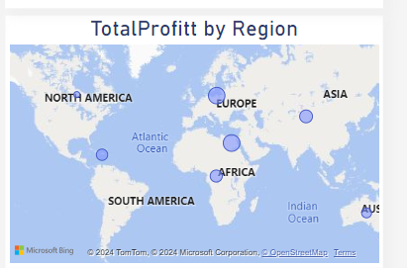

* Filters enable drilling down into specific years and regions.

**5. Cleaning Steps**

Detail the specific cleaning steps with code in python examples:

#### **1. Handling Missing Values**

df = df.dropna()

**2.replace values**

df['Order Priority'].replace('L', 'Low', inplace=True)

df['Order Priority'].replace('H', 'High', inplace=True)

df['Order Priority'].replace('M', 'Median', inplace=True)

df['Order Priority'].replace('C', 'Crtical', inplace=True)

**3.remove duplicates**

df.drop_duplicates(inplace = True)

**6. Visualizations**

The dashboard incorporates various visualization types for clear insights:

* **Bar Charts:** Compare sales and profit by region, item type, and channel.
* **Area Charts:** Display time-based trends over the years and profit margin and cost by region.
* **Pie Charts:** Proportion-based visualizations of sales by region or item type.
* **Donut Chart:** For total profit by sales channels.
* **Treemap:** Shows top 5 item types by sales.
* **Clustered Column Chart:** Displays revenue and profit by region.
* **Map:** Shows regions with the highest profit.

**Design:**  
The visualizations focus on simplicity and clarity, with interactive elements. Bar charts highlight differences between regions and item types. Line graphs show year-over-year trends, and pie charts and provide clear, easy-to-understand data. Colors and labels are chosen to match the company’s branding and improve the user experience

**7. Interactivity**

Users can explore data interactively through the following filters:

* Year
* Region
* Item Type
* Sales Channel (Online/Offline)

**8. Key Data Insights and Performance Questions**

**Key Insight:**  
 **1.** The data shows a significant **Drop** in both **total revenue** and **total profit** in 2017 compared to previous years:

**2017 Highlights:**

* 2016 Total Revenue: $17.46 billion, 2017 Total Revenue: $10.00 billion
* 2016 Total Profit: $5.17 billion, 2017 Total Profit: $2.98 billion
* 2016 Total Cost: $12.29 billion, 2017 Total Profit: $7.01 billion
* Units Sold in 2017 also dropped significantly to around 37.98 million from 65.56 million in 2016.
* "The most comprehensive response to this critical question can be divided into two essential components, which are:"
* "Breach of Contractual Obligations and Its Effect on Company Sectors"
* In addition, one of the primary reasons for the company's struggles, especially in real estate, was its failure to meet contractual obligations. The company did not deliver housing units on time, severely damaging its reputation. This breach of trust led to widespread dissatisfaction, causing significant losses across all sectors, with real estate being the most affected.
* "Impact of Economic Factors on Company Performance"

Most sectors within the company experienced significant downturns due to the economic challenges brought about by the currency floatation and broader economic issues. A key indicator of this is that essential goods, such as meat, saw only a minimal decline, while more liquidity-sensitive sectors like real estate suffered the most. The flight of foreign capital («hot money») from the market further compounded the impact, particularly in the real estate sector, which is highly dependent on financial liquidity.

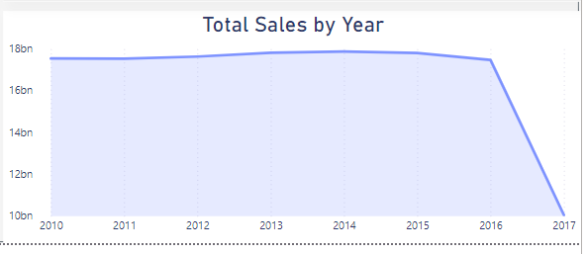

1. What is the total sales revenue? **(133.61bn)**
2. Which region generated the highest profit? **(Sub-Saharan Africa)**
3. Which product category generates the highest profit? **(Cosmetics)**
4. Which product category has the highest sales volume? **(Household (3.73bn))**
5. What is the total number of units sold for the top 5 products (by sales)?

**1. Household (41M)**

**2. Office supplies (42M)**

**3. Cosmetics (42m)**

**4. Meat(42M)**

**5. Baby Food (42M)**

**7.** What is the average profit margin for the top 5 products?

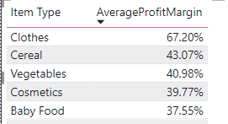

**8.** How has sales revenue changed year-over-year?

**2010: $17,52 billion**

**2011: $17,51 billion**

**2012: $17,62 billion**

**2013: $17,80 billion**

**2014: $17,86 billion**

**2015: $17,79 billion**

**2016: $17,46 billion**

**2017: $10,00 billion**

**What is the average profit margin for region?**

**9-**

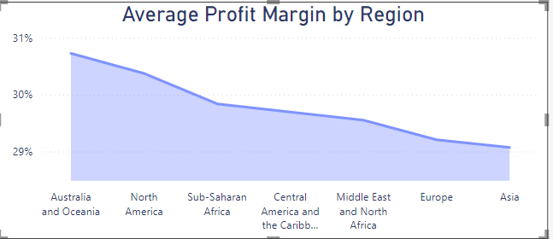

**9. Tools and Implementation**

**Tools Used:**

* **Power BI:** For data modeling, interactive visualizations, and analysis.
* **Excel:** For initial data validation.
* **Python :**to make clean data

**10. Glossary**

* **Total Profit**=Total Revenue-Total Cost
* **Average Order Value =** Total Revenue **/** Number of Orders
* **Average Profit Margin =** Total Profit **/** Total Revenue
* **Average Unit Sold =** Total Units Sold **/** Number of Orders