Exloris 2
Game Design Document
Design overview and current gameplay specification
Document details | Value
Project | Exloris 2
Document purpose | Describe the player experience, learning activity, mechanics, content, and design decisions.
Revision | 1.0
Prepared | 12 October 2026
Evidence basis | Current Unity scenes, scripts, build settings, and project documentation.

This document separates features visible in the project from design recommendations and items that still need confirmation. Scene routes and serialized interactions have not all been verified in a running build.

Contents
01 Concept and design snapshot
02 Experience pillars
03 World and narrative
04 Player journey and core loop
05 Boat challenge
06 Nilometer learning activity
07 Progression and rewards
08 Interface, controls, and accessibility
09 Art, audio, and localization
10 Content and level design
11 Playtest goals and acceptance checks
12 Current scope and design decisions
13 Project reference
The contents entries are clickable. The document uses the checked-in project as its source of truth and marks proposed design targets as recommendations.

01 Concept and design snapshot
Exloris 2 is a 2D educational adventure set along the Nile in ancient Egypt. The player chooses a traveler, follows a map route, steers a boat through a three-lane obstacle course, and then measures changing Nile water levels in a Nilometer quiz. The learning activity connects visual number reading to seasonal flooding, farming, and the cubit as an old unit of measurement.
Design area | Current description | Status
Genre | Educational adventure with arcade-style lane movement and a narrated measurement quiz. | Observed in scenes and scripts
Player role | A young traveler represented by a selectable boy or girl avatar. | Avatar options are configured; age range is not specified
Setting | A journey on the Nile and a Nilometer learning scene in ancient Egypt. | Supported by project text and scenes
Primary challenge | Choose lanes to avoid obstacles, collect coins, and reach the dock. | Implemented in BoatLevel code
Learning focus | Read the height of rising water and connect marks to cubits. | Dialogue and quiz flow are configured
Languages | English and Arabic locale assets, with RTL text support present. | Runtime translation quality needs playtesting
Platforms | Android, iPhone, Standalone, and WebGL configuration exists. | No release platform or successful build is confirmed

02 Experience pillars
These pillars summarize the experience already visible in the project and give future content and interface work a consistent design test.
Pillar | Player-facing principle | Design implication
Learn by seeing | The player watches the water meet numbered marks before answering. | Keep the water line, scale, and answer choices visible together.
Guided challenge | The boat section introduces movement before asking the player to react to hazards. | Keep the lane input immediate and make obstacle feedback easy to read.
Encouraging feedback | Dialogue responds to correct answers, mistakes, hints, and completion. | Correct errors gently and explain the answer before moving on.
Accessible participation | The project offers keyboard and pointer/touch input and English/Arabic content. | Validate both input modes and both reading directions at target sizes.

03 World and narrative
The menu invites the player to explore the Nile. The Nilometer scene frames the player as a little traveler and introduces the seasonal flood, a marked measuring column, and the way high water supports green fields. An elder guide delivers dialogue while the selected traveler reacts through character expressions.
The narrative is a light frame for learning rather than a branching story. No named protagonist, historical timeline, antagonist, or dialogue-choice system is established in the inspected project. The current content is focused on reaching a learning activity and completing it.
Story element | Current role
Traveler | Player-selected avatar who explores and answers questions.
Elder guide | Introduces the Nilometer, prompts the player, and gives feedback.
Nile and flood | The setting and reason for measuring seasonal water height.
Nilometer | The visual instrument the player uses to read water level.
Cubit | The measurement unit explained in the closing lesson.

04 Player journey and core loop
The configured build order describes a journey from the main menu through player selection and the map to BoatLevel and the Nilometer. The exact button-to-scene edges depend on serialized UnityEvents, so treat this as the intended project route until it is play-tested end to end.
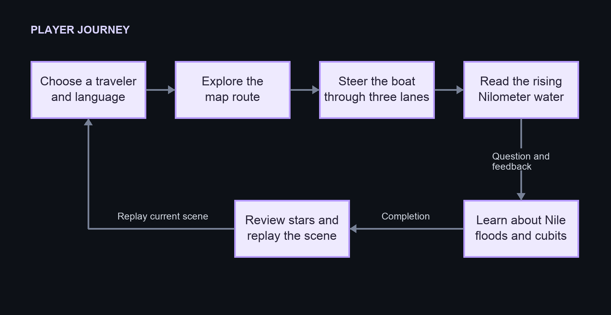
Figure 1. Player journey based on the enabled scenes and current feature flows.
The boat challenge provides an active movement section before the quieter question-and-answer activity. Completion currently leads to a results display and replay option. The visible Next control does not yet load a subsequent scene through the inspected UI handler.

05 Boat challenge
The boat advances up the river while the player moves it between three lanes. The challenge is to avoid rocks or small islands, collect optional gold coins, and reach the dock with stars remaining. The level begins with an introduction and tutorial, then enables movement and input.
Element | Current behavior | Player feedback
Lane movement | Move one lane left or right; the controller clamps movement to three lanes. | Boat movement and lane-move sound.
Keyboard | A/D or left/right arrow keys request lane steps. | The lane changes immediately while play is active.
Touch or pointer | A horizontal swipe changes lanes. A tap on the left or right half selects that direction. Pointer input over UI is ignored. | Input is disabled during intro, pause/settings, and arrival.
Coins | A coin is collected once, increments the total, and becomes inactive after its collection animation. | HUD total, coin sound, and collection effect.
Obstacles | A collision can push or block the boat. The flow removes at most one star for an eligible first hit. | Bump sound, possible star loss, impact effect.
Dock | Near the dock, the game disables input and uses autopilot to reach the stop point. | Arrival dialogue and completion card.

The boat begins with three stars. The current state flow has no explicit game-over transition when stars reach zero. The design therefore reads as a forgiving score/feedback system rather than a fail-and-restart challenge; confirm this intent before adding harsher consequences.

06 Nilometer learning activity
The Nilometer activity teaches the player to read where rising water meets the marks on a measuring column. The configured dialogue says that the Nile floods in summer, that each number shows water height, and that high water helps farmers. The closing cubit dialogue explains the elbow-to-hand measurement and states that each mark represents one cubit.
Beat | Player experience | Current implementation notes
Welcome | The elder introduces the Nilometer and seasonal flooding. | Three serialized intro lines with voice references.
Observe | The water rises to a stage while the player watches the scale. | WaterAnimator moves the visual; the UI waits for the completion callback.
Answer | The player chooses the number at the top of the water. | Multiple-choice buttons submit a stage index and answer index.
Get help | The player can request a hint about the water/scale. | Two hint lines are serialized; the current index advances through them.
Receive feedback | Correct answers receive positive feedback; wrong answers remove a star and narrow the remaining choices. | The first miss plays “Almost”; the second gives the answer and advances.
Connect the lesson | The activity explains Nile measurement, farming, and cubits. | Lesson and cubit dialogue arrays are configured after the questions.
Finish | The player sees a completion display with remaining stars. | No separate failure state was identified.

The project contains answer feedback for values from zero to ten. The WaterOperator code can fall back to three water stages if no explicit level list is supplied. Confirm the intended stage count, correct-answer indexes, dialogue indexes, and voice coverage in the Unity scene before treating the learning sequence as content-complete.
The learning progression moves from observation to identification and then to a short explanation of why the instrument matters. Future questions should preserve that connection: show the evidence, ask the player to interpret it, and explain the answer in language suitable for the final age band.

07 Progression and rewards
The current project uses a map route, player data, coins, and stars to give the journey structure. The available evidence does not show a coin shop, unlock tree, daily reward, or persistent score economy.
System | Current role | Decision or follow-up
Traveler selection | Boy and girl avatar options are present; selection is stored as player data. | Confirm whether both options should persist across all scenes and languages.
Coins | Optional collectibles counted during the boat level. | Define a spending or collection purpose only if one is needed.
Stars | Three starting stars provide mistake feedback in the boat and Nilometer activity. | Confirm whether stars reset per scene or persist across the full journey.
Replay | Boat Replay reloads the active scene. | Test reset behavior for score, stars, player data, and audio.
Next | The completion UI has a Next button, but its current handler does not call the scene-loading method. | Choose and wire the next destination before release.

08 Interface controls and accessibility
The interface carries the tutorial, pause/settings controls, dialogue, boat HUD, stars, question choices, hints, and completion state. Text and voice work together in the Nilometer scene. Keep important instructions visible long enough to read and do not rely on color or sound alone to communicate a correct answer or a lost star.
Current input supports keyboard and pointer/touch for the boat. The player-selection scene includes English and Arabic controls, and the project includes right-to-left TextMeshPro support. Exact Arabic layout, localization completeness, font coverage, and device-specific tap targets still need testing.
Design check | Acceptance check to use in playtesting
Readable instructions | A first-time player can explain the boat controls after the tutorial without relying only on voice.
Clear feedback | A correct answer, a wrong answer, a lost star, and a collected coin each have a distinct visual cue.
Input tolerance | Lane changes register reliably on keyboard and touch without accidental activation of UI controls.
Pause and resume | The game restores time and input correctly after help/settings are opened and closed.
Language layout | English and Arabic screens avoid clipping, preserve intended reading order, and keep buttons operable.
Audio alternatives | Voice content has readable text; key events remain understandable with audio muted.

Recommended additions, not confirmed current features: adjustable text size, an audio/caption preference, reduced-motion option, and a clear way to replay tutorial instructions.

09 Art audio and localization
The project’s visual world is anchored by the Nile journey, the boat course, a marked Nilometer, and expressive traveler/elder characters. The checked-in project does not define a complete art bible or a formal palette, so new environments and UI should follow the existing assets rather than assume an undocumented style.
Audio includes dialogue voice, sound effects, background music, and ambience systems. The newer audio service responds to typed gameplay events, ducks background audio during voice playback, and reports voice activity to character-expression systems. Older scenes also contain a legacy SoundManager; verify which system owns a sound before adding duplicate playback.
English and Arabic locale assets are present. Translation should preserve the meaning of the water-reading lesson and cubit explanation, not only fit the same line length. Arabic screens require right-to-left layout checks for text alignment, mixed numerals, punctuation, and answer-button order.

10 Content and level design
The game has two distinct content units. Boat content controls the rhythm and readability of lane hazards. Nilometer content controls the number sequence, correct answers, hints, dialogue, voice, and lesson timing. Keep each unit’s difficulty appropriate to the player’s age and make the learning sequence independent of coin collection.
Content unit | Authoring fields to maintain | Review before release
Boat route | Lane positions, obstacle placement, coin placement, dock stop point, speed/progress curve, tutorial text. | Check sightlines, response time, collision fairness, and that the player can recover after a hit.
Water stage | Stage ID, target water height, correct answer index, related dialogue index, animation duration. | Check index alignment among stage data, buttons, spoken lines, and localized text.
Question and feedback | Prompt, answer labels, correct choice, first-miss hint/feedback, second-miss explanation. | Validate educational correctness and avoid making repeated guessing the main strategy.
Audio and localization | Voice clip, localized text, timing, mood/character expression. | Confirm every supported language has matching text, timing, and audio behavior.

The checked-in Nilometer scene contains feedback text for water heights zero through ten, while the code’s fallback water configuration provides three stages. This may be intentional test content or incomplete authoring. Resolve the mismatch in the source scene and this document after confirming the intended lesson length.

11 Playtest goals and acceptance checks
The following checks are proposed design targets for a future playtest. They are not measured results or current release criteria.
- On a first attempt, players can use the tutorial to move left and right and can identify what causes a star to be lost.
- Players understand that coins are optional and do not mistake them for the Nilometer answer or a required survival resource.
- After observing a water stage, players can select the number that matches the water line and can explain the answer after the feedback line.
- A player who answers incorrectly can recover from the feedback and finish the activity without needing an external explanation.
- The full journey works in English and Arabic, with no clipped text, reversed mixed-direction labels, or unusable controls.
- Replay returns to a known initial state; pause, resume, scene transitions, save data, and audio all behave consistently.
Record completion rate, wrong answers per stage, hint use, missed lane inputs, pause/restart frequency, and language/layout defects. Gather age-band and consent requirements before collecting data from children; no analytics or research process is documented in the current project.

12 Current scope and design decisions
The checked-in project is a playable-feature foundation rather than a fully verified release package. Static inspection confirms scene and script configuration, but it does not confirm complete play-through, build success, active Inspector bindings, or release readiness.
Decision or gap | Current evidence | Recommended owner decision
Audience and learning level | Child-directed phrases appear in dialogue; no age band is specified. | Set the age range, reading level, and intended learning outcomes.
Scene route | Five scenes are enabled in build settings; navigation depends partly on serialized UnityEvents. | Play-test the entire route and record the intended transitions.
Boat completion | The Next handler does not load the configured continuation scene; BoatHistory is not enabled. | Choose the next level or return destination and wire it.
Nilometer stage count | Answer dialogue covers zero to ten; fallback water data has three entries. | Confirm whether the shipped lesson has three, eleven, or another number of stages.
Target platforms | Settings include mobile, desktop, and WebGL platform configuration. | Select supported release platforms and validate controls/layout on each.
Progression economy | Coins are counted but no spend/unlock system was found. | Keep coins as score or define a clear use before adding related UI.
Save scope | Player level, step, and gender are saved through the current save system. | Define reset, cross-scene, and replay expectations.

13 Project reference
This GDD was prepared from the current checkout. The technical documentation remains the detailed source for component ownership, scene wiring, package configuration, scripts, data contracts, and editable technical diagrams.
Reference | Use
Documentation/00-Project-Overview.md | Project premise, verified configuration, architecture, and limitations.
Documentation/04-Gameplay-Lifecycle.md | Boat and Nilometer sequence details, including code-supported behavior.
Documentation/05-Scenes-and-Transitions.md | Enabled scenes, configured route, and scene-transition caveats.
Documentation/09-Flowcharts.md | Current gameplay and system flows.
Assets/Scenes/NiloMeter/NiloMeter.unity | Serialized Nilometer dialogue, question arrays, and lesson copy.
Assets/scripts/GameplaySystems/BoatLevel/ | Boat input, collision, movement, and level-flow behavior.
Assets/scripts/Presentation/SharedUI/NilometerUI.cs | Quiz feedback, hint, water progression, and completion orchestration.

