 | INTERNATIONAL TELECOMMUNICATION UNION  TELECOMMUNICATION  STANDARDIZATION SECTOR  STUDY PERIOD 2025-2028 |  |  | SG12-TD473
 |  |  |  | STUDY GROUP 12
 |  |  |  | Original: English
Question(s): |  | 9/12 |  | Geneva, 9-17 June 2026
TD
Source: |  | Editors P.SAMD
Title: |  | Draft new Recommendation ITU-T P.SAMD: “Single-ended ML-based models for multi-dimensional speech quality analysis”
Contact: |  | Sebastian Möller  TU Berlin  Germany | E-mail: sebastian.moeller@tu-berlin.de
Contact: |  | Wafaa Wardah  TU Berlin  Germany | E-mail: wafaa.wardah@tu-berlin.de

Abstract: | This technical document presents the revised version of the draft P.SAMD recommendation text contained in contribution SG12-C189, discussed in the ad-hoc meeting of Study Group 12. Points made during the ad-hoc meeting are incorporated to help arrive at a more defined and complete recommendation text before the end of this SG12 meeting and progress in the approval and conclusion of the P.SAMD work item.

Recommendation ITU-T <No.>
Single-ended ML-based models for multi-dimensional speech quality analysis
Summary
This Recommendation describes an objective single-ended method for predicting subjective speech quality in telecommunication applications. The algorithm operates directly on a degraded speech signal without requiring a reference or other information about the speech file or its processing, and provides predictions of both overall quality and multiple perceptual dimensions (noisiness, discontinuity, coloration, and sub-optimum loudness) on a 1-5 ACR scale, consistent with ITU-T P.800 listening-only tests for overall quality and according the dimensional scales as defined in the Annex of ITU-T P.863.2.
The method is applicable to audio signals up to fullband (FB, 20-20 000Hz) and has been trained and validated on a large set of databases reflecting a wide variety of coding, transport, and enhancement conditions. The model is specifically designed to assess listening quality of conversational speech over a wide range of different speakers, including environmental noise and non-perfect talking conditions.
This Recommendation presents a high-level description of the method and advice on how to use it. Provisions for sharing the implementation and conformance testing data will accompany this Recommendation.

Keywords
Listening quality, objective quality, voice quality, no-reference model, non-intrusive, multi-dimensional prediction, perceptual quality dimensions, sub-optimum loudness, noisiness, discontinuity, coloration.

Introduction
Recommendation ITU-T P.XXX defines a single algorithm for assessing the speech quality of telephony systems that utilize a broad variety of coding, transport and enhancement technologies. The algorithm can operate non-intrusively (single-ended) because it does not require a reference signal, rather, only the degraded signal is needed. Recommendation ITU-T P.563, published in 2004, was the first standardized single-ended model designed for narrowband speech quality assessment. Subsequent work explored alternative data-driven approaches to extend applicability across wider bandwidths and more recent voice coding, processing and transport conditions. Recommendation ITU-T P.XXX incorporates these advancements, leveraging Transformer-based deep learning methods to assess fullband conversational speech and to provide predictions of overall quality and the following perceptual dimensions: noisiness, discontinuity, coloration, and sub-optimum loudness

Scope
This Recommendation defines a single algorithm for assessing the overall speech quality and four perceptual dimensions, namely, noisiness, discontinuity, coloration, and sub-optimum loudness, of telephony systems that utilize a broad variety of coding, transport and enhancement technologies.
Based on the validation results presented within ITU-T Study Group 12, an overview of the test factors, coding technologies and applications to which this Recommendation applies or not apply is given in Tables 1 to 4. Table 1 presents test factors and coding technologies included which were used in the validation phase of the ITU-T P.XXX model. The performance of the ITU-T P.XXX model under each individual condition in Table 1 is not reflected in the table. Table 2 presents intended application scenarios of P.XXX. Table 3 presents a list of conditions for which this Recommendation is not intended to be used. Finally, Table 4 lists factors, technologies and applications for which this Recommendation has not currently been validated and is subject of further studies.
The P.XXX algorithm cannot be used to replace subjective testing.
The P.XXX algorithm does not provide a comprehensive evaluation of overall transmission or conversational quality. It predicts the effects of one-way speech degradations and noise on listening quality in the same way as they can be perceived and assessed in an ITU-T P.800 absolute category rating (ACR) listening-only test, or in test protocols defined in Annex A of ITU-T P.863.2. Predictions are given both for overall listening speech quality and for perceptual dimensions of noisiness, discontinuity, coloration and sub-optimum loudness.
Because P.XXX predicts listening quality scores only, degradations affecting talking quality or two-way conversational interaction cannot be taken into account. This means that the effects of signal loss, delay, sidetone, echo, double-talk and other conversational impairments are not reflected in the scores. It is therefore possible to obtain high P.XXX scores while still experiencing reduced conversational quality in practice.
P.XXX is designed for the prediction of listening quality in telecommunication systems up to fullband (20–20 000 Hz) audio bandwidth. Reduced bandwidths (e.g. narrowband 300-3400, wideband 50-7000Hz or super-wideband 50-14000 Hz) are seen as degradations according to their perceptibility of the band limitation.
As a no-reference method, P.XXX is inherently limited in detecting certain types of degradations - such as missing speech segments (relative to the input), incorrect phoneme reproduction, timbre alterations, or time-warping artifacts. The model primarily evaluates how natural the speech sounds, rather than how accurately it is reproduced compared to a reference (input signal, clean speech). This behavior is consistent with the model’s design philosophy.
Table 1/P.XXX – Factors included in the databases used for the validation of the ITU-T P.XXX model
Databases include multiple test factors and in different magnitudes. Individual prediction performance of the model on these test factors is not reflected in this table.
Test factors
Single and tandemned speech codecs as used in current telecommunication systems (NB to FB).
Packet loss and packet loss concealment strategies in packet-switched connections.
Frame errors and bit errors as occurring in wireless connections.
Speech signal interruptions, including un-concealed packet loss and handover effects.
Temporal clipping of speech signals.
Amplitude clipping due to overload or saturation.
Effects of speech-coding systems on pre-noised speech signals.
Variable delay and time-warping effects (short-term and long-term).
Gain variations, including those introduced by automatic gain control.
Linear distortions and spectral shaping (including time-varying linear distortions).
Voice enhancement systems in networks and terminals (e.g., noise suppression, echo cancellation, automatic level control) and their effects on listening quality.
Acoustic background noise conditions at the sending side as included in the validation datasets.
Conversational speech material in addition to structured test sentences.
Coding technologies
Waveform codecs
CELP and hybrid codecs
Adaptive multi-rate codecs
Codecs used for mobile 3GPP and OTT voice services
Low- and ultra-low bitrate including neural codecs

Table 2/P.XXX – Application scenarios of the ITU-T P.XXX model

Codec evaluation across NB, WB, SWB and FB conditions.
Terminal testing, including the influence of the acoustical path and transducers in sending and receiving direction.
Bandwidth extension technologies and SWB/FB processing.
Live network monitoring using digital or analogue connection to the network.
Live network end-to-end testing with unknown speech sources at the far-end side.
Testing of emulated and prototype networks, including VoIP and 4G/5G mobile networks
Voice transmission in video telephony and speech transmission over Bluetooth.
Evaluation of voice enhancement devices (VEDs), including noise reduction (NR), packet-loss concealment (PLC), and other enhancement algorithms.
Assessment of speech codecs and network components under conditions of background noise

Table 3/P.XXX – P.XXX is not intended to be used with these variables
Test factors
Effect of delay in conversational tests.
Talker echo.
Sidetone.
Acoustic noise in the receiving environment.
Music, tones, or other non-speech signals.
Assessment of multi-channel speech or audio and related spatial effects
Incomplete speech reproduction (missing words or speech parts)
Transformations of speaking characteristics (e.g. intonation, pronunciation) not changing the naturalness of speech sound
Applications
Talking quality, interaction quality
Two-way communication performance.
Speaker transformation, anonymization, authentication and identification systems
Text to speech synthesis system evaluation

Table 4/P.XXX – Factors, technologies and applications for which P.XXX has not or not fully been validated at the time of the standardization
Test factors
Multiple simultaneous talkers as foreground speech.
Human voice or voice-like signals as background noise.
Child voices, singing voice, or other non-standard speech styles as input.
Artificial or synthetic or transformed speech as input.
Listener echo.
Effects/artifacts from isolated echo cancellers when not part of an integrated system.
Effects/artifacts from isolated noise reduction algorithms when not part of an integrated system.
Amplitude clipping due to overload or saturation.
Gain variations, including those introduced by automatic gain control.
Assessment of voice activity detection (VAD), automatic gain control (AGC) and comfort noise insertion.
Coding technologies
Classical vocoder as coding technology.
Applications
Acoustical path in receive direction including handsfree listening.

2 References
The following ITU-T Recommendations and other references contain provisions which, through reference in this text, constitute provisions of this Recommendation. At the time of publication, the editions indicated were valid. All Recommendations and other references are subject to revision; users of this Recommendation are therefore encouraged to investigate the possibility of applying the most recent edition of the Recommendations and other references listed below. A list of the currently valid ITU-T Recommendations is regularly published. The reference to a document within this Recommendation does not give it, as a stand-alone document, the status of a Recommendation.
[ITU-T X.yyy] Recommendation ITU-T X.yyy (date), Title.

3 Definitions
None.

4 Abbreviations and acronyms
This Recommendation uses the following abbreviations and acronyms:
COL Mean opinion score of the coloration perceptual quality dimension.
DIS Mean opinion score of the discontinuity perceptual quality dimension.
LOUD Mean opinion score of the sub-optimum loudness perceptual quality dimension.
MOS Mean opinion score of overall speech quality unless stated otherwise.
NOI Mean opinion score of the noisiness perceptual quality dimension.

5 Conventions
Subjective evaluation of speech quality in telecommunication systems is typically conducted using listening-only or conversational methods of testing. For practical reasons, listening-only ACR tests are the primary basis for developing and validating objective models.
This Recommendation describes an objective, single-ended method for estimating subjective quality obtained in listening-only tests, consistent with ITU-T P.800 and with Annex A of ITU-T P.863.2. The P.XXX approach predicts the results of ACR listening quality subjective experiments by calculating:
- an overall LQO on the MOS ACR scale from 1 to 5 (MOS), and
- four perceptual dimension scores (noisiness NOI, discontinuity DIS, coloration COL, sub-optimum loudness LOUD ), each on a continuous 1-5 scale,
all aligned with the scales used in corresponding subjective test methodologies.
This Recommendation therefore relates to an absolute rating in a listening-only situation.

6 Overview of the ITU-T P.XXX algorithm
The ITU-T P.XXX algorithm passes the degraded signal Y(t) through the 5 Transformer-based modules to produce the outputs that would be given to Y(t) by subjects in a subjective listening test for assessing the overall quality (MOS) and the 4 perceptual dimensions (NOI, DIS, COL, LOUD), see Figure 1.
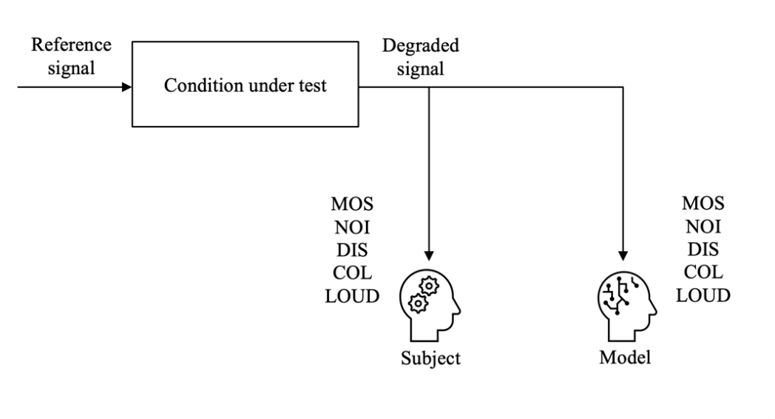
Figure 1- Overview of the ITU-T P.XXX model context.
The model consists of 5 transformer modules, as shown in Figure 2. The input embeddings for the transformer models are prepared by converting the degraded signal Y(t) into a log-mel-spectrogram, which is then cut into smaller overlapping patches that are converted to one-dimensional vectors and then positionally encoded. The prepared input is then passed through the five audio spectrogram transformer encoder modules, for assessing the overall quality (MOS) and the 4 perceptual dimensions (NOI, DIS, COL, LOUD) separately.
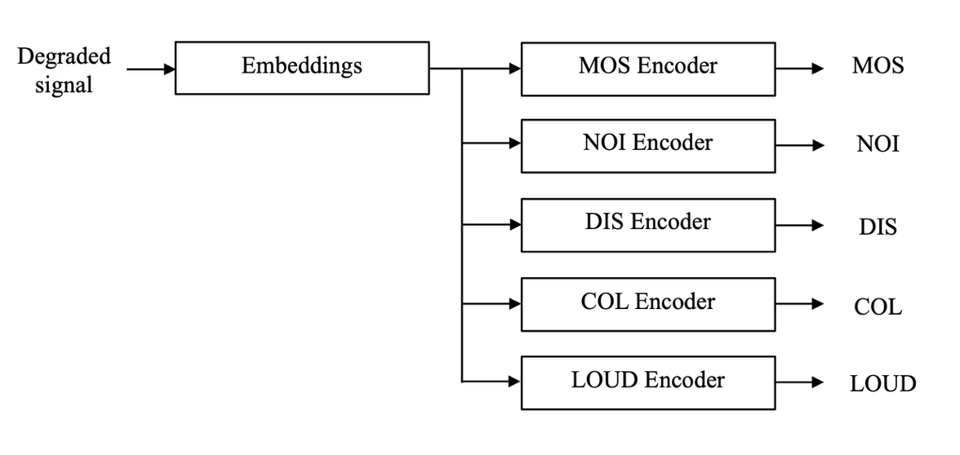
Figure 2 - Overview of the ITU-T P.XXX model architecture.
The Encoders follow the architecture of the Vision Transformer (ViT) model introduced in
[b-Dosovitskiy 2021]. They were originally trained in image data of the Data-efficient Image Transformers (DeiT) model shared in [b-Touvron 2021], then fine-tuned on audio data of the Audio Spectrogram Transformer (AST) model [b-Gong 2021]. Finally, they have been further fine-tuned to speech quality data, namely, for overall MOS, and the 4 perceptual dimensions (NOI, DIS, COL, LOUD) individually to assess the respective speech quality dimensions. This process is described in
[b-Wardah 2025].

7 Speech Material
The ITU-T P.XXX algorithm is not intended to score a per-call quality or quality for longer sequences of speech. It is focused on prediction of quality of shorter speech utterances such as 6 … 10s in length as in an ITU-T P.800 test with a minimum of active speech of 3.2s.
Other dimensions of speech quality such as conversational aspects and talking quality are not within the scope of the ITU-T P.XXX algorithm. The model considers noises and their influence on perceptual quality dimensions in a listening-only context similar to the one described in P.800 (test cabinet specifications, etc.). The prediction of quality as it can be perceived in a noisy listening environment and the related binaural effects are not in the scope of the ITU-T P.XXX model.
The algorithm predicts the listening quality of human speech, including in the presence of background noises at the sending side; however, it is not intended to rate the quality of synthetic speech, music, noise or other non-speech signals (e.g. signalling tones) alone.
Lip, breath and similar noises as well as filling sounds produced by the talker are considered as belonging to the speech signal.
The ITU-T P.XXX algorithm requires a fullband degraded signal. It shall be provided in mono at a sampling frequency of 48kHz. If the sample rate of the signal differs from 48 kHz (e.g., 32 kHz, 16 kHz or 8 kHz), the signals have to be sample rate converted externally to 48 kHz before processing.

8 Intended Scenario
Compared to common full-reference approaches, where a dedicated test connection has to be established and a test speech signal is transmitted, a no-reference approach can be applied to unknown voice signals. Since a no-reference approach does not require a dedicated test connection, it is able to predict listening quality of real live calls in monitoring scenarios.
Here two main applications are present; those are (a) predicting the quality of speech signals from a source such as e.g. a voice service like a weather forecast or (b) predicting listening quality in live conversations.
For both it has to be stated that the source speech signal cannot be pre-assumed as high quality and clean, potential degradations and environmental noises in the source will be part of the prediction.
The term 'telecommunication scenario' as mentioned above covers all transmission technologies in today’s
- Fixed and mobile public switched networks
- VoNR, VoLTE, Voice over IP and inter-technology connections
- Combination of the above with speech processing techniques (e.g.-noise reduction systems, adaptive gain control, comfort noise and other types of voice enhancement devices)and terminals.
Other technologies or components such as speech storage formats or non-telephony applications such as public safety networks or professional mobile radio connections are not in the scope of the model.

9 Description of the P.XXX Algorithm
The P.XXX algorithm consists of two main processing stages (see Figure 3):
- Feature extraction and embedding preparation
- Transformer-based encoding and quality prediction

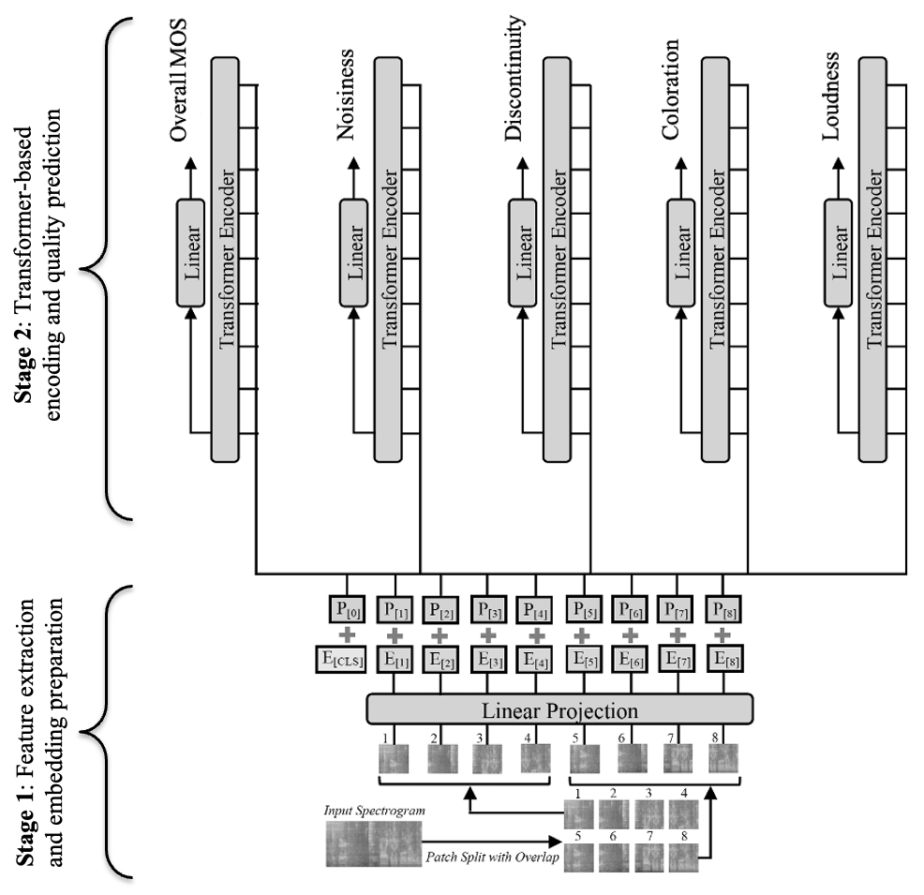
Figure 3: Diagram of the P.XXX algorithm's two-stage pipeline, adapted from [b-Gong 2021] and [b-Wardah 2025]. Stage 1 consists of the feature extraction and embedding preparation. Stage 2 consists of the transformer-based encoding and quality assessment, embodied in five separate modules.

Stage 1:

Time-Frequency Representation
The input signal is a single-channel speech signal as a discrete-time waveform of arbitrary duration. If the input signal sampling rate differs from 48 kHz, the signal is resampled to 48 kHz prior to further processing. The resampled waveform is converted into a log Mel-filterbank spectrogram using the following parameters:
- Analysis window length: 25 ms
- Window type: Hamming
- Frame shift: 10 ms (60% overlap)
- Number of Mel frequency bands: 128
The resulting representation has dimensionality $Χ∈R^{T×128}$, where $T$ denotes the number of time frames. To ensure a fixed input resolution for subsequent processing, the algorithm enforces a constant temporal length. The model processes the first 10 s of the audio at most, discarding the remainder for longer inputs. If the duration of the input signal is shorter than 10 s, padding is applied along the time axis of the log-Mel spectrogram. This padding is performed after Mel filtering and logarithmic compression. The waveform signal itself is not modified. The resulting log-Mel spectrogram has a fixed dimensionality of $1024×128$ time-frequency bins.

Patch-Based Embedding Preparation
The log-Mel spectrogram is interpreted as a two-dimensional time-frequency representation. It is partitioned into local time-frequency patches with:
- Patch height: 16 Mel bands
- Patch width: 16 time frames
Each patch represents a local spectro-temporal region of the signal. Adjacent patches overlap by 6 bins in both time and frequency dimension. The total number of patches is given by
$N=12\left\lceil (100t-16)/10\right\rceil$ where $t$ denotes the signal duration in seconds, which in this implementation is $t=10$ s.
Each patch is mapped to a fixed-dimensional embedding vector using a learned convolutional projection layer that has dimensionality of 768. The complete set of patch embeddings forms a sequence of input tokens for the transformer encoder. The resulting embedding sequence can be denoted as $\left\{z_{1}, z_{2}, …{,z}_{N}\right\}$, $z_{i}∈R^{768}$.
Since the transformer encoder does not intrinsically represent sequence order, explicit positional information is provided to the patch embeddings prior to transformer processing. Positional encoding conveys the relative time-frequency location of each patch within the log-Mel spectrogram. For each patch index $i$, a positional embedding vector $R^{768}$ is added. Positional embeddings were learned jointly with the remaining model parameters during AST pre-training in [Gong, 2021]. Due to the enforced fixed spectrogram size of 128 × 1024, the number and arrangement of patch positions are constant.

Stage 2:

Transformer Encoder Processing
The sequence of position-aware patch embeddings is processed by a stack of 12 transformer encoder layers. The transformer encoder follows the self-attention-based architecture introduced in
[b-Vaswani 2017], adapted here for processing spectro-temporal patch embeddings. The architecture is described in [b-Gong 2021] and [b-Wardah 2025].
The input sequence to the transformer encoder can be denoted as $\left\{z_{1}, z_{2}, …{,z}_{N}\right\}$, $z_{i}∈R^{768}$, and incorporates the local spectro-temporal information (via patch projection) and positional information (via positional encoding).
Each transformer encoder layer consists of a multi-head self-attention sub-layer and a position-wise feed-forward sub-layer. Residual connections and layer normalization are applied in accordance with the standard transformer formulation. The dimensionality of all intermediate representations remains 768 throughout the encoder stack.
The multi-head self-attention sub-layer enables each input token to attend to all tokens in the sequence, including itself. Let the input to a transformer encoder layer be $\left\{z_{1}, z_{2}, …{,z}_{N}\right\}$, $z_{i}∈R^{768}$. For each attention head, the input sequence is linearly projected into query, key, and value representations: $Q=ZW_{Q}$, K$=ZW_{K}$ and V$=ZW_{V}$. Self-attention is computed as a scaled dot-product attention mechanism, allowing each token to aggregate contextual information from the entire sequence. Multiple attention heads operate in parallel, enabling the model to jointly attend to information from different learned representation subspaces across the spectro-temporal patch sequence.
The outputs of all attention heads are concatenated and linearly projected to produce the sub-layer output. A residual connection is applied between the input of the self-attention sub-layer and its output. Layer normalization is applied to the result of the residual addition. Together, these operations help stabilize training and preserve input information across layers.
Through successive encoder layers, each embedding is transformed into a context-aware representation that integrates local and long-range spectro-temporal information across the entire time-freq. extent of the utterance.
The pooled output of the transformer encoder is passed to a regression layer with dimensions 768 × 1 and a sigmoid activation function. The resulting output is subsequently mapped to the target range [1,5] using an affine transformation.
The P.XXX algorithm contains five of these transformer-based encoder modules for each of the perceptual dimensions, as well as for the overall quality. This is illustrated in Figure 3.

Annex A
Conformance data and conformance tests
(This annex forms an integral part of this Recommendation.)

A.1 List of files provided for conformance validation
The conformance validation process described in this annex relates to the following files, which are provided in the "_Results_PSAMD" subdirectory of the electronic attachment:
- Test_1_results.txt containing the database name, file name, and ITU-T P.XXX scores for the overall speech quality and the perceptual dimensions for Test 1.
- Test_2_results.txt containing file name and ITU-T P.XXX scores for the overall speech quality and the perceptual dimensions for Test 2.
- Test_3_results.txt containing file name and ITU-T P.XXX scores for the overall speech quality and the perceptual dimensions for Test 3.
The PAMD_TUB_P501 speech files are in wireless access in vehicular environments (WAVE) format (16-bit linear PCM with WAVE header, little-endian byte ordering, at 48 kHz sampling rate). The SWB_TNO_601_48k and SWB_SQ_48k are in RAW format (16-bit linear PCM, little-endian byte ordering, at 48 kHz sampling rate). These files form an integral part of this annex.
For running the conformance test, the PXXX.py python script is used, and is called as follows:
python PXXX.py --path </path/to/directory> --output_dir </outputs/directory>

A.2 Conformance tests
The data sets for the conformity tests are as given in Table A.1.
Table A.1- Datasets for the conformity tests
Test | Dataset | Number of files | Sampling rate
1 | PAMD_TUB_P501 | 240 | 48 kHz
2 | SWB_TNO_601 | 400 | 48 kHz
3 | SWB_SQ_48k | 50 | 48 kHz
For all mandatory Tests 1, 2, and 3, the proportion of absolute differences exceeding 0.01 shall not exceed 0.05%.
The databases are the same as those used for ITU-T P.863.2 conformance testing and can be accessed here: https://www.itu.int/myworkspace/t-signals/vectors?val=100015010.

A.3 Digital attachments
The processing script (.py file) is contained in the electronic attachment to this Recommendation as "P.XXX.py".
Enclosed speech material is contained in the electronic attachment to this Recommendation in the following folders:
- "PAMD_TUB_P501";
- "SWB_SQ_48k";
- "SWB_TNO_601".
Annex B
Detailed descriptions of the ITU-T P.XXX algorithm
(This annex forms an integral part of this Recommendation.)

The P.XXX algorithm implementation is available as an electronic attachment with the P.XXX recommendation. Bibliography reference of the implementation is accessible via think link:
https://github.com/WafaaWardah/psamd
Annex C
Preparing the input audio files for the ITU-T P.XXX algorithm
(This annex forms an integral part of this Recommendation.)

The P.XXX algorithm does not prepare or verify the input audio signal. Instead, users are expected to provide speech signals that are appropriately prepared for the application scenarios described in Clause 7 of this Recommendation.
When the P.XXX algorithm is applied directly to lengthy speech recordings or continuous conversational streams, the presence of extended pauses and varying amounts of active speech may influence the model predictions. Since the algorithm operates on a fixed-length input representation, additional processing may be beneficial to identify suitable speech segments for analysis.
This Annex describes an optional pre-processing wrapper and associated criteria for preparing input speech signals. The procedure may be enabled when invoking the reference implementation.
NOTE: This optional pre-processing procedure was not applied during the development, training, or validation of the algorithm. The conformance testing described in Annex A also does not make use of this procedure, since the corresponding datasets consist of already structured speech recordings. The procedure described in this Annex was developed after completion of the validation phase in order to assist implementers in preparing suitable input signals, particularly for conversational and live telecommunication scenarios.
The optional pre-processing wrapper performs the following operations:
- The input signal is converted to a mono waveform and resampled to 48 kHz.
- Speech activity is monitored using a speech activity detector. A candidate speech segment is initiated when a transition from non-speech to speech is detected. Up to 100-200 ms of audio preceding the detected speech onset may be retained.
- After speech onset, an active-speech timer is started. The timer accumulates only periods classified as speech. Periods classified as non-speech do not contribute to the accumulated active-speech duration.
- If a non-speech interval occurs before the required amount of active speech has been accumulated, segment extraction is temporarily suspended. Extraction resumes when speech activity is detected again.
- If an internal non-speech interval exceeds 2 s, the candidate segment shall be rejected. This limits the risk of combining speech originating from substantially different acoustic environments.
- Once at least 5.5 s of accumulated active speech has been obtained, the wrapper searches for the next suitable short non-speech interval that may serve as a natural segment boundary.
- The search for a suitable stopping point continues until either:
  - a suitable non-speech interval is detected, in which case extraction is terminated; or
  - the maximum permitted active-speech duration is reached, in which case the candidate segment shall be rejected.
- The resulting segment should contain approximately 6-8 s of active speech while minimizing the influence of long pauses and extended non-speech intervals.
- If no valid segment satisfying the above conditions can be obtained, the input shall be flagged as unsuitable for processing by the wrapper.
- For lengthy recordings or continuous conversation streams, the wrapper may extract multiple valid segments from the same input recording. Each extracted segment shall be processed independently by P.XXX.
Rationale
The wrapper aims to reduce the sensitivity of model predictions to speech activity distribution and pause structure. Longer active-speech segments provide more stable predictions because short-term variations caused by linguistic content, speaker behaviour, and other random speech effects are averaged over a larger amount of speech material.
Furthermore, prediction bias has been observed to depend on active-speech duration. This dependency decreases as the amount of active speech increases. Selecting segments containing approximately 6-8 s of active speech therefore reduces sensitivity to small duration variations while remaining practical for longer speech recordings.
Prediction adjustment
When the optional pre-processing wrapper is enabled, the resulting P.XXX predictions shall be adjusted using a linear mapping in order to compensate for the observed dependency of the model predictions on active-speech duration.
The adjusted prediction y' is obtained from the original model prediction y according to:
y' = -1.0 + 1.2y
where y denotes the original model prediction and y' denotes the adjusted prediction. The resulting value shall subsequently be limited to the interval [1, 5], corresponding to the valid output range of the P.XXX algorithm.
NOTE: The prediction adjustment is applied after model inference and only when the optional pre-processing wrapper has been used. Predictions obtained without the wrapper shall not be adjusted.
The following command is used for running the PXXX.py python script with the pre-processing wrapper and post processing mapping enabled:
python PXXX.py --path </path/to/directory> --output_dir </outputs/directory> --prep <True>

Appendix I
Validation results
(This appendix does not form an integral part of this Recommendation.)

I.1 Overview
The P.SAMD model predicts overall listening quality and four perceptual dimensions (coloration, discontinuity, noisiness, and sub-optimum loudness) across a wide range of conditions and degradations. The model is trained on a combination of existing laboratory databases and new experiments following a well-defined test plan.
Performance metrics are summarized in clause I.5.
Each of the following clauses I.2 to I.4 presents the results from one contributing laboratory. The databases are identified by their laboratory-assigned name and cover acoustical, signal processing, network, and bandwidth impairments, as well as live network recordings.

I.2 Validation results from HEAD acoustics GmbH

I.2.1 Overview
HEAD acoustics validated the P.SAMD model on three databases sourced from ETSI TS 103 558 (V1.3.1), Annex E. These databases cover a wide range of mobile communication scenarios, including acoustical, signal processing, and network-level degradations.

I.2.2 ETSI_DB01_MAN_Validation
Database DB01 uses Mandarin speech and covers acoustical impairments, including device positioning (handset mode, DOWN position) and reverberation (handheld hands-free position). Figure Figure I.1 shows the per-condition scatter plot of subjective versus predicted scores after third-order monotonic mapping.
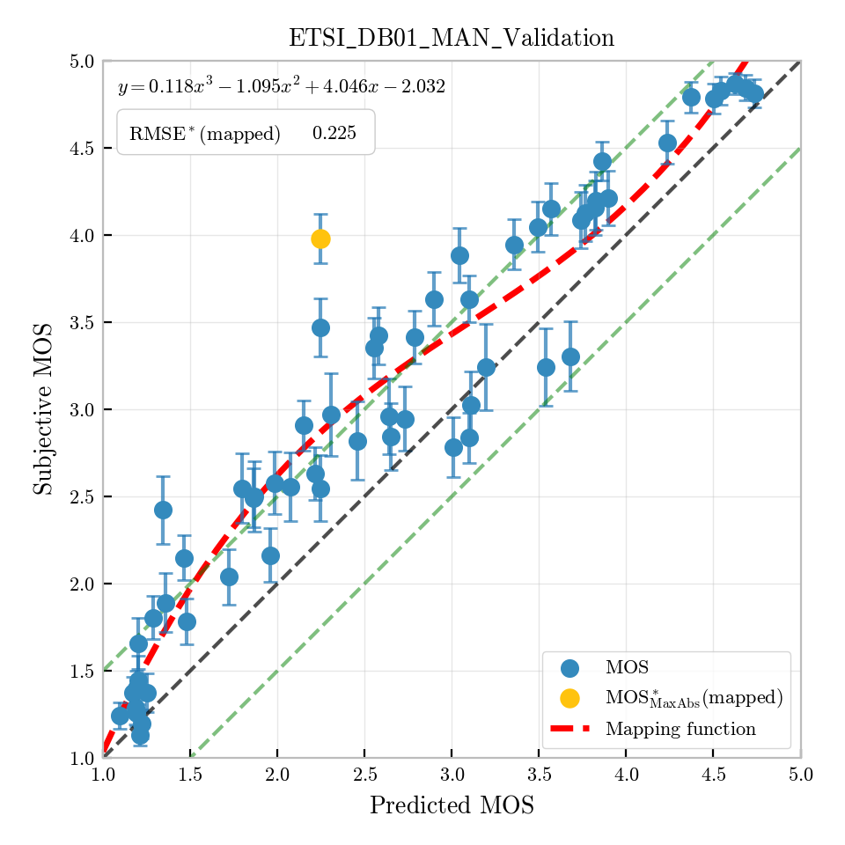
Figure I.1: Per-condition predictions for ETSI_DB01_MAN_Validation (MOS)

I.2.3 ETSI_DB02_GER_Validation
Database DB02 uses German speech and covers signal processing impairments, including time-variant low-pass (TVLP) and high-pass (TVHP) filtering and noise reduction based on spectral gating (NR100), applied to speech signals but not to noise components. Figure Figure I.2 shows the per-condition scatter plot of subjective versus predicted scores after third-order monotonic mapping.
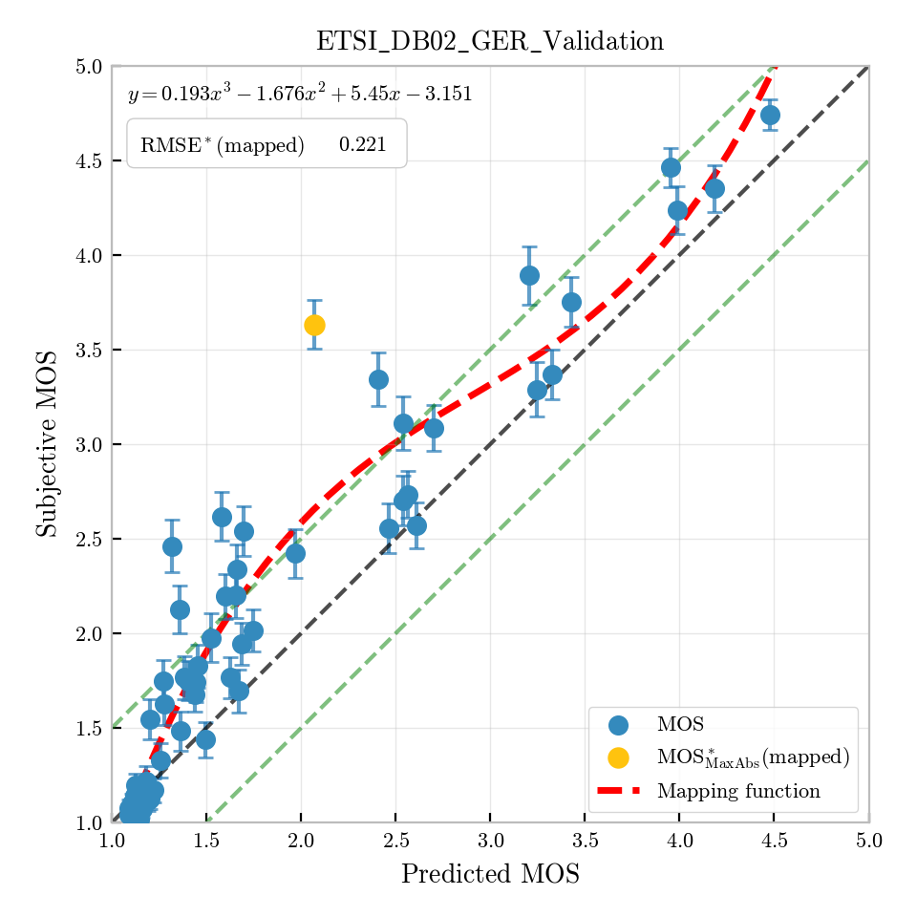
Figure I.2: Per-condition predictions for ETSI_DB02_GER_Validation (MOS)

I.2.4 ETSI_DB03_ENG_Validation
Database DB03 uses American English speech and covers network impairments, including burst packet losses simulated with a Gilbert-Elliott model and several transcoding steps. Figure Figure I.3 shows the per-condition scatter plot of subjective versus predicted scores after third-order monotonic mapping.
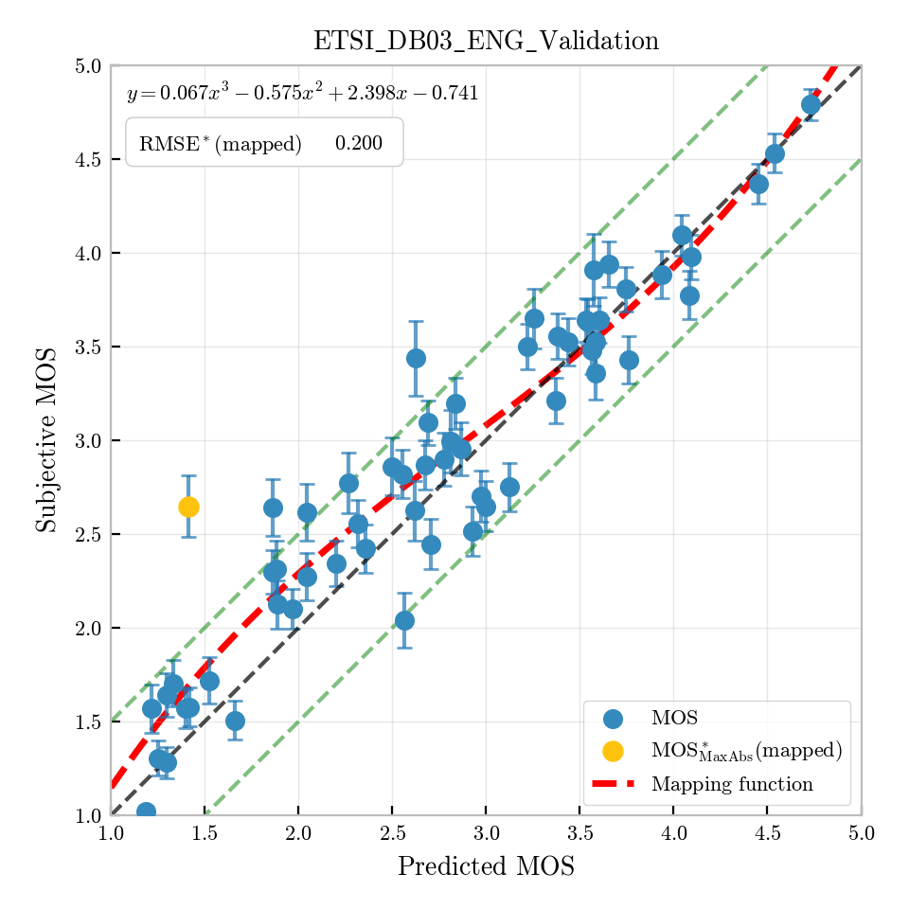
Figure I.3: Per-condition predictions for ETSI_DB03_ENG_Validation (MOS)

I.3 Validation results from Orange

I.3.1 Overview
Orange provided five databases for P.SAMD validation. The databases cover overall listening quality and, in some cases, the four perceptual dimensions.

I.3.2 PAMD_2 (2022)
This database evaluates the P.SAMD model across all four perceptual dimensions (noisiness, discontinuity, coloration, and sub-optimum loudness) in addition to overall speech quality. French speech (ITU-T P.501 Annex C, four samples, two male and two female) was used across 42 test conditions; four trained listeners participated in the diagnostic assessment. The test includes both clean and noisy conditions covering a wide range of quality from narrowband to super-wideband. Figure I.4 (overall quality), Figure I.5 (discontinuity), Figure I.6 (coloration), Figure I.7 (noisiness), and Figure I.8 (loudness), respectively show the per-condition scatter plots for overall quality, discontinuity, coloration, noisiness, and loudness, respectively.
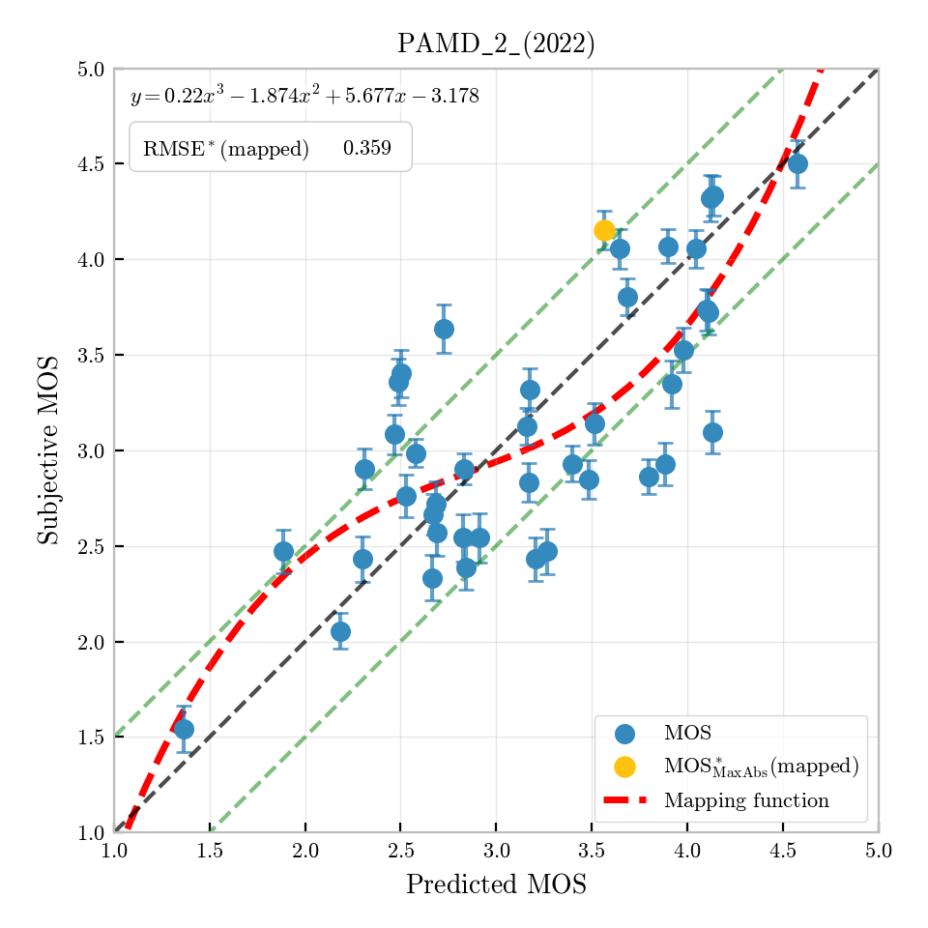
Figure I.4: Per-condition predictions for PAMD_2 (2022) (MOS)
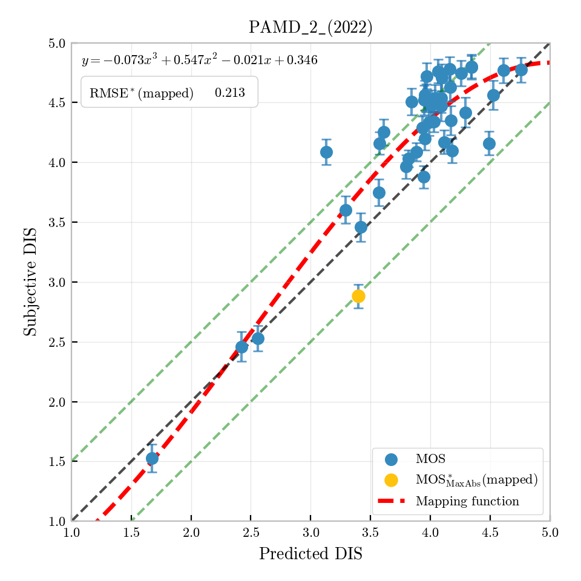
Figure I.5: Per-condition predictions for PAMD_2 (2022) (DIS)
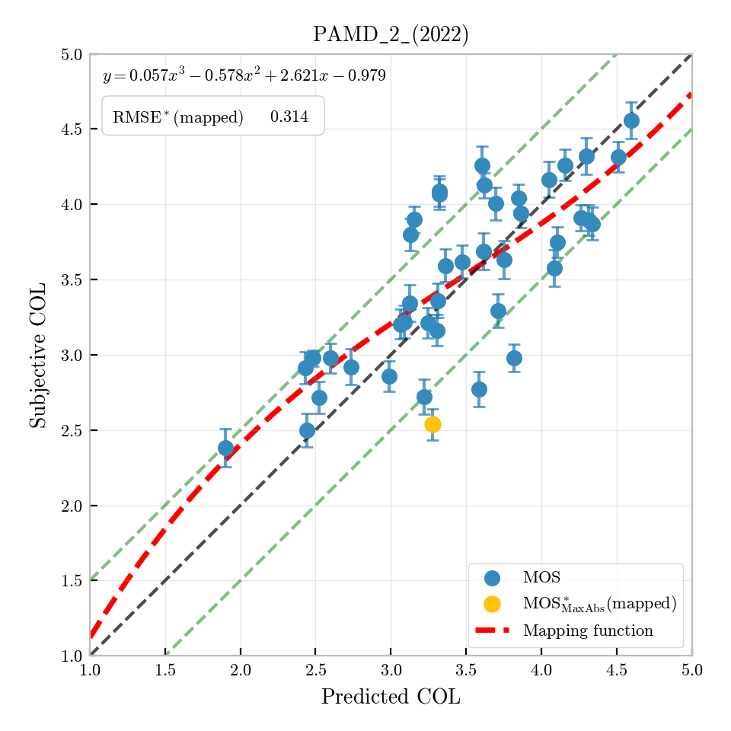
Figure I.6: Per-condition predictions for PAMD_2 (2022) (COL)
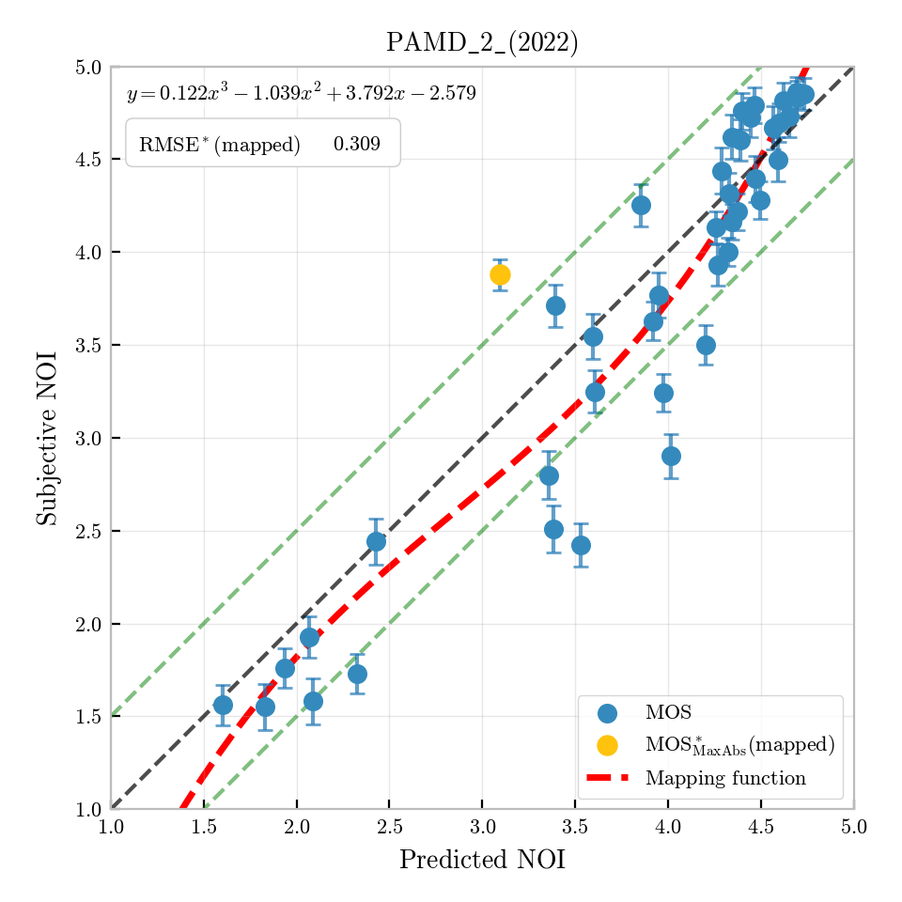
Figure I.7: Per-condition predictions for PAMD_2 (2022) (NOI)
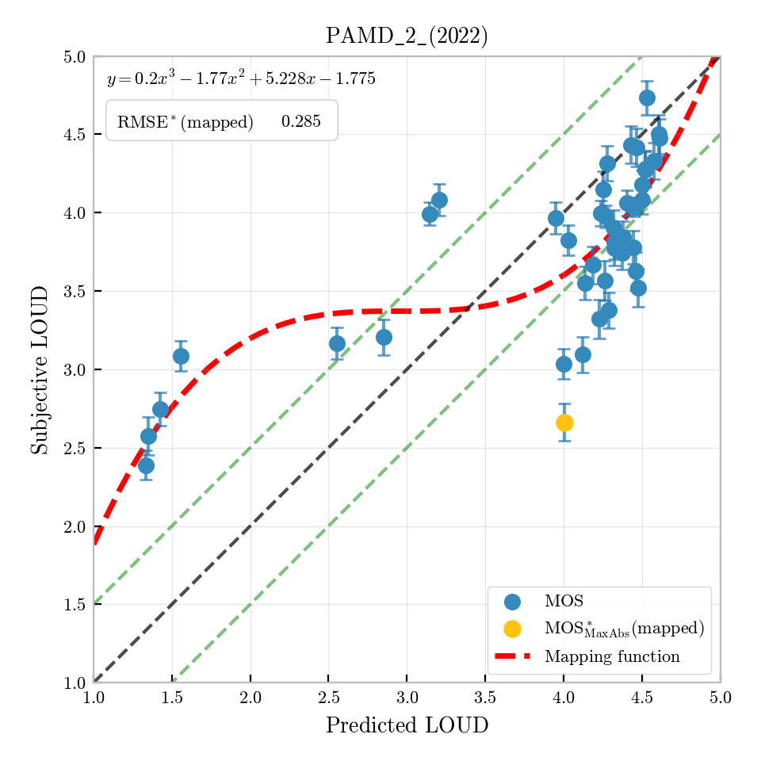
Figure I.8: Per-condition predictions for PAMD_2 (2022) (LOUD)

I.3.3 EVS-Opus (2022)
This database studies the effect of audio bandwidth and bitrate settings on listening quality for EVS and Opus at multiple combinations, complemented by AMR-WB, AMR, and anchor conditions with pure bandwidth limitations from IRS narrowband to fullband. A portion of conditions is from real-field mobile recordings under good, average, and bad network conditions. German speech (ITU-T P.501 Annex C, four samples, two male and two female) was used across 55 test conditions; 24 native listeners participated. The test is mostly noise-free with four MNRU anchor conditions. Only overall speech quality was assessed. Figure I.9 shows the per-condition scatter plot.
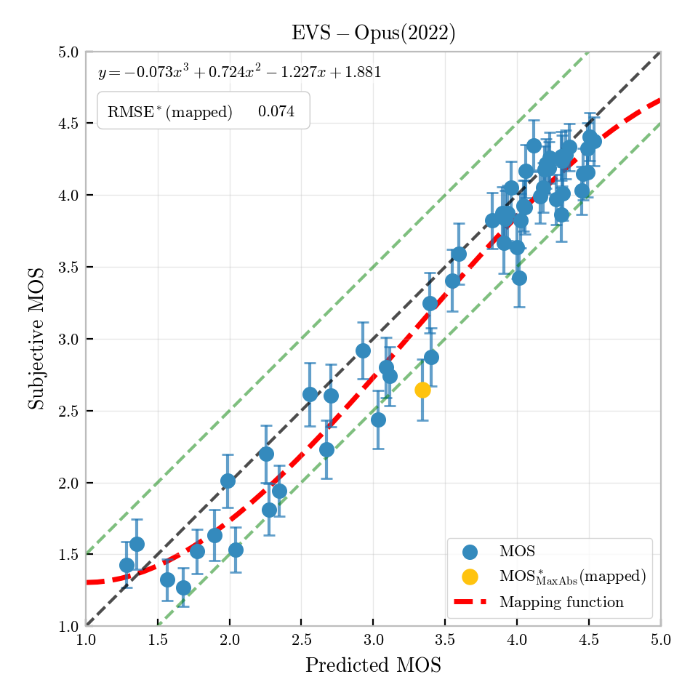
Figure I.9: Per-condition predictions for EVS-Opus (2022) (MOS)

I.3.4 Neural coders (2023)
This database evaluates ultra-low-bitrate AI-based and traditional codecs under both offline-processed and real-field mobile conditions. AI-based neural codecs (LPCNet, TAAE, DAC, Lyra V2) are compared against traditional codecs (EVS, AMR-WB, AMR). German speech (ITU-T P.501 Annex C, four samples, two male and two female) was used across 30 test conditions; 30 listeners participated. The test used the P.808 ACR methodology with overall speech quality only. Only overall speech quality was assessed. Figure I.10 shows the per-condition scatter plot.
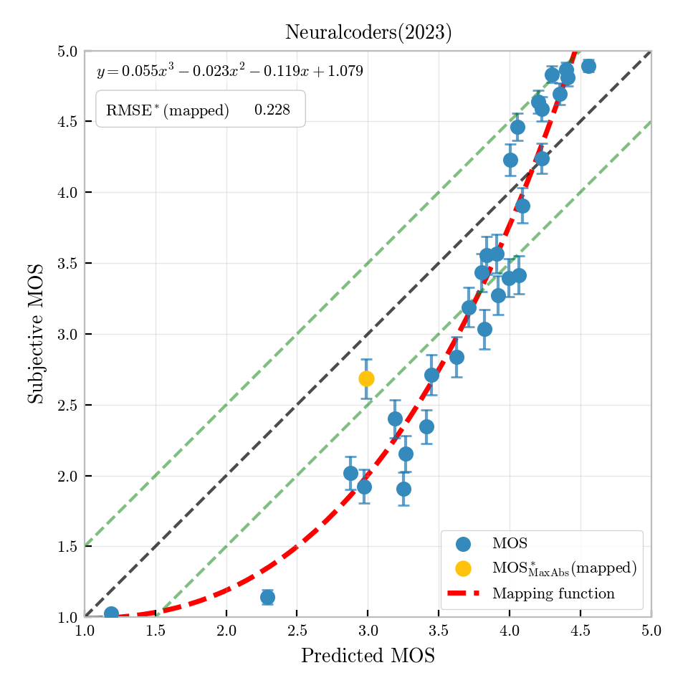
Figure I.10: Per-condition predictions for Neural coders (2023) (MOS)

I.3.5 PSAMD_1 (2024)
Database PSAMD_1 (2024) uses French speech and covers all five quality scales (overall quality, noisiness, discontinuity, coloration, and loudness). The codec conditions include EVS at several bitrates and EVS with background noise. Some of the test conditions are taken from SwissQual P.AMD database. Only a subset of conditions contain all five scales; the remainder contain only overall quality scores. Figure I.11 (overall quality), Figure I.12 (discontinuity), Figure I.13 (coloration), Figure I.14 (noisiness), and Figure I.15 (loudness), respectively show the per-condition scatter plots for overall quality, discontinuity, coloration, noisiness, and loudness, respectively.
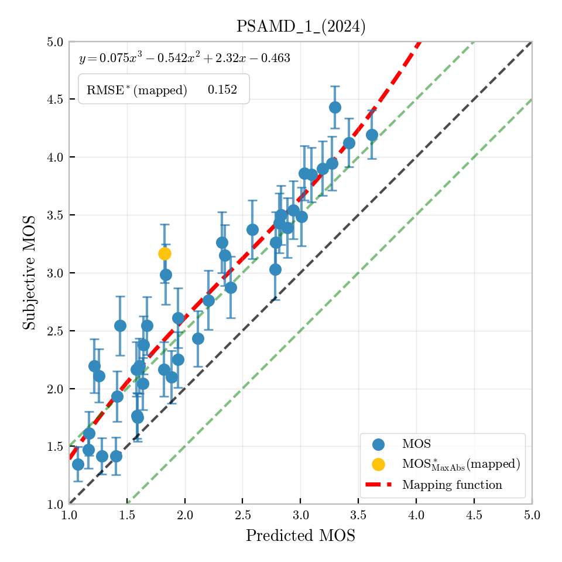
Figure I.11: Per-condition predictions for PSAMD_1 (2024) (MOS)
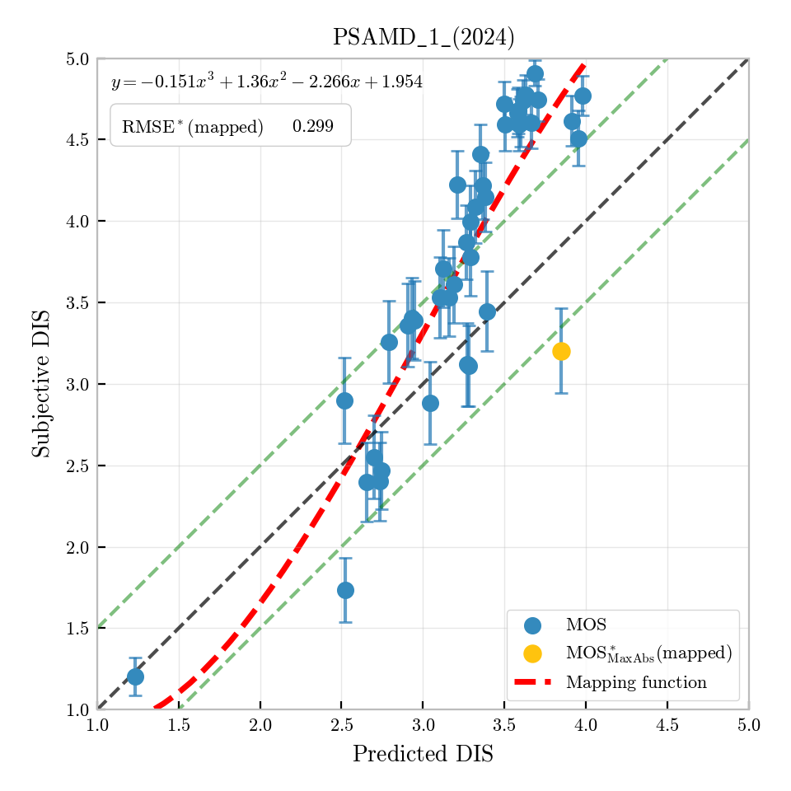
Figure I.12: Per-condition predictions for PSAMD_1 (2024) (DIS)
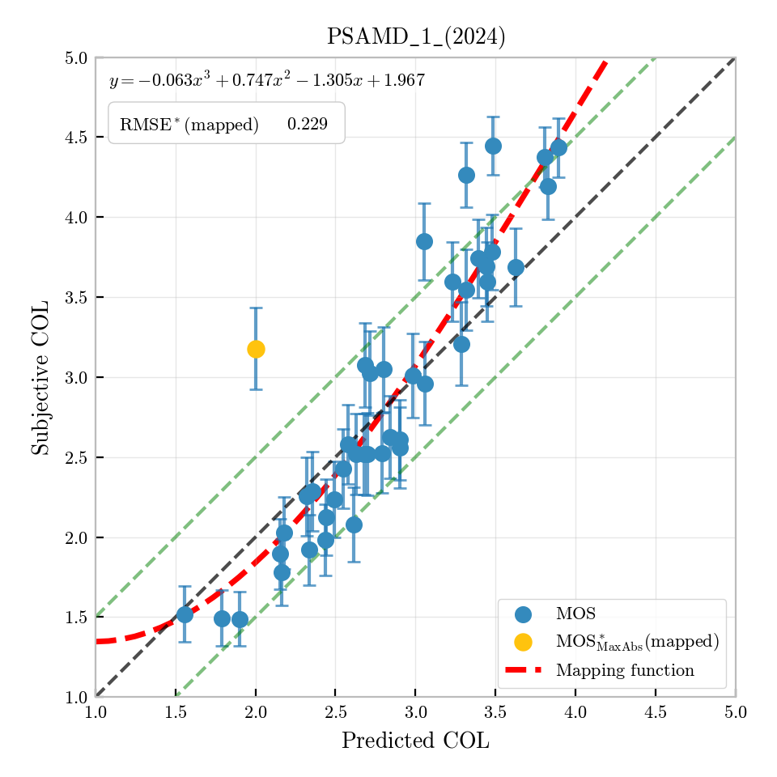
Figure I.13: Per-condition predictions for PSAMD_1 (2024) (COL)
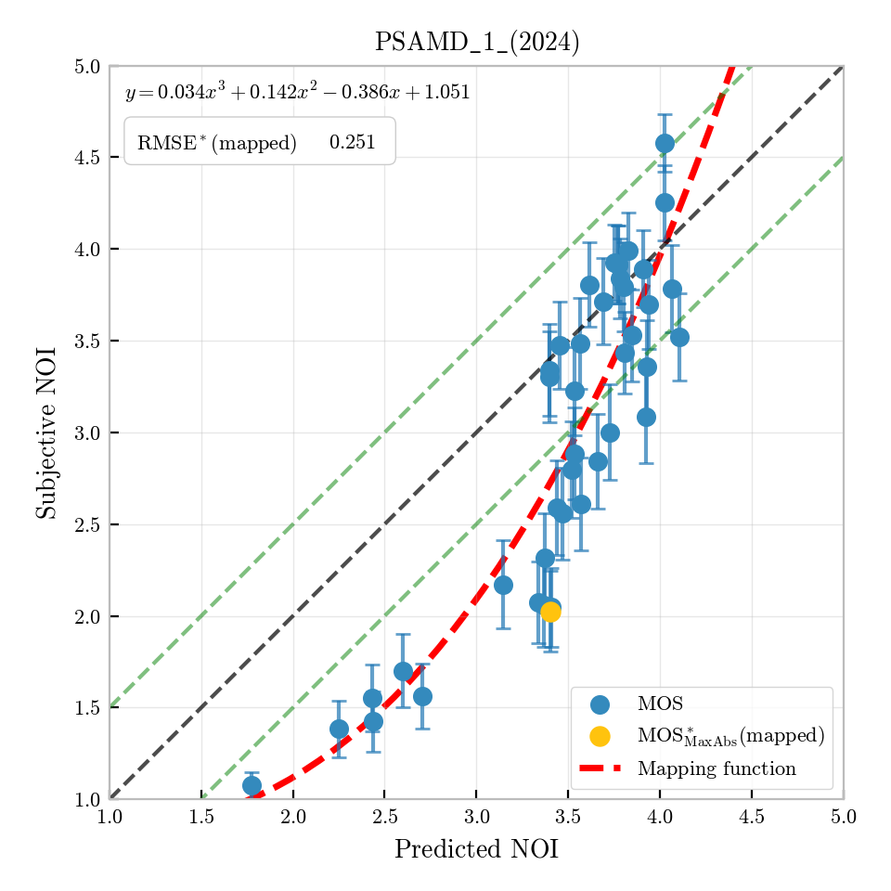
Figure I.14: Per-condition predictions for PSAMD_1 (2024) (NOI)
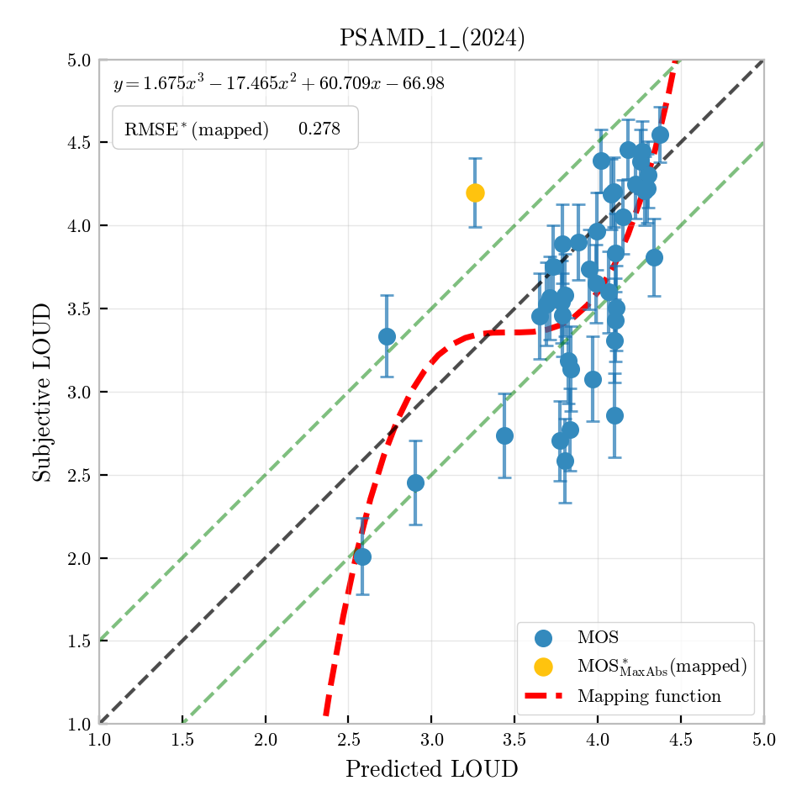
Figure I.15: Per-condition predictions for PSAMD_1 (2024) (LOUD)

I.3.6 PSAMD_2 (2024)
Database PSAMD_2 (2024) uses French speech and covers all five quality scales (overall quality, noisiness, discontinuity, coloration, and loudness). The codec conditions include EVS at several bitrates and EVS with background noise. Some of the test conditions are taken from SwissQual P.AMD database. Only a subset of conditions contain all five scales; the remainder contain only overall quality scores. Figure I.16 (overall quality), Figure I.17 (discontinuity), Figure I.18 (coloration), Figure I.19 (noisiness), and Figure I.20 (loudness), respectively show the per-condition scatter plots for overall quality, discontinuity, coloration, noisiness, and loudness, respectively.
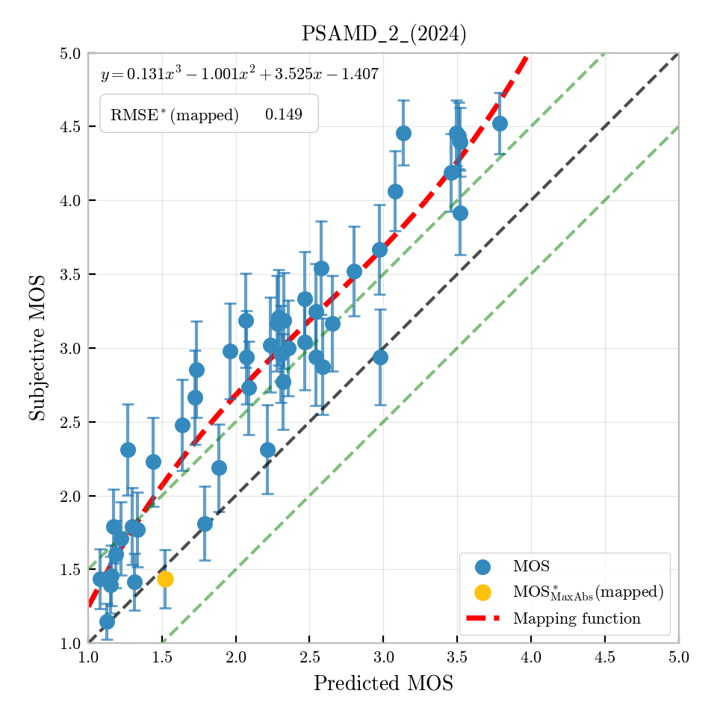
Figure I.16: Per-condition predictions for PSAMD_2 (2024) (MOS)
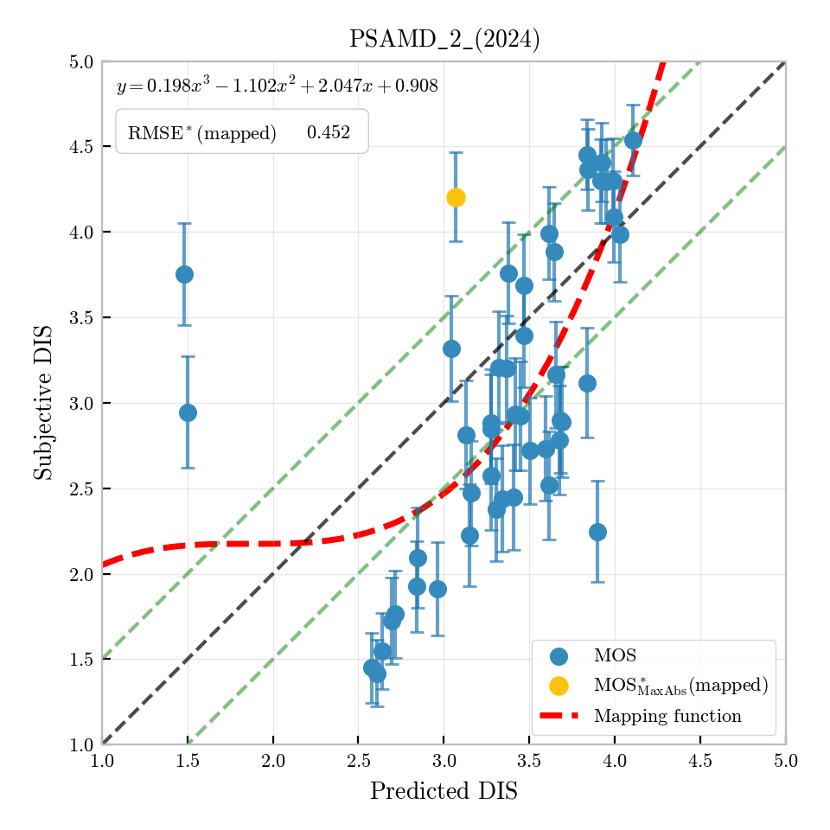
Figure I.17: Per-condition predictions for PSAMD_2 (2024) (DIS)
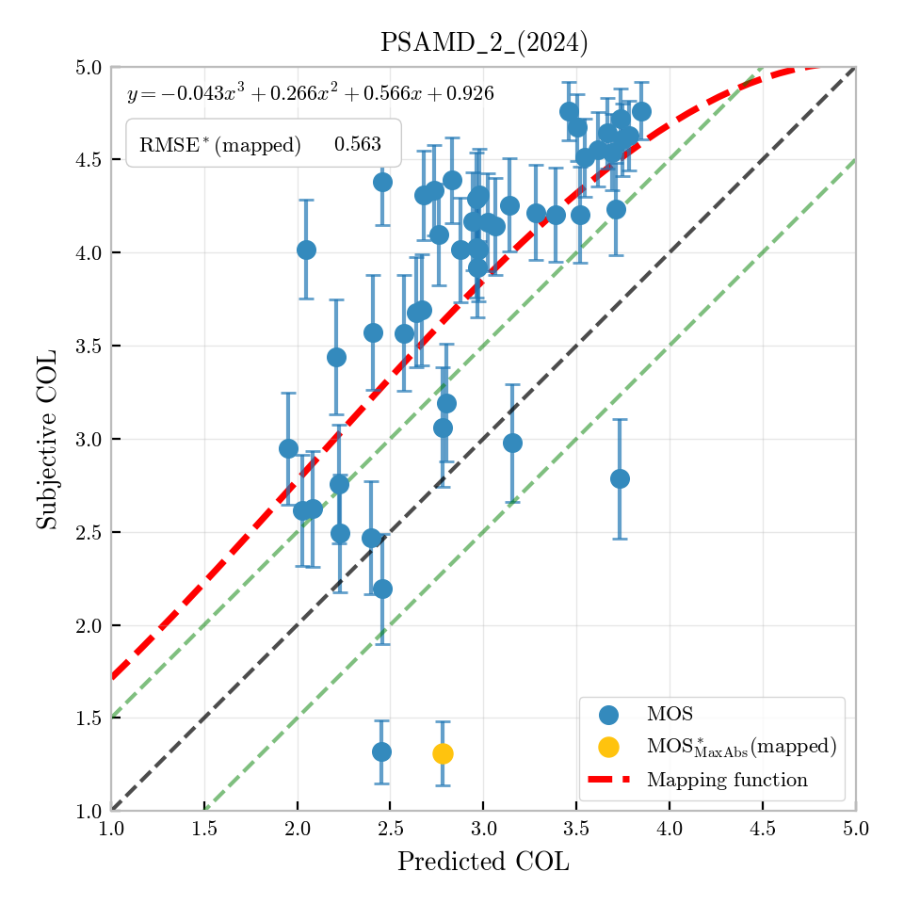
Figure I.18: Per-condition predictions for PSAMD_2 (2024) (COL)
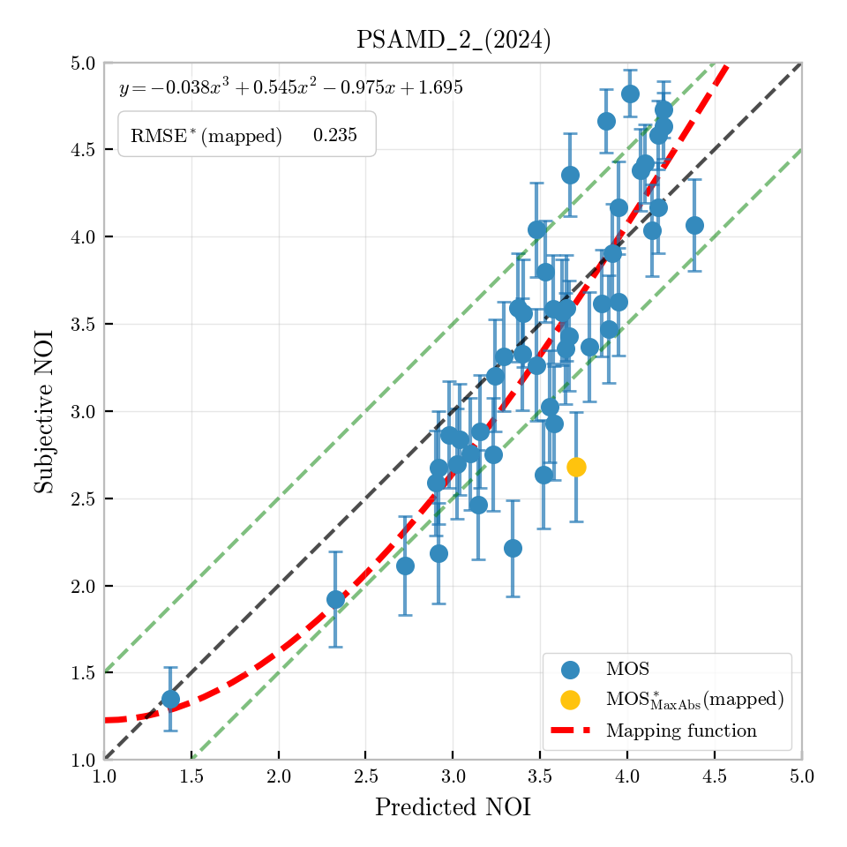
Figure I.19: Per-condition predictions for PSAMD_2 (2024) (NOI)
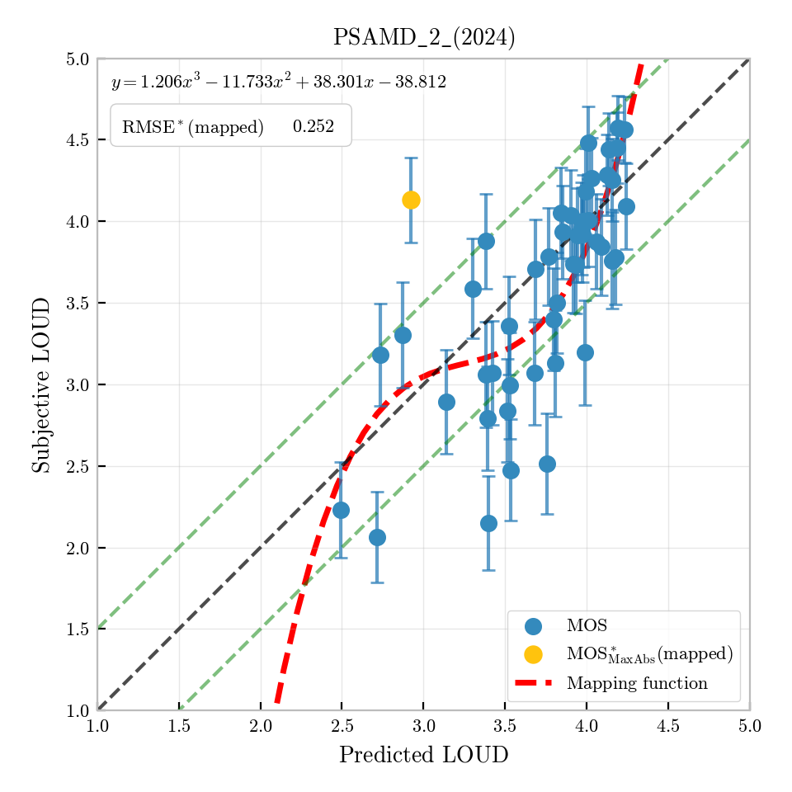
Figure I.20: Per-condition predictions for PSAMD_2 (2024) (LOUD)

I.4 Validation results from Rohde & Schwarz

I.4.1 Overview
Rohde & Schwarz contributed seven databases for P.SAMD validation. Five databases use the ITU-T P.800 ACR LOT methodology for overall speech quality assessment only. Two databases follow the P.AMD Set A methodology for multi-dimensional diagnostic assessment.

I.4.2 RS_P800_2015_FBevs
This database was developed for the validation of P.863 with fullband codecs (EVS, Opus, AMR-WB, and AMR). The mixed fullband database covers audio bandwidths from below narrowband to fullband. German speech (16 sentence pairs, four talkers, two male and two female) was used in a P.800 ACR LOT comprising 52 conditions and 208 speech samples; 24 native listeners participated. No background noise or level variation was included. Only overall speech quality was assessed. Figure I.21 shows the per-condition scatter plot.
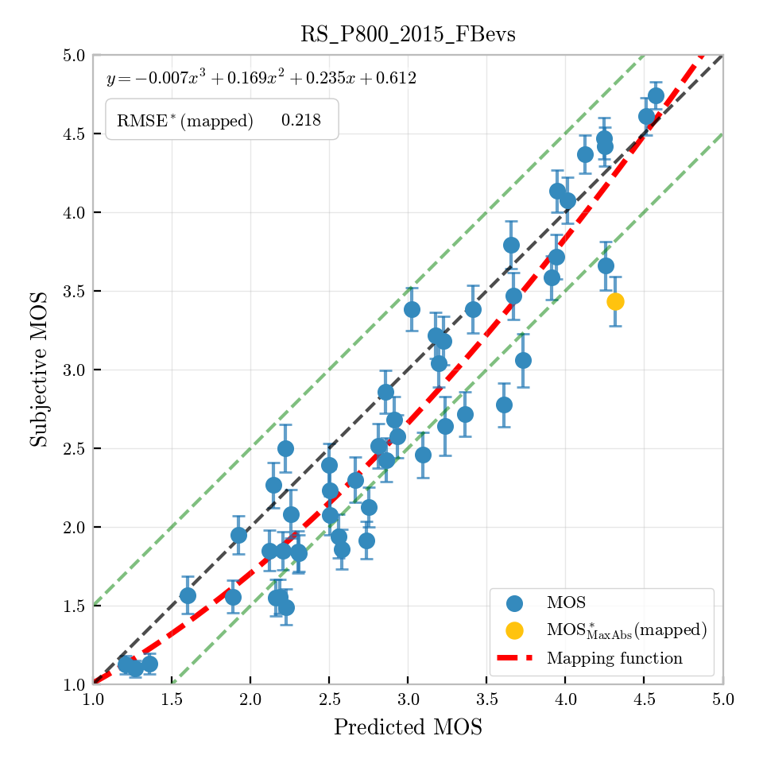
Figure I.21: Per-condition predictions for RS_P800_2015_FBevs (MOS)

I.4.3 RS_P800_2016_FBcodecs
This database evaluates EVS in fullband, extending an existing SWB database with additional fullband conditions to cover bandwidths from narrowband to fullband. EVS is compared against Opus, AMR-WB, and AMR. German speech (16 sentence pairs, four talkers, two male and two female) was used across 52 test conditions with 208 speech samples; 24 native listeners participated. No background noise or level variation was included. Only overall speech quality was assessed. Figure I.22 shows the per-condition scatter plot.
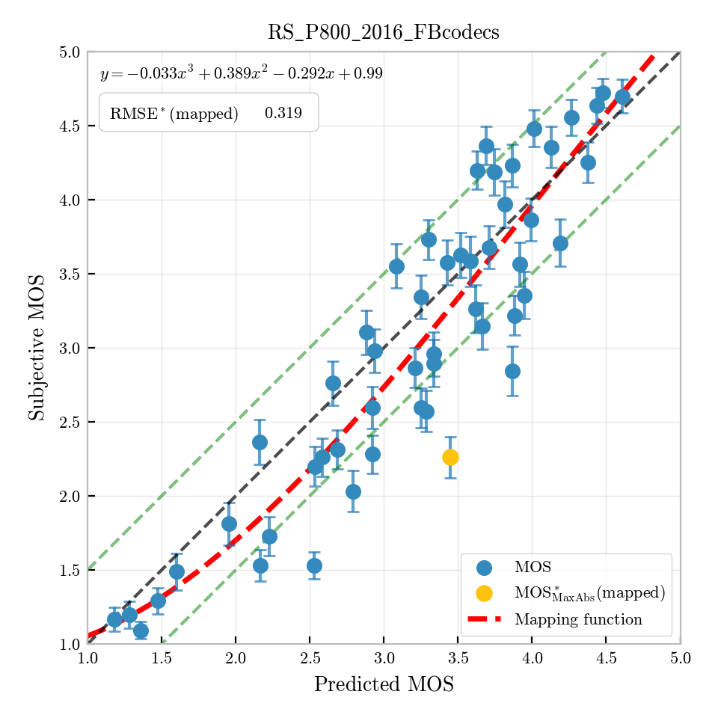
Figure I.22: Per-condition predictions for RS_P800_2016_FBcodecs (MOS)

I.4.4 RS_P800_2018_FBliveConditions
This database focuses on real-field live mobile telephony services including VoLTE, GSM/UMTS circuit switched calls, and OTT VoIP services (e.g., WhatsApp), with live recordings forming 71 % of test samples. Typical codecs are EVS, AMR-WB, AMR, and Opus. Because live recordings do not permit the usual multi-sample design, a single composed female/male German sample (ITU-T P.501 Annex D) was used for all 53 conditions and presented four times to each listener, giving a per-condition MOS based on 96 votes. Only overall speech quality was assessed. Figure I.23 shows the per-condition scatter plot.
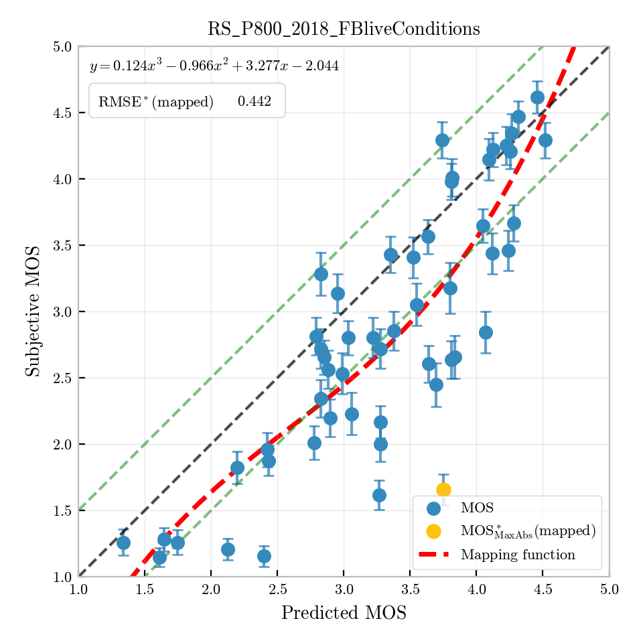
Figure I.23: Per-condition predictions for RS_P800_2018_FBliveConditions (MOS)

I.4.5 RS_PAMD_SetA_SWB_SQ_2
This database was created in 2013 by SwissQual (now Rohde & Schwarz) in collaboration with IDIAP/EPFL, following the P.AMD Set A methodology. It uses French speech with Lombard-effect voice recordings by talkers uniquely recorded at EPFL. The four perceptual dimensions (noisiness, discontinuity, coloration, loudness) are evaluated. The 29 conditions cover a super-wideband context (28 % SWB, 38 % WB, 34 % NB), with a broad range of environmental noises (pub, road, cafeteria); approximately 45 % of conditions are noise-free. Each condition comprises four samples (two male and two female French talkers). Figure I.24 (discontinuity), Figure I.25 (coloration), Figure I.26 (noisiness), and Figure I.27 (loudness), respectively show the per-condition scatter plots. NOTE – Overall speech quality was not assessed for this experiment.
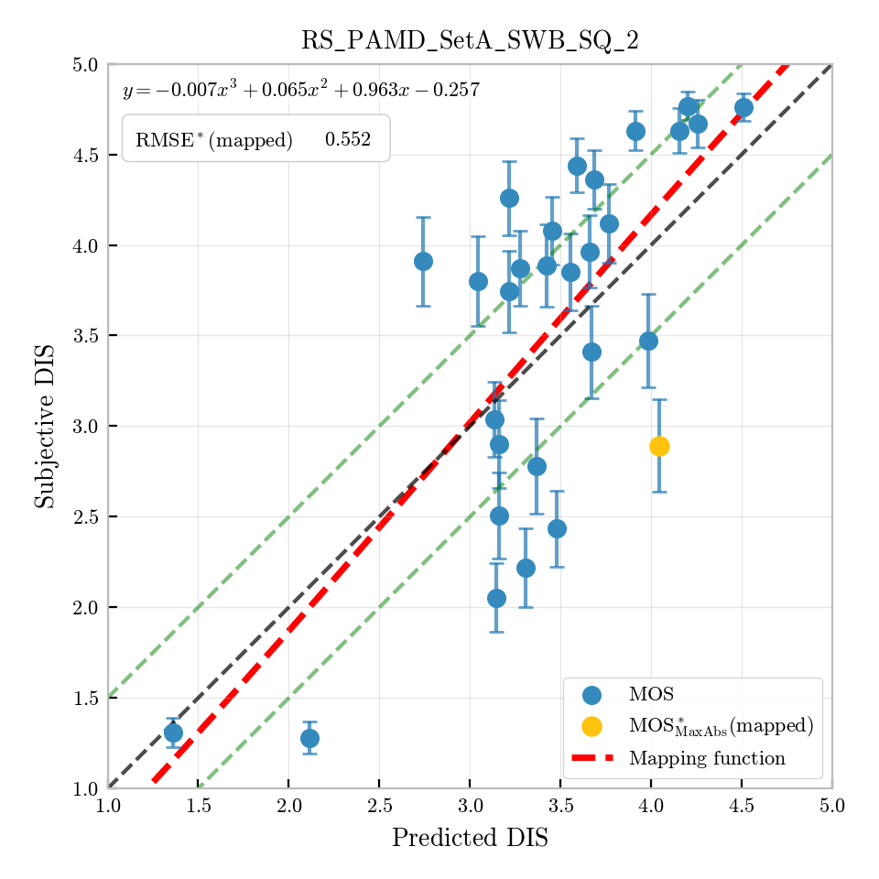
Figure I.24: Per-condition predictions for RS_PAMD_SetA_SWB_SQ_2 (DIS)
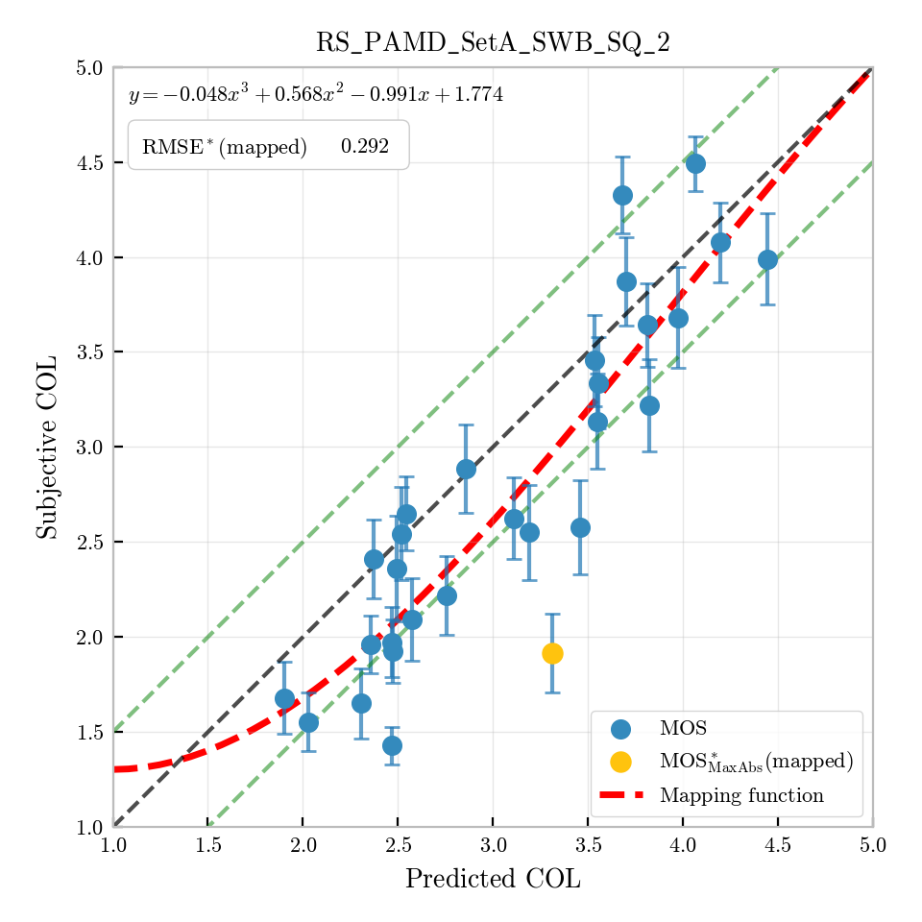
Figure I.25: Per-condition predictions for RS_PAMD_SetA_SWB_SQ_2 (COL)
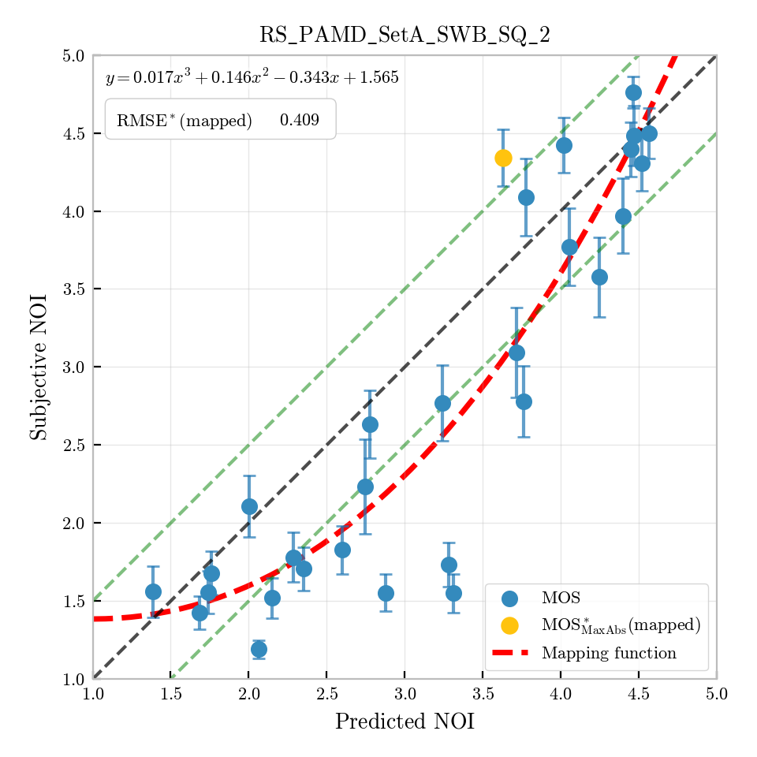
Figure I.26: Per-condition predictions for RS_PAMD_SetA_SWB_SQ_2 (NOI)
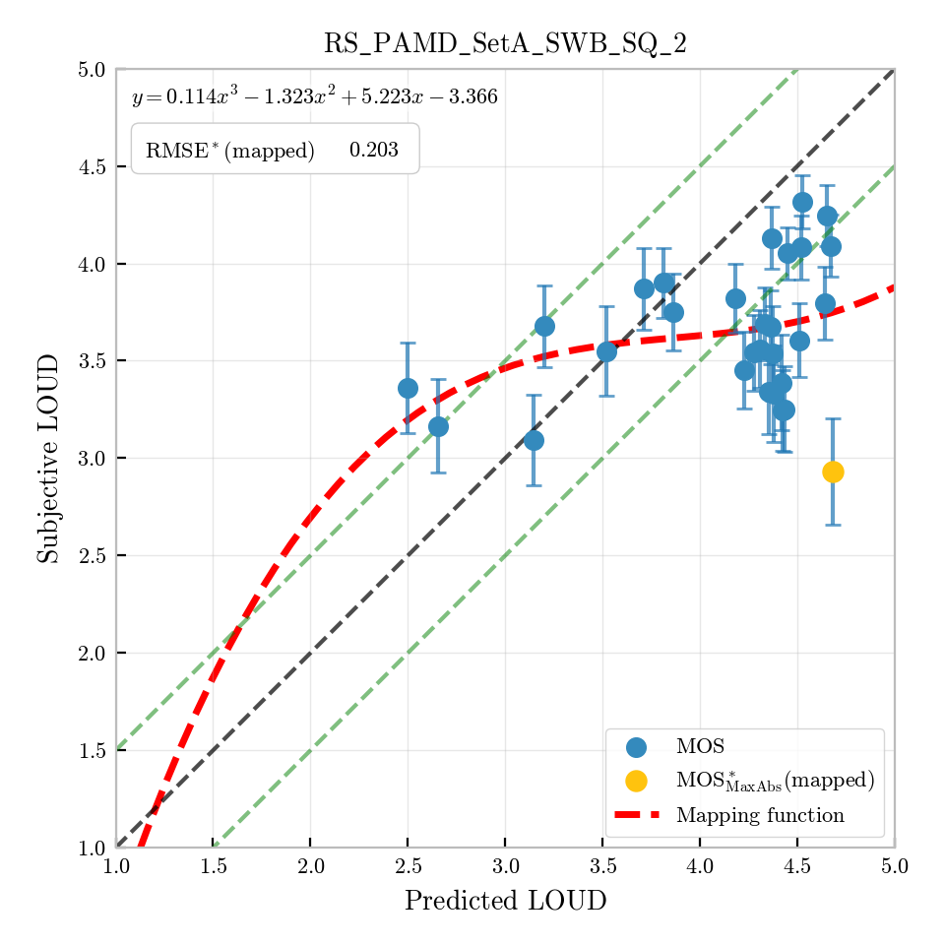
Figure I.27: Per-condition predictions for RS_PAMD_SetA_SWB_SQ_2 (LOUD)

I.4.6 RS_P800_2022_FBbandwidth
This database studies the effect of audio bandwidth and bitrate settings on listening quality for EVS and Opus at multiple combinations, complemented by AMR-WB, AMR, and anchor conditions with pure bandwidth limitations from IRS narrowband to fullband. A portion of conditions is from real-field mobile recordings under good, average, and bad network conditions. German speech (ITU-T P.501 Annex C, four samples, two male and two female) was used across 51 test conditions; 24 native listeners participated. The test is mostly noise-free with four MNRU anchor conditions. Only overall speech quality was assessed. Figure I.28 shows the per-condition scatter plot.
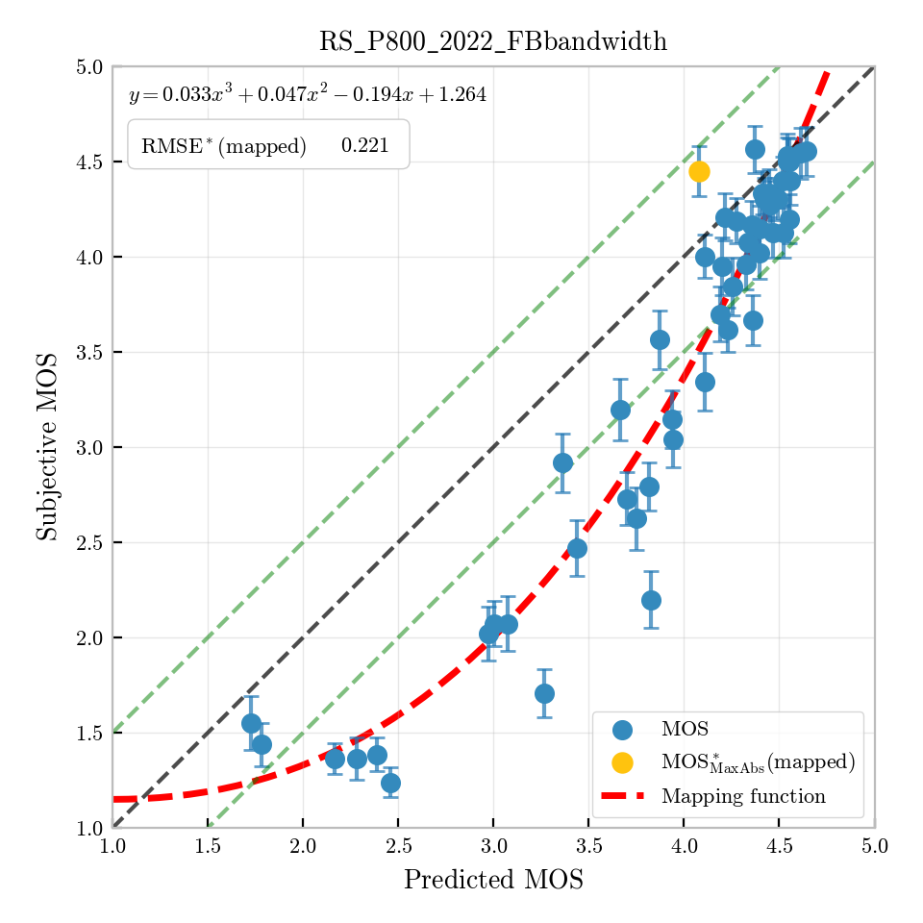
Figure I.28: Per-condition predictions for RS_P800_2022_FBbandwidth (MOS)

I.4.7 RS_P800_2025_AI_ULBR_codecs
This database was created for the evaluation of ultra-low bitrate AI-based and traditional codecs under both offline-processed and real-field mobile conditions (VoLTE, 3G/2G circuit switched calls, OTT VoIP services). AI-based neural codecs (LPCNet, TAAE, DAC, Lyra V2) are compared against traditional codecs (EVS, AMR-WB, AMR) and live network recordings. German speech (ITU-T P.501 Annex C, four samples, two male and two female) was used across 52 test conditions covering bandwidths from narrowband to fullband. Two sets (A/B) with input samples shifted by 5 ms were scored by 16 listeners each, yielding 32 listeners and 128 votes per condition. Only overall speech quality was assessed. Figure I.29 shows the per-condition scatter plot.
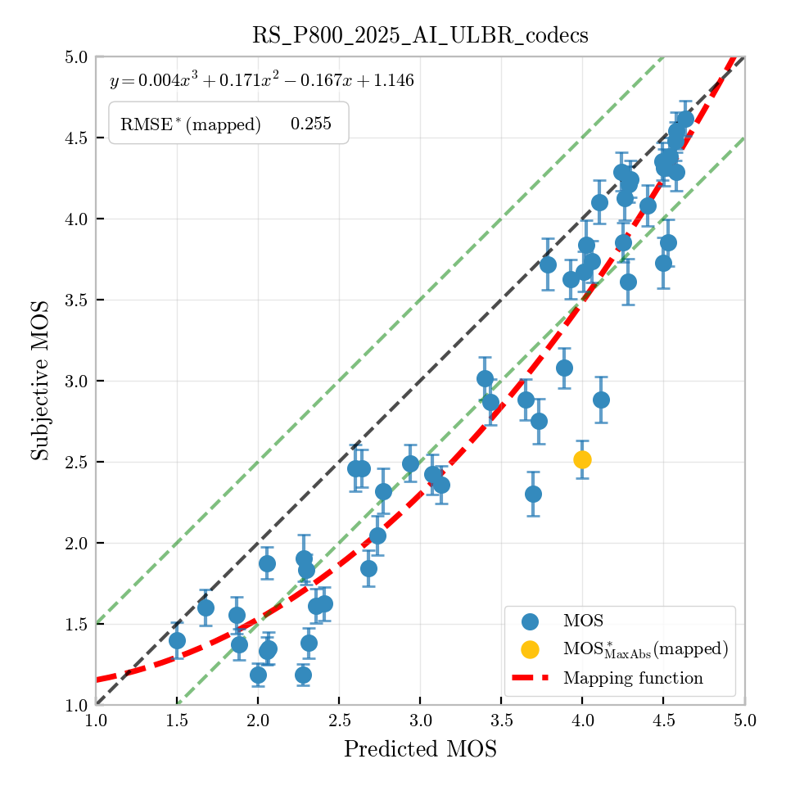
Figure I.29: Per-condition predictions for RS_P800_2025_AI_ULBR_codecs (MOS)

I.4.8 RS_PAMD_2025_AI_ULBR_codecs
This multi-dimensional database evaluates the four perceptual dimensions (noisiness, discontinuity, coloration, sub-optimum loudness). The speech content is derived from the RS_P800_2025_AI_ULBR_codecs experiment, with modifications to introduce loudness variation (level amplification and attenuation) and noisiness (environmental noise added before and after offline processing). German speech (ITU-T P.501 Annex C, four samples) was used across 31 test conditions; 32 listeners (16 per set A/B) scored each condition on a continuous 5-point scale, yielding 128 votes per condition. Figure I.30 (discontinuity), Figure I.31 (coloration), Figure I.32 (noisiness), and Figure I.33 (loudness), respectively show the per-condition scatter plots. NOTE – Overall speech quality was not assessed for this experiment.
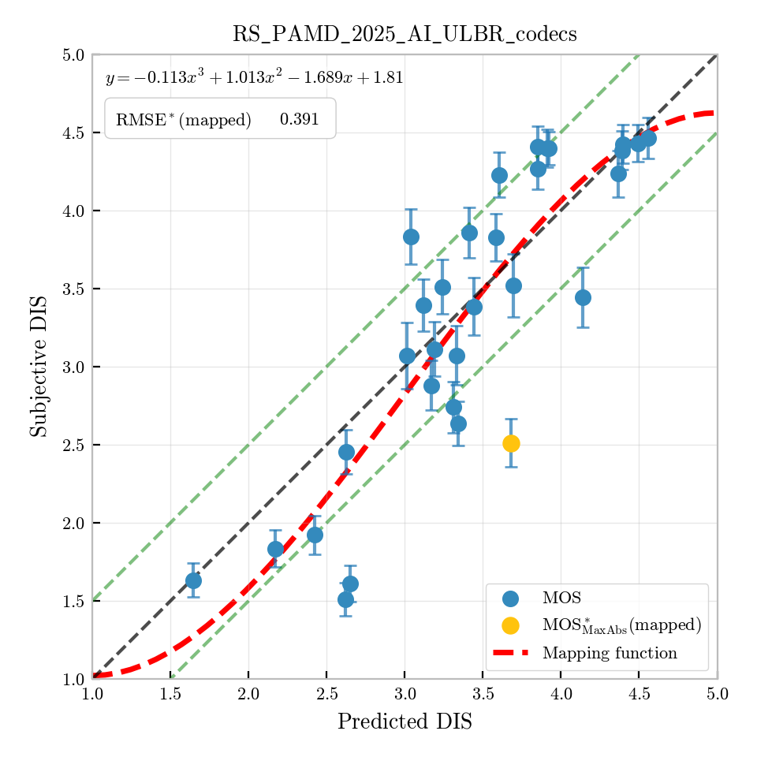
Figure I.30: Per-condition predictions for RS_PAMD_2025_AI_ULBR_codecs (DIS)
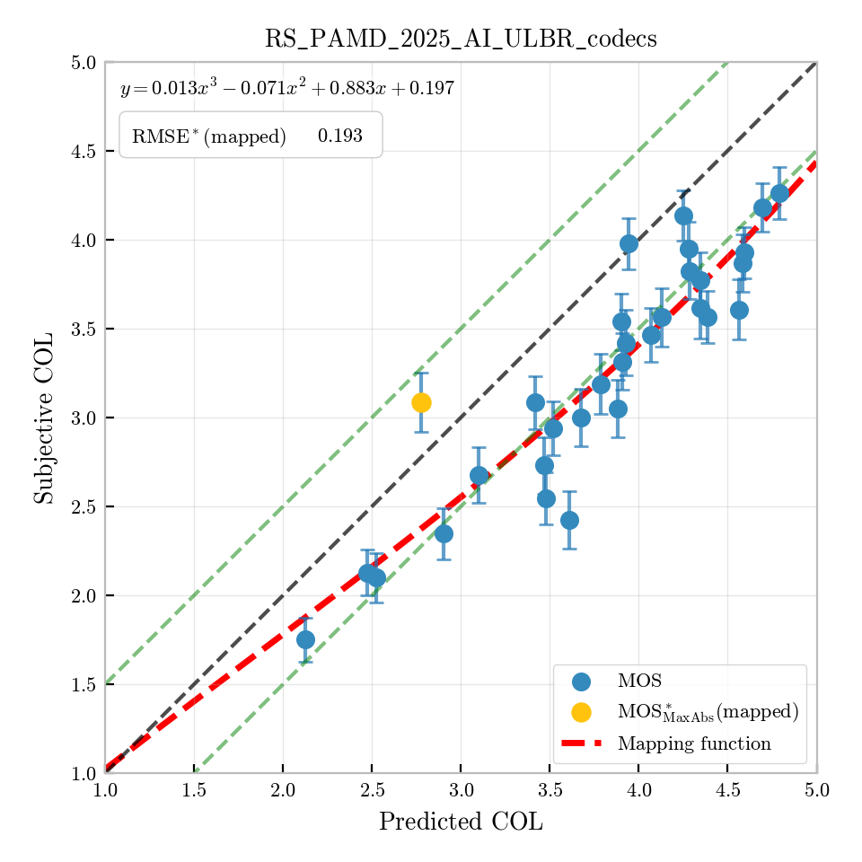
Figure I.31: Per-condition predictions for RS_PAMD_2025_AI_ULBR_codecs (COL)
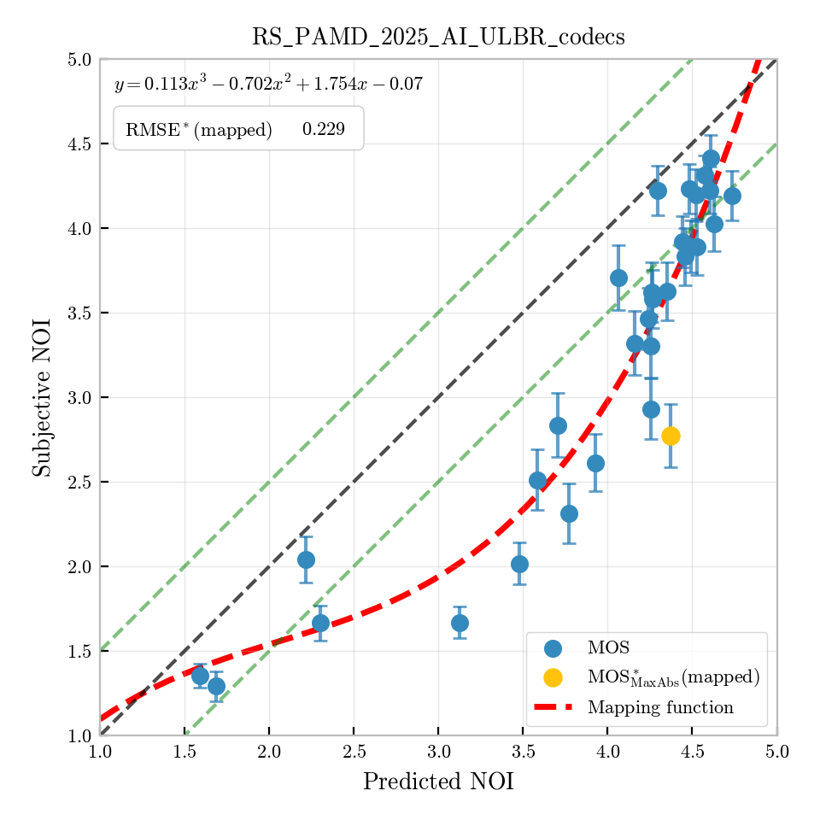
Figure I.32: Per-condition predictions for RS_PAMD_2025_AI_ULBR_codecs (NOI)
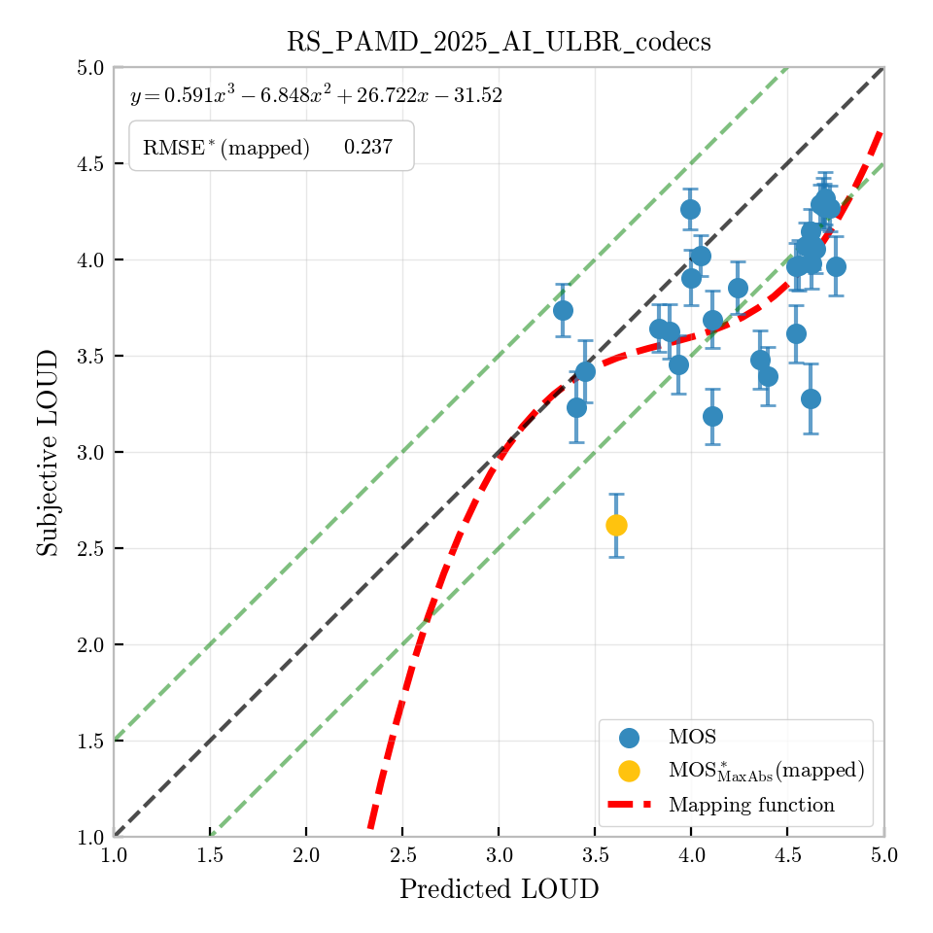
Figure I.33: Per-condition predictions for RS_PAMD_2025_AI_ULBR_codecs (LOUD)

I.5 Summary of prediction accuracy metrics
This clause provides a summary of the prediction accuracy metrics for all validation databases. Table I.1 lists general database information. Tables I.2 list the Pearson correlation coefficient r, the root-mean-square error after first-order polynomial mapping (rmse), and the root-mean-square error after third-order monotonic polynomial mapping with uncertainty compensation (rmse*) for overall speech quality, noisiness, discontinuity, coloration, and loudness, respectively.
Table I.1: Database overview
Database | Source | Conditions | Samples/condition | Votes/sample
ETSI_DB01_MAN_Validation | HEAD acoustics | 60 | 8 | 16
ETSI_DB02_GER_Validation | HEAD acoustics | 60 | 8 | 16
ETSI_DB03_ENG_Validation | HEAD acoustics | 60 | 8 | 16
PAMD_2 (2022) | Orange | 42 | 4 | 18
EVS-Opus (2022) | Orange | 55 | 4 | 24
Neural coders (2023) | Orange | 30 | 30 | 25
PSAMD_1 (2024) | Orange | 42 | 12 | 18
PSAMD_2 (2024) | Orange | 48 | 8 | 18
RS_P800_2015_FBevs | Rohde & Schwarz | 52 | 4 | 30
RS_P800_2016_FBcodecs | Rohde & Schwarz | 52 | 4 | 24
RS_P800_2018_FBliveConditions | Rohde & Schwarz | 53 | 4 | 24
RS_PAMD_SetA_SWB_SQ_2 | Rohde & Schwarz | 29 | 4 | 24
RS_P800_2022_FBbandwidth | Rohde & Schwarz | 51 | 4 | 24
RS_P800_2025_AI_ULBR_codecs | Rohde & Schwarz | 52 | 4 | 32
RS_PAMD_2025_AI_ULBR_codecs | Rohde & Schwarz | 31 | 4 | 32
Table I.2: Prediction accuracy metrics – overall speech quality
Database | r | rmse (1st order) | rmse* (3rd order)
ETSI_DB01_MAN_Validation | 0.946 | 0.3645 | 0.2252
ETSI_DB02_GER_Validation | 0.942 | 0.3483 | 0.2211
ETSI_DB03_ENG_Validation | 0.944 | 0.2916 | 0.2000
PAMD_2 (2022) | 0.742 | 0.4604 | 0.3588
EVS-Opus (2022) | 0.977 | 0.2147 | 0.0738
Neural coders (2023) | 0.909 | 0.4856 | 0.2280
PSAMD_1 (2024) | 0.939 | 0.2995 | 0.1523
PSAMD_2 (2024) | 0.941 | 0.3231 | 0.1491
RS_P800_2015_FBevs | 0.942 | 0.3314 | 0.2181
RS_P800_2016_FBcodecs | 0.913 | 0.4295 | 0.3194
RS_P800_2018_FBliveConditions | 0.835 | 0.5496 | 0.4421
RS_P800_2022_FBbandwidth | 0.935 | 0.3849 | 0.2207
RS_P800_2025_AI_ULBR_codecs | 0.945 | 0.3705 | 0.2545
Minimum |  |  | 0.0738
Average |  |  | 0.2356
Maximum |  |  | 0.4421
Table I.3: Prediction accuracy metrics – discontinuity
Database | r | rmse (1st order) | rmse* (3rd order)
PAMD_2 (2022) | 0.901 | 0.3077 | 0.2134
PSAMD_1 (2024) | 0.866 | 0.4625 | 0.2992
PSAMD_2 (2024) | 0.512 | 0.7724 | 0.4517
RS_PAMD_SetA_SWB_SQ_2 | 0.726 | 0.7011 | 0.5522
RS_PAMD_2025_AI_ULBR_codecs | 0.858 | 0.5021 | 0.3914
Minimum |  |  | 0.2134
Average |  |  | 0.3816
Maximum |  |  | 0.5522
Table I.4: Prediction accuracy metrics – coloration
Database | r | rmse (1st order) | rmse* (3rd order)
PAMD_2 (2022) | 0.761 | 0.3837 | 0.3137
PSAMD_1 (2024) | 0.907 | 0.3662 | 0.2285
PSAMD_2 (2024) | 0.611 | 0.7031 | 0.5632
RS_PAMD_SetA_SWB_SQ_2 | 0.885 | 0.4228 | 0.2918
RS_PAMD_2025_AI_ULBR_codecs | 0.911 | 0.2810 | 0.1926
Minimum |  |  | 0.1926
Average |  |  | 0.3180
Maximum |  |  | 0.5632
Table I.5: Prediction accuracy metrics – noisiness
Database | r | rmse (1st order) | rmse* (3rd order)
PAMD_2 (2022) | 0.931 | 0.3985 | 0.3094
PSAMD_1 (2024) | 0.865 | 0.4593 | 0.2513
PSAMD_2 (2024) | 0.859 | 0.4212 | 0.2351
RS_PAMD_SetA_SWB_SQ_2 | 0.889 | 0.5766 | 0.4087
RS_PAMD_2025_AI_ULBR_codecs | 0.893 | 0.4401 | 0.2286
Minimum |  |  | 0.2286
Average |  |  | 0.2866
Maximum |  |  | 0.4087
Table I.6: Prediction accuracy metrics – loudness
Database | r | rmse (1st order) | rmse* (3rd order)
PAMD_2 (2022) | 0.709 | 0.4036 | 0.2852
PSAMD_1 (2024) | 0.638 | 0.4798 | 0.2784
PSAMD_2 (2024) | 0.692 | 0.4796 | 0.2518
RS_PAMD_SetA_SWB_SQ_2 | 0.330 | 0.3427 | 0.2033
RS_PAMD_2025_AI_ULBR_codecs | 0.609 | 0.3284 | 0.2370
Minimum |  |  | 0.2033
Average |  |  | 0.2511
Maximum |  |  | 0.2852

Bibliography

[b-Dosovitskiy 2021] Dosovitskiy, A., Beyer, L., Douze, M., Kolesnikov, A., Weissenborn, D., Zhai, X., Unterthiner, T., Dehghani, M., Minderer, M., Heigold, G., Gelly, S., Uszkoreit, J., and Houlsby, N. (2021), An image is worth 16x16 words: Transformers for image recognition at scale, Proceedings of the 9th International Conference on Learning Representations, ICLR.
[b-Gong 2021] Gong, Y., Chung, Y., and Glass, J. (2021), AST: Audio Spectrogram Transformer, Proceedings of the Interspeech Conference.
[b-Touvron 2021] Touvron, H., Cord, M., Douze, M., Massa, F., Sablayrolles, A., and Jegou, H. (2021), Training data-efficient image transformers & distillation through attention, Proceedings of the 38th International Conference on Machine Learning, PMLR 139:10347-10357.
[b-Vaswani 2017] Vaswani, A., Shazeer, N., Parmar, N., Uszkoreit, J., Jones, L., Gomez, A., and Kaiser, L. (2017), Attention Is All You Need, Advances in Neural Information Processing Systems, NeurIPS.
[b-Wardah 2025] Wardah, W., Spang, R., Barriac, V., Reimes, J., Llagostera, A., Berger, J., Möller, S. (2025) SQ-AST: A transformer-based model for speech quality prediction. Proceedings of the Interspeech Conference 2025.
[b-ITU-T P.1401] Recommendation ITU-T P.1401 (2023), Statistical analysis and evaluation of objective models for quality assessment of speech, audio and audiovisual services.
[b-ETSI TS 103 558] ETSI TS 103 558 V1.3.1 (2023), Speech and multimedia Transmission Quality (STQ); Objective assessment of speech codecs.

____________________

In an ACR listening only test, the test subjects have no dedicated knowledge about the reference speech signal. Therefore, changes in the speech signal not degrading its natural sound will not or not fully be scored as degradations. Those changes are for example missing speech parts, changes in temporal structure of speech (time warping), wrongly reproduced phonemes, or changes in the timbre of the voice. Listeners did not consistently perceive such inaccuracies as degradations, which further supports the model’s focus on naturalness over fidelity.
Loudness scoring already showed inconsistencies in the subjective experiments. Moreover, the test conditions did not include scenarios with clearly non-optimal loudness levels that would result in very low-quality scores. As a result, the P.XXX has limited ability to reliably reproduce ‘Loudness scores’ as a separate dimension of quality. This is compounded by the fact that the subjective reference data itself exhibits low confidence and consistency in this dimension.

