**ICT-Lab Report**

**Submitted to**:

***Ma`am Fabiha***

**Submitted by**:

***Wafaz Ali***

**Roll No**:

***2k24-BSSE-227***

**Section**:

***B***

**Subject**:

***ICT***

**Semester**:

***1st Semester***

**Session**:

***2024-2028***

**Department**:

***Software Engineering***



# Lab 1: Typing Practices Using Typing Master Pro and Understanding Internal Computer Components

### **Introduction**

In this lab, we focused on two crucial aspects of computer literacy: typing practices and understanding the internal components of a computer. Typing is a fundamental skill in today’s digital world, where efficiency and speed are often necessary for both academic and professional work. Using **Typing Master Pro**, we aimed to improve typing proficiency, focusing on speed and accuracy. Alongside this, we explored the internal components of a computer, identifying and understanding their functions and how they contribute to the overall operation of a computer system. This lab provided a balanced approach to enhancing software-based skills while also gaining hands-on knowledge of hardware.

### Methodology

The lab was divided into two main activities: **typing practice** and **component recognition.**

### **Typing Practices Using Typing Master Pro**

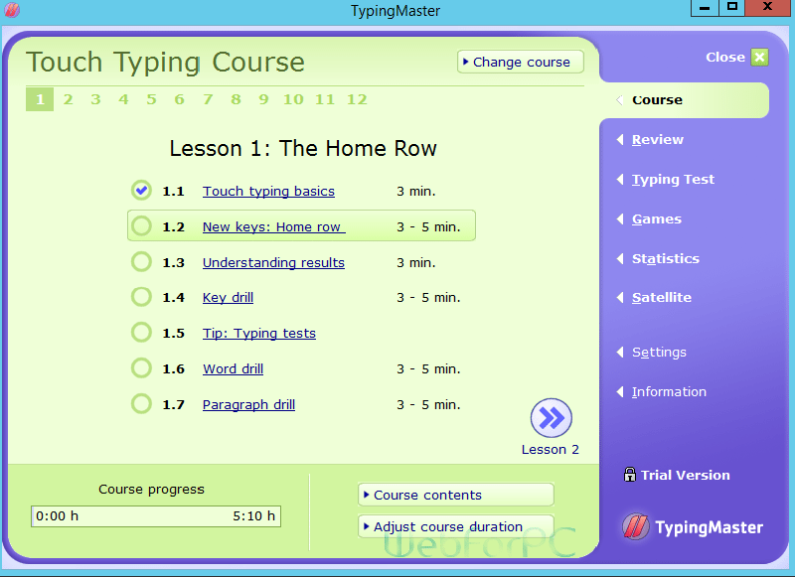

Typing is a fundamental skill in today’s digital world, and this lab focuses on improving typing efficiency and accuracy. We used **Typing Master Pro**, a popular typing tutor software designed to enhance typing speed and precision.

**What was studied:**

We began by setting up **Typing Master Pro** and familiarizing ourselves with the program’s interface. The first activity involved practicing proper hand placement and posture to ensure ergonomic typing. We then proceeded with a series of lessons, starting with basic finger exercises and gradually progressing to more complex typing tasks. The software tracks both speed (measured in words per minute or WPM) and accuracy, allowing us to monitor progress throughout the session.

We focused on improving typing speed while maintaining a high level of accuracy. As we completed exercises, the software provided feedback on mistakes, highlighting areas that needed improvement. We were encouraged to practice specific letters or key combinations where errors were most frequent. The program also offered games and timed tests to challenge us and track improvement.

At the end of the session, we reviewed our progress, noting improvements in both typing speed and accuracy. This practice emphasized the importance of consistent typing exercises in enhancing overall efficiency, which is crucial for academic and professional tasks that require frequent use of the keyboard.

### **Internal Components of a Computer**

Understanding the internal components of a computer is essential for recognizing how hardware and software interact to perform computing tasks. In this lab, we studied the major components that constitute a computer system, examined their roles, and observed their physical structures. Here’s an in-depth look at the components covered:

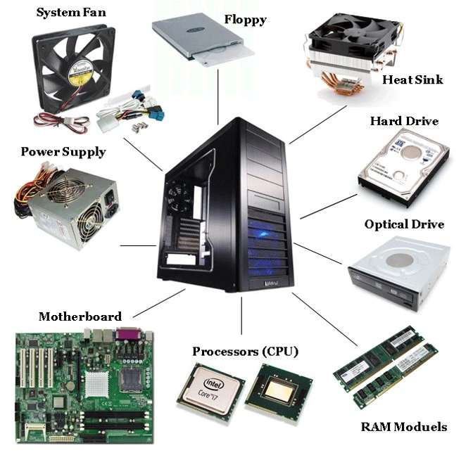

#### **1. Central Processing Unit (CPU)**

The CPU, often referred to as the "brain" of the computer, is responsible for processing instructions from programs. It performs arithmetic, logic, control, and input/output operations.

* **What was studied**:
  + The structure of the CPU, including its location on the motherboard.
  + Observed an **Intel Core i5** processor.
  + Discussed how clock speed and cores impact performance.

#### **2. Random Access Memory (RAM)**

RAM is the temporary memory used to store data that the CPU accesses during active tasks. It allows quick reading and writing access.

* **What was studied**:
  + Identified RAM modules on the motherboard.
  + Observed a **DDR4 RAM module with 8GB capacity**.
  + Learned about its role in multitasking and system responsiveness.

#### **3. Motherboard**

The motherboard is the main circuit board connecting all components, allowing communication between the CPU, memory, storage, and peripherals.

* **What was studied**:
  + Observed the layout of a standard motherboard.
  + Identified key slots and ports, such as CPU socket, RAM slots, and PCIe slots.
  + Discussed the importance of the chipset and power delivery.

#### **4. Storage Devices**

Storage devices, such as hard drives (HDDs) or solid-state drives (SSDs), are used to store data permanently.

* **What was studied**:
  + Observed a **hard disk drive (HDD)**.
  + Discussed differences between HDDs and SSDs in terms of speed and reliability.
  + Explored how storage impacts boot times and data retrieval.

#### **5. Power Supply Unit (PSU)**

The PSU converts electrical power from an outlet into usable power for the computer’s components.

* **What was studied**:
  + Examined the placement and connections of the PSU within the case.
  + Discussed how wattage and efficiency ratings affect the system’s power needs.

#### **6. Cooling System**

Cooling components, such as fans and heatsinks, are essential for maintaining optimal operating temperatures and preventing overheating.

* **What was studied**:
  + Identified the CPU heatsink and case fans.
  + Discussed the importance of airflow and thermal paste in effective cooling.

#### **7. Graphics Processing Unit (GPU)**

The GPU handles rendering of images, videos, and 3D graphics. In some systems, this may be integrated into the CPU or exist as a dedicated card.

* **What was studied**:
  + Observed an integrated GPU within the Intel processor.
  + Discussed the differences between integrated and dedicated GPUs.

#### **8. Input/Output Ports and Peripherals**

Input/output ports facilitate communication with external devices, such as keyboards, monitors, and USB drives.

* **What was studied**:
  + Examined common ports (USB, HDMI, Ethernet) on the motherboard.
  + Discussed how ports connect peripherals to expand system capabilities.

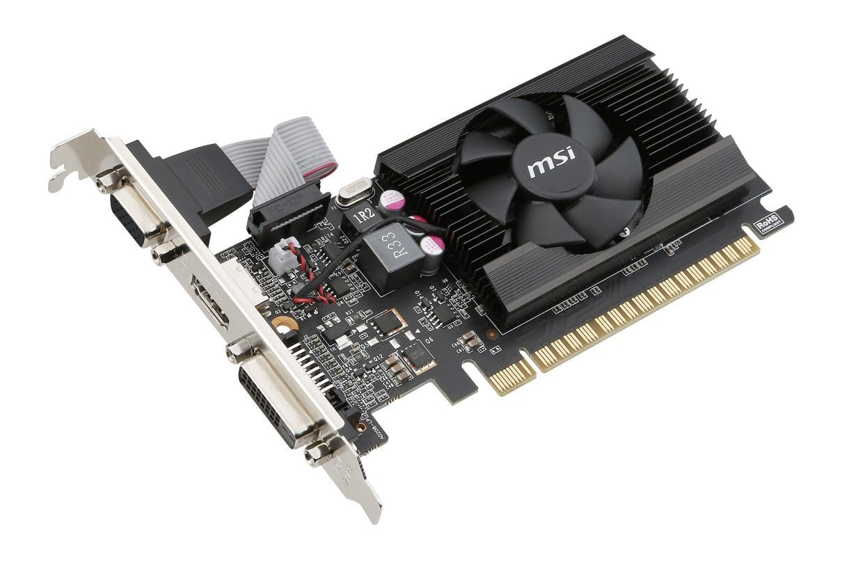

### **Results**

The results of this lab were twofold. In the typing practice segment, **Typing Master Pro** provided detailed insights into individual performance. For instance, the initial typing speed was recorded, followed by noticeable improvement as the exercises progressed. Accuracy also showed an upward trend, highlighting the effectiveness of structured typing training.

In the hardware segment, we successfully identified all key internal components of the computer. For example, we observed an Intel Core i5 processor, an 8GB DDR4 RAM module, and a 1TB hard drive. Each component was carefully analyzed, and its function was discussed in the context of the system’s overall operation.

### **Discussion**

The typing practice revealed several interesting insights. Initially, it was challenging to maintain proper hand placement and achieve consistent accuracy. However, the structured approach of Typing Master Pro, combined with repetitive exercises, led to significant improvement. This exercise underscored the importance of regular practice in achieving proficiency.

The exploration of internal computer components provided valuable practical knowledge. By physically observing and analyzing these components, we gained a deeper understanding of how hardware works together to enable software operations. This hands-on experience bridged the gap between theoretical concepts taught in class and their practical applications. Moreover, it emphasized the importance of understanding hardware for troubleshooting and optimizing computer performance.

### **Conclusion**

This lab was highly beneficial in developing both software-based and hardware-related skills. The typing practice improved our efficiency and accuracy, laying the foundation for better productivity in digital tasks. Meanwhile, the exploration of internal computer components provided critical insights into the workings of a computer system, enhancing our ability to understand and interact with technology on a deeper level. This dual focus on practical and theoretical aspects ensures a well-rounded understanding of essential computer operations.

# Lab 2: Windows installation, CPU assembling

In **Lab 2**, we explored two fundamental tasks in computer setup and assembly: **Windows Installation** and **CPU Assembling**. These tasks are essential for anyone looking to build or maintain a personal computer, as they involve configuring both the software and hardware components to ensure a fully operational system.

**Windows Installation** is a crucial step in setting up a computer system, as it provides the operating environment in which all programs and applications will run. The process involves creating installation media, configuring system settings, and ensuring that all hardware components are properly recognized by the operating system. Through this lab, we gained hands-on experience with installing **Windows 10** from scratch, using a bootable USB drive and learning how to navigate the setup process effectively. We also focused on important tasks such as partitioning hard drives, entering product keys, and installing necessary drivers to ensure the system runs optimally.

On the hardware side, **CPU Assembling** is the first step in physically building a computer. The CPU, often referred to as the "brain" of the computer, plays a critical role in processing data and executing instructions. In this lab, we learned how to handle delicate components like the **CPU**, **motherboard**, and **cooling systems**, ensuring that the CPU was correctly installed in the motherboard socket and properly secured with thermal paste and a cooling unit. We also observed how other essential components like RAM, power supply, and storage devices are integrated into the system.

Together, these activities provided us with a comprehensive understanding of both the **software installation process** and **hardware assembly**, offering valuable skills for setting up and troubleshooting modern computer systems.

### Methodology

## Windows Installation:

The installation of **Windows** is a critical step in setting up a new computer system. It involves configuring the operating system (OS) so that the computer can be used for various tasks. In this lab, we followed a systematic approach to install **Windows 10** on a clean system. Below is a more comprehensive explanation of the steps, tools, and considerations involved in the process:

* **Preparation for Installation:**  
  Before initiating the installation, we prepared the installation media. We used a **USB flash drive** with at least 8GB of free space to create a bootable installation drive using the **Windows Media Creation Tool**. This tool downloads the latest version of Windows and transfers it to the USB drive.
* **BIOS/UEFI Settings**

Once the bootable USB was created, we powered on the computer and accessed the **BIOS/UEFI** settings by pressing the designated key (typically **F2**, **DEL**, or **ESC**) during the boot process. In the BIOS, we set the boot order to ensure that the computer boots from the USB drive first. This is essential for starting the Windows installation process.

* **Booting from USB**

After saving the BIOS settings and restarting the computer, the system booted from the USB drive. The **Windows Setup** screen appeared, allowing us to begin the installation process.

* **Selecting Language, Time, and Keyboard Preferences**

Upon launching the Windows installer, we were prompted to choose the language, time zone, and keyboard layout. These settings are essential for personalizing the system based on the user’s region and preferences.

* **Entering the Product Key**

During installation, we were asked to enter a **product key** for activation. This key is a unique identifier that verifies the authenticity of the Windows copy. In this case, we used a **genuine product key** provided by the university or the software distributor.

* **Choosing the Installation Type**

After entering the product key, we selected the **custom installation** option, which allows for a fresh installation of Windows, rather than upgrading from a previous version. This is ideal when setting up a new system or reformatting an old one.

* **Partitioning the Hard Drive**

The next step was to partition the hard drive or solid-state drive (SSD). The installation program displayed available drives, and we created a primary partition on the target drive (usually labeled **Drive 0**). We chose to format the drive before installing Windows to ensure that it was clean and free of any previous data.

* **Copying Files and Installing Features**

After partitioning, the installation process began. Windows copied the necessary files to the drive and installed essential features. This process can take some time, depending on the system’s hardware, particularly the speed of the storage device (HDD vs. SSD).

* **System Configuration**

Once the files were copied, the computer restarted, and the Windows setup process continued. We were prompted to configure the system by choosing a username, password, and computer name. We also set privacy preferences regarding location tracking, Cortana (the virtual assistant), and other system services.

* **Windows Updates**

After the initial setup, Windows automatically began downloading and installing the latest updates. This step ensures that the operating system is up-to-date with the most recent security patches and features. We also manually checked for additional updates once the installation was complete.

* **Driver Installation**

The next step was to install drivers for the computer’s hardware components, such as the motherboard, graphics card, sound card, and network adapter. Windows often installs generic drivers automatically, but we manually installed specific drivers from the manufacturer’s website (e.g., for **Intel** or **NVIDIA** components) to ensure optimal performance.

* **Activating Windows**

After installation, we activated Windows using the product key, ensuring the operating system was properly licensed. If the system was connected to the internet, Windows usually activated automatically, but manual activation was available if necessary.

* **Finalizing Setup**

The final step involved configuring user preferences, including setting up a Microsoft account or creating a local user account. Once all settings were finalized, the system was ready to use.

### **Key Concepts Learned:**

* **Bootable USB Creation:** How to use the Windows Media Creation Tool to create a bootable USB drive.
* **BIOS/UEFI Configuration:** Setting the correct boot order and ensuring the system recognizes the USB drive as the primary boot device.
* **Partitioning:** How to format and partition a hard drive or SSD to ensure that the installation is clean and organized.
* **Driver Installation:** The importance of installing specific drivers for all hardware components to ensure smooth system performance.
* **Windows Updates and Activation:** The process of ensuring that the OS is up to date and properly licensed.

# CPU Assembling:

**CPU Assembling** is a critical skill in building a computer system. It involves physically installing the **Central Processing Unit (CPU)** into the motherboard and ensuring that the necessary components, such as the CPU cooler, are properly installed to prevent overheating and ensure the CPU functions efficiently.

**What Was Studied:**

1. **Understanding the CPU and Its Importance**
2. The **CPU** is often referred to as the "brain" of the computer because it processes instructions, performs calculations, and manages data flow within the system. We studied the essential role of the CPU in computing tasks, including its architecture, cores, clock speed, and the impact it has on the overall performance of a computer.

During this part of the lab, we worked with a **quad-core processor**, which provided a good example of how multiple cores enhance the system’s ability to multitask efficiently.

1. **Choosing a Compatible CPU**

Before assembling the CPU, it’s important to select a compatible processor based on the motherboard socket type (e.g., **LGA 1151**, **AM4**, etc.). We researched and chose a CPU that matched the motherboard’s specifications, ensuring compatibility between the socket and the processor. This step also involved ensuring that the **chipset** on the motherboard supports the chosen CPU to enable optimal performance.

1. **Preparing the Work Area:**   
   Assembling the CPU requires careful handling, as the processor and motherboard are sensitive components. We ensured the work area was static-free by grounding ourselves with an **anti-static wrist strap** to prevent any damage from static discharge. Additionally, we used a clean, flat surface to assemble the components.
2. **Installing the CPU into the Motherboard**

The first physical step in the assembly process was to carefully install the CPU into the motherboard. We followed these steps:

* 1. **Unlocking the CPU Socket**: Most modern CPUs use a **LGA (Land Grid Array)** or **PGA (Pin Grid Array)** socket. In the case of an LGA socket, the motherboard’s lever is lifted to unlock the socket, which will hold the processor in place.
  2. **Aligning the CPU**: We aligned the **CPU’s notched corner** with the corresponding indicator on the socket to ensure it was inserted correctly. This step is crucial because improper alignment can cause damage to the CPU or motherboard.
  3. **Inserting the CPU**: Gently placed the CPU into the socket, making sure that it fits snugly. The CPU should naturally drop into place without the need for force.
  4. **Locking the CPU**: Once the CPU was seated, we pressed the lever back down to secure the processor in place.

1. **Applying Thermal Paste**

Thermal paste is used to improve heat conductivity between the CPU and the cooler. Before installing the CPU cooler, we applied a small, pea-sized amount of **thermal paste** to the center of the CPU. This paste helps transfer heat efficiently from the processor to the cooler, preventing the CPU from overheating.

1. **Installing the CPU Cooler**

The CPU cooler is essential for dissipating the heat generated by the processor. We studied different types of coolers, such as **air coolers** (with a fan and heatsink) and **liquid coolers** (closed-loop systems). For this lab, we installed an air cooler, which included:

* 1. **Aligning the Cooler**: We carefully aligned the cooler with the CPU and motherboard mounting brackets.
  2. **Securing the Cooler**: After aligning the cooler, we gently placed it on top of the CPU, pressing down evenly to spread the thermal paste across the CPU’s surface. We then secured the cooler using screws or fasteners provided with the cooler kit.
  3. **Connecting the Cooler Fan**: Finally, we connected the cooler’s fan to the **CPU fan header** on the motherboard to ensure that the fan runs once the system is powered on.

1. **Power Supply and Final Component Integration**

After assembling the CPU and cooler, we connected the necessary power cables from the **power supply unit (PSU)** to the motherboard, ensuring that the **24-pin main power connector** and **8-pin CPU power connector** were securely attached. This step is crucial for powering up the motherboard and CPU.

We also checked that all other components, such as **RAM**, **storage devices**, and **GPU** (if necessary), were properly installed and seated in their respective slots.

1. **Post-Assembly Verification**

Once the CPU and cooler were installed, we powered on the system to check for any signs of improper installation. We monitored the **system boot-up** process and entered the BIOS to verify that the CPU was detected correctly. This step ensured that everything was functioning properly before proceeding with the operating system installation.

### **Conclusion**

This lab provided valuable practical knowledge of both software and hardware installation. Installing Windows demonstrated the importance of proper setup and configuration for system stability, while CPU assembling gave us hands-on experience in building and assembling computer components. Both tasks are crucial in ensuring that a newly built computer functions effectively and reliably.

# Lab 3: Motherboard and its internal structure

In **Lab 3**, we explored the **motherboard**, one of the most crucial components of a computer system. The motherboard serves as the central hub that connects and allows communication between all the other hardware components, including the **CPU**, **RAM**, **storage devices**, and peripheral devices. It plays a vital role in ensuring the stability and performance of the system. This lab focused on understanding the **internal structure** of the motherboard, the layout of its various components, and how each part functions to contribute to the overall system.

The primary objective of the lab was to familiarize ourselves with the motherboard's different **slots**, **ports**, and **connectors**, and learn how these elements work together to support the computer's hardware and ensure smooth data flow across the system. Additionally, we studied how to properly identify and install various components onto the motherboard to assemble a working system.

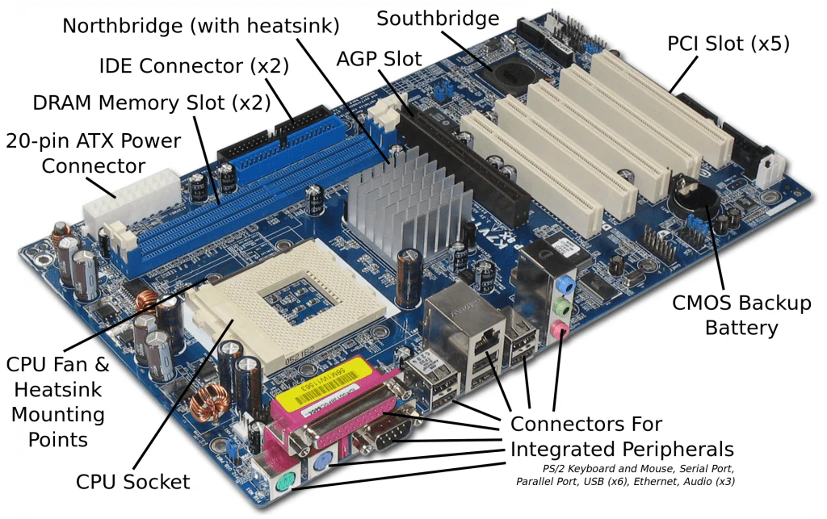

### **What Was Studied:**

1. **Motherboard Overview**
2. We began by examining the overall structure of the motherboard, which consists of a large printed circuit board (PCB) containing various electrical pathways and connectors. The motherboard houses a wide variety of critical components, including the **CPU socket**, **RAM slots**, **PCIe slots**, **SATA connectors**, and **power connectors**. The layout and design of the motherboard depend on its **form factor** (e.g., **ATX**, **Micro-ATX**, **Mini-ITX**), which determines the size and shape of the board.
3. **Key Components on the Motherboard**

We identified and studied the function of key components on the motherboard, including:

* 1. **CPU Socket**: The CPU socket is where the **central processing unit (CPU)** is installed. It is typically secured with a lever mechanism to ensure a secure connection.
  2. **RAM Slots**: The **Random Access Memory (RAM)** is installed into these slots. These slots allow the system to temporarily store data that is actively being used by the CPU.
  3. **PCIe Slots**: The **PCI Express (PCIe)** slots allow for the installation of expansion cards such as **graphics cards (GPU)**, **network cards**, and **sound cards**. We observed how these slots come in different sizes (x1, x4, x8, x16) depending on the bandwidth and requirements of the expansion card.
  4. **SATA Ports**: These ports are used for connecting storage devices such as **hard drives (HDDs)** and **solid-state drives (SSDs)**. We discussed the differences between **SATA I, II, III**, and how data transfer speed is impacted by the version.
  5. **Power Connectors**: The motherboard requires power from the **Power Supply Unit (PSU)** to function. We examined the **24-pin ATX connector** and the **4/8-pin CPU power connector**, which supply the motherboard and CPU with power.

1. **Chipset**

The **chipset** on the motherboard is responsible for managing data flow between the CPU, RAM, storage devices, and other peripherals. We discussed the role of the **northbridge** (which handles high-speed communication like the CPU and memory) and the **southbridge** (which manages slower peripherals such as USB ports and storage devices). Understanding how the chipset functions is key to understanding motherboard performance.

1. **Internal Buses and Data Flow**

We explored the various internal buses that connect the components on the motherboard, such as the **front-side bus (FSB)**, **memory bus**, and **PCI bus**. These buses facilitate communication and data transfer between the CPU, RAM, and other peripherals. The speed and bandwidth of these buses play a critical role in the overall performance of the computer system.

1. **BIOS/UEFI Firmware**

The **Basic Input/Output System (BIOS)** or **Unified Extensible Firmware Interface (UEFI)** is a critical firmware stored on the motherboard that manages hardware initialization during system startup and provides the interface for configuring system settings. We studied how BIOS/UEFI interacts with the motherboard components and controls hardware settings such as boot order, system clock, and fan speeds.

1. **Connectors and Ports**

We identified various connectors and ports on the motherboard, including:

* 1. **USB Ports**: Used for connecting external peripherals such as keyboards, mice, and USB drives.
  2. **Ethernet Port**: Provides network connectivity via an **Ethernet** cable.
  3. **Audio Jacks**: Used for connecting speakers, microphones, and headphones.
  4. **Display Outputs**: Includes **HDMI**, **DisplayPort**, and **VGA** for connecting monitors.

### **Key Concepts Learned:**

* **Motherboard Architecture**: Gained a deep understanding of how the motherboard is structured, its layout, and the role of each key component in the computer’s overall operation.
* **CPU and RAM Interaction**: How the CPU and RAM are linked via their respective sockets and slots and how they work together to process and store data.
* **Expansion Slots and Connectivity**: How expansion slots (PCIe) allow for the addition of peripherals and additional components to enhance system functionality.
* **Power Distribution**: How the motherboard distributes power to various components via power connectors and how the system’s stability depends on the power supply.
* **Data Flow and Buses**: The role of internal data buses in facilitating communication between various components, impacting system performance.
* **BIOS/UEFI and Configuration**: Understanding the BIOS/UEFI firmware and how it controls and configures system hardware at startup.

### **Conclusion**

In **Lab 3**, we gained a comprehensive understanding of the **motherboard** and its internal structure, which is crucial for assembling and troubleshooting computer systems. By studying the various components on the motherboard—such as the **CPU socket**, **RAM slots**, **PCIe slots**, and **SATA ports**—we developed a clear understanding of how these elements interact to support the functionality of the computer. Additionally, we learned about the motherboard’s **chipset**, which manages data flow between the processor, memory, and peripherals, and the role of the **BIOS/UEFI** firmware in configuring and initializing system hardware during startup.

The hands-on experience of identifying and understanding the different parts of the motherboard was invaluable in building a strong foundation in computer hardware. We also explored how to properly install components and connectors, ensuring that everything functions together efficiently.

By the end of the lab, we understood the critical role of the motherboard in the overall performance of a computer system and how each part, from power connectors to data buses, contributes to smooth operation. This knowledge is essential for anyone looking to build, maintain, or repair computer systems.

Ultimately, this lab reinforced the importance of understanding the **motherboard’s internal structure** to ensure that all components are properly installed and interact seamlessly, enabling the system to operate at its best.

# Lab 4: Introduction to MS Office, MS Word basic features

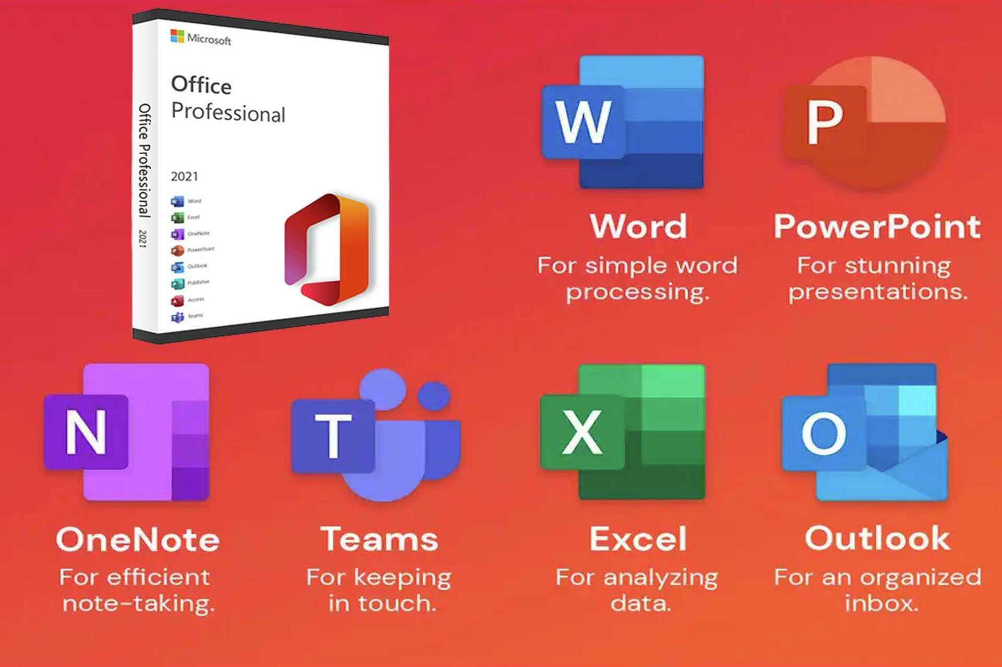

In **Lab 4**, we focused on gaining a foundational understanding of **Microsoft Office** and explored the basic features of **Microsoft Word**, one of the most widely used word processing software. **MS Office** is a suite of applications that includes programs for word processing (Word), data management (Excel), presentations (PowerPoint), and more, providing essential tools for both personal and professional use.

The focus of this lab was on **MS Word**, where we explored its interface, common tools, and features, which are essential for creating, formatting, and editing documents. Whether for academic, business, or personal use, understanding how to navigate and use **MS Word** efficiently is an important skill.

In this lab, we covered everything from creating a new document to formatting text, inserting images, working with tables, and using the **spell check** and **grammar tools**. These basic functions are fundamental for creating professional and polished documents.

### **What Was Studied:**

1. **Introduction to Microsoft Office**
2. We began by familiarizing ourselves with the **Microsoft Office suite** of applications. The suite consists of several applications, each designed to meet specific needs:
   1. **MS Word** for word processing
   2. **MS Excel** for data analysis and spreadsheets
   3. **MS PowerPoint** for presentations
   4. **MS Access** for database management
   5. **MS Outlook** for email management and scheduling
   6. **MS OneNote** for note-taking and collaboration

Understanding the purpose and basic functionality of each application within the suite allowed us to gain an appreciation for the range of tools available in MS Office for different tasks.

1. **MS Word Overview:**

The primary focus of this lab was on **Microsoft Word**, where we learned how to navigate the software and utilize its basic tools. We explored:

* 1. **The Interface**: The layout of the MS Word window, including the **Ribbon**, **Quick Access Toolbar**, **Navigation Pane**, and **Status Bar**.
  2. **Creating a New Document**: How to start a new blank document and save it with an appropriate name and location.
  3. **File Management**: Using options like **Open**, **Save**, **Save As**, and **Print** to manage document files.

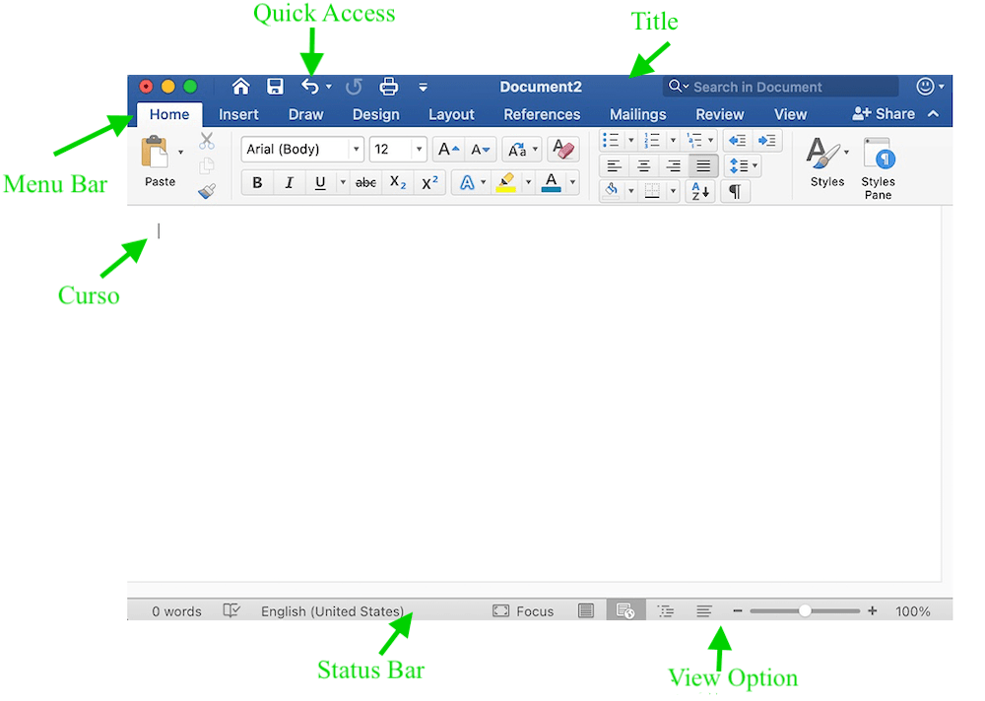

1. **Text Formatting**

MS Word provides several options for text formatting, which are essential for improving document readability and presentation:

* 1. **Font Style and Size**: How to change the font type (e.g., Times New Roman, Arial) and size to suit the document’s needs.
  2. **Bold, Italic, and Underline**: Using these basic text styles to emphasize certain parts of the document.
  3. **Text Color and Highlighting**: How to apply color to the text and highlight portions of the content to make it stand out.
  4. **Paragraph Formatting**: Adjusting line spacing, alignment (left, right, center, justified), and indentations to organize text properly.
  5. **Bullets and Numbering**: Using these tools to create lists, either bulleted or numbered, to organize information clearly.

1. **Inserting Objects**

MS Word allows the insertion of various objects to enhance documents:

* 1. **Images and Clip Art**: How to insert images from your computer or use online resources to add visuals to your document.
  2. **Tables**: Creating tables for organizing data or presenting information in a structured format. We studied how to insert, modify, and format tables.
  3. **Shapes and SmartArt**: Inserting shapes (e.g., circles, squares, arrows) and using **SmartArt** graphics to illustrate concepts visually.

1. **Spell Check and Grammar**

MS Word comes with built-in tools for spelling and grammar checking:

* 1. **Spell Check**: Automatically underlines spelling mistakes in red. We learned how to correct misspelled words by right-clicking and selecting the correct word or adding new words to the dictionary.
  2. **Grammar Check**: Highlights grammatical errors in blue, such as subject-verb agreement issues or improper sentence structure.
  3. **Thesaurus**: We explored how to use the Thesaurus tool to find synonyms for selected words, helping to improve the variety and quality of writing.

1. **Page Layout and Design**

Understanding the layout of a document is essential for its presentation:

* 1. **Margins**: Adjusting page margins (e.g., normal, narrow, wide) to control the space around the content.
  2. **Orientation**: Switching between **portrait** and **landscape** orientation based on the document’s requirements.
  3. **Headers and Footers**: Adding headers and footers to the document, including page numbers, document titles, and author names.
  4. **Page Breaks**: Inserting page breaks to control where one page ends and another begins.

1. **Review and Collaboration**

MS Word includes several features for reviewing and collaborating on documents:

* 1. **Track Changes**: Activating the **Track Changes** feature allows users to make edits that are clearly marked, making it easier to see changes in a document.
  2. **Comments**: Adding comments to the document for feedback or suggestions, which is helpful for collaboration.
  3. **Compare and Combine**: Comparing two versions of a document to see the differences or combining edits from multiple authors into a single document.

### **Key Concepts Learned:**

* **Basic Word Processing**: Understanding how to use MS Word to create, edit, and format documents.
* **Document Formatting**: Mastering text and paragraph formatting, as well as layout adjustments to improve the document’s appearance.
* **Inserting Visuals**: Learning how to enhance documents with images, tables, shapes, and SmartArt for better presentation.
* **Spell Check and Grammar Tools**: How to use MS Word’s built-in tools to proofread and ensure grammatical accuracy.
* **Page Layout and Design**: Understanding document structure, including margins, orientation, and the use of headers and footers.
* **Collaboration Tools**: How to track changes, insert comments, and collaborate with others using MS Word.

## **Conclusion:**

In **Lab 4**, we gained essential knowledge about **Microsoft Office** and **MS Word**, specifically focusing on the basic features that make it a powerful tool for word processing. We explored the **MS Office suite** and learned how MS Word is designed to help users create, edit, and format professional documents efficiently.

By the end of the lab, we had mastered fundamental text formatting, document layout, and inserting various objects like images, tables, and shapes. We also explored tools for spelling and grammar checking, ensuring documents are both accurate and polished. Moreover, the ability to manage page design, including margins, orientation, and the use of headers and footers, enhanced our skills in producing well-structured documents.

The hands-on experience with MS Word’s collaboration tools, such as **Track Changes** and **Comments**, demonstrated the software’s capabilities in group settings, making it easier to work on shared documents and track revisions. Overall, this lab equipped us with the necessary skills to effectively use MS Word in various academic, business, and personal contexts.

This foundational knowledge of MS Word is invaluable, enabling us to create professional documents with ease and precision while leveraging the powerful features of the program to enhance our productivity.

# Lab 5:

# MS Word Advanced Features Including Mail Merge TOC

# Section Breaks And References

# Headers/Footers Efficiently

In **Lab 5**, we explored some of the more advanced features of **Microsoft Word** that are essential for creating professional and complex documents. These features are particularly useful for tasks such as creating personalized letters, organizing large documents, and managing document structure for more polished and efficient writing.

The focus of this lab was on:

* **Mail Merge** for creating personalized documents.
* Creating a **Table of Contents** to automatically generate a well-organized list of sections in a document.
* Using **Section Breaks** to manage different sections with different formatting within the same document.
* Managing **Headers/Footers** to include consistent elements like page numbers and document titles.
* Using **References** to add citations, manage bibliographies, and organize content with footnotes or endnotes.

### **What Was Studied:**

#### **1. Mail Merge**

Mail Merge is a powerful feature in MS Word that allows users to create personalized documents for multiple recipients, such as form letters, labels, and envelopes. By linking a document in Word to an external data source (such as an Excel spreadsheet or Access database), you can automatically insert personalized details like names, addresses, and other unique information into each document.

**Steps Involved in Mail Merge:**

* **Creating the Document Template**: Start by creating a main document that will serve as the template for your mail merge. This can be a form letter or any other document where personalized fields need to be inserted.
* **Connecting to a Data Source**: Link the document to an external data source (e.g., an Excel spreadsheet with a list of names and addresses) that contains the information to be merged.
* **Inserting Merge Fields**: Place **merge fields** in the document where personalized information should appear (e.g., “First Name”, “Last Name”, “Address”).
* **Previewing the Merge**: You can preview how the merged documents will look before finalizing the merge process.
* **Completing the Merge**: Once satisfied with the preview, you can finish the merger and either print the documents or save them as individual files.

**Benefits of Mail Merge:**

* Saves time when sending bulk communications.
* Ensures personalization without manual edits.
* Can be used for letters, envelopes, labels, or emails.

#### **2. Table of Contents (TOC)**

A **Table of Contents** (TOC) is an essential feature for longer documents like reports, books, or research papers. It automatically generates a list of headings and subheadings along with their page numbers, making it easier for readers to navigate the document.

**Steps to Create a Table of Contents:**

* **Using Styles**: Apply the built-in **Heading styles** (Heading 1, Heading 2, etc.) to the section titles and subsections throughout your document. These styles are key to generating an organized TOC.
* **Inserting the TOC**: Go to the **References** tab, click on **Table of Contents**, and choose one of the built-in styles to insert the TOC at the beginning of the document.
* **Updating the TOC**: As you make changes to the document (e.g., adding or deleting sections), the TOC can be updated automatically by right clicking the TOC and selecting **Update Field**.
* **Customizing the TOC**: Customize the look and level of detail included in the TOC, such as choosing which heading levels to include or altering formatting options.

**Benefits of TOC:**

* Organizes large documents.
* Helps readers quickly locate sections of interest.
* Automatically updates, saving time and effort.

#### **3. Section Breaks and References**

Section breaks are used to divide a document into distinct sections that can have different formatting, such as page layout, headers/footers, or columns.

**Steps to Insert Section Breaks:**

* **Types of Section Breaks**: There are several types of section breaks:
  + **Next Page**: Starts the new section on the next page.
  + **Continuous**: Starts the new section on the same page.
  + **Even Page/Odd Page**: Starts the new section on the next even or odd page.
* **Inserting Section Breaks**: To insert a section break, go to the **Layout** tab, click **Breaks**, and select the appropriate section break type.
* **Formatting Sections Differently**: Once you have different sections, you can apply unique formatting to each section, such as different page numbers, different headers/footers, or changing the page orientation (portrait or landscape).

**Benefits of Section Breaks:**

* Enables different formatting for different parts of the document.
* Helps to manage complex documents with varied sections.
* Useful for long reports, books, and multi-section documents.

#### **4. Headers and Footers**

Headers and footers are areas at the top and bottom of each page in a document where information like page numbers, document titles, or dates can be placed. Using headers and footers efficiently ensures consistency throughout the document.

**Steps to Insert Headers and Footers:**

* **Inserting a Header/Footer**: Double-click at the top or bottom of the page to open the header/footer area. You can then type or insert elements like **page numbers**, **dates**, **author names**, and **document titles**.
* **Different Headers/Footers for Sections**: If the document is divided into sections (using section breaks), you can set different headers/footers for each section.
* **Page Numbers**: Insert page numbers by going to the **Insert** tab and selecting **Page Number**. You can choose the placement and formatting of page numbers.
* **Linking/Unlinking Headers/Footers**: By default, headers and footers are linked between sections. You can unlink them to apply unique headers/footers in different sections of the document.

**Benefits of Headers/Footers:**

* Consistency in document presentation.
* Easy access to important details like page numbers and document titles.
* Efficient for multi-page documents.

#### **5. References (Citations, Footnotes, Endnotes)**

MS Word allows you to manage **citations**, **footnotes**, and **endnotes**, making it an essential tool for academic writing and professional documents that require proper referencing.

**Steps to Add Citations:**

* **Managing Sources**: Use the **References** tab to add sources and citations. You can select a citation style (e.g., APA, MLA, Chicago) and input details for each source.
* **Inserting Citations**: Once the source is added, insert citations directly into the document where needed.
* **Generating a Bibliography**: After inserting citations, you can generate a **bibliography** at the end of the document that automatically includes all cited sources.

**Steps to Add Footnotes/Endnotes:**

* **Footnotes**: Footnotes appear at the bottom of the page and provide additional information or references without interrupting the main text. Insert them by going to the **References** tab and selecting **Insert Footnote**.
* **Endnotes**: Endnotes are similar but appear at the end of the document. You can insert them using the same method.

**Benefits of References:**

* Simplifies the process of citing sources.
* Automatically updates citations and bibliography.
* Keeps documents professional and properly formatted.

### **Key Concepts Learned:**

* **Mail Merge**: Used to create personalized documents for multiple recipients by merging data from external sources.
* **Table of Contents**: Automatically organizes large documents and provides a structured overview of headings and subheadings.
* **Section Breaks**: Divides a document into sections with different formatting options, such as page layout and headers/footers.
* **Headers/Footers**: Ensures consistency across pages, with the ability to add page numbers, titles, or dates.
* **References**: Manages citations, footnotes, and bibliographies to ensure proper referencing and professional documentation.

## Conclusion:

In **Lab 5**, we mastered several advanced features in **Microsoft Word** that are invaluable for creating and managing complex documents. **Mail Merge**, **Tables of Contents**, **Section Breaks**, **Headers/Footers**, and **References** all allow for a higher level of organization and customization, ensuring that documents are both professional and efficient.

# Lab 6: Using Mendeley, Grammarly & PDF Element Automation with Macros Create and run macros for repetitive tasks

# PDF to word conversion

# Referencing Tools & Citations

# Referencing tools for citations

# Footnotes And Endnotes

In this lab, we explored a combination of tools that significantly enhance productivity and the quality of academic and professional writing. We focused on three core software tools—**Mendeley**, **Grammarly**, and **PDF Element**—and explored how to automate repetitive tasks in **Microsoft Word** using **Macros**. Additionally, we learned how to use **referencing tools** for managing citations, footnotes, and endnotes.

**Mendeley** is a reference management tool that helps researchers organize their references and create bibliographies. **Grammarly** is a writing assistant that checks for grammar, spelling, and style issues, ensuring that your writing is polished and error-free. **PDF Element** is a versatile tool for working with PDFs, enabling users to convert PDFs to Word documents and edit them efficiently. Meanwhile, **Macros** in Word helps automate repetitive tasks, saving time and increasing productivity.

This lab aimed to introduce the practical use of these tools for improving the writing process and managing citations, references, and PDFs effectively.

### **What Was Studied:**

#### **1. Using Mendeley**

Mendeley is a reference manager that helps users organize research papers, manage references, and generate citations. It is particularly useful for students, researchers, and anyone who needs to maintain a large collection of academic sources.

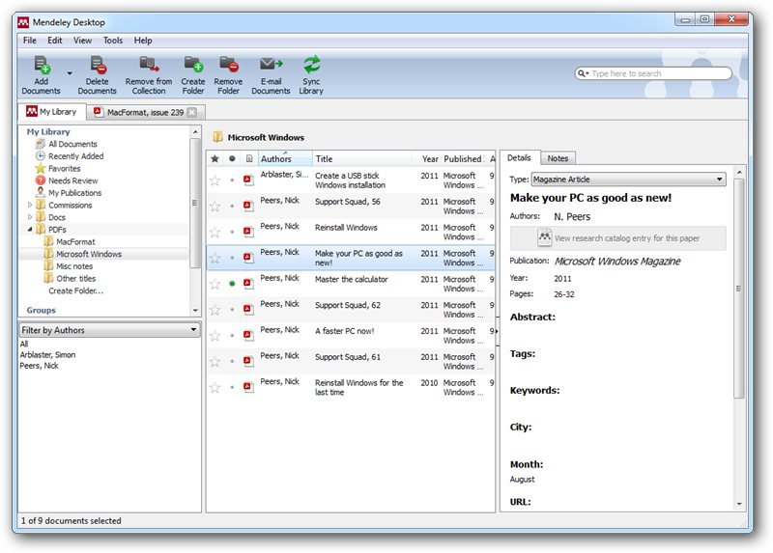

**Key Features of Mendeley:**

* **Reference Management**: Import papers and books into Mendeley from various sources (e.g., journal databases, online searches, PDFs). The software can automatically extract citation details like authors, titles, publication year, etc.
* **Citation Generation**: With Mendeley, you can generate citations in various styles (e.g., APA, MLA, Chicago) and insert them directly into your document. This helps ensure accuracy and consistency in citations and references.
* **Organizing References**: Mendeley allows you to organize your references into folders or libraries, making it easier to find and cite sources.
* **Collaboration**: Share references and notes with collaborators and colleagues through Mendeley’s cloud-based platform, making it easier to work on group research projects.
* **Integration with MS Word**: Mendeley integrates with MS Word, allowing users to insert citations and generate bibliographies directly from their library.

**Benefits of Using Mendeley:**

* Organizes and manages a large collection of research sources.
* Saves time by automatically generating citations and bibliographies.
* Helps ensure proper referencing and citation accuracy.

#### **2. Using Grammarly**

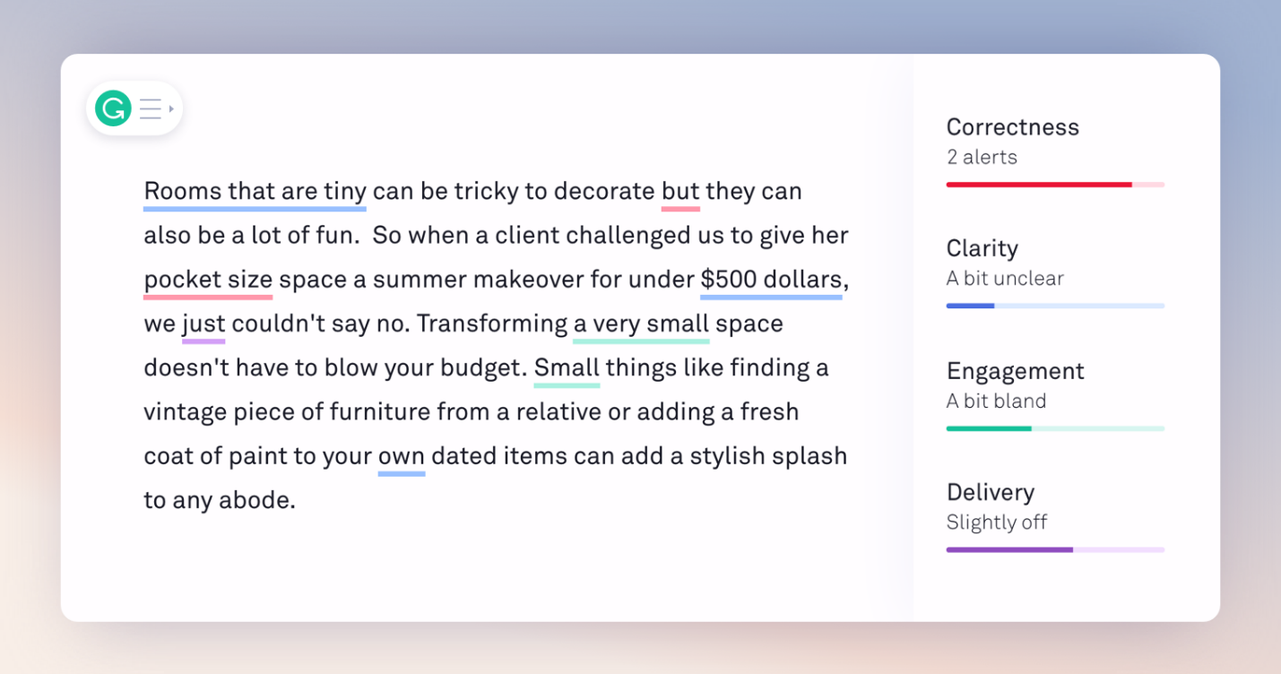

**Grammarly** is a popular writing assistant that checks spelling, grammar, punctuation, style, and tone. It helps users improve the clarity and quality of their writing.

**Key Features of Grammarly:**

* **Grammar and Spelling Check**: Identifies spelling and grammar errors, suggesting corrections or alternative phrasing.
* **Tone Detection**: Analyzes the tone of the writing and offers suggestions to match the intended tone (e.g., formal, casual, friendly).
* **Style and Readability**: Recommends changes to improve writing style and readability, making it clearer and more concise.
* **Plagiarism Detection**: Grammarly offers a plagiarism-checking tool, which compares your document against billions of online sources to ensure the originality of your work.
* **Integration with MS Word**: Grammarly can be integrated with MS Word, allowing you to check your document in real-time as you write or edit.

**Benefits of Using Grammarly:**

* It helps improve grammar and writing style, ensuring clarity and professionalism.
* Detects potential issues with tone, readability, and sentence structure.
* Ensures plagiarism-free content by scanning for copied material.

#### **3. Using PDF Element**

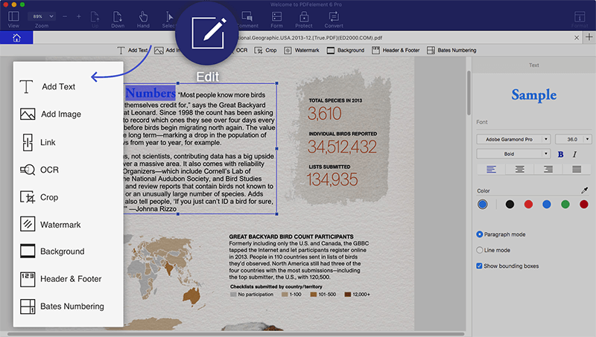

**PDF Element** is a PDF editor and converter that enables users to work with PDF files more easily. It allows you to edit, annotate, convert, and manage PDFs without losing the formatting of the original document.

**Key Features of PDF Element:**

* **PDF to Word Conversion**: Easily convert PDFs into Word documents without losing formatting, making it easier to edit and reuse content.
* **Editing PDFs**: Add, delete, or modify text and images in PDF files. You can also annotate documents with highlights, notes, and comments.
* **Form Creation and Filling**: Create fillable forms in PDFs and enable users to input data directly into the document.
* **OCR (Optical Character Recognition)**: PDF Element has an OCR feature that can recognize and extract text from scanned PDFs or images, making the text editable.
* **Merging and Splitting PDFs**: Merge multiple PDF files into one document or split a large PDF into smaller, manageable sections.

**Benefits of Using PDF Element:**

* Provides powerful tools for editing and converting PDFs to Word.
* Maintains the original formatting when converting files.
* Allows users to manage PDF documents efficiently, whether for work or academic purposes.

#### **4. Automation with Macros**

**Macros** in Microsoft Word are tools used to automate repetitive tasks, such as formatting, inserting text, or performing specific commands. By recording a series of actions, you can create a macro that repeats those actions at the click of a button, saving time and improving workflow efficiency.

**Key Features of Macros:**

* **Recording a Macro**: You can record a sequence of actions in Word (e.g., formatting text, inserting predefined text, or applying a style) and save them as a macro.
* **Running a Macro**: Once recorded, you can run the macro whenever needed, automating the process of performing those actions.
* **Assigning Macros to Buttons**: Macros can be assigned to a keyboard shortcut or a button in the Ribbon, making them easily accessible.
* **Editing Macros**: You can edit the macro code if needed to adjust or add more actions to the recorded sequence.

**Benefits of Using Macros:**

* Automates repetitive tasks, such as applying formatting or inserting text.
* Saves time and reduces manual errors.
* Increases productivity, especially when working with long documents.

#### **5. Referencing Tools for Citations, Footnotes, and Endnotes**

MS Word includes built-in referencing tools that allow users to manage citations, insert footnotes and endnotes, and create bibliographies.

**Key Features of Referencing Tools:**

* **Citations**: Insert citations in various styles (APA, MLA, Chicago, etc.) by selecting the citation style from the **References** tab and inserting them directly into the document.
* **Footnotes and Endnotes**: Easily add footnotes (which appear at the bottom of the page) or endnotes (which appear at the end of the document) to provide additional information or references. These are automatically numbered.
* **Bibliography**: After inserting citations, you can automatically generate a bibliography that lists all the references used in the document.
* **Managing Sources**: Word allows you to manage all your sources in the **Source Manager**, where you can add, edit, and delete references.

**Benefits of Using Referencing Tools:**

* Streamlines the process of adding and managing citations and references.
* Ensures proper formatting for citations, footnotes, and endnotes.
* Automatically generates a bibliography, saving time and effort.

### **Key Concepts Learned:**

* **Mendeley**: A reference manager for organizing research, generating citations, and managing bibliographies.
* **Grammarly**: A writing assistant that checks grammar, spelling, and style, ensuring polished writing.
* **PDF Element**: A tool for converting, editing, and managing PDF files.
* **Macros**: Automating repetitive tasks in Microsoft Word to improve efficiency.
* **Referencing Tools in MS Word**: Managing citations, footnotes, endnotes, and bibliographies in your documents.

### **Conclusion**

In this lab, we learned how to use various tools and software to improve our writing and document management. **Mendeley** and **Grammarly** streamline the referencing process and improve the quality of writing. **PDF Element** simplifies working with PDFs, especially converting them to editable Word documents. **Macros** in Word help automate repetitive tasks, saving time and improving productivity. Finally, MS Word’s **referencing tools** made it easier to manage citations, footnotes, and endnotes, ensuring that our documents were properly formatted and organized. Mastering these tools and features enhances both the efficiency and professionalism of academic and work-related writing.

# LAB 7 :

# Mail managements, Collaborative Tools & Document Protection, ( Track changes and comments for collaborative work

# Master reviewing and comparing documents, protect documents with passwords and control editing permissions)

In this lab, we delved into essential tools and features that enhance productivity in professional environments, focusing on effective **mail management**, **collaborative tools**, and **document protection**. These tools are particularly beneficial in teamwork settings and for ensuring secure communication and file sharing.

The lab emphasized:

* **Mail Management**: Strategies for organizing and managing emails efficiently.
* **Collaborative Tools**: Features such as **Track Changes**, **Comments**, and document comparison to streamline collaborative efforts.
* **Document Protection**: Techniques to secure documents using passwords and restrict editing permissions, ensuring the confidentiality and integrity of shared files.

Mastering these skills is crucial for maintaining professionalism and efficiency in both academic and workplace scenarios.

### **1. Mail Management**

Efficient email management is crucial in professional and academic settings, where high volumes of emails can lead to disorganization and lost productivity. The lab focused on learning strategies and tools to streamline communication, keep inboxes organized, and improve responsiveness.

#### **Techniques for Mail Management:**

1. **Creating Folders and Subfolders:**
   1. Organize emails into categories such as "Work," "Personal," "Projects," or "Assignments."
   2. Use subfolders for finer categorization, e.g., "Projects > Client A" or "Assignments > Lab Reports."
   3. This ensures that emails are easily retrievable when needed.
2. **Using Filters and Rules:**
   1. Automate sorting of incoming emails based on sender, keywords, or subject line. For example:
      1. Emails from a professor can go into a "University" folder.
      2. Emails with "Invoice" in the subject can be sent to a "Finance" folder.
   2. Tools like **Microsoft Outlook** or **Gmail** have built-in filters to set up such rules.
3. **Flagging and Prioritizing Emails:**
   1. Flag important emails or mark them as "High Priority."
   2. Use color-coded tags or labels to distinguish between urgent and routine emails.
4. **Archiving and Deleting Emails:**
   1. Archive emails that are no longer needed in the active inbox but may be required later for reference.
   2. Permanently delete spam or irrelevant emails to keep the inbox clean.
5. **Using Search Features:**
   1. Use search operators to locate specific emails quickly, such as:
      1. "[From:sender@example.com](mailto:From:sender@example.com)" to find emails from a particular sender.
      2. "Has:attachment" to find emails with files attached.

#### **Tools and Features Explored:**

* **Microsoft Outlook:** Demonstrated its advanced email sorting, search features, and integration with calendar and task management.
* **Gmail Filters and Labels:** Focused on automating sorting and categorizing emails with tags.
* **Third-Party Mail Management Tools:** Introduced apps like **Spark** or **Clean Email** for enhanced organization.

#### **Benefits of Effective Mail Management:**

* Reduces stress by decluttering the inbox.
* Saves time searching for important emails.
* Ensures that critical communications are not overlooked

### **2. Collaborative Tools**

#### **Track Changes and Comments in Microsoft Word:**

Collaborative work often involves multiple contributors editing and reviewing the same document. Features like **Track Changes** and **Comments** make this process seamless.

1. **Track Changes:**
   1. Captures all edits to the document, showing insertions, deletions, and formatting changes.
   2. Each contributor’s changes are marked with unique colors for clarity.
   3. Edits can be displayed inline, in balloons, or in a combined view.
2. **Using Comments:**
   1. Add detailed comments on specific sections or points within the document.
   2. Reply to comments to create discussions directly in the document.
   3. Mark resolved comments for clear progress tracking.
3. **Benefits for Collaboration:**
   1. Enhances clarity by keeping track of who made what changes.
   2. Facilitates detailed feedback and discussions without altering the main content.
   3. Maintains a record of revisions, which can be accepted or rejected as needed.

#### **Comparing and Reviewing Documents:**

When multiple versions of a document are created, comparing them ensures no changes are lost or conflicts arise.

1. **Comparing Documents in Microsoft Word:**
   1. Select two versions of the document via the **Compare** feature in the **Review** tab.
   2. Microsoft Word highlights differences, including text changes and formatting alterations.
2. **Reviewing Changes:**
   1. Decide which edits to keep or discard.
   2. Merge changes from multiple versions into one final document.
3. **Benefits of Document Comparison:**
   1. Saves time by automating the review process.
   2. Reduces errors by ensuring all edits are accounted for.

### **3.Document Protection**

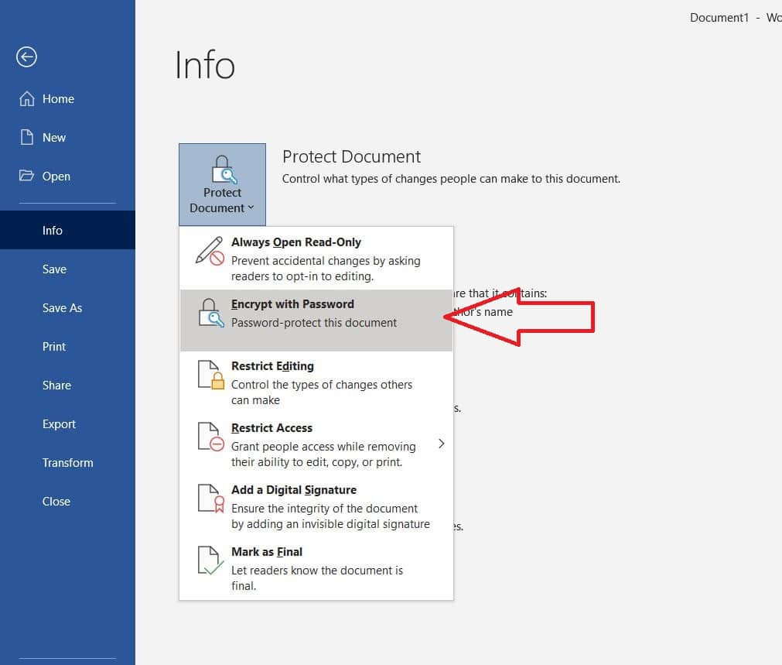

#### **Password Protection:**

Documents often contain sensitive information that requires restricted access. Password protection ensures only authorized users can open the file.

1. **Setting Passwords:**
   1. In Microsoft Word, navigate to **File > Info > Protect Document > Encrypt with Password.**
   2. Set and confirm a password. The file cannot be opened without this password.
2. **Best Practices for Passwords:**
   1. Use strong passwords with a mix of uppercase, lowercase, numbers, and symbols.
   2. Share passwords securely, avoiding insecure channels like unencrypted emails.

#### **Restricting Editing Permissions:**

Sometimes, a document needs to be shared for viewing but not for editing. Restricting permissions ensures the integrity of the document.

1. **Enabling Editing Restrictions:**
   1. Go to **File > Info > Protect Document > Restrict Editing.**
   2. Specify permissions, such as allowing only tracked changes or form filling.
   3. Optionally, enforce restrictions with a password.
2. **Custom Permissions:**
   1. Set permissions for specific users, allowing different levels of access.
   2. Use tools like Microsoft OneDrive or Google Drive for advanced sharing options.

#### **Marking a Document as Final:**

Marking a document as final signals that no further changes are required. It also disables editing by default.

1. **Steps to Mark as Final:**
   1. Navigate to **File > Info > Protect Document > Mark as Final.**
   2. This adds a notification to the document, discouraging further edits.

#### **Benefits of Document Protection:**

* Prevents unauthorized access to sensitive information.
* Maintains document integrity by restricting unwanted edits.
* Provides clear control over who can view or modify the file.

### **Conclusion**

This lab highlighted the importance of efficient email management, seamless collaboration, and robust document protection in professional and academic settings.

* **Mail management** reduces inbox clutter, enhances organization, and ensures no critical communication is missed.
* **Collaborative tools** like Track Changes and document comparison facilitate teamwork by providing clarity and structure to the review process.
* **Document protection** ensures the security and integrity of files, safeguarding sensitive information and maintaining professionalism.

# LAB 8

# Introduction to Excel and Basic Skills

# Intermediate Formulas and Functions (Working with Multiple Worksheets, Using Functions (MIN, MAX, COUNT, IF etc.)

# Introduction to Cell Referencing: Relative, Absolute, and Mixed) Introduction to Sorting and Filtering Data

This lab provided a foundational understanding of Microsoft Excel and its capabilities for data management, analysis, and visualization. Participants explored basic Excel functionalities, intermediate formulas, and essential data manipulation techniques. These skills are pivotal in professional and academic tasks involving spreadsheets, enabling efficiency and accuracy.

The session covered three main aspects:

* **Basic Skills**: Navigating Excel’s interface and using essential tools.
* **Intermediate Formulas and Functions**: Utilizing mathematical and logical functions for data analysis.
* **Sorting and Filtering**: Organizing and analyzing data efficiently.

### Basic Skills in Microsoft Excel

Basic skills in Excel serve as the foundation for efficient spreadsheet creation, data entry, and management. These skills allow users to interact effectively with Excel’s interface and tools, enabling them to perform routine tasks seamlessly.

#### **Navigating the Excel Interface**

* **Workbook and Worksheet Basics:**  
  A workbook in Excel is the main file containing one or more worksheets. Worksheets are individual sheets where data is stored, organized, and manipulated. Users learned to switch between worksheets, rename them, and add or delete sheets as needed.
* **Ribbon and Toolbar Navigation:**  
  The ribbon contains tabs like **Home**, **Insert**, **Page Layout**, and others, each with grouped commands for specific tasks. For example:
  + The **Home** tab includes basic editing tools such as cut, copy, paste, and formatting options.
  + The **Insert** tab allows the addition of charts, tables, and illustrations.
* **Quick Access Toolbar (QAT):**  
  Provides one-click access to commonly used features, such as saving, undoing, or redoing actions.

#### **Data Entry and Editing**

* **Entering Data:**  
  Participants practiced entering text, numbers, and dates into cells. They learned about:
  + Using the Tab key to move across columns.
  + Using the Enter key to move down rows.
* **Editing Data:**  
  Data in cells can be modified directly by double-clicking the cell or using the formula bar.
* **Autofill Feature:**
  + Dragging the fill handle (a small square at the bottom-right corner of the selected cell) to quickly copy or extend data patterns, such as sequences of numbers or dates.

#### **Formatting Cells**

Formatting enhances the readability and presentation of data. Key formatting techniques included:

* **Font and Alignment Options:**
  + Changing font type, size, and color.
  + Aligning text horizontally and vertically within cells.
* **Number Formatting:**
  + Applying formats like currency, percentage, date, or custom number formats to suit the data type.
* **Cell Borders and Shading:**
  + Adding borders to define table structures.
  + Using fill colors to highlight important data or differentiate sections.

#### **Working with Rows, Columns, and Cells**

* **Inserting and Deleting:**
  + Adding or removing rows, columns, and individual cells as needed.
  + Using shortcut commands for quick adjustments.
* **Resizing Rows and Columns:**
  + Manually dragging the row or column edges.
  + Using the **AutoFit** option to automatically adjust sizes based on content.

#### **Basic Data Operations**

* **Copying and Pasting:**
  + Copying data within or across worksheets using commands like Ctrl+C and Ctrl+V.
  + Practicing **Paste Special** to paste values, formats, or formulas only.
* **Cutting and Moving Data:**
  + Moving data to new locations within the sheet using the cut (Ctrl+X) and paste commands.
* **Undo and Redo Actions:**
  + Quickly reversing or reapplying recent changes using Ctrl+Z and Ctrl+Y.

### **Basic Skills in Microsoft Excel**

Basic skills in Excel serve as the foundation for efficient spreadsheet creation, data entry, and management. These skills allow users to interact effectively with Excel’s interface and tools, enabling them to perform routine tasks seamlessly.

#### **Navigating the Excel Interface**

* **Workbook and Worksheet Basics:**  
  A workbook in Excel is the main file containing one or more worksheets. Worksheets are individual sheets where data is stored, organized, and manipulated. Users learned to switch between worksheets, rename them, and add or delete sheets as needed.
* **Ribbon and Toolbar Navigation:**  
  The ribbon contains tabs like **Home**, **Insert**, **Page Layout**, and others, each with grouped commands for specific tasks. For example:
  + The **Home** tab includes basic editing tools such as cut, copy, paste, and formatting options.
  + The **Insert** tab allows the addition of charts, tables, and illustrations.
* **Quick Access Toolbar (QAT):**  
  Provides one-click access to commonly used features, such as saving, undoing, or redoing actions.

#### **Data Entry and Editing**

* **Entering Data:**  
  Participants practiced entering text, numbers, and dates into cells. They learned about:
  + Using the Tab key to move across columns.
  + Using the Enter key to move down rows.
* **Editing Data:**  
  Data in cells can be modified directly by double-clicking the cell or using the formula bar.
* **Autofill Feature:**
  + Dragging the fill handle (a small square at the bottom-right corner of the selected cell) to quickly copy or extend data patterns, such as sequences of numbers or dates.

#### **Formatting Cells**

Formatting enhances the readability and presentation of data. Key formatting techniques included:

* **Font and Alignment Options:**
  + Changing font type, size, and color.
  + Aligning text horizontally and vertically within cells.
* **Number Formatting:**
  + Applying formats like currency, percentage, date, or custom number formats to suit the data type.
* **Cell Borders and Shading:**
  + Adding borders to define table structures.
  + Using fill colors to highlight important data or differentiate sections.

#### **Working with Rows, Columns, and Cells**

* **Inserting and Deleting:**
  + Adding or removing rows, columns, and individual cells as needed.
  + Using shortcut commands for quick adjustments.
* **Resizing Rows and Columns:**
  + Manually dragging the row or column edges.
  + Using the **AutoFit** option to automatically adjust sizes based on content.

#### **Basic Data Operations**

* **Copying and Pasting:**
  + Copying data within or across worksheets using commands like Ctrl+C and CTRL+V.
  + Practicing **Paste Special** to paste values, formats, or formulas only.
* **Cutting and Moving Data:**
  + Moving data to new locations within the sheet using the cut (Ctrl+X) and paste commands.
* **Undo and Redo Actions:**
  + Quickly reversing or reapplying recent changes using Ctrl+Z and Ctrl+Y.

#### **Workbook Management**

* **Saving Workbooks:**
  + Participants practiced saving workbooks in different formats, such as .xlsx and .csv.
  + Emphasis was placed on regularly saving work to avoid data loss.
* **Sheet Management:**
  + Renaming sheets for clarity.
  + Coloring sheet tabs to differentiate between sections or categories.
  + Rearranging sheets by dragging tabs to new positions.

#### **Importance of Basic Skills**

* These skills build the confidence needed to navigate Excel effectively.
* They are essential for setting up and managing data, creating a solid foundation for more advanced functionalities like formulas, charts, and data analysis.
* Mastery of these basics ensures that users can efficiently utilize Excel for both academic and professional purposes.

# Intermediate Formulas and Functions in Microsoft Excel

Intermediate formulas and functions in Excel are essential tools for managing, analyzing, and interpreting complex datasets. They help automate calculations, streamline data analysis, and uncover valuable insights, making Excel a powerful tool in professional and academic settings.

#### **Key Formulas and Functions**

1. **MIN and MAX Functions:**

These functions are used to identify the smallest and largest values in a dataset. They are especially useful for analyzing performance metrics, such as minimum and maximum scores, sales, or other measurable data points.

1. **COUNT Function:**

The COUNT function is used to count the number of numerical entries within a specific range. This is beneficial for determining the quantity of transactions, completed tasks, or any other numeric data points in a dataset.

1. **IF Function:**

The IF function allows for conditional logic, enabling the user to set up scenarios where a specific result is returned if a condition is met. For instance, it can categorize data into groups like Pass/Fail or Above/Below Target, making it ideal for decision-making and categorization.

#### **Working with Multiple Worksheets**

1. **Cross-Sheet Referencing:**
2. Data from multiple worksheets can be linked, allowing calculations and summaries to include data from various sources. This is particularly useful for compiling reports, creating dashboards, or managing projects that span multiple categories or departments.
3. **3D References:**

These enable users to calculate values across multiple sheets in a workbook, simplifying the process of summarizing data from various sections.

#### **Introduction to Cell Referencing**

1. **Relative References:**

Relative references adjust automatically when a formula is copied to another cell, making them ideal for repetitive calculations across multiple rows or columns.

1. **Absolute References:**

Absolute references remain fixed on a specific cell, ensuring consistency in calculations when formulas are copied.

1. **Mixed References:**

Mixed references combine aspects of both relative and absolute referencing, providing flexibility in situations where only certain parts of a reference need to remain constant.

#### **Sorting and Filtering Data**

1. **Sorting:**
2. Sorting allows users to organize data in ascending or descending order based on one or multiple columns. This is useful for arranging data like alphabetical lists, numerical values, or chronological entries for better readability.
3. **Filtering:**

Filtering displays only the data that meets specific criteria, enabling focused analysis by isolating relevant information. Advanced filters allow for more complex queries, such as filtering by multiple conditions.

# Applications in Real-World Scenarios

* **Data Analysis:** Quickly calculate and analyze trends in large datasets, such as finding the top-performing products or identifying areas needing improvement.
* **Financial Planning:** Automate budgeting and forecasting tasks using conditional logic and cross-sheet calculations.
* **Project Management:** Track progress, allocate resources, and categorize tasks efficiently.
* **Reporting:** Summarize data across multiple worksheets to create comprehensive reports for decision-making.

### **Benefits of Intermediate Formulas and Functions**

* **Efficiency:** Automates repetitive calculations, saving time and effort.
* **Accuracy:** Reduces errors associated with manual data manipulation.
* **Scalability:** Easily handles large datasets or multi-sheet workbooks.
* **Insight Generation:** Simplifies complex data analysis to derive meaningful conclusions.

## **Sorting and Filtering Data in Microsoft Excel**

Sorting and filtering are essential data management techniques in Excel that allow users to organize, analyze, and focus on specific subsets of data. These tools enhance productivity and accuracy in handling large datasets, making them invaluable for both academic and professional tasks.

#### **Sorting Data**

Sorting rearranges data in a specific order, making it easier to identify trends, patterns, or outliers. Sorting can be applied to columns with text, numbers, dates, or even custom lists.

**Types of Sorting:**

1. **Single-Column Sorting:**
   1. Data in a single column is organized in ascending or descending order.
   2. For example, arranging names alphabetically or sorting sales figures from lowest to highest.
2. **Multi-Level Sorting:**
   1. Sorting is applied to multiple columns for more detailed organization.
   2. For instance, sorting a dataset first by department and then by employee names within each department.

**Customization Options:**

* **Ascending Order:** From smallest to largest for numbers or A to Z for text.
* **Descending Order:** From largest to smallest for numbers or Z to A for text.
* **Custom Lists:** Sorting based on user-defined criteria, such as arranging data by priority levels (High, Medium, Low).

**Practical Applications:**

* Organizing datasets for better readability and structured reporting.
* Prioritizing tasks, deadlines, or sales targets.

#### **Filtering Data**

Filtering allows users to temporarily hide rows that do not meet specific criteria, focusing only on the relevant data. Filters are applied directly to columns and can be customized based on the data type.

**Types of Filters:**

1. **Text Filters:**
   1. Used to isolate rows containing specific text or patterns.
   2. Options include filtering by exact matches, containing specific keywords, or beginning/ending with characters.
2. **Number Filters:**
   1. Filters numerical data based on conditions like greater than, less than, between, or equal to specific values.
   2. For example, showing only sales figures greater than $10,000.
3. **Date Filters:**
   1. Focuses on rows based on date criteria, such as filtering by a specific year, month, or day.
   2. Useful for isolating data from a particular time period, such as quarterly reports or yearly summaries.
4. **Custom Filters:**
   1. Combines multiple criteria for complex filtering.
   2. For instance, displaying rows where sales are greater than $10,000 **and** the region is "North."
5. **Advanced Filters:**
   1. Provides more control over the filtering process by allowing criteria to be defined in separate cells.
   2. Supports unique filters, such as showing records with unique or duplicate entries only.

### **Sorting and Filtering Data in Microsoft Excel**

Sorting and filtering are essential data management techniques in Excel that allow users to organize, analyze, and focus on specific subsets of data. These tools enhance productivity and accuracy in handling large datasets, making them invaluable for both academic and professional tasks.

#### **Sorting Data**

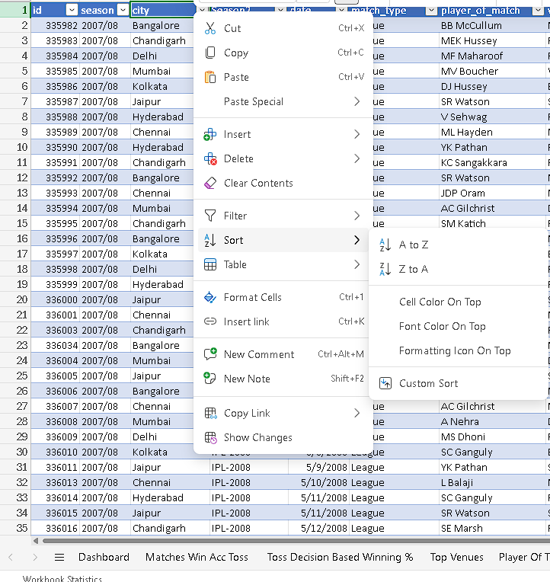

Sorting rearranges data in a specific order, making it easier to identify trends, patterns, or outliers. Sorting can be applied to columns with text, numbers, dates, or even custom lists.

**Types of Sorting:**

1. **Single-Column Sorting:**
   1. Data in a single column is organized in ascending or descending order.
   2. For example, arranging names alphabetically or sorting sales figures from lowest to highest.
2. **Multi-Level Sorting:**
   1. Sorting is applied to multiple columns for more detailed organization.
   2. For instance, sorting a dataset first by department and then by employee names within each department.

**Customization Options:**

* **Ascending Order:** From smallest to largest for numbers or A to Z for text.
* **Descending Order:** From largest to smallest for numbers or Z to A for text.
* **Custom Lists:** Sorting based on user-defined criteria, such as arranging data by priority levels (High, Medium, Low).

**Practical Applications:**

* Organizing datasets for better readability and structured reporting.
* Prioritizing tasks, deadlines, or sales targets.

#### **Filtering Data**



Filtering allows users to temporarily hide rows that do not meet specific criteria, focusing only on the relevant data. Filters are applied directly to columns and can be customized based on the data type.

**Types of Filters:**

1. **Text Filters:**
   1. Used to isolate rows containing specific text or patterns.
   2. Options include filtering by exact matches, containing specific keywords, or beginning/ending with characters.
2. **Number Filters:**
   1. Filters numerical data based on conditions like greater than, less than, between, or equal to specific values.
   2. For example, showing only sales figures greater than $10,000.
3. **Date Filters:**
   1. Focuses on rows based on date criteria, such as filtering by a specific year, month, or day.
   2. Useful for isolating data from a particular time period, such as quarterly reports or yearly summaries.
4. **Custom Filters:**
   1. Combines multiple criteria for complex filtering.
   2. For instance, displaying rows where sales are greater than $10,000 **and** the region is "North."
5. **Advanced Filters:**
   1. Provides more control over the filtering process by allowing criteria to be defined in separate cells.
   2. Supports unique filters, such as showing records with unique or duplicate entries only.

#### **Sorting and Filtering Together**

Sorting and filtering are often used in combination to create a structured, focused view of the dataset. For example:

* First, sort sales data by region.
* Then, apply a filter to display only the rows where sales exceed a specific target.

#### **Key Features and Tools:**

1. **AutoFilter:**
   1. A built-in tool that adds dropdown menus to the header row of a dataset, allowing users to apply basic sorting and filtering quickly.
2. **Search in Filters:**
   1. Enables users to search for specific text or values within the filter options, speeding up the process of finding relevant data.
3. **Clear Filters:**
   1. Quickly removes all applied filters to restore the original dataset view.
4. **Sort and Filter in Tables:**
   1. Excel tables come with built-in sorting and filtering tools, making data manipulation seamless when working with structured datasets.

#### **Benefits of Sorting and Filtering Data**

1. **Enhanced Clarity:**
   1. Organizes data for easy interpretation and presentation.
2. **Focused Analysis:**
   1. Isolates specific subsets of data for targeted analysis.
3. **Time Efficiency:**
   1. Reduces the time spent manually searching through large datasets.
4. **Accuracy:**
   1. Ensures consistent organization and error-free analysis.

#### **Real-World Applications:**

1. **Academic:**
   1. Organizing survey results or experiment data for clear analysis.
   2. Filtering student scores to identify top performers or areas of improvement.
2. **Professional:**
   1. Analyzing sales reports to find trends or focus on specific regions or products.
   2. Sorting and filtering customer databases for marketing campaigns or client segmentation.
3. **Project Management:**
   1. Sorting tasks by deadlines or priority levels.
   2. Filtering resource allocation reports to focus on specific teams or departments.

# Lab 9 :

# Data Visualization and Advanced Features

This lab focused on enhancing data presentation and analysis through advanced Excel tools. By leveraging charts, graphs, and formatting techniques, participants learned how to transform raw data into insightful visual representations. Additional features like creating barcodes and QR codes, working with tables, and employing statistical functions further expanded the scope of data analysis.

#### **Creating Charts and Graphs**

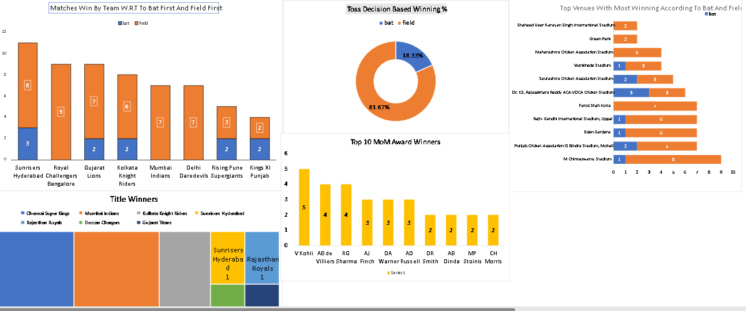

**1. Types of Charts and Their Uses:**

* **Bar Charts:**  
  Ideal for comparing categorical data, such as sales by product or performance across departments.
* **Line Charts:**  
  Best for showing trends over time, like monthly revenue or temperature changes.
* **Pie Charts:**  
  Effective for displaying proportions and percentages, such as market share or budget allocations.

**2. Chart Customization:**

* Participants explored adding labels, legends, and titles for clarity.
* Formatting options, such as changing colors, adjusting axis scales, and using 3D effects, were demonstrated.

**3. Applications in Real Life:**

* Business: Sales reports and financial trends.
* Academic: Representing survey results or research findings.

# Conditional Formatting in Microsoft Excel

Conditional Formatting is a powerful Excel feature that allows users to apply visual cues to data based on specific conditions. This tool enhances data interpretation by highlighting patterns, trends, or outliers, making it easier to identify important information immediately.

#### **Key Features of Conditional Formatting**

1. **Dynamic Data Visualization:**
2. Conditional formatting applies colors, icons, and data bars dynamically, meaning the formatting updates automatically as the data changes.
3. **Ease of Use:**

Users can quickly set up rules using Excel's built-in templates or customize conditions to meet specific requirements.

#### **Types of Conditional Formatting**

1. **Highlight Cell Rules:**
   1. **Purpose:** Highlights cells based on predefined criteria.
   2. **Examples:**
      1. Greater than/less than: Highlight sales above $10,000.
      2. Equal to: Mark specific dates or values.
      3. Text that contains: Highlight rows containing the word "Pending."
2. **Top/Bottom Rules:**
   1. **Purpose:** Identifies top or bottom values within a dataset.
   2. **Examples:**
      1. Highlight the top 10% of performers in a class.
      2. Mark the bottom 5 lowest sales in a region.
3. **Data Bars:**
   1. **Purpose:** Visualize values as horizontal bars within cells.
   2. **Examples:**
      1. Represent budget utilization, with longer bars indicating higher values.
4. **Color Scales:**
   1. **Purpose:** Uses gradient colors to represent data ranges.
   2. **Examples:**
      1. Green-to-red scale for profit margins, where green indicates high profits and red indicates losses.
5. **Icon Sets:**
   1. **Purpose:** Uses icons to represent different categories or performance levels.
   2. **Examples:**
      1. Arrows to indicate increasing or decreasing trends.
      2. Traffic light icons to show project status (e.g., On Track, At Risk, Off Track).
6. **Custom Conditional Formatting:**
   1. **Purpose:** Allows users to define specific rules using formulas.
   2. **Examples:**
      1. Highlight overdue tasks by setting a formula to check if a deadline is earlier than today’s date.
      2. Format cells where sales are higher than the regional average.

#### **How to Apply Conditional Formatting**

1. **Select Data Range:**
   1. Highlight the cells or range of data you want to format.
2. **Access Conditional Formatting Menu:**
   1. Go to the **Home** tab and click **Conditional Formatting** in the Styles group.
3. **Choose a Rule Type:**
   1. Select from built-in rules or create a new rule for custom formatting.
4. **Define Criteria:**
   1. Specify conditions or input formulas based on your needs.
5. **Choose Formatting Style:**
   1. Customize colors, icons, or data bars based on the selected rule.
6. **Apply the Rule:**
   1. Click **OK** to apply the formatting.

### **Advanced Features in Conditional Formatting**

1. **Using Formulas for Rules:**
   1. Conditional formatting can be tied to logical conditions via formulas.
   2. Example: Highlight cells where sales exceed 80% of the total using a formula like =B2>0.8*SUM(B$2:B$10).
2. **Priority of Rules:**
   1. When multiple rules overlap, Excel applies them based on priority, which can be adjusted in the **Manage Rules** section.
3. **Clear Rules:**
   1. Users can remove rules for specific cells or the entire worksheet using the **Clear Rules** option.

# Creating Barcodes in Excel

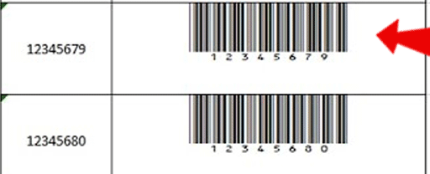

Barcodes are graphical representations of data, usually in the form of vertical lines and spaces that can be read by scanners. They are commonly used in retail, inventory systems, and shipping.

##### 1. Using Barcode Fonts

One way to generate barcodes is by installing and using barcode fonts. These fonts convert text or numbers into barcode images directly within Excel.

* **Steps to Create Barcodes Using Barcode Fonts:**
  + **Download and Install a Barcode Font:**
    - Some popular barcode fonts include **Code 39**, **EAN-13**, or **UPC-A**. These can be downloaded from websites that offer free or paid barcode fonts. After downloading, install the font on your system.
  + **Enter the Data:**
    - In Excel, enter the data you want to encode into a barcode, such as a product code or serial number.
  + **Apply the Barcode Font:**
    - Highlight the cells with the data, then change the font to the barcode font you installed.
  + **Adjust Font Size:**
    - Resize the font as needed to make the barcode easily readable by scanners.

**Limitations of Barcode Fonts:**

* Not all barcode types are supported by standard fonts.
* Barcodes created this way may not have the same level of scan ability as images created with specialized software.

## 2. Using Barcode Add-ins

For more advanced barcode generation, you can use an Excel barcode add-in, such as **TBarCode Office** or **Barcode Add-In for Excel**. These tools create high-quality, scannable barcode images and offer more customization options than barcode fonts.

* **Steps to Create Barcodes Using Add-ins:**
  + **Install the Add-in:**
    - Download and install a barcode add-in like **TBarCode Office**.
  + **Enter Data:**
    - Input the text or number to be encoded into a barcode.
  + **Use the Add-in’s Tools:**
    - Open the add-in toolbar within Excel and choose the type of barcode you wish to create (e.g., Code 39, EAN-13).
  + **Generate the Barcode:**
    - Click on the button to generate the barcode. The barcode will be inserted directly into the cell as an image.

#### **Creating QR Codes in Excel**

QR (Quick Response) codes are two-dimensional barcodes that store more information, such as URLs, contact details, or text. Unlike traditional barcodes, QR codes can store large amounts of data and are frequently used for marketing, website links, and digital business cards.

## 1. Using a QR Code Generator Add-in

There are various Excel add-ins that allow for the easy creation of QR codes. Some popular options include **QR4Office** and **QRCode Add-in for Excel**.

* **Steps to Create QR Codes Using Add-ins:**
  + **Install the QR Code Add-in:**
    - Search for and install a QR code generator add-in, such as **QR4Office** from the Microsoft Office Store.
  + **Enter the Data:**
    - In Excel, type the URL, contact information, or text that you want to encode in the QR code.
  + **Insert the QR Code:**
    - Select the cell containing the data, and then use the add-in to generate the QR code. The QR code will appear as a scannable image.

## 2. Using an Online QR Code Generator

If you don’t want to use an add-in, you can create a QR code externally and then insert it into Excel as an image. Websites like **QR Code Generator** or **GoQR.me** allow you to generate QR codes for free.

* **Steps to Create QR Codes Using an Online Generator:**
  + **Generate the QR Code Online:**
    - Go to a QR code generator website, enter the data you want to encode (such as a website URL), and generate the QR code.
  + **Download the QR Code Image:**
    - After the QR code is generated, download the image file to your computer.
  + **Insert the QR Code into Excel:**
    - In Excel, go to the **Insert** tab, select **Pictures**, and upload the QR code image. Resize and position it within your worksheet.

#### **Working with Tables and Data Validation**

**1. Working with Tables:**

* Tables simplify data management by offering built-in sorting, filtering, and formatting options.
* Participants learned to structure datasets efficiently, enabling dynamic referencing and easier analysis.

**2. Data Validation:**

* Ensures data accuracy by restricting input to specific criteria (e.g., numerical ranges, dropdown lists).
* Participants explored setting validation rules and displaying error alerts for incorrect entries.

**Applications:**

* Ensuring accurate data entry in surveys or financial records.
* Maintaining data consistency in collaborative environments.

#### **Frequency Function**

The FREQUENCY function was introduced to calculate the distribution of data points across specified intervals.

**1. Features:**

* Groups data into bins or ranges, providing a clear picture of how often values occur within each range.
* Useful for summarizing large datasets.

**2. Applications:**

* Academic Research: Analyzing test scores or survey results.
* Business: Understanding sales distribution across price brackets.

#### **Statistical Analysis Functions**

**1. Functions Covered:**

* **AVERAGE:** Calculates the meaning of a dataset.
* **MEDIAN:** Identifies the middle value in a dataset.
* **MODE:** Determines the most frequently occurring value.
* **STDEV (Standard Deviation):** Measures the spread of data around the mean.

**2. Applications:**

* Academic: Analyzing research data for variability and trends.
* Business: Assessing consistency in production quality or customer satisfaction.

# Lab 10 :

# Advanced Tools and Final Project

This lab focused on advanced Excel tools and techniques, such as Pivot Tables, VLOOKUP and HLOOKUP functions, and Macros. The final project required students to analyze and visualize a dataset by applying the skills and tools they learned throughout the course. This combination of theoretical knowledge and practical application helped to solidify key concepts in data manipulation, analysis, and automation.

#### **Introduction to Pivot Tables**

Pivot Tables are one of the most powerful features in Excel for summarizing and analyzing large datasets. They allow users to dynamically reorganize, filter, and aggregate data, providing deep insights without altering the original data structure.

* **Key Features of Pivot Tables:**
  + **Data Summarization:** Pivot Tables allow users to quickly summarize large volumes of data by categories. For example, you can summarize sales data by region, product, or time period.
  + **Grouping:** Data can be grouped by date, numeric ranges, or other criteria, providing flexibility in analysis.
  + **Aggregation:** Common aggregation methods include sum, average, count, and percentage, making it easier to perform calculations within the table.
* **Steps to Create a Pivot Table:**
  + **Select Data Range:**
    - Highlight the data you wish to analyze.
  + **Insert Pivot Table:**
    - Go to the **Insert** tab, click on **PivotTable**, and select the data range.
  + **Choose Pivot Table Fields:**
    - Drag and drop fields into the Row, Column, Value, and Filter areas to organize the data.
  + **Format the Pivot Table:**
    - Adjust the design and layout, apply filters, and refine the table for optimal data presentation.
* **Applications:**
  + **Business Analysis:** Summarize sales, profit, or customer data by region, product, or period.
  + **Academic Research:** Group survey responses or test scores to identify trends.

#### **Using VLOOKUP and HLOOKUP**

**VLOOKUP** and **HLOOKUP** are lookup functions in Excel that allow users to search for specific values in a table and retrieve related information.

* **VLOOKUP (Vertical Lookup):**
  + **Purpose:** Searches for a value in the first column of a table and returns a value in the same row from another column.
  + **Formula:** =VLOOKUP(lookup_value, table_array, col_index_num, [range_lookup])
  + **Example:** To find a product price based on its product ID, you can use VLOOKUP to look up the product ID in a list and return the corresponding price.
* **HLOOKUP (Horizontal Lookup):**
  + **Purpose:** Similar to VLOOKUP, but HLOOKUP searches horizontally across the top row and returns a value from the corresponding column.
  + **Formula:** =HLOOKUP(lookup_value, table_array, row_index_num, [range_lookup])
  + **Example:** To search for monthly sales data in a row and retrieve sales figures for a specific month.
* **Applications:**
  + **Business:** Look up product details, customer information, or pricing from a database.
  + **Academics:** Retrieve student grades or survey results based on student IDs or other identifiers.

#### **Introduction to Macros**

**Macros** are a set of recorded actions that automate repetitive tasks in Excel. They can save time, increase accuracy, and ensure consistency by allowing users to perform complex actions with a single click.

* **Recording a Macro:**
  + **Enable the Developer Tab:**
    - Go to **File > Options > Customize Ribbon** and check **Developer** to make the tab visible.
  + **Record Macro:**
    - Click **Record Macro** on the Developer tab, give it a name, and specify the shortcut key (optional).
  + **Perform Actions:**
    - While recording, perform the actions you want to automate, such as formatting cells or running calculations.
  + **Stop Recording:**
    - Click **Stop Recording** when done. The macro will be saved and can be run by clicking the shortcut key or using the Macros menu.
* **Running a Macro:**
  + Macros can be run from the **Developer tab** or by using the assigned shortcut key.
* **Applications:**
  + **Data Formatting:** Automate formatting tasks like applying styles or changing font colors.
  + **Repetitive Calculations:** Create macros to perform calculations on different data sets.
  + **Task Automation:** Automate any series of Excel tasks to save time, especially for tasks done frequently.

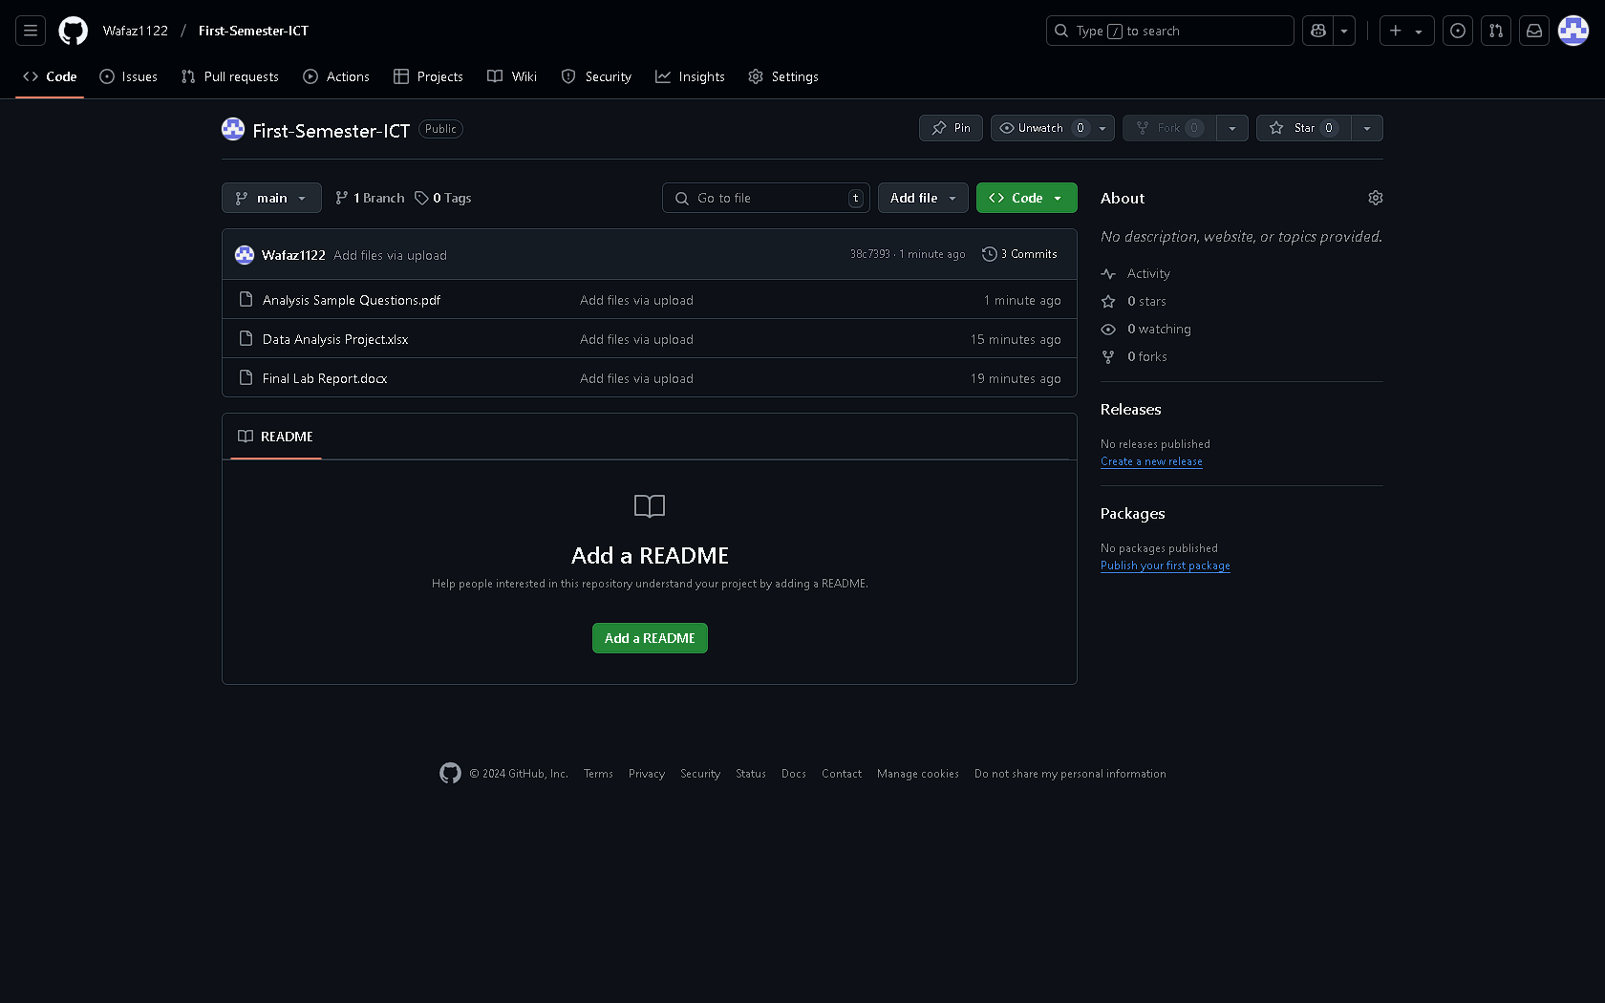

Link : [GITHUB](https://github.com/Wafaz1122/First-Semester-ICT)

# Final Project

This Interactive Dashboard in Excel tutorial demonstrates how to create dynamic visualizations using charts, slicers, and pivot tables. It guides users in building an intuitive dashboard for real-time data analysis and insights.

Link Of the Project : [IPL DASHBOARD.xlsx](https://classicera-my.sharepoint.com/:x:/g/personal/admin_classicera_onmicrosoft_com/ESeYA5sjcb5Agpv-kk8tg2cBxXcQcNsT54OJICRxbJ63OQ?e=Nc0LpG)

Link : [GITHUB](https://github.com/Wafaz1122/First-Semester-ICT)