Zaman Ahmer

[Company name]  [Company address]

[Document title]

Q. No1: Write a program that outputs inflation rates for two successive years and whether the inflation is increasing or decreasing. Ask the user to input the current price of an item and its price one year and two years ago. To calculate the inflation rate for a year, subtract the price of the item for that year from the price of the item one year ago and then divide the result by the price a year ago. Your program must contain at least the following functions: a function to get the input, a function to calculate the results, and a function to output the results. Use appropriate parameters to pass the information in and out of the function. Do not use any global variables.

Code:

#include <iostream>

using namespace std;

void input(double& x,double& y,double& z);

void price(double x,double y,double z,double& now,double& before);

void output(double now, double before);

int main()

{

double x=0,y=0,z=0,now=0,before=0;

input(x,y,z);

price(x,y,z,now,before);

output(now,before);y

}

void input(double& x,double& y,double& z){

cout<<"Enter price of item"<<endl;

cin>>x;

cout<<"Enter price of item year ago"<<endl;

cin>>y;

cout<<"Enter price of item two years ago"<<endl;

cin>>z;

}

void price(double x,double y,double z,double& now,double& before)

{

now=(x-y)/y;

before=(y-z)/z;

}

void output(double now, double before){

if(now>before)

cout<<now<<" and "<<before<<" is So Inflation rate is increasing";

else if(before>now)

cout<<now<<" and "<<before<<" is So Inflation rate is decreasing";

else

cout<<now<<" and "<<before<<" is So Inflation rate is stable";

}

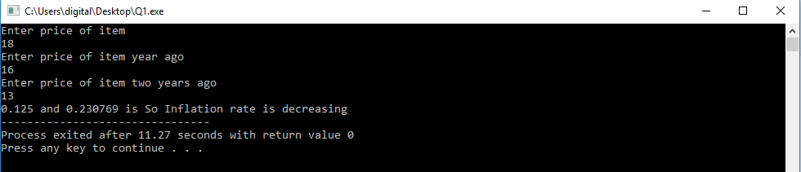

Q. No2:

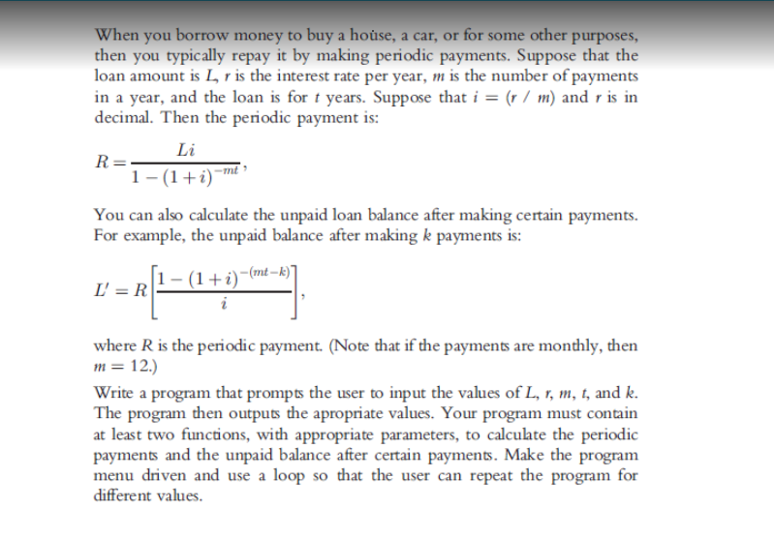

Code:

#include <iostream>

#include <math.h>

using namespace std;

void periodic(double &,double &, double &,double &, double &, double &,double &);

void unpaid(double &,double &, double &, double &,double &, double &,double &,double &);

int main()

{

double L=0,i=0,m=0,r=0,t=0,k=0,R=0,Lpr=0;

cout<<"Enter Loan amount= ";

cin>>L;

cout<<"Enter number of payments= ";

cin>>m;

cout<<"Enter interest per year= ";

cin>>r;

cout<<"Enter Loan for years= ";

cin>>t;

cout<<"Enter unpaid paments = ";

cin>>k;

i=(r/m);

periodic(L,i,m,r,k,t,R);

unpaid(L,i,m,r,k,t,R,Lpr);

return 0;

}

void periodic(double &L,double &i, double &m, double &r,double &k, double &t,double &R)

{

R=((L\*i)/(1-pow((1+i),(-1\*m\*t))));

cout<<"Periodic Payment "<<R<<endl;

}

void unpaid(double &L,double &i, double &m, double &r,double &k, double &t,double &R,double &Lpr)

{

Lpr=((R\*(1-pow((1+i),(-1\*m\*t\*-k))/i)));

cout<<"Unpaid balance="<<Lpr<<endl;

}

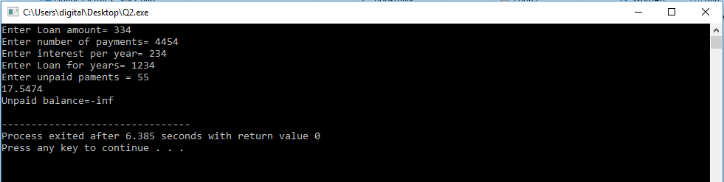

Q. No1: During the tax season, every Friday, J&amp;J accounting firm provides assistance to people who

prepare their own tax returns. Their charges are as follows.

• If a person has low income (&lt;= 25,000) and the consulting time is less than or

equal to 30 minutes, there are no charges; otherwise, the service charges are

40% of the regular hourly rate for the time over 30 minutes.

• For others, if the consulting time is less than or equal to 20 minutes, there are no

service charges; otherwise, service charges are 70% of the regular hourly rate

for the time over 20 minutes.

(For example, suppose that a person has low income and spent 1 hour and 15 minutes, and the

hourly rate is $70.00. Then the billing amount is 70.00 \* 0.40 \* (45 / 60) = $21.00.)

Write a program that prompts the user to enter the hourly rate, the total consulting time, and

whether the person has low income. The program should output the billing amount.

Your program must contain a function that takes as input the hourly rate, the total consulting

time, and a value indicating whether the person has low income. The function should return the

billing amount. Your program may prompt the user to enter the consulting time in minutes..

Code:

#include<iostream>

using namespace std;

int tax(float consultingtime,float income,float hourlyrate)

{

float bill;

if (income <= 2500)

{

if (hourlyrate <= 30)

{

return 0;

}

else

{

bill = hourlyrate\*0.40\*((consultingtime - 30) / 60.0);

}

}

else

{

if (consultingtime <= 20)

{

return 0;

}

else

{

bill = hourlyrate\*0.70\*((consultingtime - 20) / 60.0);

}

}

return bill;

}

int main()

{

float income;

float consultingtime;

float hourlyrate;

cout << "Enter your total income : " << endl;

cin >> income;

cout << "Enter your total consultingtime in minutes : " << endl;

cin >> consultingtime;

cout << "Enter your hourly pay rate : " << endl;

cin >> hourlyrate;

cout << "Your billing amount are : " << tax(consultingtime,income,hourlyrate) << " Rupees" << endl;

system("pause");

}

