|  |
| --- |
| CS18-A |
| Lab 5 |
| Muhammad Ahmer Zaman |
|  |
| **18F0336** |
| **10/10/2018** |

|  |
| --- |
| [Type the abstract of the document here. The abstract is typically a short summary of the contents of the document. Type the abstract of the document here. The abstract is typically a short summary of the contents of the document.] |

Question1:

Write a program that prompts the user to input a number. The program

should then output the number and a message saying whether the number is

positive, negative, or zero.

Code1:

#include <iostream>

using namespace std;

int main()

{

int number;

cout<<"enter number=";

cin>>number;

if (number>0)

{

cout<<number<<" is greater than zero"<<endl;

}

else if (number<0)

{

cout<<number<<" is less than zero"<<endl;

}

else

cout<<number<<" is equal to zero"<<endl;

return 0;

}

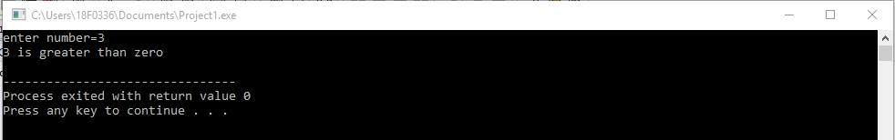

Question 2)

Write a program which will have one integer input as an n. Your algorithm must show whether

this n is a perfect square or not. For Example: n=64, Yes it is a perfect square (Square of 8).

Note: Use sqrt() to find the square root of number and implement using if else statements.

Code:

#include <iostream>

#include <math.h>

using namespace std;

int main()

{

int n;

float squareroot,mod;

cout<<"enter a number =";

cin>>n;

squareroot=sqrt(n);

mod=n%squareroot;

if (mod==0)

{

cout<<n<<" is not a perfect square."<<endl;

}

else

cout<<n<<" is not a perfect square."<<endl;

return 0;

}

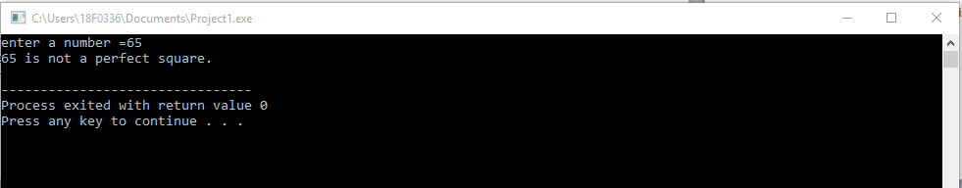

Question 3)

Write a program which takes a 5-digit number from the user and checks if it is palindrome or not

and then prints appropriate message.

Note: Use if else statements.

CODE)

#include <iostream>

#include <math.h>

using namespace std;

int main()

{

int number,div1,div2,div3,div4,mod1,mod2,mod3,mod4,pallindrom;

cout<<"Enter number=";

cin>>number;

if (number%10000!=0)

{

div1=number/10000;

mod1=number%10000;

div2=mod1/1000;

mod2=mod1%1000;

div3=mod2/100;

mod3=mod2%100;

div4=mod3/10;

mod4=mod3%10;

pallindrom=(mod4*10000)+(div4*1000)+(div3*100)+(div2*10)+div1;

if (number==pallindrom)

{

cout<<number<<" is pallindrom"<<endl;

}

else

{

cout<<number<<" is not pallindrom"<<endl;

}

}

else

cout<<"invalid input"<<endl;

return 0;

}

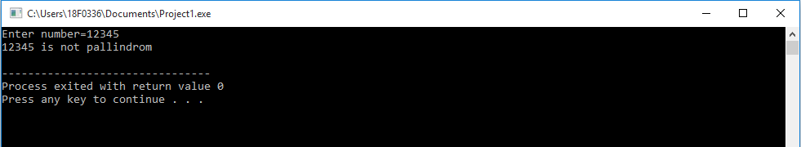

Question4)

Implement a Simple Calculator having +, -, *, %, /, Square Root(Hint: sqrt() for Square Root)

Note: Use switch case statements.

Code)

#include <iostream>

#include <math.h>

using namespace std;

int main()

{

int numb1,numb2;

char operat;

cout<<"Enter number1=";

cin>>numb1;

cout<<"Enter number2=";

cin>>numb2;

cout<<" Enter operator= ";

cin>>operat;

switch (operat)

{

case ('+'):

cout<<"Sum= "<<numb1+numb2<<endl;

break;

case ('-') :

cout<<"Subtraction= "<<numb1-numb2<<endl;

break;

case ('*') :

cout<<"Product= "<<numb1*numb2<<endl;

break;

case ('/') :

cout<<"division= "<<numb1/numb2<<endl;

break;

case ('#') :

cout<<"Square root= "<<sqrt(numb1)<<endl;

cout<<"Squareroot2= "<<sqrt(numb2)<<endl;

break;

default:

cout<<"Invalid operator"<<endl;

break;

}

return 0;

}

