Assignment#5

**Roll No# 18F-0336**

**CSI8-A**

**Question 1: Write a program to print the Fibonacci series up to a number given by the user to the function.**

**Code:**

#include <iostream>

using namespace std;

void fabb(int);

int main()

{

int number = 0;

cout << "Enter Number= ";

cin >> number;

fabb(number);

system("pause>0");

return 0;

}

void fabb(int numb)

{

int number = 0, numb1 = 1, sum = 1;

cout << "Fabonacci series:";

for (int i = 0;i < numb;i++)

{

sum = numb1 + number;

cout << sum << ", ";

number = numb1;

numb1 = sum;

}

}

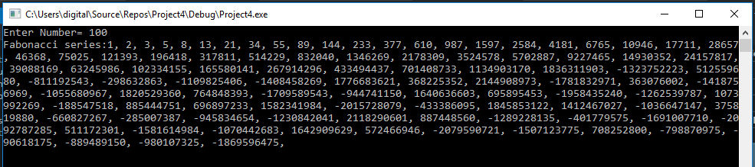

**Question 2: Write a program that prints the table of a number (entered by user) in main (). Create a function to multiply two numbers. Hint: use loop**

**Code:**

#include <iostream>

using namespace std;

void table(int , int );

int main()

{

int number = 0,size=0;

cout << "Enter Number= ";

cin >> number;

cout << "Enter Number upto you want to print table= ";

cin >> size;

table(number,size);

system("pause>0");

return 0;

}

void table(int numb,int size)

{

for (int i = 1;i <= size;i++)

{

cout << numb << " * " << i << " = " << numb * i << endl;

}

}

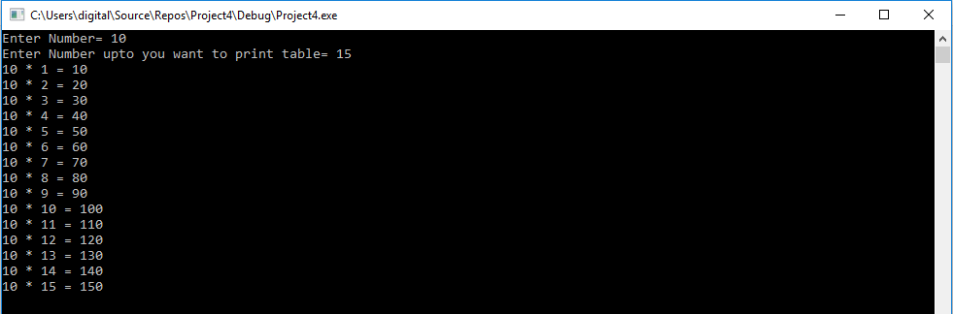

**Question 3: Write a function to check whether the number passed to it is a Palindrome or not. Hint: Palindrome is a number that reads the same backwards as forwards e.g. 12321**

**Code:**

#include <iostream>

using namespace std;

void Palin(int );

int main()

{

int number = 0;

cout << "Enter Number= ";

cin >> number;

Palin(number);

system("pause>0");

return 0;

}

void Palin(int number)

{

int rev = 0, numb = 0, digit = 0;

numb = number;

do

{

digit = numb % 10;

rev = (rev * 10) + digit;

numb = numb / 10;

}

while(numb != 0);

cout << "Reverse of number is " << rev << endl;

if (number == rev)

{

cout << number << " is Pallindrom." << endl;

}

else

{

cout << number << " is not Pallindrom." << endl;

}

}

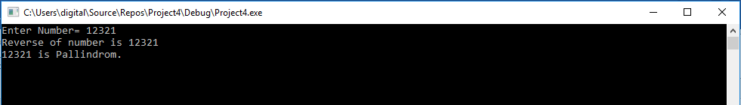

**Question 4:**

#include <iostream>

#include <string>

#include <cstring>

using namespace std;

void Anagram(string , string );

int main()

{

string first, second;

cout << "Enter First word= ";

cin >> first;

cout << "Enter Second word= ";

cin >> second;

Anagram(first, second);

system("pause>0");

return 0;

}

void Anagram(string nam1,string nam2)

{

int count = 0;

if (nam1.length() == nam2.length())

{

for (int i = 0; i < nam1.length();i++)

{

for (int j = 0;j < nam2.length();j++)

{

if (nam1.at(i) == nam2.at(j))

{

count++;

}

}

}

if (nam2.length() == count)

{

cout << "Strings are anagram of each other. " << endl;

}

else

{

cout << "Strings are not anagram." << endl;

}

}

else

{

cout << "Strings are not anagram of each other." << endl;

}

}

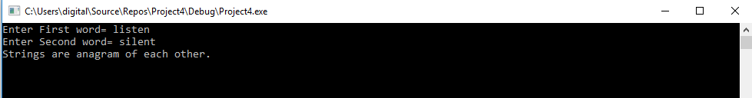

**Question 5: Write a function that swaps two numbers passed to it, without using a third variable. Display swapped values in main.**

**Code:**

#include <iostream>

using namespace std;

void swap(int , int );

int main()

{

int first=0, second=0;

cout << "Enter First word= ";

cin >> first;

cout << "Enter Second word= ";

cin >> second;

swap(first, second);

system("pause>0");

return 0;

}

void swap(int num1, int num2)

{

num1 = num1 + num2;

num2 = num1 - num2;

num1 = num1 - num2;

cout << "First Swapped Number= " << num1 << endl;

cout << "Second Swapped Number= " << num2 << endl;

}

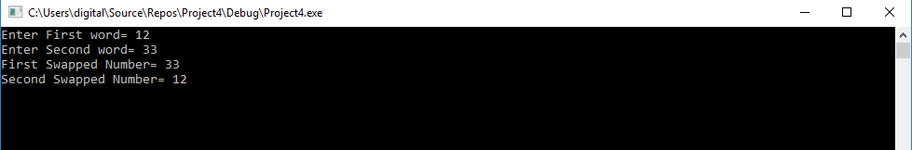

**Question 6: Write functions to convert a decimal number to binary and hexa-decimal. Use function overloading**

**Code:**

#include <iostream>

using namespace std;

void Binary(int);

void hexa(int);

int main()

{

int number = 0;

cout << "Enter Number= ";

cin >> number;

Binary(number);

hexa(number);

system("pause>0");

return 0;

}

void Binary(int num)

{

int binar = 0;

cout << "Binary of number " << num << " is ";

while (num > 0)

{

binar = num % 2;

cout << binar;

num = num / 2;

}

cout << endl;

}

void hexa(int num)

{

int hex;

cout << "Hexadecimal of " << num << " is ";

while (num > 0)

{

hex = num % 16;

{

if (hex > 9)

{

switch (hex)

{

case 10:

cout << "A";

break;

case 11:

cout << "B";

break;

case 12:

cout << "C";

break;

case 13:

cout << "D";

break;

case 14:

cout << "E";

break;

case 15:

cout << "F";

break;

}

}

else

{

cout << hex;

}

num = num / 16;

}

}

cout << endl;

}

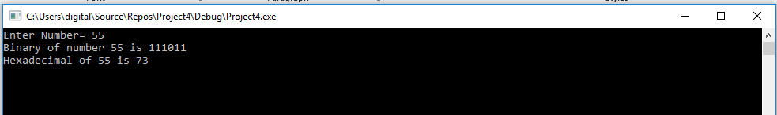

**Question 7: Write a program to calculate the wages of employees by passing hours and wage per hour of an employee. If user doesn’t enter wage per hour price the function should use default value. Repeat the process until user wants to end.**

**Code:**

#include <iostream>

using namespace std;

int wage(int, int);

int main()

{

char menu;

int hours, wph;

do

{

cout << "Input hours:";

cin >> hours;

cout << "Input wages per hr (0 for default rate)= $";

cin >> wph;

if (wph == 0)

wph = 15;

if (wph > 0)

cout << "Wages: $" << wage(hours, wph);

cout << endl;

cout<<"Enter Y to input again, anything else to exit: " << endl;

cin >> menu;

} while (menu == 'y' || menu == 'Y');

cout << "Program Quitted. ThankYou" << endl;

system("pause>0");

return 0;

}

int wage(int hrs, int wge=15)

{

return hrs * wge;

}

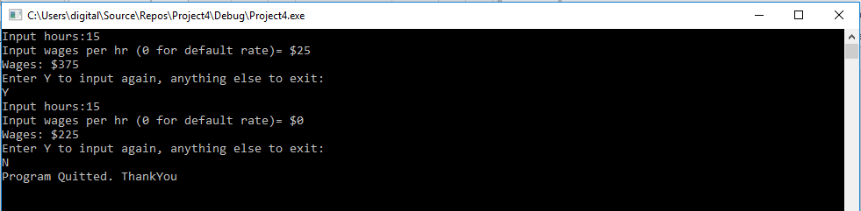

**Question 8: Write a function to check whether the number passed to it is a prime number or not.**

**Code:**

#include <iostream>

using namespace std;

void prime(int );

int main()

{

int number = 0, count=0;

cout << "Enter Number= ";

cin >> number;

prime(number);

system("pause>0");

return 0;

}

void prime(int number)

{

int count = 0;

for (int i = 1; i <= number;i++)

{

if (number%i == 0)

{

count++;

}

}

if (count == 2)

{

cout << number << " is a prime number." << endl;

}

else

{

cout << number << " is not a prime number." << endl;

}

}



**Question 9: Perfect number is a positive integer that is equal to the sum of its proper divisors. The smallest perfect number is 6, which is the sum of 1, 2, and 3. Write a function which takes a number and print perfect numbers from 1 to that number. e.g. if user enters 1000 output → 6, 28, 496.**

**Code:**

#include <iostream>

using namespace std;

void perfect(int );

int main()

{

int number = 0;

cout << "Enter Number= ";

cin >> number;

perfect(number);

system("pause>0");

return 0;

}

void perfect(int number)

{

int sum = 0, div = 0;

cout << "Perfect numbers are :" << endl;

for (int j = 2;j <= number;j++)

{

sum = 0;

for (int i = 1;i < j;i++)

{

if (j%i == 0)

{

sum = sum + i;

}

}

if (sum == j)

{

cout << j << " ";

}

}

}

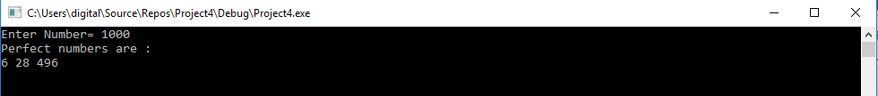

**Question 10: Write a void function that reverses the string passed to it. Print reversed string in main. Note: don’t print it in reverse order. Make it reversed.**

**Code:**

#include <iostream>

#include <string>

#include <cstring>

using namespace std;

void reverse(string );

int main()

{

string name;

cout << "Enter String= ";

cin >> name;

reverse(name);

system("pause>0");

return 0;

}

void reverse(string str)

{

int j = 0;

string str2;

for (int j = str.length() - 1;j >= 0;j--)

{

if ((j == str.length() - 1))

{

str2 = str.at(j) - 32;

cout << str2;

}

else if (j == 0 && (str.at(0)>=65 && str.at(0)<=90))

{

str2 = str.at(0) + 32;

cout << str2;

}

else

{

str2 = str.at(j);

cout << str2;

}

}

}



**Question 11: Write a program to take as many inputs from the user as he wants, and find the average of those numbers and display in main (). Use static variable. Your program should contain three functions. Count() → updating the value of count Add() → Adding the numbers together average→ Calculating average**

**Code:**

#include <iostream>

using namespace std;

int count();

int add(int);

void avge(int);

int main()

{

int number = 0, sum = 0,times=0;

do

{

cout << "Enter Number= ";

cin >> number;

sum=add(number);

} while (number > 0);

avge(sum);

system("pause>0");

return 0;

}

int count()

{

static int count = 0;

count++;

return count;

}

int add(int number)

{

static int sum=0;

sum = sum + number;

count();

return sum;

}

void avge(int number)

{

float avg = 0,times=0;

times = count() - 2;

avg = number / times;

cout << "Average= " << avg;

}

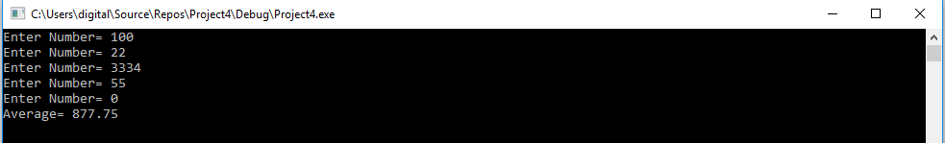

**Question 12: Write a function that make such a pattern like right angle triangle with number increased by 1 up to the number passed to the function. e.g. input= 10 output:**

**1**

**2 3**

**4 5 6**

**7 8 9 10**

**Code:**

#include <iostream>

using namespace std;

void tri(int);

int main()

{

int number = 0,k=1,numb=0,row=0;

cout << "Enter Input=";

cin >> number;

tri(number);

system("pause>0");

return 0;

}

void tri(int numb)

{

int k = 1, row = 0;

row = (numb / 2.5);

for (int i = 1;i <= row;i++)

{

for (int j = 1;j <= i;j++, k++)

{

if (k <= numb)

{

cout << k;

}

else

{

cout << " ";

}

}

cout << endl;

}

}

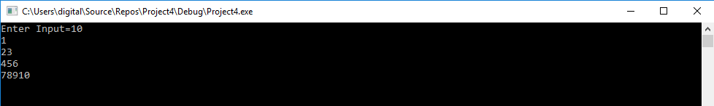

**Question 13: write a program to find the area of a triangle, rectangle, and surface area of a sphere. Use function overloading.**

**Code:**

#include <iostream>

using namespace std;

const float PI = 3.1415;

int area(int, int);

float area(float, float);

float area(float);

int main()

{

int length, breadth;

float base, height, radius;

cout << "Enter length and breadth of rectangle:" << endl;

cin >> length;

cin >> breadth;

cout << "Enter base and height of triangle:" << endl;

cin >> base;

cin >> height;

cout << "Enter radius of a sphere:" << endl;

cin >> radius;

cout << "Area of rectangle is " << area(length, breadth) << endl;

cout << "Area of triangle is " << area(base, height) << endl;

cout << "surface area of sphere is:" << area(radius) << endl;

system("pause>0");

return 0;

}

int area(int l, int b)

{

return(l*b);

}

float area(float bs, float ht)

{

return((bs*ht) / 2);

}

float area(float r)

{

return(4 * PI *r*r);

}

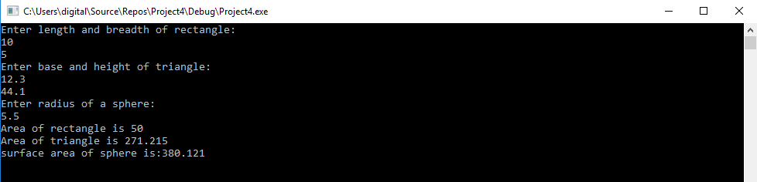

**Question 14: Write a program to define overloaded functions add(). Invoke the overloaded function through another overloaded function.**

**Code:**

**Question 15: Write a program that converts from 24-hour notation to 12-hour nota-tion. For example, it should convert 14:25 to 2:25 PM. The input is givenas two integers. There should be at least three functions, one for input,one to do the conversion, and one for output. Record the AM/PM infor-mation as a value of type char,'A' for AM and 'P' for PM. Thus, thefunction for doing the conversions will have a call-byreference formalparameter of type char to record whether it is AM or PM. (The function will have other parameters as well.) Include a loop that lets the user repeat this computation for new input values again and again until the user says he or she wants to end the program.**

**Code:**

#include <iostream>

using namespace std;

const float PI = 3.1416;

void Input(int & , char & , int & );

void Change(int &, char &, int &);

void Output(int &, char &, int &);

int main()

{

int hour, mins;

char ap;

char again;

do

{

Input(hour, ap, mins);

Change(hour, ap, mins);

Output(hour, ap, mins);

cout << "Enter Y to put again, and anything else to exit." << endl;

cin >> again;

}while (again == 'y' || again == 'Y');

cout << "Program quitted. " << endl;

system("pause>0");

return 0;

}

void Input(int &hours, char &ap , int &mins)

{

char mid=':';

cout << "Enter time in 24 hours format HH:MM = " << endl;

cin >> hours >> mid >> mins;

}

void Change(int &hours, char &ap, int &mins)

{

if (hours > 12)

{

hours = hours - 12;

ap = 'p';

}

else if ( hours == 12)

{

ap = 'p';

}

else

{

ap = 'a';

}

}

void Output(int &hours, char &ap, int &mins)

{

if (ap == 'p')

{

cout << "Times in 12-Hours Format= " << endl;

cout << hours << " : " << mins << "PM" << endl;

}

if (ap == 'a')

{

cout << "Times in 12-Hours Format= " << endl;

cout << hours << " : " << mins << "PM" << endl;

}

}

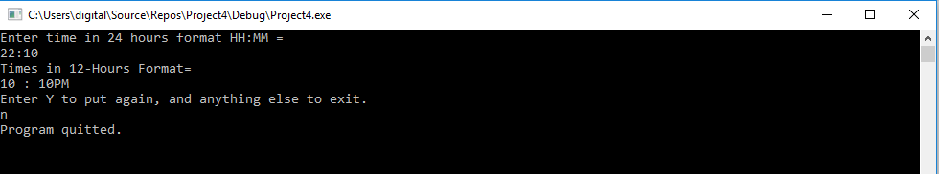

**Question 16: You have invented a vending machine capable of deep frying twinkies. Write a program to simulate the vending machine. It costs $3.50 to buy adeep-fried twinkie, and the machine only takes coins in denominations of a dollar, quarter, dime, or nickel. Write code to simulate a personputting money into the vending machine by repeatedly prompting theuser for the next coin to be inserted. Output the total entered so far wheneach coin is inserted. When $3.50 or more is added, the program shouldoutput “Enjoy your deep-fried twinkie” along with any change that shouldbe returned.**

**Code:**

#include <iostream>

using namespace std;

const float twinki = 3.50;

void money();

int main()

{

money();

system("pause>0");

return 0;

}

void money()

{

double total = 0, change;

char coin;

cout << "Menu of Coins. " << endl;

cout << "D for Dollar " << endl;

cout << "Q for quarter " << endl;

cout << "d for dime " << endl;

cout << "N for Nickel " << endl;

do

{

cout << "A twinkie price is $3.50. Enter Your coin in Q,D,d,N. Enter your coin please: " << endl;

cin >> coin;

if (coin == 'Q' || coin == 'D' || coin == 'q' || coin == 'N')

{

switch (static_cast<int>(coin))

{

case 68:

cout << "You have entered $1 ";

total = total + 1;

cout << "A twinkie price is $3.50. Your total is " << total;

break;

case 78:

cout << "You have entered $2 ";

total = total + 2;

cout << "A twinkie price is $3.50. Your total is " << total;

break;

case 81:

cout << "You have entered $1.5 ";

total = total + 1.5;

cout << "A twinkie price is $3.50. Your total is " << total;

break;

case 100:

cout << "You have entered $0.5 ";

total = total + 0.5;

cout << "A twinkie price is $3.50. Your total is " << total;

break;

}

}

else

{

cout << "Wrong input" << endl;

}

} while (total <= twinki);

cout << "Enjoy your deep-fried twinkie" << endl;

change = total - 3.50;

cout << "your Change : $" << change << endl;

cout << "Thankyou!" << endl;

}