Zaman Ahmer

[Draw your reader in with an engaging abstract. It is typically a short summary of the document. When you’re ready to add your content, just click here and start typing.]

[Document title]

[Document subtitle]

Qs1: Write a C++ Program for a Soft Drink Machine.

First User Enter the Amount and if the amount is less than the price of one bottle then display

an error Message and allow the user to Renter the Amount again.

Second user enter the Code of Drink and Quantity of Drinks.

You have to display the Final Bill and Balance amount to the user.

You also have to handle all the possible exceptions.

Code:

#include<iostream>

#include<iomanip>

#include<string.h>

using namespace std;

int main()

{

int amount = 0, quantity, code, bill,temp=0;

bool x = true;

cout << "Codes" << setw(15) << "Products" << setw(30) << "Prices:Rs" << setw(25) << "Quantity" << endl;

cout << " 1 " << setw(15) << "CocaCola" << setw(27) << "75" << setw(25) << "20" << endl;

cout << " 2 " << setw(15) << " 7up " << setw(27) << "75" << setw(25) << "20" << endl;

cout << " 3 " << setw(15) << " Sprite " << setw(27) << "80" << setw(25) << "20" << endl;

cout << " 4 " << setw(15) << " Malt " << setw(27) << "80" << setw(25) << "20" << endl;

do

{

cout << "Entre the amount: ";

cin >> amount;

if (amount < 75)

{

cout << "Amount must be greater than 75 rupees. ";

x = false;

}

else

x = true;

} while (x != true);

do

{

cout << "Entre the code of soft drink(from 1 to 4): ";

cin >> code;

switch (code)

{

case 1:

cout << "Entre the quantity: ";

cin >> quantity;

bill = quantity \* 75;

temp = 5;

cout << "Product= CocaCola" << endl;

break;

case 2:

cout << "Entre the quantity: ";

cin >> quantity;

bill = quantity \* 75;

temp = 5;

cout << "Product= 7up" << endl;

break;

case 3:

cout << "Entre the quantity: ";

cin >> quantity;

bill = quantity \* 80;

temp = 5;

cout << "Product= Sprite" << endl;

break;

case 4:

cout << "Entre the quantity: ";

cin >> quantity;

bill = quantity \* 80;

temp = 5;

cout << "Product= Malt" << endl;

break;

case 5:

cout << "Exit" << endl;

temp = 5;

break;

default:

cout << "Please entre a code from 1 to 4";

}

} while (temp != 5);

if ((bill < amount) &&(code!=5))

{

cout << "------------------------------------------------------------------------------------------------------" << endl;

cout << endl;

cout << "Codes" << setw(15) << "Quantity" << setw(30) << "Total" << setw(25) << "Remaining" << endl;

cout << code << setw(15) << quantity << setw(33) << bill << setw(25) << amount - bill << endl;

cout << endl;

cout << "------------------------------------------------------------------------------------------------------" << endl;

cout << setw(50) << "Thankyou For Shopping" << endl;

}

else

{

cout << "Sorry Insufficient amount" << endl;

}

system("pause>0");

return 0;

}

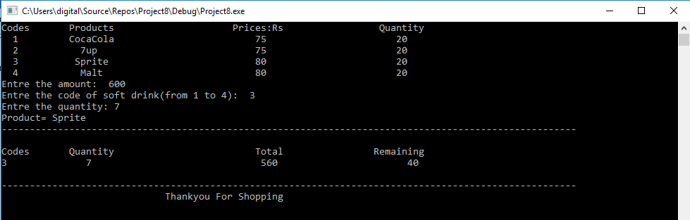

Qs: Write a C++ Program which take a string as an input from user and check that either all the characters of

that string belongs to single line of Keyboard.

If all the Characters belongs to single Keyboard line than Display the Line Number.

Example

INPUT: Roy

Output: Roy Belongs to 2nd Line of Keyboard.

INPUT: Lab

OUTPUT: Lab Not belongs to any Single Line of Keyboard.

Code:

#include<iostream>

#include<iomanip>

#include<Windows.h>

#include<string>

using namespace std;

int main()

{

int i, j, len, count1 = 0, count2 = 0, count3 = 0;

string input;

char key1[10] = { 'q','w','e','r','t','y','u','i','o','p' };

char key2[10] = { 'Q','W','E','R','T','Y','U','I','O','P' };

char key3[9] = { 'a','s','d','f','g','h','j','k','l' };

char key4[10] = { 'A','S','D','F','G','H','J','K','L' };

char key5[7] = { 'z','x','c','v','b','n','m' };

char key6[10] = { 'Z','X','C','V','B','N','M' };

cout << "Enter String of Keyboard: ";

cin >> input;

len = input.length();

for (i = 0; i < len; i++) //For Row 1

{

for (j = 0; j < 10; j++)

{

if ((input[i] == key1[j])|| (input[i] == key2[j]))

count1++;

}

}

for (i = 0; i < len; i++) //For Row 2

{

for (j = 0; j < 9; j++)

{

if ((input[i] == key3[j])|| (input[i] == key4[j]))

count2++;

}

}

for (i = 0; i < len; i++) //For Row 3

{

for (j = 0; j < 7; j++)

{

if ((input[i] == key5[j]) || (input[i] == key6[j]))

count3++;

}

}

if (count1 == len)

cout << "Your String is Part of the Row 1." << endl;

else if (count2 == len)

cout << "Your String is Part of the Row 2." << endl;

else if (count3 == len)

cout << "Your String is Part of the Row 3." << endl;

else

cout << "Nope, The String is Mixed. Sorry!" << endl;

system("pause>0");

return 0;

}

