Assignment 6

18F-0336

CS18-A

PF

**Write a program that takes input from the user the salaries of the people working in the software house, and calculate who gets the maximum salary and what is the average salary of that particular software house? Maximum number of employees in the software house can be 100. For each calculation use separate function that will calculate and return the desired value. Now extend program in question 1 that takes the names of the employees of the software house and prints the name of the person who gets the maximum and minimum salary. [USE ARRAYS]**

**Code:**

#include <iostream>

#include <cstring>

using namespace std;

void max(int arr[],int size);

void avg(int arr[],int size);

int main()

{

int arr[100] = { 0 };

for (int i = 0;i < 100;i++)

{

cout << "Enter value number " << i+1 << " = ";

cin >> arr[i];

}

max(arr, 100);

avg(arr, 100);

system("pause>0");

return 0;

}

void max(int arr[],int size)

{

int large = arr[0], ind = 0;

for (int i = 0;i < size;i++)

{

if (arr[i] > large)

{

large = arr[i];

ind = i;

}

}

cout << "Index " << ind << " has the maximum salary = " << large << endl;

}

void avg(int arr[],int size)

{

int sum = 0,average=0;

for (int i = 0;i < size;i++)

{

sum = sum + arr[i];

}

average = sum / 100;

cout << "Average Salary of the software house is= " << average << endl;

}

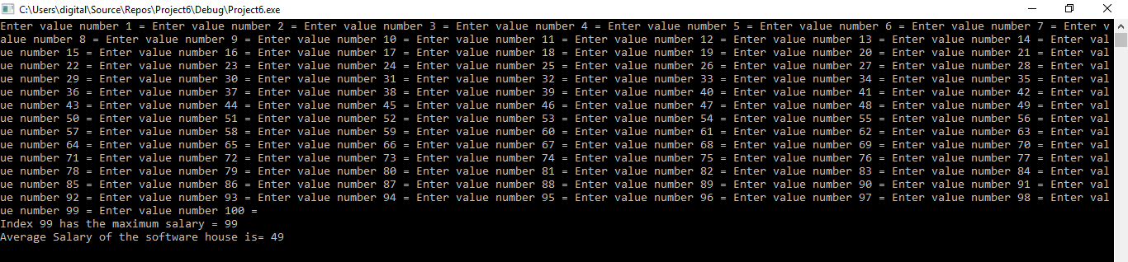

#include<iostream>

#include<string>

using namespace std;

int MAX(int[], int size);

void MIN(int[], int size, string [],int size2);

double AVERAGE(int[], int size);

int main()

{

int salary[100], size = 1;

char check;

string names[100];

for (int i = 0; i < 100; ++i)

{

cout << "Enter your name: ";

cin >> names[i];

cout << "Enter salary: Rs.";

cin >> salary[i];

cout << "Add more employee name & salary:(y/n): ";

cin >> check;

if (check == 'n' || check=='N')

{

break;

}

size++;

}

cout << "Average Salary: Rs." << AVERAGE(salary, size) << endl;

for (int i = 0; i < size; ++i)

{

if (salary[i] == MAX(salary, size))

{

cout << "Name of Employee taking Maximum salary: " << names[i] << " Maximum Salary: Rs." << MAX(salary, size) << endl;

}

}

MIN(salary, size, names, 100);

system("pause>0");

return 0;

}

int MAX(int salary[], int size)

{

int maxSalary = salary[0];

for (int i = 0; i < size; ++i)

{

if (salary[i] > maxSalary)

{

maxSalary = salary[i];

}

}

return maxSalary;

}

double AVERAGE(int salary[], int size)

{

double average = 0.0, sum = 0.0;

int n = 1;

for (int i = 0; i < size; ++i)

{

sum += salary[i];

++n;

}

average = sum / --size;

return average;

}

void MIN(int salary[], int size, string names[],int size2)

{

int temp = 0;

int minSalary = salary[0];

for (int i = 0; i < size; ++i)

{

if (salary[i] < minSalary)

{

minSalary = salary[i];

temp = i;

}

}

cout << "Name of Employee taking Minimum salary: " << names[temp] <<" Minimum Salary= "<< minSalary << endl;

}

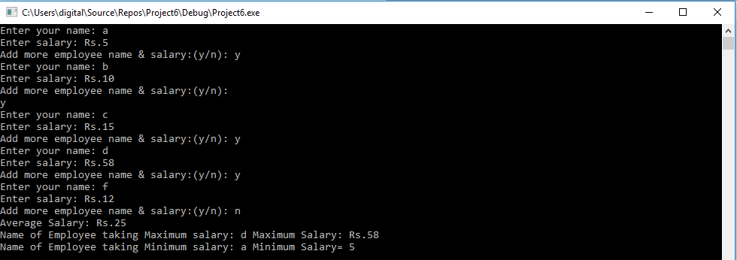

**2. Enter a word and check if it is palindrome or not. Length may vary up to 100. User can input 99 or less characters, your program should determine the length first and then check whether it is palindrome or not. [Use character arrays and explore strlen() function]**

**Code:**

#include<iostream>

#include<string>

using namespace std;

int main()

{

int length=0,count=0;

char word[100];

cout << "Enter a word: ";

cin >> word;

char gets(char*word);

length = strlen(word);

for (int i = 0; i < length/2; ++i)

{

if (word[i] == word[length - i - 1])

{

count++;

}

}

if (count == length / 2)

{

cout << "Word is Palindrome! " << endl;

}

else

{

cout << "Word is NOT Palindrome! " << endl;

}

system("pause>0");

return 0;

}



**3. Write a program that takes input array (up to 20 characters) sort the array in ascending order.**

**Code:**

#include <iostream>

using namespace std;

int main()

{

int arr[20];

int small, temp;

cout << "Input 20 Numbers : " << endl;

for (int i = 0; i < 20; ++i)

{

cin >> arr[i];

}

cout << endl << "Array is : " << endl;

for (int i = 0; i < 20; ++i)

{

cout << arr[i] << ", ";

}

for (int i = 0; i < 20; ++i)

{

small = i;

for (int j = small + 1; j < 20; ++j)

{

if (arr[j] < arr[small])

{

small = j;

}

}

temp = arr[i];

arr[i] = arr[small];

arr[small] = temp;

}

cout << endl << "Now Array has been Sorted in Ascending Order : " << endl;

for (int i = 0; i < 20; ++i)

{

cout << arr[i] << ", ";

}

cout << endl << endl;

system("pause>0");

return 0;

}

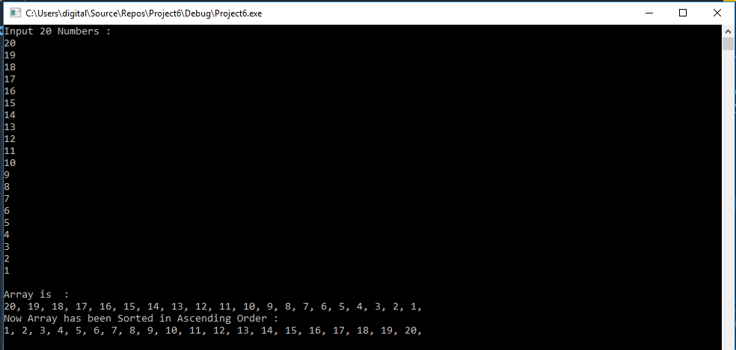

**4. Write a program to insert an element in a sorted integer array.**

**Code:**

#include <iostream>

using namespace std;

int main()

{

int arr[10], e,small,temp;

cout << "Enter array in a sorted way:";

cout << endl;

for (int i = 0; i < 10; i++)

{

cin >> arr[i];

}

for (int i = 0; i < 10; ++i)

{

small = i;

for (int j = small + 1; j < 10; ++j)

{

if (arr[j] < arr[small])

{

small = j;

}

}

temp = arr[i];

arr[i] = arr[small];

arr[small] = temp;

}

for (int i = 0;i < 10;i++)

{

cout << arr[i];

}

cout << endl;

cout << "Enter element:";

cin >> e;

int i = 10;

while (e < arr[i - 1] && i >= 0)

{

arr[i] = arr[i - 1];

i--;

}

arr[e] = e;

for (int i = 0; i < 10; ++i)

{

small = i;

for (int j = small + 1; j < 10; ++j)

{

if (arr[j] < arr[small])

{

small = j;

}

}

temp = arr[i];

arr[i] = arr[small];

arr[small] = temp;

}

cout << "Array after insertion:";

for (int i = 0; i <= 10; i++)

{

cout << arr[i] << " ";

}

cout << endl;

system("pause>0");

return 0;

}

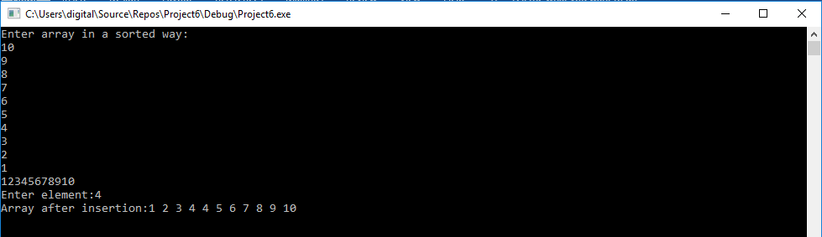

**5. Take input an array of length 10 from user and separate the elements of the array in two separate arrays EVEN and ODD. i.e. All even numbers in Even array and all Odd numbers in Odd array. In the end there must be only one function that will be called to print the contents of these Even and Odd arrays.**

**Code:**

#include <iostream>

#include <cstring>

using namespace std;

void separate(int arr[],int size);

int main()

{

int arr[10] = { 0 };

for (int i = 0;i < 10;i++)

{

cout << "Enter value number " << i+1 << " = ";

cin >> arr[i];

}

separate(arr, 10);

system("pause>0");

return 0;

}

void separate(int arr[],int size)

{

int even[10] = { 0 }, odd[10] = {0};

for (int j = 0;j < size;j++)

{

if (arr[j] % 2 == 0)

{

even[j] = arr[j];

}

else

{

odd[j] = arr[j];

}

}

cout << "Even numbers are: ";

for (int k = 0;k<size;k++)

{

if (even[k] != 0)

{

cout << even[k] <<" ";

}

}

cout << endl;

cout << "Odd numbers are: " ;

for (int x = 0;x<size;x++)

{

if (odd[x] != 0)

{

cout << odd[x] << " ";

}

}

}

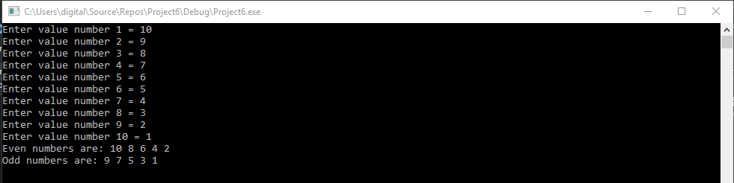

**6. Make a function ‘FUN1’ that takes array name as argument and asks for the index as input and then passes this information to another function ‘FUN2’. FUN2 should take input integer X and rotate the elements of array beyond that point (index) X times. For example, [1,2,3,4,5], index= 2, X=1. The resultant array should be [1,2,5,3,4] [1,2,3,4,5], index= 1, X=2. The resultant array should be [1,4,5,2,3]**

**Code:**

#include <iostream>

#include <cstring>

using namespace std;

void FUN1(int arr[],int size);

void FUN2(int arr[],int size, int index, int value);

int main()

{

int arr[5] = { 0 };

for (int i = 0;i < 5;i++)

{

cout << "Enter value number " << i+1 << " = ";

cin >> arr[i];

}

FUN1(arr, 5);

system("pause>0");

return 0;

}

void FUN1(int arr[],int size)

{

int index = 0, value = 0;

cout << "Enter Index number: ";

cin >> index;

cout << "Enter How many times you want to rotate: ";

cin >> value;

FUN2(arr, 5, index, value);

}

void FUN2(int arr[],int size, int index,int value)

{

int temp = 0;

for (int i = 0;i < value;i++)

{

cout << "Array is { " << arr[i]<<" , ";

}

cout << "}";

for (int i = 0;i < value+1;i++)

{

temp= arr[index + i];

arr[index + i] = arr[size - 1];

arr[size - 1] = temp;

}

cout << "After rotating " << value << " times array become {";

for (int i = 0;i < 5;i++)

{

cout<< arr[i] << " , ";

}

cout << "}";

}

