Assignment 5

18F-0336

cs18-a

4-11-2018

Q. No1: Write a C++ Program to Display Hollow Diamond and Filed form outside if Given Size 5

Code:

#include<iostream>

#include<iomanip>

using namespace std;

int main()

{

int s,h=1;

cout<<"Enter the size of diomond= ";

cin>>s;

for(int n=1;n<=s;++n)

{

for(int i=s;i>=n;i--)

{

cout<<"*";

}

if(n>=1)

{

for(int g=1;g<=h;++g)

{

cout<<" ";

}

h+=2;

}

for(int d=s;d>=n;d--)

{

cout<<"*";

}

cout<<endl;

}

h-=2;

for(int n=1;n<=s;++n)

{

for(int i=1;i<=n;i++)

{

cout<<"*";

}

if(n>=1)

{

for(int g=1;g<=h;++g)

{

cout<<" ";

}

h-=2;

}

for(int d=1;d<=n;d++)

{

cout<<"*";

}

cout<<endl;

}

}

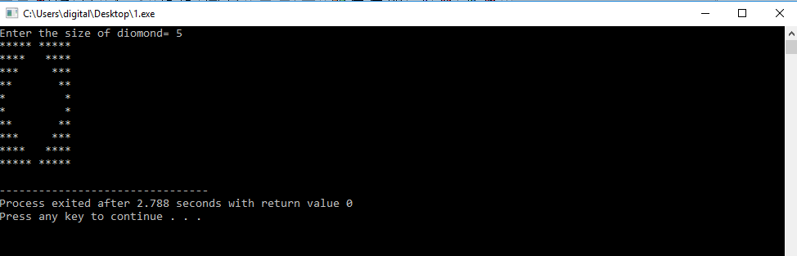

Q. No2: Write a C++ Program to Display a Triangle of Given Size 6

Code:

#include<iostream>

using namespace std;

int main()

{

int i,j,k,l,rows;

cout<<"Enter the size=";

cin>>rows;

for(i=1;i<=rows;i++)

{

for(j=i*2;j<=rows*2;j++)

{

cout<<" ";

}

l=i;

for(j=1;j<=i;j++)

{

cout<<l;

l--;

}

for(k=2 ;k<=i ;k++)

{

cout<<k;

}

cout<<endl;

}

}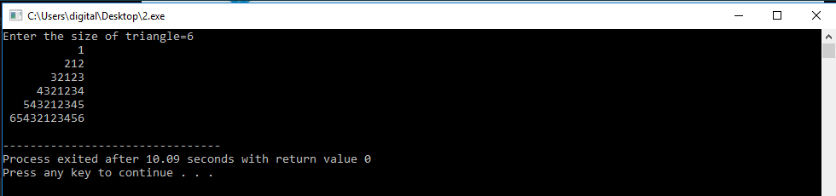

Q. No3: Write a C++ Program to Display Shape Give below of Given Size (Hint: ASCII value of a is 97)

types.

Code:

#include <iostream>

using namespace std;

int main()

{

int row, i,j,k,l=1;

char c='a';

cout<<"Enter the size=";

cin>>row;

for(int i=1 ; i<=row ; i++)

{

for(int j=1 ; j<=i ; j++)

{

if(j==i)

cout<<"*";

else

cout<<" ";

}

for(int k=2*row-1;k>=i*2-1; k--)

{

if(i==1)

{

cout<<"*";

}

else if(i%2==0)

{

cout<<l;

}

else

cout<<c;

}

if(i%2==0)

l++;

else if(i%2!=0 && i!=1)

c++;

cout<<"*";

cout<<endl;

}

for(int i=1 ; i<=row ; i++)

{

for(int j=i ; j<=row ; j++)

{

if(j==row)

cout<<"*";

else

cout<<" ";

}

for(k=1 ; k<=2*i-1 ; k++)

{

if(row%2!=0)

{

if(i==row)

{

cout<<"*";

}

else if(i%2==0)

{

cout<<c;

}

else

cout<<l;

}

else

{

if(i==row)

{

cout<<"*";

}

else if(i%2==0)

{

cout<<l;

}

else

cout<<c;

}

}

if(row%2!=0)

{

if(i%2==0)

c++;

else if(i%2!=0)

l++;

}

else

{

if(i%2==0)

l++;

else if(i%2!=0)

c++;

}

cout<<"*";

cout<<endl;

}

return 0;

}

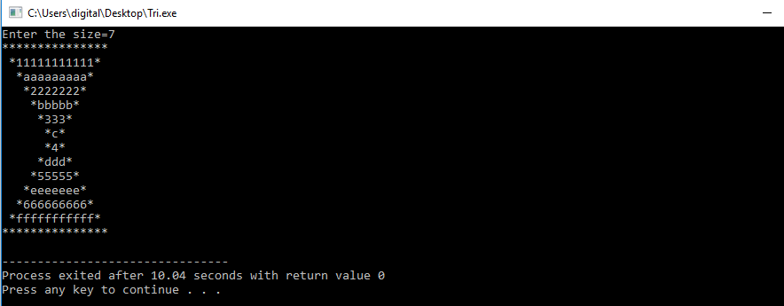

Q. No4: Write a C++ Program to Print Pascal Triangle of Given Size 5

types.

Code:

#include <iostream>

using namespace std;

int main()

{

int row,a=1,j,i,k;

cout<<"Enter Size: ";

cin>>row;

for(i=0;i<row;i++)

{

for(j=1;j<=row-i;j++)

cout<<" ";

for(k=0;k<=i;k++)

{

if (k==0||i==0)

a=1;

else

a=a*(i-k+1)/k;

cout<<" "<<a;

}

cout<<endl;

}

return 0;

}

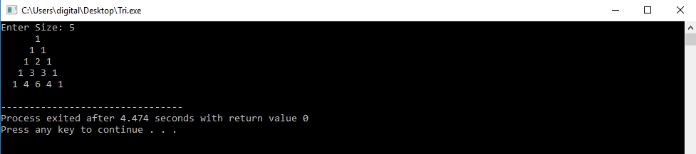

Q. No5: Write a C++ Program to Print the Clock of Given Size 8

Code:

#include<iostream>

using namespace std;

int main()

{

int row, x=12, y=1;

cout<<"Enter Size : ";

cin>>row;

for(int i=1; i<=row; i++)

{

for(int j=i*2-2; j<=row*2; j++)

cout <<" ";

for(int k=1; k<=4*i-3; k++)

{

if(k==1 && i%2!=0)

{

cout<<x;

x--;

}

else if(k==4*i-3 && i%2!=0 && i!=1)

{

cout<<y;

y++;

}

else

cout<<" ";

}

cout<<endl;

}

for(int i=1; i<=row; i++)

{

for(int j=1; j<=i*2+2; j++)

cout<<" ";

for(int k=row*4-3; k>=i*4-3 ; k--)

{

if(k==row*4-3 && i%2!=0 && i!=1) /*|| k==i*4-1)*/

{

cout<<x;

x--;

}

if(k==i*4-3 && i%2!=0 && k!=row*2 && i!=1 && i!=row)

{

cout<<y;

y++;

}

else

cout<<" ";

}

cout<<endl;

}

}

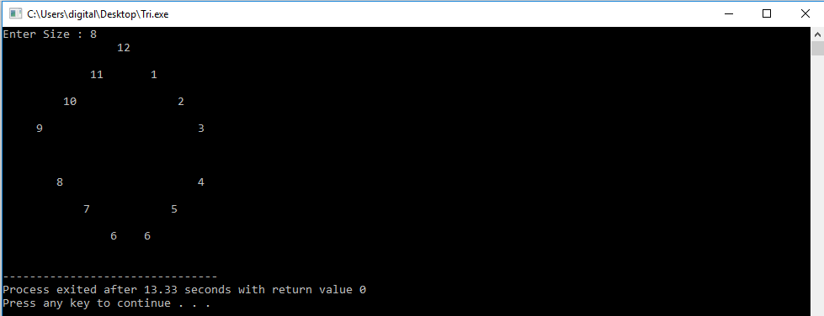

Q. No6: Write a C++ Program to Print a Heart of Given Size.

Code:

#include<iostream>

using namespace std;

int main()

{

int i,j,rows;

cout<<"Enter Size:";

cin>>rows;

for(i=rows/2;i<=rows;i+=2){

for(j=1;j<rows-i;j=j+2){

cout<<" ";}

for(j=1;j<=i;j++){

cout<<"*";

}

for(j=1;j<=rows-i;j++){

cout<<" ";

}

for(j=1;j<=i;j++){

cout<<"*";

}

cout<<endl;

}

for(i=rows;i>=1;i--){

for(j=i;j<rows;j++){

cout<<" ";

}

for(j=1;j<=(i*2)-1;j++)

{

cout<<"*";}

cout<<endl;

}

return 0;

}

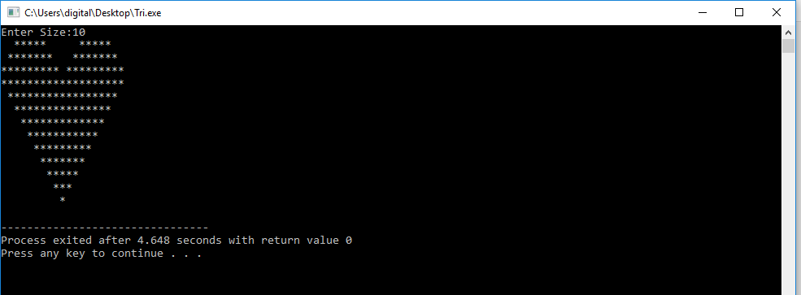

Q. No7: Write a program which accepts amount as integer and display total number of Notes of Rs. 500, 100, 50, 20, 10, 5 and 1. For example, when user enter a number, 575, the results would be like this...

Code:

#include <iostream>

using namespace std;

int main()

{

int numb,fivehund,hund,fift,twent,ten,five,two,one;

cout<<"Enter number of notes :";

cin>>numb;

fivehund=numb/500;

hund=(numb%500)/100;

fift=((numb%500)%100)/50;

twent=(((numb%500)%100)%50)/20;

ten=((((numb%500)%100)%50)%20)/10;

five=(((((numb%500)%100)%50)%20)%10)/5;

two=((((((numb%500)%100)%50)%20)%10)%5)/2;

one=(((((((numb%500)%100)%50)%20)%10)%5)%2);

cout<<"Number of notes: "<<endl;

cout<<"500: "<<fivehund<<endl;

cout<<"100: "<<hund<<endl;

cout<<"50: "<<fift<<endl;

cout<<"20: "<<twent<<endl;

cout<<"10: "<<ten<<endl;

cout<<"5: "<<five<<endl;

cout<<"2: "<<two<<endl;

cout<<"1: "<<one<<endl;

return 0;

}

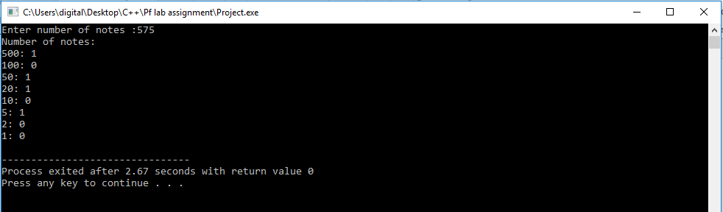

Q. No8: Write a program which accepts days as integer and display total number of years, months and days in it.

for

example:

If user input as 856 days, the output should be 2 years 4 months 6 days.

Code:

#include <iostream>

#include <iomanip>

using namespace std;

int main()

{

int totaldays=0,year=0,month=0,day=0,initial=0;

cout<<"Input Total Days=";

cin>>totaldays;

year=totaldays/365;

initial=totaldays%365;

month=initial/30;

day=initial%30;

cout<<year<<" years "<<month<<" months "<<day<<" days "<<endl;

return 0;

}

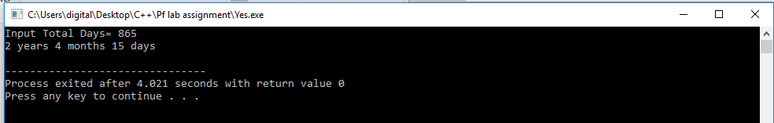

Q. No9: Write a program using nested for loop that asks the user to enter number of rows and then displays the

pattern like a pyramid using asterisk and each row contain an odd number of asterisks. Moreover, the

pyramid should be a moving pyramid. It should keep moving on screen.

Sample Output: Enter a number: 3

Time Pyramid Position

Hint: use system(“cls”) to clear screen , use Sleep(1000) to stop function for 1 sec Library for that is

#include<Whindo.h>

Code:

#include<iostream>

#include<iomanip>

using namespace std;

int main()

{

int s=0,h=1,l=1,f=1,w=2,x=1,z=0,c=0;

cout<<"Enter the size";

cin>>s;

z=s;

for(int i=1;i<=s;i++)

{

for(int j=s;j>f;j--)

{

cout<<" ";

}

for(int k=1;k<=l;k++)

{

cout<<"*";

}

cout<<endl;

l+=2;

f++;

}

for(int v=1;v>=1;v++)

{

c=s*w+2*s;

x=1;

z=s;

for(int y=1;y<=s;y++)

{

for(int b=c;b>=z;b--)

{

cout<<" ";

}

for(int n=1;n<=x;n++)

{

cout<<"*";

}

cout<<endl;

x+=2;

z++;

w++;

}

}

return 0;

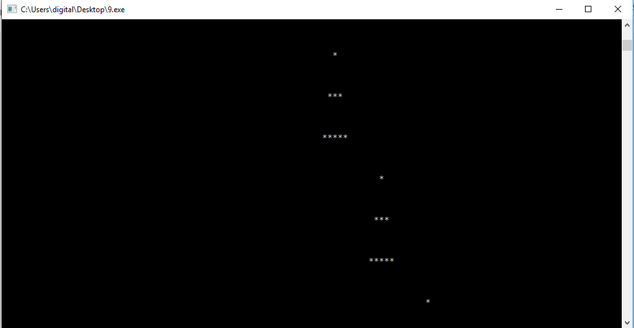

Q. No10: Write a C++ Program to Print the Given Shape. 7

Code:

#include<iostream>

#include<iomanip>

using namespace std;

int main()

{

int s,h=65,o=1,l=1,a;

cout<<"Enter the size =";

cin>>s;

cout<<endl;

for(int k=1;k<=s;k++)

{

h=65;

for(int i=s;i>=o;i--)

{

cout<<static_cast<char>(h);

a=h;

h++;

if(h==91)

{

h=65;

}

}

for(int u=1;u<=l;u++)

{

cout<<" ";

}

for(int p=s;p>=o;p--)

{

cout<<static_cast<char>(a);

a--;

if(a==64)

{

a=90;

}

}

cout<<endl;

o++;

l+=2;

}

return 0;

}