

PF LAb 4

30-9-2018



Muhammad Ahmer Zaman

Section=A

Roll Number=18F-0336

Q. No1: Write a C++ program that prompts the user to input the elapsed time for an event in hours, minutes, and seconds. The program then outputs the elapsed time in seconds.

Code:

#include <iostream> //including input output stream from library

using namespace std; //using namespace std function

/* run this program using the console pauser or add your own getch, system("pause") or input loop */

int main() //Starting of main program

{ //Starting of Code

int hours=0,minutes=0,seconds=0,hours_seconds=0,minutes_seconds=0,elasped_time=0; //Declaring integral variables

cout<<"Input hours="; //Displaying input hours

cin>>hours; //Taking hours input from user

cout<<"Input minutes="; //Displaying input minutes

cin>>minutes; //Taking minutes input from user

cout<<"Input seconds="; //Displaying input seconds

cin>>seconds; //Taking seconds input from user

hours_seconds=hours*3600; //Converting hours into seconds

minutes_seconds=minutes*60; //Converting minutes into seconds

elasped_time=hours_seconds+minutes_seconds+seconds; //Calculating elasped time

cout<<"Elasped time="<<elasped_time<<" (seconds)"<<endl; //Displaying Elasped time

return 0; //After Ending returning zero value

} //Ending of Code

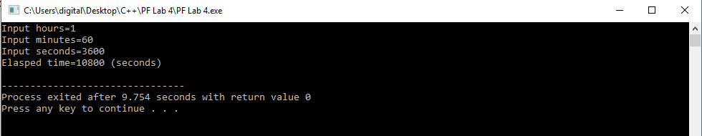

Q. No2: 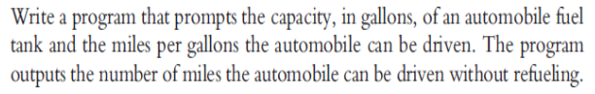

Code 2:

#include <iostream> //including input output stream from library

using namespace std; //using namespace std function

/* run this program using the console pauser or add your own getch, system("pause") or input loop */

int main() //Starting of main program

{ //Starting of Code

int capacity=0,miles_per_gallon=0,total_miles=0; //Declaring Variables

cout<<"Input Capacity in Gallons="; //Displaying Input Capacity in Gallons

cin>>capacity; //Taking Capacity from user

cout<<"Input Miles per Gal#inlon="; //Displaying Miles per Gallon

cin>>miles_per_gallon; //Taking miles per Gallon from user

total_miles=capacity*miles_per_gallon; //Calculating total miles

cout<<"Total Miles="<<total_miles<<endl; //Displaying total miles

return 0; //After Ending returning zero value

} //Ending of Code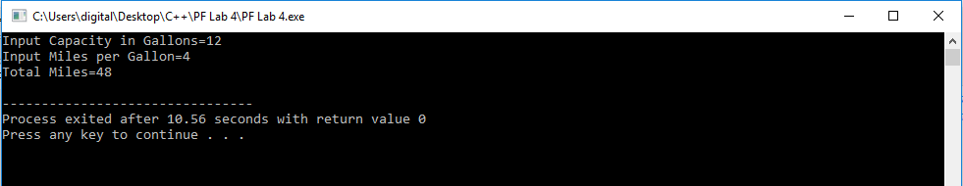

Q. No3: Write a program that prompts the user to input a length expressed in centimetres. The program should then convert the length to inches (to the nearest inch) and output the length expressed in yards, feet, and inches, in that order. For example, suppose the input for centimetres is 312. To the nearest inch, 312 centimetres is equal to 123 inches. 123 inches would thus be output as:

3 yard(s), 1 feet (foot), and 3 inch(es).

Code 3:

#include <iostream> //including input output stream from library

using namespace std; //using namespace std function

/* run this program using the console pauser or add your own getch, system("pause") or input loop */

int main() //Starting of main program

{ //Starting of Code

int centimeters=0,inches=0,yards=0,feet=0; //Declaring Variables

cout<<"Input Centimeters ="; //Displaying Input centimeters

cin>>centimeters; //Taking Centimeters from user

inches=centimeters*0.39; //Calculating inches

yards=inches/36; //Calculating yards

feet=inches/12; //Calculating feet

cout<<yards<<"Yard(s),"<<feet<<"feet(foot),"<<inches<<"inch(es)"<<endl; //Displaying yards,feet and inches

return 0; //After Ending returning zero value

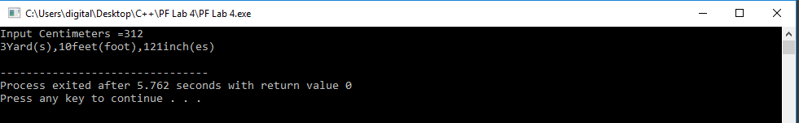} //Ending of Code //Ending of Code

Q. No4: Write a program that calculates and prints the monthly pay check for an Employee. The net pay is calculated after taking the following deductions:

Federal Income Tax: 15%

State Tax: 3.5% Social

Security Tax: 5.75%

Medicare/Medicaid Tax: 2.75%

Pension Plan: 5%

Health Insurance: $75.00

Code 4:

**#include <iostream> //including input output stream from library**

**using namespace std; //using namespace std function**

**/* run this program using the console pauser or add your own getch, system("pause") or input loop */**

**int main() //Starting of main program**

**{ //Starting of Code**

**int pay=0,federaltax=0,statetax=0,securitytax=0,medicaretax=0,pensionplan=0,healthinsurance=0,initialsum=0,netpay=0; //Declaring Variables**

**cout<<"Input Pay ="; //Displaying Input Pay**

**cin>>pay; //Taking Pay from user**

**federaltax=pay*(15/100); //Calculating Federal Income Tax**

**statetax=pay*(3.5/100); //Calculating State tax**

**securitytax=pay*(5.75/100); //Calculating Social Security tax**

**medicaretax=pay*(2.75/100); //Calculating Medicare tax**

**pensionplan=pay*(5/100); //Calculating Pension plan**

**initialsum=federaltax+statetax+securitytax+medicaretax+pensionplan; //Calculating initial sum of all taxes**

**healthinsurance=75; //Setting value of health insurance**

**netpay=(pay*0.32)-75; //Calculating net pay**

**cout<<"Net pay="<<netpay<<endl; //Displaying Net Pay**

**return 0; //After Ending returning zero value**

**} //Ending of Code**

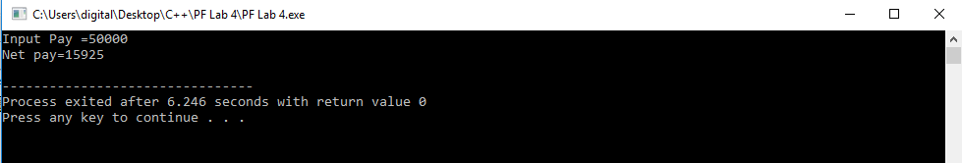

Q. No5: Write a program that prompts the user to enter the weight of a person in kilograms and outputs The equivalent weight in pounds. Output both the weights rounded to two decimal places. (Note that 1 kilogram ¼ 2.2 pounds.) Format your output with two decimal places.

Code 5:

**#include <iostream> //including input output stream from library**

**#include <iomanip> //Including input output manipulation from library**

**using namespace std; //using namespace std function**

**/* run this program using the console pauser or add your own getch, system("pause") or input loop */**

**int main() //Starting of main program**

**{ //Starting of Code**

**double kilogram=0,pounds=0; //Declaring Variables**

**cout<<"Input Weight in kilogram="; //Displaying Input Weight in Kilogram**

**cin>>kilogram; //Taking Weight in Kg from user**

**pounds=kilogram*2.2; //Converting weight in pounds**

**cout<<"Weight in pounds ="<<setprecision(3)<<pounds<<endl; //Displaying Weight in pounds**

**return 0; //After Ending returning zero value**

**} //Ending of Code**

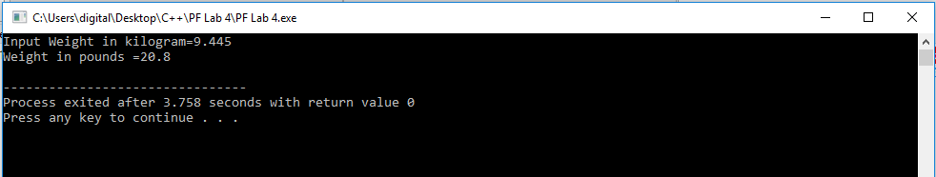

Q. No6: Write a program which accept temperature in Fahrenheit and print it in centigrade.

Code 6:

**#include <iostream> //including input output stream from library**

**#include <iomanip> //Including input output manipulation from library**

**using namespace std; //using namespace std function**

**/* run this program using the console pauser or add your own getch, system("pause") or input loop */**

**int main() //Starting of main program**

**{ //Starting of Code**

**double farenheit=0,centigrade=0; //Declaring Variables**

**cout<<"Input temperature in farenheit="; //Displaying Input Temperature in farenheit**

**cin>>farenheit; //Taking Temperature in Farenheit from user**

**centigrade=(farenheit-32)*0.55; //Converting Temperature in Centigrade**

**cout<<"Temperature in centigrades ="<<centigrade<<endl; //Displaying Temperature in Centigrade**

**return 0; //After Ending returning zero value**

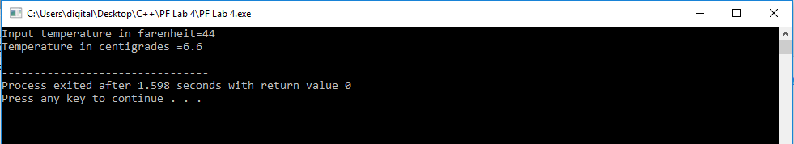**} //Ending of Code**

Q. No7: Write a program which accept principle, rate and time from user and print the simple interest.

Code 7:

**#include <iostream> //including input output stream from library**

**#include <iomanip> //Including input output manipulation from library**

**using namespace std; //using namespace std function**

**/* run this program using the console pauser or add your own getch, system("pause") or input loop */**

**int main() //Starting of main program**

**{ //Starting of Code**

**double principl=0,ratepercent=0,time=0,simpleinterest=0,rate; //Declaring Variables**

**cout<<"Input Principle="; //Displaying Input Principle**

**cin>>principl; //Taking Principle from user**

**cout<<"Input Rate in percent="; //Displaying Rate**

**cin>>ratepercent; //Taking Rate from user**

**cout<<"Input Time="; //Displaying Input Time**

**cin>>time; //Taking time from user**

**rate=ratepercent/100; //Calculating rate**

**simpleinterest=principl*(1+(rate*time)); //Calculating simple interest**

**cout<<"Simple interest =$"<<simpleinterest<<endl; //Displaying simple interest**

**return 0; //After Ending returning zero value**

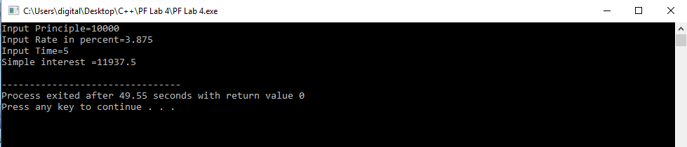**} //Ending of Code**

Q. No8: Write a program which accepts a character and display its ASCII value

Code 8:

**#include <iostream> //including input output stream from library**

**#include <iomanip> //Including input output manipulation from library**

**using namespace std; //using namespace std function**

**/* run this program using the console pauser or add your own getch, system("pause") or input loop */**

**int main() //Starting of main program**

**{ //Starting of Code**

**char character=0; //Declaring Variables**

**cout<<"Input Character="; //Displaying Input Character**

**cin>>character; //Taking Character from user**

**cout<<"ASCII of Character="<<static_cast<int>(character)<<endl; //Showing Ascii**

**return 0; //After Ending returning zero value**

**} //Ending of Code**

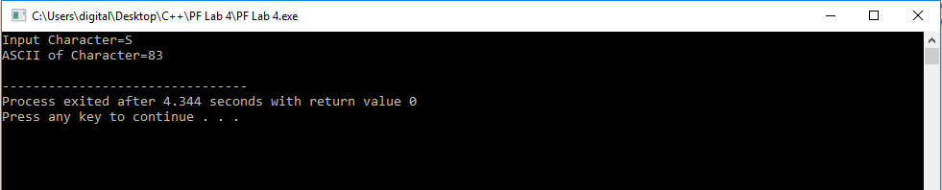

Q. No9: Write a program to swap value of two variables without using third variable

Code 9:

**#include <iostream> //including input output stream from library**

**#include <iomanip> //Including input output manipulation from library**

**using namespace std; //using namespace std function**

**/* run this program using the console pauser or add your own getch, system("pause") or input loop */**

**int main() //Starting of main program**

**{ //Starting of Code**

**int number1=0,number2=0; //Declaring Variables**

**cout<<"Input Number1="; //Displaying Input Number1**

**cin>>number1; //Taking Number1 from user**

**cout<<"Input Number2="; //Displaying Input Number2**

**cin>>number2; //Taking Number2 from user**

**number1=number1+number2; //Adding both numbers and storing in first**

**number2=number1-number2; //Swapping value of 1 in 2**

**number1=number1-number2; //Swapping value of 2 in 1**

**cout<<"Number 1="<<number1<<endl; //Displaying number 1**

**cout<<"Number 2="<<number2<<endl; //Displaying number 2**

**return 0; //After Ending returning zero value**

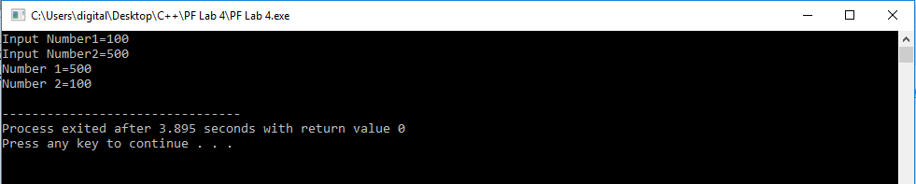**} //Ending of Code**

Q. No10: Write a program which accepts days as integer and display total number of years, months and days in it.

for example : If user input as 856 days the output should be 2 years 4 months 6 days.

Code 10:

**#include <iostream> //including input output stream from library**

**#include <iomanip> //Including input output manipulation from library**

**using namespace std; //using namespace std function**

**/* run this program using the console pauser or add your own getch, system("pause") or input loop */**

**int main() //Starting of main program**

**{ //Starting of Code**

**int totaldays=0,year=0,month=0,day=0,initial=0; //Declaring Variables**

**cout<<"Input Total Days="; //Displaying Input Total Days**

**cin>>totaldays; //Taking total days from user**

**year=totaldays/365; //Calculating years**

**initial=totaldays%365; //Taking Mod**

**month=initial/30; //Calculating months**

**day=initial%30; //Calculating days**

**cout<<year<<"years "<<month<<"months "<<day<<"days "<<endl; //Displaying years,months and days**

**return 0; //After Ending returning zero value**

**} //Ending of Code**

