Assignmenr #4

18F-0336

CS18-A

10/28/2018

Q. No1: Write a C++ Program to perform input/output of all basic data

types.

Code:

#include <iostream>

using namespace std;

int main()

{

int dat1;

float dat2;

char dat3[10000000];

double dat4;

bool dat5;

string dat6;

cout<<"Enter Integral value: ";

cin>>dat1;

cout<<"Enter floating value: ";

cin>>dat2;

cout<<"Enter character value: ";

cin>>dat3;

cout<<"Enter double value: ";

cin>>dat4;

cout<<"Enter boolean value: ";

cin>>dat5;

cout<<"Enter string value: ";

cin>>dat6;

cout<<"Integral value= "<<dat1<<endl;

cout<<"Floataing value= "<<dat2<<endl;

cout<<"Character = "<<dat3<<endl;

cout<<"Double value= "<<dat4<<endl;

cout<<"Boolean value= "<<dat5<<endl;

cout<<"String value= "<<dat6<<endl;

return 0;

}

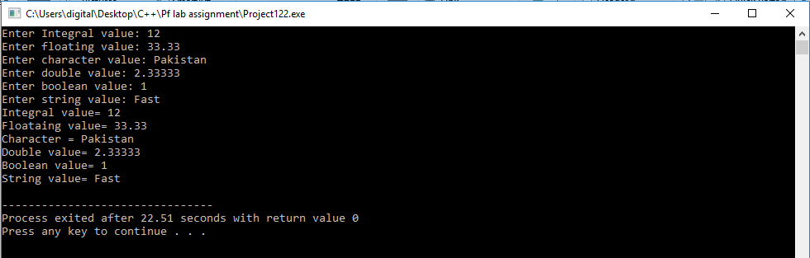

Q. No2: Write a C++ Program to enter two numbers and find their sum.

Code:

#include <iostream>

using namespace std;

int main()

{

int numb1,numb2,sum;

cout<<"Enter First Number: ";

cin>>numb1;

cout<<"Enter Second Number: ";

cin>>numb2;

sum=numb1+numb2;

cout<<"Sum = "<<sum<<endl;

return 0;

}

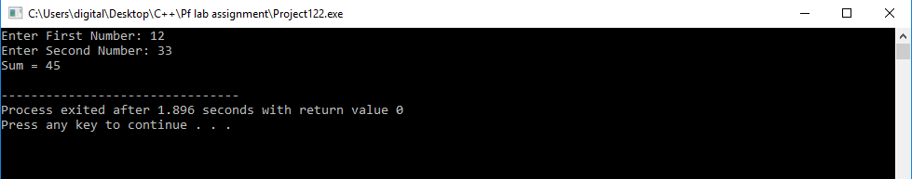

Q. No3: Write a C++ Program to enter two numbers and perform all arithmetic operations.

Code:

#include <iostream>

using namespace std;

int main()

{

int numb1,numb2,sum,prod,div,sub;

int mod;

cout<<"Enter First Number: ";

cin>>numb1;

cout<<"Enter Second Number: ";

cin>>numb2;

sum=numb1+numb2;

sub=numb1-numb2;

prod=numb1*numb2;

mod=numb1%numb2;

cout<<"Sum = "<<sum<<endl;

cout<<"Subtraction = "<<sub<<endl;

cout<<"Product = "<<prod<<endl;

cout<<"Modulus = "<<mod<<endl;

if (numb2!=0)

{

div=numb1/numb2;

cout<<"Division = "<<div<<endl;

}

else

{

cout<<"Division = infinity or not possoble"<<endl;

}

return 0;

}

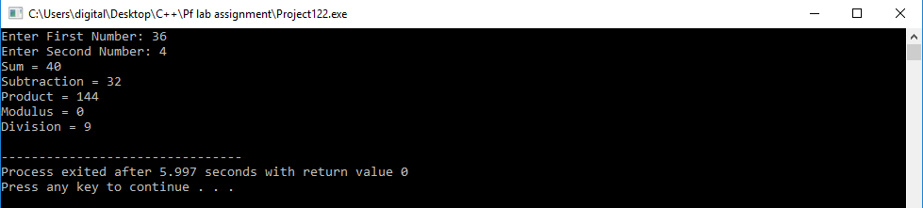

Q. No4: Write a C++ Program to enter length and breadth of a rectangle and find its perimeter.

Code:

#include <iostream>

using namespace std;

int main()

{

int length,breadth,peri;

cout<<"Enter Length: ";

cin>>length;

cout<<"Enter Breadth: ";

cin>>breadth;

peri=2*(length+breadth);

cout<<"Perimeter of Rectangle is "<<peri<<endl;

return 0;

}

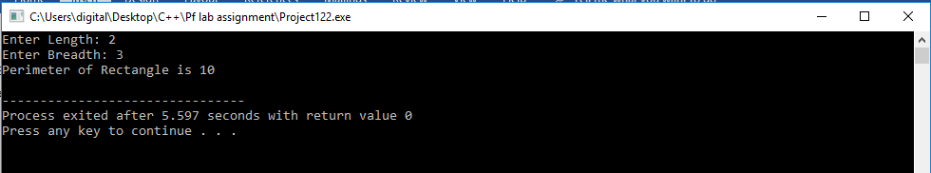

Q. No5: Write a C++ Program to enter length and breadth of a rectangle and find its area.

Code:

#include <iostream>

using namespace std;

int main()

{

int length,breadth,area;

cout<<"Enter Length: ";

cin>>length;

cout<<"Enter Breadth: ";

cin>>breadth;

area=length*breadth;

cout<<"Area of Rectangle is "<<area<<endl;

return 0;

}

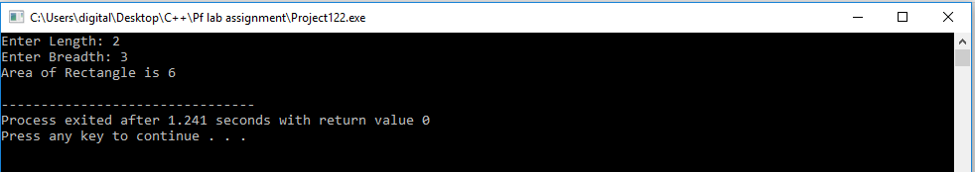

Q. No6: Write a C++ Program to enter radius of a circle and find its diameter, circumference and area.

Code:

#include <iostream>

using namespace std;

int main()

{

int rad,circ,area,diam;

cout<<"Enter Radius: ";

cin>>rad;

area=3.14*(rad*rad);

diam=rad/2;

circ=2*3.14*rad;

cout<<"Diameter of Triangle is "<<diam<<endl;

cout<<"Area of Triangle is "<<area<<endl;

cout<<"Circumference of Triangle is "<<circ<<endl;

return 0;

}

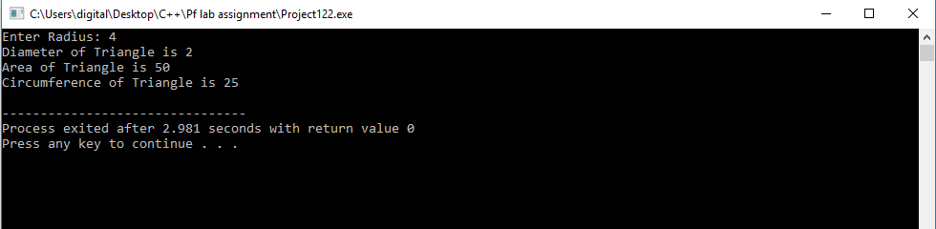

Q. No7: Write a C++ Program to enter radius of a circle and find its diameter, circumference and area.

Code:

#include <iostream>

using namespace std;

int main()

{

int cm;

double m,km;

cout<<"Enter Length in Centimeters: ";

cin>>cm;

m=cm/100;

km=m/1000;

cout<<cm<<" centimeters = "<<m<<" meters"<<endl;

cout<<cm<<" centimeters = "<<km<<" kilometers"<<endl;

return 0;

}

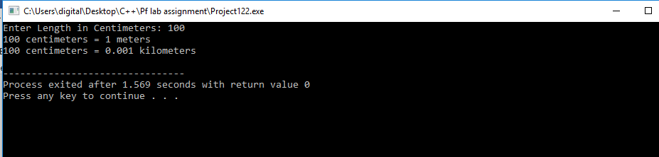

Q. No8: Write a C++ Program to enter temperature in Celsius and convert it into Fahrenheit.

Code:

#include <iostream>

using namespace std;

int main()

{

double cent,far;

cout<<"Enter Temperature in Celcius: ";

cin>>cent;

far=(cent*1.8)+32;

cout<<cent<<" centigrade = "<<far<<" farenheit"<<endl;

return 0;

}

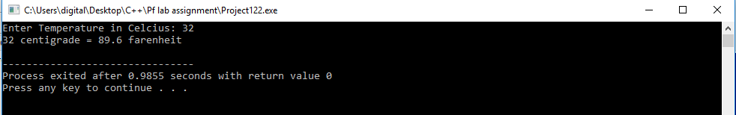

Q. No9: Write a C++ Program to enter temperature in Fahrenheit and convert to Celsius

Code:

#include <iostream>

using namespace std;

int main()

{

double cent,far;

cout<<"Enter Temperature in farenheit: ";

cin>>far;

cent=(far-32)*0.556;

cout<<far<<" farenheit = "<<cent<<" celcius"<<endl;

return 0;

}

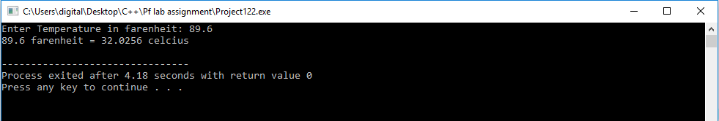

Q. No10: Write a C++ Program to convert days into years, weeks and days.

Code:

#include <iostream>

using namespace std;

int main()

{

int day,month,year,mod1;

cout<<"Enter number of days: ";

cin>>day;

year=day/365;

mod1=day%365;

month=mod1/30;

day=mod1%30;

cout<<year<<" years "<<month<<" months "<<day<<" days"<<endl;

return 0;

}

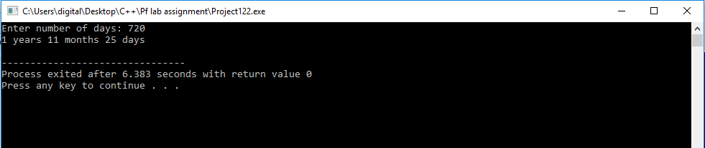

Q. No11: Write a C++ Program to find power of any number x ^ y.

Code:

#include <iostream>

using namespace std;

int main()

{

int numb=0,pow=0,prod=1;

cout<<"Enter number: ";

cin>>numb;

cout<<"Enter Number of power: ";

cin>>pow;

for (int i=0;i<pow;i++)

{

prod=prod*numb;

}

cout<<"Power of "<<numb<<" raise to exponent "<<pow<<" = "<<prod<<endl;

return 0;

}

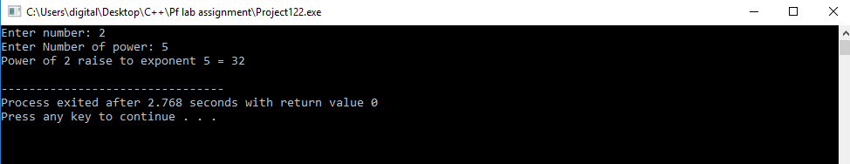

Q. No12: Write a C++ Program to enter any number and calculate its square root.

Code:

#include <iostream>

#include <math.h>

using namespace std;

int main()

{

double numb=0,srt=0;

cout<<"Enter number: ";

cin>>numb;

srt=sqrt(numb);

cout<<"Square root of "<<numb<<" is "<<srt<<endl;

return 0;

}

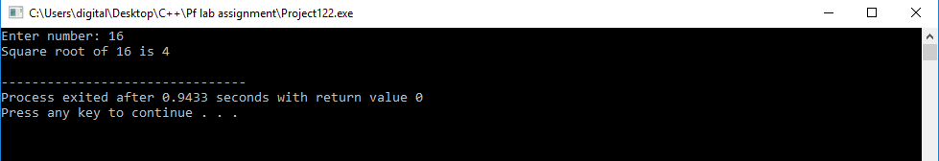

Q. No13: Write a C++ Program to enter two angles of a triangle and find the third angle.

Code:

#include <iostream>

using namespace std;

int main()

{

double angle1=0,angle2=0,angle3=0,sum=0;

cout<<"Enter First angle: ";

cin>>angle1;

cout<<"Enter Second angle: ";

cin>>angle2;

sum=angle1+angle2;

angle3=(180-sum);

cout<<"Third Angle = "<<angle3<<endl;

return 0;

}

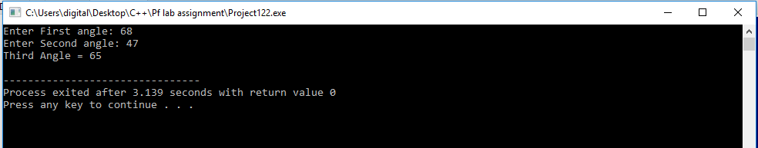

Q. No14: Write a C++ Program to enter base and height of a triangle and find its area.

Code:

#include <iostream>

using namespace std;

int main()

{

double base=0,height=0,area=0;

cout<<"Enter base: ";

cin>>base;

cout<<"Enter height: ";

cin>>height;

area=(base*height)/2;

cout<<"Area = "<<area<<endl;

return 0;

}

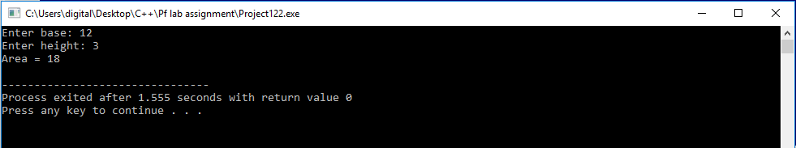

Q. No15: Write a C++ Program to calculate area of an equilateral triangle.

Code:

#include <iostream>

using namespace std;

int main()

{

double side=0,area=0;

cout<<"side: ";

cin>>side;

area=(1.7321/4)*(side*side);

cout<<"Area of Equilateral triangle = "<<area<<endl;

return 0;

}

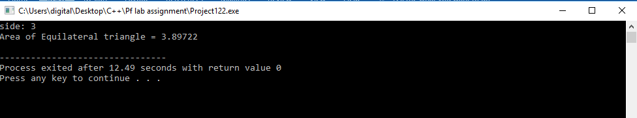

Q. No16: Write a C++ Program to enter marks of five subjects and calculate total, average and percentage.

Code:

#include <iostream>

using namespace std;

int main()

{

int marks=0;

double total=0,average=0,percent=0;

for (int i=1;i<=5;i++)

{

cout<<"Enter Marks of subject "<<i<<" = ";

cin>>marks;

if (marks<=100)

{

total=total+marks;

}

else

{

cout<<"Invalid input"<<endl;

i--;

}

}

average=total/5;

percent=(total/500)*100;

cout<<"Total Marks = "<<total<<endl;

cout<<"Average = "<<average<<endl;

cout<<"Percentage = "<<percent<<"%"<<endl;

return 0;

}

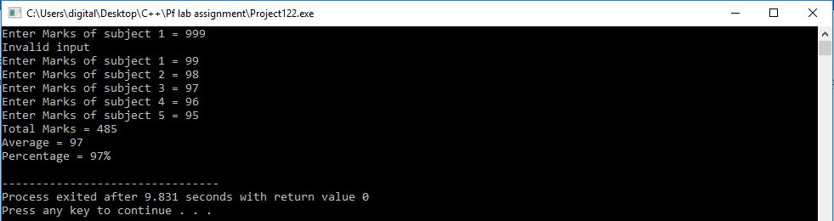

Q. No17: Write a C program to input principle, time and rate (P, T, R) from user and find Simple Interest.

Code:

#include <iostream>

using namespace std;

int main()

{

double principle=0,time=0,rate=0,si=0;

cout<<"Enter Principle = ";

cin>>principle;

cout<<"Enter time = ";

cin>>time;

cout<<"Enter rate = ";

cin>>rate;

si=(principle*time*rate)/100;

cout<<"Simple Interest = "<<si<<endl;

return 0;

}

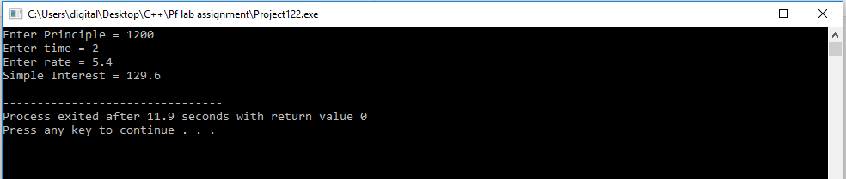

Q. No18: Write a C program to input principle, time and rate (P, T, R) from user and find Compound Interest.

Code:

#include <iostream>

#include <math.h>

using namespace std;

int main()

{

float p=0,t=0,r=0,ci=0;

cout<<"Enter Principle = ";

cin>>p;

cout<<"Enter time = ";

cin>>t;

cout<<"Enter rate = ";

cin>>r;

ci=p*pow((1+r/100),t);

cout<<"Compound Interest = "<<ci<<endl;

return 0;

}

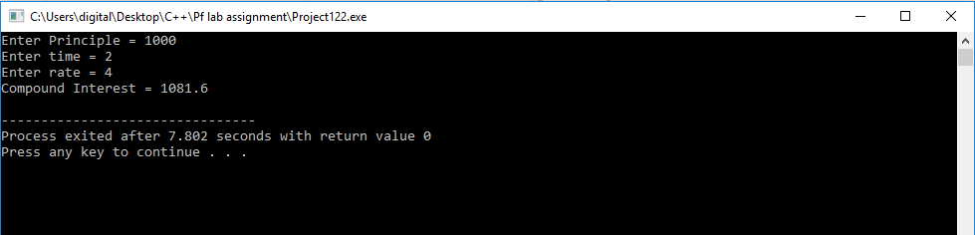

Q. No19: Write a C++ Program to input basic salary of an employee and

calculate its Gross salary according to following:

Basic Salary <= 10000: HORA = 20%, DA = 80%

Basic Salary <= 20000: HORA = 25%, DA = 90%

Basic Salary > 20000: HORA = 30%, DA = 95%

Code:

#include <iostream>

#include <math.h>

using namespace std;

int main()

{

int salary;

float hora=0,da=0,gross;

cout<<"Enter Salary = ";

cin>>salary;

if (salary<=10000)

{

hora=0.2*salary;

da=0.8*salary;

}

else if (salary<=20000)

{

hora=0.25*salary;

da=0.9*salary;

}

else (salary>20000);

{

hora=0.3*salary;

da=0.95*salary;

}

gross=salary+hora+da;

cout<<"Gross Salary = "<<gross<<endl;

return 0;

}

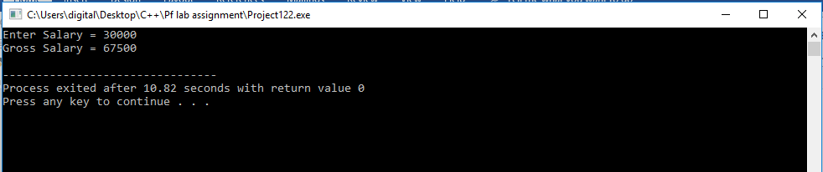

Q. No18: Write a C++ Program to input electricity unit charges and

calculate total electricity bill

according to the given condition:

For first 50 units Rs. 0.50/unit

For next 100 units Rs. 0.75/unit

For next 100 units Rs. 1.20/unit

For unit above 250 Rs. 1.50/unit

An additional surcharge of 20% is added to the to the bill.

Code:

#include <iostream>

#include <math.h>

using namespace std;

int main()

{

int units;

float price=0,total=0,add=0;

cout<<"Enter units = ";

cin>>units;

if (units<=50)

{

price=0.50*units;

}

else if (units<=150)

{

price=0.75*units;

}

else if (units<=250)

{

price=1.20*units;

}

else (units>250);

{

price=1.50*units;

}

add=price*0.20;

total=price+add;

cout<<"Total Bill Rs. "<<total<<endl;

return 0;

}

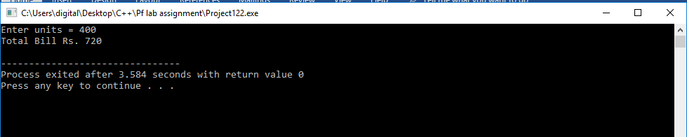

Q. No21: Write a C++ Program to input marks of five subjects

Physics, Chemistry, Biology, Mathematics and Computer.

Calculate percentage and grade according to following:

Percentage >= 90%: Grade A

Percentage >= 80%: Grade B

Percentage >= 70%: Grade C

Percentage >= 60%: Grade D

Percentage >= 40%: Grade E

Percentage < 40%: Grade F

Code:

#include <iostream>

#include <math.h>

using namespace std;

int main()

{

int phy,chem,math,eng,comp,sum;

float percentage=0;

cout<<"Enter Physics Marks = ";

cin>>phy;

cout<<"Enter Chemistry Marks = ";

cin>>chem;

cout<<"Enter Mathematics Marks = ";

cin>>math;

cout<<"Enter English Marks = ";

cin>>eng;

cout<<"Enter Computer Marks = ";

cin>>comp;

sum=phy+comp+math+eng+chem;

percentage=sum/5;

if (percentage>=90)

{

cout<<"Percentage ="<<percentage<<"% and Grade is A"<<endl;

}

else if (percentage>=80)

{

cout<<"Percentage ="<<percentage<<"% and Grade is B"<<endl;

}

else if (percentage>=70)

{

cout<<"Percentage ="<<percentage<<"% and Grade is C"<<endl;

}

else if(percentage>=60)

{

cout<<"Percentage ="<<percentage<<"% and Grade is D"<<endl;

}

else if(percentage>=40)

{

cout<<"Percentage ="<<percentage<<"% and Grade is E"<<endl;

}

else

{

cout<<"Percentage ="<<percentage<<"% and Grade is F"<<endl;

}

return 0;

}

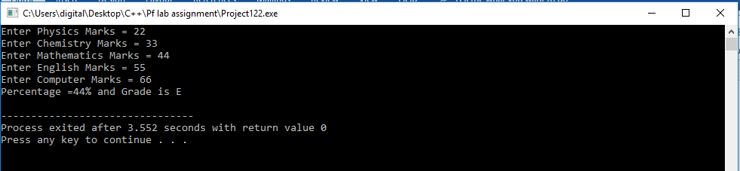

Q. No22: Write a C++ Program to find maximum between two numbers.

Code:

#include <iostream>

#include <math.h>

using namespace std;

int main()

{

int numb1,numb2;

cout<<"Enter first number = ";

cin>>numb1;

cout<<"Enter second number = ";

cin>>numb2;

if (numb1>numb2)

{

cout<<numb1<<" is maximum"<<endl;

}

else

{

cout<<numb2<<" is maximum"<<endl;

}

return 0;

}

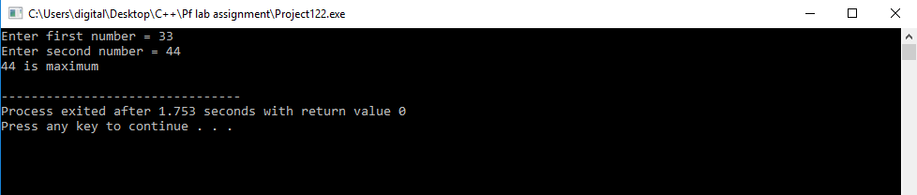

Q. No23: Write a C++ Program to find maximum between three numbers.

Code:

#include <iostream>

#include <math.h>

using namespace std;

int main()

{

int numb1=0,numb2=0,numb3=0;

cout<<"Enter first number = ";

cin>>numb1;

cout<<"Enter second number = ";

cin>>numb2;

cout<<"Enter third number = ";

cin>>numb3;

if ((numb1>numb2) && (numb1>numb3))

{

cout<<numb1<<" is maximum"<<endl;

}

else if ((numb2>numb3) && (numb2>numb1))

{

cout<<numb2<<" is maximum"<<endl;

}

else

{

cout<<numb3<<" is maximum"<<endl;

}

return 0;

}

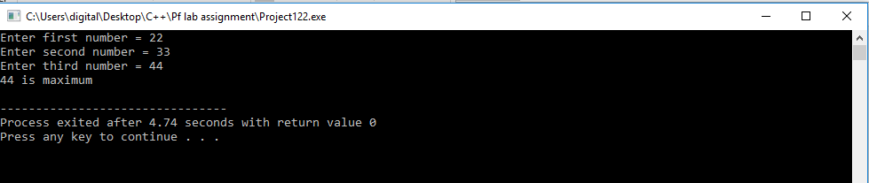

Q. No24: Write a C++ Program to check whether a number is negative, positive or zero.

Code:

#include <iostream>

#include <math.h>

using namespace std;

int main()

{

int numb1=0;

cout<<"Enter first number = ";

cin>>numb1;

if (numb1<0)

{

cout<<numb1<<" is negative"<<endl;

}

else if (numb1>0)

{

cout<<numb1<<" is positive"<<endl;

}

else

{

cout<<numb1<<" is equal to zero"<<endl;

}

return 0;

}

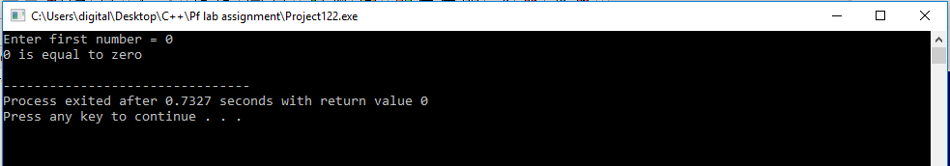

Q. No25: Write a C++ Program to check whether a number is divisible by 5 and 11 or not.

Code:

#include <iostream>

#include <math.h>

using namespace std;

int main()

{

int numb=0;

cout<<"Enter first number = ";

cin>>numb;

if ((numb%5==0)&&(numb%11==0))

{

cout<<numb<<" is divisible by 5 and 11"<<endl;

}

else

{

cout<<numb<<" is not divisible by 5 and 11"<<endl;

}

return 0;

}

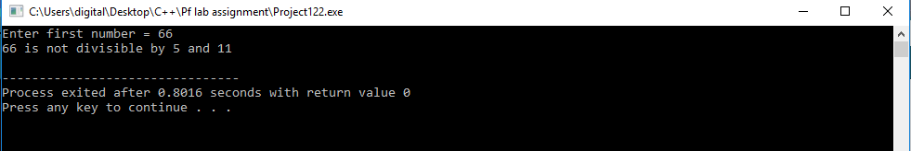

Q. No26: Write a C++ Program to check whether a number is even or odd.

Code:

#include <iostream>

#include <math.h>

using namespace std;

int main()

{

int numb=0;

cout<<"Enter first number = ";

cin>>numb;

if (numb%2==0)

{

cout<<numb<<" is even"<<endl;

}

else

{

cout<<numb<<" is odd"<<endl;

}

return 0;

}

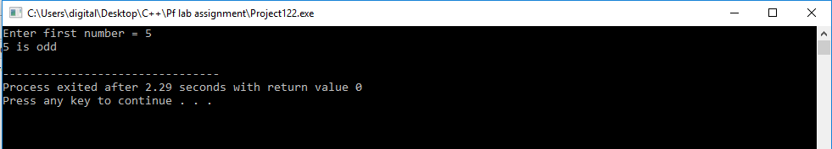

Q. No27: Write a C++ Program to check whether a year is leap year or not.

Code:

#include <iostream>

using namespace std;

int main()

{

int year;

cout<<"Enter the year you want to check=";

cin>>year;

if (year%4==0)

{

if (year%100==0)

{

if (year%400==0)

cout<<year<<" is a leap year."<<endl;

else

cout<<year<<" is not a leap year."<<endl;

}

cout<<year<<" is a leap year."<<endl;

}

else

cout<<year<<" is not a leap year."<<endl;

return 0;

}

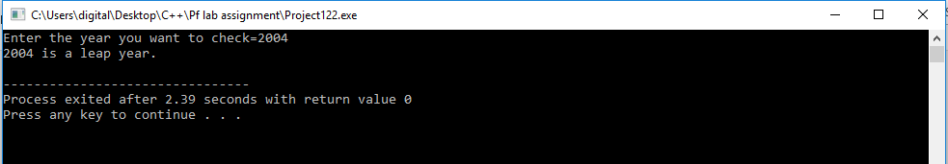

Q. No28: Write a C++ Program to check whether a character is alphabet or not.

Code:

#include <iostream>

using namespace std;

int main()

{

int numb;

char alpha;

cout<<"Enter a character: ";

cin>>alpha;

numb=static_cast<int>(alpha);

if ((numb>=65)&&(numb<=90))

{

cout<<alpha<<" is an alphabet"<<endl;

}

else if ((numb>=97)&&(numb<=122))

{

cout<<alpha<<" is an alphabet"<<endl;

}

else

{

cout<<alpha<<" is not an alphabet"<<endl;

}

return 0;

}

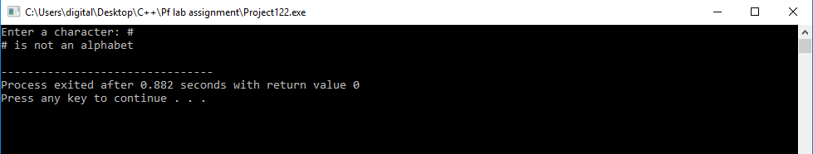

Q. No29: Write a C++ Program to check whether a character is alphabet or not.

Code:

#include <iostream>

using namespace std;

int main()

{

int numb;

char alpha;

cout<<"Enter a character: ";

cin>>alpha;

numb=static_cast<int>(alpha);

if ((numb==65)||(numb==69)||(numb==73)||(numb==79)||(numb==85)||(numb==97)||(numb==101)||(numb==105)||(numb==111)||(numb==117))

{

cout<<alpha<<" is a vowel"<<endl;

}

else

{

cout<<alpha<<" is a consonant"<<endl;

}

return 0;

}

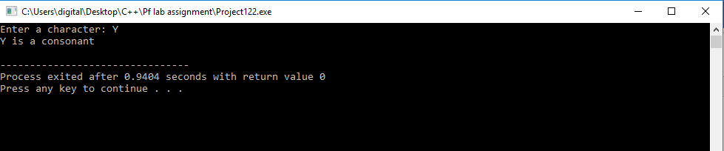

Q. No30: Write a C++ Program to input any character and check whether it is alphabet, digit or special character.

Code:

#include <iostream>

using namespace std;

int main()

{

int numb;

char alpha;

cout<<"Enter a character: ";

cin>>alpha;

numb=static_cast<int>(alpha);

if ((numb>=65)&&(numb<=90)||(numb>=97)&&(numb<=122))

{

cout<<alpha<<" is an alphabet"<<endl;

}

else if ((numb>=48)&&(numb<=57))

{

cout<<alpha<<" is a digit"<<endl;

}

else

{

cout<<alpha<<" is a special character"<<endl;

}

return 0;

}

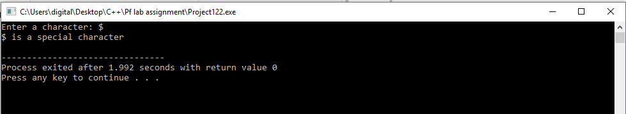

Q. No31: Write a C++ Program to print hollow diamond star pattern

series of n rows using for loop. How to print hollow diamond

star pattern structure in C++ Program. Logic to print hollow

diamond star pattern in C++ Program Ming.

Code:

#include <iostream>

using namespace std;

int main()

{

int no, row, column, i, j, k;

cout<<"Enter length :";

cin>>row;

for (i = 1; i <= row; i++)

{

for (j = 1; j <= row - i; j++)

{

cout << " ";

}

while (k != (2 * i - 1))

{

if (k == 0 or k == 2 * i - 2)

cout << "*";

else

cout << " ";

k++;

}

k = 0;

cout << endl;

}

row--;

for (i = row; i >= 1; i--)

{

for (j = 0; j <= row-i; j++)

{

cout << " ";

}

k = 0;

while (k != (2*i-1))

{

if (k == 0 or k == 2*i-2)

cout << "*";

else

cout << " ";

k++;

}

cout << endl;

}

}

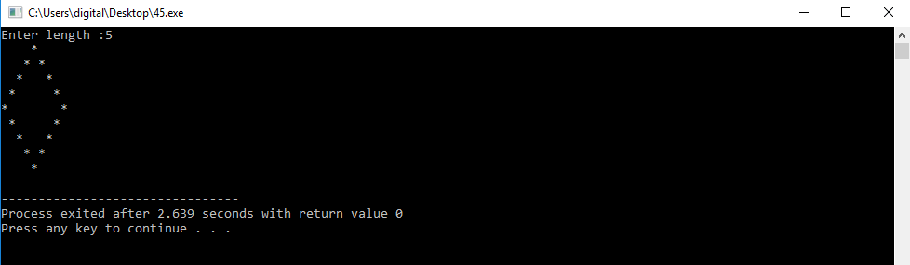

Q. No32: Write a C++ Program to print equilateral triangle or Pyramid

star pattern series of n rows using for loop. How to print

Pyramid star pattern series in C++ Program. Logic to print

pyramid star pattern series in C++ Program Ming.

Example

Input

Input rows: 5

Output

*

***

*****

*******

Code:

#include <iostream>

using namespace std;

int main()

{

int blank,rows;

cout<<"Enter number of rows :";

cin>>rows;

for (int i=1,k=0 ; i <= rows ; ++i, k=0)

{

for (blank=1 ; blank <= rows-i; ++blank)

{

cout<<" ";

}

while (k != 2*i-1)

{

cout<< "* ";

++k;

}

cout<<endl;

}

return 0;

}

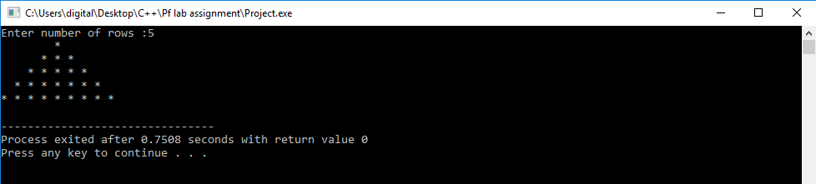

Q. No33: Write a C++ Program to input amount from user and print

minimum number of notes (Rs. 500, 100, 50, 20, 10, 5, 2, 1)

required for the amount. How to the minimum number of notes

required for the given amount in C++ Program Ming. Program

to find minimum number of notes required for the given

denomination. Logic to find minimum number of

denominations for a given amount in C++ Program.

Example

Input

Input amount: 575

Output

Total number of notes:

500: 1

100: 0

50: 1

20: 1

10: 0

5: 1

2: 0

1: 0

Code:

#include <iostream>

using namespace std;

int main()

{

int numb,fivehund,hund,fift,twent,ten,five,two,one;

cout<<"Enter number of notes :";

cin>>numb;

fivehund=numb/500;

hund=(numb%500)/100;

fift=((numb%500)%100)/50;

twent=(((numb%500)%100)%50)/20;

ten=((((numb%500)%100)%50)%20)/10;

five=(((((numb%500)%100)%50)%20)%10)/5;

two=((((((numb%500)%100)%50)%20)%10)%5)/2;

one=(((((((numb%500)%100)%50)%20)%10)%5)%2);

cout<<"Number of notes: "<<endl;

cout<<"500: "<<fivehund<<endl;

cout<<"100: "<<hund<<endl;

cout<<"50: "<<fift<<endl;

cout<<"20: "<<twent<<endl;

cout<<"10: "<<ten<<endl;

cout<<"5: "<<five<<endl;

cout<<"2: "<<two<<endl;

cout<<"1: "<<one<<endl;

return 0;

}

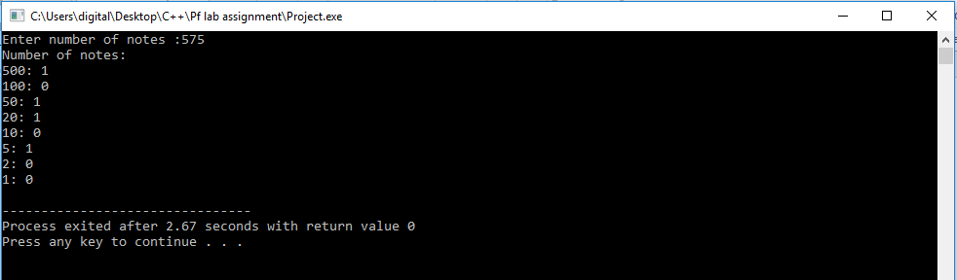

Q. No34: Write a C++ Program for printing the table of the number

inputted by user

Code:

#include <iostream>

using namespace std;

int main()

{

int number=0,length=0,count=1;

cout<<"Enter Number you want to find table=";

cin>>number;

cout<<"Enter range to which you want to find table=";

cin>>length;

while (count<=length)

{

cout<<number<<"*"<<count<<"="<<number*count<<endl;

count++;

}

return 0;

}

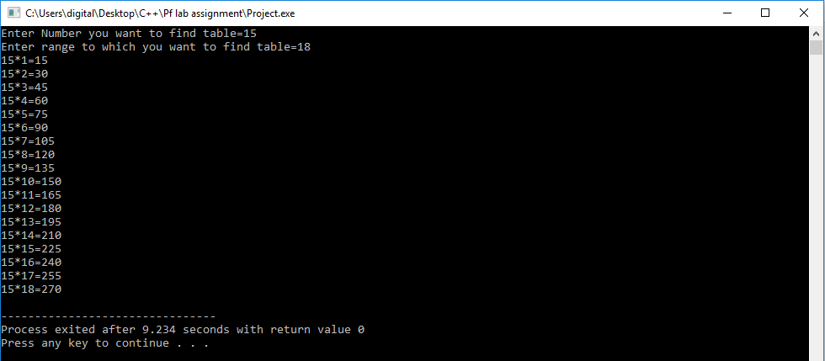

Q. No36: Write a program to validate the date entered by user for example 31st September 2018 is a wrong date as September only has 30 days and 29th February 2019 is a wrong date as 2019 is not a leap year

Code:

#include<iostream>

using namespace std;

int main()

{

int dd=0,mm=0,yy=0;

cout<<"Enter date:";

cin>>dd;

cout<<"Enter Month: ";

cin>>mm;

cout<<"Enter Year: ";

cin>>yy;

if(yy>0)

{

if(mm==1||mm==3||mm==5||mm==7||mm==8||mm==10||mm==12 && dd>0 && dd<31)

cout<<"Date is Valid";

else if(mm==4||mm==6||mm==9||mm==11 && dd>0 && dd<30)

cout<<"Date is Valid";

else if(mm==2)

{

if((yy%400==0||(yy%100!=0 && yy%4==0 )) && dd>0&&dd<=29)

cout<<"Date is Valid";

else

cout<<"Date is invalid";

}

else

cout<<"Date is invalid";

}

else

cout<<"Date is invalid";

return 0;

}

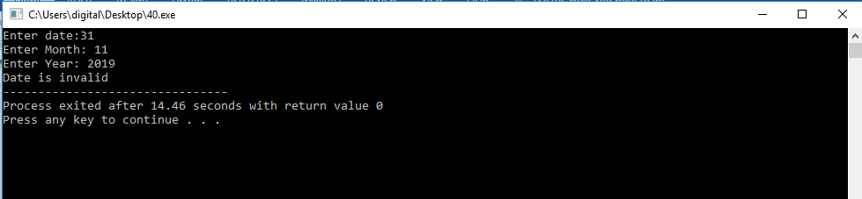

Q. No37: Write a C++ Program to find difference between two

times inputted in (hh:mm: ss) format

Code:

Q. No38: Write a C++ Program to find Fibonacci series till term 100

Code:

#include <iostream>

using namespace std;

int main()

{

int number=0,numb=1,sum=1;

cout<<"Fabonacci series:"<<number;

for (int i=0;i<100;i++)

{

sum=numb+number;

cout<<sum<<", ";

number=numb;

numb=sum;

}

return 0;

}

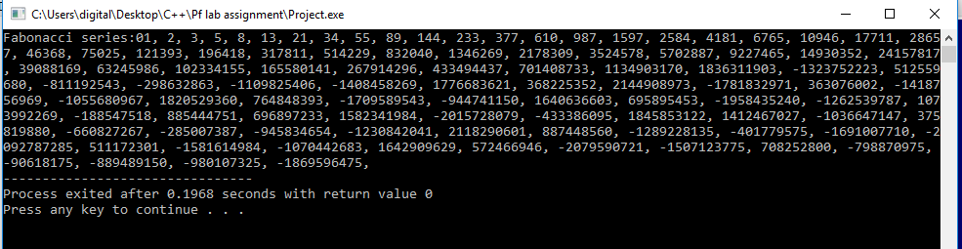

Q. No39: Write a c++ code to print out all Armstrong numbers between

1 and 500. If sum of cubes of each digit of the number is equal to the

number itself, then the number is called an Armstrong number. For

example, 153 = (1 * 1 * 1) + (5 * 5 * 5) + (3 * 3 * 3)

Code:

#include <iostream>

#include <math.h>

using namespace std;

int main()

{

int numb=0,arms=0;

for (int i=0;i<5;i++)

{

for (int j=0;j<10;j++)

{

for (int k=0;k<=10;k++)

{

numb=i*100+j*10+k;

arms=pow(i,3)+pow(j,3)+pow(k,3);

if (arms==numb)

{

cout<<numb<<" is an armstrong number"<<endl;

}

}

}

}

return 0;

}

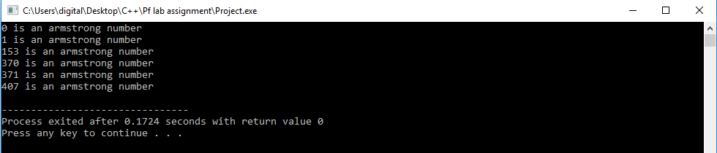

Q. No40: Design the Code for a program that calculates the current balance in a

savings account. The program should obtain from the user the following

information: the starting balance, the total amount of deposits made, the

total amount of withdrawals made, and the monthly interest rate. After the

program has calculated the current balance, it should be displayed on the

screen. Assume one input for deposits and one input for withdrawals.

Code:

#include<iostream>

#include<math.h>

using namespace std;

int main()

{

int a,b,c,sum,t;

float i;

cout<<"Enter the Starting balance=";

cin>>a;

cout<<"Enter the deposits=";

cin>>b;

cout<<"Enter the with-drawels=";

cin>>c;

sum=a+b;

cout<<"Enter the interest rate also=";

cin>>i;

i=i/100;

t=sum-c;

sum=t*i+t;

cout<<"The toatal current balance is="<<sum;

return 0;

}

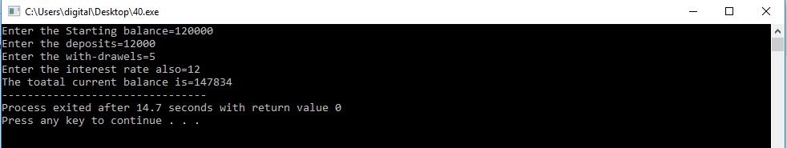

Q. No41: Write a Code to check whether a triangle is valid or not,

when the three angles of the triangle are entered by the user. A triangle is valid if the sum of all the three angles is equal to 180 degrees.

Code:

#include <iostream>

#include <math.h>

using namespace std;

int main()

{

int a=0,b=0,c=0,sum=0;

cout<<"Enter Angle of triangle= ";

cin>>a;

cout<<"Enter Angle of triangle= ";

cin>>b;

cout<<"Enter Angle of triangle= ";

cin>>c;

sum=a+b+c;

if (sum==180)

{

cout<<"It is a triangle."<<endl;

}

else

{

cout<<"It is not a triangle."<<endl;

}

return 0;

}

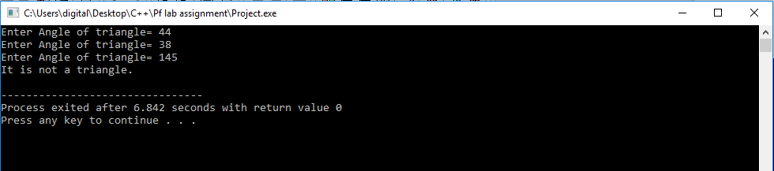

Q. No42: 42. Write a program to validate the date entered by user for example 31st September 2018 is a wrong date as September only has 30 days and 29th February 2019 is a wrong date as 2019 is not a leap year

Code:

#include<iostream>

using namespace std;

int main()

{

int dd=0,mm=0,yy=0;

cout<<"Enter date:";

cin>>dd;

cout<<"Enter Month: ";

cin>>mm;

cout<<"Enter Year: ";

cin>>yy;

if(yy>0)

{

if(mm==1||mm==3||mm==5||mm==7||mm==8||mm==10||mm==12 && dd>0 && dd<31)

cout<<"Date is Valid";

else if(mm==4||mm==6||mm==9||mm==11 && dd>0 && dd<30)

cout<<"Date is Valid";

else if(mm==2)

{

if((yy%400==0||(yy%100!=0 && yy%4==0 )) && dd>0&&dd<=29)

cout<<"Date is Valid";

else

cout<<"Date is invalid";

}

else

cout<<"Date is invalid";

}

else

cout<<"Date is invalid";

return 0;

}



Q. No43: Write a C++ program to produce the output as shown below:

Results:

x value y value expressions results

10 | 5 | x=y+3 | x=8

10 | 5 | x=y-2 | x=3

10 | 5 | x=y*5 | x=25

10 | 5 | x=x/y | x=2

10 | 5 | x=x%y | x=0

Code:

#include <iostream>

#include <math.h>

using namespace std;

int main()

{

cout<<10<<" | "<<5<<" | "<< " x=y+3" << " | x= " << 5+3 <<endl;

cout<<10<<" | "<<5<<" | "<< " x=y-2" << " | x= " << 5-3 <<endl;

cout<<10<<" | "<<5<<" | "<< " x=y*5" << " | x= " << 5*5 <<endl;

cout<<10<<" | "<<5<<" | "<< " x=x/y" << " | x= " << 10/5 <<endl;

cout<<10<<" | "<<5<<" | "<< " x=x%y" << " | x= " << 10%5 <<endl;

return 0;

}

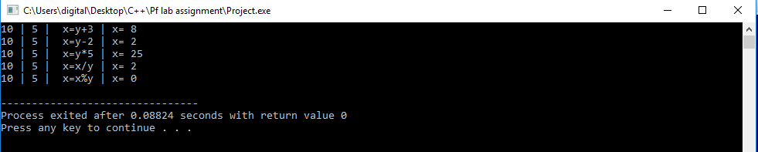

Q. No43: Write a program to prompt the user to input the integral

value of a and print out the result as

shown below:

Result:

The value of a is: 10 .......................... The value of ++a is: 11

Now the value of a is: 11

The value of a++ is: 11

Now the value of a is: 12

The value of --a is:11

Now the value of a is:11

The value of a-- is: 11

Now the value of a is: 10

Code:

#include <iostream>

#include <math.h>

using namespace std;

int main()

{

int a;

cout<<"Enter number: ";

cin>>a;

cout<<"The value of a is: "<<a<<"..........................";

cout<<"The value of ++a is: "<<++a<<endl;

cout<<"Now value of a is: "<<a<<endl;

cout<<"The value of a++ is: "<<a++<<endl;

cout<<"Now value of a is: "<<a<<endl;

cout<<"The value of --a is: "<<--a<<endl;

cout<<"Now value of a is: "<<a<<endl;

cout<<"The value of a-- is: "<<a--<<endl;

cout<<"Now value of a is: "<<a<<endl;

return 0;

}

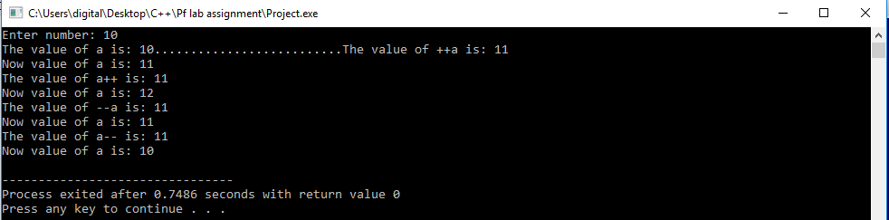

Q. No45: Write a code to calculate SGPA of a student

Code:

#include<iostream>

#include<math.h>

using namespace std;

int main()

{

float c=1,grs,s,gr=0,cr=0,et=0,a=0;

cout<<"Enter the Number of Subjects=";

cin>>s;

for(c=1;c<=s;++c)

{

cout<<"Enter the Grades=";

cin>>grs;

cout<<"Enter the Credit hour=";

cin>>et;

gr=gr+grs;

cr=cr+et;

}

a=gr/cr;

cout<<"SGPA="<<a;

return 0;

}

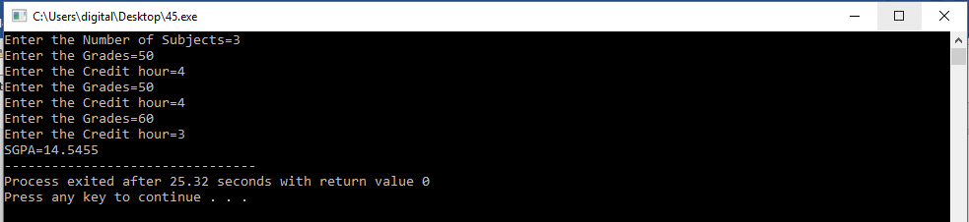

Q. No46: Write a C++ Program to print diamond star pattern series

using for loop. How to print diamond star pattern structure in

C++ Program . Logic to print diamond star pattern series in C++

Program ming.

Example

Input

Input rows: 5

Code:

#include <iostream>

#include <math.h>

using namespace std;

int main()

{

int i=0,j=0,k=0,row=0;

cout<<"Enter length :";

cin>>row;

for (i = 1; i <= row; i++)

{

for (j = 1; j <= row - i; j++)

{

cout << " ";

}

while (k != (2 * i - 1)) 414

{

cout << "*";

k++;

}

k = 0;

cout << endl;

}

row--;

for (i = row; i >= 1; i--)

{

for (j = 0; j <= row-i; j++)

{

cout << " ";

}

k = 0;

while (k != (2*i-1))

{

cout << "*";

k++;

}

cout << endl;

}

return 0;

}

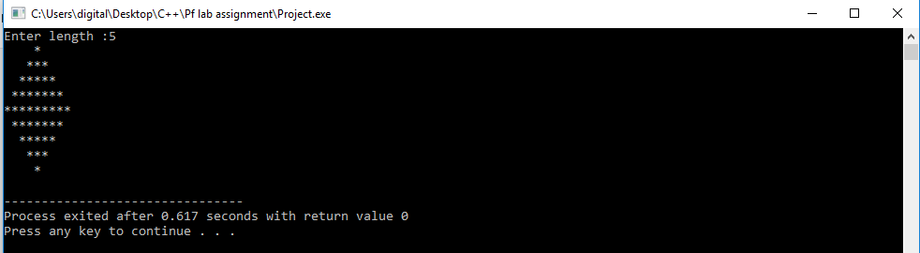

Q. No45: Write a C++ Program to toggle case of a character.

Code:

#include <iostream>

#include <math.h>

using namespace std;

int main()

{

int numb=0,numb1=0;

char alpha;

cout<<"Enter an alphabet: ";

cin>>alpha;

numb=static_cast<int>(alpha);

if ((numb>=65)&&(numb<=90))

{

numb1=numb+32;

cout<<"Toggle cased = "<<static_cast<char>(numb1)<<endl;

}

if ((numb>=97)&&(numb<=122))

{

numb1=numb-32;

cout<<"Toggle cased = "<<static_cast<char>(numb1)<<endl;

}

else

{

cout<<"You have entered invalid input"<<endl;

}

return 0;

}

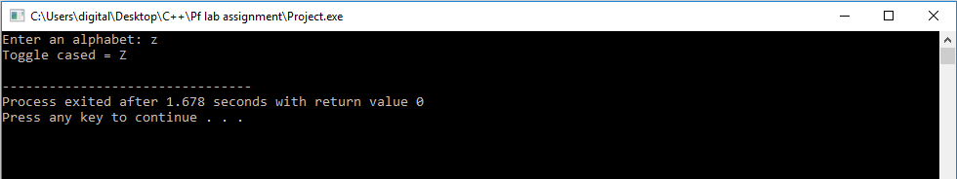

Q. No48 Write a C++ Program to find reverse of a number.

Code:

#include <iostream>

using namespace std;

int main()

{

int number=1,reverse=0,mod=0;

cout<<"Enter negative number to exit."<<endl;

while (number>0)

{

cout<<"Enter number=";

cin>>number;

if (number>0)

{

reverse=number;

cout<<"The number is "<<number<<" And its mod is ";

while (reverse>0)

{

mod=reverse%10;

reverse=reverse/10;

cout<<mod;

}

cout<<endl;

}

}

return 0;

}

