Muhammad Ahmer Zaman

18F-0336

Section C

Assignment 1

Sir Danish Shahzad

Q2:

Code:

#include<iostream>

#include<iomanip>

#include<string.h>

#include<windows.h>

using namespace std;

int main()

{

int arr[5];

int sum=0;

cout<<"Enter the Array entries :\n";

for(int i=0;i<5;i++)

{

cout<<"Enter the Entry at ARRAY ["<<i<<"] index = ";

cin>>arr[i];

}

int *ptr=arr;

for(int i=0;i<5;i++)

{

sum+=*(ptr+i);

}

cout<<"\n The sum of All the entries is :"<<sum;

system("pause>0");

}

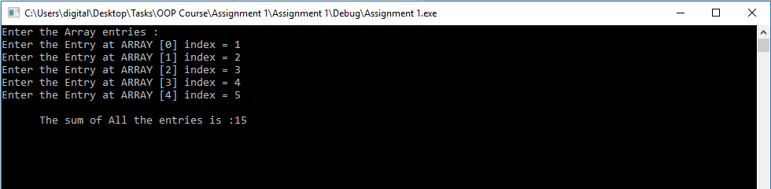

Q3:

Code:

#include<iostream>

#include<iomanip>

using namespace std;

int main()

{

int *arr=new int[10];

for(int j=0;j<10;j++)

{

cout<<"arr ["<<j<<"] = ";

cin>>arr[j];

}

double sum=0;

double avg=0;

for(int j=0;j<10;j++)

{

sum+=arr[j];

}

avg=sum/10;

cout<<"\nThe sum of the array elemwnt is "<<sum;

cout<<"\n The avergae of the 10 number is :"<<avg;

system("pause>0");

}

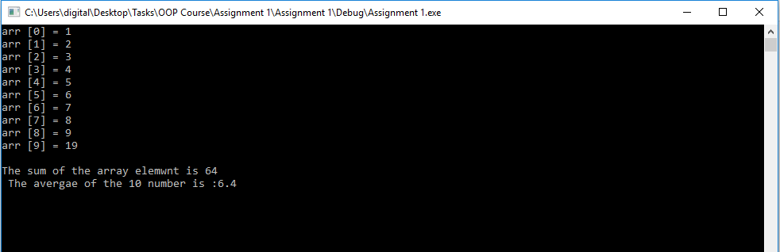

Q4:

Code:

#include<iostream>

using namespace std;

int main()

{

int ***arr = new int **[4];

for (int i = 0;i < 4;i++)

{

arr[i] = new int*[5];

for (int j = 0;j < 5;j++)

{

arr[i][j] = new int[10];

}

}

for (int i = 0;i < 4;i++)

{

for (int j = 0;j < 5;j++)

{

for (int k = 0;k < 10;k++)

{

cout << "arr [" << i << "]" << "[" << j << "]" << "[" << k << "] = ";

cin >> arr[i][j][k];

}

}

}

cout << "Now the output is :\n";

for (int i = 0;i < 4;i++)

{

for (int j = 0;j < 5;j++)

{

for (int k = 0;k < 10;k++)

{

cout << "arr [" << i << "]" << "[" << j << "]" << "[" << k << "] = " << arr[i][j][k] << endl;

}

}

}

delete[]arr;

system("pause>0");

}

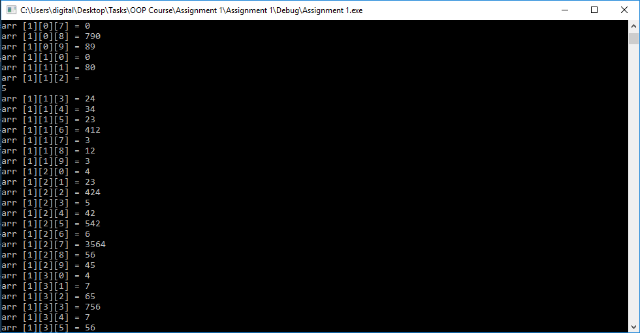

Q8:

Code:

#include<iostream>

#include<math.h>

using namespace std;

void selection_S(int arr1[], int size)

{

int Temp;

cout << "Enter elements of the array to sort=" << endl;

for (int i = 0;i < size;i++)

{

cin >> arr1[i];

}

for (int i = 0;i < size;i++)

{

for (int j = i + 1;j < size;j++)

{

if (arr1[i] > arr1[j])

{

Temp = arr1[i];

arr1[i] = arr1[j];

arr1[j] = Temp;

}

}

}

cout << "Array after selection sort is=" << endl;

for (int i = 0;i < size;i++)

{

cout << arr1[i];

cout << " ";

}

cout << endl;

}

void bubble_S(int arr1[], int size)

{

int Temp;

cout << "Enter elements of the array to sort=" << endl;

for (int i = 0;i < size;i++)

{

cin >> arr1[i];

}

for (int i = 0;i < size;i++)

{

for (int j = 0;j < size - 1;j++)

{

if (arr1[j] > arr1[j + 1])

{

Temp = arr1[j];

arr1[j] = arr1[j + 1];

arr1[j + 1] = Temp;

}

}

}

cout << "Array after bubble sorting is=" << endl;

for (int i = 0;i < size;i++)

{

cout << arr1[i];

cout << " ";

}

cout << endl;

}

void insertion_S(int arr1[], int size)

{

int Temp;

int j;

cout << "Enter elements of the array to sort=" << endl;

for (int i = 0;i < size;i++)

{

cin >> arr1[i];

}

for (int i = 0;i < size;i++)

{

Temp = arr1[i];

j = i - 1;

while (j >= 0 && arr1[j] > Temp)

{

arr1[j + 1] = arr1[j];

j = j - 1;

}

arr1[j + 1] = Temp;

}

cout << "Array after insertion sort is=" << endl;

for (int i = 0;i < size;i++)

{

cout << arr1[i];

cout << " ";

}

cout << endl;

}

int main()

{

int s;

cout << "Please enter size of array=" << endl;

cin >> s;

int arr2[20];

selection_S(arr2, s);

bubble_S(arr2, s);

insertion_S(arr2, s);

system("pause>0");

}

