**QUESTION 2**

**CODE:**

#include<iostream>

using namespace std;

int main()

{

int size, sum = 0;

cout << "Enter size of the array:";

cin >> size;

int *arr = new int[size];

cout << "Enter elements of array:";

for (int i = 0; i < size; i++)

{

cin >> *(arr + i);

sum = sum + *(arr + i);

}

cout << "Sum of the array elements:" << sum;

delete[]arr;

arr = NULL;

cout << endl;

system("pause");

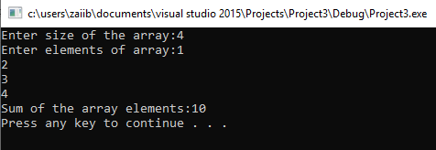}

**QUESTION 3**

**CODE:**

#include<iostream>

using namespace std;

int main()

{

int sum = 0;

int *arr = new int[10];

cout << "Enter elements of array:";

for (int i = 0; i < 10; i++)

{

cin >> *(arr + i);

sum = sum + *(arr + i);

}

cout << "Sum of the array elements:" << sum << endl;

cout << "Average of the array elements:" << sum / 10;

delete[]arr;

arr = NULL;

cout << endl;

system("pause");

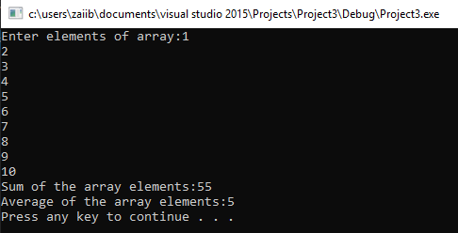}

**QUESTION 4**

**CODE:**

#include<iostream>

using namespace std;

int main()

{

int***arr = new int**[4];

for (int i = 0; i < 4; i++)

{

arr[i] = new int*[5];

for (int j = 0; j < 5; j++)

{

arr[i][j] = new int[10];

}

}

cout << "Enter elements of array:";

for (int i = 0; i < 4; i++)

{

for (int j = 0; j < 5; j++)

{

for (int k = 0; k < 10; k++)

{

cin >> *(*(*(arr + i) + j) + k);

}

}

}

cout << "Elements of array are:";

for (int i = 0; i < 4; i++)

{

for (int j = 0; j < 5; j++)

{

for (int k = 0; k < 10; k++)

{

cout << *(*(*(arr + i) + j) + k);

}

cout << endl;

}

cout << endl << endl;

}

for (int i = 0; i < 4; i++)

{

for (int j = 0; j < 5; j++)

{

delete[] arr[i][j];

}

delete[] arr[i];

}

delete[] arr;

arr = NULL;

cout << endl << endl;

system("pause");

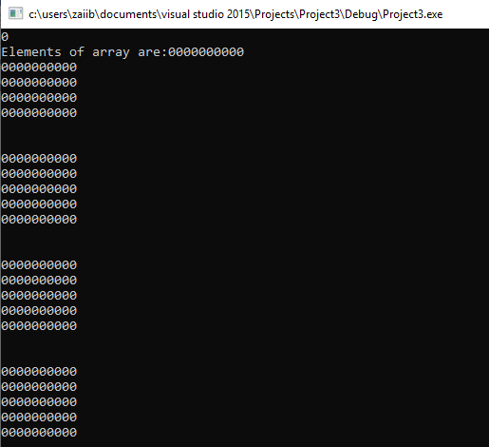}

**QUESTION 7**

**CODE:**

#include<iostream>

using namespace std;

int main()

{

int **matrix1, **matrix2, **mul;

int r1, r2, c1, c2;

cout << "Enter rows of first matrix:";

cin >> r1;

cout << "Enter columns of first matrix:";

cin >> c1;

matrix1 = new int*[r1];

for (int i = 0; i < r1; i++)

{

*(matrix1 + i) = new int[c1];

}

cout << "Enter elements of first matrix: ";

for (int i = 0; i < r1; i++)

{

for (int j = 0; j < c1; j++)

{

cin >> *(*(matrix1 + i) + j);

}

}

cout << "Enter rows of second matrix: ";

cin >> r2;

cout << "Enter columns of second matrix: ";

cin >> c2;

matrix2 = new int*[r2];

for (int i = 0; i < r2; i++)

{

*(matrix2 + i) = new int[c2];

}

cout << "Enter elements of second matrix: ";

for (int i = 0; i < r2; i++)

{

for (int j = 0; j < c2; j++)

{

cin >> *(*(matrix2 + i) + j);

}

}

if (r1 != r2 || c1 != c2)

{

cout << "Arrays don't have same order: ";

}

else

{

cout << "Sum of Arrays:" << endl;

for (int i = 0; i < r2; i++)

{

for (int j = 0; j < c2; j++)

{

cout << *(*(matrix1 + i) + j) + *(*(matrix2 + i) + j) << " ";

}

cout << endl;

}

cout << "Difference of Arrays: " << endl;

for (int i = 0; i < r2; i++)

{

for (int j = 0; j < c2; j++)

{

cout << *(*(matrix1 + i) + j) - *(*(matrix2 + i) + j) << " ";

}

cout << endl;

}

}

if (c1 == r2)

{

int**mul;

mul = new int*[r2];

for (int i = 0; i < c1; i++)

{

*(mul + i) = new int[r2];

}

for (int i = 0; i < c1; i++)

{

for (int j = 0; j < c1; j++)

{

mul[i][j] = 0;

for (int k = 0; k < r2; k++)

{

mul[i][j] += matrix1[i][k] * matrix2[k][j];

}

}

}

cout << "Product of Arrays: " << endl;

for (int i = 0; i < c1; i++)

{

for (int j = 0; j < r2; j++)

{

cout << *(*(mul + i) + j) << " ";

}

cout << endl;

}

}

else

{

cout << "Arrays cannot be multiplied!";

}

for (int i = 0; i < r1; i++)

{

delete[]matrix1[i];

}

delete[]matrix1;

matrix1 = NULL;

for (int i = 0; i < r2; i++)

{

delete[]matrix2[i];

}

delete[]matrix2;

matrix2 = NULL;

cout << endl << endl;

system("pause");

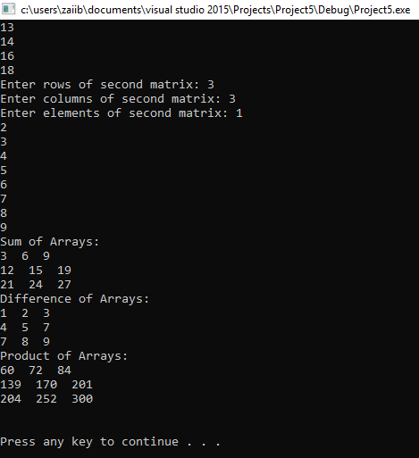}

**QUESTION 8**

**CODE:**

#include<iostream>

using namespace std;

int*bubbleSort(int*arr, int size)

{

int temp;

for (int i = 0; i < size - 1; i++)

{

for (int j = 0; j < size - i - 1; j++)

{

if (arr[j] > arr[j + 1])

{

temp = arr[j];

arr[j] = arr[j + 1];

arr[j + 1] = temp;

}

}

}

return arr;

}

int*selectionSort(int*arr, int size)

{

int temp, select;

for (int i = size - 1; i > 0; i--)

{

select = 0;

for (int j = 0; j <= i; j++)

{

if (arr[j] > arr[select])

{

select = j;

}

}

temp = arr[select];

arr[select] = arr[i];

arr[i] = temp;

}

return arr;

}

int*insertionSort(int*arr, int size)

{

int key, j;

for (int i = 1; i < size; i++)

{

key = arr[i];

for (j = i - 1; j >= 0 && arr[j] > key; j--)

{

arr[j + 1] = arr[j];

}

arr[j + 1] = key;

}

return arr;

}

int main()

{

char cond;

int size;

cout << "Enter size: ";

cin >> size;

int *arr;

arr = new int[size];

cout << "Enter elements in array: " << endl;

for (int i = 0; i < size; i++)

{

cin >> *(arr + i);

}

cout << "1 for Bubble sorting: " << endl

<< "2 for selection sorting: " << endl

<< "3 for insertion sorting: " << endl;

cin >> cond;

switch (cond)

{

case '1':

bubbleSort(arr, size);

break;

case '2':

selectionSort(arr, size);

break;

case '3':

insertionSort(arr, size);

break;

default:

cout << endl;

}

for (int i = 0; i < size; i++)

{

cout << *(arr + i) << endl;

}

delete[]arr;

arr = NULL;

cout << endl;

system("pause");

