Question 1:

Code:

#include <iostream>

using namespace std;

class Matrix

{

private:

int size;

int *ptr;

public:

void get(int a)

{

size = a;

ptr = new int[a];

for (int i = 0;i < a;i++)

{

ptr[i] = i;

}

}

void Disp()

{

for (int i = 0;i < size;i++)

{

cout << ptr[i] << " ";

}

cout << endl;

}

void operator[](int index)

{

if (index >= size)

{

cout << "Array Out of Bound";

}

else

{

cout << "Value= " << ptr[index];

}

cout << endl << endl;

}

};

int main()

{

int s = 0, i = 0;

int Exit = 0;

Matrix Arr;

do

{

cout << "Enter Positive Integer for Size of Array:" << endl;

cin >> s;

} while (s <= 0);

Arr.get(s);

Arr.Disp();

do

{

do

{

cout << "Enter A positive Index Number to Check: " << endl;

cin >> i;

} while (i <= 0);

Arr[i];

cout << "If You donot Want to Continue, Enter 0 to Exit!!!" << endl << endl;

cin >> Exit;

} while (Exit != 0);

cout << "You Exitted!" << endl;

system("pause>0");

return 0;

}

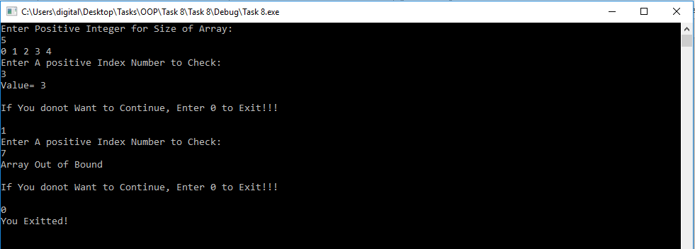

Question 2:

Code:

#include <iostream>

using namespace std;

class Time

{

private:

int Hour;

int Minutes;

int Seconds;

public:

void Reg()

{

string

command,

name, password,

inName, inPassword,

registerName, registerPassword;

ofstream g("registration.txt");

if (!g.is_open())

{

cout << "could not open file\n";

return 0;

}

cout << "\n\n\n"

<< "New Username: ";

getline(cin, registerName);

cout << "New Password: ";

getline(cin, registerPassword);

g << registerName;

g << '\n';

g << registerPassword;

g.close();

}

void get()

{

do

{

cout << "Enter Hours: " << endl;

cin >> Hour;

} while (Hour <= 0 || Hour >= 24);

do

{

cout << "Enter Minutes: " << endl;

cin >> Minutes;

} while ((Minutes <= 0 || Minutes >= 59));

do

{

cout << "Enter Seconds: " << endl;

cin >> Seconds;

} while ((Seconds <= 0 || Seconds >= 59));

}

void Disp()

{

if (Hour < 10)

{

cout << "0" << Hour << " : ";

}

else if (Hour>=23)

{

cout << "Next Day " << Hour << " : ";

}

else if (Hour < 0)

{

cout << "Previous Day " << Hour<< " : ";

}

else

{

cout << Hour << " : ";

}

if (Minutes < 10)

{

cout << "0" << Minutes << " : ";

}

else

{

cout << Minutes << " : ";

}

if (Seconds < 10)

{

cout << "0" << Seconds << endl;

}

else

{

cout << Seconds << endl;

}

}

Time operator+(Time t2)

{

Time t;

t.Hour = Hour + t2.Hour;

t.Minutes = Minutes + t2.Minutes;

t.Seconds = Seconds + t2.Seconds;

if (t.Seconds >= 60)

{

t.Seconds = t.Seconds - 60;

t.Minutes = t.Minutes + 1;

}

if (t.Minutes >= 60)

{

t.Minutes = t.Minutes - 60;

t.Hour = t.Hour + 1;

}

return t;

}

Time operator-(Time t2)

{

Time t;

t.Hour = Hour - t2.Hour;

t.Minutes = Minutes - t2.Minutes;

t.Seconds = Seconds - t2.Seconds;

if (t.Seconds <= 0)

{

t.Seconds = 60 - t.Seconds;

t.Minutes = t.Minutes - 1;

}

if (t.Minutes <= 0)

{

t.Minutes = 60 - t.Minutes;

t.Hour = t.Hour - 1;

}

return t;

}

Time operator*(Time t2)

{

Time t;

t.Hour = Hour * t2.Hour;

t.Minutes = Minutes * t2.Minutes;

t.Seconds = Seconds * t2.Seconds;

return t;

}

Time operator/(Time t2)

{

Time t;

t.Hour = Hour / t2.Hour;

t.Minutes = Minutes / t2.Minutes;

t.Seconds = Seconds / t2.Seconds;

return t;

}

Time operator--()

{

Time t;

t.Hour = --Hour;

t.Minutes = --Minutes;

t.Seconds = --Seconds;

return t;

}

Time operator--(int)

{

Time t;

t.Hour = Hour--;

t.Minutes = Minutes--;

t.Seconds = Seconds--;

return t;

}

Time operator++()

{

Time t;

t.Hour = ++Hour;

t.Minutes = Minutes;

t.Seconds = Seconds;

return t;

}

Time operator++(int)

{

Time t;

t.Hour = Hour++;

t.Minutes = Minutes++;

t.Seconds = Seconds++;

return t;

}

};

int main()

{

Time T1,T2;

T1.get();

T1.Disp();

T2.get();

T2.Disp();

Time T3 = T1 + T2;

T3.Disp();

Time T4 = T1 - T2;

T4.Disp();

Time T5 = T1 * T2;

T5.Disp();

Time T6 = T1 / T2;

T6.Disp();

Time T7 = ++T1;

T7.Disp();

Time T8 = T1++;

T8.Disp();

Time T9 = --T1;

T9.Disp();

Time T10 = T1--;

T10.Disp();

system("pause>0");

return 0;

}

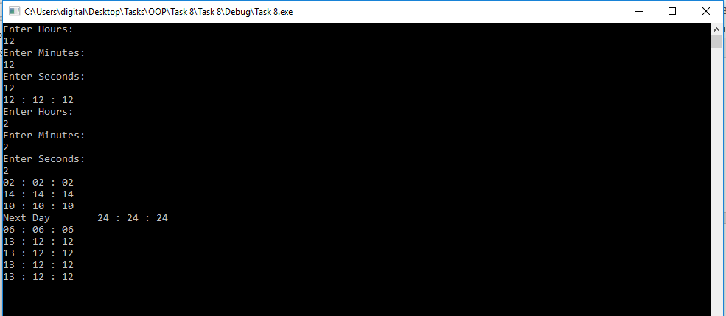

Question 3:

Code 3:

#include<iostream>

#include<fstream>

#include<string>

using namespace std;

class User

{

public:

string

Name,

ID,

Password;

};

class Student :public User

{

private:

int Total_Subjects,Total_Credits, Total_Credits_Earned,ss,sp;

string *Subjects_Studying, *Subjects_Passed;

float CGPA;

public:

void get()

{

do

{

cout << "Enter Total Number of Subjects You are Studying: ";

cin >> Total_Subjects;

} while (Total_Subjects <= 0);

do

{

cout << "Enter Number of Subjects You are Currently Studying: ";

cin >> ss;

} while (ss <= 0);

do

{

cout << "Enter Number of Subjects You have Passed: ";

cin >> sp;

} while(sp <= 0);

Subjects_Studying = new string[ss];

Subjects_Passed = new string[sp];

for (int i = 0;i < ss;i++)

{

cout << "Enter Subjects Number " << i + 1 << " Which You are Currently Studying";

cin >> Subjects_Studying[i];

}

for (int i = 0;i < ss;i++)

{

cout << "Enter Subjects Number " << i + 1 << " Which You have passed";

cin >> Subjects_Passed[i];

}

do

{

cout << "Enter Total Credit Hours: ";

cin >> Total_Credits;

} while (Total_Credits <= 0);

do

{

cout << "Enter Attempted Credit Hours: ";

cin >> Total_Credits_Earned;

} while (Total_Credits_Earned <= 0);

do

{

cout << "Enter CGPA: ";

cin >> CGPA;

} while (CGPA < 0||CGPA > 4);

}

};

class Teacher :public User

{

private:

int Total_Subs;

string * Sub_Teach;

int * Studs;

public:

void get()

{

do

{

cout << "Enter Total number of Subjects Teaching: "

cin >> Total_Subs;

} while (Total_Subs <= 0);

Sub_Teach = new int[Total_Subs];

for (int i = 0;i < ss;i++)

{

cout << "Enter Name of Subjects Number " << i + 1 <<;

cin >> Sub_Teach[i];

}

}

};