18F-0336

Section C

Muhammad Ahmer Zaman

Task 1

Question 1:

Write a Program in which you declare 2 integer pointers. Now take your roll no. 18F-XXYY and

Pointer P1 should have a value that is equal to the first 2 digits of your roll no. XX and Pointer

P2 should have a value that is equal to the last 2 digits of your roll no. YY. The write a function

in which these two pointers are passed as reference and no other variable is created in the

function and it should swap the value of pointers. You are not allowed to use SWAP function.

Display the value of the pointers before and after calling the function.

Output:

Roll no: 18F-XXYY

P1: XX P2: YY

P1: YY P2: XX

Code:

#include <iostream>

using namespace std;

void swapp(int *P1, int *P2);

int main()

{

int *P1, *P2;

int arr[2] = { 0 };

cout << "Enter Roll number in Format 18F-XXYY" << endl;

cout << "Enter XX" << endl;

do

{

cin >> arr[0];

if (arr[0] > 100)

{

cout << "Enter again.." << endl;

}

} while (arr[0] >= 100);

cout << "Enter YY" << endl;

P1 = &arr[0];

do

{

cin >> arr[1];

if (arr[1] > 100)

{

cout << "Enter again.." << endl;

}

} while (arr[1] >= 100);

P2 = &arr[1];

if (*P1 < 10)

{

cout << "Roll Number: 18F-0" << *P1 << *P2 << endl;

}

else if (*P2 < 10)

{

cout << "Roll Number: 18F-" << *P1 << "0" << *P2 << endl;

}

else if ((*P1 < 10) && (*P2 < 10))

{

cout << "Roll Number: 18F-0" << *P1 << "0" << *P2 << endl;

}

else

{

cout << "Roll Number: 18F-" << *P1 << *P2 << endl;

}

swapp(P1, P2);

system("pause>0");

return 0;

}

void swapp(int *P1, int *P2)

{

cout << "P1: " << *P1 << " P2: " << *P2 << endl;

*P2 = *P1 + *P2;

*P1 = *P2 - *P1;

*P2 = *P2 - *P1;

cout << "P1: " << *P1 << " P2: " << *P2 << endl;

}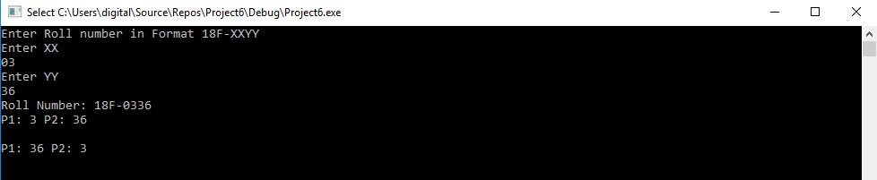

Question 2:

#include <iostream>

using namespace std;

void ROLL_DICE(int * Ptr);

int main()

{

int arr[4] = { 0 };

int * iPtr=arr;

cout << "Enter Roll Number in format 18F-WXYZ" << endl;

for (int i = 0;i < 4;i++)

{

cin >> iPtr[i];

}

cout << "Roll Number: ";

for (int i = 0;i < 4;i++)

{

cout << *(iPtr++);

}

cout << endl;

*iPtr = arr[0] + arr[1] + arr[2] + arr[3];

cout << "P1 : " << *iPtr << endl;

for (int i = 1;i <= *iPtr;i++)

{

cout << "Value " << i <<" : ";

ROLL_DICE(iPtr);

}

system("pause>0");

return 0;

}

void ROLL_DICE(int * iPtr)

{

cout << rand() % 6 + 1 << endl;

}

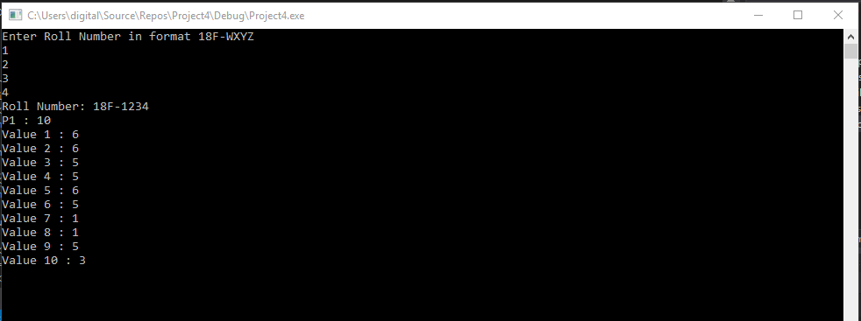

Question 3:

Design a calculator that performs:

1) Addition

2) Subtraction

3) Multiplication

4) Division

Create functions ADD SUB MUL DIV and for each arithmetic operation that takes 2 Pointers and

uses those pointer to perform the operations then returns another pointer.

In the main program you take 2 number inputs and 1 operation input form the user and call the

above functions accordingly.

Code:

#include <iostream>

using namespace std;

void Add(int * P1, int * P2);

void Sub(int * P1, int * P2);

void Pro(int * P1, int * P2);

void Div(int * P1, int * P2);

int main()

{

int First = 0, Second = 0, Select;

int * P1, *P2;

P1 = &First;

P2 = &Second;

cout << "Enter First and Second Number = " << endl;

cin >> First >> Second;

cout << endl;

cout << "Enter 1 for Addition" << endl;

cout << "Enter 2 for Subtraction" << endl;

cout << "Enter 3 for Multiplication" << endl;

cout << "Enter 4 for Division" << endl;

cout << "Anyother to Exit" << endl;

cout << "Enter Operation Selection" << endl << endl;

cin >> Select;

if (Select == 1)

{

Add(P1, P2);

}

else if (Select == 2)

{

Sub(P1, P2);

}

else if (Select == 3)

{

Pro(P1, P2);

}

else if (Select == 4)

{

Div(P1, P2);

}

else

{

cout << "Exitted..." << endl;

}

system("pause>0");

return 0;

}

void Add(int * P1, int * P2)

{

cout << "Addition= " << *P1 + *P2 << endl;

}

void Sub(int * P1, int * P2)

{

cout << "Subtraction= " << *P1 - *P2 << endl;

}

void Pro(int * P1, int * P2)

{

cout << "Multiplication= " << *P1 * *P2 << endl;

}

void Div(int * P1, int * P2)

{

if (&P1 != 0)

{

cout << "Division= " << *P1 / *P2 << endl;

}

else

{

cout << "Math Error" << endl;

}

}

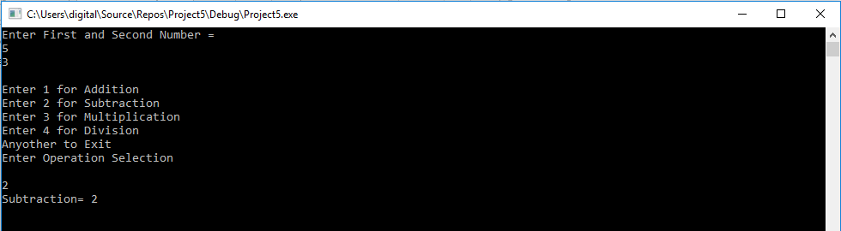

Question 4:

1) Create a program that creates pointers of integer type, floating type, character type and

string type. Take input from the users in each type and display its output.

2) As you know an integer is of 4 bytes and a char is of 1 bytes. Declare different types of

pointer and display the amount of memory they are using

HINT: you can use sizeof() function.

CODE:

#include <iostream>

#include <string>

using namespace std;

void swapp(int *P1, int *P2);

int main()

{

int numb = 0;

int *iPtr = &numb;

char word;

char *cPtr = &word;

string str;

string *sPtr = &str;

float deci;

float *fPtr = &deci;

cout << "Enter Interger" << endl;

cin >> numb;

cout << "Enter Character" << endl;

cin >> word;

cout << "Enter String" << endl;

cin >> str;

cout << "Enter float" << endl;

cin >> deci;

cout << "Integer = " << *iPtr << endl;

cout << "Character = " << *cPtr << endl;

cout << "String = " << *sPtr << endl;

cout << "Float = " << *fPtr << endl << endl;

cout << "Size of Integer = " << sizeof( *iPtr) << endl;

cout << "Size of Character = " << sizeof( *cPtr) << endl;

cout << "Size of String = " << sizeof( *sPtr) << endl;

cout << "Size of Float = " << sizeof ( *fPtr) << endl;

system("pause>0");

return 0;

}

