Problem 1:

#include <iostream>

using namespace std;

class Matrix

{

private:

int row, column;

int \*\* ptr;

public:

Matrix(int a,int b)

{

row = a;

column = b;

ptr = new int\*[row];

for (int i = 0;i < row;i++)

{

ptr[i] = new int[column];

}

for(int i=0;i<row;i++)

{

for (int j = 0;j < column;j++)

{

ptr[i][j] = 0;

}

}

}

// Matrix()

// {

//

// };

void input()

{

cout << "Enter Values:" << endl;

for (int i = 0;i < row;i++)

{

for (int j = 0;j < column;j++)

{

cin >> ptr[i][j];

}

}

}

int operator==(Matrix S)

{

if ((row == S.row) && (column == S.column))

{

return 1;

}

return 0;

}

Matrix operator+(Matrix S)

{

Matrix temp(S.row,S.column);

for (int i = 0;i < row;i++)

{

for (int j = 0;j < column;j++)

{

temp.ptr[i][j] = ptr[i][j] + S.ptr[i][j];

}

}

return temp;

}

Matrix operator-(Matrix S)

{

Matrix temp(S.row, S.column);

for (int i = 0;i < row;i++)

{

for (int j = 0;j < column;j++)

{

temp.ptr[i][j] = ptr[i][j] - S.ptr[i][j];

}

temp.row = row;

temp.column = column;

}

return temp;

}

Matrix operator\*(Matrix S)

{

Matrix temp(S.row,S.column);

for (int i = 0;i < row;i++)

{

for (int j = 0;j < column;j++)

{

for (int k = 0;k < column;k++)

{

temp.ptr[i][j] = temp.ptr[i][j] + ptr[i][k] \* S.ptr[k][j];

}

}

}

return temp;

}

void show()

{

for (int i = 0;i < row;i++)

{

for (int j = 0;j < column;j++)

{

cout << ptr[i][j] << " ";

}

cout << endl;

}

}

};

int main()

{

int x = 0, y = 0;

cout << "Enter number of Rows:";

cin >> x;

cout << "Enter number of Columns:";

cin >> y;

Matrix m1(x,y), m2(x, y), m3(x, y), m4(x, y), m5(x, y);

m1.input();

m2.input();

if (m1 == m2)

{

m3 = m1 + m2;

m4 = m1 - m2;

m5 = m1 \* m2;

cout << "Addition of matrices: " << endl;

m3.show();

cout << "Subtraction of matrices: " << endl;

m4.show();

cout << "Multiplication of matrices: " << endl;

m5.show();

}

else

{

cout << "Order of the input matrices is not identical" << endl;

}

system("pause>0");

return 0;

}

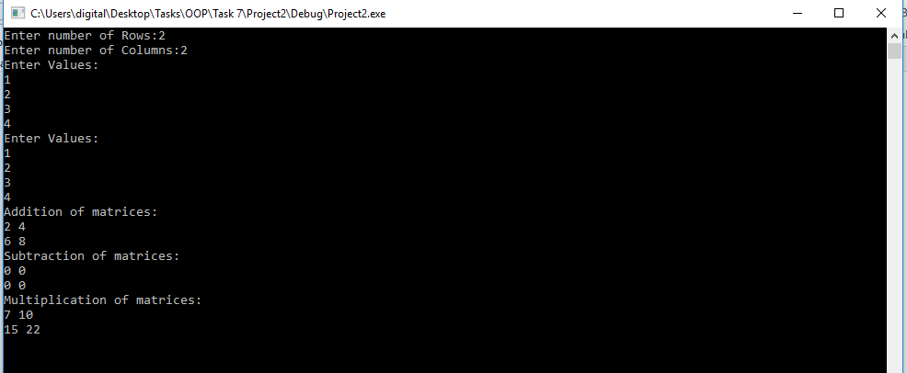

Problem 2:

#include <iostream>

using namespace std;

class instance

{

private:

static int count;

public:

instance()

{

count++;

}

void show()

{

cout << "Class is Called total " << count << " times!" << endl;

}

};

int instance :: count = 0;

int main()

{

instance x, y, z;

z.show();

system("pause>0");

return 0;

}

