Develop an Employee Management Lightning Web Component
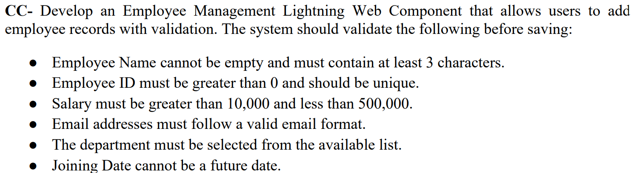
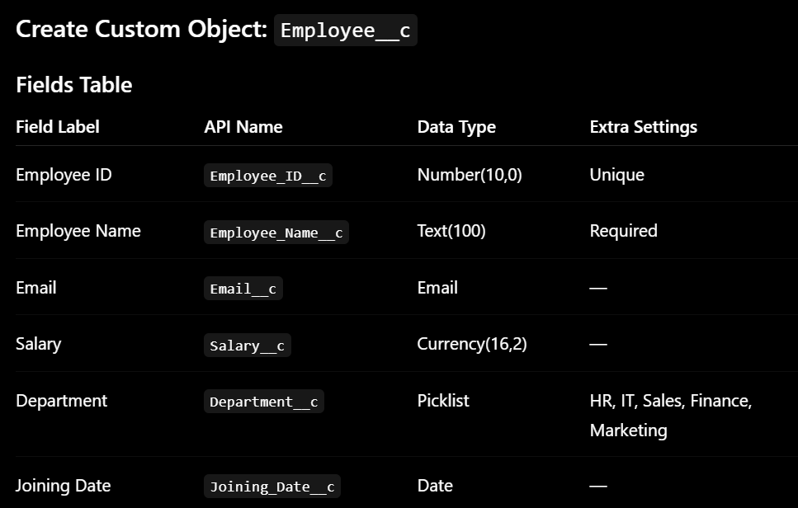

Validation Rule Conditions

1. Employee Name Validation
Condition:
- Cannot be empty
- Must contain at least 3 characters
Formula:
OR(
ISBLANK(Employee_Name__c),
LEN(Employee_Name__c) < 3
)
Error Message:
Employee Name must contain at least 3 characters.

2. Employee ID Validation
Condition:
- Must be greater than 0
Formula:
Employee_ID__c <= 0
Error Message:
Employee ID must be greater than 0.

3. Employee ID Unique Validation
Instead of validation rule:
While creating field:
✔ Check:
Unique
Salesforce automatically prevents duplicates.

4. Salary Validation
Condition:
- Greater than 10,000
- Less than 500,000
Formula:
OR(
Salary__c <= 10000,
Salary__c >= 500000
)
Error Message:
Salary must be between 10,000 and 500,000.

5. Email Validation
If field type is Email, Salesforce automatically validates format.
No extra validation needed.

6. Department Validation
If field is marked Required OR handled in LWC:
No validation rule needed.
Otherwise:
ISBLANK(TEXT(Department__c))
Error Message:
Please select a Department.

7. Joining Date Validation
Condition:
- Cannot be future date
Formula:
Joining_Date__c > TODAY()
Error Message:
Joining Date cannot be a future date.

Best Practice for This Assignment
Use:
✔ Required checkbox for:
- Name
- Department
✔ Unique checkbox for:
- Employee ID
✔ Email datatype for:
- Email validation

Develop a College Management Lightning Application
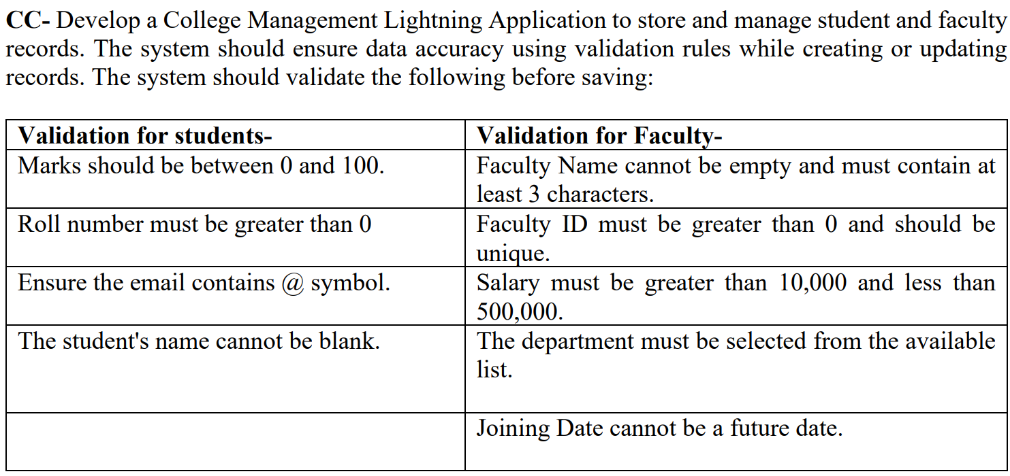
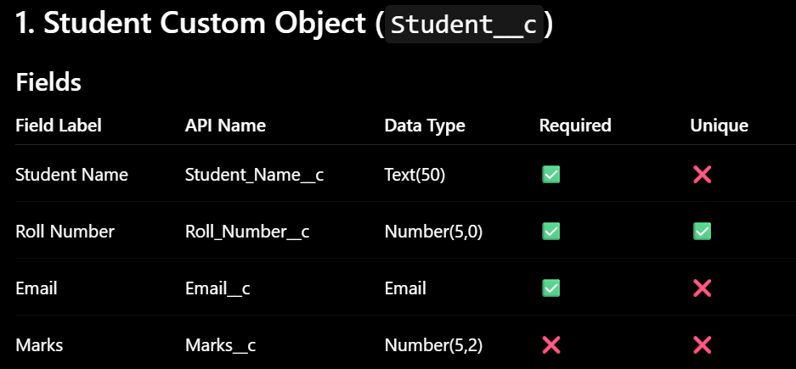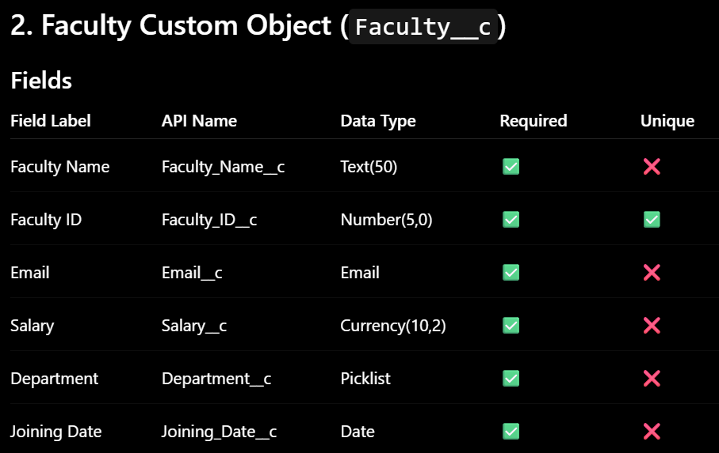
Student Validation Rules
1. Roll Number must be greater than 0 and exactly 5 digits
Rule Name
Student_Roll_Number_Validation
Formula
OR(
Roll_Number__c <= 0,
LEN(TEXT(Roll_Number__c)) != 5
)
Error Message
Roll Number must be positive and exactly 5 digits.

2. Marks should be between 0 and 100
Rule Name
Student_Marks_Validation
Formula
OR(
Marks__c < 0,
Marks__c > 100
)
Error Message
Marks must be between 0 and 100.

Faculty Validation Rules
1. Faculty Name must contain at least 3 characters
Rule Name
Faculty_Name_Validation
Formula
LEN(Faculty_Name__c) < 3
Error Message
Faculty Name must contain at least 3 characters.

2. Faculty ID must be greater than 0 and exactly 5 digits
Rule Name
Faculty_ID_Validation
Formula
OR(
Faculty_ID__c <= 0,
LEN(TEXT(Faculty_ID__c)) != 5
)
Error Message
Faculty ID must be positive and exactly 5 digits.

3. Salary must be between 10,000 and 500,000
Rule Name
Faculty_Salary_Validation
Formula
OR(
Salary__c <= 10000,
Salary__c >= 500000
)
Error Message
Salary must be greater than 10,000 and less than 500,000.

4. Joining Date cannot be future date
Rule Name
Faculty_Joining_Date_Validation
Formula
Joining_Date__c > TODAY()
Error Message
Joining Date cannot be a future date.

Picklist Values for Department
Create Picklist values like:
Computer
IT
Mechanical
Civil
ENTC
AI & DS

Final Setup Summary
Mark as Required
- Student Name
- Roll Number
- Email
- Faculty Name
- Faculty ID
- Salary
- Department
- Joining Date

Mark as Unique
- Roll Number
- Faculty ID

Use Email Field Type
- Student Email
- Faculty Email
Salesforce automatically validates email format.

