AHSANULLAH UNIVERSITY OF SCIENCE & TECHNOLOGY
Dept. Of Computer Science & Technology



Course no: CSE 316
Course name: Microprocessor Based System Design Lab

PROJECT PROPOSAL (C1)

Submitted To:

Md. Mosaddek Khan

Submitted By:

1. Taslima Rahman Prema 2. Nure Naushin Sharmy
Id: 11.01.04.121 Id: 11.01.04.124

3. Shakila Sarker 4. Sadia Jahan
Id : 11.01.04.135 Id: 11.01.04.157

INDEX

Project Title………………………………………………………………………. 2
Abstract……………………………………….……………………………………. 2
Block Diagram……………………………………………………………….…... 3
Description………………………………………………………………………... 4
Name of Microcontroller……………………………………………………. 5
Time Formation………………………………………………………………… 6

Page No: 01

Project Title:

Password Based Door Locking System.

Abstract:

Many times we forgot to carry the key of our home. Or sometimes we come out of our home and door latch closes by mistake. In these cases it is really difficult to get inside the house. Moreover, In day to day life security of any object or place is plays a major role. This project has considered about that and created a secure access for a door which needs a password to open the door. Using keypad it enters a password to the system and if it is entered correctly door is open by motor which is used to rotate the handle of the door lock. The Buzzer will be tuned when password is entered wrong for multiple times. Some features like adding new users and changing old password are configure by the keypad.LCD module is used to display messages to the user.

Page No: 02

Block Diagram:

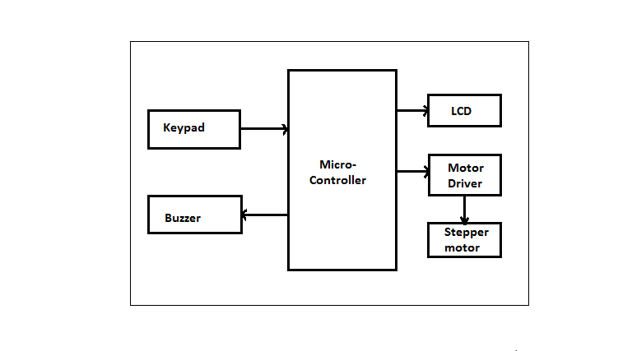
Figure: Block Diagram of Password based door locking system.

Page No: 03

Description:

Our project mainly consists of following blocks:

- Microcontroller:
This is the CPU (central processing unit) of our project. We are going to use a microcontroller of 8051 family. The various functions of microcontroller are like:
- Reading the digital input from Keypad
- Sending this data to LCD so that the person operating this project should read the password
- Sensing the password using keypad and to check whether it is a correct password or a wrong password and rotate the stepper motor if the password entered is a correct password.
- Sending the data to the computer using serial port. This data consist of the status of entered password (Correct/wrong).

Page No: 04

- LCD:
We are going to use 16x2 alphanumeric Liquid Crystal Display (LCD) which means it can display alphabets along with numbers on 2 lines each containing 16 characters.

- Buzzer:
We are going to use a buzzer to indicate the wrong password to open the door.

- Keypad:
User will enter the password using the keypad. Various keys of keypad are as following
      - 0 to 9
      - Enter
      - Escape

Name of the microcontroller:

We are using microprocesor 8051 for the password based door locking system.

Page No: 05

Time formation:

- 1st week:
In the 1st week we will draw the circuit diagram of our proposed system & also create a list of required equipments.

- 2nd week:
After that in the next week we will test our required equipments to check whether they work or not & also we will do the coding part for the system to work properly.

- 3rd week:
In the 3rd week we'll burn code in microprocessor chip , then we will set up the microprocessor chip in bread board & connect the keypad to read the digital input from user.

- 4th week:
In 4th week we'll Connect LCD monitor to display the numbers and alphabets & stepper motor in the system.

- 5th week:
Finally in the last week, we'll test our system.

Page No: 06

