***AHSANULLAH UNIVERSITY OF SCIENCE & TECHNOLOGY***

***Dept. Of Computer Science & Technology***



**TELEPHONE DIRECTORY**

***Group no: 01***

***Group name: Phoenix***

***Course no: CSE 100***

***Course name: Software Development-I***

***Submitted By: Submitted To:***

***1. Nure Naushin Sharmy 1. Sanjib Kumar Saha***

***Id:11.01.04.124 2. Syeda Shabnam Hasan***

***2. Sadia Jahan***

***Id: 11.01.04.157***

INDEX

* Introduction…………………………………………………………. 1
* Features……………………………………………………………….. 1
* Implementation……………………………………………………. 1
* Conclusion………………………………………………………….....97

**INTRODUCTION**

A telephone directory software is a listing of telephone [subscribers](http://en.wikipedia.org/wiki/Subscriber) in a geographical area. In principle every subscriber in the geographical coverage area is listed, but subscribers may request the exclusion of their number from the directory, often for a fee; their number is then said to be "unlisted" ([American English](http://en.wikipedia.org/wiki/American_English)), "ex-directory" ([British English](http://en.wikipedia.org/wiki/British_English)) or "private" ([Australia](http://en.wikipedia.org/wiki/Australia) and [New Zealand](http://en.wikipedia.org/wiki/New_Zealand)).

**FEATURES**

Telephone Directory software provides:

* This software allow the telephone number of a subscriber identified by name, email id and address.
* Subscriber names are listed in alphabetical order, together with their postal or street address and [telephone number](http://en.wikipedia.org/wiki/Telephone_number).
* This software also provides important numbers for emergency services such as Police Station’s number, Fire Brigade’s number, Hospital’s number that can provide support in time of crisis.

**IMPLEMENTATION**

A brief implementation of this software is given below:

***main():***

When the operating system runs a program in C, it passes control of the computer over to that program. This is like the captain of a huge ocean liner handing you the wheel. Aside from any fears that may induce, the key point is that the operating system needs to know where inside your program the control needs to be passed. In the case of a C language program, it's the main() function that the operating system is looking for.

**page : 1**

***clrscr():***

This is used for clearing the output screen i.e console suppose you run a program, alter

it andrun it again you may find that the previous output is still stucked there itself, at this time clrscr(); would clean the previous screen.

***scanf:***

reads formatted byte/wchar_t input from stdin,a file stream or a buffer

***printf:***

prints formatted byte/wchar_t output to stdout,a file stream or a buffer

***getch():***

getch() is a function which has its protype defined in conio.h header file.  
it is basically used to take input a single characterfrom keyboard. and this char is not displayed at the screen.It waits until itn gets a input that's why it can be used as a screen stopped.

***fopen:***

Opens a file indicated by filename and returns a file stream associated with that file. mode is used to determine the file access mode.

***fclose:***

Closes the given file stream.

***strcmp():***

Tests the strings for equality. Returns a negative number if string1 is less than string2, returns zero if the two strings are equal, and returns a positive number is string1 is greater than string2 .

**page : 2**

***feof:***

Checks if the end of the given file stream has been reached. Return nonzero value if the end of the stream has been reached, otherwise​.

***closegraph():***

closegraph function is used to reset back to text mode screen or in other words it used to exit from the graphics screen. In case your program requires both graphics and text mode, you can use initgraph and closegraph function to achieve this.

***delay function:***

delay function is used to suspend execution of a program for a particular time.

Some snap shots of the software---

* Opening page of the software…………..



**page:3**

* Showing alphabetically ………

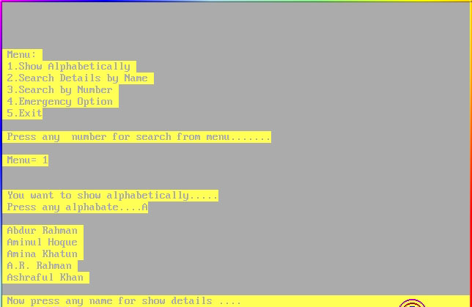

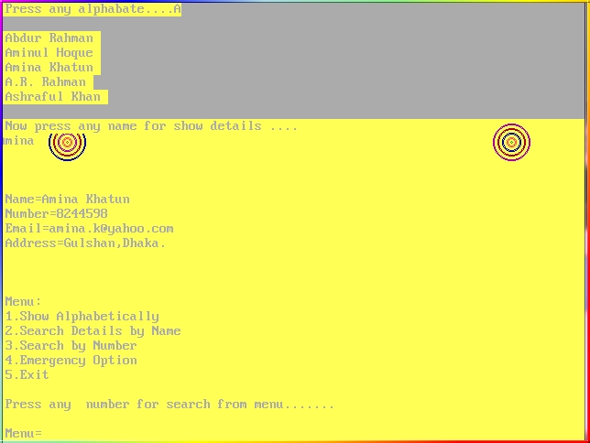

**page: 4**

* Searching by name…………

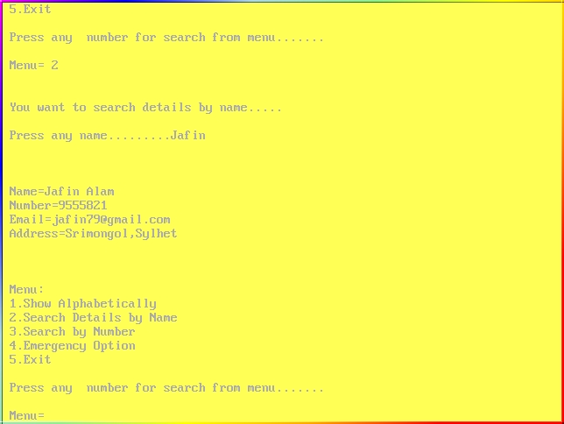

* Searching by number…………

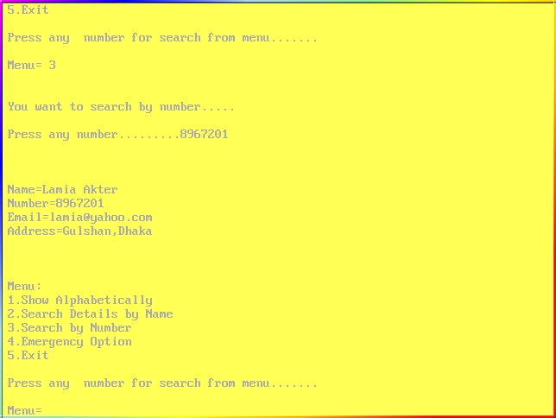

**page: 5**

* Searching emergency details…………

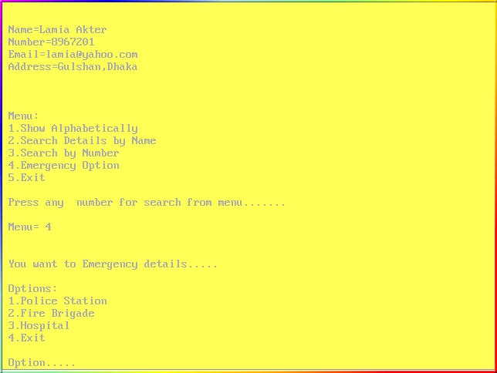

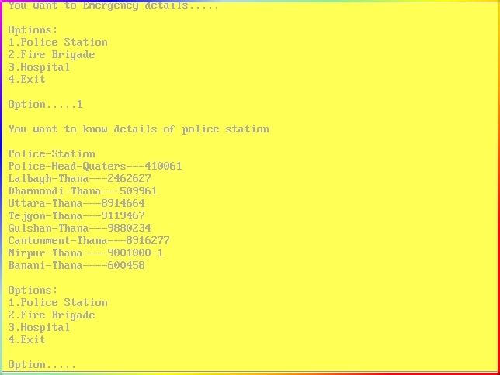

**page: 6**

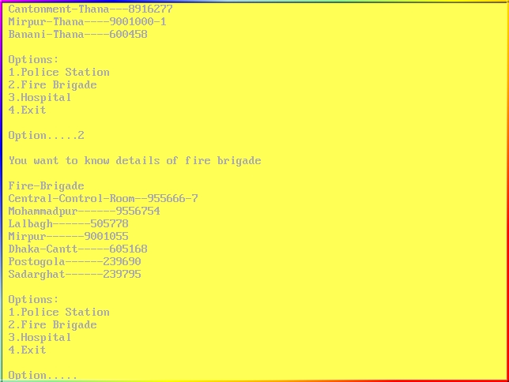

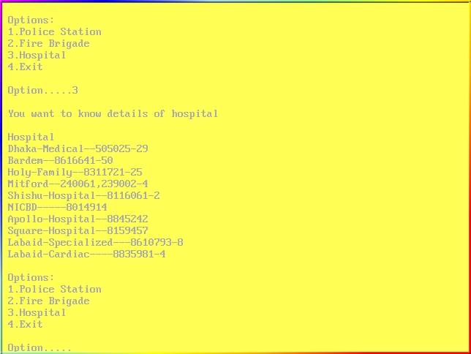

**page: 7**

* Exiting from emergency detais…………

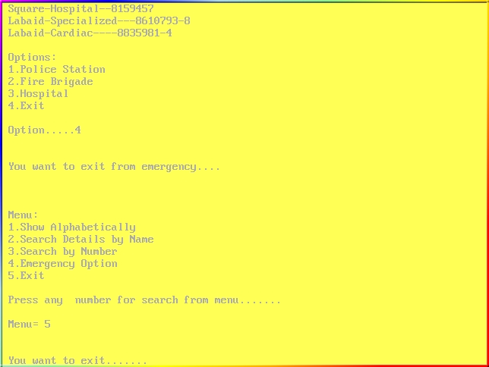

* Closing page of the software……………



**page: 8**

**Code:**

#include<stdio.h>

#include<string.h>

#include<graphics.h>

#include<dos.h>

void alphabate();

void name();

void number();

void police();

void fire();

void hospital();

void main()

{

int gd = DETECT, gm;

initgraph(&gd, &gm, "C:\\TC\\BGI");

setbkcolor(YELLOW);

setcolor(BLUE);

circle(75,75,50);

setcolor(BLUE);

**page:9**

circle(75,75,49);

setcolor(RED);

circle(75,75,45);

setcolor(RED);

circle(75,75,44);

setcolor(MAGENTA);

circle(75,75,40);

setcolor(MAGENTA);

circle(75,75,39);

setcolor(DARKGRAY);

circle(75,75,35);

setcolor(DARKGRAY);

circle(75,75,34);

setcolor(BROWN);

circle(75,75,30);

setcolor(BROWN);

circle(75,75,29);

setcolor(LIGHTRED);

circle(75,75,25);

setcolor(LIGHTRED);

circle(75,75,24);

**page:10**

setcolor(CYAN);

circle(75,75,20);

setcolor(CYAN);

circle(75,75,19);

setcolor(GREEN);

circle(75,75,15);

setcolor(GREEN);

circle(75,75,14);

setcolor(LIGHTMAGENTA);

circle(75,75,10);

setcolor(LIGHTMAGENTA);

circle(75,75,9);

setcolor(LIGHTBLUE);

circle(75,75,5);

setcolor(LIGHTBLUE);

circle(75,75,4);

setcolor(LIGHTMAGENTA);

circle(75,75,1);

setcolor(BLUE);

circle(75,185,42);

**page: 11**

setcolor(BLUE);

circle(75,185,41);

setcolor(RED);

circle(75,185,37);

setcolor(RED);

circle(75,185,36);

setcolor(MAGENTA);

circle(75,185,32);

setcolor(MAGENTA);

circle(75,185,31);

setcolor(DARKGRAY);

circle(75,185,27);

setcolor(DARKGRAY);

circle(75,185,26);

setcolor(BROWN);

circle(75,185,22);

setcolor(BROWN);

circle(75,185,21);

setcolor(LIGHTRED);

circle(75,185,17);

setcolor(LIGHTRED);

**page:12**

circle(75,185,16);

setcolor(CYAN);

circle(75,185,12);

setcolor(CYAN);

circle(75,185,11);

setcolor(GREEN);

circle(75,185,7);

setcolor(GREEN);

circle(75,185,6);

setcolor(LIGHTMAGENTA);

circle(75,185,2);

setcolor(LIGHTMAGENTA);

circle(75,185,1);

setcolor(BLUE);

circle(75,280,35);

setcolor(BLUE);

circle(75,280,34);

setcolor(RED);

circle(75,280,30);

**page:13**

setcolor(RED);

circle(75,280,29);

setcolor(MAGENTA);

circle(75,280,25);

setcolor(MAGENTA);

circle(75,280,24);

setcolor(DARKGRAY);

circle(75,280,20);

setcolor(DARKGRAY);

circle(75,280,19);

setcolor(BROWN);

circle(75,280,15);

setcolor(BROWN);

circle(75,280,14);

setcolor(LIGHTRED);

circle(75,280,10);

setcolor(LIGHTRED);

circle(75,280,9);

setcolor(CYAN);

circle(75,280,5);

setcolor(CYAN);

**page:14**

circle(75,280,4);

setcolor(LIGHTMAGENTA);

circle(75,280,1);

setcolor(BLUE);

circle(75,360,28);

setcolor(BLUE);

circle(75,360,27);

setcolor(RED);

circle(75,360,23);

setcolor(RED);

circle(75,360,22);

setcolor(MAGENTA);

circle(75,360,17);

setcolor(MAGENTA);

circle(75,360,16);

setcolor(DARKGRAY);

circle(75,360,12);

setcolor(DARKGRAY);

circle(75,360,11);

setcolor(LIGHTRED);

**page:15**

circle(75,360,7);

setcolor(LIGHTRED);

circle(75,360,6);

setcolor(BROWN);

circle(75,360,2);

setcolor(BROWN);

circle(75,360,1);

setcolor(BLUE);

circle(75,425,20);

setcolor(BLUE);

circle(75,425,19);

setcolor(RED);

circle(75,425,15);

setcolor(RED);

circle(75,425,14);

setcolor(MAGENTA);

circle(75,425,10);

setcolor(MAGENTA);

circle(75,425,9);

setcolor(LIGHTRED);

**page:16**

circle(75,425,5);

setcolor(LIGHTRED);

circle(75,425,4);

setcolor(BROWN);

circle(75,425,1);

setcolor(MAGENTA);

circle(560,75,50);

setcolor(MAGENTA);

circle(560,75,49);

setcolor(RED);

circle(560,75,45);

setcolor(RED);

circle(560,75,44);

setcolor(BLUE);

circle(560,75,40);

setcolor(BLUE);

circle(560,75,39);

setcolor(DARKGRAY);

circle(560,75,35);

setcolor(DARKGRAY);

**page:17**

circle(560,75,34);

setcolor(BROWN);

circle(560,75,30);

setcolor(BROWN);

circle(560,75,29);

setcolor(LIGHTRED);

circle(560,75,25);

setcolor(LIGHTRED);

circle(560,75,24);

setcolor(CYAN);

circle(560,75,20);

setcolor(CYAN);

circle(560,75,19);

setcolor(GREEN);

circle(560,75,15);

setcolor(GREEN);

circle(560,75,14);

setcolor(LIGHTMAGENTA);

circle(560,75,10);

setcolor(LIGHTMAGENTA);

circle(560,75,9);

**page:18**

setcolor(LIGHTBLUE);

circle(560,75,5);

setcolor(LIGHTBLUE);

circle(560,75,4);

setcolor(LIGHTRED);

circle(560,75,1);

setcolor(LIGHTRED);

setcolor(MAGENTA);

circle(560,185,42);

setcolor(MAGENTA);

circle(560,185,41);

setcolor(RED);

circle(560,185,37);

setcolor(RED);

circle(560,185,36);

setcolor(BLUE);

circle(560,185,32);

setcolor(BLUE);

circle(560,185,31);

setcolor(DARKGRAY);

**page:19**

circle(560,185,27);

setcolor(DARKGRAY);

circle(560,185,26);

setcolor(BROWN);

circle(560,185,22);

setcolor(BROWN);

circle(560,185,21);

setcolor(LIGHTRED);

circle(560,185,17);

setcolor(LIGHTRED);

circle(560,185,16);

setcolor(CYAN);

circle(560,185,12);

setcolor(CYAN);

circle(560,185,11);

setcolor(GREEN);

circle(560,185,7);

setcolor(GREEN);

circle(560,185,6);

setcolor(LIGHTMAGENTA);

circle(560,185,2);

**page:20**

setcolor(LIGHTMAGENTA);

circle(560,185,1);

setcolor(MAGENTA);

circle(560,280,35);

setcolor(MAGENTA);

circle(560,280,34);

setcolor(RED);

circle(560,280,30);

setcolor(RED);

circle(560,280,29);

setcolor(BLUE);

circle(560,280,25);

setcolor(BLUE);

circle(560,280,24);

setcolor(DARKGRAY);

circle(560,280,20);

setcolor(DARKGRAY);

circle(560,280,19);

setcolor(CYAN);

circle(560,280,15);

**page:21**

setcolor(CYAN);

circle(560,280,14);

setcolor(LIGHTRED);

circle(560,280,10);

setcolor(LIGHTRED);

circle(560,280,9);

setcolor(GREEN);

circle(560,280,5);

setcolor(GREEN);

circle(560,280,4);

setcolor(LIGHTMAGENTA);

circle(560,280,1);

setcolor(MAGENTA);

circle(560,360,28);

setcolor(MAGENTA);

circle(560,360,27);

setcolor(RED);

circle(560,360,23);

setcolor(RED);

circle(560,360,22);

setcolor(BLUE);

**page:22**

circle(560,360,18);

setcolor(BLUE);

circle(560,360,17);

setcolor(DARKGRAY);

circle(560,360,13);

setcolor(DARKGRAY);

circle(560,360,12);

setcolor(LIGHTRED);

circle(560,360,8);

setcolor(LIGHTRED);

circle(560,360,7);

setcolor(GREEN);

circle(560,360,3);

setcolor(GREEN);

circle(560,360,2);

setcolor(MAGENTA);

circle(560,425,20);

setcolor(MAGENTA);

circle(560,425,19);

setcolor(RED);

**page:23**

circle(560,425,15);

setcolor(RED);

circle(560,425,14);

setcolor(BLUE);

circle(560,425,10);

setcolor(RED);

setcolor(BLUE);

circle(560,425,9);

setcolor(LIGHTRED);

circle(560,425,5);

setcolor(LIGHTRED);

circle(560,425,4);

setcolor(GREEN);

circle(560,425,1);

for(int i=1;i<=5;i++)

{

setcolor(i);

settextstyle(TRIPLEX_SCR_FONT,HORIZ_DIR,6);

outtextxy(180,96,"WELCOME");

delay(400);

**page:24**

setcolor(i);

settextstyle(TRIPLEX_SCR_FONT,HORIZ_DIR,6);

outtextxy(280,176,"TO");

delay(400);

setcolor(i);

settextstyle(TRIPLEX_FONT,HORIZ_DIR,7);

outtextxy(140,256,"TELEPHONE");

delay(400);

setcolor(i);

settextstyle(TRIPLEX_FONT,HORIZ_DIR,7);

outtextxy(150,320,"DIRECTORY");

delay(400);

if(i==5)

break;

}

getch();

clrscr();

setbkcolor(YELLOW);

int p=0;

**page:25**

while(p!=6)

{

printf("\n\n\n");

printf("\n Menu: \n 1.Show Alphabetically \n 2.Search Details by Name \n 3.Search by Number \n 4.Emergency Option \n 5.Exit");

printf("\n\n Press any number for search from menu.......");

printf("\n\n Menu= ");

scanf("%d",& p);

if(p==1)

{

printf("\n\n You want to show alphabetically.....");

alphabate();

}

if(p==2)

{

printf("\n\n You want to search details by name.....");

name();

}

if(p==3)

{

printf("\n\n You want to search by number.....");

**page:26**

number();

}

if(p==4)

{

printf("\n\n You want to Emergency details.....");

int m=0;

while(m!=4)

{

printf("\n\n Options: \n 1.Police Station \n 2.Fire Brigade \n 3.Hospital \n 4.Exit");

printf("\n\n Option.....");

scanf("%d",& m);

if(m==1)

{ printf("\n You want to know details of police station ");

police();

}

if(m==2)

{ printf("\n You want to know details of fire brigade");

fire();

}

if(m==3)

**page:27**

{ printf("\n You want to know details of hospital ");

hospital();

}

}

printf("\n\n You want to exit from emergency....");

}

if(p==5)

{

printf("\n\n You want to exit.......");

getch();

clrscr();

setcolor(YELLOW);

setfillstyle(SOLID_FILL,YELLOW);

bar(0,0,640,640);

setcolor(BLUE);

ellipse(310, 360, 0, 360, 80, 55);

setcolor(BLUE);

ellipse(310, 360, 0, 360, 79, 54);

setcolor(RED);

**page:28**

ellipse(310, 360, 0, 360, 75, 50);

setcolor(RED);

ellipse(310, 360, 0, 360, 74, 49);

setcolor(MAGENTA);

ellipse(310, 360, 0, 360, 70, 45);

setcolor(MAGENTA);

ellipse(310, 360, 0, 360, 69, 44);

setcolor(DARKGRAY);

ellipse(310, 360, 0, 360, 65, 40);

setcolor(DARKGRAY);

ellipse(310, 360, 0, 360, 64, 39);

setcolor(BROWN);

ellipse(310, 360, 0, 360, 60, 35);

setcolor(BROWN);

ellipse(310, 360, 0, 360, 59, 34);

setcolor(LIGHTRED);

ellipse(310, 360, 0, 360, 55, 30);

setcolor(LIGHTRED);

ellipse(310, 360, 0, 360, 54, 29);

setcolor(CYAN);

ellipse(310, 360, 0, 360, 50, 25);

**page:29**

setcolor(CYAN);

ellipse(310, 360, 0, 360, 49, 24);

setcolor(GREEN);

ellipse(310, 360, 0, 360, 45, 20);

setcolor(GREEN);

ellipse(310, 360, 0, 360, 44, 19);

setcolor(LIGHTMAGENTA);

ellipse(310, 360, 0, 360, 40, 15);

setcolor(LIGHTMAGENTA);

ellipse(310, 360, 0, 360, 39, 14);

setcolor(LIGHTBLUE);

ellipse(310, 360, 0, 360, 35, 10);

setcolor(LIGHTBLUE);

ellipse(310, 360, 0, 360, 34, 9);

setcolor(MAGENTA);

ellipse(310, 360, 0, 360, 30, 5);

setcolor(MAGENTA);

ellipse(310, 360, 0, 360, 29, 4);

setcolor(LIGHTGRAY);

ellipse(310, 360, 0, 360, 25, 2);

setcolor(LIGHTGRAY);

**page:30**

ellipse(310, 360, 0, 360, 24, 1);

setcolor(LIGHTGRAY);

ellipse(310, 360, 0, 360, 27, 3);

setcolor(LIGHTGRAY);

ellipse(310, 360, 0, 360, 24, 1);

line(280,360,340,360);

setcolor(BLUE);

circle(75,75,50);

setcolor(BLUE);

circle(75,75,49);

setcolor(RED);

circle(75,75,45);

setcolor(RED);

circle(75,75,44);

setcolor(MAGENTA);

circle(75,75,40);

setcolor(MAGENTA);

circle(75,75,39);

setcolor(DARKGRAY);

**page:31**

circle(75,75,35);

setcolor(DARKGRAY);

circle(75,75,34);

setcolor(BROWN);

circle(75,75,30);

setcolor(BROWN);

circle(75,75,29);

setcolor(LIGHTRED);

circle(75,75,25);

setcolor(LIGHTRED);

circle(75,75,24);

setcolor(CYAN);

circle(75,75,20);

setcolor(CYAN);

circle(75,75,19);

setcolor(GREEN);

circle(75,75,15);

setcolor(GREEN);

circle(75,75,14);

setcolor(LIGHTMAGENTA);

circle(75,75,10);

**page:32**

setcolor(LIGHTMAGENTA);

circle(75,75,9);

setcolor(LIGHTBLUE);

circle(75,75,5);

setcolor(LIGHTBLUE);

circle(75,75,4);

setcolor(LIGHTMAGENTA);

circle(75,75,1);

setcolor(BLUE);

circle(75,185,42);

setcolor(BLUE);

circle(75,185,41);

setcolor(RED);

circle(75,185,37);

setcolor(RED);

circle(75,185,36);

setcolor(MAGENTA);

circle(75,185,32);

setcolor(MAGENTA);

circle(75,185,31);

**page:33**

setcolor(DARKGRAY);

circle(75,185,27);

setcolor(DARKGRAY);

circle(75,185,26);

setcolor(BROWN);

circle(75,185,22);

setcolor(BROWN);

circle(75,185,21);

setcolor(LIGHTRED);

circle(75,185,17);

setcolor(LIGHTRED);

circle(75,185,16);

setcolor(CYAN);

circle(75,185,12);

setcolor(CYAN);

circle(75,185,11);

setcolor(GREEN);

circle(75,185,7);

setcolor(GREEN);

circle(75,185,6);

setcolor(LIGHTMAGENTA);

**page:34**

circle(75,185,2);

setcolor(LIGHTMAGENTA);

circle(75,185,1);

setcolor(BLUE);

circle(75,280,35);

setcolor(BLUE);

circle(75,280,34);

setcolor(RED);

circle(75,280,30);

setcolor(RED);

circle(75,280,29);

setcolor(MAGENTA);

circle(75,280,25);

setcolor(MAGENTA);

circle(75,280,24);

setcolor(DARKGRAY);

circle(75,280,20);

setcolor(DARKGRAY);

circle(75,280,19);

setcolor(BROWN);

circle(75,280,15);

**page:35**

setcolor(BROWN);

circle(75,280,14);

setcolor(LIGHTRED);

circle(75,280,10);

setcolor(LIGHTRED);

circle(75,280,9);

setcolor(CYAN);

circle(75,280,5);

setcolor(CYAN);

circle(75,280,4);

setcolor(LIGHTMAGENTA);

circle(75,280,1);

setcolor(BLUE);

circle(75,360,28);

setcolor(BLUE);

circle(75,360,27);

setcolor(RED);

circle(75,360,23);

setcolor(RED);

circle(75,360,22);

**page:36**

setcolor(MAGENTA);

circle(75,360,17);

setcolor(MAGENTA);

circle(75,360,16);

setcolor(DARKGRAY);

circle(75,360,12);

setcolor(DARKGRAY);

circle(75,360,11);

setcolor(LIGHTRED);

circle(75,360,7);

setcolor(LIGHTRED);

circle(75,360,6);

setcolor(BROWN);

circle(75,360,2);

setcolor(BROWN);

circle(75,360,1);

setcolor(BLUE);

circle(75,425,20);

setcolor(BLUE);

circle(75,425,19);

**page:37**

setcolor(RED);

circle(75,425,15);

setcolor(RED);

circle(75,425,14);

setcolor(MAGENTA);

circle(75,425,10);

setcolor(MAGENTA);

circle(75,425,9);

setcolor(LIGHTRED);

circle(75,425,5);

setcolor(LIGHTRED);

circle(75,425,4);

setcolor(BROWN);

circle(75,425,1);

setcolor(MAGENTA);

circle(560,75,50);

setcolor(MAGENTA);

circle(560,75,49);

setcolor(RED);

circle(560,75,45);

**page:38**

setcolor(RED);

circle(560,75,44);

setcolor(BLUE);

circle(560,75,40);

setcolor(BLUE);

circle(560,75,39);

setcolor(DARKGRAY);

circle(560,75,35);

setcolor(DARKGRAY);

circle(560,75,34);

setcolor(BROWN);

circle(560,75,30);

setcolor(BROWN);

circle(560,75,29);

setcolor(LIGHTRED);

circle(560,75,25);

setcolor(LIGHTRED);

circle(560,75,24);

setcolor(CYAN);

circle(560,75,20);

setcolor(CYAN);

**page:39**

circle(560,75,19);

setcolor(GREEN);

circle(560,75,15);

setcolor(GREEN);

circle(560,75,14);

setcolor(LIGHTMAGENTA);

circle(560,75,10);

setcolor(LIGHTMAGENTA);

circle(560,75,9);

setcolor(LIGHTBLUE);

circle(560,75,5);

setcolor(LIGHTBLUE);

circle(560,75,4);

setcolor(LIGHTRED);

circle(560,75,1);

setcolor(LIGHTRED);

setcolor(MAGENTA);

circle(560,185,42);

setcolor(MAGENTA);

circle(560,185,41);

**page:40**

setcolor(RED);

circle(560,185,37);

setcolor(RED);

circle(560,185,36);

setcolor(BLUE);

circle(560,185,32);

setcolor(BLUE);

circle(560,185,31);

setcolor(DARKGRAY);

circle(560,185,27);

setcolor(DARKGRAY);

circle(560,185,26);

setcolor(BROWN);

circle(560,185,22);

setcolor(BROWN);

circle(560,185,21);

setcolor(LIGHTRED);

circle(560,185,17);

setcolor(LIGHTRED);

circle(560,185,16);

setcolor(CYAN);

**page:41**

circle(560,185,12);

setcolor(CYAN);

circle(560,185,11);

setcolor(GREEN);

circle(560,185,7);

setcolor(GREEN);

circle(560,185,6);

setcolor(LIGHTMAGENTA);

circle(560,185,2);

setcolor(LIGHTMAGENTA);

circle(560,185,1);

setcolor(MAGENTA);

circle(560,280,35);

setcolor(MAGENTA);

circle(560,280,34);

setcolor(RED);

circle(560,280,30);

setcolor(RED);

circle(560,280,29);

setcolor(BLUE);

**page:42**

circle(560,280,25);

setcolor(BLUE);

circle(560,280,24);

setcolor(DARKGRAY);

circle(560,280,20);

setcolor(DARKGRAY);

circle(560,280,19);

setcolor(CYAN);

circle(560,280,15);

setcolor(CYAN);

circle(560,280,14);

setcolor(LIGHTRED);

circle(560,280,10);

setcolor(LIGHTRED);

circle(560,280,9);

setcolor(GREEN);

circle(560,280,5);

setcolor(GREEN);

circle(560,280,4);

setcolor(LIGHTMAGENTA);

circle(560,280,1);

**page:43**

setcolor(MAGENTA);

circle(560,360,28);

setcolor(MAGENTA);

circle(560,360,27);

setcolor(RED);

circle(560,360,23);

setcolor(RED);

circle(560,360,22);

setcolor(BLUE);

circle(560,360,18);

setcolor(BLUE);

circle(560,360,17);

setcolor(DARKGRAY);

circle(560,360,13);

setcolor(DARKGRAY);

circle(560,360,12);

setcolor(LIGHTRED);

circle(560,360,8);

setcolor(LIGHTRED);

circle(560,360,7);

setcolor(GREEN);

**page:44**

circle(560,360,3);

setcolor(GREEN);

circle(560,360,2);

setcolor(MAGENTA);

circle(560,425,20);

setcolor(MAGENTA);

circle(560,425,19);

setcolor(RED);

circle(560,425,15);

setcolor(RED);

circle(560,425,14);

setcolor(BLUE);

circle(560,425,10);

setcolor(RED);

setcolor(BLUE);

circle(560,425,9);

setcolor(LIGHTRED);

circle(560,425,5);

setcolor(LIGHTRED);

circle(560,425,4);

**page:45**

setcolor(GREEN);

circle(560,425,1);

for(int i=1;i<=5;i++)

{

setcolor(i);

settextstyle(TRIPLEX_SCR_FONT,HORIZ_DIR,7);

outtextxy(200,96,"THANK");

delay(600);

setcolor(i);

settextstyle(TRIPLEX_SCR_FONT,HORIZ_DIR,7);

outtextxy(244,176,"YOU...");

delay(600);

if(i==5)

break;

}

break;

}

}

getch();

**page:46**

closegraph();

}

void alphabate()

{

struct array

{

char name1[10];

char name2[10];

char number[10];

char email[23];

char add[20];

}directory[52];

FILE *fp;

int i=0;

fp=fopen("name.txt","r");

while(!feof(fp))

{

fscanf(fp,"%s %s %s %s %s",directory[i].name1, directory[i].name2, directory[i].number, directory[i].email, directory[i].add);

i++;

**page:47**

}

fclose(fp);

struct array1

{

char name3[10];

char name4[10];

char number1[10];

char email1[23];

char add1[20];

}directory1[22];

FILE *fp1;

int j=0;

fp1=fopen("name1.txt","r");

while(!feof(fp1))

{

fscanf(fp1,"%s %s %s %s %s",directory1[j].name3, directory1[j].name4, directory1[j].number1, directory1[j].email1, directory1[j].add1);

j++;

}

fclose(fp1);

**page:48**

char ch;

printf("\n Press any alphabate....");

scanf("%s",& ch);

if(ch=='A')

{

for(int a=0;a<=4;a++)

{

printf("\n %s",directory[a].name1);

printf(" %s ",directory[a].name2);

}

char ch1[8];

int x,z,y;

printf("\n\n Now press any name for show details ....");

scanf("%s",& ch1);

for(y=0;y<=6;y++)

{

x=strcmp(directory[y].name1,ch1);

z=strcmp(directory[y].name2,ch1);

if(x==0 || z==0)

{

**page:49**

printf("\n\n");

printf("\n Name=%s",directory[y].name1);

printf(" %s ",directory[y].name2);

printf("\n Number=%s",directory[y].number);

printf("\n Email=%s",directory[y].email);

printf("\n Address=%s",directory[y].add);

break;

}

}

if(x!=0 && z!=0)

printf("\n\n Name is not exist....");

}

if(ch=='B')

{

for(int b=5;b<=8;b++)

{

printf("\n %s",directory[b].name1);

printf(" %s ",directory[b].name2);

}

char ch1[8];

**page:50**

int x,y,z;

printf("\n\n Now press any name for show details....");

scanf("%s",& ch1);

for(y=5;y<=9;y++)

{

x=strcmp(directory[y].name1,ch1);

z=strcmp(directory[y].name2,ch1);

if(x==0 || z==0)

{

printf("\n\n");

printf("\n Name=%s",directory[y].name1);

printf(" %s ",directory[y].name2);

printf("\n Number=%s",directory[y].number);

printf("\n Email=%s",directory[y].email);

printf("\n Address=%s",directory[y].add);

break;

}

}

if(x!=0 && z!=0)

printf("\n\n Name is not exist....");

}

**page:51**

if(ch=='C')

{

for(int c=9;c<=10;c++)

{

printf("\n %s",directory[c].name1);

printf(" %s ",directory[c].name2);

}

char ch1[8];

int x,y,z;

printf("\n\n Now press any name for show details....");

scanf("%s",& ch1);

for(y=9;y<=10;y++)

{

x=strcmp(directory[y].name1,ch1);

z=strcmp(directory[y].name2,ch1);

if(x==0 || z==0)

{

printf("\n\n");

printf("\n Name=%s",directory[y].name1);

printf(" %s ",directory[y].name2);

printf("\n Number=%s",directory[y].number);

**page:52**

printf("\n Email=%s",directory[y].email);

printf("\n Address=%s",directory[y].add);

break;

}

}

if(x!=0 && z!=0)

printf("\n\n Name is not exist....");

}

if(ch=='D')

{

for(int d=11;d<=14;d++)

{

printf("\n %s",directory[d].name1);

printf(" %s ",directory[d].name2);

}

char ch1[8];

int x,y,z;

printf("\n\n Now press any name for show details ....");

scanf("%s",& ch1);

for(y=11;y<=14;y++)

**page:53**

{

x=strcmp(directory[y].name1,ch1);

z=strcmp(directory[y].name2,ch1);

if(x==0 || z==0)

{

printf("\n\n");

printf("\n Name=%s",directory[y].name1);

printf(" %s ",directory[y].name2);

printf("\n Number=%s",directory[y].number);

printf("\n Email=%s",directory[y].email);

printf("\n Address=%s",directory[y].add);

break;

}

}

if(x!=0 && z!=0)

printf("\n\n Name is not exist....");

}

if(ch=='E')

{

for(int e=15;e<=17;e++)

**page:54**

{

printf("\n %s",directory[e].name1);

printf(" %s ",directory[e].name2);

}

char ch1[8];

int x,y,z;

printf("\n\n Now press any name for show details....");

scanf("%s",& ch1);

for(y=15;y<=17;y++)

{

x=strcmp(directory[y].name1,ch1);

z=strcmp(directory[y].name2,ch1);

if(x==0 || z==0)

{

printf("\n\n");

printf("\n Name=%s",directory[y].name1);

printf(" %s ",directory[y].name2);

printf("\n Number=%s",directory[y].number);

printf("\n Email=%s",directory[y].email);

printf("\n Address=%s",directory[y].add);

**page:55**

break;

}

}

if(x!=0 && z!=0)

printf("\n\n Name is not exist....");

}

if(ch=='F')

{

for(int f=18;f<=19;f++)

{

printf("\n %s",directory[f].name1);

printf(" %s ",directory[f].name2);

}

char ch1[8];

int x,y,z;

printf("\n\n Now press any name for show details ....");

scanf("%s",& ch1);

for(y=18;y<=19;y++)

{

x=strcmp(directory[y].name1,ch1);

**page:56**

z=strcmp(directory[y].name2,ch1);

if(x==0 || z==0)

{

printf("\n\n");

printf("\n Name=%s",directory[y].name1);

printf(" %s ",directory[y].name2);

printf("\n Number=%s",directory[y].number);

printf("\n Email=%s",directory[y].email);

printf("\n Address=%s",directory[y].add);

break;

}

}

if(x!=0 && z!=0)

printf("\n\n Name is not exist....");

}

if(ch=='G')

{

for(int g=20;g<=21;g++)

{

printf("\n %s",directory[g].name1);

**page:57**

printf(" %s ",directory[g].name2);

}

char ch1[8];

int x,y,z;

printf("\n\n Now press any name for show details ....");

scanf("%s",& ch1);

for(y=20;y<=21;y++)

{

x=strcmp(directory[y].name1,ch1);

z=strcmp(directory[y].name2,ch1);

if(x==0 || z==0)

{

printf("\n\n");

printf("\n Name=%s",directory[y].name1);

printf(" %s ",directory[y].name2);

printf("\n Number=%s",directory[y].number);

printf("\n Email=%s",directory[y].email);

printf("\n Address=%s",directory[y].add);

break;

}

}

**page:58**

if(x!=0 && z!=0)

printf("\n\n Name is not exist....");

}

if(ch=='H')

{

for(int h=22;h<=25;h++)

{

printf("\n %s",directory[h].name1);

printf(" %s ",directory[h].name2);

}

char ch1[8];

int x,y,z;

printf("\n\n Now press any name for show details......");

scanf("%s",& ch1);

for(y=22;y<=25;y++)

{

x=strcmp(directory[y].name1,ch1);

z=strcmp(directory[y].name2,ch1);

if(x==0 || z==0)

{

**page:59**

printf("\n\n");

printf("\n Name=%s",directory[y].name1);

printf(" %s ",directory[y].name2);

printf("\n Number=%s",directory[y].number);

printf("\n Email=%s",directory[y].email);

printf("\n Address=%s",directory[y].add);

break;

}

}

if(x!=0 && z!=0)

printf("\n\n Name is not exist....");

}

if(ch=='I')

{

for(int a=26;a<=27;a++)

{

printf("\n %s",directory[a].name1);

printf(" %s ",directory[a].name2);

}

char ch1[8];

**page:60**

int x,y,z;

printf("\n\n Now press any name for show details ....");

scanf("%s",& ch1);

for(y=26;y<=27;y++)

{

x=strcmp(directory[y].name1,ch1);

z=strcmp(directory[y].name2,ch1);

if(x==0 || z==0)

{

printf("\n\n");

printf("\n Name=%s",directory[y].name1);

printf(" %s ",directory[y].name2);

printf("\n Number=%s",directory[y].number);

printf("\n Email=%s",directory[y].email);

printf("\n Address=%s",directory[y].add);

break;

}

}

if(x!=0 && z!=0)

printf("\n\n Name is not exist....");

}

**page:61**

if(ch=='J')

{

for(int j=28;j<=31;j++)

{

printf("\n %s",directory[j].name1);

printf(" %s ",directory[j].name2);

}

char ch1[8];

int x,y,z;

printf("\n\n Now press any name for show details....");

scanf("%s",& ch1);

for(y=28;y<=31;y++)

{

x=strcmp(directory[y].name1,ch1);

z=strcmp(directory[y].name2,ch1);

if(x==0 || z==0)

{

printf("\n\n");

printf("\n Name=%s",directory[y].name1);

printf(" %s ",directory[y].name2);

printf("\n Number=%s",directory[y].number);

**page:62**

printf("\n Email=%s",directory[y].email);

printf("\n Address=%s",directory[y].add);

break;

}

}

if(x!=0 && z!=0)

printf("\n\n Name is not exist....");

}

if(ch=='K')

{

for(int k=32;k<=34;k++)

{

printf("\n %s",directory[k].name1);

printf(" %s ",directory[k].name2);

}

char ch1[8];

int x,y,z;

printf("\n\n Now press any name for show details....");

scanf("%s",& ch1);

for(y=32;y<=34;y++)

**page:63**

{

x=strcmp(directory[y].name1,ch1);

z=strcmp(directory[y].name2,ch1);

if(x==0 || z==0)

{

printf("\n\n");

printf("\n Name=%s",directory[y].name1);

printf(" %s ",directory[y].name2);

printf("\n Number=%s",directory[y].number);

printf("\n Email=%s",directory[y].email);

printf("\n Address=%s",directory[y].add);

break;

}

}

if(x!=0 && z!=0)

printf("\n\n Name is not exist....");

}

if(ch=='L')

{

for(int l=35;l<=37;l++)

**page:64**

{

printf("\n %s",directory[l].name1);

printf(" %s ",directory[l].name2);

}

char ch1[8];

int x,y,z;

printf("\n\n Now press any name for show details....");

scanf("%s",& ch1);

for(y=35;y<=37;y++)

{

x=strcmp(directory[y].name1,ch1);

z=strcmp(directory[y].name2,ch1);

if(x==0 || z==0)

{

printf("\n\n");

printf("\n Name=%s",directory[y].name1);

printf(" %s ",directory[y].name2);

printf("\n Number=%s",directory[y].number);

printf("\n Email=%s",directory[y].email);

printf("\n Address=%s",directory[y].add);

break;

**page:65**

}

}

if(x!=0 && z!=0)

printf("\n\n Name is not exist....");

}

if(ch=='M')

{

for(int m=38;m<=40;m++)

{

printf("\n %s",directory[m].name1);

printf(" %s ",directory[m].name2);

}

char ch1[8];

int x,y,z;

printf("\n\n Now press any name for show details....");

scanf("%s",& ch1);

for(y=38;y<=40;y++)

{

x=strcmp(directory[y].name1,ch1);

z=strcmp(directory[y].name2,ch1);

**page:66**

if(x==0 || z==0)

{

printf("\n\n");

printf("\n Name=%s",directory[y].name1);

printf(" %s ",directory[y].name2);

printf("\n Number=%s",directory[y].number);

printf("\n Email=%s",directory[y].email);

printf("\n Address=%s",directory[y].add);

break;

}

}

if(x!=0 && z!=0)

printf("\n\n Name is not exist....");

}

if(ch=='N')

{

for(int n=41;n<=44;n++)

{

printf("\n %s",directory[n].name1);

printf(" %s ",directory[n].name2);

**page:67**

}

char ch1[8];

int x,y,z;

printf("\n\n Now press any name for show details....");

scanf("%s",& ch1);

for(y=41;y<=44;y++)

{

x=strcmp(directory[y].name1,ch1);

z=strcmp(directory[y].name2,ch1);

if(x==0 || z==0)

{

printf("\n\n");

printf("\n Name=%s",directory[y].name1);

printf(" %s ",directory[y].name2);

printf("\n Number=%s",directory[y].number);

printf("\n Email=%s",directory[y].email);

printf("\n Address=%s",directory[y].add);

break;

}

}

if(x!=0 && z!=0)

**page:68**

printf("\n\n Name is not exist....");

}

if(ch=='O')

{

for(int o=45;o<=46;o++)

{

printf("\n %s",directory[o].name1);

printf(" %s ",directory[o].name2);

}

char ch1[8];

int x,y,z;

printf("\n\n Now press any name for show details....");

scanf("%s",& ch1);

for(y=45;y<=46;y++)

{

x=strcmp(directory[y].name1,ch1);

z=strcmp(directory[y].name2,ch1);

if(x==0 || z==0)

{

printf("\n\n");

**page:69**

printf("\n Name=%s",directory[y].name1);

printf(" %s ",directory[y].name2);

printf("\n Number=%s",directory[y].number);

printf("\n Email=%s",directory[y].email);

printf("\n Address=%s",directory[y].add);

break;

}

}

if(x!=0 && z!=0)

printf("\n\n Name is not exist....");

}

if(ch=='P')

{

for(int p=47;p<=48;p++)

{

printf("\n %s",directory[p].name1);

printf(" %s ",directory[p].name2);

}

char ch1[8];

int x,y,z;

**page:70**

printf("\n\n Now press any name for show details....");

scanf("%s",& ch1);

for(y=47;y<=48;y++)

{

x=strcmp(directory[y].name1,ch1);

z=strcmp(directory[y].name2,ch1);

if(x==0 || z==0)

{

printf("\n\n");

printf("\n Name=%s",directory[y].name1);

printf(" %s ",directory[y].name2);

printf("\n Number=%s",directory[y].number);

printf("\n Email=%s",directory[y].email);

printf("\n Address=%s",directory[y].add);

break;

}

}

if(x!=0 && z!=0)

printf("\n\n Name is not exist....");

}

**page:71**

if(ch=='Q')

{

for(int q=50;q<=50;q++)

{

printf("\n %s",directory[q].name1);

printf(" %s ",directory[q].name2);

}

char ch1[8];

int x,y,z;

printf("\n\n Now press any name for show details....");

scanf("%s",& ch1);

for(y=49;y<=50;y++)

{

x=strcmp(directory[y].name1,ch1);

z=strcmp(directory[y].name2,ch1);

if(x==0 || z==0)

{

printf("\n\n");

printf("\n Name=%s",directory[y].name1);

printf(" %s ",directory[y].name2);

printf("\n Number=%s",directory[y].number);

**page:72**

printf("\n Email=%s",directory[y].email);

printf("\n Address=%s",directory[y].add);

break;

}

}

if(x!=0 && z!=0)

printf("\n\n Name is not exist....");

}

if(ch=='R')

{

for(int r=0;r<=2;r++)

{

printf("\n %s",directory1[r].name3);

printf(" %s ",directory1[r].name4);

}

char ch1[8];

int x,y,z;

printf("\n\n Now press any name for show details....");

scanf("%s",& ch1);

for(y=0;y<=2;y++)

**page:73**

{

x=strcmp(directory1[y].name3,ch1);

z=strcmp(directory1[y].name4,ch1);

if(x==0 || z==0)

{

printf("\n\n");

printf("\n Name=%s",directory1[y].name3);

printf(" %s ",directory1[y].name4);

printf("\n Number=%s",directory1[y].number1);

printf("\n Email=%s",directory1[y].email1);

printf("\n Address=%s",directory1[y].add1);

break;

}

}

if(x!=0 && z!=0)

printf("\n\n Name is not exist....");

}

if(ch=='S')

{

**page:74**

for(int s=3;s<=6;s++)

{

printf("\n %s",directory1[s].name3);

printf(" %s ",directory1[s].name4);

}

char ch1[8];

int x,y,z;

printf("\n\n Now press any name for show details....");

scanf("%s",& ch1);

for(y=3;y<=6;y++)

{

x=strcmp(directory1[y].name3,ch1);

z=strcmp(directory1[y].name4,ch1);

if(x==0 || z==0)

{

printf("\n\n");

printf("\n Name=%s",directory1[y].name3);

printf(" %s ",directory1[y].name4);

printf("\n Number=%s",directory1[y].number1);

printf("\n Email=%s",directory1[y].email1);

printf("\n Address=%s",directory1[y].add1);

**page:75**

break;

}

}

if(x!=0 && z!=0)

printf("\n\n Name is not exist....");

}

if(ch=='T')

{

for(int t=7;t<=10;t++)

{

printf("\n %s",directory1[t].name3);

printf(" %s ",directory1[t].name4);

}

char ch1[8];

int x,y,z;

printf("\n\n Now press any name for show details....");

scanf("%s",& ch1);

for(y=7;y<=10;y++)

{

x=strcmp(directory1[y].name3,ch1);

**page:76**

z=strcmp(directory1[y].name4,ch1);

if(x==0 || z==0)

{

printf("\n\n");

printf("\n Name=%s",directory1[y].name3);

printf(" %s ",directory1[y].name4);

printf("\n Number=%s",directory1[y].number1);

printf("\n Email=%s",directory1[y].email1);

printf("\n Address=%s",directory1[y].add1);

break;

}

}

if(x!=0 && z!=0)

printf("\n\n Name is not exist....");

}

if(ch=='U')

{

for(int u=11;u<=12;u++)

{

printf("\n %s",directory1[u].name3);

**page:77**

printf(" %s ",directory1[u].name4);

}

char ch1[8];

int x,y,z;

printf("\n\n Now press any name for show details....");

scanf("%s",& ch1);

for(y=11;y<=12;y++)

{

x=strcmp(directory1[y].name3,ch1);

z=strcmp(directory1[y].name4,ch1);

if(x==0 || z==0)

{

printf("\n\n");

printf("\n Name=%s",directory1[y].name3);

printf(" %s ",directory1[y].name4);

printf("\n Number=%s",directory1[y].number1);

printf("\n Email=%s",directory1[y].email1);

printf("\n Address=%s",directory1[y].add1);

break;

}

}

**page:78**

if(x!=0 && z!=0)

printf("\n\n Name is not exist....");

}

if(ch=='V')

{

for(int v=13;v<=14;v++)

{

printf("\n %s",directory1[v].name3);

printf(" %s ",directory1[v].name4);

}

char ch1[8];

int x,y,z;

printf("\n\n Now press any name for show details....");

scanf("%s",& ch1);

for(y=13;y<=14;y++)

{

x=strcmp(directory1[y].name3,ch1);

z=strcmp(directory1[y].name4,ch1);

if(x==0 || z==0)

{

**page:79**

printf("\n\n");

printf("\n Name=%s",directory1[y].name3);

printf(" %s ",directory1[y].name4);

printf("\n Number=%s",directory1[y].number1);

printf("\n Email=%s",directory1[y].email1);

printf("\n Address=%s",directory1[y].add1);

break;

}

}

if(x!=0 && z!=0)

printf("\n\n Name is not exist....");

}

if(ch=='W')

{

for(int w=15;w<=16;w++)

{

printf("\n %s",directory1[w].name3);

printf(" %s ",directory1[w].name4);

}

char ch1[8];

**page:80**

int x,y,z;

printf("\n\n Now press any name for show details....");

scanf("%s",& ch1);

for(y=15;y<=16;y++)

{

x=strcmp(directory1[y].name3,ch1);

z=strcmp(directory1[y].name4,ch1);

if(x==0 || z==0)

{

printf("\n\n");

printf("\n Name=%s",directory1[y].name3);

printf(" %s ",directory1[y].name4);

printf("\n Number=%s",directory1[y].number1);

printf("\n Email=%s",directory1[y].email1);

printf("\n Address=%s",directory1[y].add1);

break;

}

}

if(x!=0 && z!=0)

printf("\n\n Name is not exist....");

}

**page:81**

if(ch=='X')

{

for(int m=17;m<=17;m++)

{

printf("\n %s",directory1[m].name3);

printf(" %s ",directory1[m].name4);

}

char ch1[8];

int x,y,z;

printf("\n\n Now press any name for show details....");

scanf("%s",& ch1);

for(y=16;y<=17;y++)

{

x=strcmp(directory1[y].name3,ch1);

z=strcmp(directory1[y].name4,ch1);

if(x==0 || z==0)

{

printf("\n\n");

printf("\n Name=%s",directory1[y].name3);

printf(" %s ",directory1[y].name4);

printf("\n Number=%s",directory1[y].number1);

**page:82**

printf("\n Email=%s",directory1[y].email1);

printf("\n Address=%s",directory1[y].add1);

break;

}

}

if(x!=0 && z!=0)

printf("\n\n Name is not exist....");

}

if(ch=='Y')

{

for(int k=18;k<=18;k++)

{

printf("\n %s",directory1[k].name3);

printf(" %s ",directory1[k].name4);

}

char ch1[8];

int x,y,z;

printf("\n\n Now press any name for show details....");

scanf("%s",& ch1);

for(y=18;y<=19;y++)

**page:83**

{

x=strcmp(directory1[y].name3,ch1);

z=strcmp(directory1[y].name4,ch1);

if(x==0 || z==0)

{

printf("\n\n");

printf("\n Name=%s",directory1[y].name3);

printf(" %s ",directory1[y].name4);

printf("\n Number=%s",directory1[y].number1);

printf("\n Email=%s",directory1[y].email1);

printf("\n Address=%s",directory1[y].add1);

break;

}

}

if(x!=0 && z!=0)

printf("\n\n Name is not exist....");

}

if(ch=='Z')

{

for(int m=19;m<=19;m++)

**page:84**

{

printf("\n %s",directory1[m].name3);

printf(" %s ",directory1[m].name4);

}

char ch1[8];

int x,y,z;

printf("\n\n Now press any name for show details....");

scanf("%s",& ch1);

for(y=18;y<=20;y++)

{

x=strcmp(directory1[y].name3,ch1);

z=strcmp(directory1[y].name4,ch1);

if(x==0 || z==0)

{

printf("\n\n");

printf("\n Name=%s",directory1[y].name3);

printf(" %s ",directory1[y].name4);

printf("\n Number=%s",directory1[y].number1);

printf("\n Email=%s",directory1[y].email1);

printf("\n Address=%s",directory1[y].add1);

break;

**page:85**

}

}

if(x!=0 && z!=0)

printf("\n\n Name is not exist....");

}

}

void name()

{

struct array

{

char name1[10];

char name2[10];

char number[10];

char email[23];

char add[20];

}directory[52];

FILE *fp;

int i=0;

fp=fopen("name.txt","r");

**page:86**

while(!feof(fp))

{

fscanf(fp," %s %s %s %s %s",directory[i].name1, directory[i].name2, directory[i].number, directory[i].email, directory[i].add);

i++;

}

fclose(fp);

struct array1

{

char name3[10];

char name4[10];

char number1[10];

char email1[23];

char add1[20];

}directory1[22];

FILE *fp1;

int j=0;

fp1=fopen("name1.txt","r");

while(!feof(fp1))

{

**page:87**

fscanf(fp1,"%s %s %s %s %s",directory1[j].name3, directory1[j].name4, directory1[j].number1, directory1[j].email1, directory1[j].add1);

j++;

}

fclose(fp1);

int x,z,a,b;

int y,k;

char ch[10];

printf("\n\n Press any name.........");

scanf("%s",&ch);

for(y=0;y<=50;y++)

{

x=strcmp(directory[y].name1,ch);

z=strcmp(directory[y].name2,ch);

if(x==0 || z==0)

{

printf("\n\n");

printf("\n Name=%s",directory[y].name1);

printf(" %s ",directory[y].name2);

printf("\n Number=%s",directory[y].number);

printf("\n Email=%s",directory[y].email);

**page:88**

printf("\n Address=%s",directory[y].add);

break;

}

}

for(k=0;k<=20;k++)

{

a=strcmp(directory1[k].name3,ch);

b=strcmp(directory1[k].name4,ch);

if(a==0 || b==0)

{

printf("\n\n");

printf("\n Name=%s",directory1[k].name3);

printf(" %s ",directory1[k].name4);

printf("\n Number=%s",directory1[k].number1);

printf("\n Email=%s",directory1[k].email1);

printf("\n Address=%s",directory1[k].add1);

break;

}

}

if(x!=0 && z!=0 && a!=0 && b!=0)

**page:89**

printf("\n\n Name is not exist.....");

}

void number()

{

struct array

{

char name1[10];

char name2[10];

char number[10];

char email[23];

char add[20];

}directory[52];

FILE *fp;

int i=0;

fp=fopen("name.txt","r");

while(!feof(fp))

{

fscanf(fp,"%s %s %s %s %s",directory[i].name1, directory[i].name2, directory[i].number, directory[i].email, directory[i].add);

i++;

**page:90**

}

fclose(fp);

struct array1

{

char name3[10];

char name4[10];

char number1[10];

char email1[23];

char add1[20];

}directory1[22];

FILE *fp1;

int j=0;

fp1=fopen("name1.txt","r");

while(!feof(fp1))

{

fscanf(fp1,"%s %s %s %s %s",directory1[j].name3, directory1[j].name4, directory1[j].number1, directory1[j].email1, directory1[j].add1);

j++;

}

fclose(fp1);

**page:91**

int x,z,a,b;

int y;

char ch[8];

printf("\n\n Press any number.........");

scanf("%s",&ch);

for(y=0;y<=75;y++)

{

x=strcmp(directory[y].number,ch);

a=strcmp(directory1[y].number1,ch);

if(x==0)

{

printf("\n\n");

printf("\n Name=%s",directory[y].name1);

printf(" %s ",directory[y].name2);

printf("\n Number=%s",directory[y].number);

printf("\n Email=%s",directory[y].email);

printf("\n Address=%s",directory[y].add);

break;

}

if(a==0)

{

**page:92**

printf("\n\n");

printf("\n Name=%s",directory1[y].name3);

printf(" %s ",directory1[y].name4);

printf("\n Number=%s",directory1[y].number1);

printf("\n Email=%s",directory1[y].email1);

printf("\n Address=%s",directory1[y].add1);

break;

}

}

if(x!=0 && a!=0)

printf("\n\n Number is not exist.....");

}

void police()

{

struct pol

{

char name1[33];

}station[10];

FILE *fq;

**page:93**

int i=0;

fq=fopen("police.txt","r");

while(!feof(fq))

{

fscanf(fq,"%s", station[i].name1);

i++;

}

fclose(fq);

int j;

printf("\n");

for(j=0;j<=9;j++)

{

printf("\n");

printf(" %s " ,station[j].name1);

}

}

void fire()

{

struct fir

{

char name1[32];

**page:94**

} brigade[10];

FILE *fq;

int i=0;

fq=fopen("fire.txt","r");

while(!feof(fq))

{

fscanf(fq,"%s", brigade[i].name1);

i++;

}

fclose(fq);

int j;

printf("\n");

for(j=0;j<=7;j++)

{

printf("\n");

printf(" %s ",brigade[j].name1);

}

}

void hospital()

{

**page:95**

struct hos

{

char name1[32];

}pital[12];

FILE *fq;

int i=0;

fq=fopen("hospital.txt","r");

while(!feof(fq))

{

fscanf(fq,"%s", pital[i].name1);

i++;

}

fclose(fq);

int j;

printf("\n");

for(j=0;j<=10;j++)

{

printf("\n");

printf(" %s ",pital[j].name1);

}

}

**page:96**

**CONCLUSION**

In this software there is a maximum limit of accessing data. If we cross that limit ,then there will be a wrong output. For that reason we can’t access a large amount of data in this software and this is the limitation of our software.

In future, whenever we work with this software we will try to solve this limitation and access a large amount of data to upgrade our software features.

**page:97**

*………………………………………………………………………………………………………………………………………………………………………………………………………………………………………………………………………………………………………………………*