

**Sadia jahan**

**ID: 11.01.04.157**

**section: C**

**Farjana Akhter**

**ID: 11.01.04.168**

**section: C**

**Israt jahan**

**ID: 11.01.04.163**

**section: C**

NETWORK PROGRAMMING (CSE-425)

PROJECT REPORT

|  |
| --- |
|  |
| Ahsanullah University of Science & Technology |
|  |
| Dept. of CSE |

Web-hospital

# Introduction

Hospitals – like any other organization – continuously aim to improve the efficiency of their most costly resources. Faced with the uncertain and highly variable nature of the care process, they try to manage the flow of patients in such a way that operational inefficiencies (overtime in the operating theatre, bed shortages in hospital wards, etc.) are minimized, while still providing care to all patients in a timely fashion. One key instrument in this management process is the admission planning of elective patients. The question that we pose is: what automated, intelligent tools can we provide to support this decision-making process? For this purpose we are creating an application that will help people to guide through all these admission process

# Motivation

Our country does not possess sufficient hospitals or doctors for its habitants. For 156.6 million people, there are around 1800 hospitals! This results hazardous situation when one wants to admit in hospitals or want to take appointment. If one needs emergency assistance, then he/she will require to first collect medical number then call to know if there is any available seats! Often people want to know who the available doctor in specific hospitals are. For this reason hospitals allow us to call them and guide us through the appointment process. This process leads to unnecessary time wastage, man power and often confusion regarding serials. We want to build an application which will be beneficial to both hospital authority and mass people.

Our application will help people to find provided hospital’s available doctor lists, their time tables. We will also provide a 24 hour chat service available which may help the people who is confused about what kind of doctor he might need.

# Used Technology

## Language

We use **Java** as our main programming language. Java is one of the mostly used object-oriented programming language that is widely used in today’s world. The reason behind choosing OOP based language is it helps to create a well-structured and designed application model. In future if we decide to add more features in our application or any modification of current features; it will be very easy to implement.

## Servlets

Our application is divided into two part. Clients and Server. In order to increase the power of our server we will be using servlets.

The Servlet [API](http://en.wikipedia.org/wiki/Application_programming_interface), contained in the [Java package](http://en.wikipedia.org/wiki/Java_package) hierarchy [**javax.servlet**](http://docs.oracle.com/javaee/7/api/javax/servlet/package-summary.html)**,** defines the expected interactions of the web container and a servlet.[1]

## Web Container

To deploy and run a servlet, a [web container](http://en.wikipedia.org/wiki/Web_container) must be used. A web container (also known as a servlet container) is essentially the component of a web server that interacts with the servlets. The web container is responsible for managing the lifecycle of servlets, mapping a URL to a particular servlet and ensuring that the URL requester has the correct access rights.

We use Apache Tomcat as web container in our application.

## Database

Database is the most important feature of our application. Without a perfectly configured database we are not be able to handle user requests properly which will lead to system malfunction. We use MySQL as our database in this project

## JDBC

Since we use database in our project we will be using JDBC connector in our application.

# Application Architecture

N-tier application architecture provides a model by which developers can create flexible and reusable applications. By segregating an application into tiers, developers acquire the option of modifying or adding a specific layer, instead of reworking the entire application. A three-tier architecture is typically composed of a presentation tier, business logic tier, and a data storage tier.

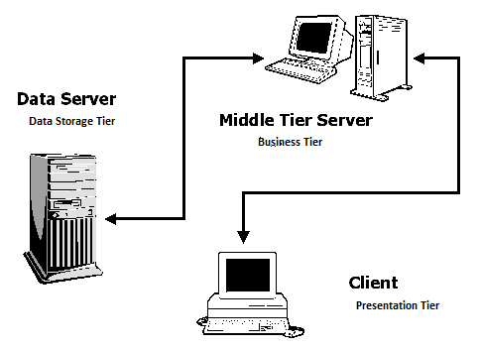

While the concepts of layer and tier are often used interchangeably, one fairly common point of view is that there is indeed a difference. This view holds that a layer is a logical structuring mechanism for the elements that make up the software solution, while a tier is a physical structuring mechanism for the system infrastructure.

* Presentation Tier:

Though in case of web service, no GUI is usually implemented. But for user friendliness there are some GUI using either HTML or XML.

* Business Tier:

Service, JPA and all other class is implemented here. All classes will be written in JAVA

* Data Logic Tier:  
  All backend information stored in db is implemented in this tier.

# Snap Shot

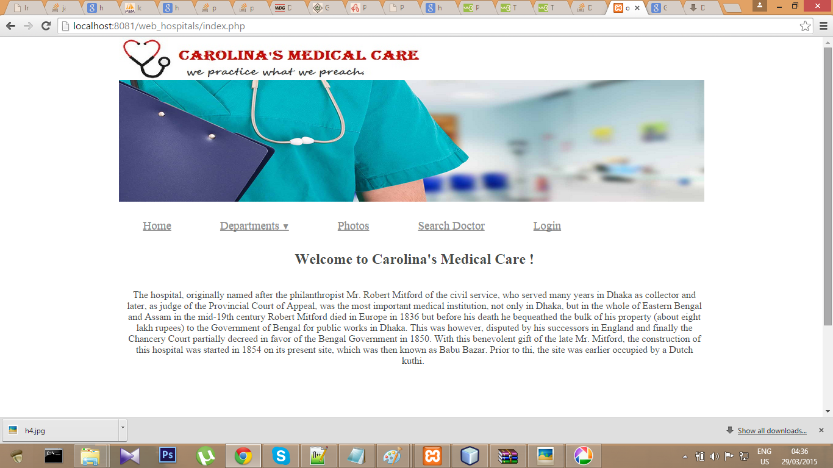

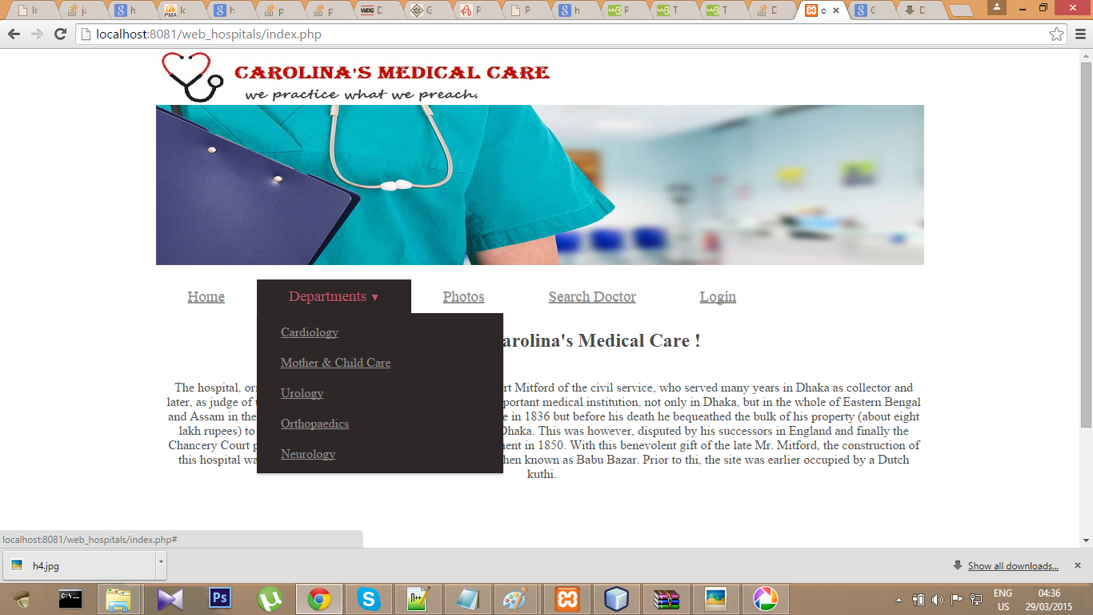

The first pages of our project

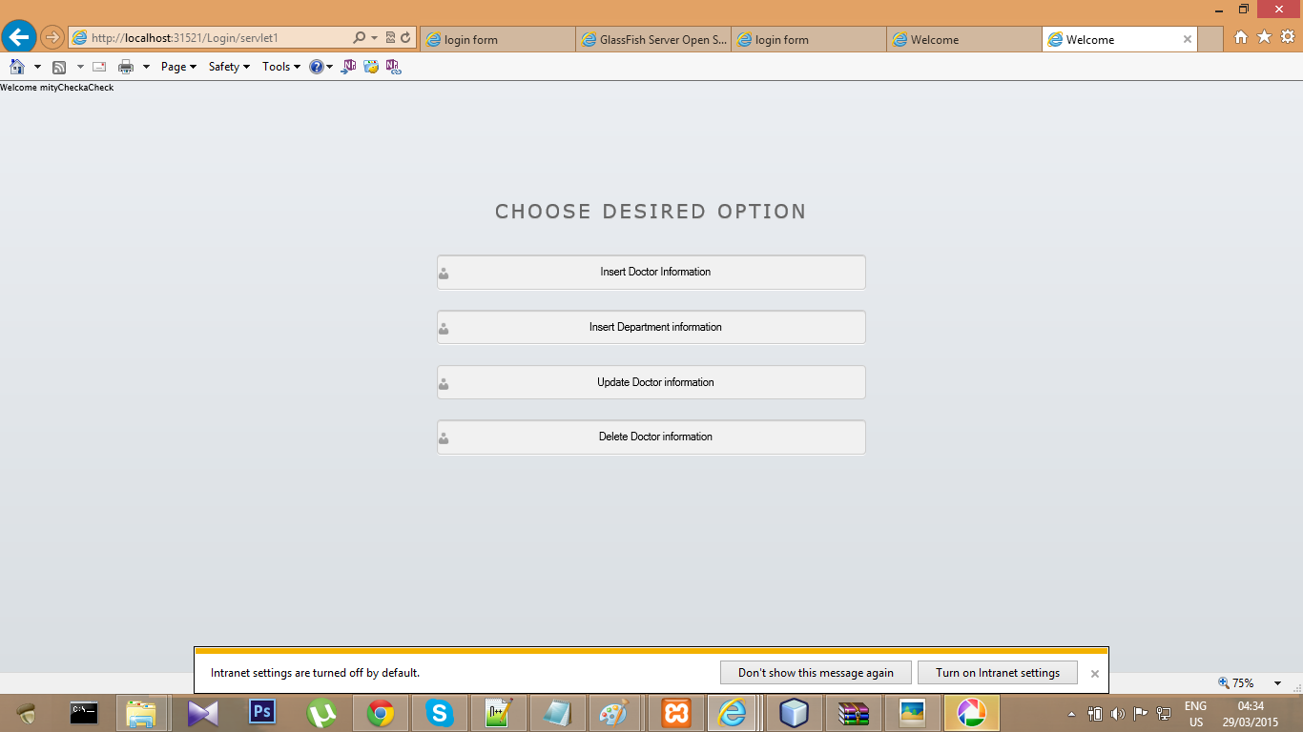

The page after login form

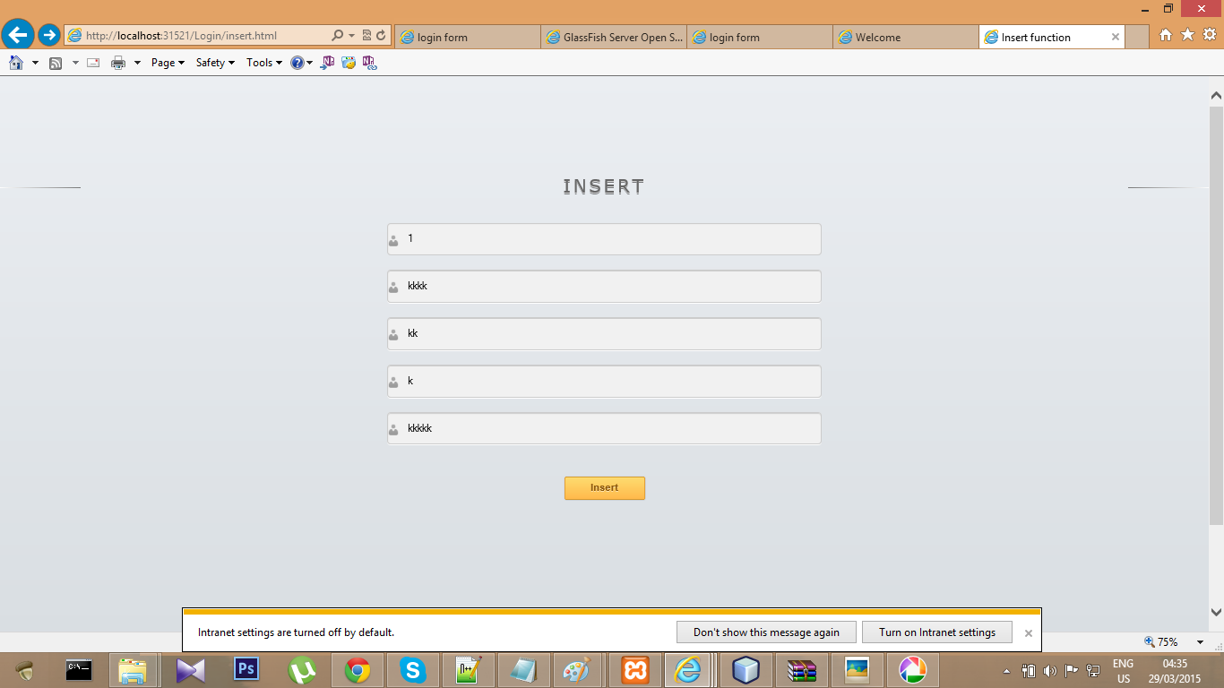

The inserting form of doctor information which take input from admin

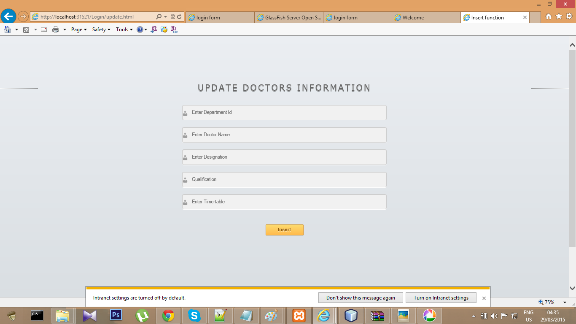

The form of updating doctor information

# Functionality of Application

* Anyone could know the depertment of hospital
* Patient could know the information of doctor that whic doctor is available at which time

# Conclusion

Our application may have little features or may seems not important; but we decided to develop this application to provide a better hospital admission process for people. Everyday there are lots of calls to each hospital regarding appointment schedule or admission query. We firmly believe automation of these process will help people to get their desired service as well as hospitals will be able to provide better healthcare services.

1. weblogs.java.net/blog/driscoll/archive/2005/12/servlet_history_1.html