

**MERU UNIVERSITY OF SCIENCE AND TECHNOLOGY**

**SCHOOL OF COMPUTING AND INFORMATICS**

**COURSE: BACHELOR OF SCIENCE IN INFORMATION**

**TECHNOLOGY**

**NAME: MONG’OMA J WAFULA**

**Y4S2**

**INDUSTRIAL ATTACHMENT REPORT**

**Context Experts Agencies - Ruiru**

**REG NO: CT203/103399/20**

# DECLARATION

This report is my original work prepared with no other than the indicated support and has not been presented by anyone

Student Name………………………………………………… Reg No ………………………… Sign ………………………………………….. Date …………………………………………….

Supervisor ……………………………………… Sign ……………………………………………

# ACKNOWLEDGEMENT

Though it is neither possible nor practical to thank everyone who has assisted me through my entire attachment at Context Experts Agencies, minimal acknowledgment is inevitable.

First and foremost, I thank the Almighty God for granting me this opportunity to be able to do my attachment successfully in this organization.

Secondly, I warrant a special recognition to my supervisor, Mr. Stephen Ngunjiri and my University assessor Mr. Njuguna. For always ensuring that my attachment was duly done well as per the university rules and regulation.

# ABSTRACT

This report documents the activities and experiences gained during my attachment at Context Experts Agencies. The attachment provided an invaluable opportunity to enhance my skills in various IT-related fields. I engaged in creating visual content, learning to use tools such as Adobe Photoshop and Illustrator to design logos, brochures, and social media graphics. I also participated in developing and maintaining websites, employing languages and frameworks such as HTML, CSS, JavaScript, PHP, and MySQL. This involved both front-end and back-end development tasks.

Additionally, I was involved in troubleshooting and maintaining computer systems, ensuring smooth operation and minimal downtime. I gained hands-on experience in configuring routers, setting up networks, and ensuring secure and efficient data transmission within the organization. The attachment period was instrumental in bridging the gap between theoretical knowledge and practical application, providing me with a comprehensive understanding of the IT industry's working environment and the skills required to thrive within it.

Contents

DECLARATION ii

ACKNOWLEDGEMENT iii

ABSTRACT iv

CHAPTER ONE 1

INTRODUCTION 1

1.0 Background of the Industrial Attachment Program 1

1.1 Objectives of the Field Attachment 1

1.2 Background of the Organization 2

1.3 Structure and Organization 3

1.4 Major Activities and Focus of the Department 5

CHAPTER TWO 7

INDUSTRIAL TRAINING EXPERIENCE 7

2.0 Duties and Responsibilities 7

2.1 New Knowledge and Skills Gained 8

2.2 Level of Accomplishment 8

2.3 Relationship with Other Staff 9

2.4 Things Enjoyed Most and Least 9

2.5 Challenges Experienced and How Handled 10

2.6 Major Benefits Derived from the Industrial Attachment Program 10

CHAPTER FOUR 12

CONCLUSION AND RECOMMENDATIONS 12

4.1 Conclusion 12

4.2 Recommendations 12

REFERENCES 14

APPENDICES 15

Appendix A: Sample Graphic Design Projects 15

Appendix B: Web Development Projects 18

Appendix C: System Maintenance Documentation 20

Appendix D: Networking Configuration 21

# CHAPTER ONE

# INTRODUCTION

## 1.0 Background of the Industrial Attachment Program

The industrial attachment program is an essential component of the academic curriculum, designed to bridge the gap between theoretical knowledge and practical application. This program provides students with the opportunity to gain hands-on experience in their field of study by working in a real-world professional environment. The primary aim is to enhance students' understanding of workplace dynamics, expose them to industry standards and practices, and equip them with the skills necessary to excel in their careers. The program fosters professional growth by allowing students to engage in actual work projects, interact with industry professionals, and apply their academic learning in a practical setting.

## 1.1 Objectives of the Field Attachment

The field attachment aims to achieve several key objectives:

1. **Application of Knowledge:** Enable students to apply theoretical concepts learned in the classroom to practical situations in a real-world environment.
2. **Skill Development:** Enhance technical, analytical, and problem-solving skills through hands-on experience with industry-standard tools and practices.
3. **Professional Growth:** Foster the development of essential soft skills such as communication, teamwork, and time management, which are crucial for professional success.
4. **Industry Insight:** Provide students with a deeper understanding of the operational aspects, challenges, and trends within the industry.
5. **Networking:** Offer opportunities to build professional relationships with industry experts, which can be beneficial for future career prospects.
6. **Career Orientation:** Help students explore various career paths within their field of study, clarifying their career goals and aspirations.

## 1.2 Background of the Organization

Context Experts Agencies is a leading IT solutions provider based in Ruiru, renowned for its innovative and customized IT services. The organization specializes in a broad spectrum of IT related activities, including graphic design, web design and development, system maintenance, and networking solutions. Context Experts Agencies is dedicated to delivering high-quality and efficient IT solutions to its diverse clientele, which includes small businesses, large enterprises, and individual clients. With a team of highly skilled professionals, the organization is committed to staying ahead of technological advancements and providing exceptional service.

## 1.3 Structure and Organization

The organizational structure of Context Experts Agencies is designed to promote efficiency and specialization across different IT services. The main departments within the organization include:

1. **Graphic Design Department:** Focuses on creating visual content and branding materials using advanced design tools like Adobe Photoshop and Illustrator.
2. **Web Design and Development Department:** Responsible for developing and maintaining websites and web applications, employing various programming languages and frameworks.
3. **System Maintenance Department:** Ensures the smooth operation and maintenance of IT systems and infrastructure, addressing any technical issues that arise.
4. **Networking Department:** Manages the setup, configuration, and maintenance of network systems, ensuring secure and reliable data transmission.

I was deployed primarily to the Graphic Design Department, which is crucial to the organization’s operations. This department focuses on creating visual content and branding materials, utilizing advanced design tools like Adobe Photoshop and Illustrator and Canva. I gained skills in creating the following; Posters, Brochures, Pamphlets, Logos etc. The collaborative structure within the department ensures a streamlined workflow and the delivery of high-quality visual solutions. Each project is overseen by a senior professional who provides mentorship and guidance to team members, fostering a creative and productive environment.

In addition to my primary deployment in the Graphic Design Department, I also had the opportunity to work in other departments, including Web Design and Development, System Maintenance, and Networking. This rotational approach allowed me to gain a comprehensive understanding of the organization's operations and develop a diverse set of skills. By working in various departments, I was able to experience different aspects of IT services, enhancing my technical knowledge and practical experience.

## 1.4 Major Activities and Focus of the Department

The Web Design and Development Department at Context Experts Agencies is dedicated to creating and maintaining robust, user-friendly websites and web applications. The department's focus is on delivering high-quality, innovative web solutions that meet clients' needs and exceed their expectations. By staying updated with the latest industry trends and technologies, the team continually improves its processes and deliverables, maintaining Context Experts Agencies' reputation as a leader in the IT solutions sector. Major activities include:

1. **Front-End Development:**
   * Designing and implementing the user interface using HTML, CSS, and

JavaScript. o Creating responsive and visually appealing websites that provide a seamless user experience.

1. **Back-End Development:**
   * Developing server-side logic, managing databases, and integrating various technologies such as PHP and MySQL.
   * Ensuring the functionality, security, and performance of web applications.
2. **Quality Assurance:**
   * Conducting thorough testing of websites and applications to identify and fix bugs.
   * Ensuring that the deliverables meet the required standards and specifications.
3. **Collaborative Projects:**
   * Working closely with the Graphic Design Department to integrate visual elements. o Collaborating with the Networking Department to ensure optimal performance and security.

# CHAPTER TWO

# INDUSTRIAL TRAINING EXPERIENCE

## 2.0 Duties and Responsibilities

During my industrial attachment at Context Experts Agencies, I undertook a range of duties across various departments, which provided me with comprehensive exposure to the organization's operations. In the **Graphic Design Department**, my responsibilities included designing visual content such as logos, brochures, and promotional materials. I used tools like Adobe Photoshop and Illustrator to create high-quality designs that aligned with client specifications and brand guidelines. In the **Web Design and Development Department**, I was involved in both front-end and back-end development tasks, which entailed coding user interfaces using HTML, CSS, and JavaScript, as well as developing server-side functionalities with PHP and MySQL. In the **System Maintenance Department**, I was responsible for performing routine maintenance, troubleshooting technical issues, and ensuring the smooth operation of IT systems. In the **Networking Department**, my duties included configuring network systems, maintaining network security, and resolving connectivity issues.

## 2.1 New Knowledge and Skills Gained

Throughout my attachment, I acquired a wealth of knowledge and skills pertinent to each department. In the **Graphic Design Department**, I enhanced my proficiency in graphic design software and learned advanced techniques for creating impactful visual content. I gained a deeper understanding of design principles such as color theory, typography, and layout, which significantly improved my ability to produce professional-quality designs. In the **Web Design and Development Department**, I broadened my technical skill set by working with various web technologies. I became adept at using HTML, CSS, and JavaScript for front-end development and learned how to manage databases and server-side scripting using PHP and MySQL. My time in the **System Maintenance Department** taught me practical skills in system diagnostics and maintenance, including how to troubleshoot common technical problems and perform routine system checks. In the **Networking Department**, I gained hands-on experience in configuring network devices, ensuring data security, and optimizing network performance.

## 2.2 Level of Accomplishment

My accomplishments during the attachment were notable in each department. In the **Graphic Design Department**, I successfully completed several high-profile design projects that were well-received by clients and contributed to the department's creative output. My designs played a significant role in enhancing the visual identity of various brands and marketing materials. In the **Web Design and Development Department**, I contributed to the development of several web applications, implementing features that improved functionality and user experience. My work on quality assurance helped identify and resolve bugs, ensuring that the web applications met high standards. In the **System Maintenance Department**, I effectively handled technical issues and performed maintenance tasks that resulted in improved system performance and reduced downtime. In the **Networking Department**, I assisted with optimizing network configurations and addressing connectivity issues, which led to more reliable network operations. Overall, my contributions were recognized for their quality and effectiveness, reflecting my growing expertise and commitment.

## 2.3 Relationship with Other Staff

Building and maintaining positive relationships with colleagues was a key aspect of my industrial attachment experience. In the **Graphic Design Department**, I worked closely with senior designers and other interns, receiving valuable feedback and support that enhanced my skills. In the **Web Design and Development Department**, I collaborated with developers, designers, and quality assurance specialists, contributing to a team environment that fostered learning and innovation. My interactions with staff in the **System Maintenance Department** and **Networking Department** were also constructive, as I learned from experienced technicians and worked together to solve complex problems. These relationships facilitated my integration into the team and contributed to a supportive and collaborative work environment.

## 2.4 Things Enjoyed Most and Least

I particularly enjoyed the creative challenges and opportunities for innovation in the **Graphic Design Department**, where I could apply my creativity to design projects and see the tangible results of my work. The collaborative and dynamic nature of the **Web Design and Development Department** was also highly stimulating, as working on diverse projects with a team allowed me to learn and grow. Conversely, I found some of the routine maintenance tasks in the **System Maintenance Department** to be less engaging, although they were essential for ensuring system stability. Additionally, the high-pressure situations in the **Networking Department** during network issues were challenging, but they provided valuable learning experiences and helped me develop problem-solving skills.

## 2.5 Challenges Experienced and How Handled

Throughout my attachment, I encountered several challenges. In the **Web Design and**

**Development Department**, integrating complex features into websites presented difficulties. To overcome these challenges, I sought advice from senior developers, conducted additional research, and participated in troubleshooting sessions. In the **System Maintenance Department**, unexpected system failures required quick thinking and effective problem-solving. I addressed these challenges by relying on my training, consulting with experienced technicians, and applying systematic troubleshooting methods. The demanding nature of the **Networking Department** presented challenges in maintaining network security, which I managed by staying informed about best practices, collaborating with the team, and implementing effective solutions.

## 2.6 Major Benefits Derived from the Industrial Attachment Program

The industrial attachment program provided substantial benefits, enhancing my professional development and technical expertise. I gained practical experience in various IT domains, from graphic design and web development to system maintenance and networking. This hands-on experience improved my proficiency with industry-standard tools and practices, broadened my understanding of IT operations, and prepared me for future career opportunities. The program also offered valuable insights into professional work environments, helping me clarify my career goals and build a network of industry contacts. Overall, the attachment was a transformative experience that significantly contributed to my growth as a future IT professional.

# CHAPTER FOUR

# CONCLUSION AND RECOMMENDATIONS

## 4.1 Conclusion

The industrial attachment program at Context Experts Agencies provided me with a robust and multifaceted learning experience. One of the major strengths of the program was the comprehensive exposure to different IT departments, which enabled me to gain a wide range of skills, from graphic design to web development, system maintenance, and networking. The mentorship and guidance from experienced professionals greatly enhanced my technical abilities and professional knowledge. However, one weakness of the program was the limited time allocated to each department, which sometimes made it challenging to delve deeply into complex projects. Additionally, there were occasional instances of insufficient resources or tools, which hindered the efficiency of some tasks.

## 4.2 Recommendations

To improve the industrial attachment program as part of the academic curriculum at MUST, I recommend extending the duration of the attachment to allow students more time to immerse themselves in each department. This will enable a deeper understanding and mastery of complex tasks. Additionally, enhancing the collaboration between the university and industry partners can ensure that students have access to the latest tools and technologies, thereby improving the learning experience.

For the improvement of service delivery in the industry, I suggest that organizations like Context Experts Agencies invest in continuous professional development for their staff. This can be achieved through regular training sessions and workshops on the latest industry trends and technologies. Moreover, fostering a culture of innovation and encouraging feedback from interns and junior staff can lead to fresh ideas and improvements in processes and service delivery.

# REFERENCES

All relevant citations such as textbooks, personal communications, internet material, codes of practice, and guidelines that I used during the industrial attachment and report writing are listed below in APA style:

* Adobe Systems Incorporated. (2020). *Adobe Photoshop User Guide*. Retrieved from <https://helpx.adobe.com/photoshop/user-guide.html>
* Adobe Systems Incorporated. (2020). *Adobe Illustrator User Guide*. Retrieved from <https://helpx.adobe.com/illustrator/user-guide.html>
* W3Schools. (2021). *HTML, CSS, JavaScript Tutorial*. Retrieved from [https://www.w3schools.com](https://www.w3schools.com/)
* PHP Documentation Group. (2021). *PHP Manual*. Retrieved from <https://www.php.net/manual/en/>
* MySQL Documentation Team. (2021). *MySQL Reference Manual*. Retrieved from <https://dev.mysql.com/doc/>
* Cisco Systems. (2020). *Cisco Networking Essentials*. Retrieved from https://www.cisco.com/c/en/us/training-events/training-certifications/training/trainingservices.html
* Personal communications with senior designers, web developers, and IT technicians at

Context Experts Agencies (2023).

# APPENDICES

This section includes additional materials that support the report, such as drawings, design charts, and photographs. These appendices provide further evidence of the work and learning outcomes achieved during the industrial attachment.

### Appendix A: Sample Graphic Design Projects

* Logo designs



* Brochures

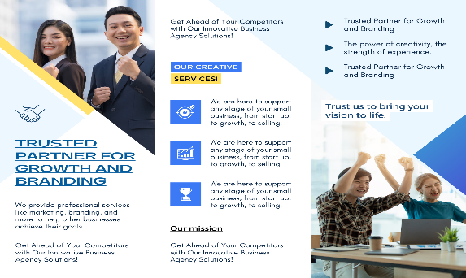

* Pamphlets

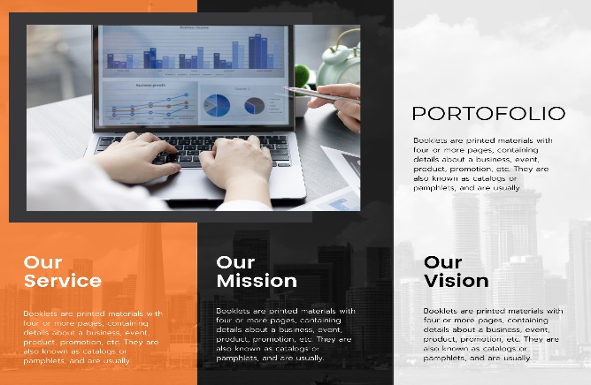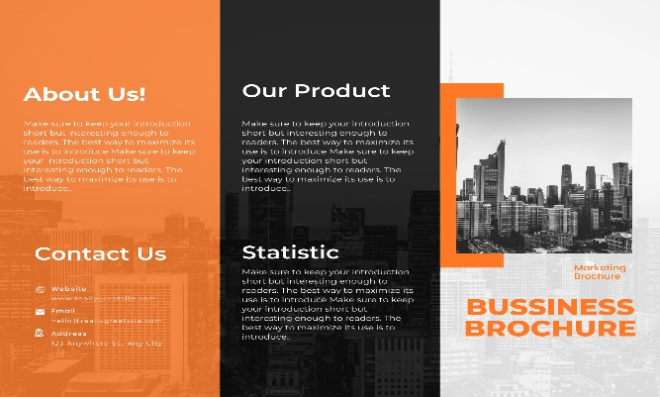

* Posters

 

## Appendix B: Web Development Projects

* Screenshots of developed websites

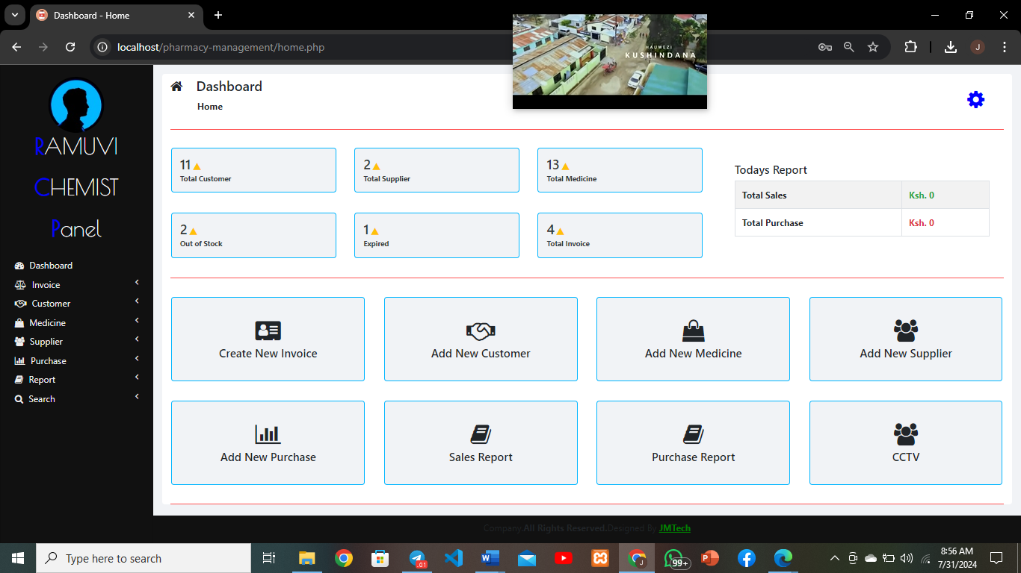

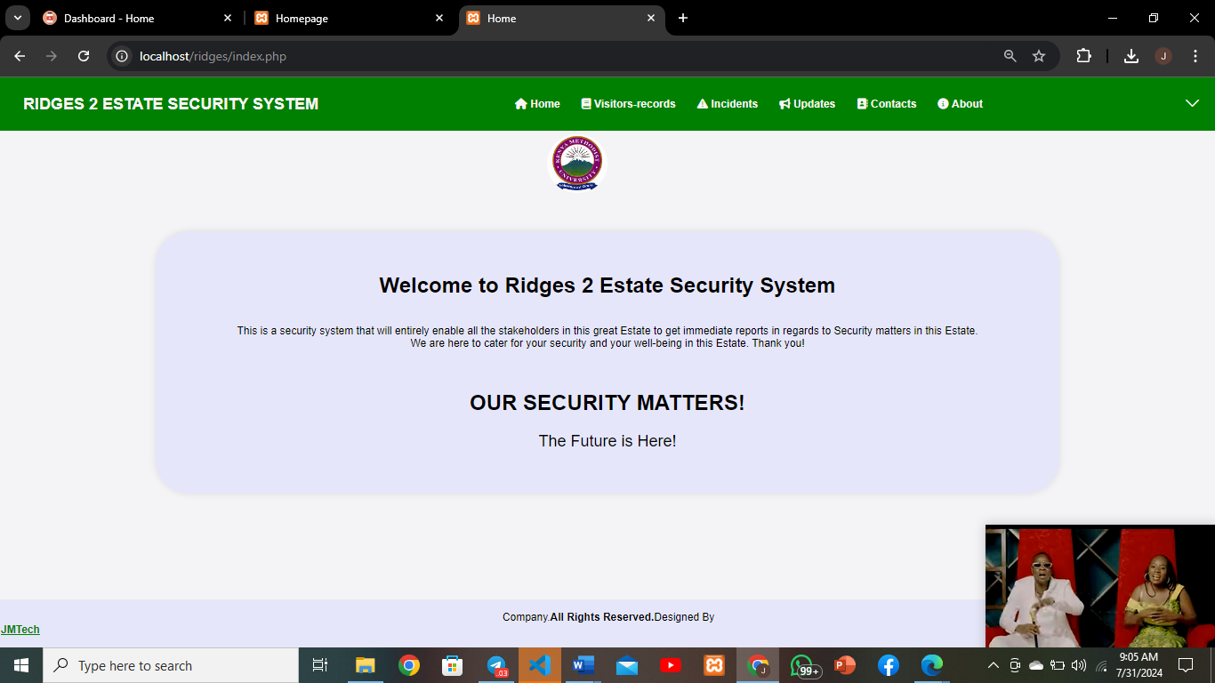

* Code snippets

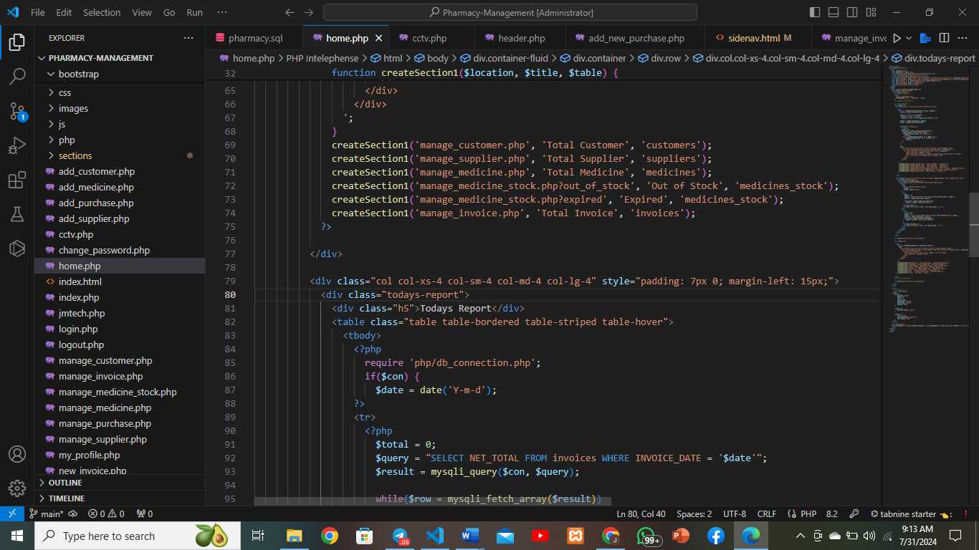

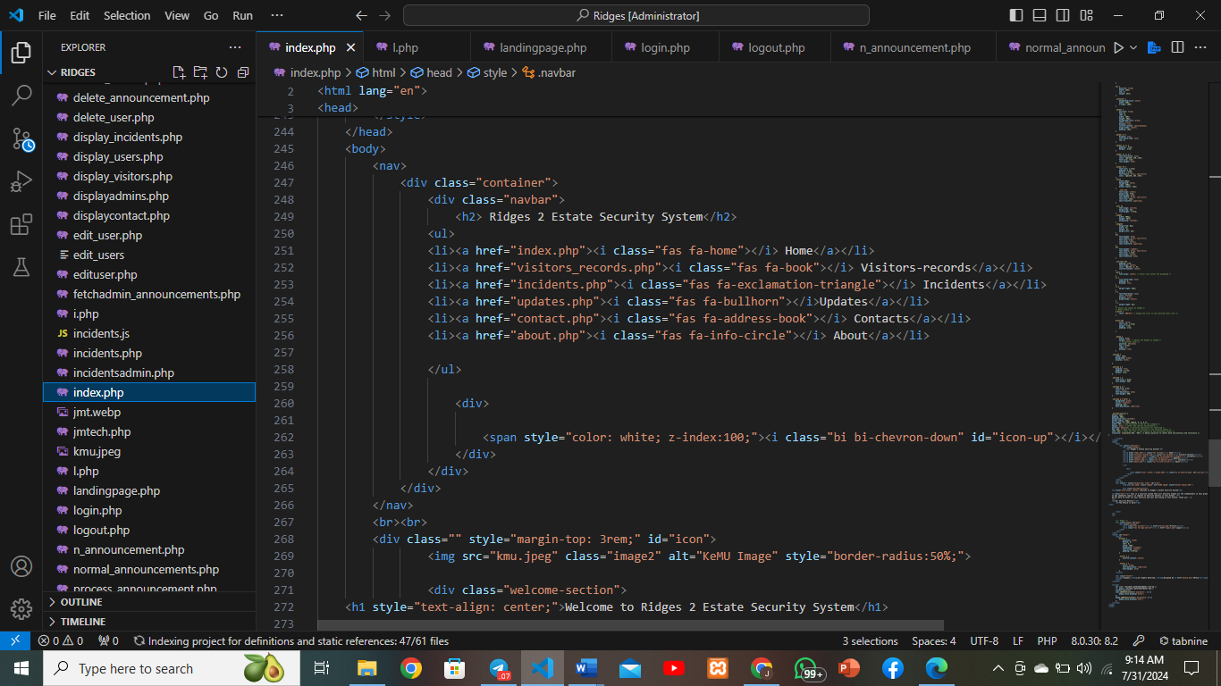

# Appendix C: System Maintenance Documentation

* Troubleshooting guides

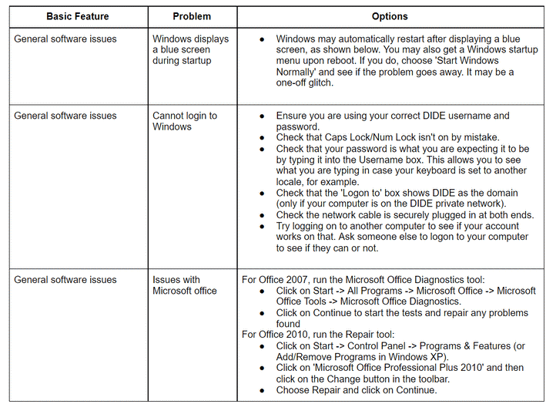

# Appendix D: Networking Configuration

* Network diagrams

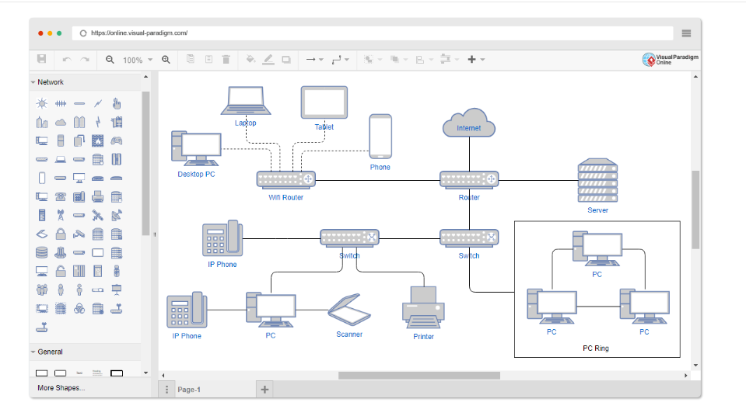

* Configuration settings

