**T1,2,3 Hvac controller**

**Direct comms cable**

The intent of this cable is to bypass all unit and car wiring to establish a serial connection with the controller. This cable also works on the bench to test, load and check firmware on the controller.

PARTS

1. 4 pin amp connector –CPC-3
   1. 285-2138-X
2. 14 ft Wire, min. 3 strand
3. Male serial connector
   1. Trimet PN. Xxxxxxxxxxxxxxx
4. DB-9 body
   1. DB9 clamshell body
5. Serial DB9 pins
   1. Crimp Trimet PN. xxxxxxxxxxxxxxx
   2. Wing crimp Trimet PN. xxxxxxxxxxxxxxx

Assembly

1. Put it together

Pinout

CPC-3 Wire DB9 serial

3 rx/tx 3

1 gnd 5

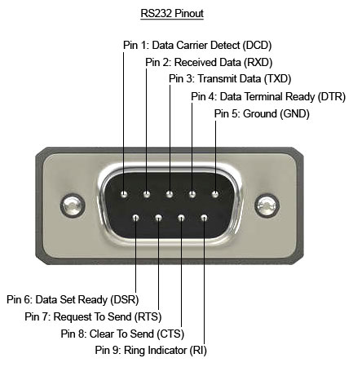4 tx/rx 2