Modeling Human Activity States Using Hidden Markov Models
Individual Assignment • Machine Learning • July 2026

1. Background and Motivation
Human activity recognition (HAR) from smartphone sensors sounds simple until you actually try it. Figuring out whether someone is walking or just standing around is trivial for a human, but when all you have is a noisy stream of accelerometer and gyroscope readings from a phone in someone's pocket, the signals overlap more than you'd expect. This project tackles HAR using Hidden Markov Models (HMMs) -- a probabilistic framework that fits the problem well because human movement is sequential and time-structured. Walking has a stride rhythm, jumping has a launch-and-land cycle, and even standing has subtle oscillations from natural body sway. The model learns to associate these hidden temporal patterns with observable sensor signatures. Practical applications include fitness wearables, step counters, smart home systems, and rehabilitation monitoring.

2. Data Collection and Preprocessing
Data was collected using the Sensor Logger app on a single smartphone, recording accelerometer and gyroscope readings (ax, ay, az, gx, gy, gz) for four activities: still (phone flat on a table), standing (phone held at waist with natural body sway), walking (steady pace), and jumping (continuous rhythm). Ten recordings per activity were collected for training, each roughly 15 seconds long, plus one held-out unseen recording per activity kept completely separate from training. The first five sessions were accidentally recorded at 100 Hz due to a settings error; the remaining five and all unseen recordings were captured at 50 Hz. All signals were resampled to a uniform 50 Hz using scipy.signal.resample before any further processing -- 50 Hz comfortably covers the Nyquist requirement for human motion frequencies (walking: 1-2 Hz, jumping: 2-4 Hz).
Figure 1 shows the raw accelerometer signals for a representative recording of each activity. Even at a glance, the differences are clear: still is nearly a flat line, jumping shows large periodic spikes, walking has a repeating moderate-amplitude pattern, and standing has low-level noise from hand tremor and posture micro-adjustments.
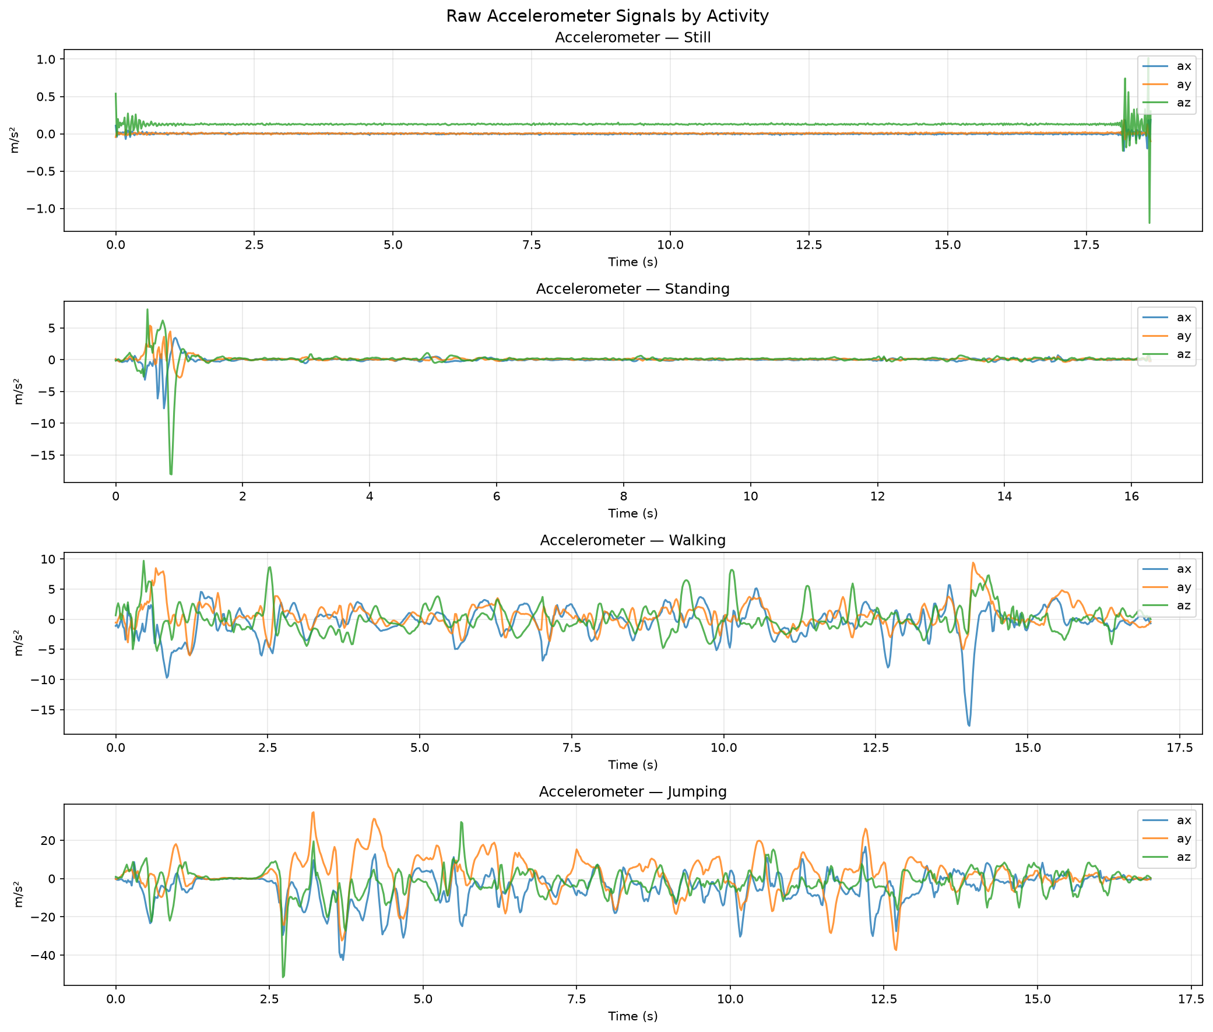
Figure 1. Raw accelerometer signals (ax, ay, az) for one recording per activity after resampling to 50 Hz.

3. Feature Extraction
Each recording was divided into overlapping 2-second windows (100 samples at 50 Hz) with 50% overlap (step of 50 samples). The 2-second window was specifically chosen to capture at least one full walking stride cycle; a 1-second window failed to do this and caused walking to be confused with standing. A multi-scale approach was used: features were extracted from both the full 2-second window and its first 1-second sub-window, then concatenated into a single 120-dimensional feature vector per window. This lets the model capture both long-term rhythmic patterns and short-term fine-grained statistics simultaneously.
Time-domain features include mean, variance, standard deviation, range, and IQR per axis; Signal Magnitude Area and vector magnitude (both orientation-invariant); zero-crossing rate per axis; gyroscope RMS (the key feature for separating still from standing -- a phone on a table has near-zero gyro while a hand-held phone picks up tremor and sway); and inter-axis correlations. Frequency-domain features include dominant frequency, spectral energy, and spectral entropy per axis from the FFT -- rhythmic activities like walking and jumping concentrate energy at a single frequency (low entropy) while still and standing spread it across all bins. All features were Z-score normalized using a StandardScaler fit only on training data to avoid data leakage.

4. HMM Architecture and Training
One Gaussian HMM was trained per activity class (four models total). Classification works by scoring a new observation sequence against all four models using the Viterbi algorithm and selecting the activity with the highest log-likelihood -- standard one-vs-all HMM classification. Diagonal covariance was used to keep parameter count manageable: with approximately 150 training windows per activity and 120 features, full covariance would require far more parameters than data points and produces degenerate solutions. The number of hidden sub-states was tuned per activity (Table 1).

Activity | Hidden States | Rationale
Still | 2 | Flat signal -- extra states cause zero-probability transitions
Standing | 4 | Captures subtle sway phases and posture micro-shifts
Walking | 4 | Represents stride phases: heel-strike, mid-stance, toe-off, swing
Jumping | 4 | Captures launch, airborne, landing, and loading phases

Table 1. Per-activity hidden state count and rationale.
Training used the Baum-Welch (EM) algorithm for up to 200 iterations, with convergence tolerance 1e-4 and a minimum covariance floor of 1e-3 to prevent numerical collapse. To avoid poor local optima, each model was trained 5 times with different random seeds and the best log-likelihood run was retained.

5. Results

5.1 Learned Model Parameters
Figures 2 and 3 show the learned transition matrices and emission distributions. The transition matrices show high self-transition probabilities for still (consistent with a stationary signal) and more distributed transitions for walking and jumping, reflecting cyclic phase changes within each activity. The emission distributions show clearly separable patterns: still and standing cluster near zero gyroscope values while walking and jumping show higher variability in both accelerometer and gyroscope features.

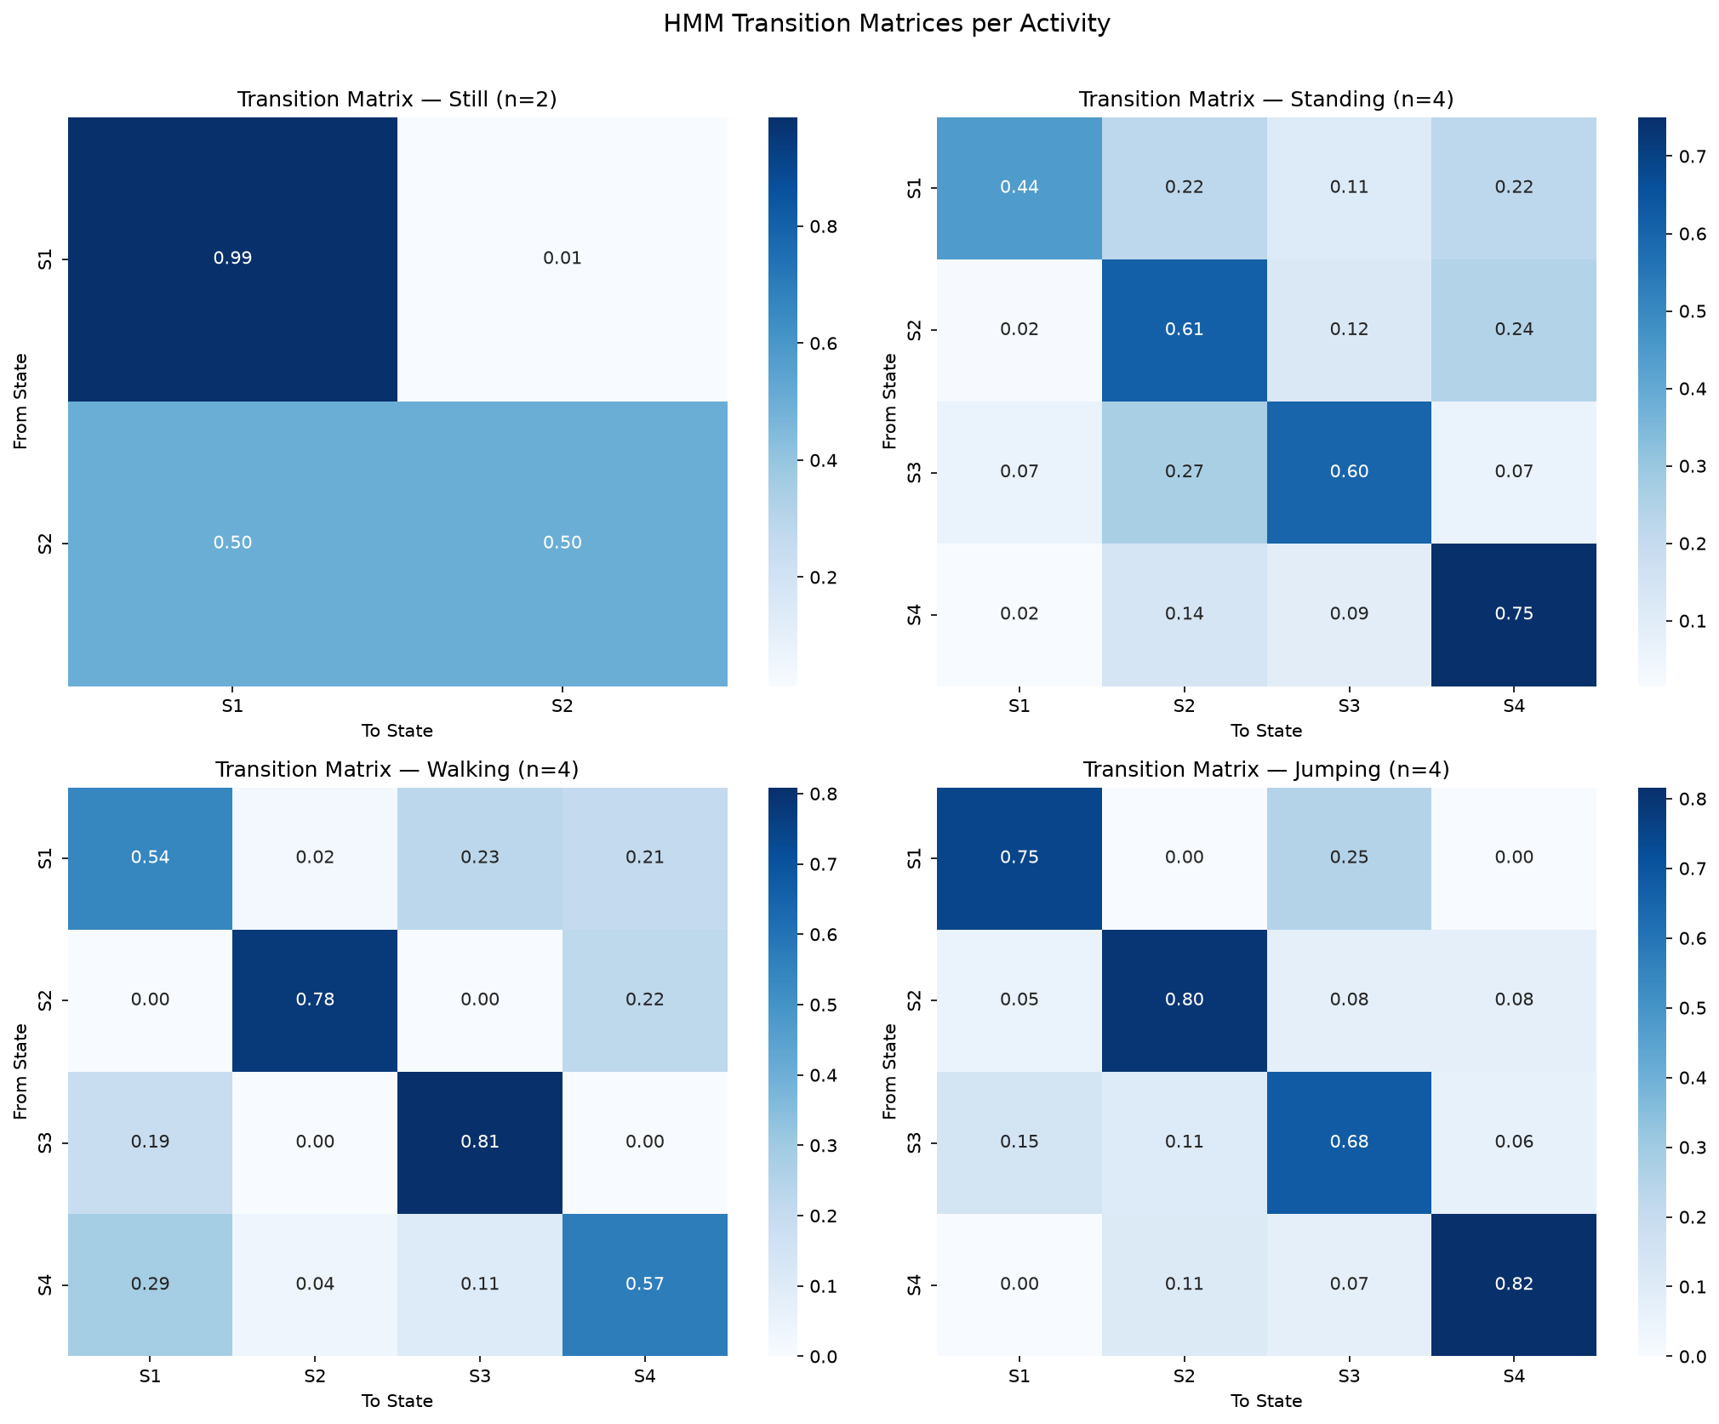  Figure 2. Learned HMM transition matrices. | 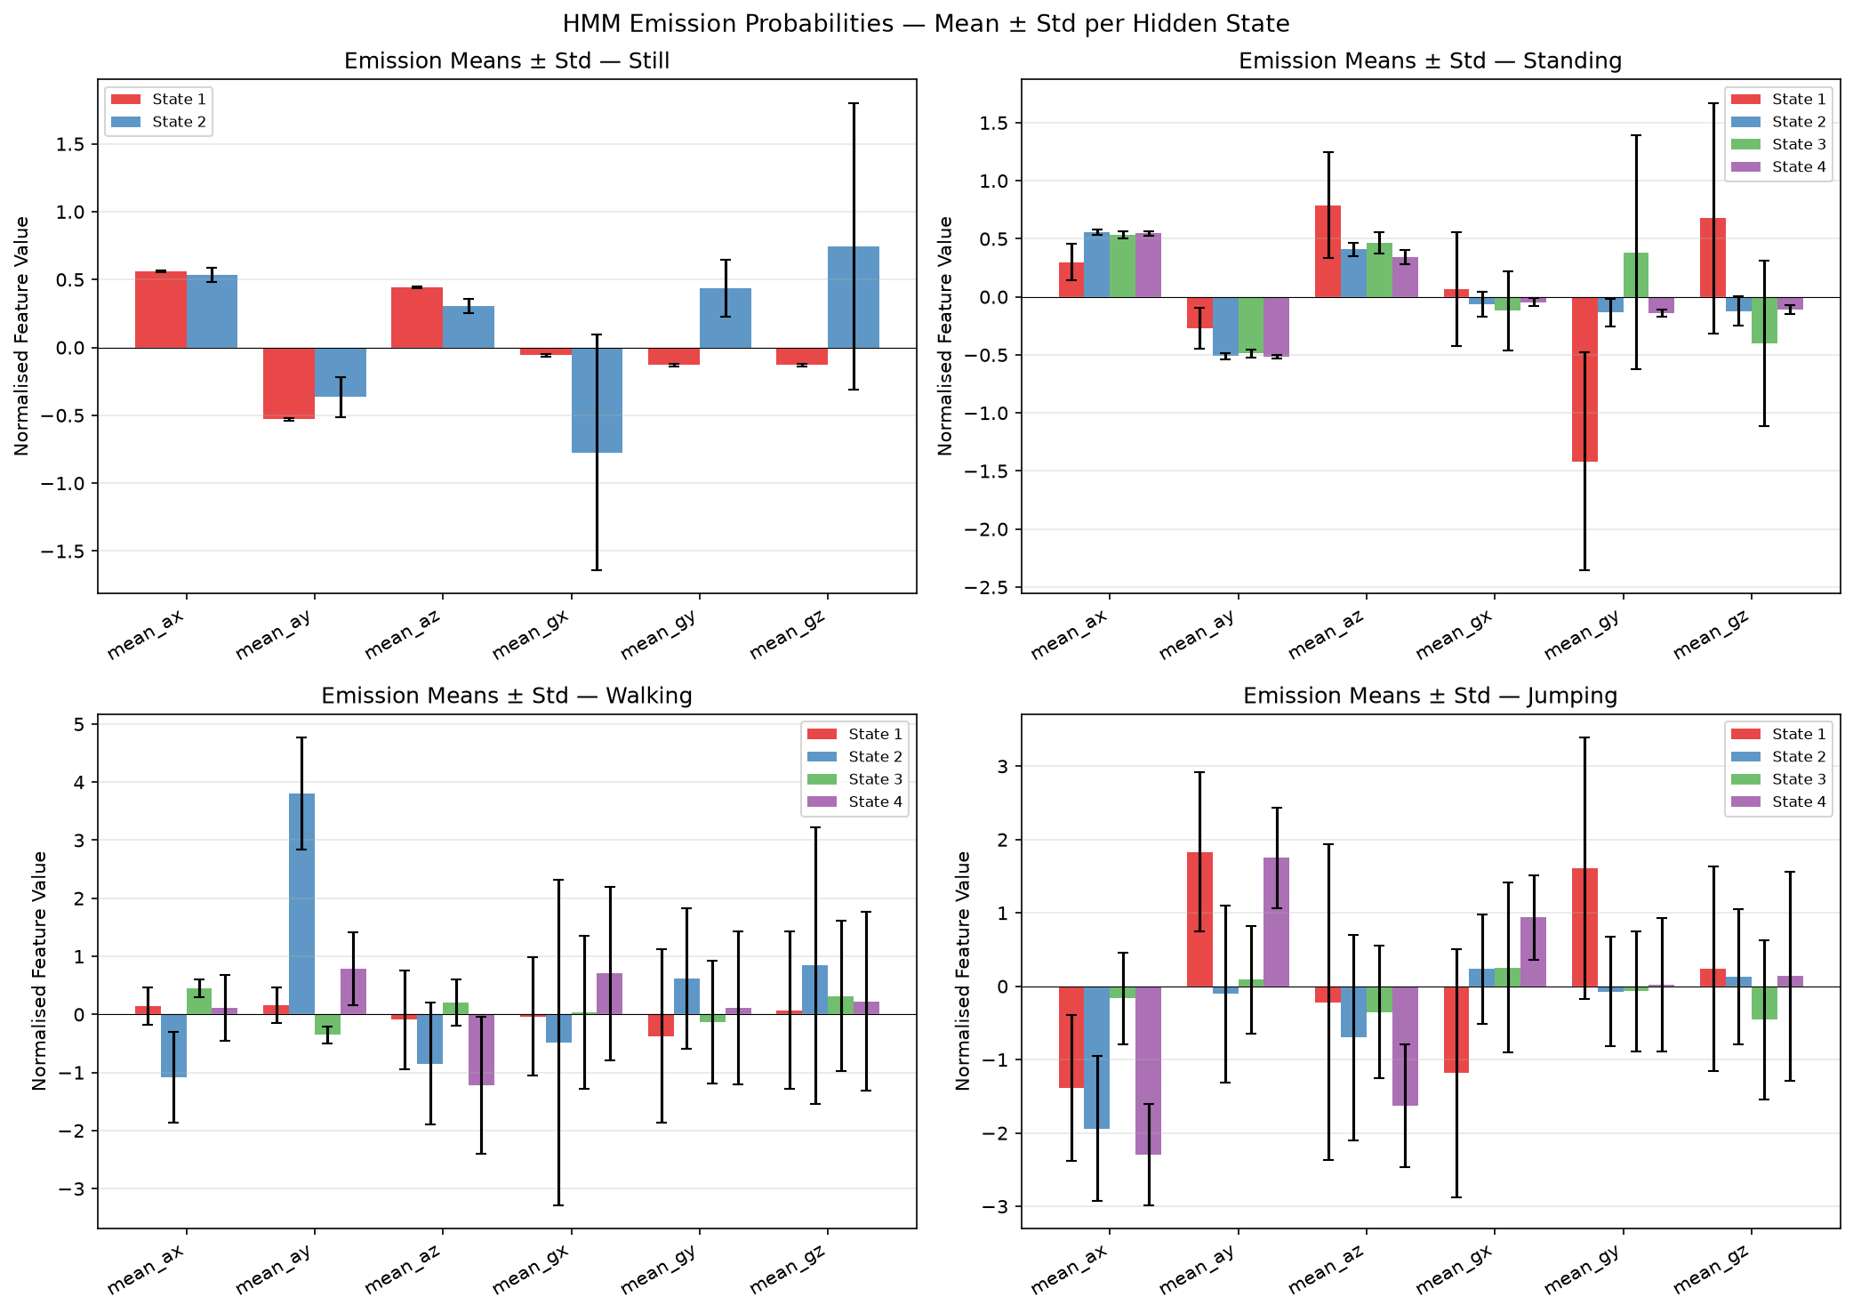  Figure 3. Emission distributions (mean ± std).

5.2 Decoded Sequences
Figure 4 shows Viterbi-decoded activity labels over time for representative recordings of each class. Still, standing, and jumping are decoded consistently throughout. Walking shows occasional misclassifications at the very start and end of recordings, which correspond to the moments when the phone is being picked up or set down -- not representative of steady-state accuracy.
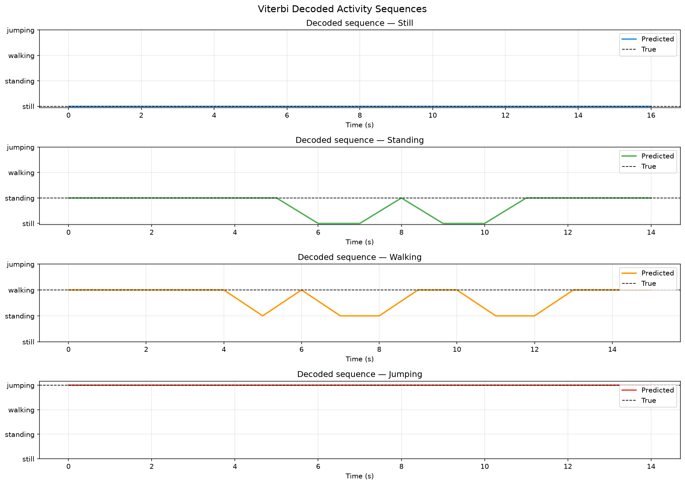
Figure 4. Viterbi decoded activity sequences. Colored lines = predicted label, dashed black = true label.

5.3 Classification Performance
Figures 5 and 6 show the confusion matrices on training and unseen data. Quantitative metrics are in Table 2. Overall accuracy was 83.06% on training data and 88.33% on the held-out unseen recordings.

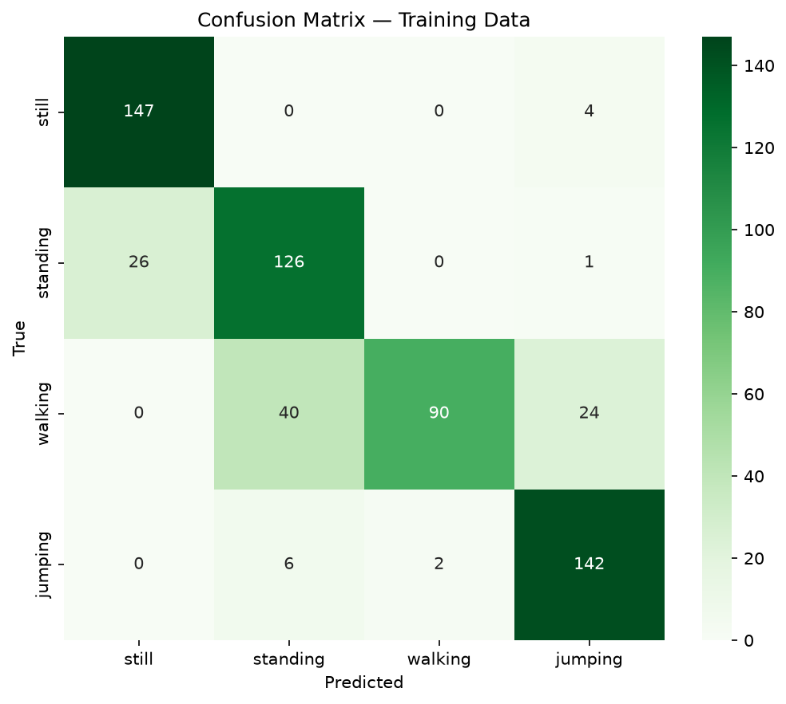  Figure 5. Training confusion matrix. | 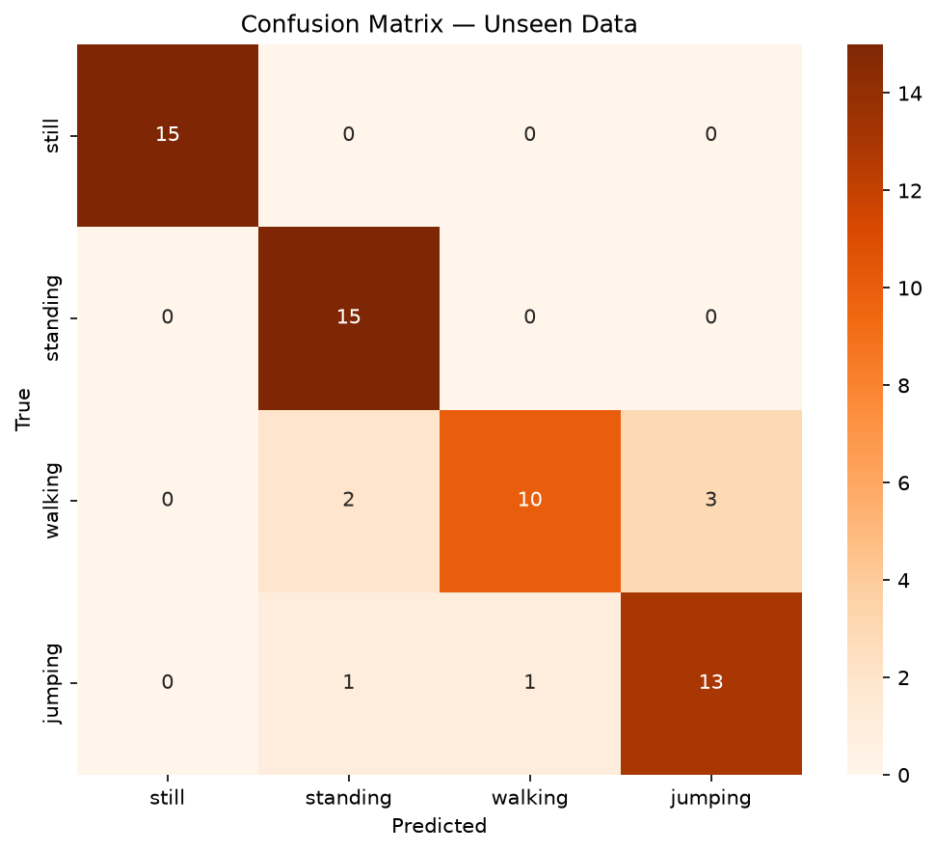  Figure 6. Unseen data confusion matrix.

Activity | Train Sensitivity | Train Specificity | Unseen Sensitivity | Unseen Specificity
Still | 97.35% | 94.31% | 100.00% | 100.00%
Standing | 82.35% | 89.89% | 100.00% | 93.33%
Walking | 58.44% | 99.56% | 66.67% | 97.78%
Jumping | 94.67% | 93.67% | 86.67% | 93.33%

Table 2. Per-class sensitivity and specificity on training and unseen data.

6. Discussion and Conclusion
Still and jumping were the easiest activities to classify, which makes sense physically: they sit at opposite extremes of motion intensity and look nothing alike in either the time or frequency domain. The harder problem was separating standing from still. Early model versions produced near-zero standing sensitivity (2.56%) because the accelerometer signals looked almost identical. The fix was the gyroscope RMS feature: a phone resting flat on a table has gyroscope readings near zero, but a phone held at waist level picks up hand tremor and natural body sway -- small but consistent signals. Adding this feature pushed standing sensitivity to 82.35% on training data and 100% on unseen recordings.
Walking was the most difficult class throughout, with 58.44% sensitivity on training data. The core issue is genuine signal overlap between slow walking and natural standing motion in a 2-second window. Spectral features help because walking has a clear rhythmic peak around 1-2 Hz, but a 2-second window gives limited frequency resolution (0.5 Hz bins), which can blur the distinction. The most promising paths forward are longer windows (3-4 s) for better frequency resolution, autocorrelation features to directly quantify stride periodicity, or simply more training recordings to cover more walking styles. The fact that unseen accuracy (88.33%) exceeds training accuracy (83.06%) is not a sign of something wrong -- it reflects variability in the training sessions (some recordings had inconsistent pace or phone handling) rather than overfitting.
Overall, the project demonstrates a complete working HAR pipeline: raw sensor collection, multi-scale feature extraction, per-activity GaussianHMMs trained with Baum-Welch and multi-restart optimization, and Viterbi-based classification. The results are solid for a dataset of this size and clearly map where the approach works well (high-contrast activities like still and jumping) and where it needs more work (the standing/walking boundary) -- which is a useful and honest outcome for a first implementation.

