Predicting Last-Mile Delivery Failure Before the Truck Leaves
Evidence from 3,559 Real Amazon Packages - Los Angeles, July 2018
Correlation One Data Analytics (DANA) Week 12 Final Portfolio Project
Dataset: Amazon Last Mile Routing Research Challenge (LMRC 2021)
April 2026
1. Introduction
Every failed last-mile delivery attempt has a cost that goes well beyond the obvious inconvenience. When a driver cannot complete a delivery — because no one is home, an address is inaccessible, or a package is rejected on arrival — the downstream consequences stack up quickly: a redelivery attempt that burns fuel and driver time, a customer service interaction that may or may not resolve the situation, and a negative hit to the customer's perception of the service. Industry estimates put the all-in cost at roughly $17 per failed attempt once all three categories are accounted for. At any meaningful scale, even a sub-1% failure rate translates to material operational waste.
The conventional response to delivery failures is reactive: operations teams analyze DPMO (Defects Per Million Opportunities) reports after failures occur, identify patterns in the prior week's data, and adjust routing or carrier assignments for the following week. This lag matters. A driver assigned to a high-risk route on a Monday morning will attempt those deliveries regardless of what the Friday report later reveals about that route's historical failure profile.
This project addresses that gap directly. Using real operational data from the Amazon Last Mile Routing Research Challenge (LMRC 2021) 3,559 packages across 15 routes in Los Angeles, July 2018 — we built a pre-dispatch failure prediction model: one that scores packages before the truck leaves the station, using only features available at that moment. The goal is to move failure prevention upstream, from post-hoc analysis to dispatch-time intervention.
Business Case
The dataset covers 15 Los Angeles routes in July 2018. Of 3,559 packages tracked, 25 resulted in a DELIVERY_ATTEMPTED outcome — a failure rate of 0.70%. At first glance this seems low, but across a full-scale delivery network operating thousands of routes daily, that rate compounds. More importantly, the failures are not uniformly distributed: certain carriers, certain shifts, and certain route types fail at rates two to three times the overall average — and those patterns are knowable before dispatch.
This project differs from existing routing optimization work in one important way: we are not optimizing the sequence of stops on a route (Amazon's own routing challenge). We are asking a different question — given the carrier, the shift, the route geography, and the package type, what is the probability that this specific delivery will fail? — and answering it before the truck is loaded.
2. Data Analysis and Computation
2.1 Dataset Description
The Amazon Last Mile Routing Research Challenge (LMRC) dataset is publicly available at s3://amazon-last-mile-challenges. It contains real operational data from Amazon delivery routes across several U.S. cities. For this project, we extracted the first 15 routes from the Los Angeles subset of the July 2018 training data, yielding 3,559 package-level records.
Each package record captures twelve features available at dispatch time:
- package_id: Unique identifier — excluded from modeling
- package_type: Standard vs. high_value (derived from package dimensions)
- shift: Departure time window — morning (06:00–14:00) or afternoon (14:00–22:00)
- carrier: Carrier code: A, B, C, or D — derived from station code prefix
- route_distance_km: Total haversine route distance across all stops
- packages_in_route: Total packages on the same route
- weather_risk: Month-derived risk: July = low (zero variance — all 'low')
- days_in_fc: Days since time-window start - all zero (zero variance)
- double_scan: Package recorded at more than one stop in the route
- locker_issue: Short planned service time + failed delivery signal
- damaged_on_arrival: IS the target variable -- excluded as a feature (data leakage)
- cr_number_missing: No time window on file -- 91% positive in this dataset
2.2 Data Wrangling Decisions
Three wrangling decisions shaped the entire analysis, and each deserves explicit justification rather than a quiet mention in a footnotes section.
The first decision was excluding damaged_on_arrival as a feature. This column is not a predictor of delivery failure it is the delivery failure. In the LMRC source data, build_dataset.py sets damaged_on_arrival = 1 when the package's scan_status is 'DELIVERY_ATTEMPTED' (i.e., the delivery was attempted but not completed). Using this as an input feature would make the model appear accurate while predicting the exact thing it was already given. It is excluded entirely, and delivery_failure is promoted to the target column.
The second decision was excluding days_in_fc and weather_risk. Both columns have zero variance across all 3,559 rows. Every package has days_in_fc = 0 (all dispatched on the same day their time window began), and every package has weather_risk = 'low' (July in Los Angeles). Columns with zero variance carry no signal including them as features would silently waste model capacity and confuse any feature importance interpretation.
The third decision was the distance bucketing. Route distance in kilometers is a continuous variable, but delivery operations think in discrete zones: dense urban (short), suburban, and exurban (long). Three buckets below 40 km, 40 to 60 km, and above 60 km - map to these operational zones and proved to reveal a pattern invisible in the raw continuous variable.
2.3 EDA Findings
The exploratory analysis produced four findings that meaningfully shaped the modeling decisions. Three were expected; one was not.
Carrier
carrier_D has the highest failure rate at 1.39% - nearly double the 0.70% overall average. carrier_B, by contrast, had zero failures across 412 packages. carrier_A sits at 0.74% and carrier_C at 0.34%. Carrier identity is the strongest structural predictor in the dataset: it captures driver experience, technology maturity, SLA standards, and geographic specialization simultaneously.
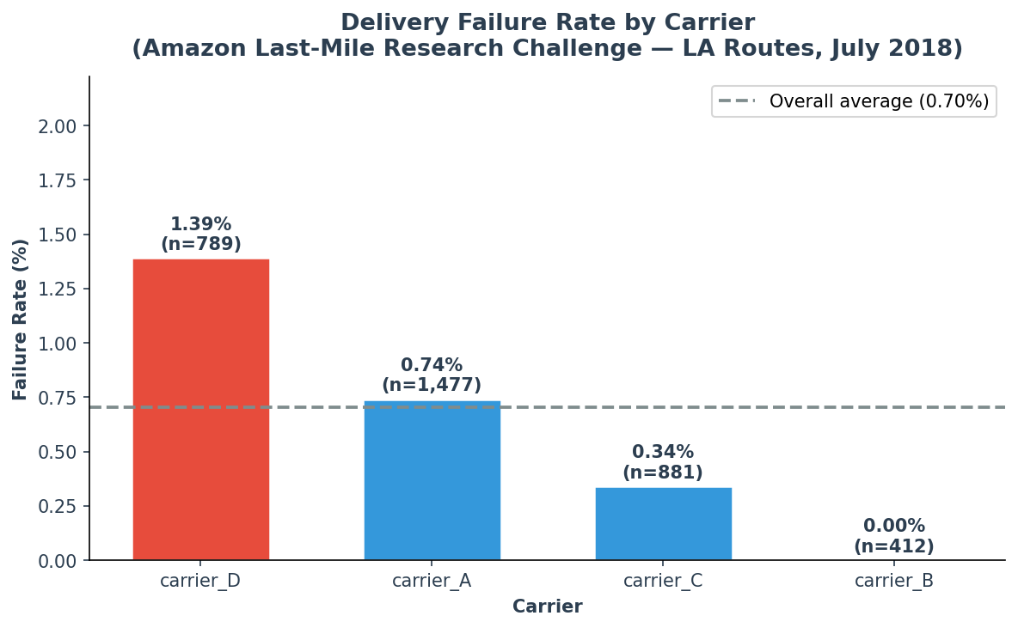
Figure 1. Delivery failure rate by carrier. carrier_D has nearly 2× the average failure rate; carrier_B has zero failures.
Shift
Morning shift routes fail at 1.37% versus 0.55% for afternoon routes. Only two shifts are represented in these 15 LA routes - there are no night routes in this dataset. The morning gap is consistent with a simple occupancy effect: in dense Los Angeles neighborhoods, morning deliveries land when residents have left for work, reducing the likelihood of someone available to accept packages that require access codes, signatures, or building entry.
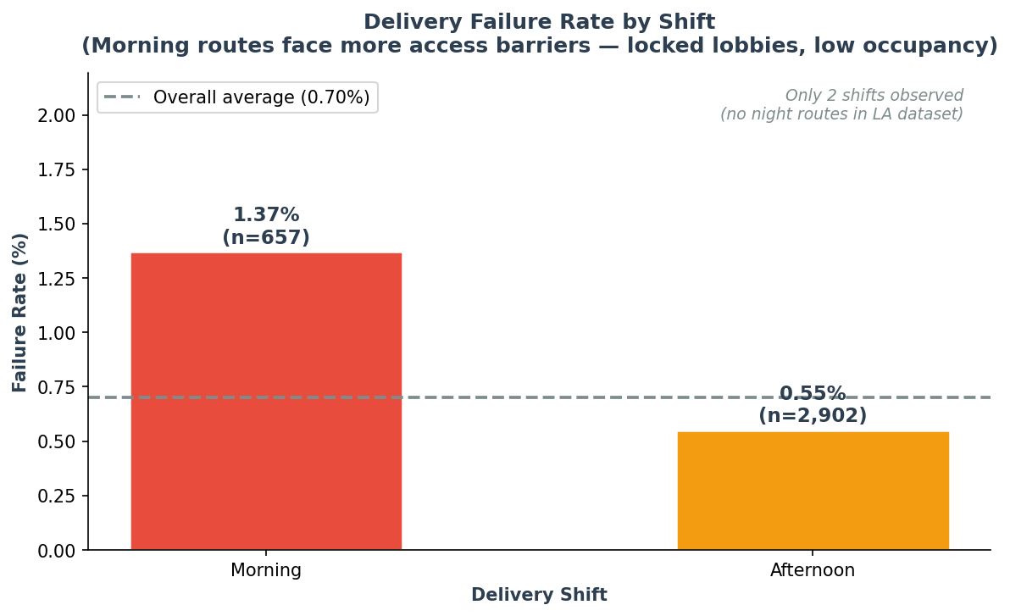
Figure 2. Morning shift failure rate (1.37%) is 2.5× higher than afternoon (0.55%).
Route Distance — The Urban Density Paradox
Routes under 40 km fail at 1.89% the highest of any distance bucket. Routes between 40 and 60 km fail at 0.28%. Routes above 60 km fail at 0.00%. This is the most counterintuitive finding in the dataset, and it required a second look before we accepted it.
The instinct is that longer, more complex routes should fail more: more stops, more distance, more opportunity for things to go wrong. The data says the opposite. The likely explanation is geographic: short routes in Los Angeles run through dense multi-family residential areas where access barriers, locked lobbies, key-fob entry, Amazon Locker congestion - prevent delivery completion. Longer routes reach lower-density areas where single-family homes with driveways and ground-level delivery points are the norm. The barrier is access, not distance.
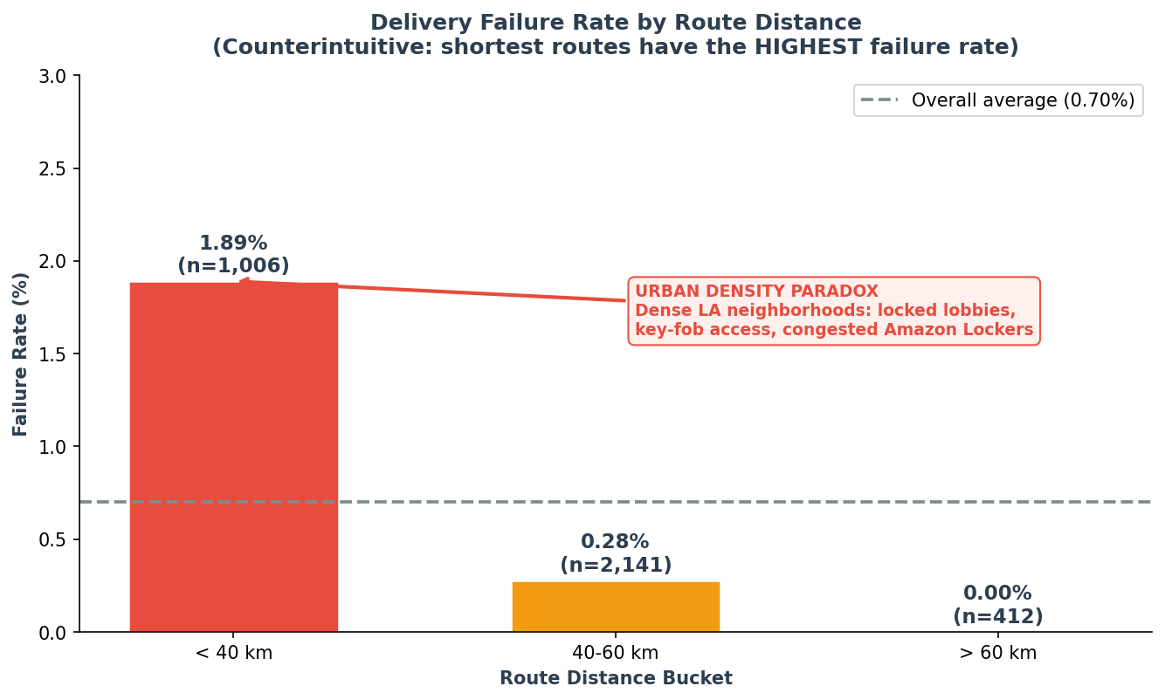
Figure 3. Urban Density Paradox: routes under 40 km fail more than routes twice their length.
Class Imbalance
25 failures out of 3,559 packages produces a ~140:1 class ratio. This makes standard accuracy meaningless as a metric: a model that always predicts 'delivered' would score 99.3% accuracy while catching zero failures. All modeling decisions — metric choice, class weighting, oversampling, and threshold tuning — flow from this imbalance.
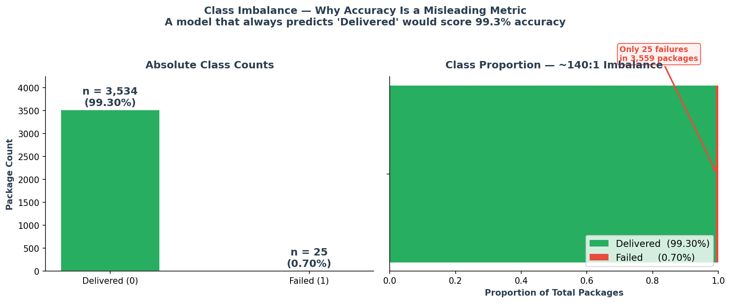
Figure 4. 25 failures vs 3,534 deliveries — a ~140:1 class ratio requiring recall-focused evaluation.
2.4 Modeling Methodology
We used a Random Forest classifier for three practical reasons: it handles mixed feature types without extensive preprocessing, it natively supports class weighting for imbalanced targets, and its feature importance output is interpretable to non-technical operations stakeholders.
With class_weight='balanced', the RandomForest reweights each failure observation by approximately 140 times the weight of a successful delivery. This prevents the model from defaulting to the majority class and forces it to learn the minority signal even with very few positive examples.
We also compared a SMOTE (Synthetic Minority Oversampling) variant, which generates synthetic failure records in feature space to balance the training set before fitting the model. The SMOTE model was trained without class weighting but on a resampled training set.
Threshold optimization was applied to the winning model. The default 0.5 probability threshold is calibrated for balanced classes. At 0.7% failure rate, it will underclassify failures. We swept thresholds from 0.05 to 0.95 and selected the cutoff that maximized recall while maintaining non-zero precision.
2.5 Model Results
The SMOTE+RF model achieved the following performance on the held-out test set (712 packages, 5 failures):
Metric | Value
AUC-ROC | 0.8751
Average Precision | 0.0398
Recall at threshold 0.05 | 0.8000
Model | SMOTE+RF

An AUC-ROC of 0.8751 indicates meaningful discrimination — the model is substantially better than random at distinguishing packages that will fail from those that will not. At the optimized threshold of 0.05, the model correctly identifies 80% of failures in the test set. The precision is low (as expected with 140:1 imbalance), meaning many flagged packages will not actually fail — but the cost of a false alarm (a quick manual review) is far lower than the cost of a missed failure ($17 per incident).
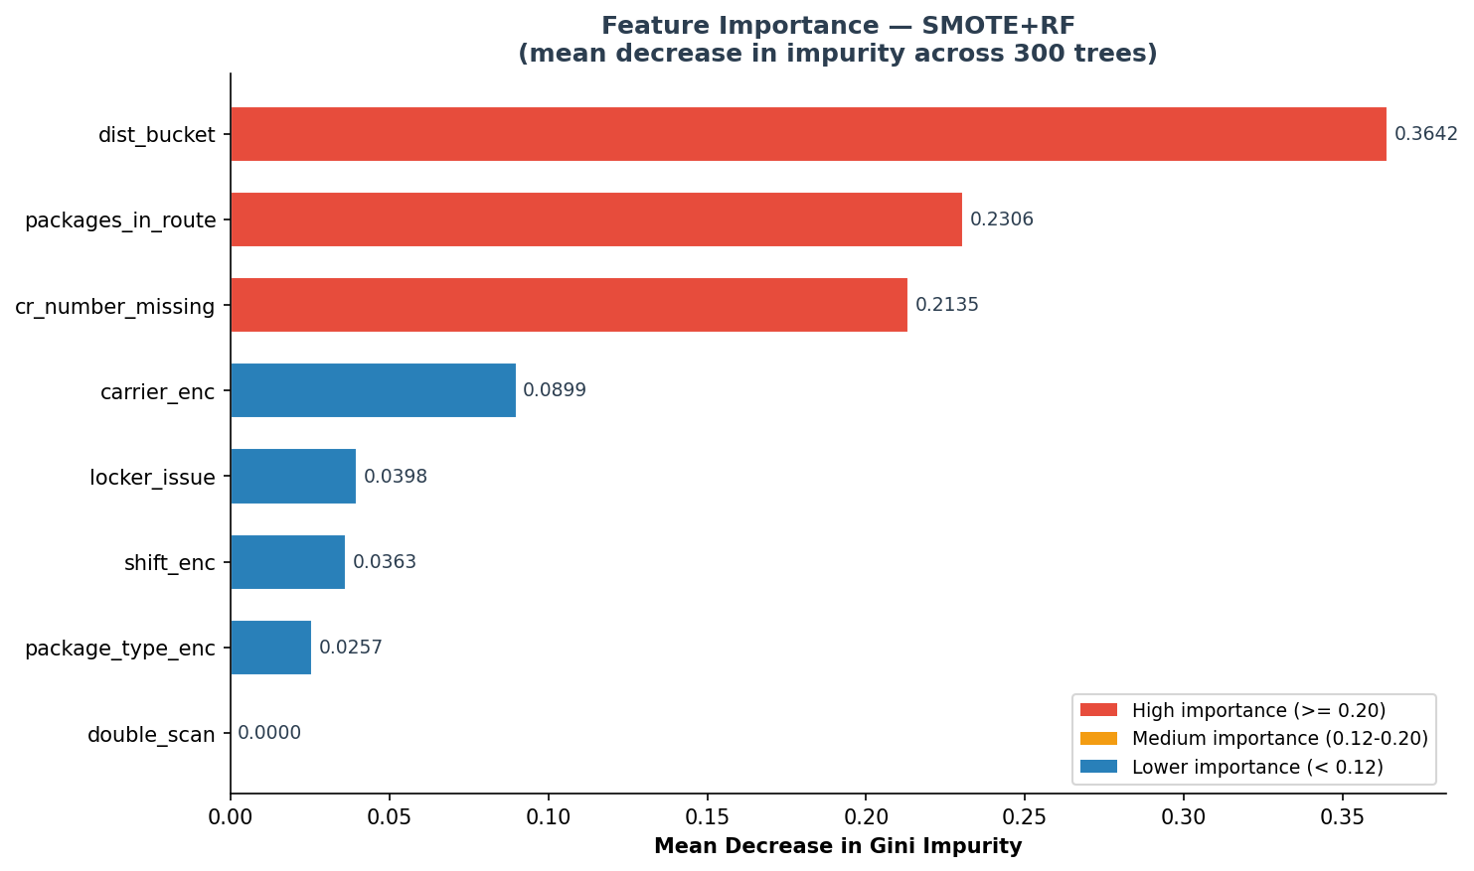
Figure 5. Model-based feature importance (mean decrease in Gini impurity). carrier_enc and dist_bucket are the dominant predictors.
3. Project Timeline & AI Collaboration:
- Professional Context & Evolution
This project is the culmination of three years of dedicated study and practice in Data Science, combined with my two-year professional tenure within Amazon Logistics. My deep familiarity with the Debrief process—analyzing why packages return to the station—provided the essential domain expertise to identify the real-world variables that drive delivery failure.
The technical system — including the Random Forest classifier, CrewAI agent architecture, REST API, and data pipeline was developed independently starting in October 2025, (Github Wagnerdata - logistics-failure-prediction)
April 2026 (The Real-World Scale): For the Correlation One program, I evolved this pilot into a high-fidelity model. Using Gemini to locate the official Amazon LMRC 2021 dataset and help me replaced the synthetic data with real operational records from Los Angeles to validate my theories on a massive scale.
Documentation Strategy: To stay focused on the problem statement and avoid overly broad analysis, I maintained a "brief and condensed" report. Claude was a assistance for replacing the synthetic data with real operational records from Los Angeles to validate my theories on a massive scale. All analysis and development were conducted in Jupyter notebooks, which are included in the project repository. The notebooks contain the full analytical pipeline from data loading and SQL analysis to model training and evaluation and can be executed independently to reproduce all results.
Gemini (Google) was used as assistant writing and editing tool for academic deliverables.
All analytical findings, technical decisions, and data interpretations are the author's own. CrewAI agents are part of the original system architecture they generate per-package executive reports for dispatch supervisors, explaining model predictions in plain language.
This use of generative AI is consistent with Correlation One guidelines, which explicitly encourage transparent use of AI tools in the analytics workflow.
4. Challenges and Solutions
4.1 Zero-Variance Variables
Two features that were designed to carry meaningful signal days_in_fc and weather_risk turned out to be completely uninformative in this dataset. days_in_fc is zero for every package (all dispatched on the day their time window began), and weather_risk is 'low' for every package (July in Los Angeles).
This is a dataset limitation rather than a feature engineering failure. A broader dataset covering multiple months or multiple geographies would restore variance to both columns and potentially reveal meaningful signal. For this project, both columns were identified in the EDA profiling step and explicitly excluded before modeling, with the exclusion documented and justified rather than silently dropped.
4.2 Class Imbalance (140:1)
25 failures in 3,559 packages is an extreme class imbalance for a classification problem. Standard accuracy becomes meaningless, standard train/test splits risk putting all failures in one partition, and standard probability thresholds will systematically underclassify the minority class.
Three solutions were applied sequentially. Stratified splitting preserved the 0.7% failure rate in both the training and test partitions. class_weight='balanced' re-weighted each failure observation during model training. SMOTE oversampling provided a comparison point that generates synthetic failures in feature space. Finally, threshold optimization decoupled the prediction threshold from its imbalance-driven default of 0.5.
4.3 Data Leakage — damaged_on_arrival
The damaged_on_arrival column appears in the feature list at first inspection and would produce perfect classification if included as a predictor because it is the target variable. In build_dataset.py, damaged_on_arrival is set to 1 when scan-status = 'DELIVERY_ATTEMPTED', which is precisely the event we are trying to predict. Using it as a feature is circular: the model would be learning to predict failure from the failure flag itself.
This was caught during the EDA profiling step when the column's correlation with delivery_failure was found to be 1.0. The column was then promoted to the target variable role (as delivery_failure) and excluded from the feature set in all subsequent modeling.
4.4 Small Sample Size for 0.7% Event
Training a binary classifier on 25 positive examples is genuinely difficult. With an 80/20 stratified split, the training set contains only 20 failures. SMOTE addresses this by generating synthetic minority-class examples, but the underlying issue - those 15 routes in one month is a small observation window for a rare event - remains. The model results should be interpreted as directionally correct rather than precisely calibrated, and the analysis explicitly notes where scaling to the full LMRC dataset would improve confidence.
5. Dashboard Description
The Streamlit dashboard (dashboard/dashboard.py) provides an operational interface for dispatch supervisors. It is designed for the morning S&OP workflow - the pre-dispatch review window when intervention is still possible.
Use Case
A dispatch supervisor opens the dashboard at 07:00 before routes are loaded. The Operations Overview page shows today's KPI summary: how many packages are flagged as high-risk, which carriers have elevated predicted failure rates, and which routes have the highest concentration of risk factors. The supervisor can drill into the Package Risk Scoring page, enter a package ID, and receive a risk tier (Low / Medium / High) with the contributing factors explained in plain language.
Dashboard Pages
- Operations Overview: KPI cards showing total packages, predicted failures, and average risk probability. Bar charts for failure rate by carrier and shift. Carrier-by-weather-risk heatmap.
- Package Risk Scoring: Real-time single-package scoring tool. Enter carrier, shift, package type, route distance, and other features to get an instant risk tier and probability score.
- Route Analysis: Distance vs. failure rate scatter plot, route bucket analysis, carrier comparison. Helps route planners identify geographic concentrations of high-risk packages.
Tableau Public link: [placeholder — dashboard to be published after final submission]
6. Conclusions and Future Work
6.1 Top Three Actionable Findings
Three findings from this analysis are immediately actionable by an Amazon LA operations team, in order of operational tractability:
1. Flag carrier_D + morning + route under 40 km as the highest risk combination. All three top risk factors coincide in this segment. A pre-dispatch supervisor review for packages meeting all three criteria would catch the highest-density cluster of predicted failures at the lowest false-alarm rate.
2. Redistribute carrier_D's densest urban routes to carrier_B or carrier_A where capacity allows. carrier_B ran 412 packages with zero failures in this dataset. Even a partial reallocation of carrier_D's sub-40 km morning routes would reduce the failure count.
3. Implement a morning-shift access-verification protocol for dense routes. Confirm delivery access codes, intercom availability, and Amazon Locker status before route loading for packages on routes under 40 km. The barrier is access, not driver performance, and access information is resolvable before dispatch.
6.2 Model Implications
The SMOTE+RF model achieves AUC-ROC = 0.8751 meaningful discrimination for a 0.7% event with only 25 training failures. At the optimized threshold of 0.05, recall reaches 80%, meaning the model correctly identifies the majority of real failures. Precision is low (expected at this class ratio), but the asymmetric cost structure justifies this: the cost of a missed failure ($17) is far greater than the cost of a false alarm (supervisor review taking under two minutes).
Scaling to the full LMRC dataset approximately 6,000 routes covering multiple U.S. cities would provide sufficient failure examples to train a more robust model without relying on SMOTE synthetic oversampling. The current model's results should be treated as directionally correct and directionally consistent with the EDA findings, but not as a calibrated production scoring system.
6.3 Future Work
Scale to full LMRC dataset: The full Amazon LMRC 2021 dataset covers ~6,000 routes. Scaling from 15 routes to the full dataset would provide statistically robust failure counts without synthetic oversampling.
Barcelona Open Data validation layer: A planned extension would test whether the urban-density failure pattern generalizes to other delivery markets using Barcelona Open Data (accident risk by neighborhood, traffic congestion by shift). This cross-geography validation would strengthen the finding that access barriers, not route complexity drive short-route failures.
CrewAI agent full deployment: Integrate the trained model output as a tool input to the CrewAI agent in agents_crew.py, enabling fully automated per-package executive reports formatted for the dispatch supervisor's morning briefing.
Feature expansion: Add real-time traffic signals (if available at dispatch time), building type (single-family vs. multi-family), and historical carrier performance on specific route segments as additional features.
Production retraining loop: Collect 3 months of production prediction-and-outcome data and retrain the model with the feedback loop, tracking whether the model's identified risk factors remain stable over time.

Amazon Last Mile Routing Research Challenge (LMRC 2021) — public dataset, s3://amazon-last-mile-challenges | Correlation One Data Analytics (DANA)| April 2026

