A VIM Tutorial

Starting, not saving, saving, and exiting VIM

To start VIM, type vim <the file you want to open> into the console. If there is no file, it will make a new file.



Once opened, the console should look like this or, if it is an existing file, full of words.

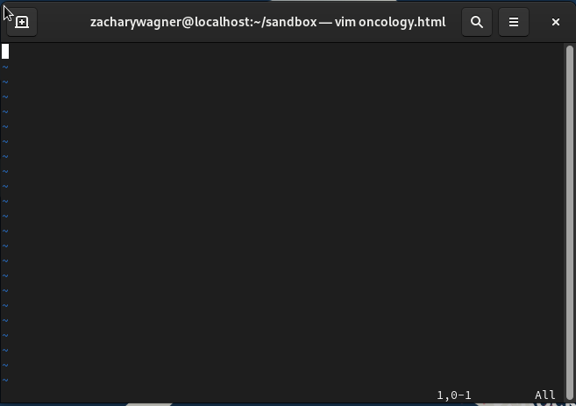

To exit the file without saving, type :q! into the console from command mode.

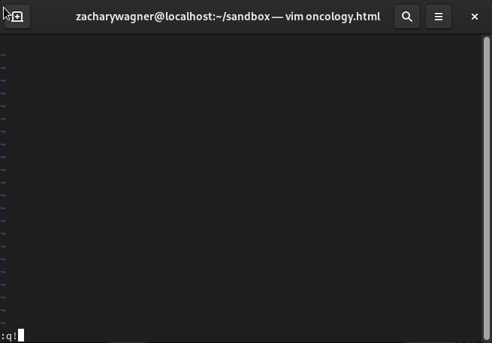

To exit the file while saving it, type :wq into the console. If you just want to save the file without quitting, type :w in command mode.

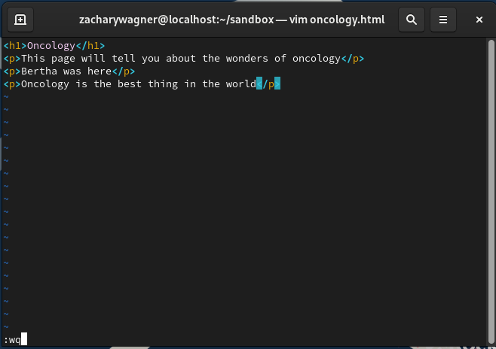

The Modes

The mode VIM enters a file in is normal mode and is used to navigate to the other modes. To get back to normal mode, press the esc key.



From normal mode, if you press :, you will be taken to command mode, where you can execute commands like q or date, which gives you the current date.

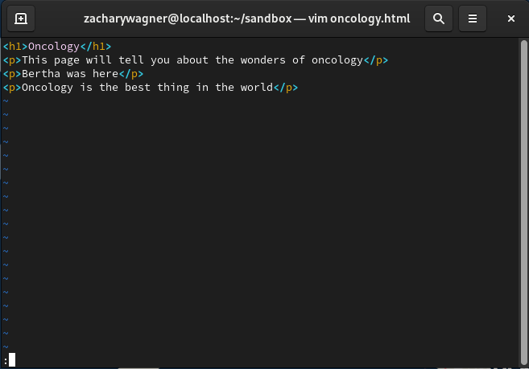

From normal mode, if you press i, you will be taken to insert mode, where you can modify the text by typing like a normal text editor.

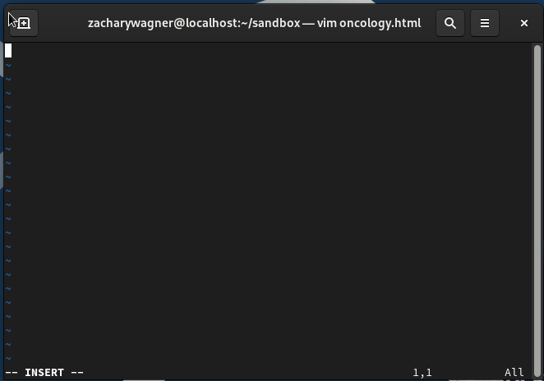

From normal mode, if you press v, you will be taken to visual mode which allows you to select areas for commands to affect.

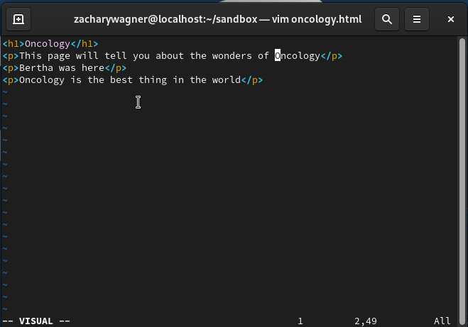

Alternatively, pressing V will take you to visual line mode, where you can cut, copy, and paste the text.

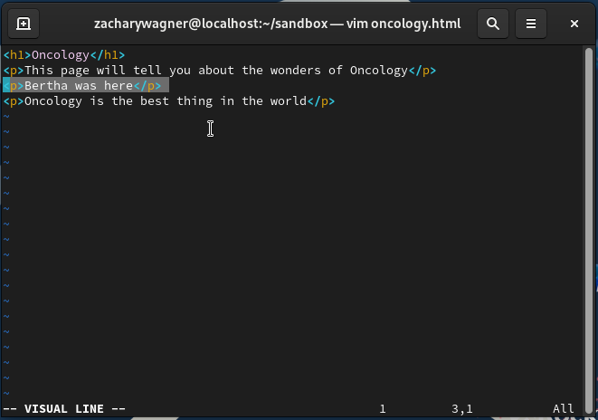

Searching in VIM

To search through a text document in vim, you must first be in normal mode. From normal mode, type /(insert the word you want to find) and the word you are looking for will be highlighted.

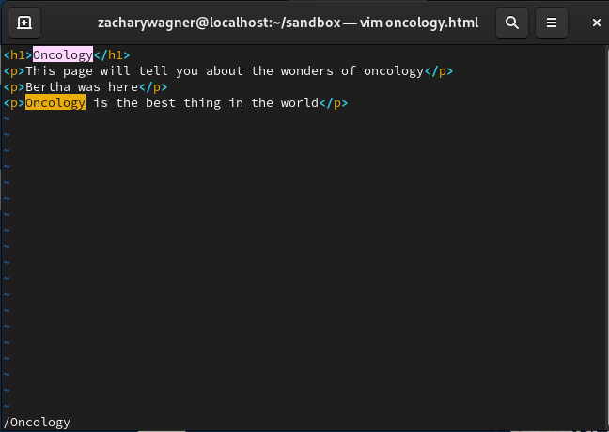

Moving the Cursor

In VIM, you move the cursor with your keyboard. I use the arrow keys, but if your keyboard doesn’t have those, you can use the h j k l keys. The h key moves the cursor left, j is down, k is up, and l is right.

Inserting and Deleting Text

From insert mode, you can insert and delete text. To insert text, just type what you want using your keyboard. To delete text, move the cursor to be a space in front of what you want to delete and press the backspace button.

Cut, Copy, and Paste

To copy a part of text, enter visual line mode, highlight the text you want to copy, and press y to “yank” the text.



To paste, enter visual line code, move the cursor to where you want to paste, and press p.

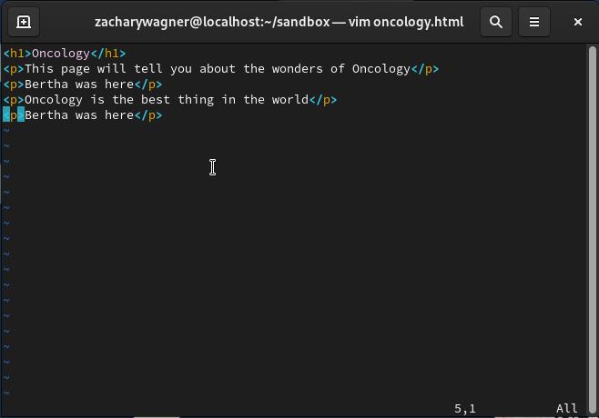

To cut a line of text, highlight the text in visual line mode and press d.

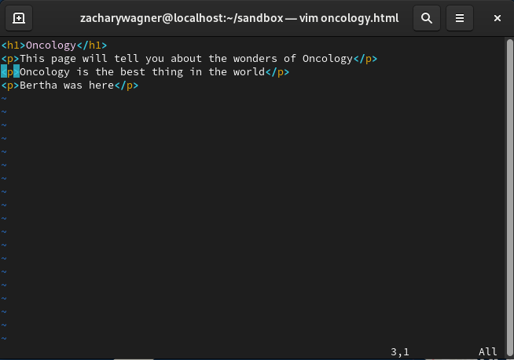

Inserting Command Output into Text File

To insert the output of a command into the text, enter command mode and press r ! (the command you want in the text) to put the output in the text. I used the date command, which outputs the current date.

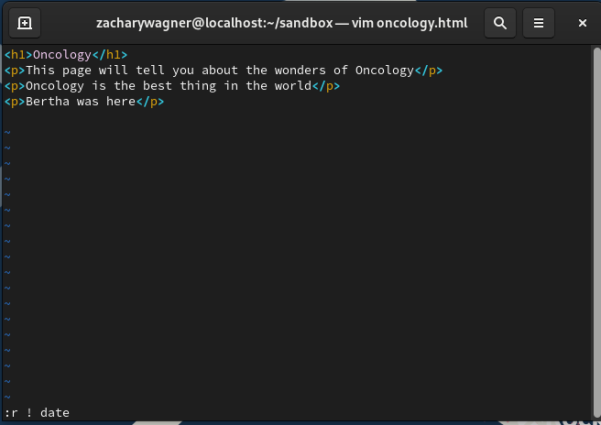

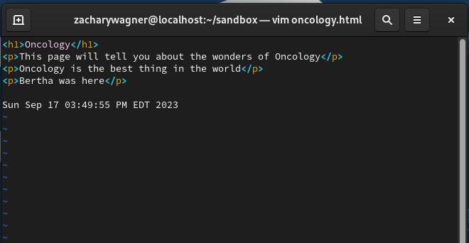

.exrc File

The .exrc file lets you configure how your VIM files look and behave. To create a .exrc file, go to the main directory and type vim .exrc into the console and press enter. This will make an empty file which you can personalize with commands as much as you want, however it is recommended to have the following in the file.

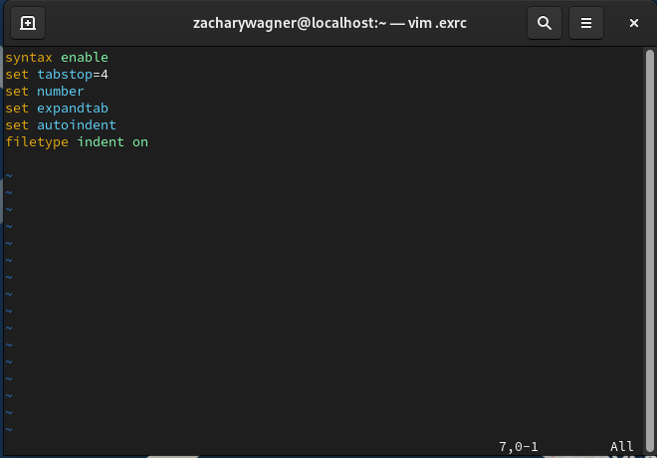

Some other helpful commands include the ruler and errorbells commands. Ruler puts numbers on the side of the text, so you always know what line you are looking at, and errorbells plays a sound every time you mess