**4.Relational Schema**

* DRIVER(DID,DNAME,ADDRESS,PHONE)
* YBSBUS(BID,BCOLOR,MAX_SEATS)
* PERIOD(BID,BSID,PERIOD)
* RUNS_ON(BID,RID,PID)
* BUS_STOP(BSID,BNAME)
* ROUTE(RID,RCOLOR,RNAME)
* PATH(PID,FROM_PATH,TO_PATH)

6.SQL Queries

Q1…Get the bus number that runs on the same path ‘Hlegu’.

Answer:

SELECT BID

FROM RUNS_ON

WHERE PID IN

(SELECT PID

FROM PATH WHERE FROM_PATH ='Hlegu');

Output table:

Q2… Get the route name and route color for route number ‘R4’.

Answer:

SELECT RCOLOR, RNAME

FROM ROUTE

WHERE RID='R4';

Output table:

Q3..Get the driver id and name who live in the address ‘Dagon (South)’.

Answer:

SELECT DRIVER.DID, DNAME

FROM DRIVER

WHERE ADDRESS=‘Dagon (south)';

Output table:

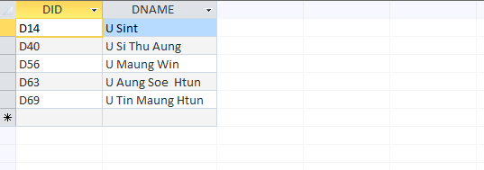

Q4….Get the bus car id that have the same route color ‘red’.

Answer:

SELECT BID

FROM YBSBUS

WHERE BID IN

(SELECT BID

FROM RUNS_ON

WHERE RID IN

(SELECT RID

FROM ROUTE

WHERE RCOLOR='red'));

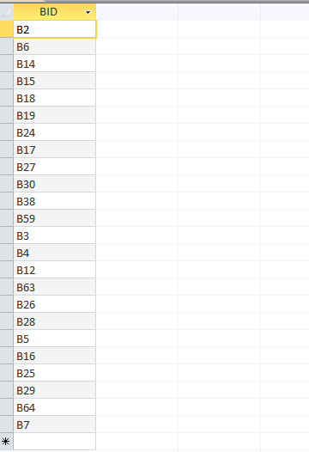

Q5…Get the from and to path for bus car that have the route color blue.

Answer:

SELECT FROM_PATH, TO_PATH

FROM PATH

WHERE PID IN

(SELECT PID

FROM RUNS_ON

WHERE RID IN

(SELECT RID

FROM ROUTE

WHERE RCOLOR='blue'));

Output table:

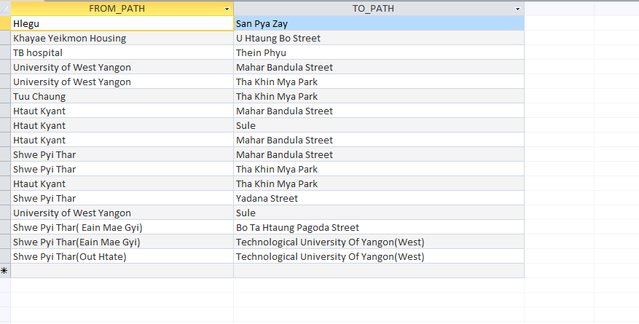

Q6….Get the driver name who drives the bus car has the color ‘Green’.

Answer:

SELECT DNAME

FROM DRIVER

WHERE DID IN

(SELECT DRIVER

FROM YBSBUS

WHERE BCOLOR='R5');

Output table:

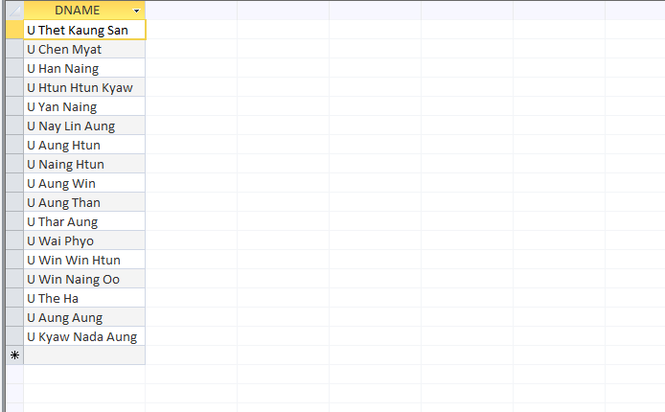

7.Conclusion

The database design of the YBS Reservation System is a paradise for passenger. It helps passenger to ride the correct path and know the car color. And then, they know again what car color runs on what route. So passenger can ride the bus correctly and safely.

**YBS  
(Yangon Bus Service)  
ႏွင့္  
ရန္ကုန္ၿမိဳ့ကိုပတ္ၾကစို့  
  
(လိုရာခရီးေရာက္ရွိဖို့ ၀ိုင္း၀န္းကူညီေဆာင္ရြက္စို့)**