**Adding Items to Evil Bad’s Item Database**

Anytime you want to add items to the game, just follow these steps :

Create a single tile for the item , place this item in the Resources Folder.

Select the item, in the inspector you will see a dropdown menu that says “texture” - change this to sprite2D/UI.

Select the ItemDatabase object in the Hierarchy. In the inspector you will see a script called ItemDatabase.

DoubleClick the script to open it in monodevelop.

you will see a list of items that look like this:

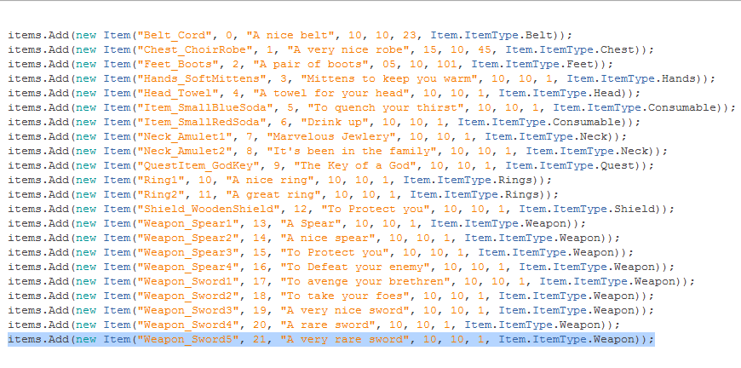

copy the last line and replace what is in the parentheses with your item name. In this case “Weapon_Sword5” would be replaced with “YourItemName”. Make sure the item name is EXACTLY the same as the item’s name in the resources folder.

Next replace the number, in this case “21”, with the next number in the line. So here we would put “22”.

Next replace the description with the description of your item. the description is “A very rare sword”

the numbers 10, 10, 1, represent power, speed, and value -- I will update these with actual stats later, then update this documentation.

the last thing you replace is itemtype with your item’s type.

Thats how you add to the database!

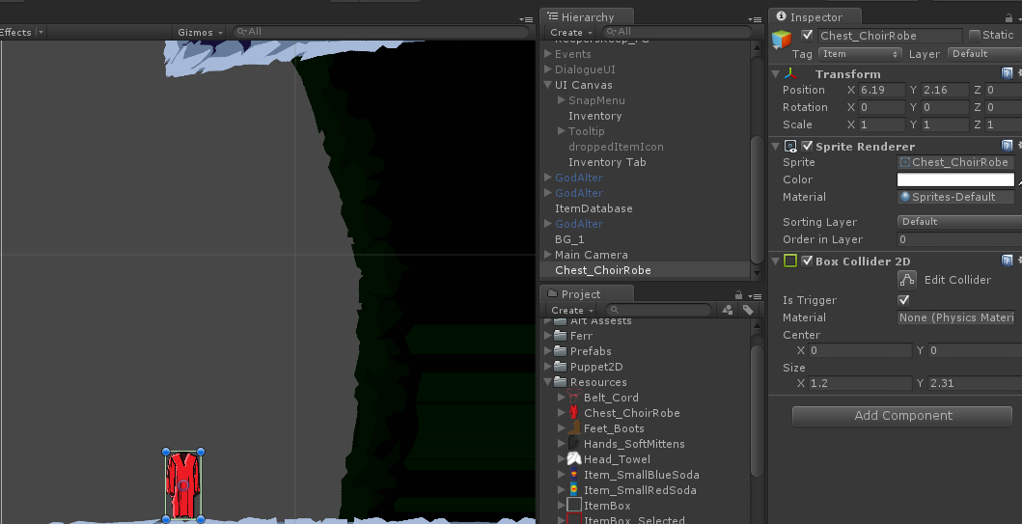

To add one of these items to the level to pick up, just drag it from the resources folder to the scene where you want it to be. add a box collider and checkmark “isTrigger”. The script handles the rest.