Non-Solid Platforms

I have created a script that allows any platform to be non-solid. First the "create colliders" option on that platform needs to be unchecked. Then a 2d Box Collider should be added as well as the NonSolidPlatforms script.

Press down when standing on a collider and you will pass through it.

See the picture below:

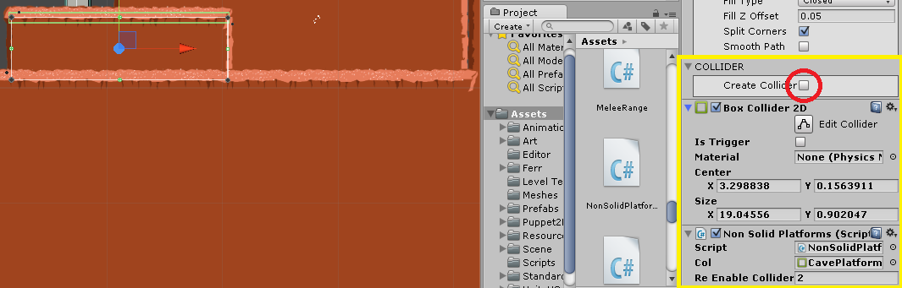

SolidPlatforms

Any platform that must remain solid only needs the "CreateCollider" option enabled to be solid, Ferr2D takes care of the rest.